Slide 3 - Oracle Human Capital Management Cloud Release 11
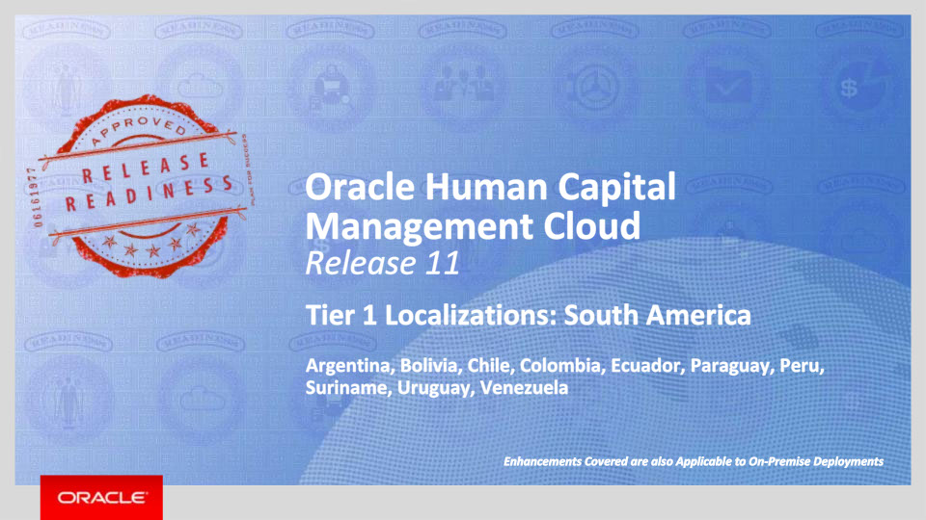
Slide notes
Welcome to the Release 11 Training for the Tier 1 Oracle Human Capital Management Cloud Localizations. In this session, we’ll introduce you to the new capabilities available with Fusion HCM Release 11 for Argentina, Bolivia, Chile, Colombia, Ecuador, Paraguay, Peru, Suriname, Uruguay, and Venezuela.

Notes

Slide 4 - Agenda
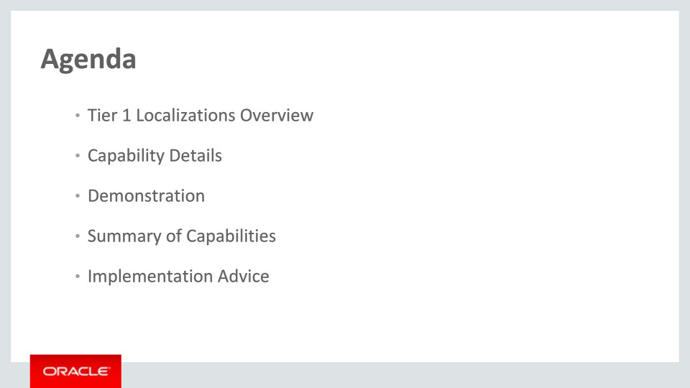
Slide notes
This is the agenda:
We’ll give an overview of the new Tier 1 Localizations in the context of the Global HCM Cloud, followed by more detail to explain what they deliver and what business value they bring.
Then we’ll walk you through a demonstration.
Next we’ll explain what you need to consider before enabling these capabilities in your business, and what you need to know to set them up.

Notes

Slide 5 - Tier 1 Localizations Overview
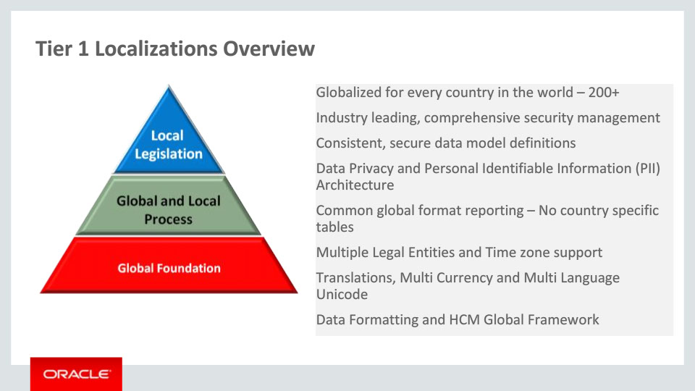
Slide notes
The HCM Global Framework already delivers functionality that can be used in over 200 countries, such as configurable data privacy, data formatting and multiple languages. All localizations are built within this global framework to ensure a consistent data model.
The HCM Global Framework is flexible, allowing both global and local processes to be configured to support multiple legal entities. The user works with natural language screens and formats, and the business flows follow cultural and legal compliance processes.
The application is extensible. The supported processes can be organizationally unique, and the upgrade safe. In addition, generic configurable interfaces for Benefits and Payroll are available as part of the Global Foundation.

Notes

Slide 6 - Tier 1 Localizations Overview
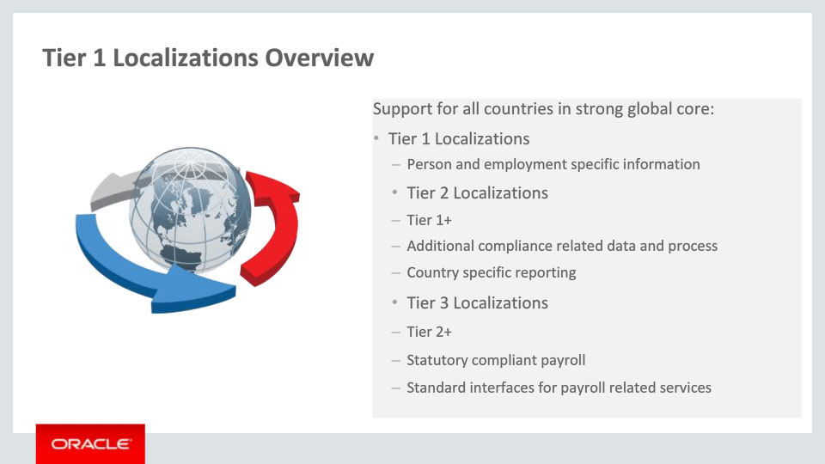
Slide notes
We deliver three tiers of localization content: Tier 1, Tier 2 and Tier 3 Localizations. The Tier 1 Localizations deliver person and employment-specific content formatted for a given country. The Tier 2 Localizations, in addition to Tier 1, enable additional compliance-related functionality (such as data and process) and where required, deliver specific Human Resources statutory reporting. In addition, the Tier 3 Localizations provide a statutory compliant payroll and or standard interfaces for payroll related services.

Notes

Slide 7 - Tier 1 Localizations Overview
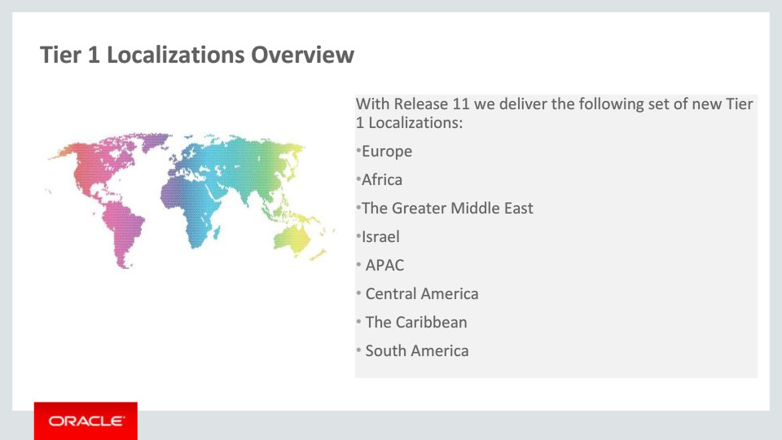
Slide notes
A set of 69 new Tier 1 Localizations are delivered with Release 11- in this slide you can see the grouping by different regions. Note that additional functionality is also available now for 9 Tier 1 Localizations that were delivered with Release 10. Countries per each training session are shown in the last slide of this presentation- Associated Release Training.
This current training covers the new Tier 1 Localizations for South America, namely Argentina, Bolivia, Chile, Colombia, Ecuador, Paraguay, Peru, Suriname, Uruguay, and Venezuela.

Notes

Slide 8 - Tier 1 Localizations Overview
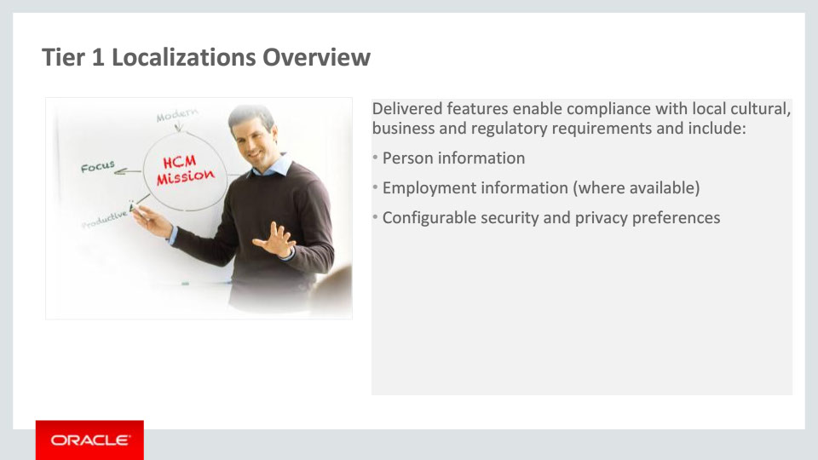
Slide notes
Each of the Tier 1 Localizations provides country-specific content based on the existing global functionalities and is targeted at simplifying and enriching the user experience for customers implementing Fusion HCM globally.

Delivered features for Tier 1 Localizations enable compliance with local requirements and include person information, employment information, security and privacy preferences.

Notes

Slide 9 - Oracle Fusion HCM for Argentina
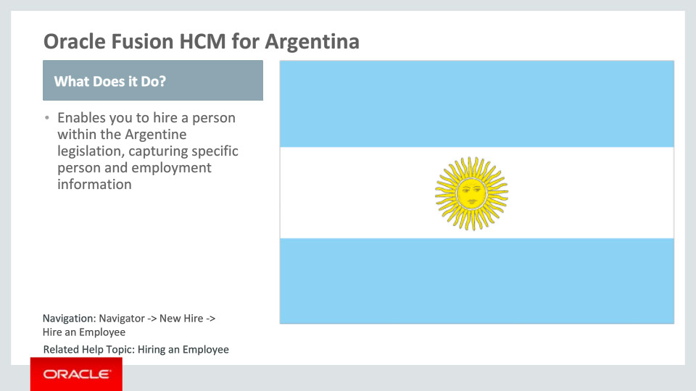
Slide notes
Oracle Fusion HCM for Argentina supports country-specific features and functions. It enables users to follow local business practices and assists in complying with its statutory requirements by capturing particular person and employment information.

Notes

Slide 10 - Oracle Fusion HCM for Argentina
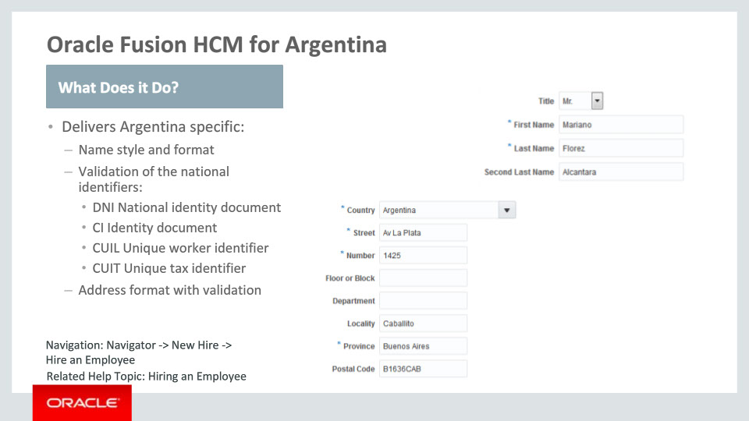
Slide notes
Let’s have a closer look at what has been delivered for Argentina.
First we have a local person name style, consisting of the Title, First Name, Last Name and Second Last Name. The First and Last Name are required.
We have also delivered predefined values for the common national identifiers for Argentina. These are:
· DNI National identity document
· CI Identity document (also known as the Identity Card)
· CUIL Unique worker identifier
· CUIT Unique tax identifier
These national identifiers are validated upon entry.
In addition, a local address format has been seeded for Argentina. This address format is enabled by choosing the address style: “Supplemental Taxation and Reporting Address” using the task ”Manage Features by Country or Territory.“ The Country, Street, Number and Province are required. The Postal Code is also validated against a specific format: a letter in upper case followed by 4 digits and other 3 letters in upper case.
Notes

Slide 11 - Oracle Fusion HCM for Argentina
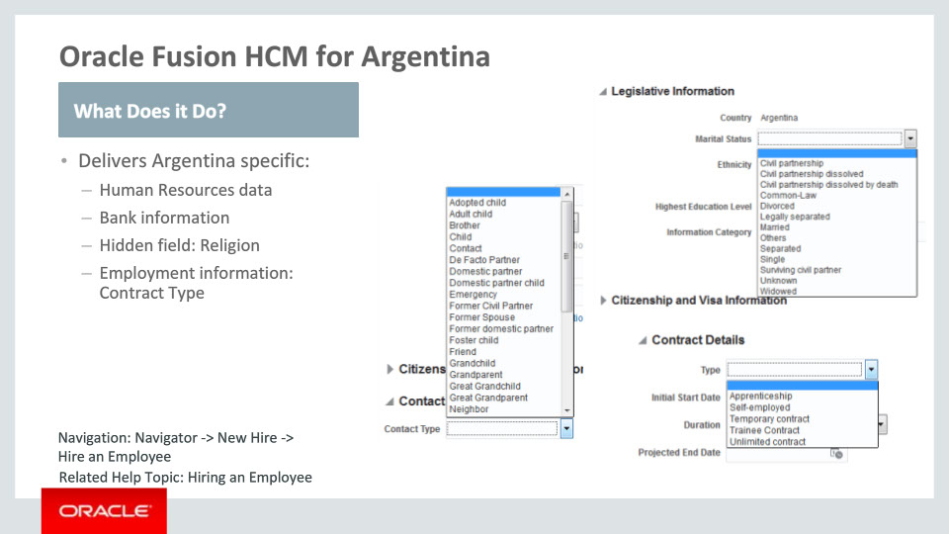
Slide notes
Various Human Resources attributes are tailored for Argentina, including predefined lookup values for Marital Status, Contacts, Passports, Visa and Permit Types, and Highest Education Level.
The available country-specific bank information is also available, providing the required banking attributes that customers would expect in Argentina.
In addition, we are hiding the Religion attribute to meet the Argentinean statutory, business and cultural practices and requirements.
Finally, an employment-related attribute, the Contract Type contains a predefined set of values for Argentina.

Notes

Slide 12 - Oracle Fusion HCM for Bolivia
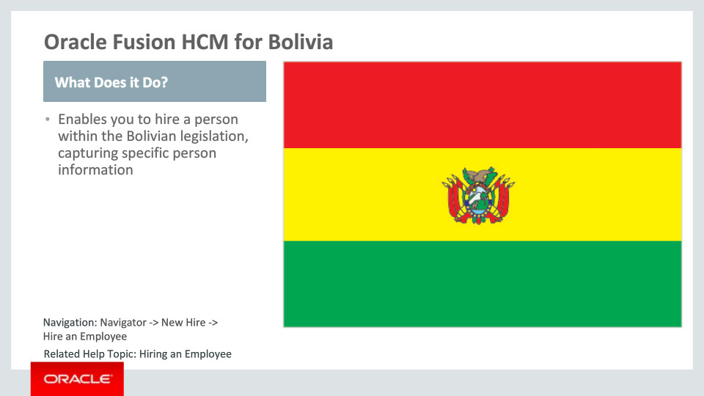
Slide notes
Oracle Fusion HCM for Bolivia supports country-specific features and functions. It enables users to follow Bolivian business practices and assists in complying with its statutory requirements by capturing particular person information.

Notes

Slide 13 - Oracle Fusion HCM for Bolivia
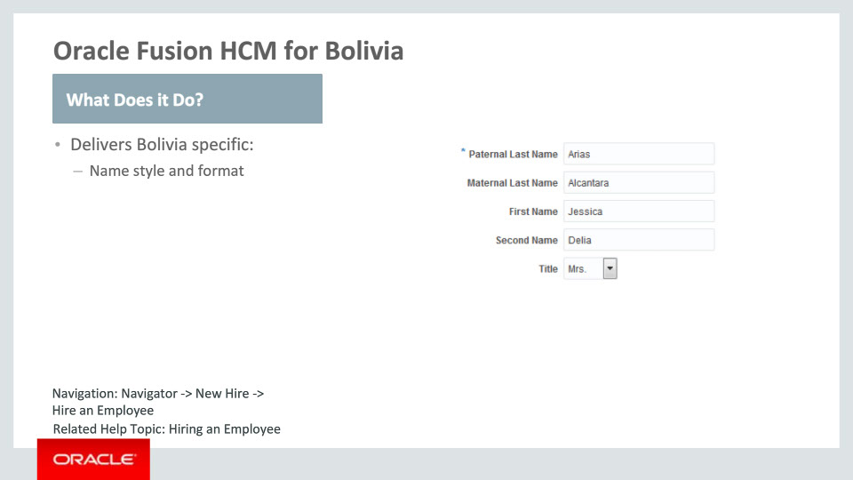
Slide notes
The functionality delivered for Bolivia consists of a local name style and format. The name style contains the Paternal and Maternal Last Names, a First and Second Name, and the Title.

Notes

Slide 14 - Oracle Fusion HCM for Chile
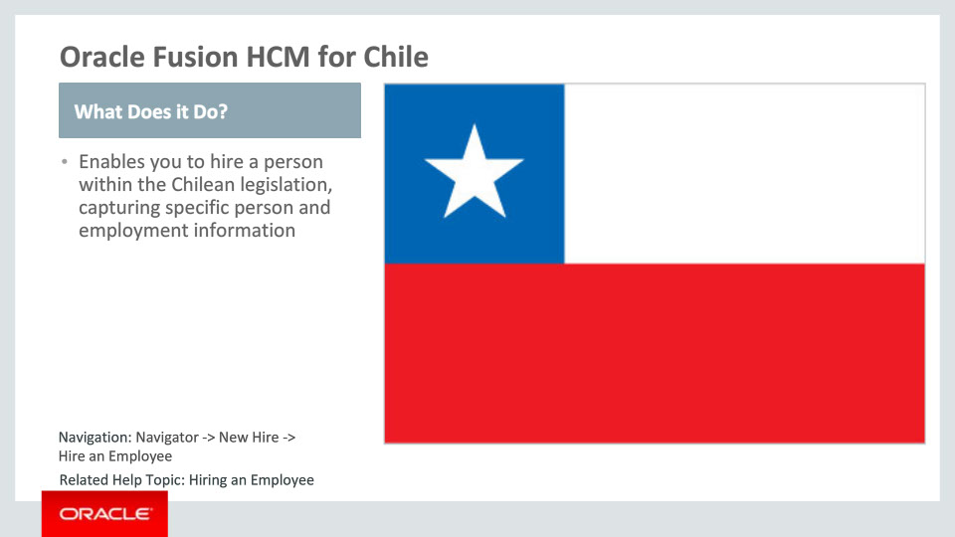
Slide notes
Oracle Fusion HCM for Chile supports country-specific features and functions. It enables users to follow the Chilean business practices and assists in complying with its statutory requirements by capturing particular person and employment information.

Notes

Slide 15 - Oracle Fusion HCM for Chile
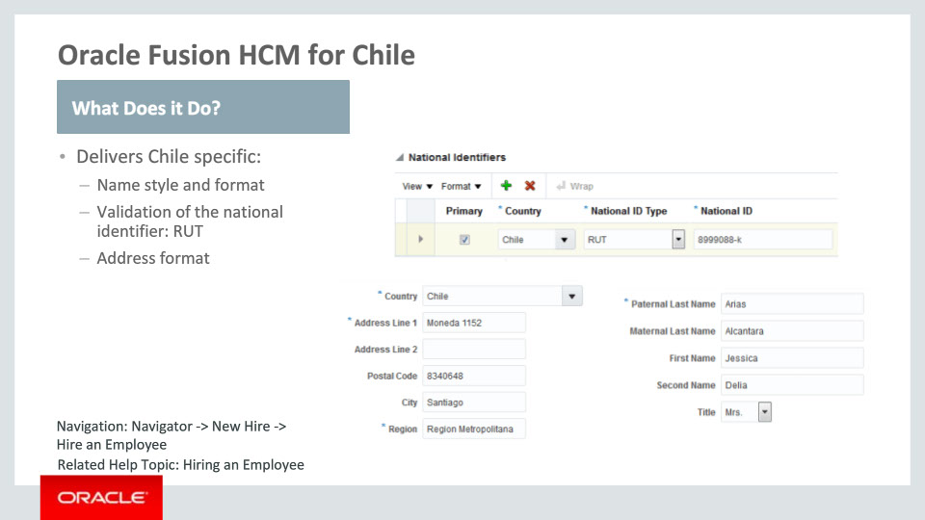
Slide notes
Let’s take a closer look at what has been delivered for Chile.
A local name style and format are available. The name style contains the Paternal and Maternal Last Names, a First and Second Name, and the Title.
The national identifier “RUT” has been delivered. This is validated upon entry: it should have 8 or 9 digits of which the last digit is a verification number that goes from 0 to 9 or the letter “K”.
There is also a local address format delivered for Chile. This address format is enabled by choosing the address style: “Supplemental Taxation and Reporting Address” using the task ”Manage Features by Country or Territory.“ The Country, Address Line 1 and Region are required. No further address validations take place.

Notes

Slide 16 - Oracle Fusion HCM for Chile
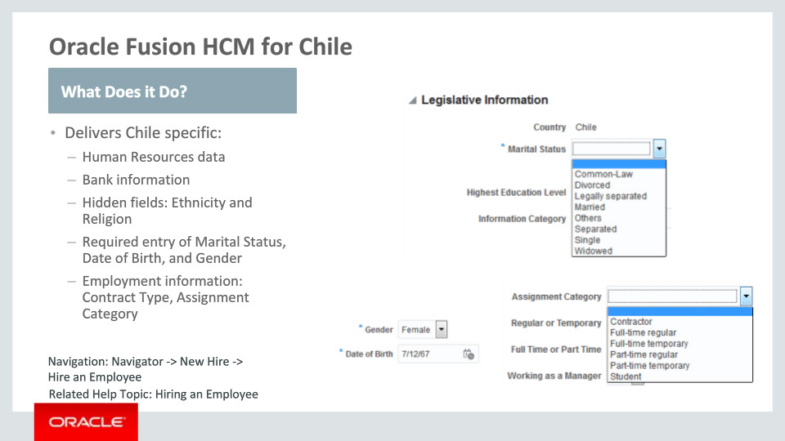
Slide notes
In addition to this, we have also enabled country-specific Human Resources data capture by delivering predefined lookup values for Marital Status, Contacts, Passports, Visa and Permit Types, Disabilities, and Highest Education Level.
The local bank information is also available and out-of-the-box we are hiding the Ethnicity and Religion attributes, in order to meet the Chilean statutory, business and cultural practices and requirements.
The entry of the Marital Status, Date of Birth and the person’s Gender have been made required.
Finally, we have delivered various employment-related specific lookup values for Chile: the Contract Type and the Assignment Category.

Notes

Slide 17 - Oracle Fusion HCM for Colombia
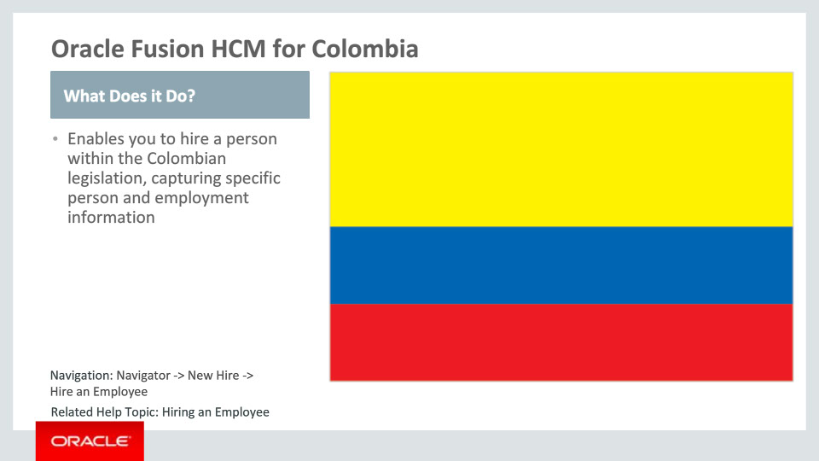
Slide notes
Oracle Fusion Human Capital Management for Colombia supports country-specific features and functions. It enables users to follow Colombian business practices and assists in complying with its statutory requirements by capturing particular person and employment information.

Notes

Slide 18 - Oracle Fusion HCM for Colombia
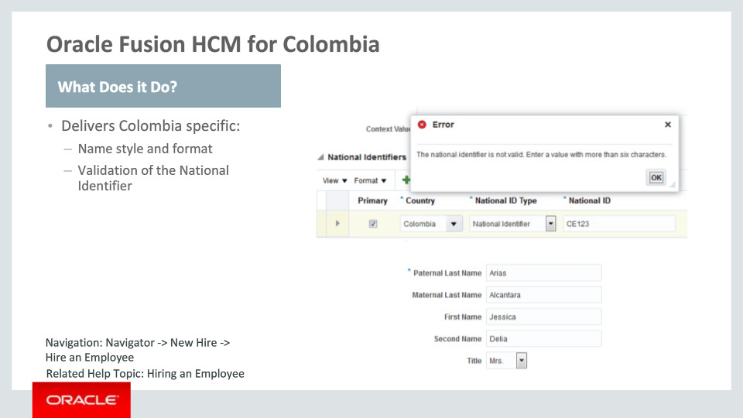
Slide notes
Let’s continue by going over the functionality delivered for Colombia in more detail.
First, we have delivered a country-specific person name style. This name style contains the Paternal and Maternal Last Names, a First and Second Name, and the Title.
Second, validation for the National Identifier of Columbia has been delivered. The National Identifier for Colombian nationals has 7 or 8 digits. For foreign people it begins with “CE” and has 6 or 7 digits.

Notes

Slide 19 - Oracle Fusion HCM for Colombia
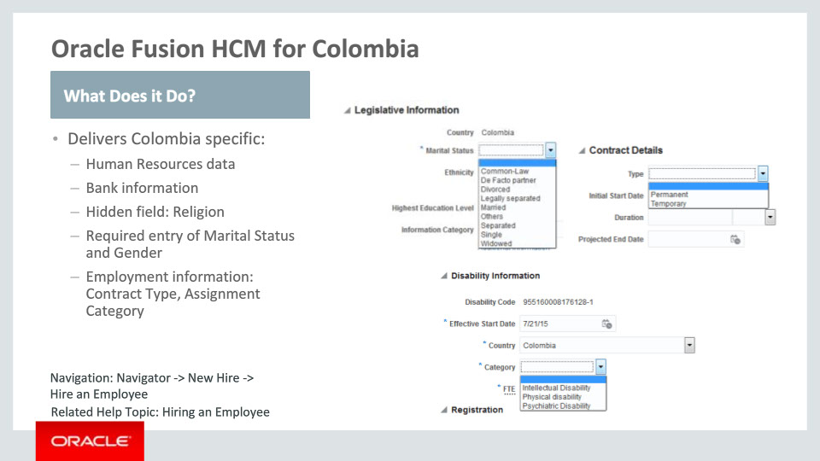
Slide notes
In addition to this, we have also enabled specific Human Resources data capture for Colombia by delivering predefined lookup values for Marital Status, Contacts, Visa and Permit Types, Disabilities, and Highest Education Level.
Local bank information is also available, and out-of-the-box we are hiding the Religion attribute, to meet the Colombian statutory, business and cultural practices and requirements.
The entry of the Marital Status and the person’s Gender is now required.
Finally, we have also delivered various employment-related, country-specific lookup values for Colombia: the Contract Type and the Assignment Category.

Notes

Slide 20 - Oracle Fusion HCM for Ecuador
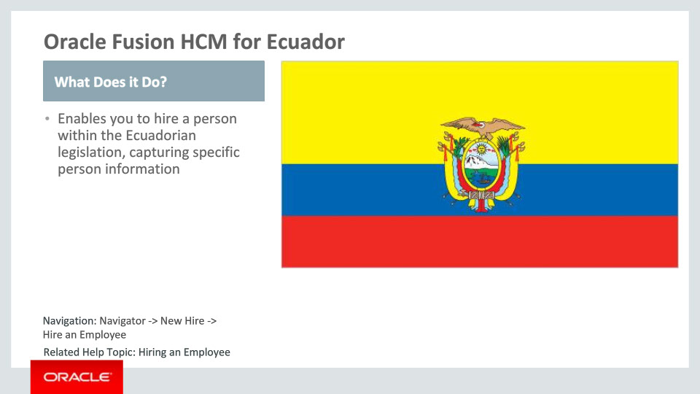
Slide notes
Oracle Fusion Human Capital Management for Ecuador supports country-specific features and functions. It enables users to follow Ecuadorian business practices and assists in complying with its statutory requirements by capturing particular person information.

Notes

Slide 21 - Oracle Fusion HCM for Ecuador
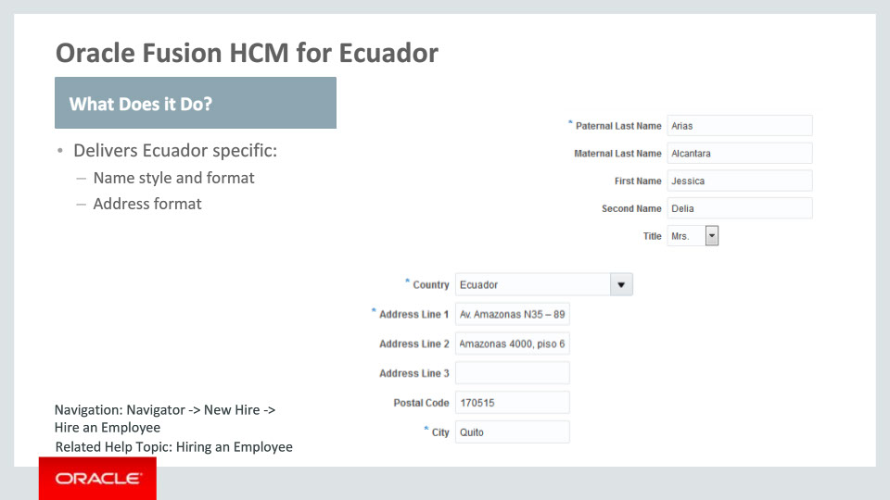
Slide notes
Let’s go over the functionality delivered for Ecuador in more detail.
First, we have delivered a local person name style for Ecuador. This name style contains the Paternal and Maternal Last Names, a First and Second Name, and the Title.
Second, a local address format has been seeded for Ecuador. This address format is enabled by choosing the address style: “Supplemental Taxation and Reporting Address” using the task ”Manage Features by Country or Territory.“ The Country, Address Line 1 and City are required fields.

Notes

Slide 22 - Oracle Fusion HCM for Paraguay
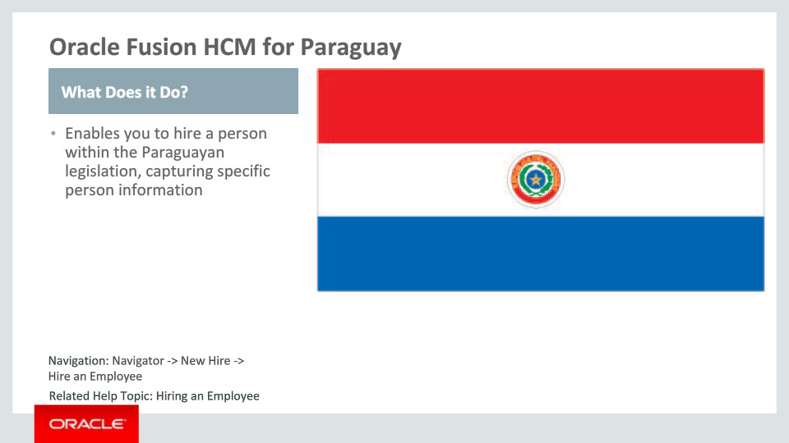
Slide notes
Oracle Fusion Human Capital Management for Paraguay supports country-specific features and functions. It enables users to follow Paraguayan business practices and assists in complying with its statutory requirements by capturing particular person information.

Notes

Slide 23 - Oracle Fusion HCM for Paraguay
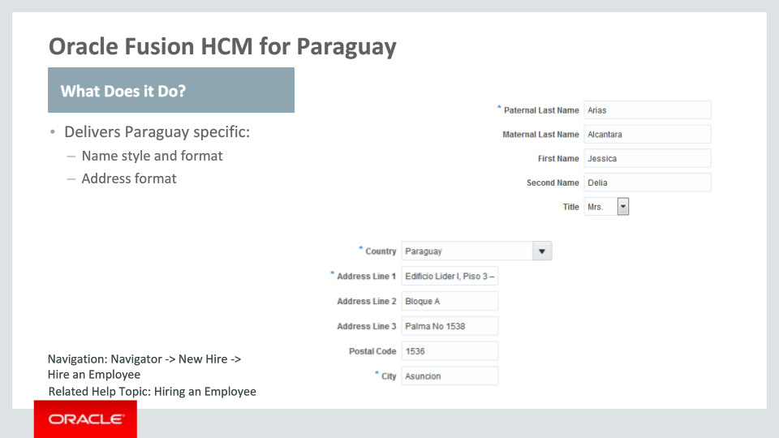
Slide notes
Let’s go over the functionality delivered for Paraguay in more detail.
First, we have delivered a country-specific person name style. This name style contains the Paternal and Maternal Last Names, a First and Second Name, and the Title.
Second and last, a local address format is available for Paraguay. This address format is enabled by choosing the address style: “Supplemental Taxation and Reporting Address” using the task ”Manage Features by Country or Territory.“ The Country, Address Line 1 and City are required. No further address validations take place.

Notes

Slide 24 - Oracle Fusion HCM for Peru
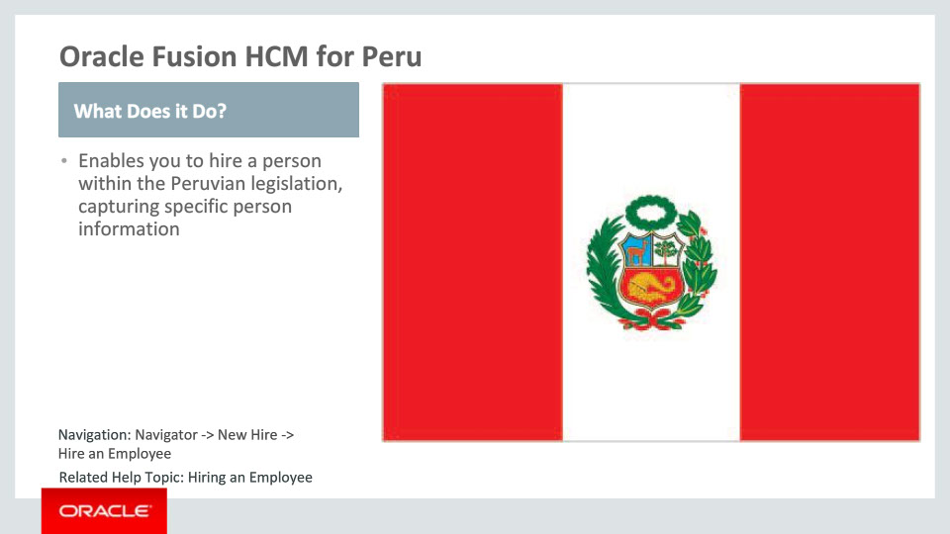
Slide notes
Oracle Fusion Human Capital Management for Peru supports country-specific features and functions. It enables users to follow Peruvian business practices and assists in complying with its statutory requirements by capturing particular person information.

Notes

Slide 25 - Oracle Fusion HCM for Peru
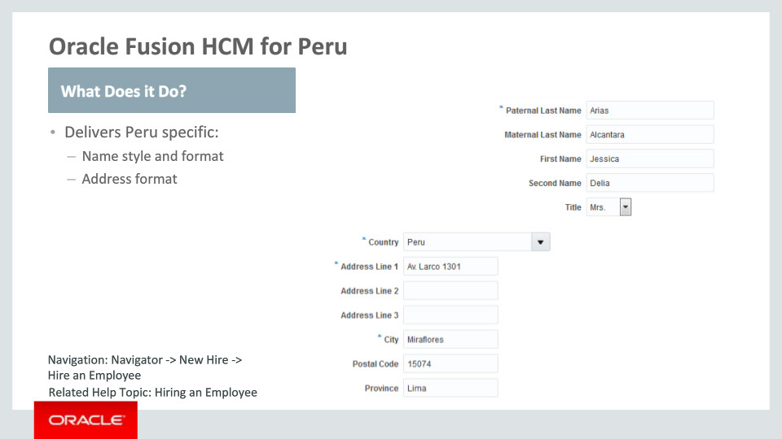
Slide notes
Let’s go over the functionality delivered for Peru in more detail.
We have enabled a local person name style for Peru. This name style contains the Paternal and Maternal Last Names, a First and Second Name, and the Title.
We have also delivered a local address format for Peru. This address format is enabled by choosing the address style: “Supplemental Taxation and Reporting Address” using the task ”Manage Features by Country or Territory.“ The Country, Address Line 1 and City are required.

Notes

Slide 26 - Oracle Fusion HCM for Suriname
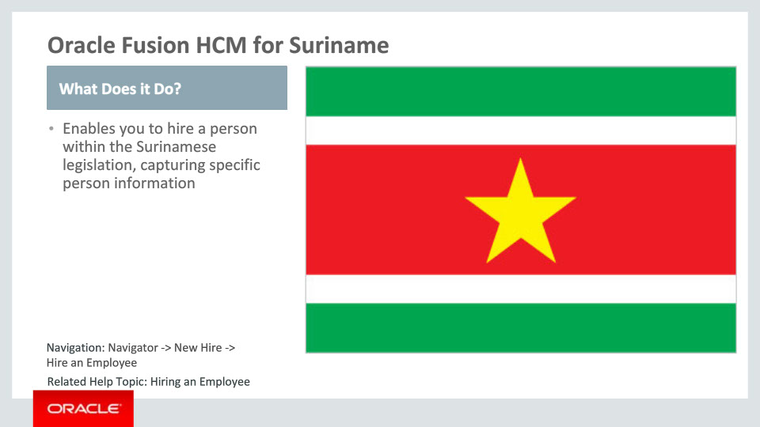
Slide notes
Oracle Fusion Human Capital Management for Suriname supports country-specific features and functions. It enables users to follow Surinamese business practices and assists in complying with its statutory requirements by capturing particular person information.

Notes

Slide 27 - Oracle Fusion HCM for Suriname
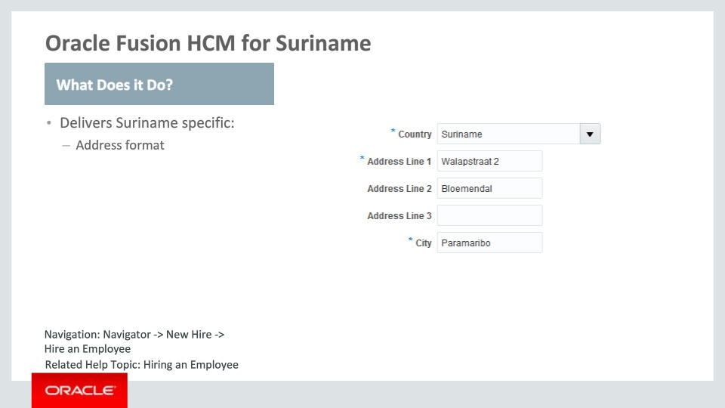
Slide notes
Let’s go over the functionality delivered for Suriname in more detail.
A local address format has been seeded for Suriname. This address format is enabled by choosing the address style: “Supplemental Taxation and Reporting Address” using the task ”Manage Features by Country or Territory.“ The Country, Address Line 1 and City are required. No other address validations take place.

Notes

Slide 28 - Oracle Fusion HCM for Uruguay
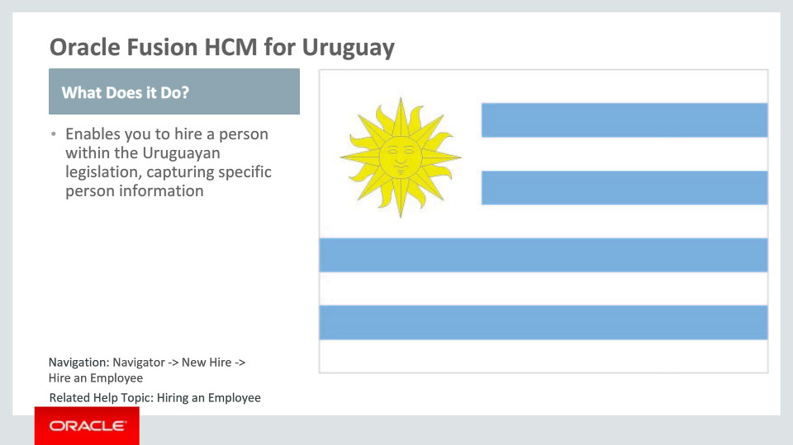
Slide notes
Oracle Fusion Human Capital Management for Uruguay supports country-specific features and functions. It enables users to follow Uruguayan business practices and assists in complying with its statutory requirements by capturing particular person information.

Notes

Slide 29 - Oracle Fusion HCM for Uruguay
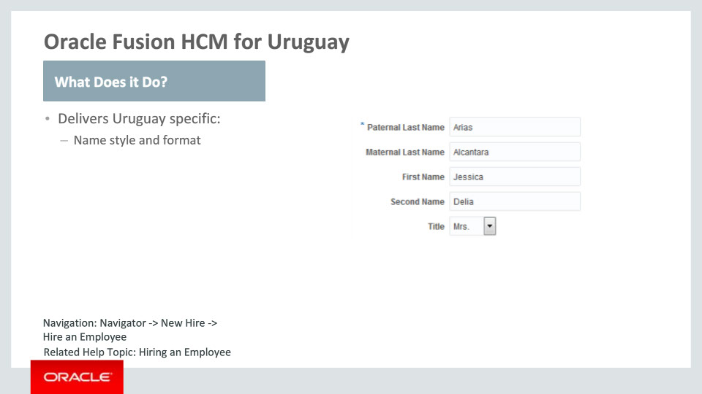
Slide notes
Functionality delivered for Uruguay consists of a local person name style and format. The name style contains the Paternal and Maternal Last Names, a First and Second Name, and the Title. The Paternal Last Name is required.

Notes

Slide 30 - Oracle Fusion HCM for Venezuela
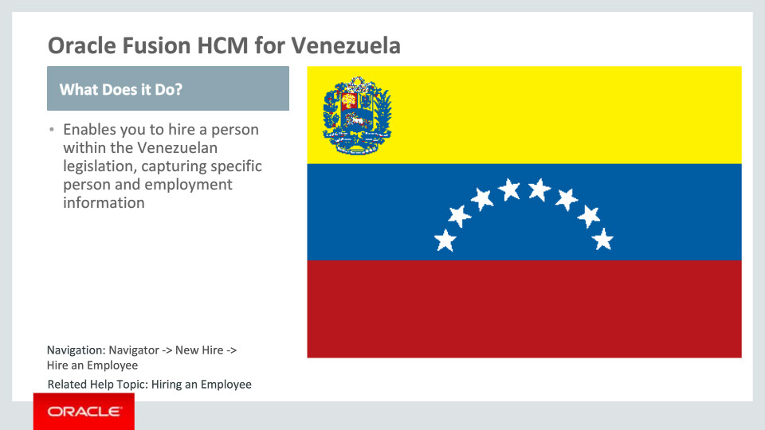
Slide notes
Oracle Fusion Human Capital Management for Venezuela supports country-specific features and functions. It enables users to follow Venezuelan business practices and assists in complying with its statutory requirements by capturing particular person and employment information.

Notes

Slide 31 - Oracle Fusion HCM for Venezuela
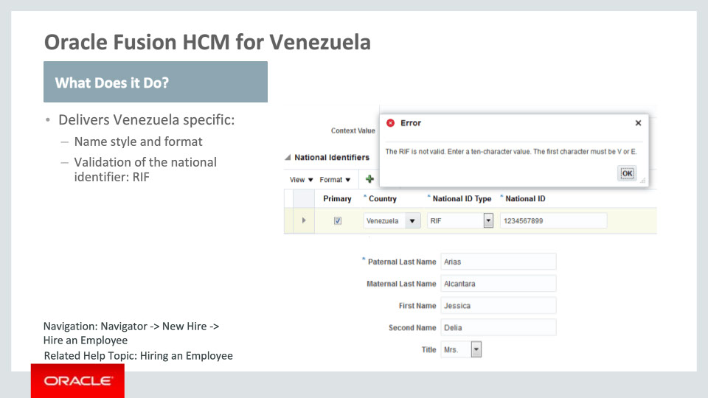
Slide notes
Finally, let’s go over the functionality delivered for Venezuela in more detail.
A local person name style is available. This name style contains the Paternal and Maternal Last Names, a First and Second Name, and the Title.
A predefined value for the national identifier is delivered for Venezuela, called “RIF”, and validation logic is provided. The RIF number should be ten characters in length and start with a “V” or an “E”.

Notes

Slide 32 - Oracle Fusion HCM for Venezuela
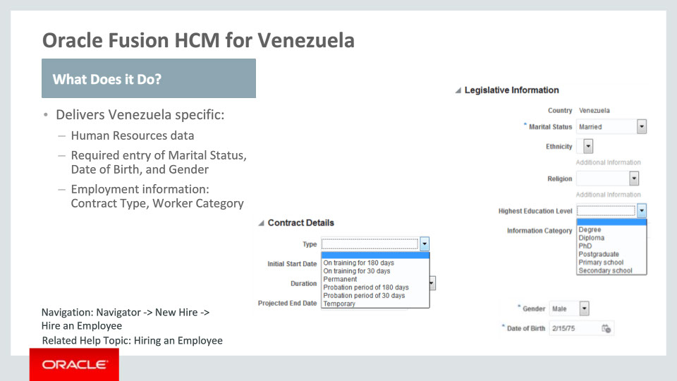
Slide notes
In addition to this, we have also enabled country-specific Human Resources data capture for Venezuela by delivering lookup values for Contacts, Passports, Visa and Permit Types, and Highest Education Level.
The entry of the Marital Status, Date of Birth and the person’s Gender have been made required.
Finally, we have also delivered various employment-related predefined lookup values for Venezuela: the Contract Type and the Worker Category.

Notes

Slide 33 - Tier 1 Localizations
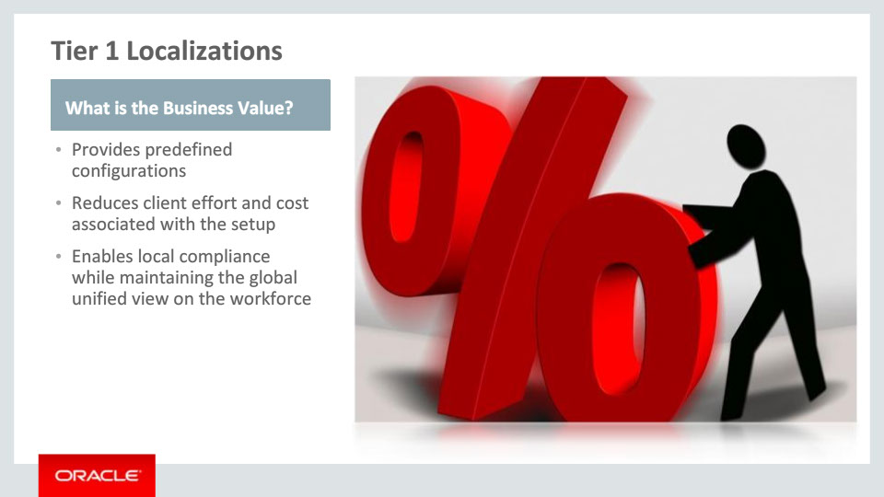
Slide notes
The new Tier 1 Localizations provide your organization with Business Value: first, by providing predefined configurations and content aligned with the country-specific requirements on capturing person information; then, by reducing cost and time taken to implement HCM.

Last but not least, business value is added by assisting customers to achieve local compliance while retaining the global unified view of their workforce.

Notes

Slide 202 - Summary of Capabilities
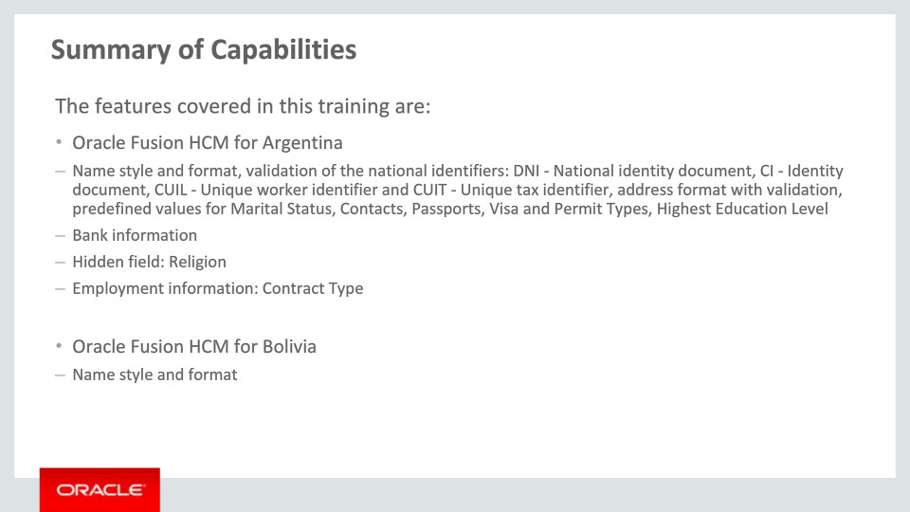
Slide notes
Here is the summary of the features I have talked about today. I began by talking about the Tier 1 Localizations for Argentina and Bolivia, and the functionalities that have been delivered for each, which you can review here.

Notes

Slide 203 - Summary of Capabilities
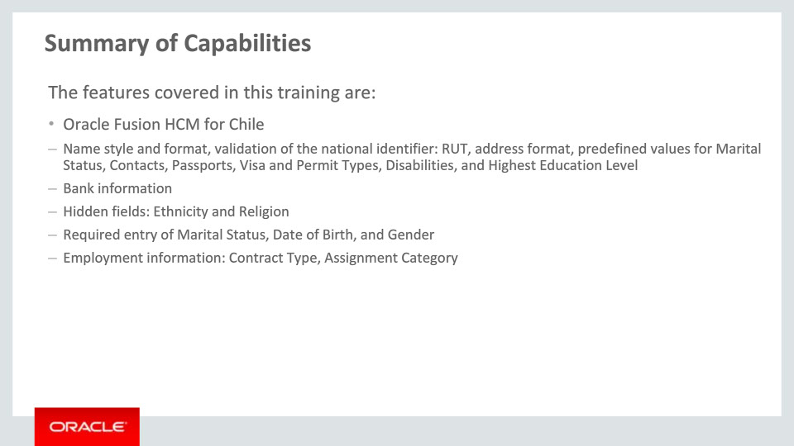
Slide notes
I continued by talking about functionalities enabled for Chile, which you can review here.

Notes

Slide 204 - Summary of Capabilities
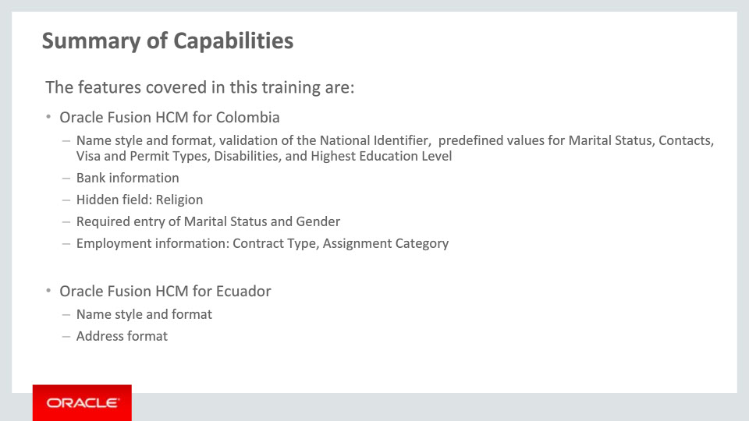
Slide notes
I then described the Tier 1 Localizations for Colombia and Ecuador. A summary of the delivered capabilities can be reviewed here.

Notes

Slide 205 - Summary of Capabilities
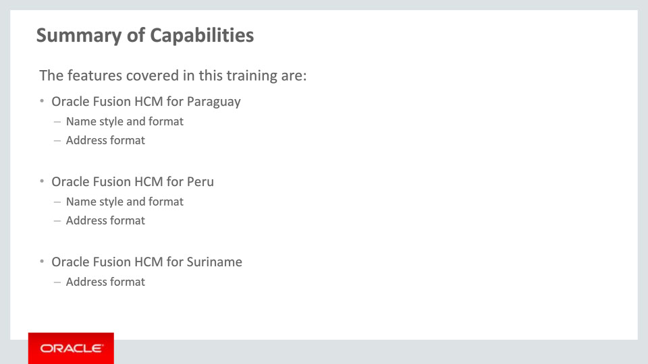
Slide notes
After this I covered the Tier 1 Localizations for Paraguay, Peru and Suriname. A summary of the delivered capabilities can be reviewed here.

Notes

Slide 206 - Summary of Capabilities
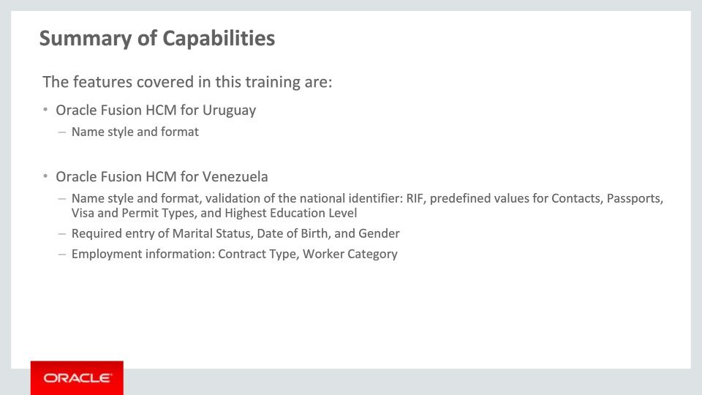
Slide notes
And finally I covered the Tier 1 Localizations for Uruguay and Venezuela. Please take a moment to review this information.

These new features and functionalities will help you and your organization achieve compliance in a global context.

Notes

Slide 207 - Additional Information
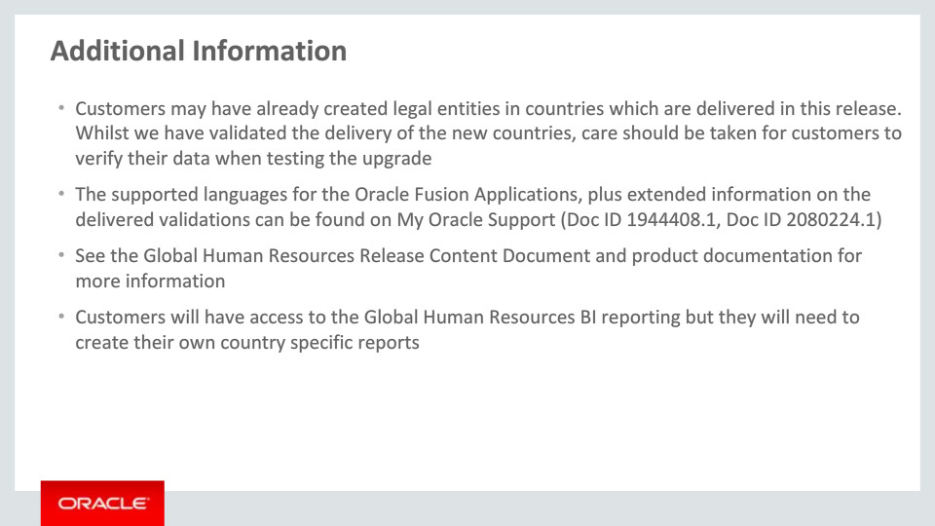
Slide notes
Here is some additional helpful information. Be aware that if customers have already created legal entities for a country which is now delivered, they will need to verify their data after the upgrade.
Please also refer to the Release Content Document for Global Human Resources to get an overview of all new features delivered with this release and My Oracle Support for the latest status of translations.
Customers should review the Global Human Resources documentation when they implement the Tier 1 Localization functionality.
Finally, whilst customers have access to the Global Human Resources BI reporting, they will need to create their own country specific reports.

Notes

Slide 208 - Implementation Advice

Slide notes
In this implementation advice section we will go through what you need to consider before enabling these features in your business, and what you need to know to set them up.

Notes

Slide 209 - Feature Impact Guidelines
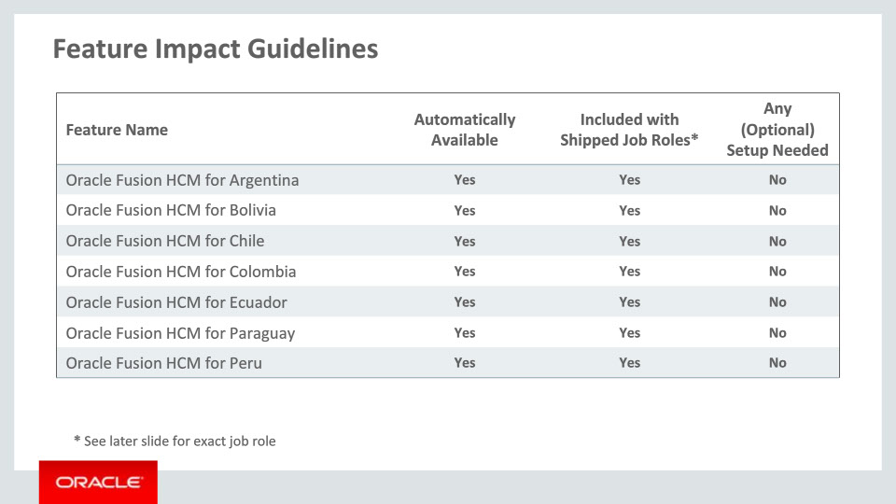
Slide notes
This table depicts key implementation information for the features covered in this training. It details:
• If a feature is automatically available after installation
• If a feature can be accessed using the shipped job roles – the exact job roles are detailed later in this section
• And if a feature has any setup associated with it
All features included in this release are automatically available and included with the shipped job roles. No specific setup is required to access the features outlined.

Notes

Slide 210 - Feature Impact Guidelines
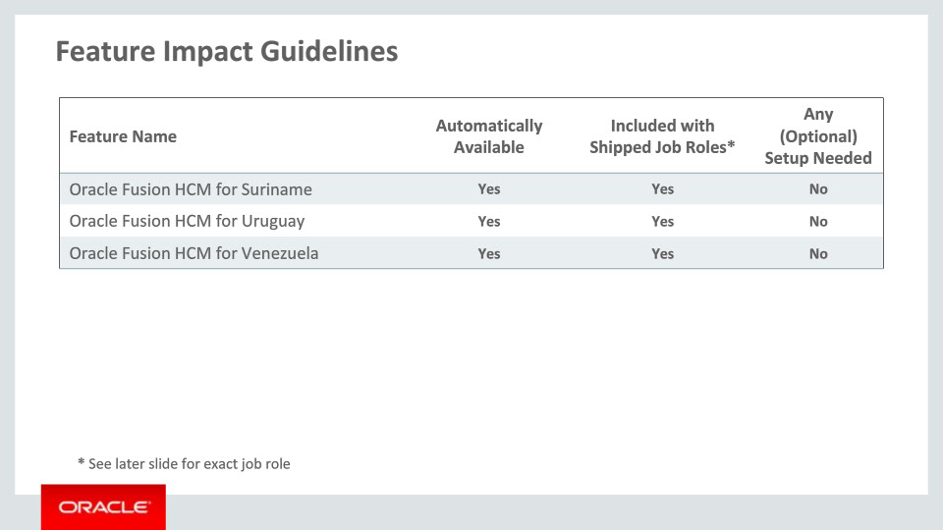
Slide notes
These are the rest of the features described in the current training. They are also automatically available and included with the shipped job roles, with no specific setup required to access them.

Notes

Slide 211 - Job Roles
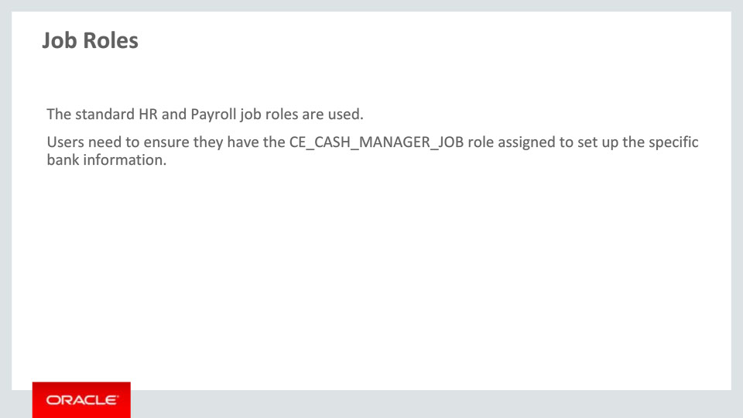
Slide notes
Here are the shipped job roles that will access the new capabilities covered in this training. While the standard HR and Payroll job roles are used (for example Human Resources Specialist, Human Resources Manager), users will need to assign the CE_CASH_MANAGER_JOB role in order to set up the local bank information.

Notes

Slide 212 - Business Process Model Information
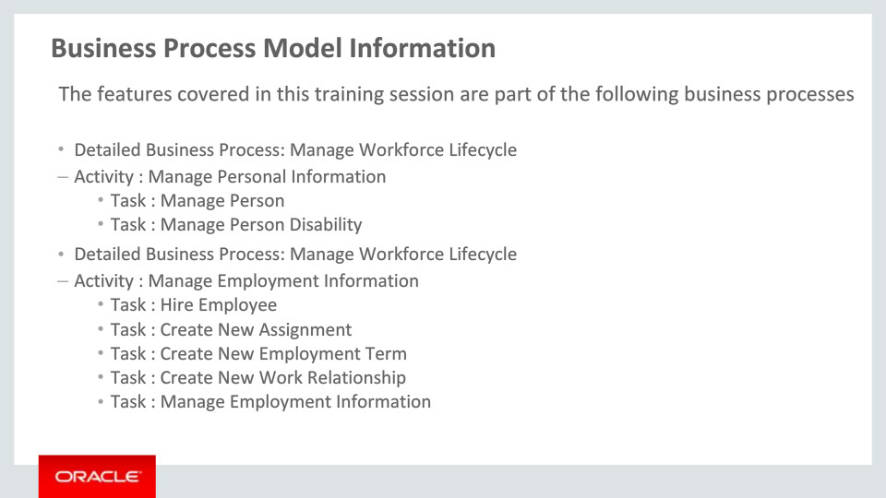
Slide notes
The business processes associated with the new capabilities covered in this training are detailed here. General processes are mentioned first, then component activities and finally the various tasks as part of the activities. Please take a moment to review them.

Notes

Slide 213 - Business Process Model Information
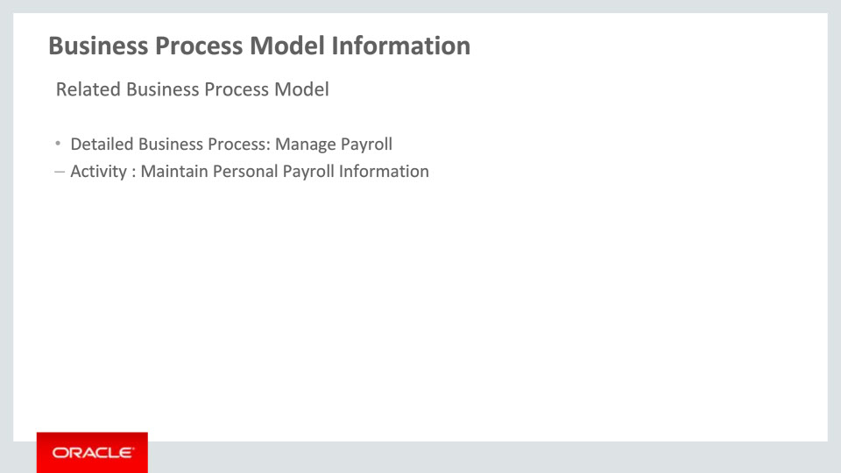
Slide notes
The related business processes and activity associated with the new capabilities covered in this training are detailed here.

Notes

Slide 214 - Associated Release Training
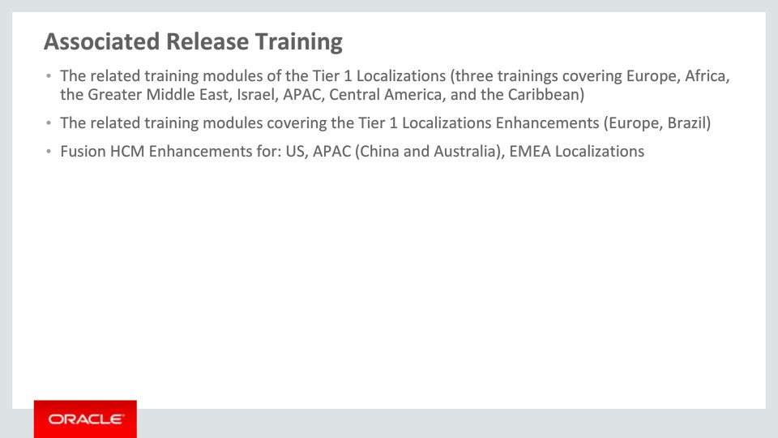
Slide notes
This training module is part of a ten-group set on the new Tier 1 Localizations available with Release 11. The nine other groups are: Europe (with three groups), Africa, the Arab Countries, Israel, APAC, Central America, and the Caribbean.
Besides these ten groups, a set of two Tier 1 Localizations Enhancements trainings must be mentioned: one for Europe and one for Brazil. These two sessions cover the enhancements available with Release 11 for the six Tier 1 Localizations delivered with Release 10.
Please refer to the next slide to see details on countries for the training sessions mentioned here.
Other training modules that cover the new functionality added to existing localizations and are recommended viewing are Fusion HCM Enhancements for US, Asia Pacific (China and Australia) and various EMEA Localizations.
Notes

Slide 215 - Associated Release Training
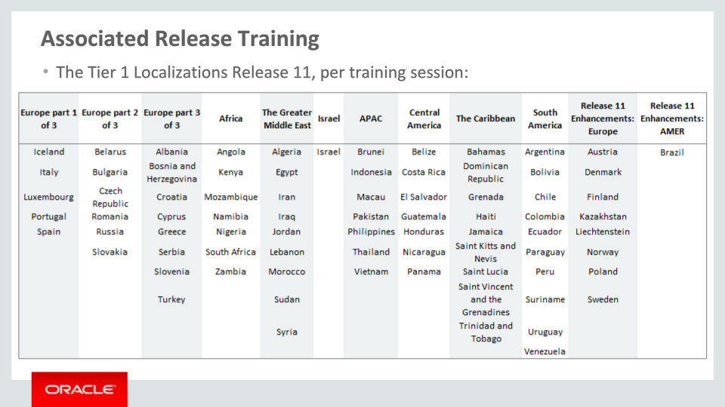
Slide notes
As previously mentioned, this slide depicts the Tier 1 Localizations per training session. The first ten groups cover the new localizations available with Release 11, while the last two show the enhancements available with Release 11 for nine Tier 1 Localizations delivered with Release 10. Please take a moment to review the countries of each training session.
This concludes this presentation, thank you for listening. You can easily pause and rewind any of these slides if you require additional time to take in the detail.

Notes

