Slide 3 - Oracle Human Capital Management Cloud Release 11
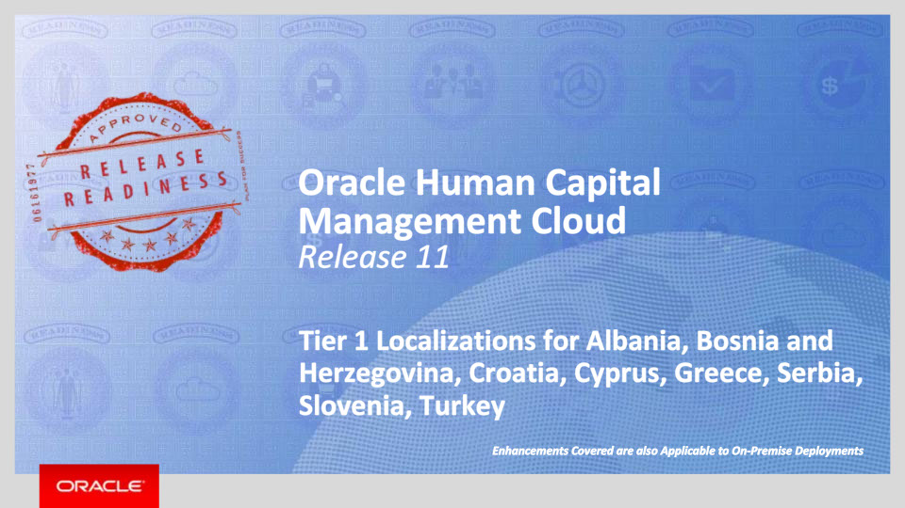
Slide notes
Welcome to the Release 11 Training for the Tier 1 Oracle Human Capital Management Cloud Localizations. In this session, we’ll introduce you to the new capabilities available with Fusion HCM Release 11 for Albania, Bosnia and Herzegovina, Croatia, Cyprus, Greece, Serbia, Slovenia, and Turkey.

Notes

Slide 4 - Agenda
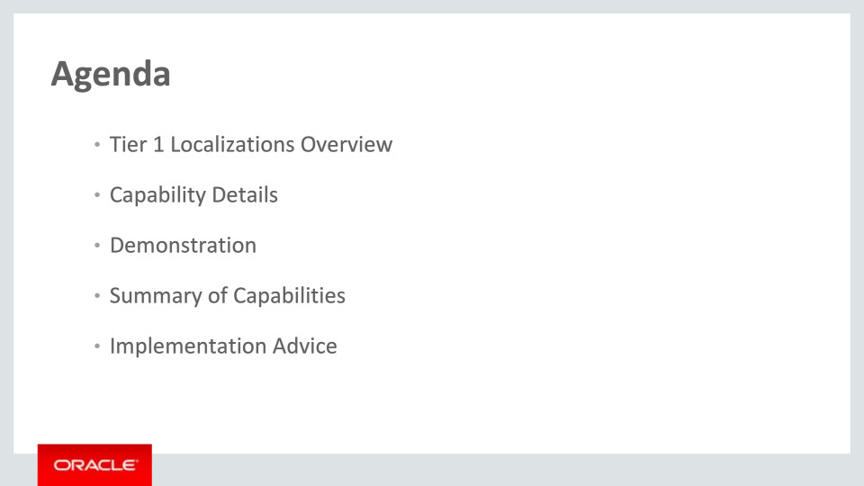
Slide notes
This is the agenda:
We’ll give an overview of the new Tier 1 Localizations in the context of the Global HCM Cloud, followed by more detail to explain what they deliver and what business value they bring.
Then we’ll walk you through a demonstration.
Next we’ll explain what you need to consider before enabling these capabilities in your business, and what you need to know to set them up.

Notes

Slide 5 - Tier 1 Localizations Overview
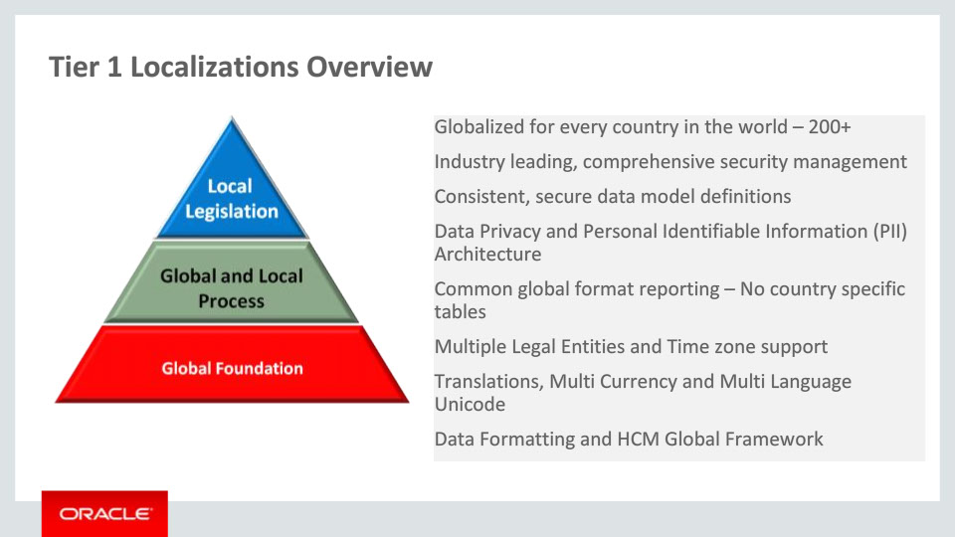
Slide notes
The HCM Global Framework already delivers functionality that can be used in over 200 countries, such as configurable data privacy, data formatting and multiple languages. All localizations are built within this global framework to ensure a consistent data model.
The HCM Global Framework is flexible, allowing both global and local processes to be configured to support multiple legal entities. The user works with natural language screens and formats, and the business flows follow cultural and legal compliance processes.
The application is extensible. The supported processes can be organizationally unique, and the upgrade safe. In addition, generic configurable interfaces for Benefits and Payroll are available as part of the Global Foundation.

Notes

Slide 6 - Tier 1 Localizations Overview
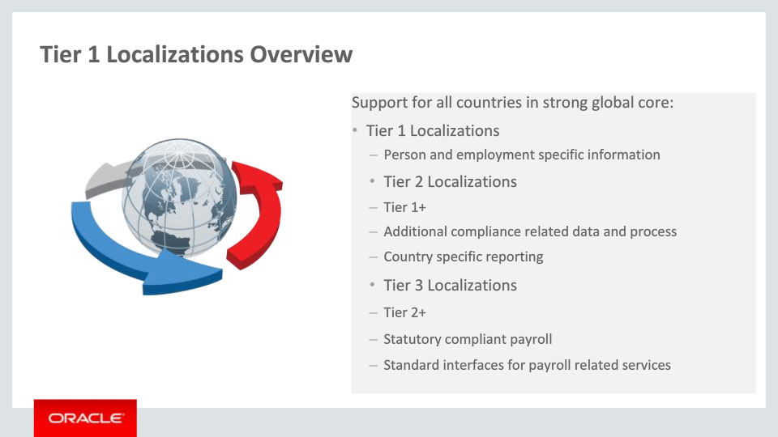
Slide notes
We deliver three tiers of localization content: Tier 1, Tier 2 and Tier 3 Localizations. The Tier 1 Localizations deliver person and employment-specific content formatted for a given country. The Tier 2 Localizations, in addition to Tier 1, enable additional compliance-related functionality (such as data and process) and where required, deliver specific Human Resources statutory reporting. In addition, the Tier 3 Localizations provide a statutory compliant payroll and or standard interfaces for payroll related services.

Notes

Slide 7 - Tier 1 Localizations Overview
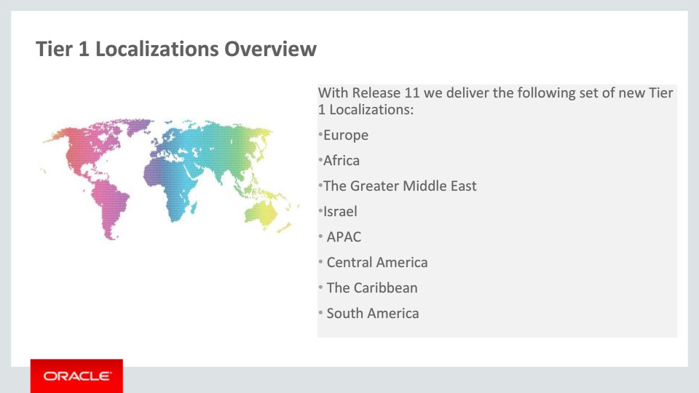
Slide notes
A set of 69 new Tier 1 Localizations are delivered with Release 11- in this slide you can see the grouping by different regions. Note that additional functionality is also available now for 9 Tier 1 Localizations that were delivered with Release 10. Countries per each training session are shown in the last slide of this presentation- Associated Release Training.

This current training covers the new Tier 1 Localizations for part of the European group, namely Albania, Bosnia and Herzegovina, Croatia, Cyprus, Greece, Serbia, Slovenia, and Turkey.

Notes

Slide 8 - Tier 1 Localizations Overview
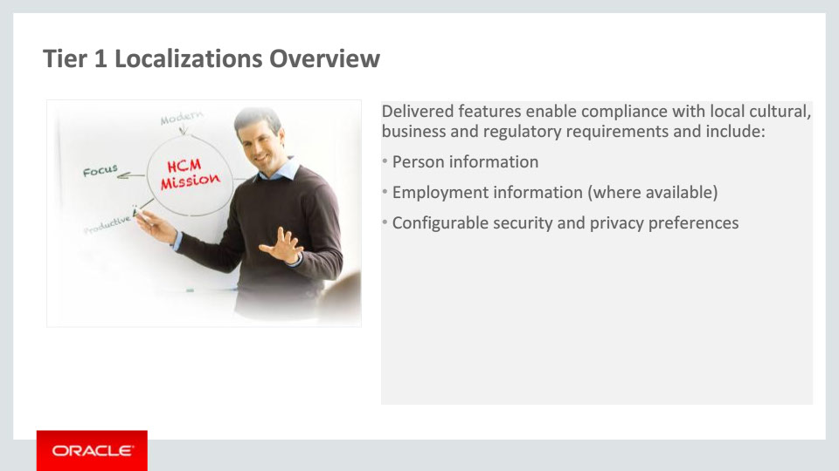
Slide notes
Each of the Tier 1 Localizations provides country-specific content based on the existing global functionalities and is targeted at simplifying and enriching the user experience for customers implementing Fusion HCM globally.

Delivered features for Tier 1 Localizations enable compliance with local requirements and include person information, employment information, security and privacy preferences.

Notes

Slide 9 - Oracle Fusion HCM for Albania
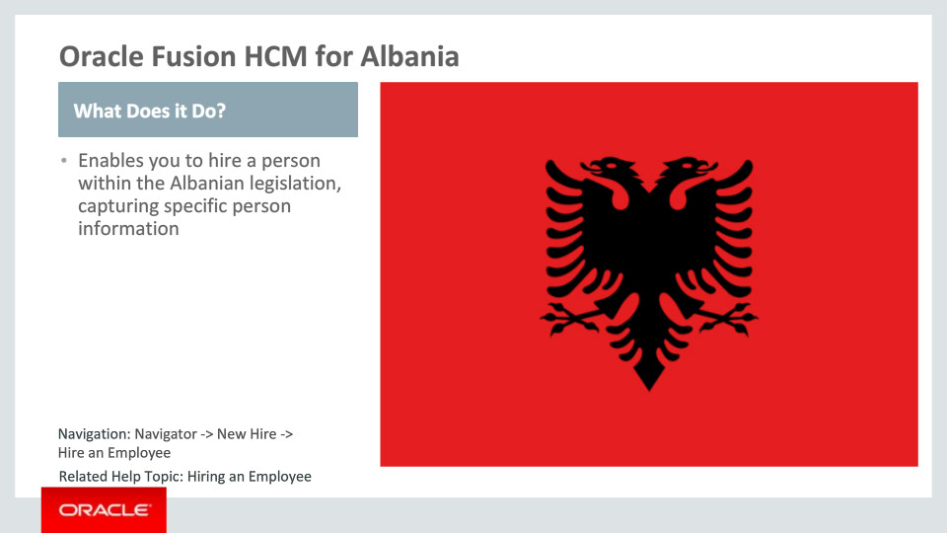
Slide notes
Oracle Fusion HCM for Albania supports country-specific features and functions. It enables users to follow Albania’s business practices and assists in complying with its statutory requirements by capturing particular person information.

Notes

Slide 10 - Oracle Fusion HCM for Albania
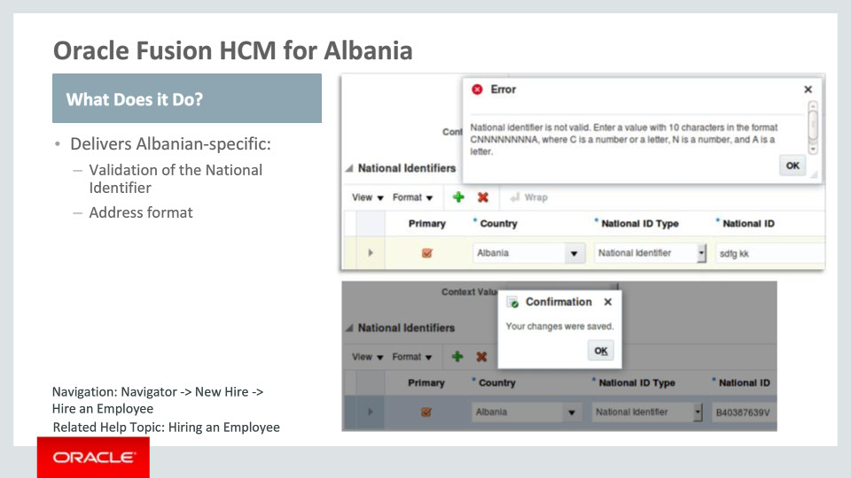
Slide notes
Let’s go over the functionality delivered for Albania in more detail.
First, there is new functionality that provides validation of the National Identifier. Albanian law mandates the National Identifier to be entered as ten characters, whereby the first character can be a letter or number, followed by eight numbers and a letter at the end. Otherwise, an error message is triggered.
Second, a local address format is available. This is enabled by choosing the address style: “Supplemental Taxation and Reporting Address” using the task ”Manage Features by Country or Territory." This task is introduced with Release 10. Within the local address format, besides Country, the Address Line 1 and City attributes are required.

Notes

Slide 11 - Oracle Fusion HCM for Bosnia and Herzegovina
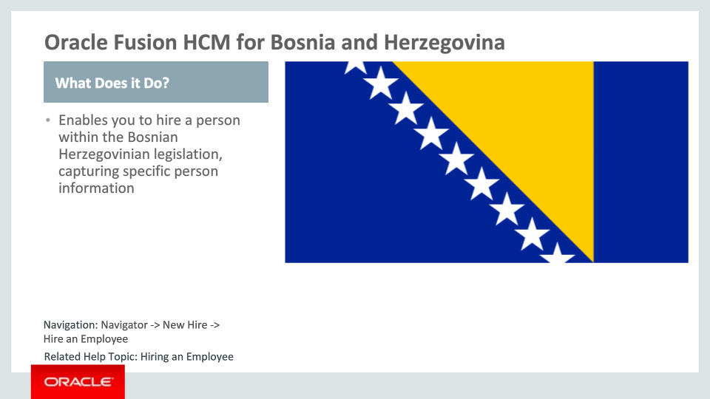
Slide notes
Oracle Fusion HCM for Bosnia and Herzegovina supports country-specific features and functions. It enables users to follow Bosnia and Herzegovina’s business practices and assists in complying with its statutory requirements by capturing particular person information.

Notes

Slide 12 - Oracle Fusion HCM for Bosnia and Herzegovina
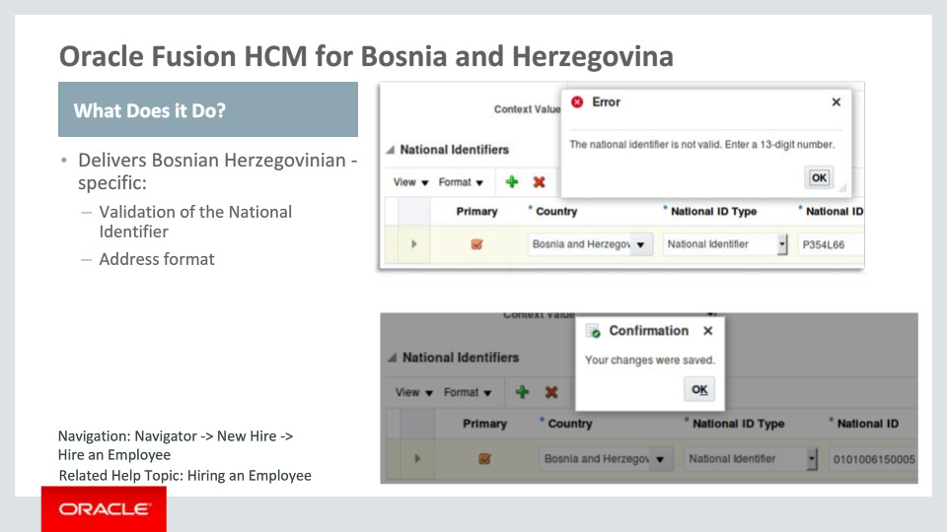
Slide notes
Now, let’s go over the functionality delivered for Bosnia and Herzegovina in more detail.
First, there is new functionality that provides validation of the National Identifier. Bosnian Herzegovinian law mandates the National Identifier to be entered as a thirteeen digit number.
Also available now is the local address format, which is enabled by choosing the address style: “Supplemental Taxation and Reporting Address” using the task ”Manage Features by Country or Territory.”

Notes

Slide 13 - Oracle Fusion HCM for Croatia
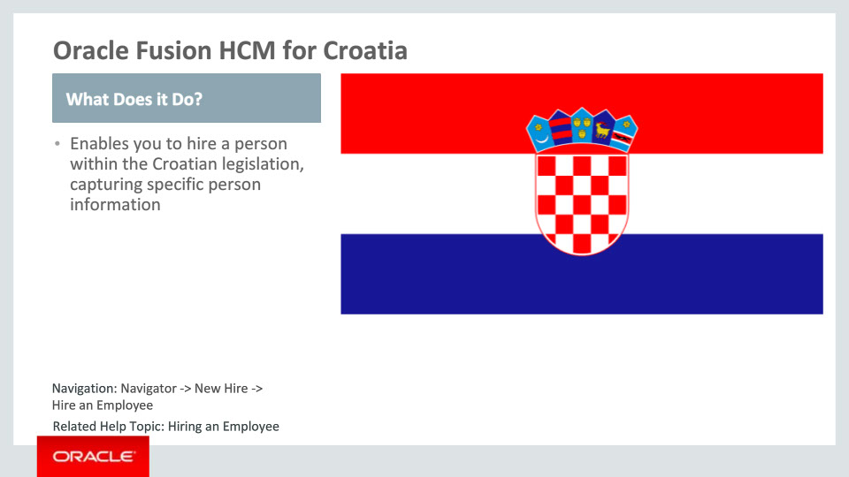
Slide notes
Oracle Fusion HCM for Croatia supports country-specific features and functions. It enables users to follow Croatia’s business practices and assists in complying with its statutory requirements by capturing particular person information.

Notes

Slide 14 - Oracle Fusion HCM for Croatia
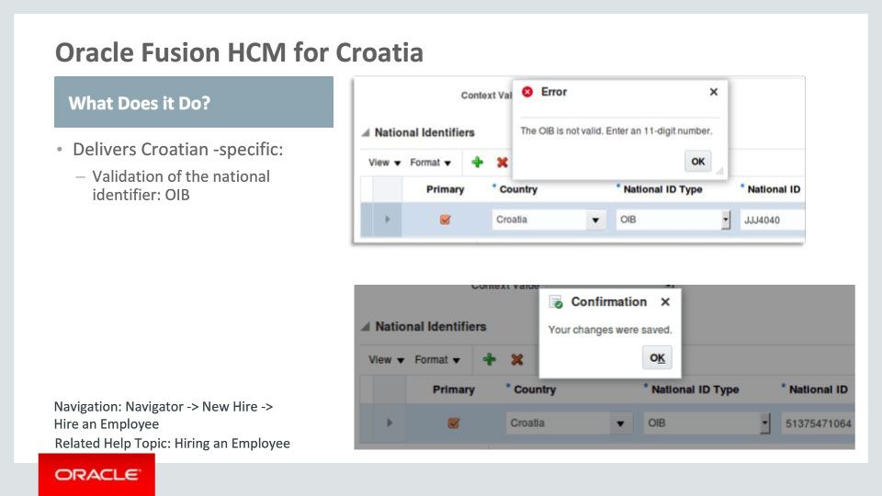
Slide notes
The functionality delivered for Croatia consists in validation of the country-specific national identifier named OIB, whereby Croatian law mandates the national identifier to be an eleven digit number.

Notes

Slide 15 - Oracle Fusion HCM for Cyprus
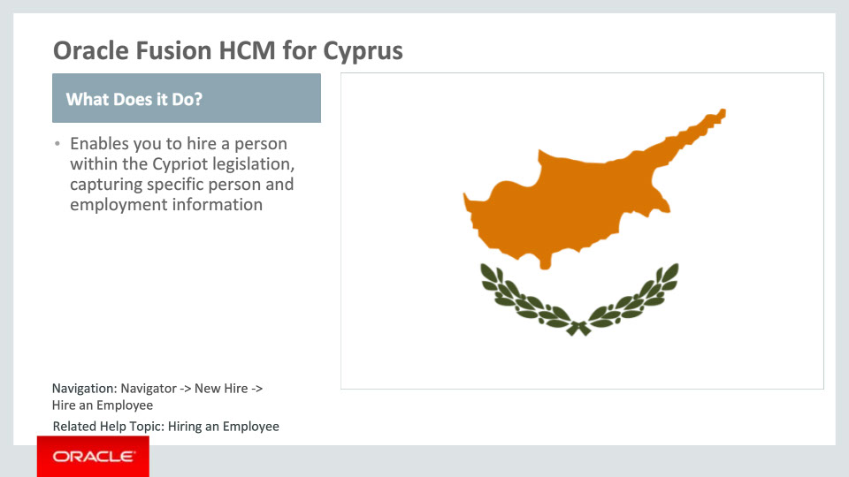
Slide notes
Oracle Fusion HCM for Cyprus supports country-specific features and functions. It enables users to follow Cyprus’ business practices and assists in complying with its statutory requirements by capturing particular person and employment information.

Notes

Slide 16 - Oracle Fusion HCM for Cyprus
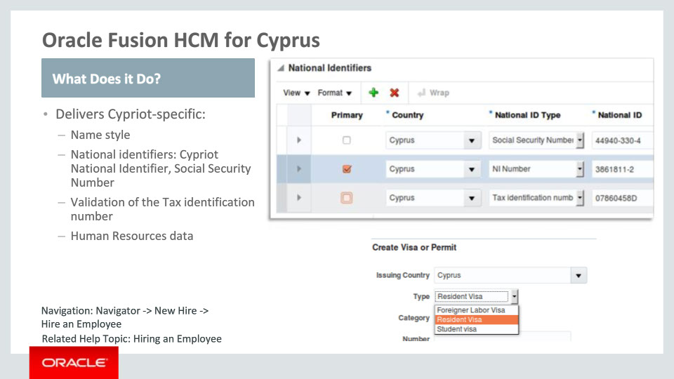
Slide notes
Let’s continue by going over the functionality delivered for Cyprus in more detail.
First, there is new functionality that provides local name style and format, including required attributes such as First and Last Name.
Then, delivered functionality also includes provision of the country-specific national identifiers: the Social Security Number and the Tax Identification Number, with the latter being validated.
Cypriot-specific lists of values are now available for: Contacts, Passports, Visa and Permit Types, and Highest Education Level.

Notes

Slide 17 - Oracle Fusion HCM for Cyprus
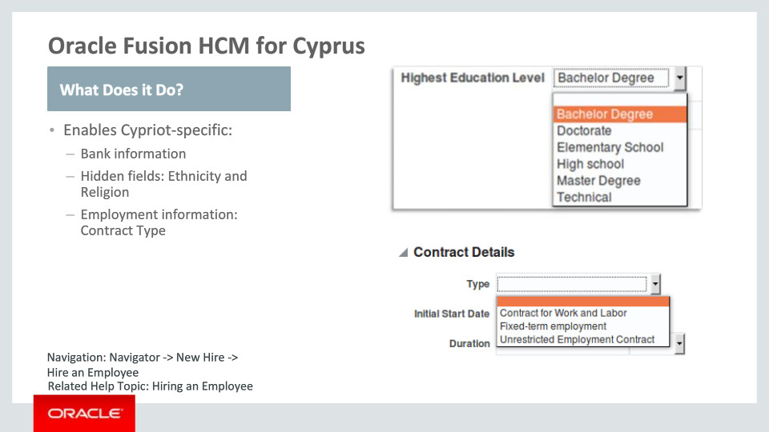
Slide notes
Functionality delivered for Cyprus also includes bank information format that meets the local requirements.

In addition, in order to meet the Cypriot statutory, business and cultural practices and requirements, the Ethnicity and Religion fields were hidden. Consequently, these fields won’t be visible by default in the Legislative Information tab.

Finally, new functionality includes predefined values for the Contract Type, as part of Employment information.

Notes

Slide 18 - Oracle Fusion HCM for Greece
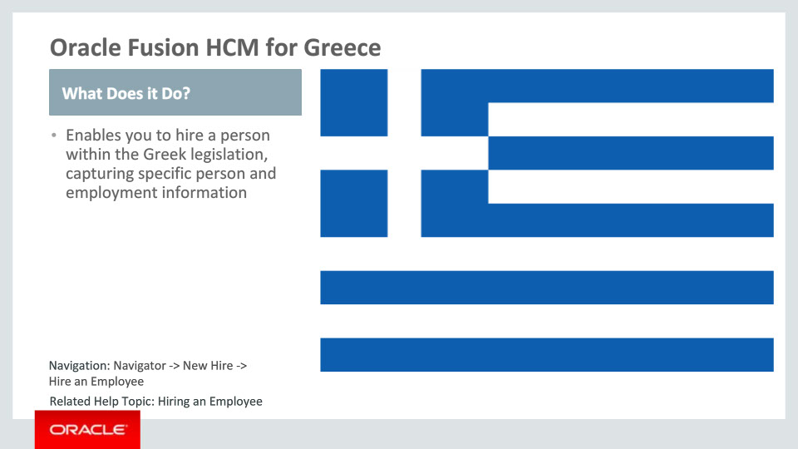
Slide notes
Oracle Fusion HCM for Greece supports country-specific features and functions. It enables users to follow local business practices and assists in complying with its statutory requirements by capturing particular person and employment information.

Notes

Slide 19 - Oracle Fusion HCM for Greece
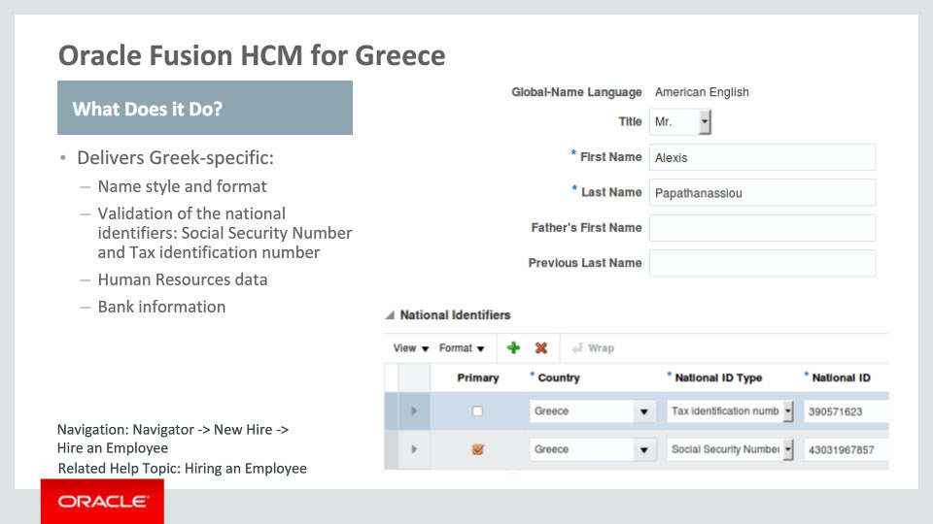
Slide notes
Let’s go over the functionality delivered for Greece in more detail.
First, there is new functionality that provides local name style and format, including attributes such as Father’s First Name.
The delivered functionality also includes validation of the country-specific national identifiers: the Social Security Number and the Tax identification number.
Greek-specific lists of values are now available for: Marital Status, Contacts, Gender, Passports, Visa and Permit Types, and Highest Education Level.
Functionality delivered for Greece also includes bank information format that meets the local requirements.

Notes

Slide 20 - Oracle Fusion HCM for Greece
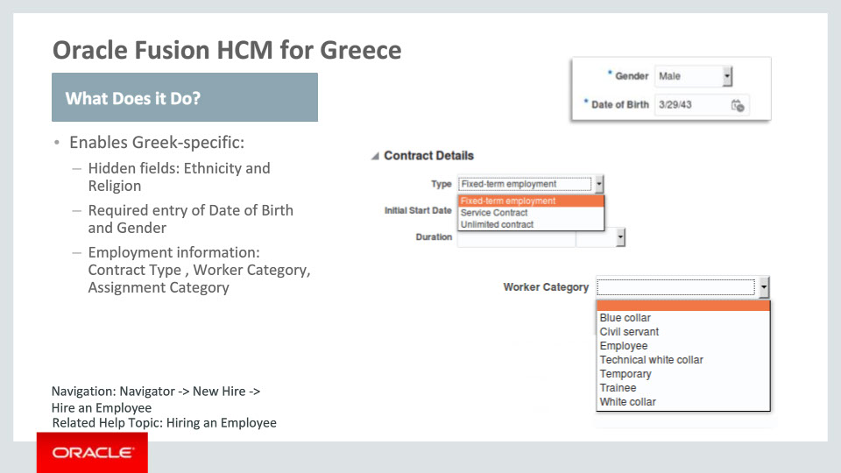
Slide notes
In addition, in order to meet the Greek statutory, business and cultural practices and requirements, the Ethnicity and Religion fields were hidden. Consequently, these fields won’t be visible by default in the Legislative Information tab.
Then, you must enter the Date of Birth and Gender, as they are now required.

Finally, delivered functionality includes predefined values for Contract Type , Worker Category and Assignment Category, as part of Employment information.

Notes

Slide 21 - Oracle Fusion HCM for Serbia
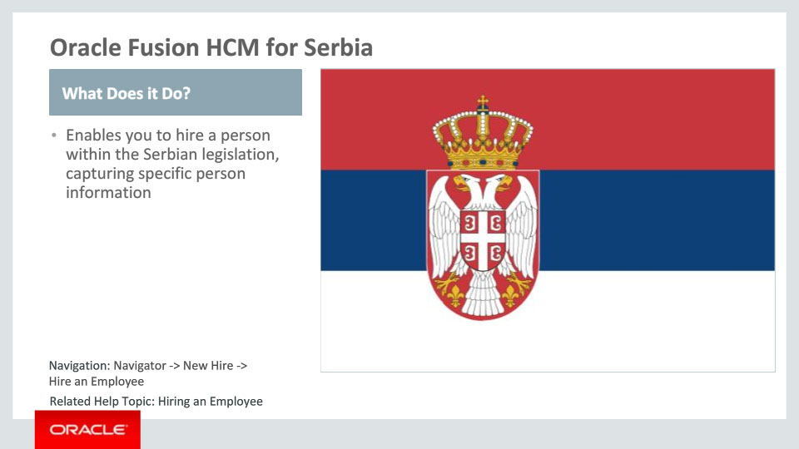
Slide notes
Oracle Fusion HCM for Serbia supports country-specific features and functions. It enables users to follow Serbia’s business practices and assists in complying with its statutory requirements by capturing particular person information.

Notes

Slide 22 - Oracle Fusion HCM for Serbia
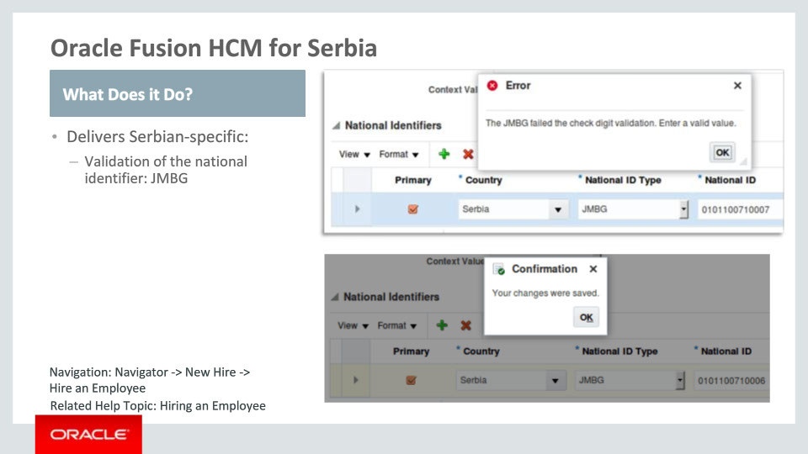
Slide notes
The functionality delivered for Serbia consists in validation of the country-specific national identifier named JMBG, which must consist of thirteen digits and pass the check-sum validation.

Notes

Slide 23 - Oracle Fusion HCM for Slovenia
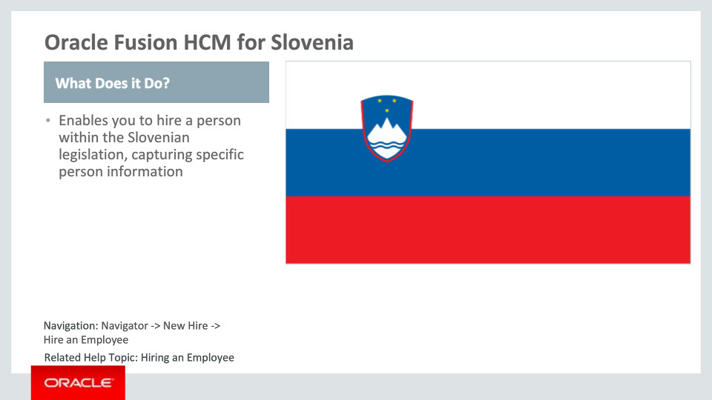
Slide notes
Oracle Fusion HCM for Slovenia supports country-specific features and functions. It enables users to follow Slovenia’s business practices and assists in complying with its statutory requirements by capturing particular person information.

Notes

Slide 24 - Oracle Fusion HCM for Slovenia
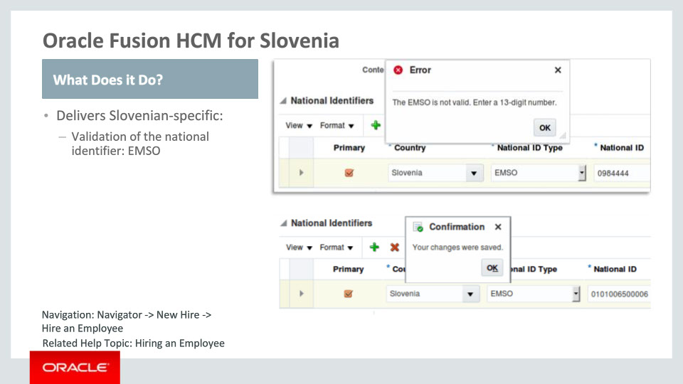
Slide notes
The functionality delivered for Slovenia consists in validation of the country-specific national identifier named EMSO. EMSO must consist of thirteen digits.

Notes

Slide 25 - Oracle Fusion HCM for Turkey
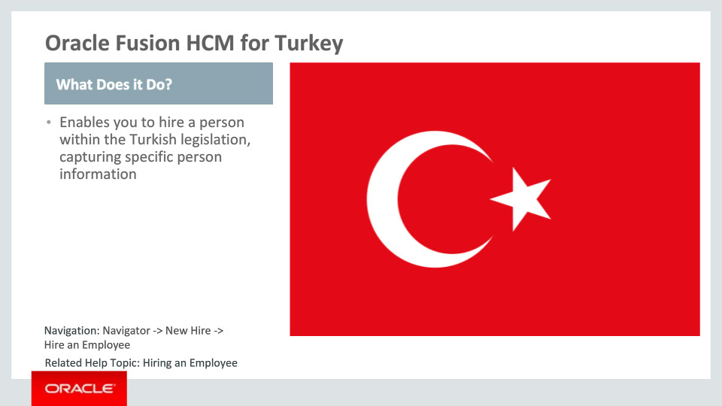
Slide notes
Oracle Fusion HCM for Turkey supports country-specific features and functions. It enables users to follow Turkey’s business practices and assists in complying with its statutory requirements by capturing particular person information.

Notes

Slide 26 - Oracle Fusion HCM for Turkey
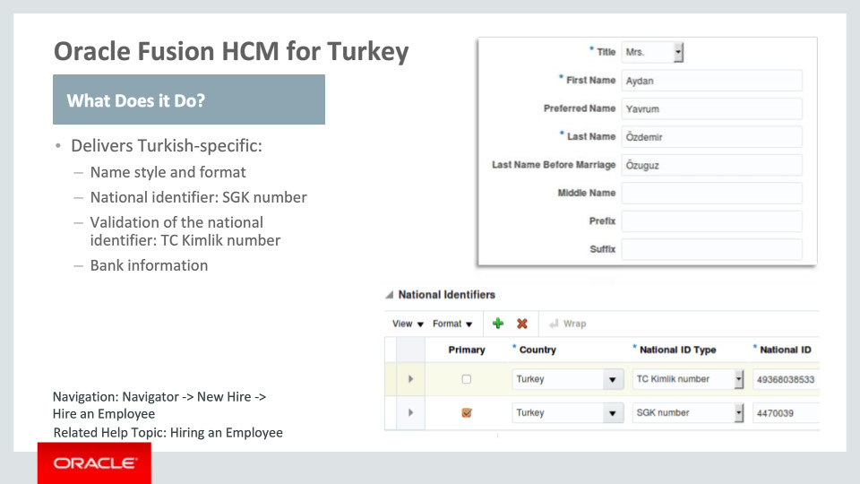
Slide notes
Now, let’s go over the functionality delivered for Turkey in more detail.
First, there is new functionality that provides local name style and format, including required attributes such as Title, First- and Last Name.
Also available now are the predefined, country-specific national identifiers SGK number and TC Kimlik number, with the latter being validated.
Then, functionality delivered for Turkey also includes bank information format that meets the local requirements.

Notes

Slide 27 - Oracle Fusion HCM for Turkey
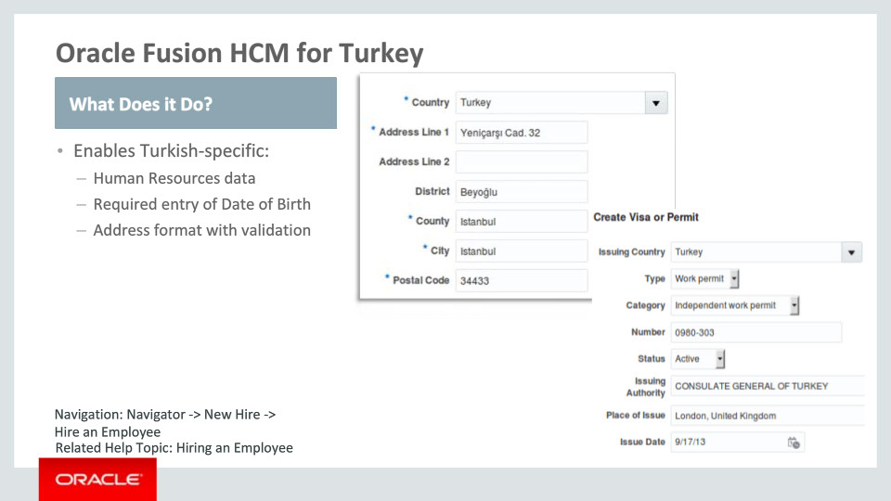
Slide notes
Turkish-specific lists of values are now available for: Title, Religion, Contacts, Gender, Visa and Permit (types and categories), and Highest Education Level.
Then, you must enter the Date of Birth, as it is now required.
Finally, a local address format is seeded for Turkey. This is enabled by choosing the address style: “Supplemental Taxation and Reporting Address” using the task ”Manage Features by Country or Territory." As stated before, this task is introduced with Release 10. Address validation rules are also enabled for Turkey: the Postal Code must be a 5-digit number.

Notes

Slide 28 - Tier 1 Localizations
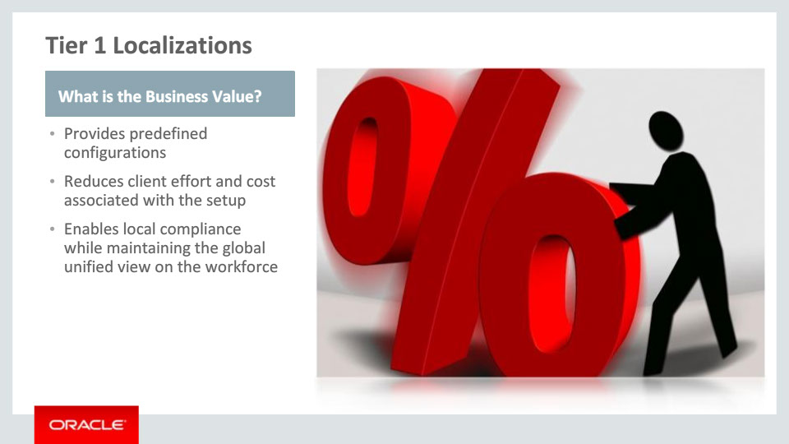
Slide notes
The new Tier 1 Localizations provide your organization with Business Value: first, by providing predefined configurations and content aligned with the country-specific requirements on capturing person and employment information; then, by reducing cost and time taken to implement HCM.

Last but not least, business value is added by assisting customers to achieve local compliance while retaining the global unified view of their workforce.

Notes

Slide 222 - Summary of Capabilities
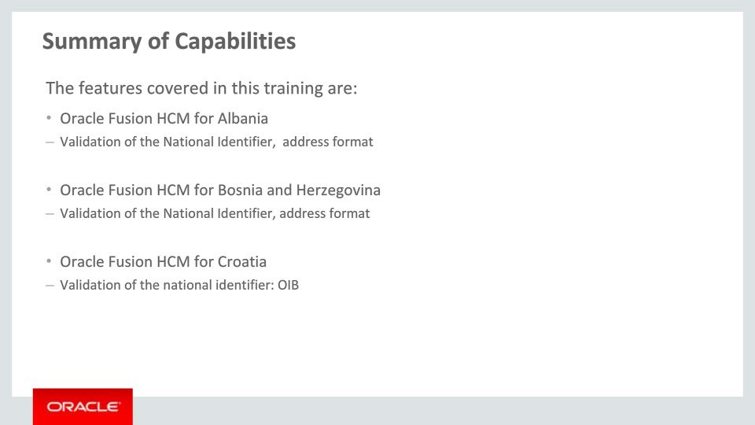
Slide notes
Here is the summary of the features I have talked about today. I began by talking about the Tier 1 Localizations for Albania, Bosnia and Herzegovina and Croatia, and the functionalities that have been delivered for each, which you can review here.

Notes

Slide 223 - Summary of Capabilities
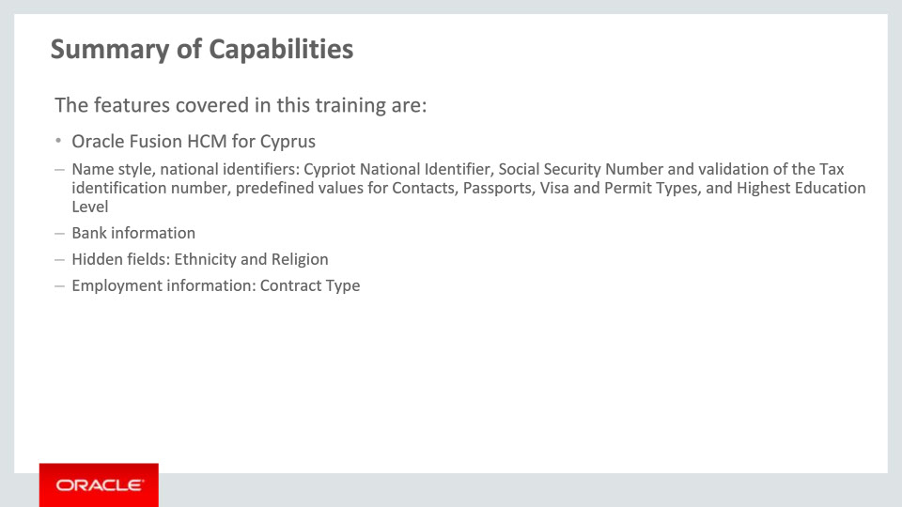
Slide notes
I continued by talking about functionalities enabled for Cyprus Tier 1 Localization, which you can review here.

Notes

Slide 224 - Summary of Capabilities
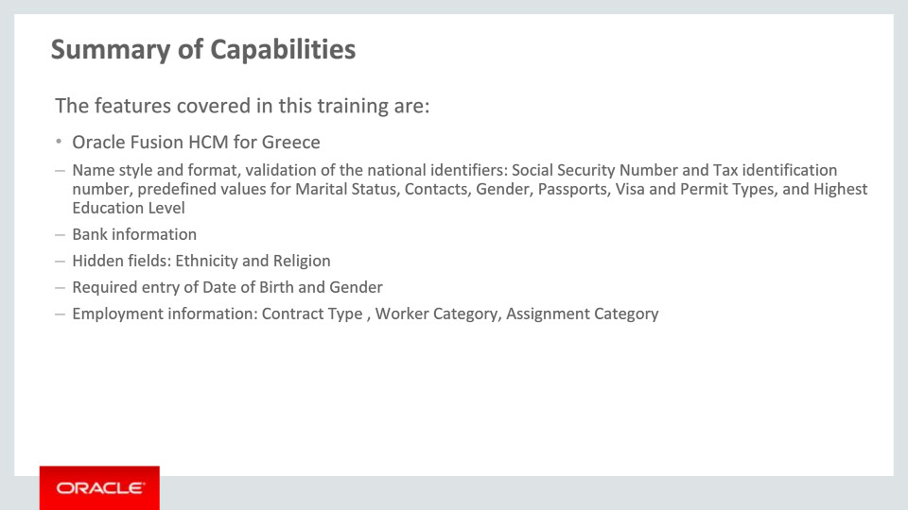
Slide notes
Next, we described the Tier 1 Localization for Greece and the delivered functionalities, which you can review here.

Notes

Slide 225 - Summary of Capabilities
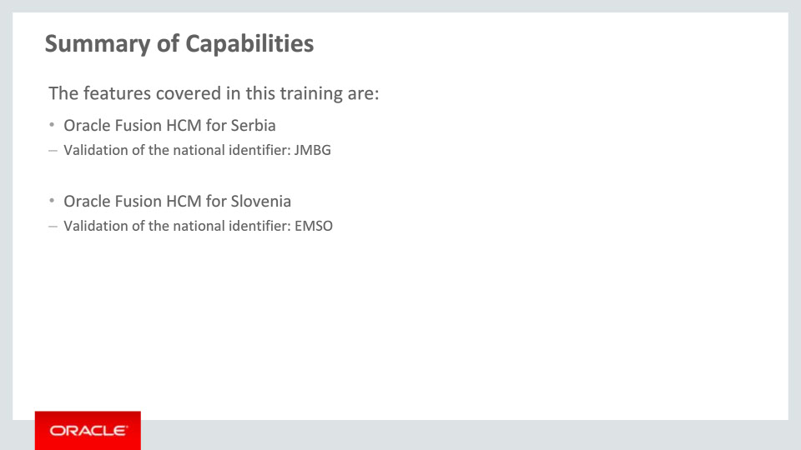
Slide notes
We continued by describing the functionalities delivered for the Tier 1 Localization for Serbia and Slovenia.

Notes

Slide 226 - Summary of Capabilities
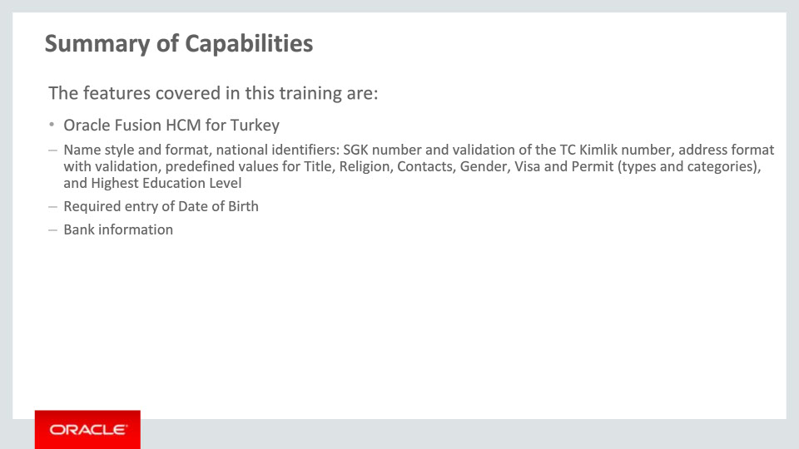
Slide notes
Finally, we talked about the Tier 1 Localization for Turkey, and the functionalities that have been delivered.
Please take a moment to review this information.
These new features and functionalities will help you and your organization achieve compliance in a global context.

Notes

Slide 227 - Additional Information
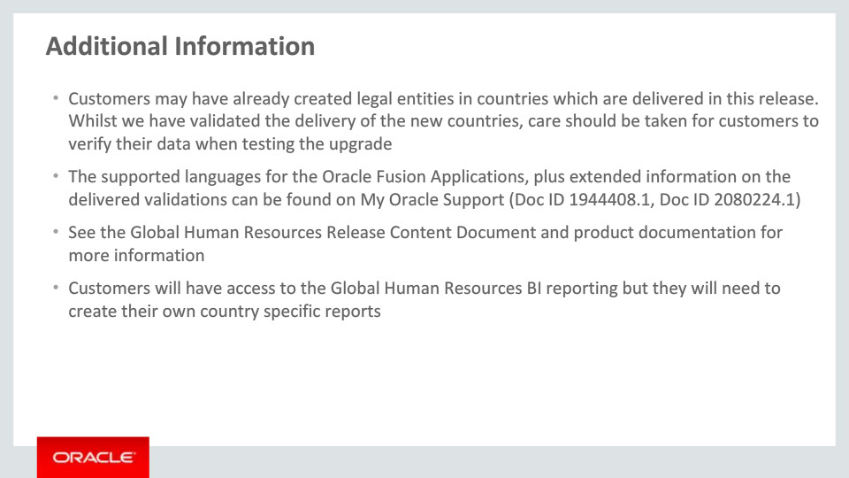
Slide notes
Here is some additional helpful information. Be aware that if customers have already created legal entities for a country which is now delivered, they will need to verify their data after the upgrade.
Please also refer to the Release Content Document for Global Human Resources to get an overview of all new features delivered with this release and My Oracle Support for the latest status of translations.
Customers should review the Global Human Resources documentation when they implement the Tier 1 Localization functionality.
Finally, whilst customers have access to the Global Human Resources BI reporting, they will need to create their own country specific reports.

Notes

Slide 228 - Implementation Advice

Slide notes
In this implementation advice section we will go through what you need to consider before enabling these features in your business, and what you need to know to set them up.

Notes

Slide 229 - Feature Impact Guidelines
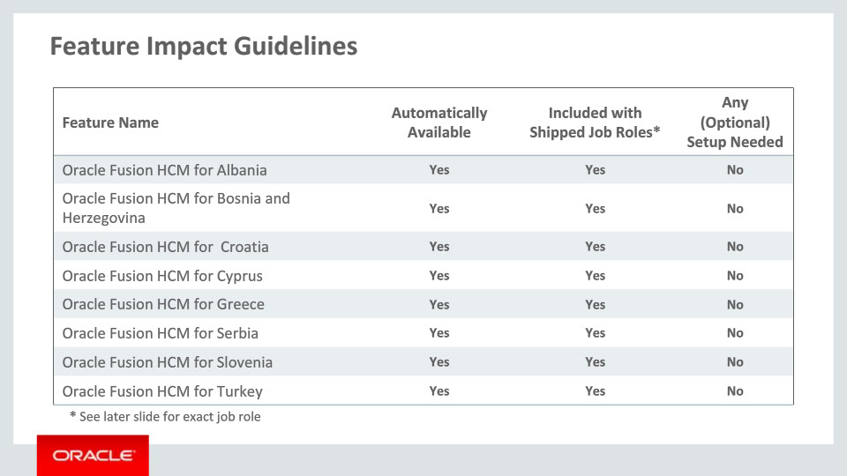
Slide notes
This table depicts key implementation information for the features covered in this training. It details:
• If a feature is automatically available after installation
• If a feature can be accessed using the shipped job roles – the exact job roles are detailed later in this section
• And if a feature has any setup associated with it
All features included in this release are automatically available and included with the shipped job roles. No specific setup is required to access the features outlined.
Notes

Slide 230 - Job Roles
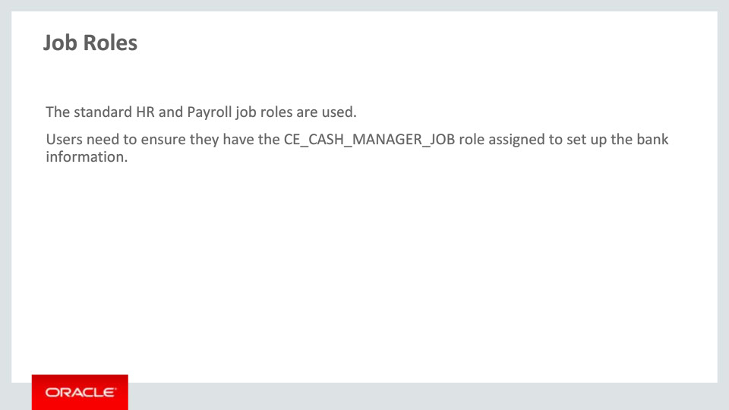
Slide notes
Here are the shipped job roles that will access the new capabilities covered in this training. While the standard HR and Payroll job roles are used (for example Human Resources Specialist, Human Resources Manager), users will need to assign the CE_CASH_MANAGER_JOB role in order to set up the local bank information.

Notes

Slide 231 - Business Process Model Information
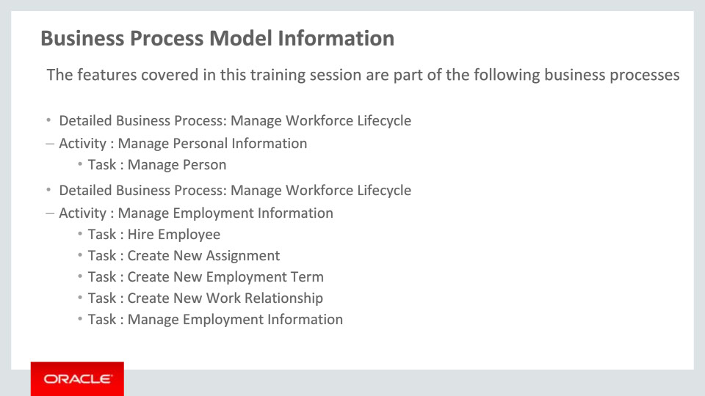
Slide notes
The business processes associated with the new capabilities covered in this training are detailed here. General processes are mentioned first, then component activities and finally the various tasks as part of the activities. Please take a moment to review them.

Notes

Slide 232 - Business Process Model Information
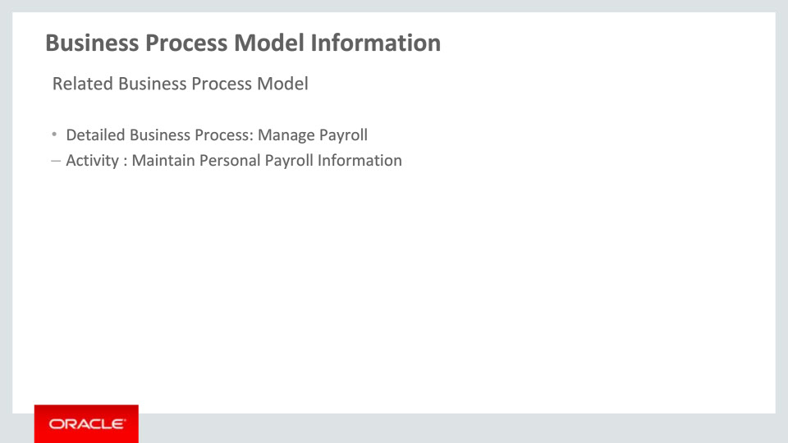
Slide notes
The related business processes and activity associated with the new capabilities covered in this training are detailed here.

Notes

Slide 233 - Associated Release Training
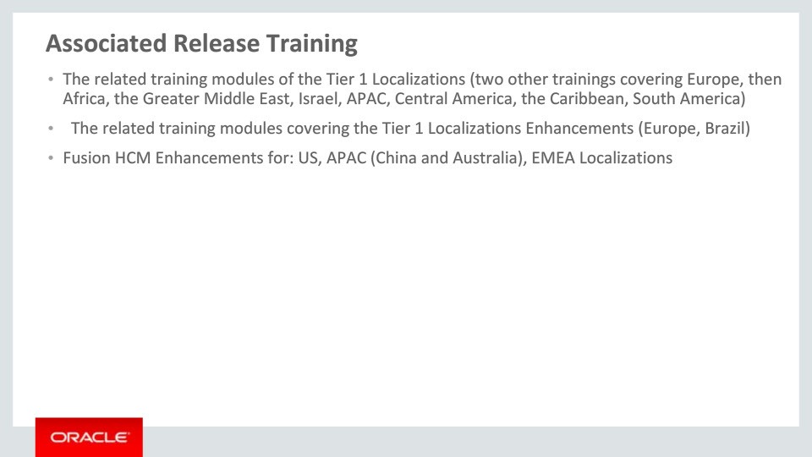
Slide notes
This training module is part of a ten-group set on the new Tier 1 Localizations available with Release 11. The nine other groups are: two more for Europe, Africa, the Arab Countries, Israel, APAC, Central America, the Caribbean and South America.
Besides these ten groups, a set of two Tier 1 Localizations Enhancements trainings must be mentioned: one for Europe and one for Brazil. These two sessions cover the enhancements available with Release 11 for the nine Tier 1 Localizations delivered with Release 10.
Please refer to the next slide to see details on countries for the training sessions mentioned here.
Other training modules that cover the new functionality added to existing localizations and are recommended viewing are Fusion HCM Enhancements for US, Asia Pacific (China and Australia) and various EMEA Localizations.

Notes

Slide 234 - Associated Release Training
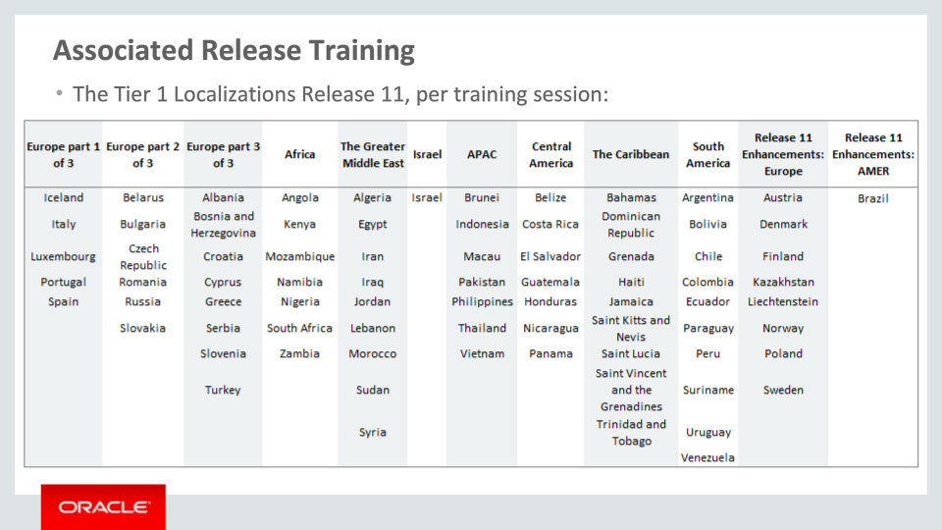
Slide notes
As previously mentioned, this slide depicts the Tier 1 Localizations per training session. The first ten groups cover the new localizations available with Release 11, while the last two show the enhancements available with Release 11 for nine Tier 1 Localizations delivered with Release 10. Please take a moment to review the countries of each training session.

This concludes this presentation, thank you for listening. You can easily pause and rewind any of these slides if you require additional time to take in the detail.

Notes

