Slide 3 - Oracle Human Capital Management Cloud Release 11
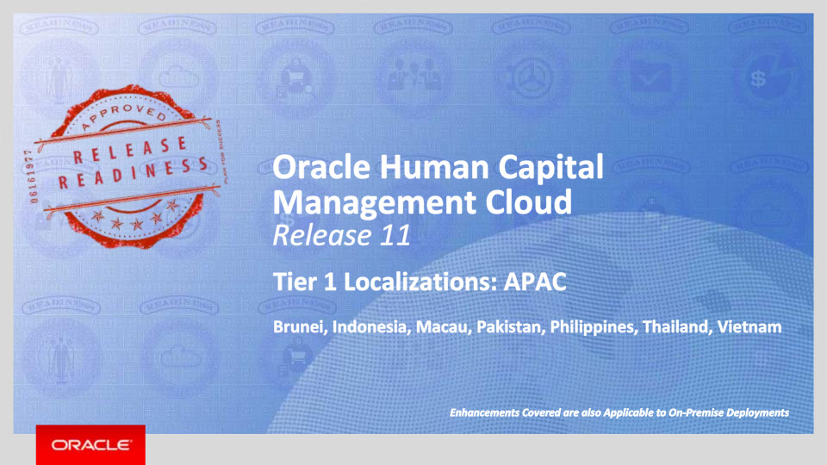
Slide notes
Welcome to the Release 11 Training for the Tier 1 Oracle Human Capital Management Cloud Localizations. In this session, we’ll introduce you to the new capabilities available with Fusion HCM Release 11 for Brunei, Indonesia, Macau, Pakistan, Philippines, Thailand, and Vietnam.

Notes

Slide 4 - Agenda
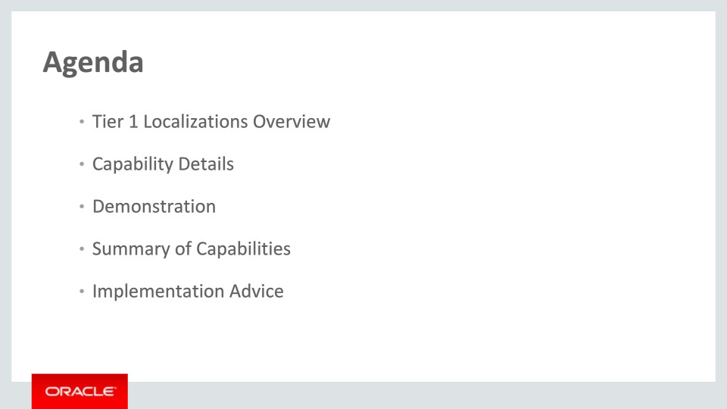
Slide notes
This is the agenda:
We’ll give an overview of the new Tier 1 Localizations in the context of the Global HCM Cloud, followed by more detail to explain what they deliver and what business value they bring.
Then we’ll walk you through a demonstration.
Next we’ll explain what you need to consider before enabling these capabilities in your business, and what you need to know to set them up.

Notes

Slide 5 - Tier 1 Localizations Overview
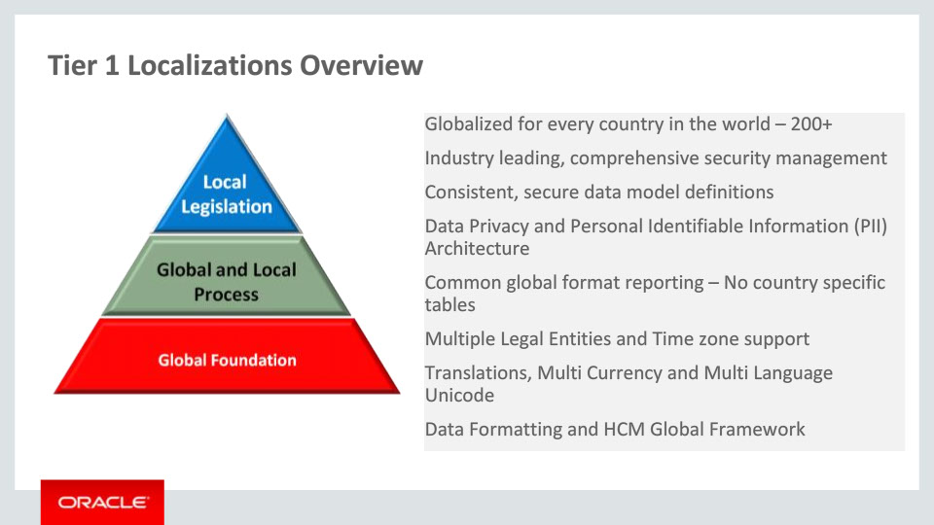
Slide notes
The HCM Global Framework already delivers functionality that can be used in over 200 countries, such as configurable data privacy, data formatting and multiple languages. All localizations are built within this global framework to ensure a consistent data model.
The HCM Global Framework is flexible, allowing both global and local processes to be configured to support multiple legal entities. The user works with natural language screens and formats, and the business flows follow cultural and legal compliance processes.
The application is extensible. The supported processes can be organizationally unique, and the upgrade safe. In addition, generic configurable interfaces for Benefits and Payroll are available as part of the Global Foundation.

Notes

Slide 6 - Tier 1 Localizations Overview
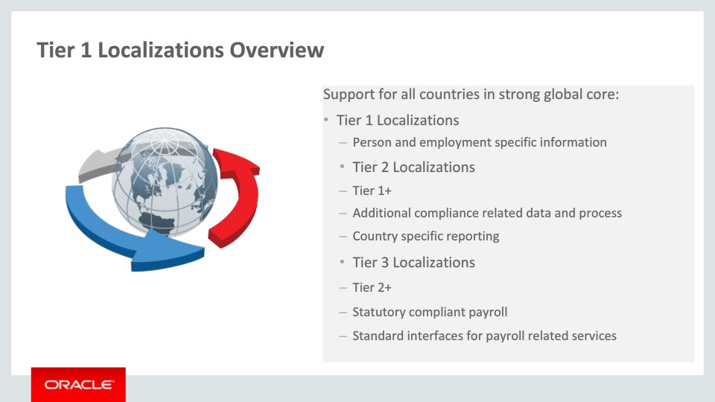
Slide notes
We deliver three tiers of localization content: Tier 1, Tier 2 and Tier 3 Localizations. The Tier 1 Localizations deliver person and employment-specific content formatted for a given country. The Tier 2 Localizations, in addition to Tier 1, enable additional compliance-related functionality (such as data and process) and where required, deliver specific Human Resources statutory reporting. In addition, the Tier 3 Localizations provide a statutory compliant payroll and or standard interfaces for payroll related services.

Notes

Slide 7 - Tier 1 Localizations Overview
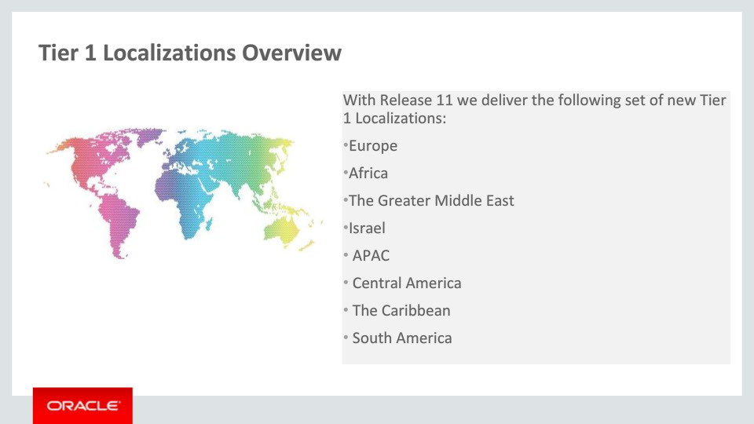
Slide notes
A set of 69 new Tier 1 Localizations are delivered with Release 11- in this slide you can see the grouping by different regions. Note that additional functionality is also available now for 9 Tier 1 Localizations that were delivered with Release 10. Countries per each training session are shown in the last slide of this presentation- Associated Release Training.
This current training covers the new Tier 1 Localizations for the Asia Pacific region, namely Brunei, Indonesia, Macau, Pakistan, Philippines, Thailand, and Vietnam.

Notes

Slide 8 - Tier 1 Localizations Overview
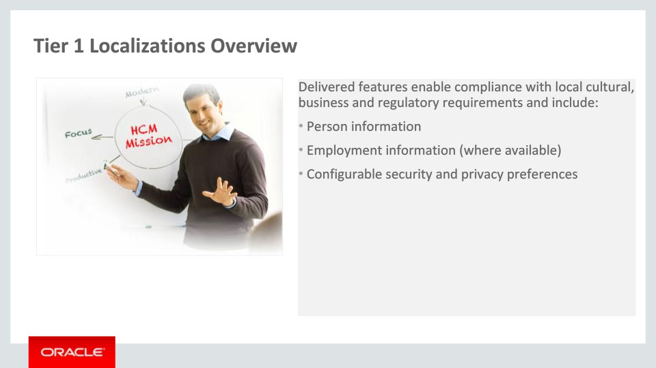
Slide notes
Each of the Tier 1 Localizations provides country-specific content based on the existing global functionalities and is targeted at simplifying and enriching the user experience for customers implementing Fusion HCM globally.

Delivered features for Tier 1 Localizations enable compliance with local requirements and include person information, employment information, security and privacy preferences.

Notes

Slide 9 - Oracle Fusion HCM for Brunei
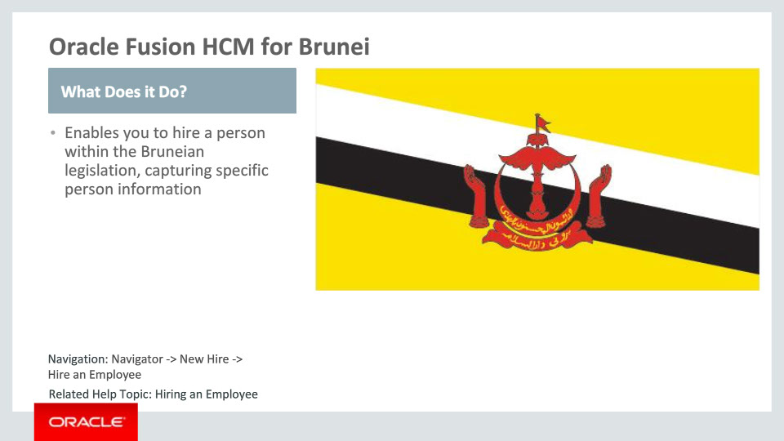
Slide notes
Oracle Fusion HCM for Brunei supports country-specific features and functions. It enables users to follow Brunei’s business practices and assists in complying with its statutory requirements by capturing particular person information.

Notes

Slide 10 - Oracle Fusion HCM for Brunei
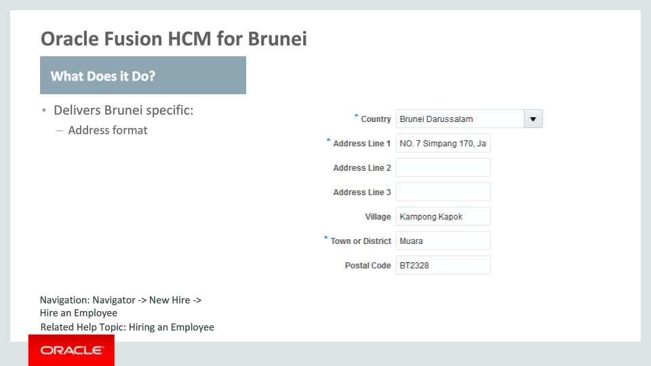
Slide notes
Let’s have a closer look at what has been delivered for Brunei.

A local address format has been seeded for Brunei. This address format is enabled by choosing the address style: “Supplemental Taxation and Reporting Address” using the task ”Manage Features by Country or Territory.“ The Country, Address Line 1 and Town or District are required. There are no other validations provided.

Notes

Slide 11 - Oracle Fusion HCM for Indonesia
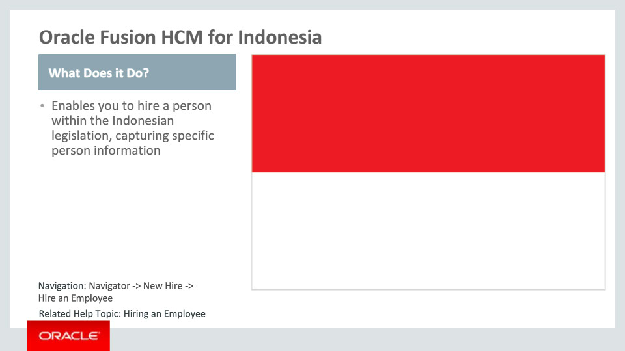
Slide notes
Oracle Fusion HCM for Indonesia supports country-specific features and functions. It enables users to follow local business practices and assists in complying with its statutory requirements by capturing particular person information.

Notes

Slide 12 - Oracle Fusion HCM for Indonesia
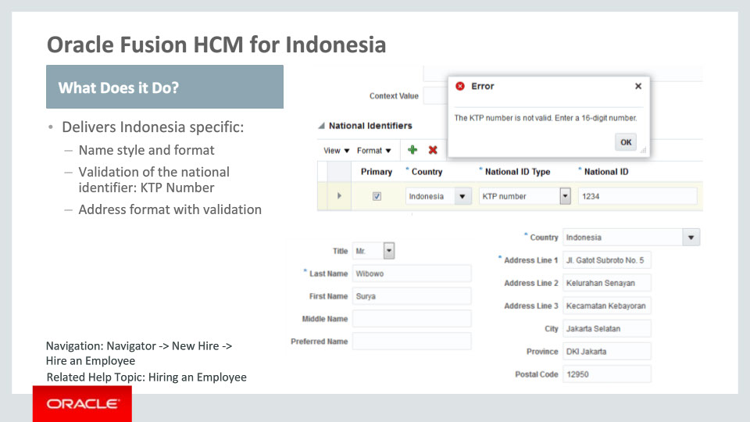
Slide notes
Let’s look at the specific features that have been delivered for Indonesia.
First there is the local name style. The Indonesian name style consists of the Last Name, which is required, the First Name, Middle Name and the Preferred Name.
Second, we have provided the national identifier for Indonesia, which is the KTP number. This number is validated upon entry: it must be a 16-digit number.

Third, a local address format is now available. The Country and Address Line 1 are required. The Postal Code is validated: it should be five digits.

Notes

Slide 13 - Oracle Fusion HCM for Indonesia
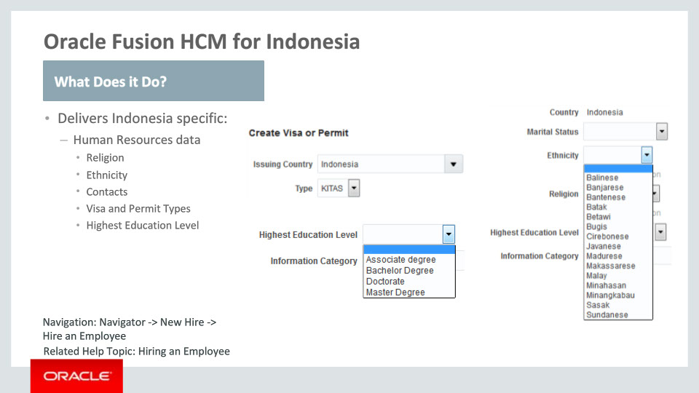
Slide notes
In addition to the three features that were covered on the previous slide, we have also provided Indonesia-specific data in the Human Resources area. There are predefined values for Religion, Ethnicity, the Contact type, for Visa and Permit Types as well as for the Highest Education Level attribute.

Notes

Slide 14 - Oracle Fusion HCM for Macau
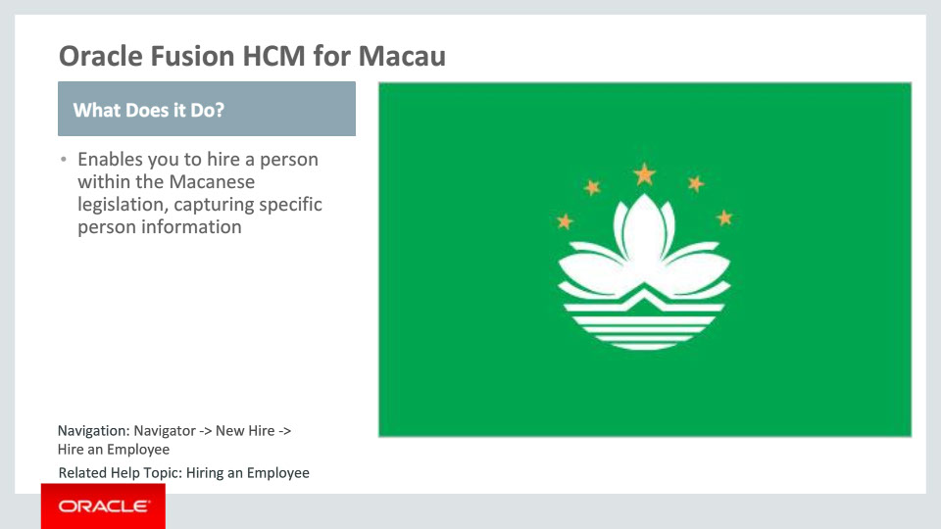
Slide notes
Oracle Fusion HCM for Macau supports country-specific features and functions. It enables users to follow local business practices and assists in complying with its statutory requirements by capturing particular person information.

Notes

Slide 15 - Oracle Fusion HCM for Macau
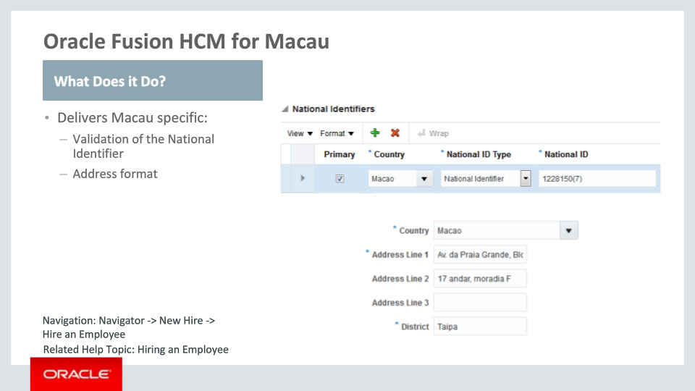
Slide notes
Let’s take a look now at what has been delivered for Macau.
We are providing validation for the National Identifier: 10 characters must be entered; 8 digits and parentheses are allowed, as in the sample provided.
There is also a local address format delivered for Macau. This address format is enabled by choosing the address style: “Supplemental Taxation and Reporting Address” using the task ”Manage Features by Country or Territory.“ The Country, Address Line 1 and District are required.

Notes

Slide 16 - Oracle Fusion HCM for Pakistan
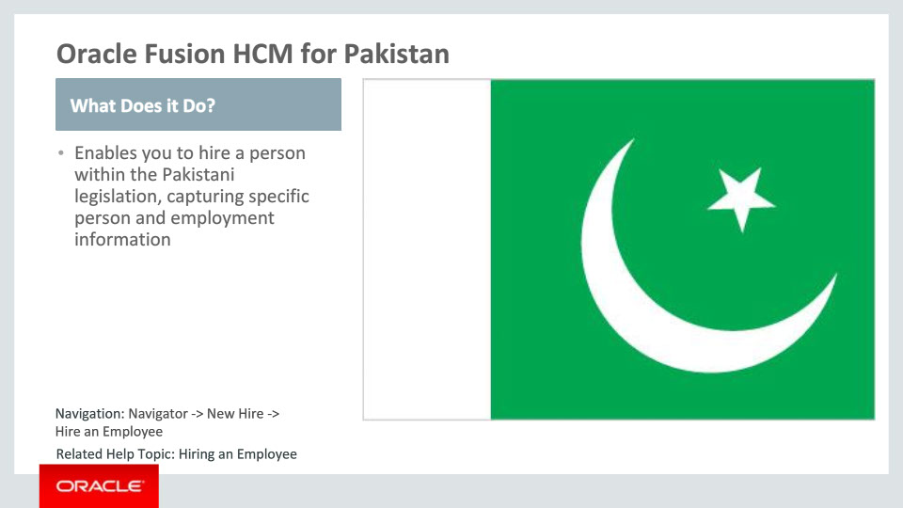
Slide notes
Oracle Fusion HCM for Pakistan supports country-specific features and functions. It enables users to follow Pakistan’s business practices and assists in complying with its statutory requirements by capturing particular person and employment information.

Notes

Slide 17 - Oracle Fusion HCM for Pakistan
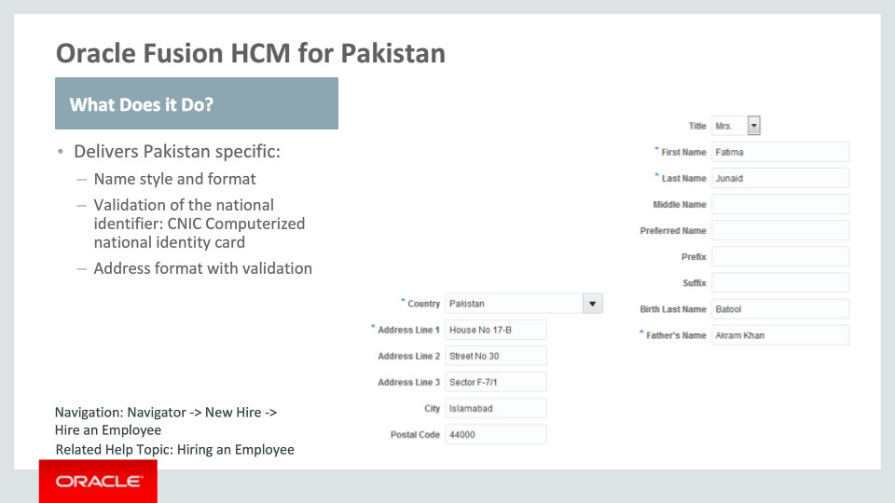
Slide notes
Let’s talk about what has been delivered for Pakistan in more detail.
First, we have the local name style and format. The First Name, Last Name and Father’s Name are the required attributes of a person’s name.
Second, we have the predefined value “CNIC Computerized national identity card” in the National Identifiers table. This number is validated upon entry. It must consist of 5 digits, a dash, 7 digits, another dash and ends with a single digit.
There is also a local address format delivered for Pakistan. This address format is enabled by choosing the address style: “Supplemental Taxation and Reporting Address” using the task ”Manage Features by Country or Territory.“ The Country and Address Line 1 are required. The Postal Code is validated and should be 5 digits.

Notes

Slide 18 - Oracle Fusion HCM for Pakistan
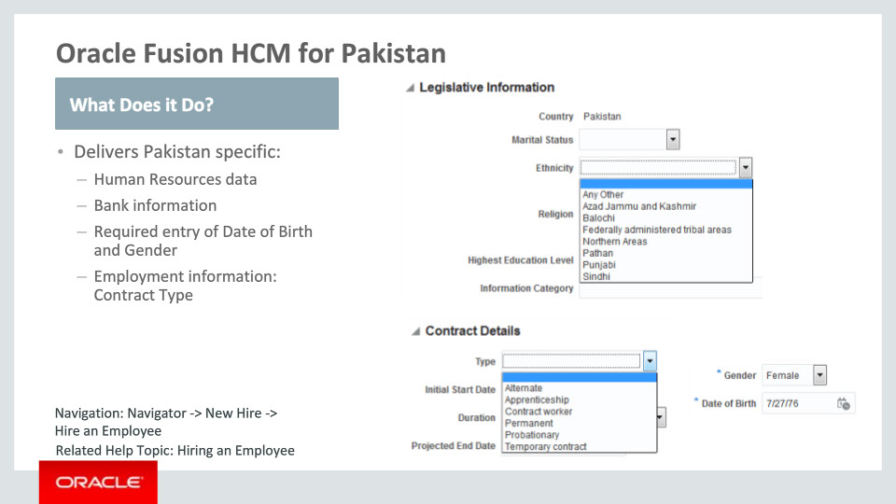
Slide notes
In addition to this, we have also delivered the following for Pakistan:
• Other Human Resources data. This includes predefined values for Ethnicity, Religion, Gender, Passports, Visa and Permit Types, Disabilities and the Highest Education Level.
• Bank information has been tailored so users can store local bank accounts and related information.
• The entry of the Date of Birth and Gender has been made required.
• Pakistan-specific Contract Type values can be entered under Employment information.
Notes

Slide 19 - Oracle Fusion HCM for the Philippines
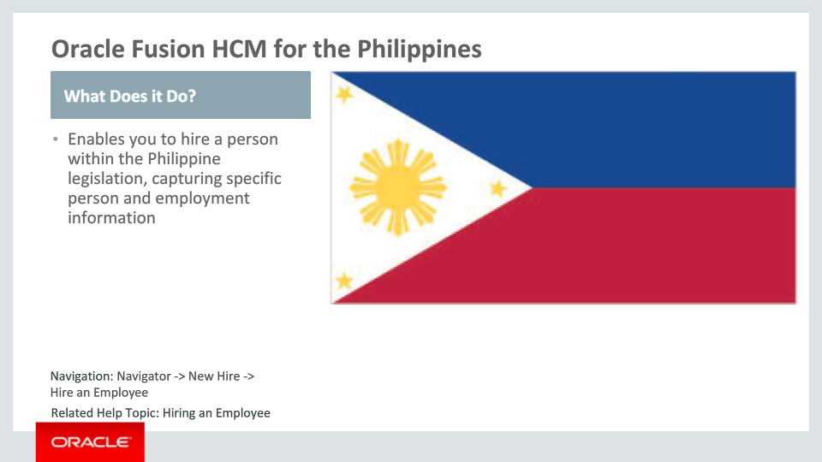
Slide notes
Oracle Fusion HCM for the Philippines supports country-specific features and functions. It enables users to follow Philippines’ business practices and assists in complying with its statutory requirements by capturing particular person and employment information.

Notes

Slide 20 - Oracle Fusion HCM for the Philippines
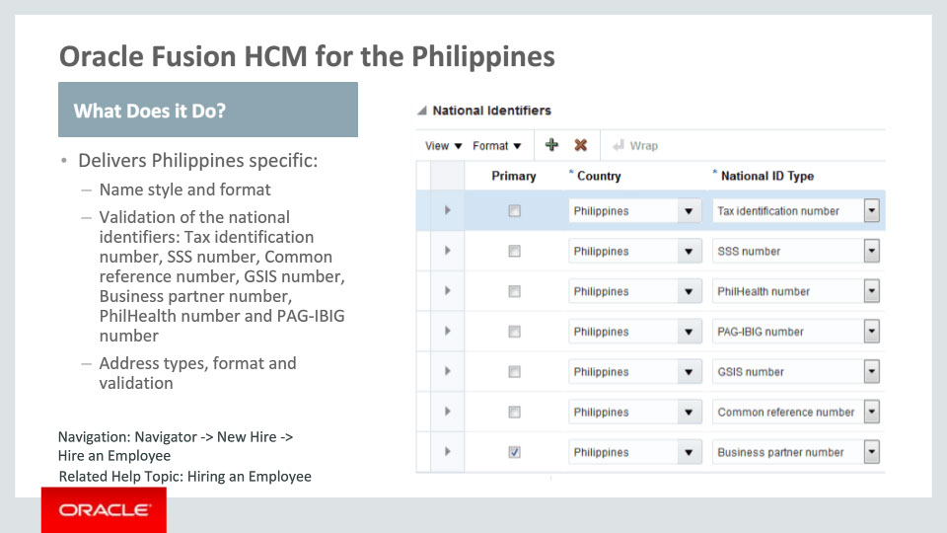
Slide notes
Let’s go over the functionality delivered for the Philippines in more detail.
For the Philippines we have delivered country-specific name style and formats. The name style consists of the Title, Last Name, First Name, Middle Name, Prefix, Suffix and Preferred Name. The Last Name is required. Predefined values that are common in the Philippines are available for the Title lookup.
In addition to this, we have provided Philippine national identifiers. The format validation is also available for these identifiers, warning messages being triggered for incorrect entries.
We have also provided a local address format and address types, including validation. The address format is enabled by choosing the address style: “Supplemental Taxation and Reporting Address” using the task ”Manage Features by Country or Territory.“ The Country and Address Line 1 are required when entering an address. Also, the Postal Code is validated and must be four digits. The address types Permanent Address and Provincial have been added for the Philippines.

Notes

Slide 21 - Oracle Fusion HCM for the Philippines
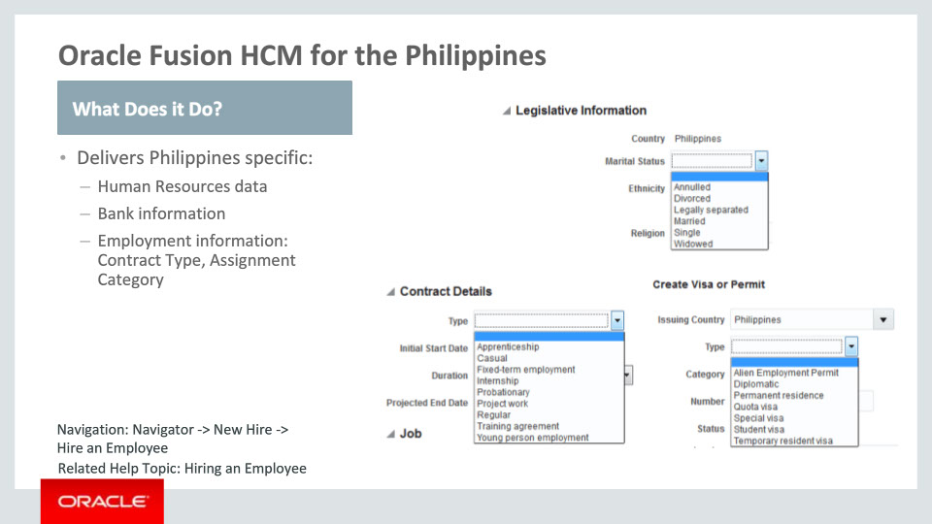
Slide notes
In addition to what was mentioned on the previous slide, we have delivered the following features for the Philippines:
- Additional Human Resources data, including predefined values for Title, Religion, Marital Status, Contacts, Passports, Visa and Permit Types, Disabilities and the Highest Education Level.
- We are delivering country-specific bank information so users can create local bank accounts and associated information.
- In the Employment area there are predefined values for the Contract Type and Assignment Category.
This concludes our overview of Philippine features.
Notes

Slide 22 - Oracle Fusion HCM for Thailand
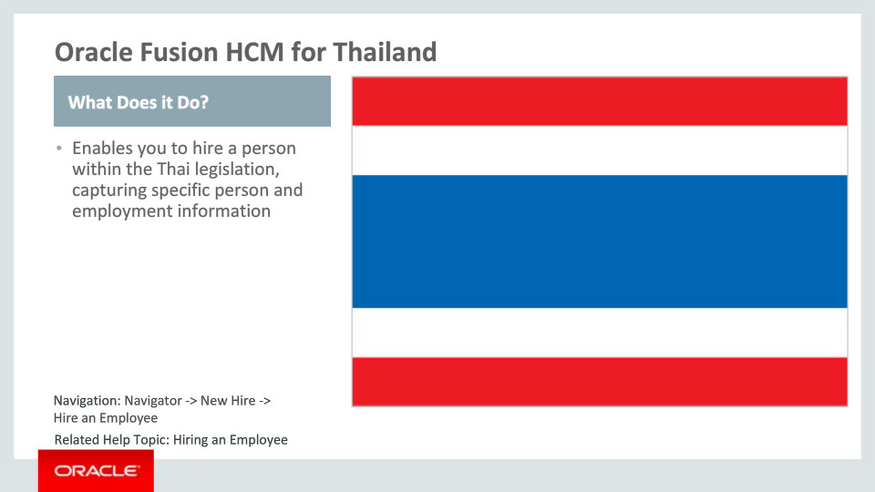
Slide notes
Oracle Fusion HCM for Thailand supports country-specific features and functions. It enables users to follow Thailand’s business practices and assists in complying with its statutory requirements by capturing particular person and employment information.

Notes

Slide 23 - Oracle Fusion HCM for Thailand
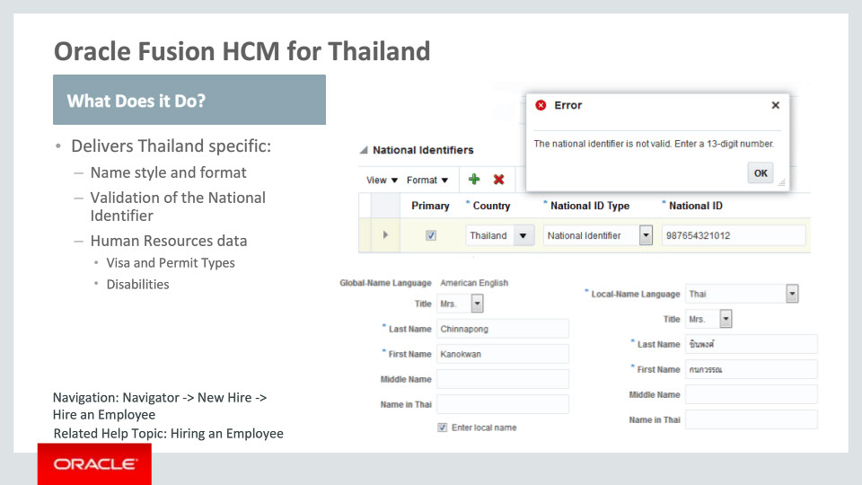
Slide notes
Let’s go over the functionality delivered for Thailand in more detail.
First we have the local name style and format. The name style contains the Title, Last Name, First Name, Middle Name and the Name in Thai. The Last Name and First Name are required.
We are also providing validation of the Thai National Identifier. It should have 13 digits. If it doesn’t, an error message will be raised.
Finally, we are delivering additional Human Resources data, including predefined values for Visa and Permit Types and Disabilities.

Notes

Slide 24 - Oracle Fusion HCM for Vietnam
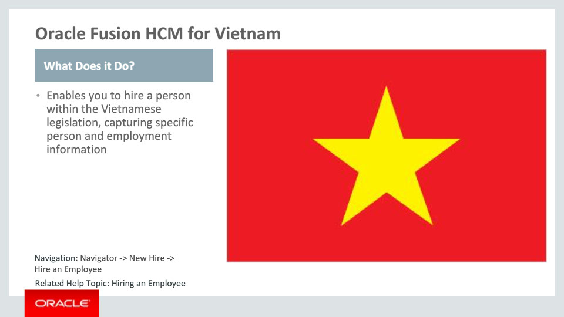
Slide notes
Oracle Fusion HCM for Vietnam supports country-specific features and functions. It enables users to follow Vietnam’s business practices and assists in complying with its statutory requirements by capturing particular person information. It is the last Asia Pacific country we are covering in this session.

Notes

Slide 25 - Oracle Fusion HCM for Vietnam
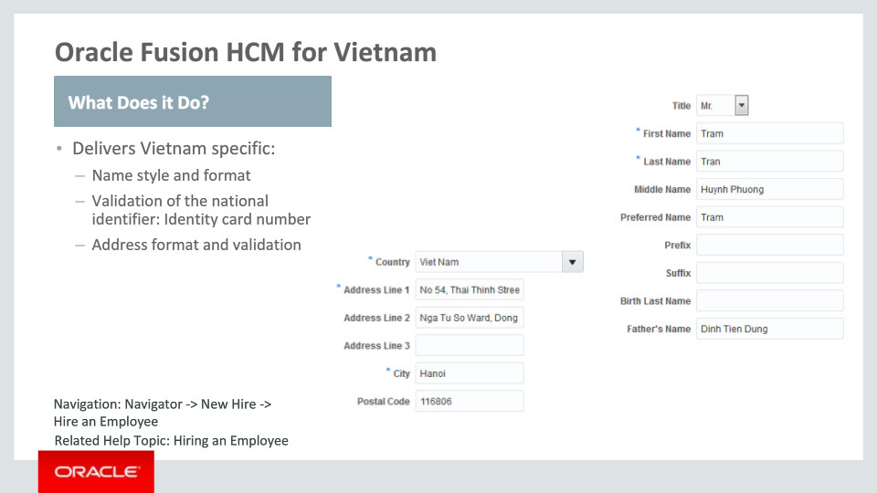
Slide notes
The following features are delivered for Vietnam:
First, there is a local name style delivered. This name style contains the Title, First Name, Last Name, Middle Name, Preferred Name, Prefix, Suffix, Birth Last Name and the Father’s Name. The First and Last Names are required when entering a name.
Second, a country-specific predefined value is available for the national identifier: the Identity card number. This number is validated: it should be 9 or 12 digits.
Third, we have also delivered a local address format for Vietnam. This address format is enabled by choosing the address style: “Supplemental Taxation and Reporting Address” using the task ”Manage Features by Country or Territory.“ The Country, Address Line 1 and City are required when entering an address. The Postal Code is validated and should have 6 digits.

Notes

Slide 26 - Oracle Fusion HCM for Vietnam
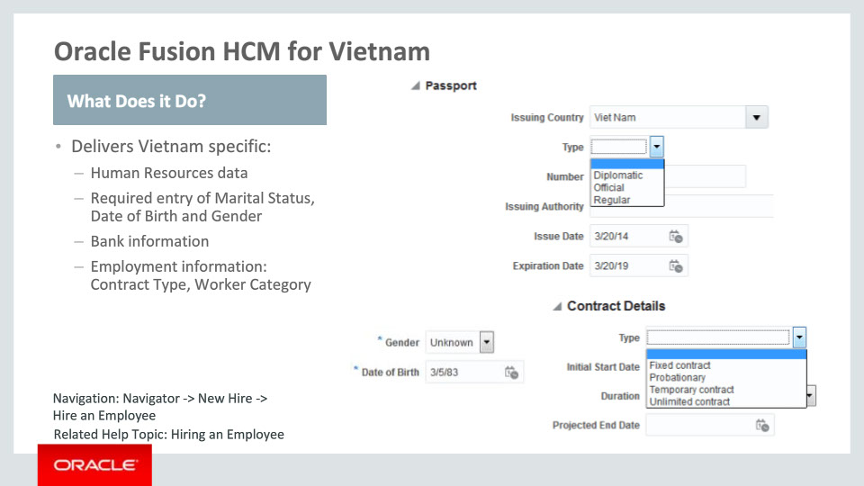
Slide notes
Moving on with the features for Vietnam, we have also delivered the following:
There is additional Human Resources data available, including predefined values for Religion, Marital Status, Contacts, Gender, Passports, and Highest Education Level.
The Marital Status, Date of Birth and Gender have been made required attributes for Vietnam.
We are also delivering local bank information so users can create local bank accounts and associated information.
Finally, in the Employment area we have delivered predefined values for the Contract Type and the Worker Category.
Notes

Slide 27 - Tier 1 Localizations
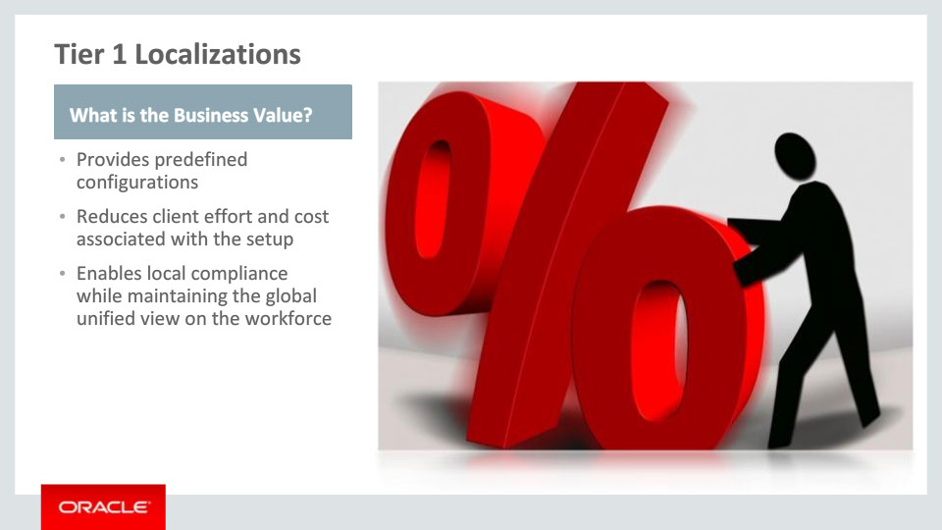
Slide notes
The new Tier 1 Localizations provide your organization with Business Value: first, by providing predefined configurations and content aligned with the country-specific requirements on capturing person and employment information; then, by reducing cost and time taken to implement HCM.
Last but not least, business value is added by assisting customers to achieve local compliance while retaining the global unified view of their workforce.

Notes

Slide 221 - Summary of Capabilities
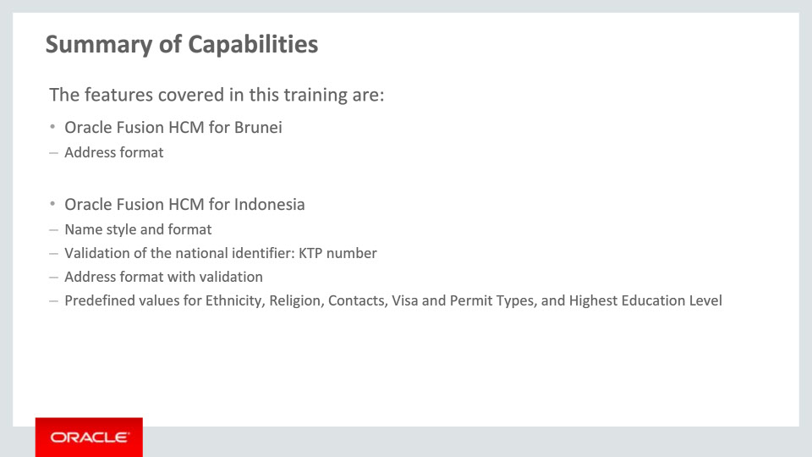
Slide notes
Here is the summary of the features I have talked about today. I began by talking about the Tier 1 Localizations for Brunei and Indonesia, and the functionalities that have been delivered for each, which you can review here.
Notes

Slide 222 - Summary of Capabilities
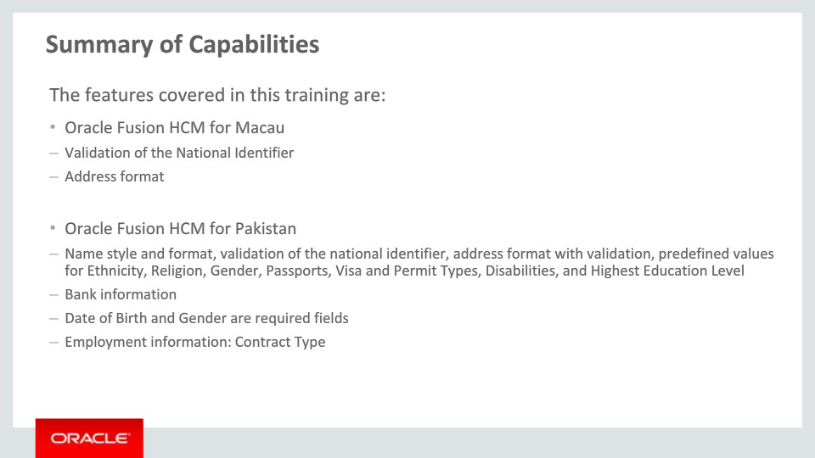
Slide notes
I continued by talking about functionalities enabled for Macau and Pakistan, which you can review here.

Notes

Slide 223 - Summary of Capabilities
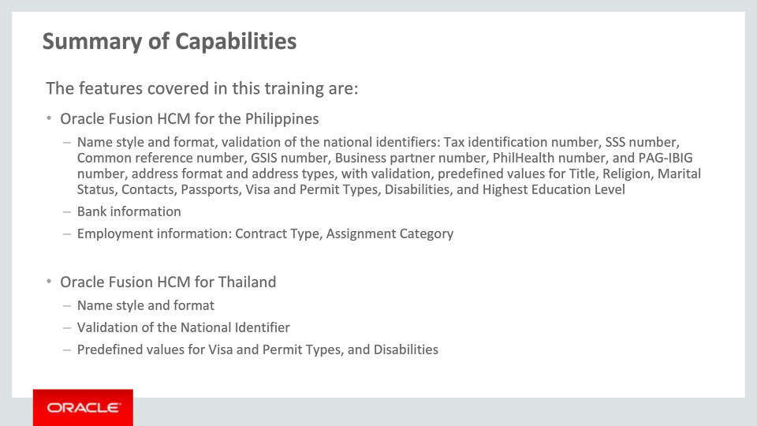
Slide notes
I then described the Tier 1 Localizations for the Philippines and Thailand. A summary of the delivered capabilities can be reviewed here.

Notes

Slide 224 - Summary of Capabilities
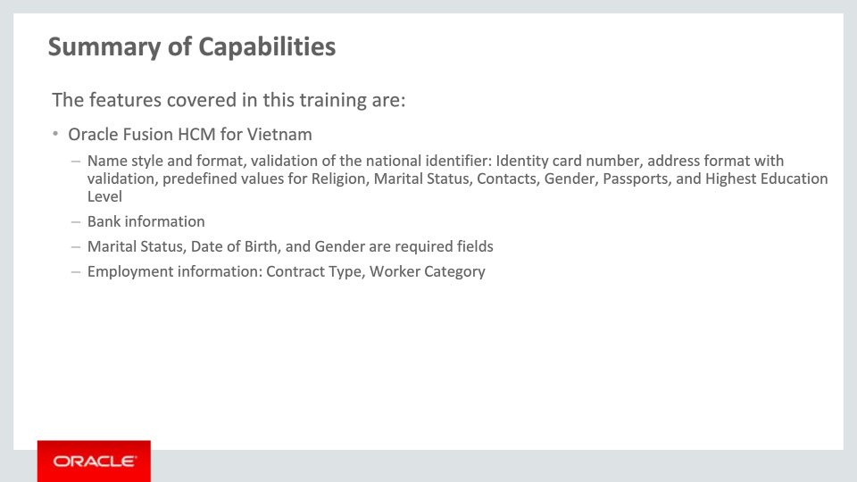
Slide notes
And finally I covered the Tier 1 Localization for Vietnam. A summary of the delivered capabilities can be reviewed here.
These new features and functionalities will help you and your organization achieve compliance in a global context.

Notes

Slide 225 - Additional Information
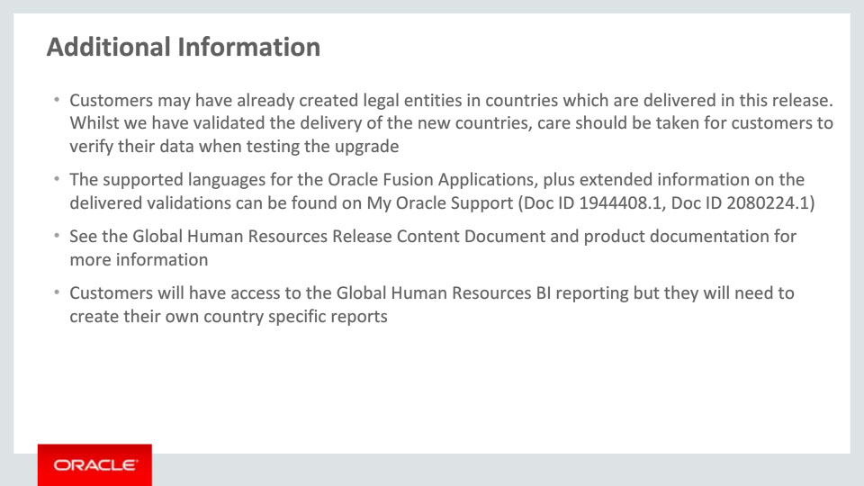
Slide notes
Here is some additional helpful information. Be aware that if customers have already created legal entities for a country which is now delivered, they will need to verify their data after the upgrade.
Please also refer to the Release Content Document for Global Human Resources to get an overview of all new features delivered with this release and My Oracle Support for the latest status of translations and validations.
Customers should review the Global Human Resources documentation when they implement the Tier 1 Localization functionality.
Finally, whilst customers have access to the Global Human Resources BI reporting, they will need to create their own country specific reports.

Notes

Slide 226 - Implementation Advice
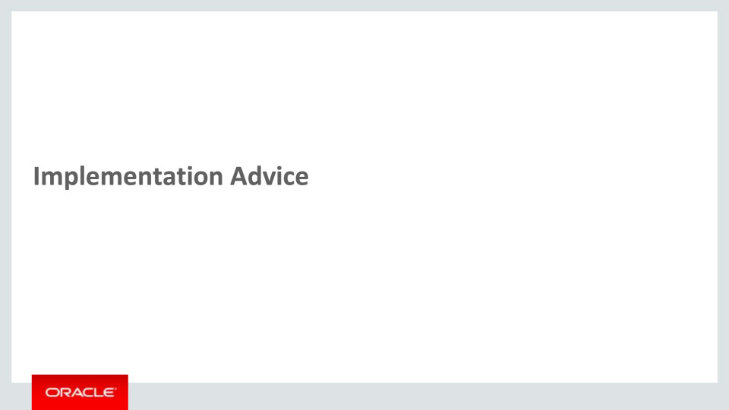
Slide notes
In this implementation advice section we will go through what you need to consider before enabling these features in your business, and what you need to know to set them up.

Notes

Slide 227 - Feature Impact Guidelines
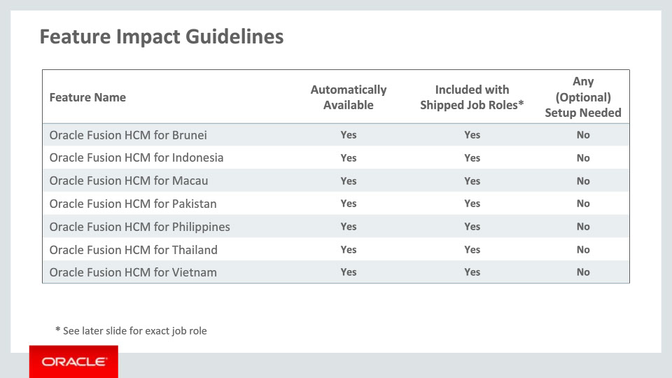
Slide notes
This table depicts key implementation information for the features covered in this training. It details:
• If a feature is automatically available after installation
• If a feature can be accessed using the shipped job roles – the exact job roles are detailed later in this section
• And if a feature has any setup associated with it
All features included in this release are automatically available and included with the shipped job roles. No specific setup is required to access the features outlined.
Notes

Slide 228 - Job Roles
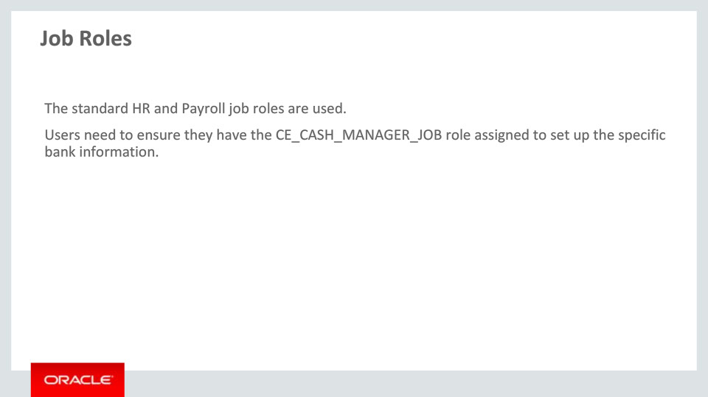
Slide notes
Here are the shipped job roles that will access the new capabilities covered in this training. While the standard HR and Payroll job roles are used (for example Human Resources Specialist, Human Resources Manager), users will need to assign the CE_CASH_MANAGER_JOB role in order to set up the local bank information.

Notes

Slide 229 - Business Process Model Information
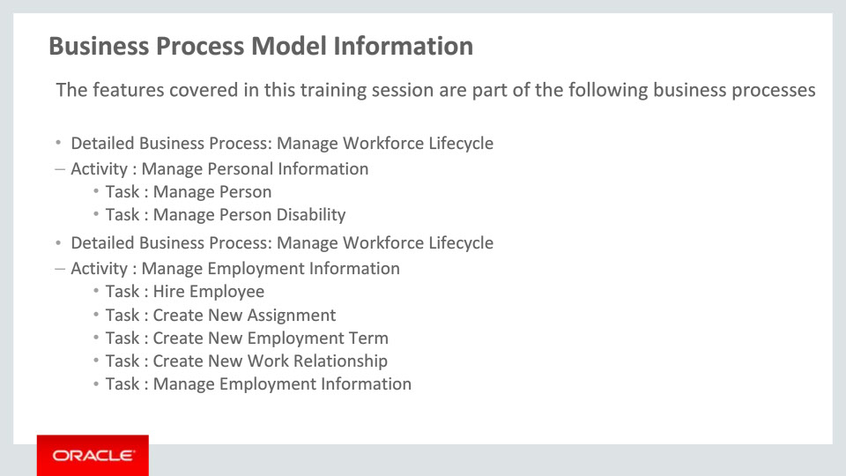
Slide notes
The business processes associated with the new capabilities covered in this training are detailed here. General processes are mentioned first, then component activities and finally the various tasks as part of the activities. Please take a moment to review them.

Notes

Slide 230 - Business Process Model Information
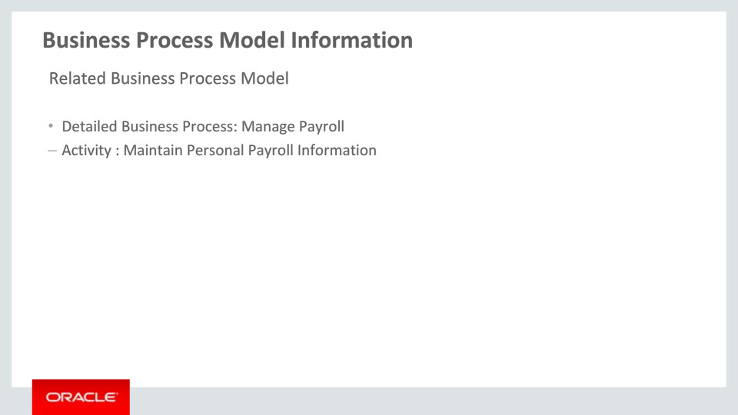
Slide notes
The related business processes and activity associated with the new capabilities covered in this training are detailed here.

Notes

Slide 231 - Associated Release Training
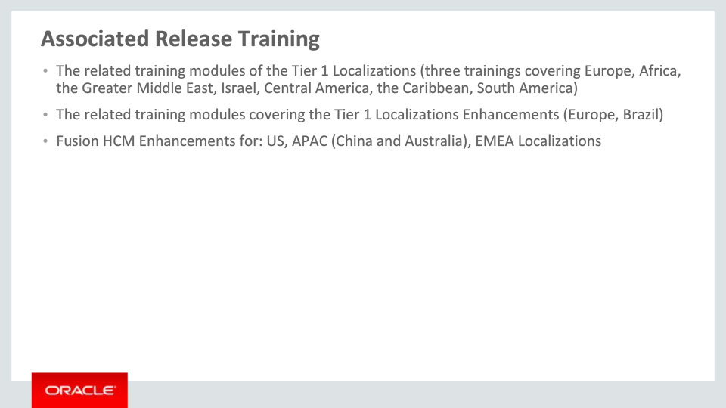
Slide notes
This training module is part of a ten-group set on the new Tier 1 Localizations available with Release 11. The nine other groups are: Europe (with three groups), Africa, the Arab Countries, Israel, Central America, the Caribbean and South America.
Besides these ten groups, a set of two Tier 1 Localizations Enhancements trainings must be mentioned: one for Europe and one for Brazil. These two sessions cover the enhancements available with Release 11 for the six Tier 1 Localizations delivered with Release 10.
Please refer to the next slide to see details on countries for the training sessions mentioned here.
Other training modules that cover the new functionality added to existing localizations and are recommended viewing are Fusion HCM Enhancements for US, Asia Pacific (China and Australia) and various EMEA Localizations.

Notes

Slide 232 - Associated Release Training
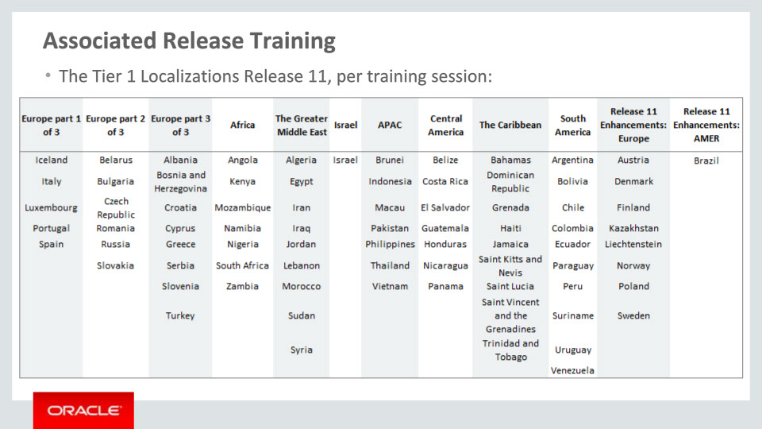
Slide notes
As previously mentioned, this slide depicts the Tier 1 Localizations per training session. The first ten groups cover the new localizations available with Release 11, while the last two show the enhancements available with Release 11 for nine Tier 1 Localizations delivered with Release 10. Please take a moment to review the countries of each training session.

This concludes this presentation, thank you for listening. You can easily pause and rewind any of these slides if you require additional time to take in the detail.
Notes

