Slide 3 - Oracle Supply Chain Planning Cloud
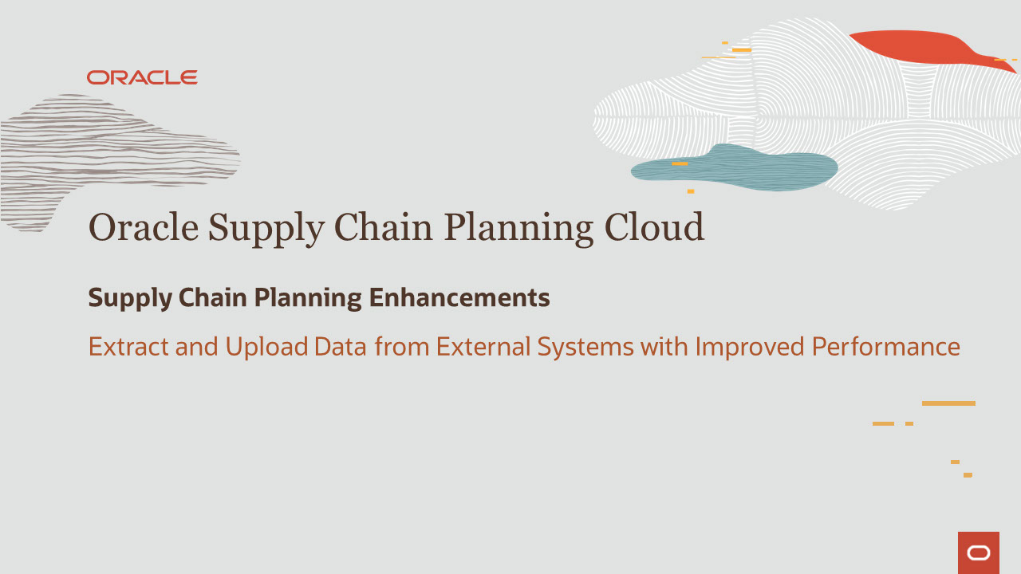
Slide notes
Hello, my name is Srikanta. Welcome to training for Supply Planning in Oracle Supply Chain Planning Cloud.
In this session, we talk about Extract and Upload Data from External Systems with Improved Performance in Supply Chain Planning.

Notes

Slide 4 - Agenda

Slide notes
For the capabilities covered in this training, we’ll give an overview, followed by more detail to explain how you can use them, and what business value they bring.
Next, we’ll explain what you need to consider before enabling these features in your business, and what you need to know to set them up.

Notes

Slide 5 - Extract and Upload Data from External Systems with Improved Performance
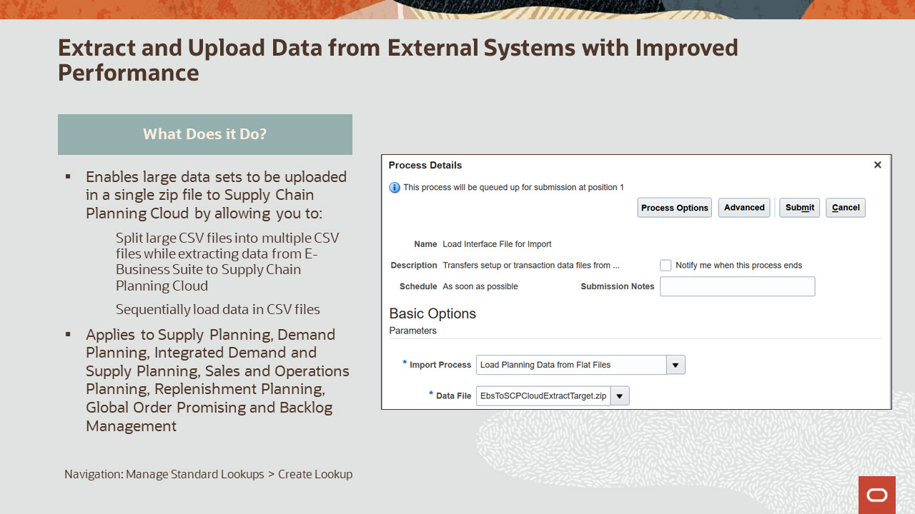
Slide notes
Extract and Upload Data from External Systems with Improved Performance enables large data sets to be uploaded in a single zip file to Supply Chain Planning Cloud by allowing you to:
Split large CSV files into multiple CSV files while extracting data from E-Business Suite to Supply Chain Planning Cloud and
Sequentially load data in CSV files.
Extract and Upload Data from External Systems with Improved Performance is applicable to Supply Planning, Demand Planning, Integrated Demand and Supply Planning, Sales and Operations Planning, Replenishment Planning, Global Order Promising and Backlog Management.

Notes

Slide 6 - Extract and Upload Data from External Systems with Improved Performance
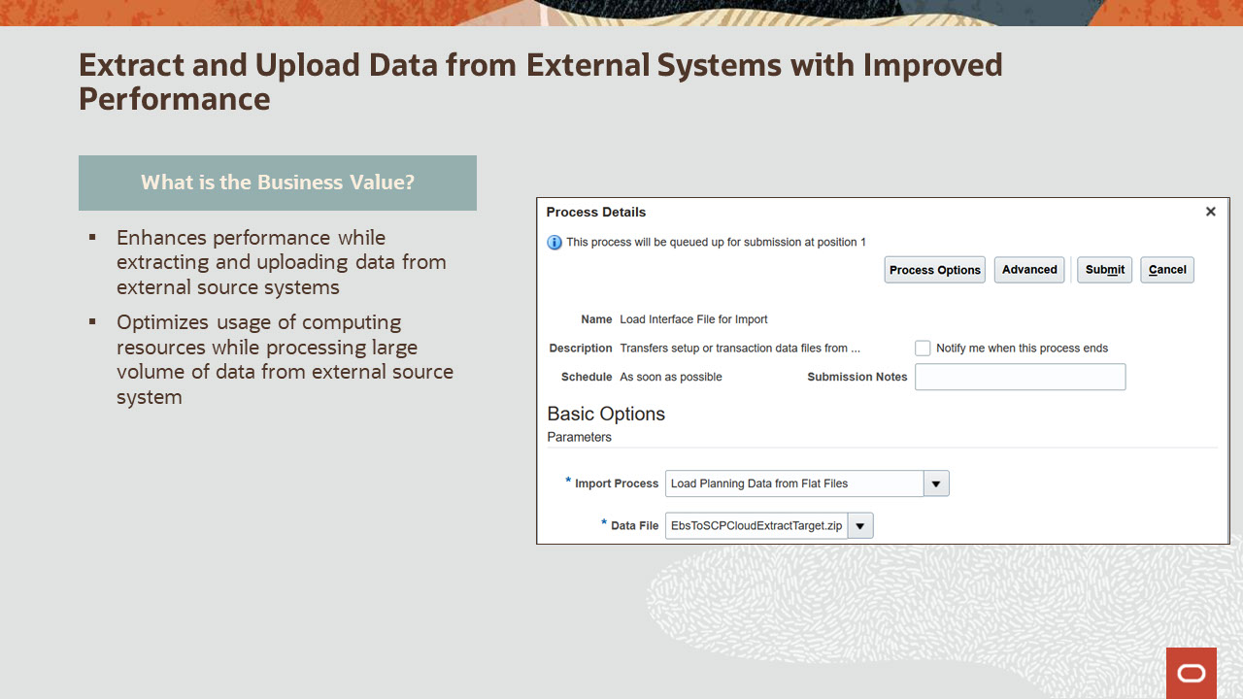
Slide notes
Extract and Upload Data from External Systems with Improved Performance enhances performance while extracting and uploading data from external source systems. It also optimizes usage of computing resources while processing large volume of data from external source system.

Notes

Slide 7 - Additional Information for Extract and Upload Data from External Systems with Improved Performance
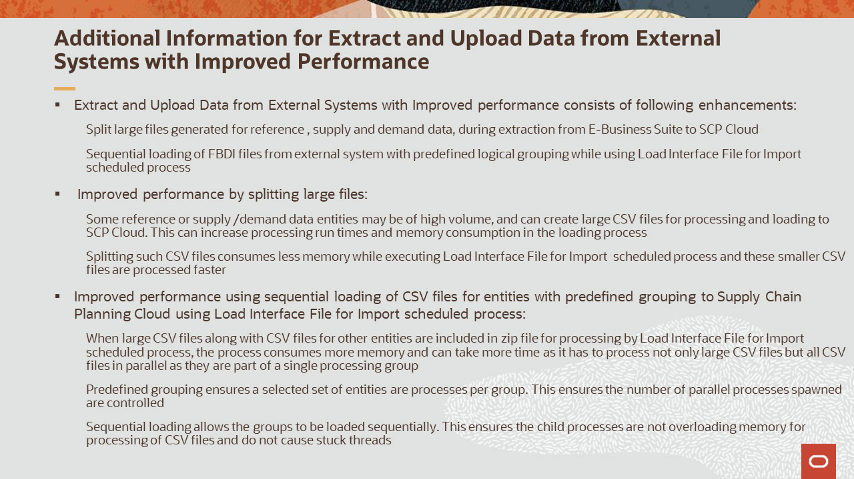
Slide notes
Let’s now understand some additional information about Extract and Upload Data from External Systems with Improved Performance.
Extract and Upload Data from External Systems with Improved Performance consists of following enhancements:
You can split large files generated for reference, supply and demand data, during extraction from E-Business Suite to SCP Cloud, and
You can perform sequential loading of FBDI files from external system with predefined logical grouping while using Load Interface File for Import scheduled process.
Here’s how this feature Improves performance by splitting large files:
Some reference or supply or demand data entities may be of high volume, and can create large CSV files for processing and loading to SCP Cloud. This can increase processing run times and memory consumption in the loading process.
Splitting such CSV files consumes less memory while executing Load Interface File for Import scheduled process and lesser size CSV files are processed faster.
Here’s how this feature improves performance using sequential loading of CSV files for entities with a predefined grouping to Supply Chain Planning Cloud using Load Interface File for Import scheduled process:
When large CSV files along with CSV files for other entities are included in zip file for processing by Load Interface File for Import scheduled process, the process consumes more memory and can take more time as it has to process not only large CSV files but all CSV files in parallel as they are part of a single processing group.

Predefined grouping ensures a selected set of entities are processes per group. This ensures the number of parallel processes spawned are controlled.
Finally, sequential loading allows the groups to be loaded sequentially. This ensures the child processes are not overloading memory for processing of CSV files and do not cause stuck threads.

Notes

Slide 8 - Additional Information for Extract and Upload Data from External Systems with Improved Performance
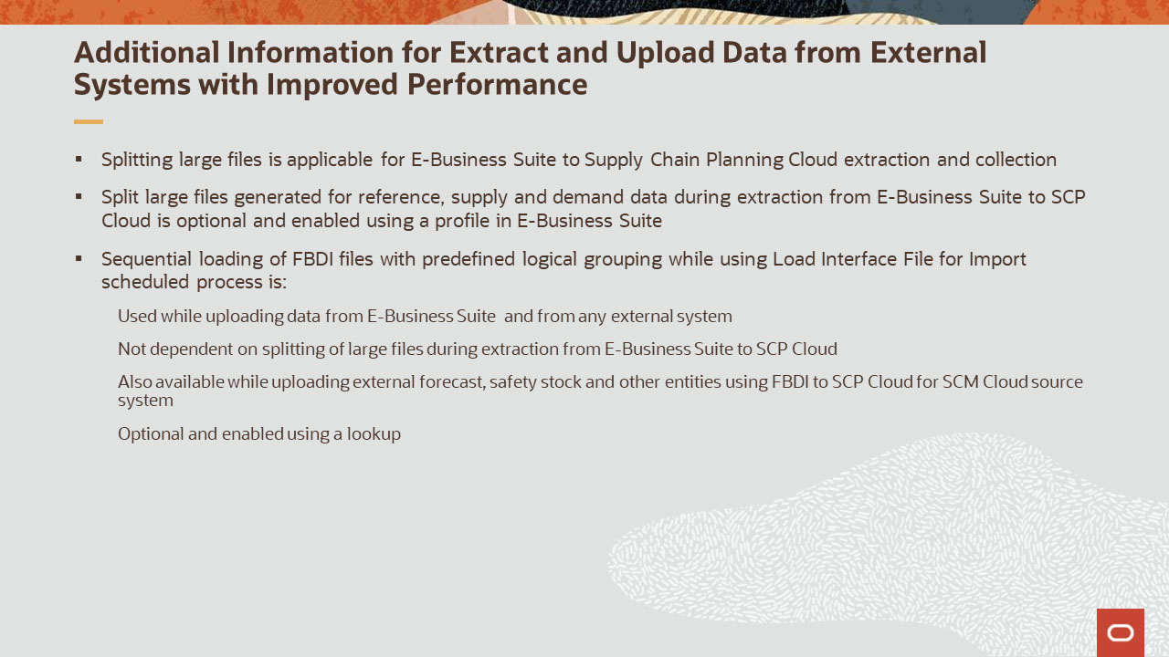
Slide notes
Let’s now understand some additional information about Extract and Upload Data from External Systems with Improved Performance.
Splitting large files is applicable for E-Business Suite to Supply Chain Planning Cloud extraction and collection.
Split large files generated for reference, supply and demand data during extraction from E-Business Suite to SCP Cloud is optional and enabled using a profile in E-Business Suite.
Sequential loading of FBDI files with predefined logical grouping while using Load Interface File for Import scheduled process is:
Used while uploading data from E-Business Suite and from any external system,
Not dependent on splitting of large files during extraction from E-Business Suite to SCP Cloud,
It’s also available while uploading external forecast, safety stock and other entities using FBDI to SCP Cloud for SCM Cloud source system, and
Is optional and enabled using a lookup.

Notes
Slide 9 - Additional Information for Extract and Upload Data from External Systems with Improved Performance by splitting large files
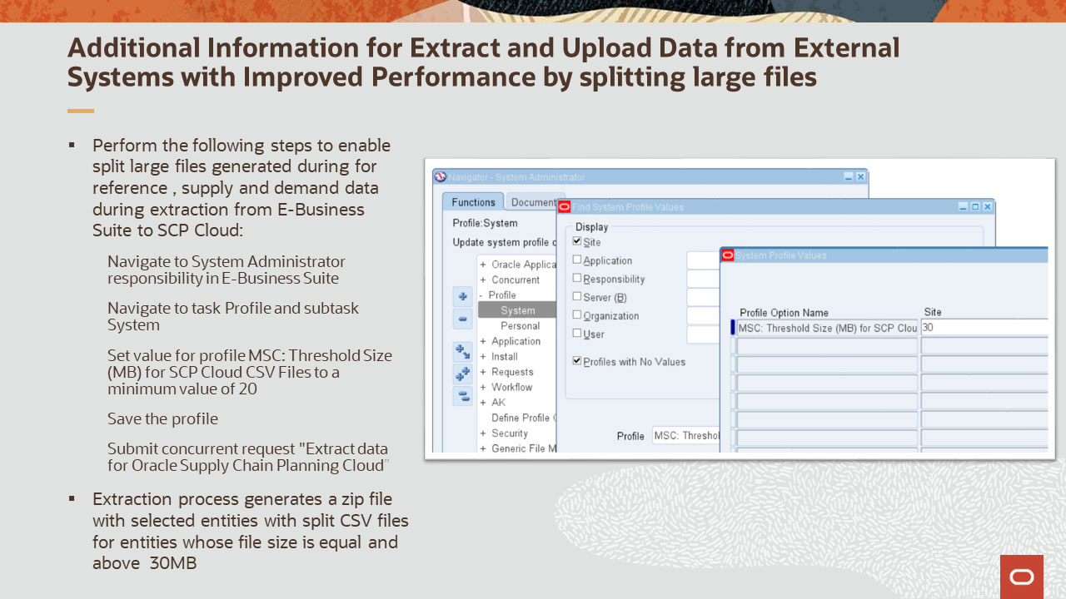
Slide notes
Perform the following steps to enable split large files generated during for reference, supply and demand data during extraction from E-Business Suite to SCP Cloud:
Navigate to System Administrator responsibility in E-Business Suite.
Navigate to task Profile and subtask System.
Set value for profile MSC: Threshold Size (MB) for SCP Cloud CSV Files to a minimum value 20 to allow to start splitting.
Save the profile and
Submit concurrent request "Extract data for Oracle Supply Chain Planning Cloud.”
Once the above steps are completed, extraction process generates a zip file with selected entities with split CSV files for entities whose file size is equal and above 20MB.

Notes
Slide 10 - Additional Information for Extract and Upload Data from External Systems with Improved Performance by splitting large files
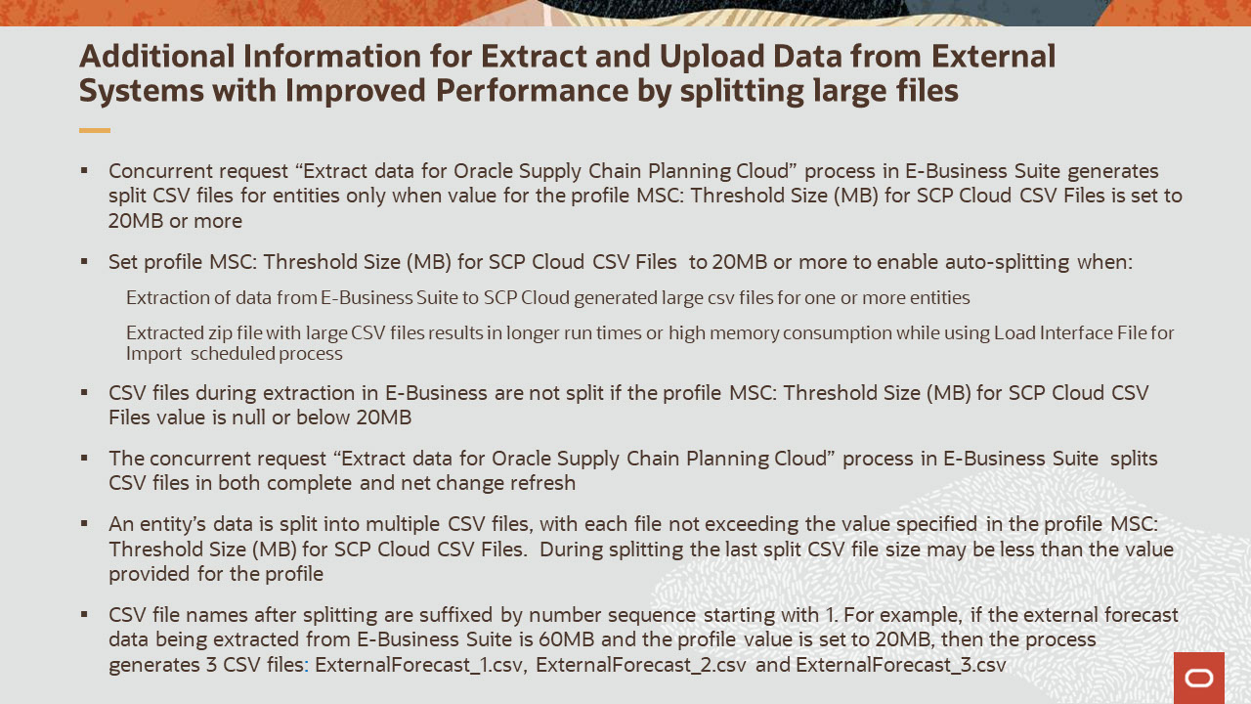
Slide notes
Some more additional considerations related to splitting of files during extraction from E-Business Suite are:
Concurrent request “Extract data for Oracle Supply Chain Planning Cloud” process in E-Business Suite generates split CSV files for entities only when value for the profile MSC: Threshold Size (MB) for SCP Cloud CSV Files is set to 20MB or more.
Set profile MSC: Threshold Size (MB) for SCP Cloud CSV Files to 20MB or more to enable auto-splitting when:
Extraction of data from E-Business Suite to SCP Cloud generated large csv files for one or more entities and
Extracted zip file with large CSV files results in longer run times or high memory consumption while using Load Interface File for Import scheduled process.
CSV files during extraction in E-Business are not split if the profile MSC: Threshold Size (MB) for SCP Cloud CSV Files value is null or below 20MB.
The concurrent request “Extract data for Oracle Supply Chain Planning Cloud” process in E-Business Suite splits CSV files in both complete and net change refresh.
An entity’s data is split into multiple CSV files, with each file not exceeding the value specified in the profile MSC: Threshold Size (MB) for SCP Cloud CSV Files. During splitting the last split CSV file size may be less than the value provided for the profile.

CSV file names after splitting are suffixed by number sequence starting with 1. For example, if the external forecast data being extracted from E-Business Suite is 60MB and the profile value is set to 20MB, then the process generates 3 CSV files, ExternalForecast_1.csv, ExternalForecast_2.csv and ExternalForecast_3.csv.

Notes

Slide 11 - Additional Information for Extract and Upload Data from External Systems with Improved Performance by splitting large files
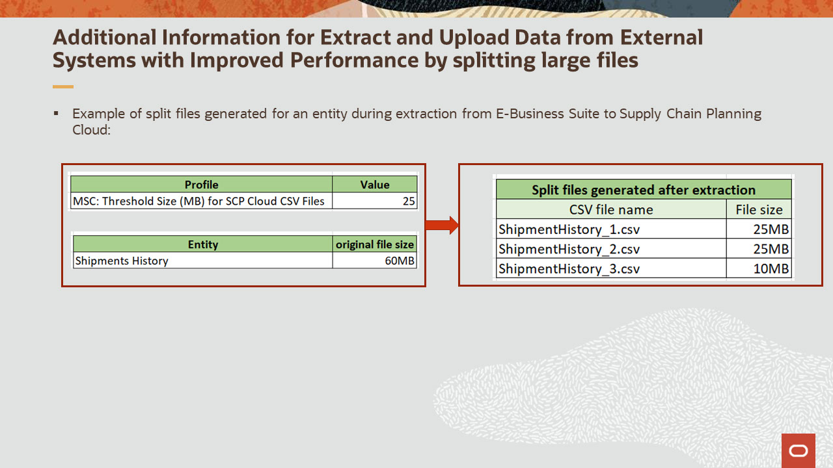
Slide notes
Let’s consider an example of split files generated for an entity during extraction of data from E-Business Suite to Supply Chain Planning Cloud.
In this example, profile MSC Threshold Size (MB) for SCP Cloud CSV Files in E-Business Suite is set to 25. The original size of the Shipments History CSV file is 60MB.
The data extraction process splits this large file into 3 files. The first file will be of 25MB in size and will be named as ShipmentHistory_1.csv , second file will be of 25MB size and with name SipmentHistory_2.csv and the last file will be of 10MB in size, which is the remaining data from original file and named as ShipmentHistory_3.csv.

Notes

Slide 12 - Additional Information for Extract and Upload Data from External Systems with Improved Performance enabling sequential loading of CSV files
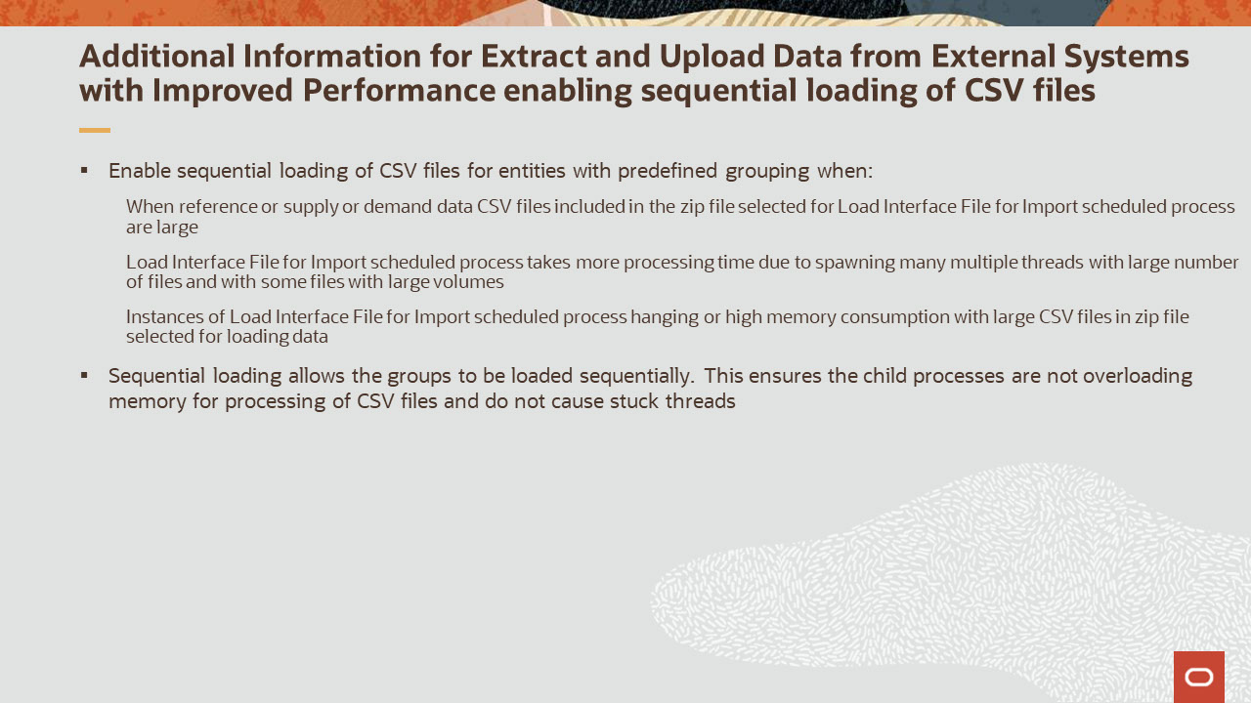
Slide notes
Here are some important points to remember. Enable sequential loading of CSV files for entities with predefined grouping when reference or supply or demand data when:
CSV files included in the zip file selected for Load Interface File for Import scheduled process are large.
The Load Interface File for Import scheduled process takes more processing time due to spawning many multiple threads with large number of files and with some files with large volumes, and
Instances of the Load Interface File for Import scheduled process are hanging or have high memory consumption with large CSV files in the zip file selected for loading data.
Sequential loading allows the groups to be loaded sequentially. This ensures the child processes are not overloading memory for processing of CSV files and do not cause stuck threads.

Notes
Slide 13 - Additional Information for Extract and Upload Data from External Systems with Improved Performance enabling sequential loading of CSV files
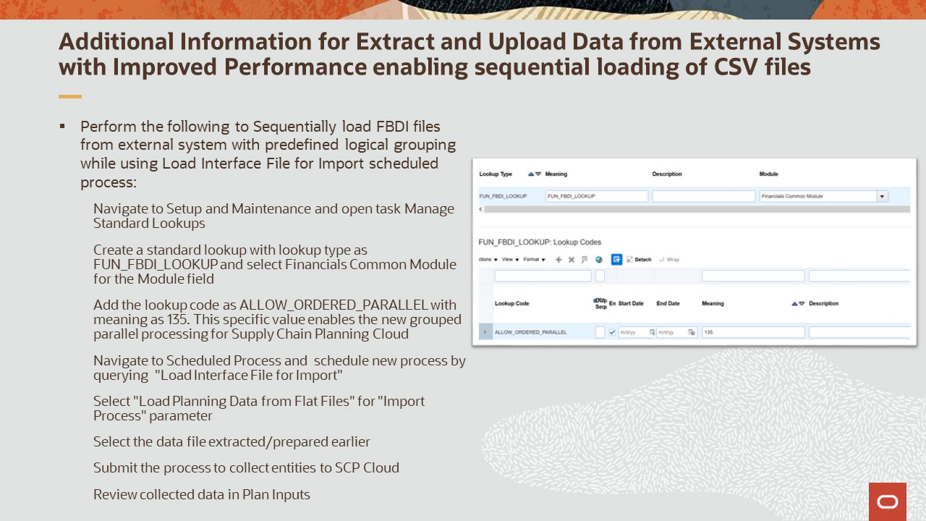
Slide notes
Perform the following to Sequentially load FBDI files from external system with predefined logical grouping while using Load Interface File for Import scheduled process:
Navigate to Setup and Maintenance and open task Manage Standard Lookups.
Create a standard lookup with lookup type as FUN_FBDI_LOOKUP and select Financials Common Module for the Module field.
Add the lookup code as ALLOW_ORDERED_PARALLEL with meaning as 135. This specific value enables the new grouped parallel processing for Supply Chain Planning Cloud.
Navigate to Scheduled Process and schedule new process by querying “Load Interface File for Import.”
Select "Load Planning Data from Flat Files" for "Import Process" parameter.
Select the data file extracted/prepared earlier.
Submit the process to collect entities to SCP Cloud, and
Review collected data in Plan Inputs.

Notes
Slide 14 - Additional Information for Extract and Upload Data from External Systems with Improved Performance enabling sequential loading of CSV files
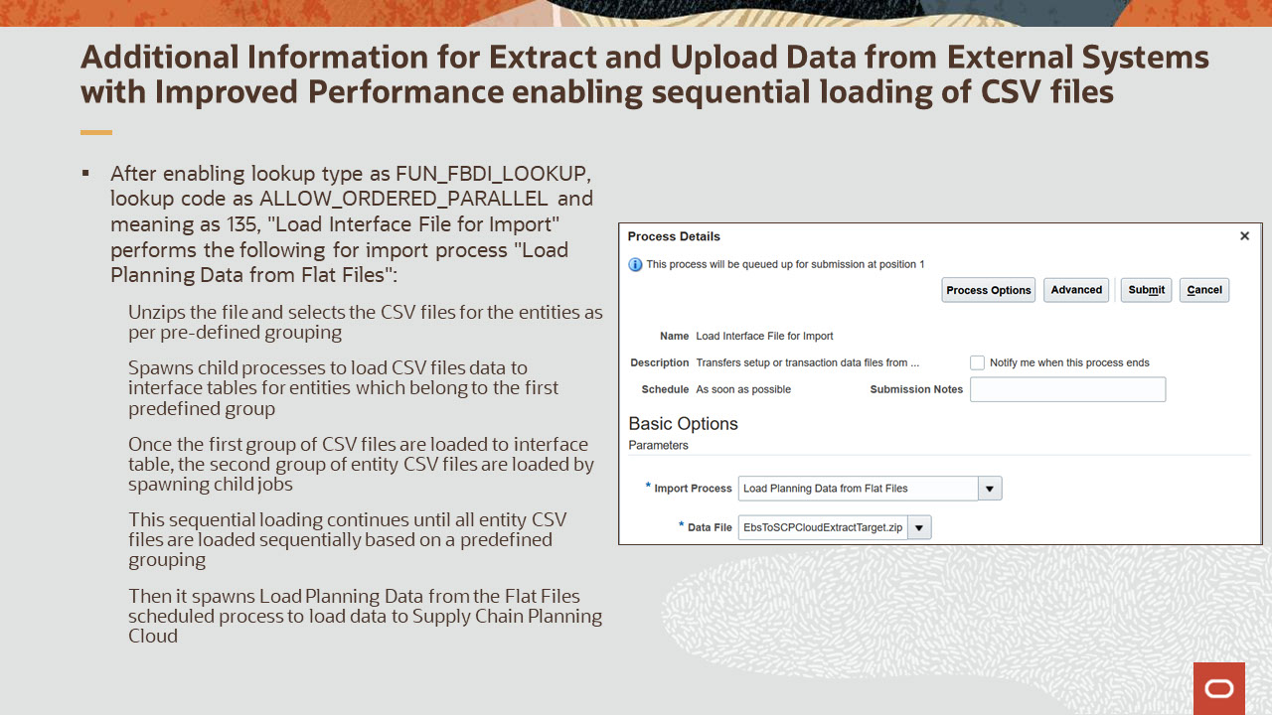
Slide notes
After enabling lookup type as FUN_FBDI_LOOKUP, lookup code as ALLOW_ORDERED_PARALLEL and meaning as 135, "Load Interface File for Import" performs the following for the import process "Load Planning Data from Flat Files":
- Unzips the file and selects the CSV files for the entities as per pre-defined grouping.
- Spawns child processes to load CSV file data to interface tables for entities which belong to the first predefined group.
- Once the first group of CSV files are loaded to interface table, the second group of entity CSV files are loaded by spawning child jobs.
This sequential loading continues until all entity CSV files are loaded sequentially based on a predefined grouping, and
Then it spawns Load Planning Data from the Flat Files scheduled process to load data to Supply Chain Planning Cloud.

Notes
Slide 15 - Additional Information for Extract and Upload Data from External Systems with Improved Performance enabling sequential loading of CSV files
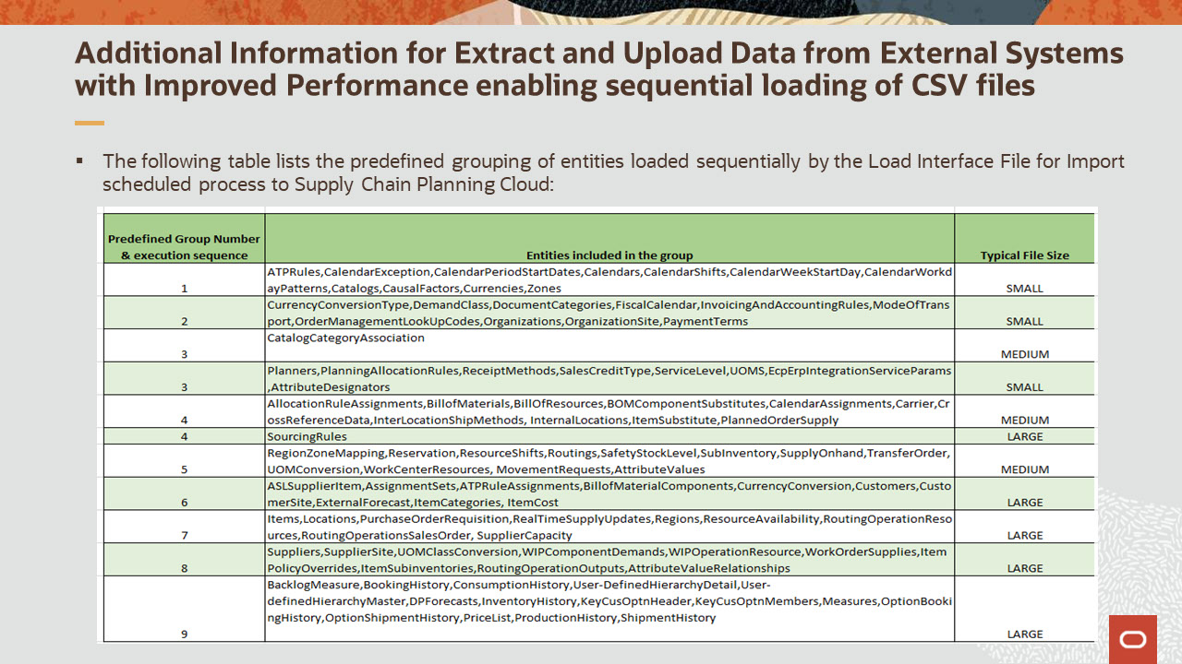
Slide notes
This table lists the predefined grouping of entities with their grouping number. The grouping number also represents the sequence in which the CSV files for these entities will be loaded using the sequential loading by the Load Interface File for Import scheduled process.
For example, CSV files for CurrencyConversionType, DemandClass, DocumentCategories, FiscalCalendar, InvoicingAndAccountingRules, ModeOfTransport, OrderManagementLookUpCodes, Organizations, OrganizationSite and PaymentTerms in a zip file selected while submitting Load Interface File for Import are always processed in the second sequence in a group.
Additionally, each group is also mentioned with its typical file size which indicates the reason for grouping these entity CSV files within same group. For example, all CSV files which belong to group 4 would typically be considered as a medium in size. However, there may be some use cases where some CSV files may be large. In these scenarios, CSV files can be split, and then sequential loading can be used for improved performance.

Notes
Slide 16 - Additional Information for Extract and Upload Data from External Systems with Improved Performance enabling sequential loading of CSV files
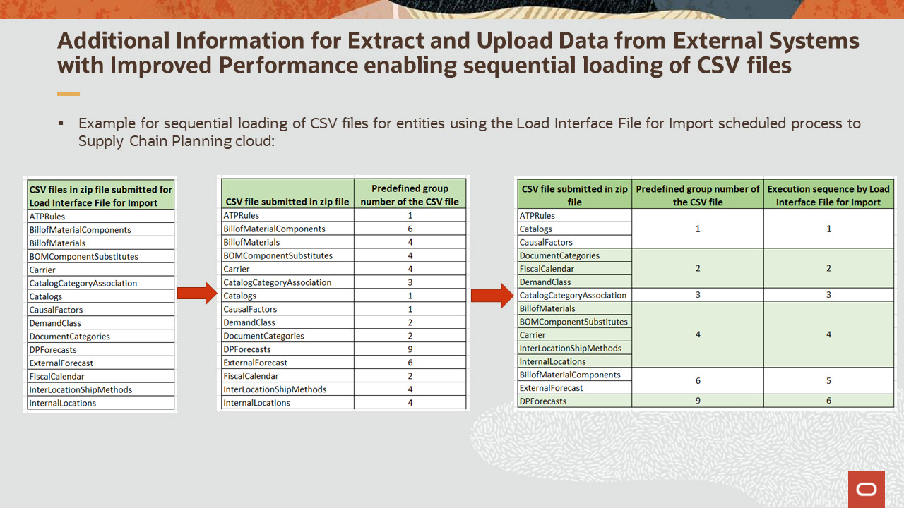
Slide notes
Let’s consider an example for sequential loading of CSV files for entities using the Load Interface File for Import scheduled process to Supply Chain Planning Cloud.
In this example we have a zip file created with ATPRules,BillofMaterialComponents,BillofMaterials,BOMComponentSubstitutes,Carrier,CatalogCategoryAssociation,Catalogs,CausalFactors,DemandClass,DocumentCategories,DPForecasts,ExternalForecast,FiscalCalendar,InterLocationShipMethods,InternalLocations CSV files.
The Load Interface File for Import scheduled process refers to the predefined grouping of these CSV files and spawns child processes to sequentially load the CSV files.
For example, BillofMaterials,BOMComponentSubstitutes,Carrier,InterLocationShipMethods and InternalLocations CSV files are part of group number 4 and will be loaded in sequence 4. Similarly, BillofMaterialComponents and ExternalForecast CSV files are part of group number 6 and will be loaded in sequence 5 in this example.

Notes
Slide 17 - Additional Information for Extract and Upload Data from External Systems with Improved Performance
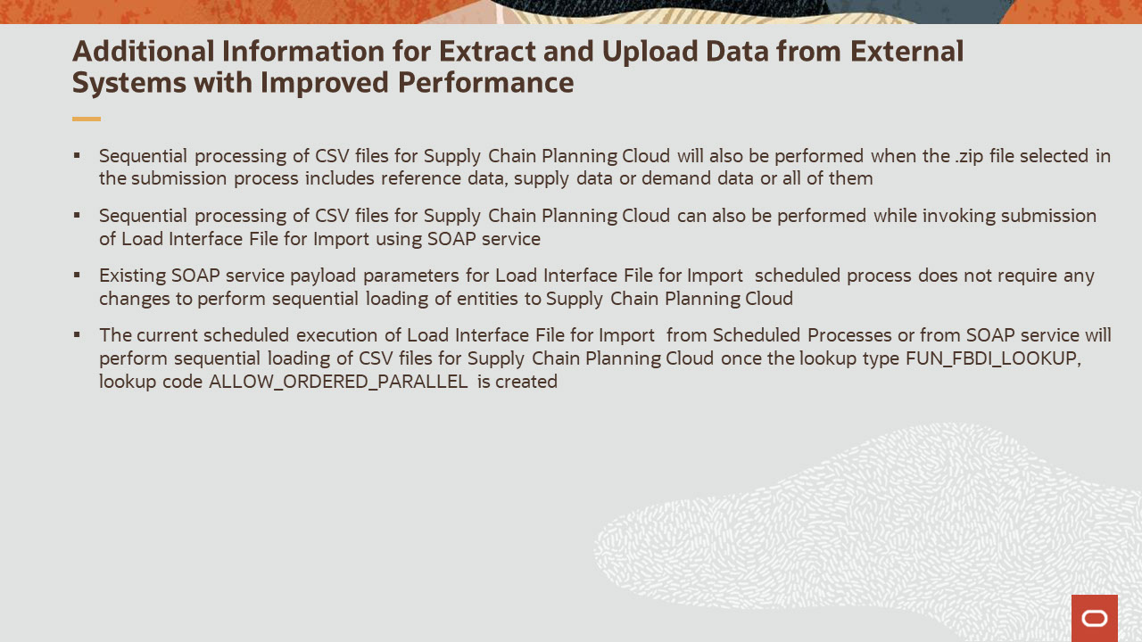
Slide notes
Here is additional information related to the feature Extract and Upload Data from External Systems with Improved Performance.
Sequential processing of CSV files for Supply Chain Planning Cloud will also be performed when the .zip file selected in the submission process includes reference data or supply data, demand data or all of them.
Sequential processing of CSV files for Supply Chain Planning Cloud can also be performed while invoking submission of Load Interface File for Import using SOAP service.
Existing SOAP service payload parameters for Load Interface File for Import scheduled process does not require any changes to perform sequential loading of entities to Supply Chain Planning Cloud.
The current scheduled execution of Load Interface File for Import from Scheduled Processes or from SOAP service will perform sequential loading of CSV files for Supply Chain Planning Cloud once the lookup type FUN_FBDI_LOOKUP, lookup code ALLOW_ORDERED_PARALLEL is created.

Notes
Slide 18 - Additional Information for Extract and Upload Data from External Systems with Improved Performance
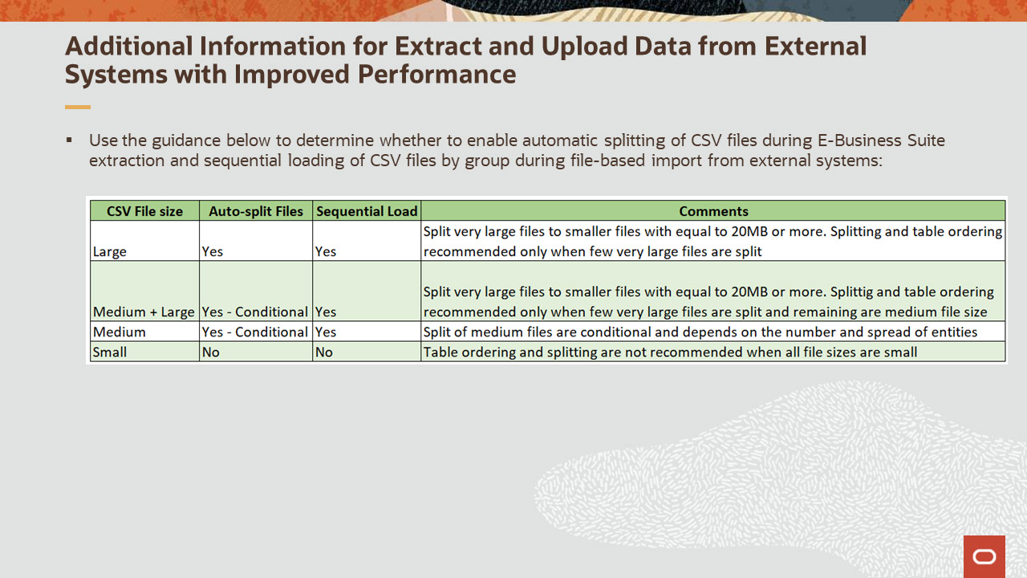
Slide notes
You can use this guidance to determine whether to enable automatic splitting of CSV files during E-Business Suite extraction and sequential loading of CSV files by group during file-based import from external systems:
If the entity CSV file sizes are large, then it’s recommended to use sequential loading of CSV files with predefined grouping along with file splitting. However, it’s recommended to split very large files to smaller files with a minimum size of 20MB or more.
If the entity CSV files have a mixture of medium and large files, then you can choose sequential loading with pre-defined grouping. However, splitting of files is conditional, and only those files which are large are recommended for splitting.
Similarly, for entity CSV files which are medium in size, you can choose to use sequential loading with predefined grouping. However, you may need to review and choose to split only a few of the medium files which are larger as compared to other files.
If the entity CSV files are smaller, then you may choose not to use both splitting and sequential loading with predefined grouping of files to Supply Chain Planning Cloud.

Notes
Slide 19 - Implementation Advice

Slide notes
In this section, we provide implementation considerations and setup instructions for the enhancements covered.

Notes

Slide 20 - Extract and Upload Data from External Systems with Improved Performance Impact
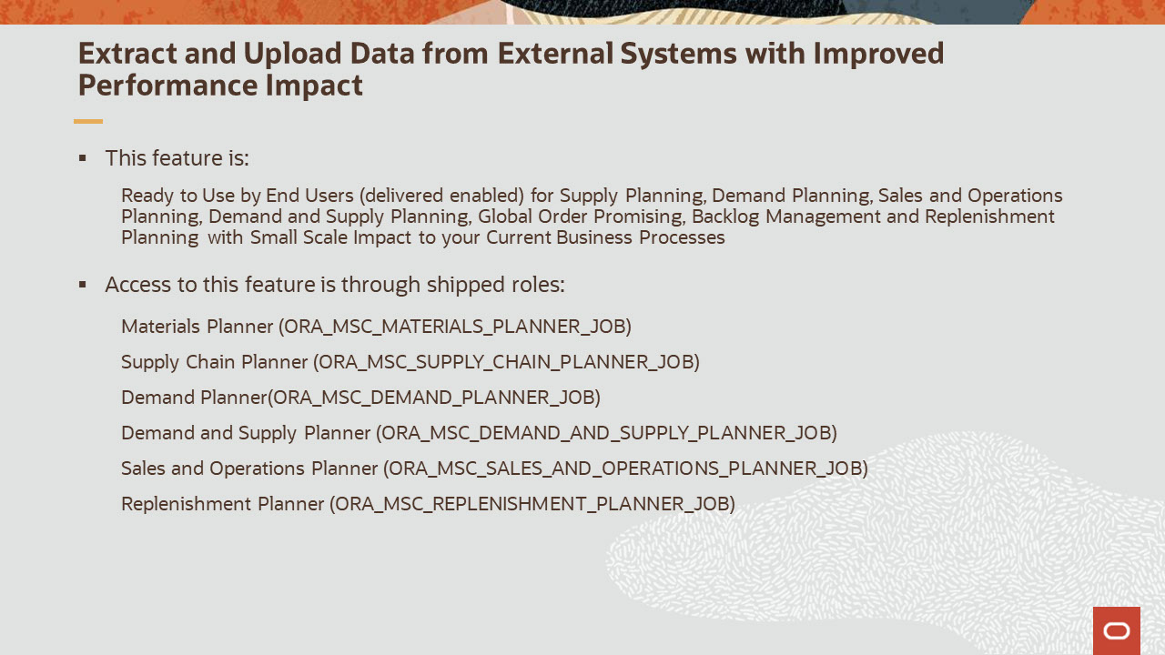
Slide notes
Extract and Upload Data from External Systems with Improved Performance feature is delivered ready to use for Supply Planning, Demand Planning, Sales and Operations Planning, Demand and Supply Planning, Global Order Promising, Backlog Management and Replenishment Planning with a small-scale impact to your current business processes.
The feature can be accessed using the job roles Materials Planner, Supply Chain Planner, Demand Planner, Demand and Supply Planner, Sales and Operations Planner and Replenishment Planner.

Notes

Slide 21 - Extract and Upload Data from External Systems with Improved Performance Impact
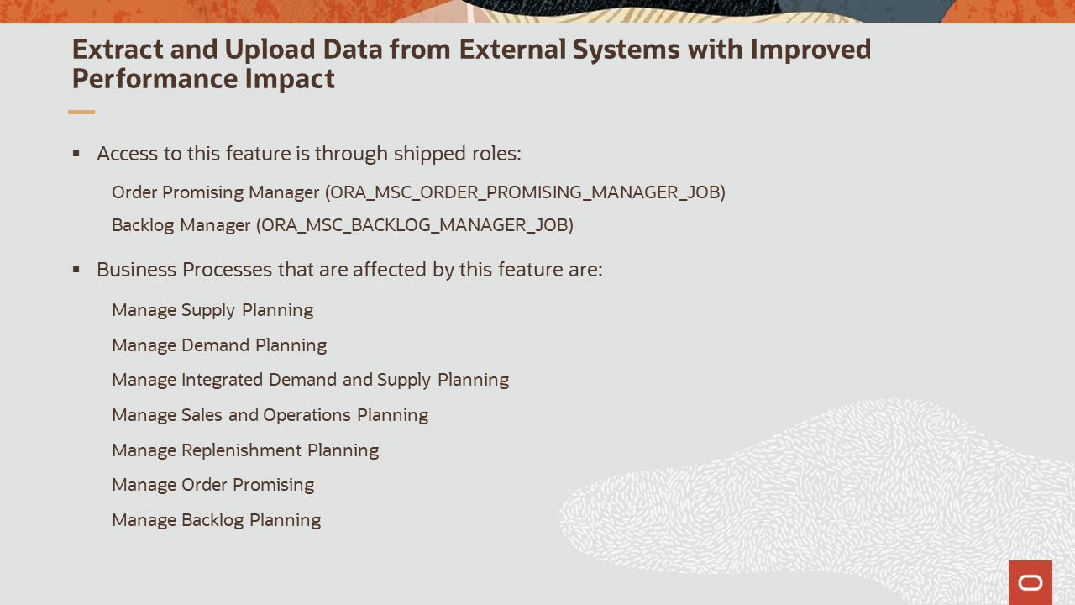
Slide notes
The Extract and Upload Data from External Systems with Improved Performance feature can be accessed using the job roles Order Promising Manager and Backlog Manager.
The business processes associated with this feature are Manage Supply Planning, Manage Demand Planning, Manage Integrated Demand and Supply Planning, Manage Sales and Operations Planning, Manage Replenishment Planning, Manage Order Promising and Manage Backlog Planning.

This concludes this presentation. Thank you for listening. You can easily pause and rewind if you require additional time to take in the detail.

Notes

