Slide 3 - Oracle Financials Cloud
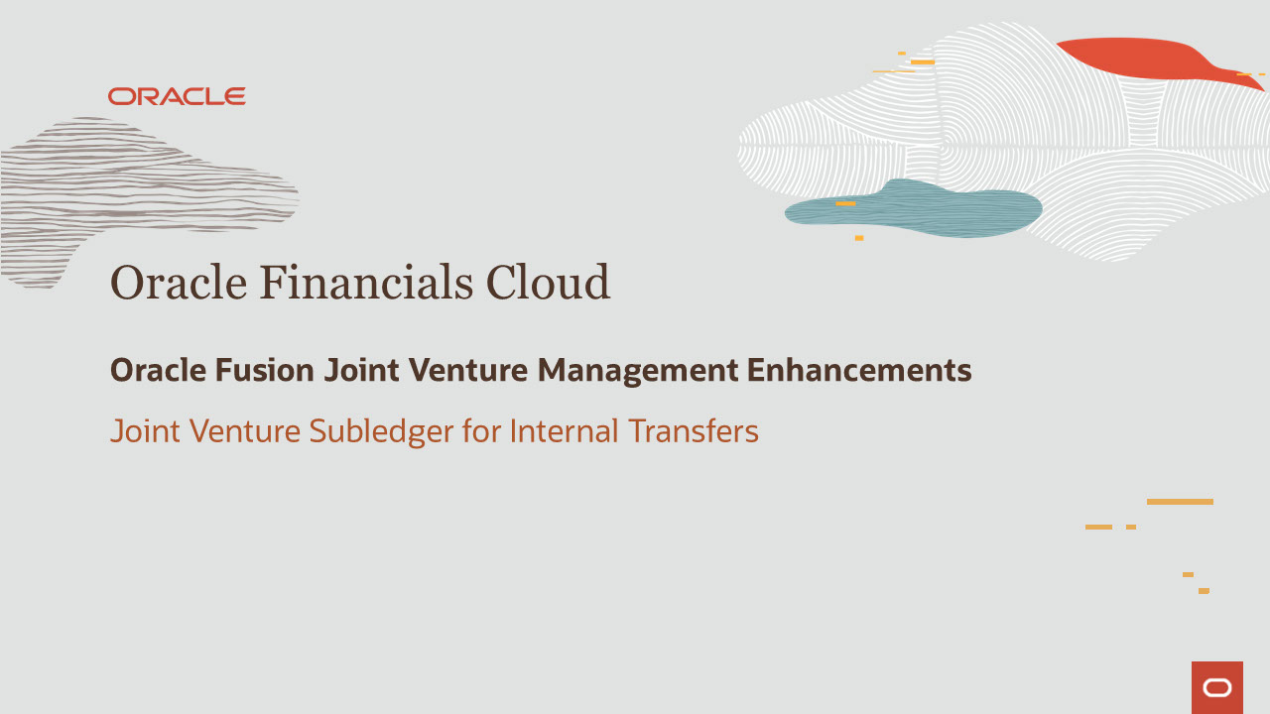
Slide notes
Hello, my name is Reni. Welcome to the training for Joint Venture Management in Oracle Financials Cloud.
In this session, we talk about Joint Venture Subledger for Internal Transfers.

Notes

Slide 4 - Agenda
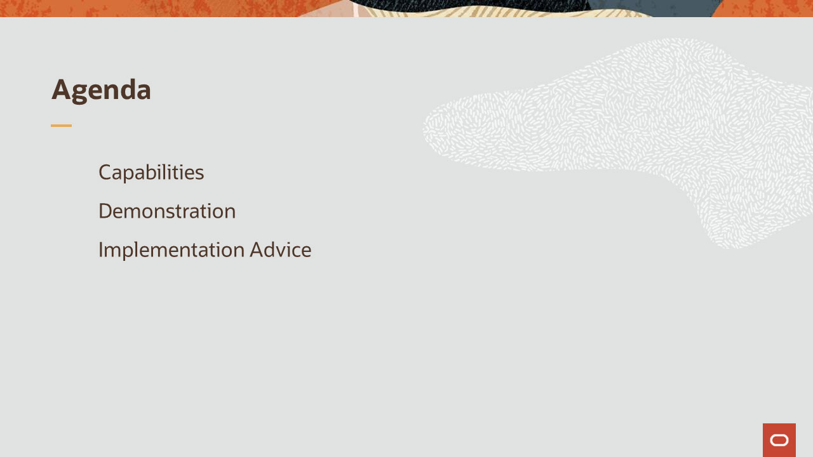
Slide notes
For the capabilities covered in this training, we’ll give an overview, followed by more detail to explain how you can use them, and what business value they bring.
Then, we’ll walk you through a demonstration.
Next, we’ll explain what you need to consider before enabling these features in your business, and what you need to know to set them up.

Notes

Slide 5 - Joint Venture Subledger for Internal Transfers
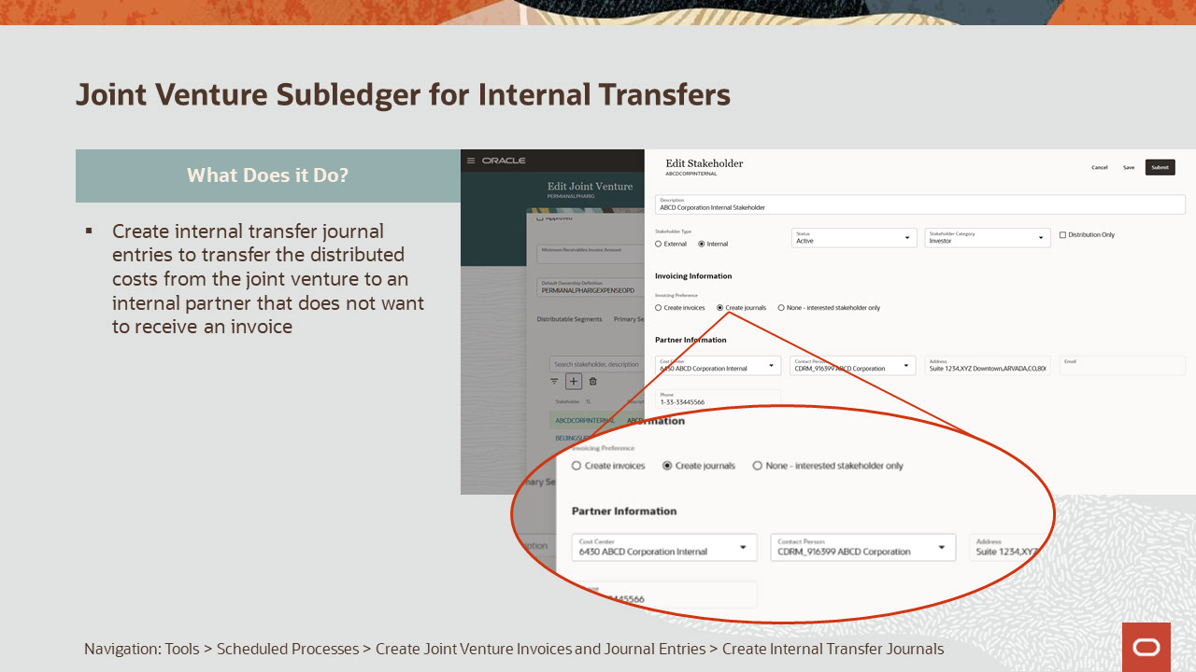
Slide notes
This capability will provide you with the ability to automatically create internal transfer journal entries to transfer the distributed costs from the joint venture to an internal partner that does not want to receive an invoice. Prior to this enhancement, the user had to manually create the journal entries to account for the internal partner’s share of costs in the joint venture.

Notes

Slide 6 - Joint Venture Subledger for Internal Transfers
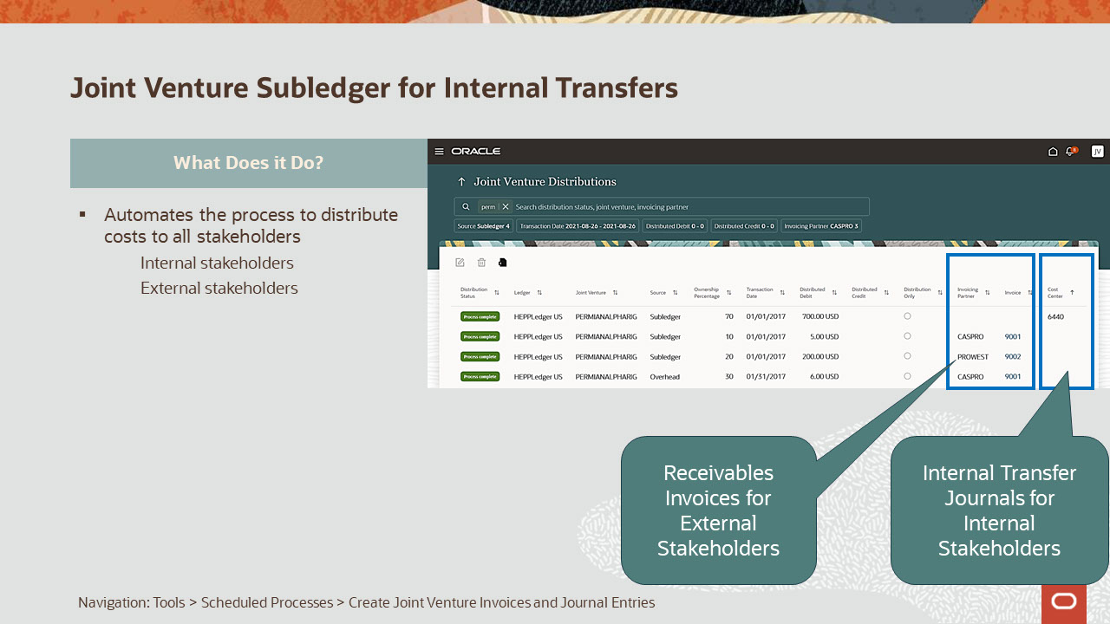
Slide notes
With the ability to create internal transfer journal entries for distributions associated to internal stakeholders’ share of costs, the process of distributing the costs incurred on the joint venture is now fully automated.
The joint venture costs can be recouped from the external stakeholders with a Receivables invoice.
In the case of internal stakeholders, the internal stakeholder can be represented as a separate cost center in the same primary ledger as the joint venture and internal transfer journal entries created to account for their share of the costs in the joint venture.
Creation of invoices and journal entries for revenue distributions is not yet automated.
For revenue distribution, you will need to manually create the Payables invoices and journal entries to account for each stakeholders share.

Notes

Slide 7 - Joint Venture Subledger for Internal Transfers
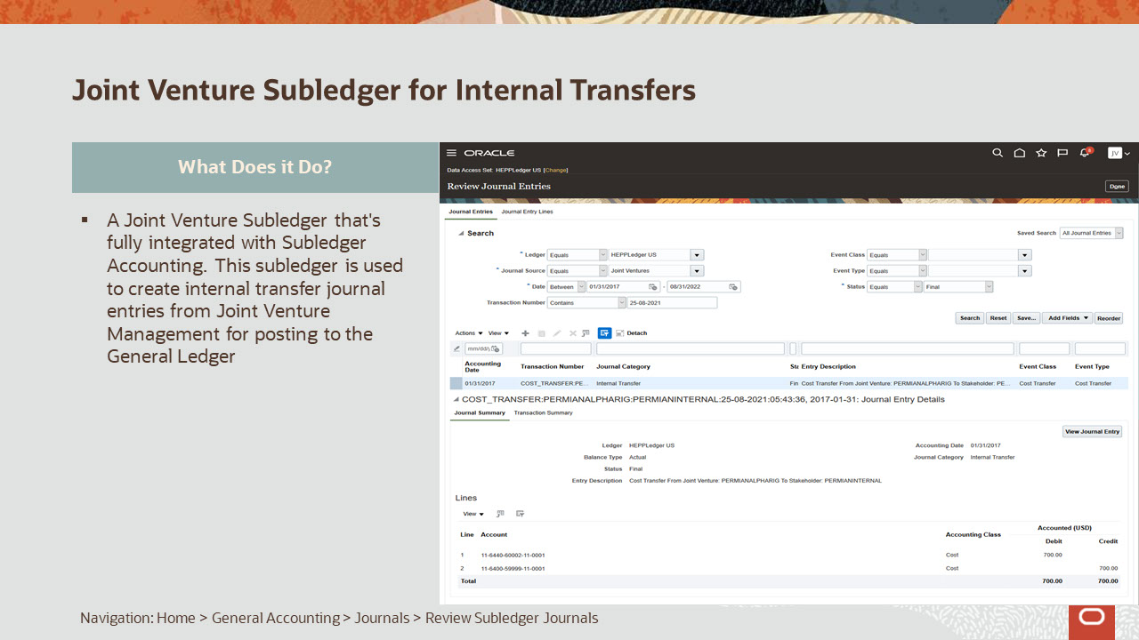
Slide notes
This has been achieved with a new Joint Venture Subledger that's fully integrated with Subledger Accounting. This subledger is used to create internal transfer journal entries from Joint Venture Management for posting to the General Ledger.

Notes

Slide 8 - Joint Venture Subledger for Internal Transfers
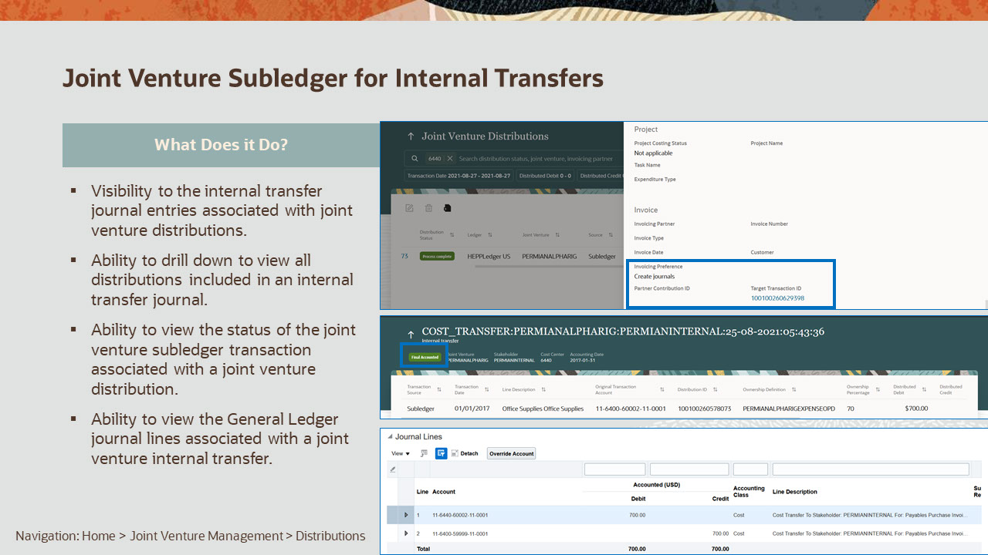
Slide notes
Interactive applications have been provided to view the internal transfer journal entries associated with joint venture distributions, drill down to the joint venture internal transfer journal page to review the transactions, view the status of the joint venture subledger transaction that’s associated with a joint venture distribution, and view the General Ledger journal lines that are associated with a joint venture internal transfer.

Notes

Slide 9 - Joint Venture Subledger for Internal Transfers

Slide notes
The business value of this feature are:
Reduce the time and effort to process joint venture cost distributions for both internal and external stakeholders with additional automated processes.
Increased visibility of the status of the Subledger Accounting entries generated by the process ensures accurate and timely period close processing.

Notes

Slide 104 - Implementation Advice

Slide notes
In this section, we provide implementation considerations and setup instructions for the enhancements covered.

Notes

Slide 105 - Joint Venture Subledger for Internal Transfers Impact
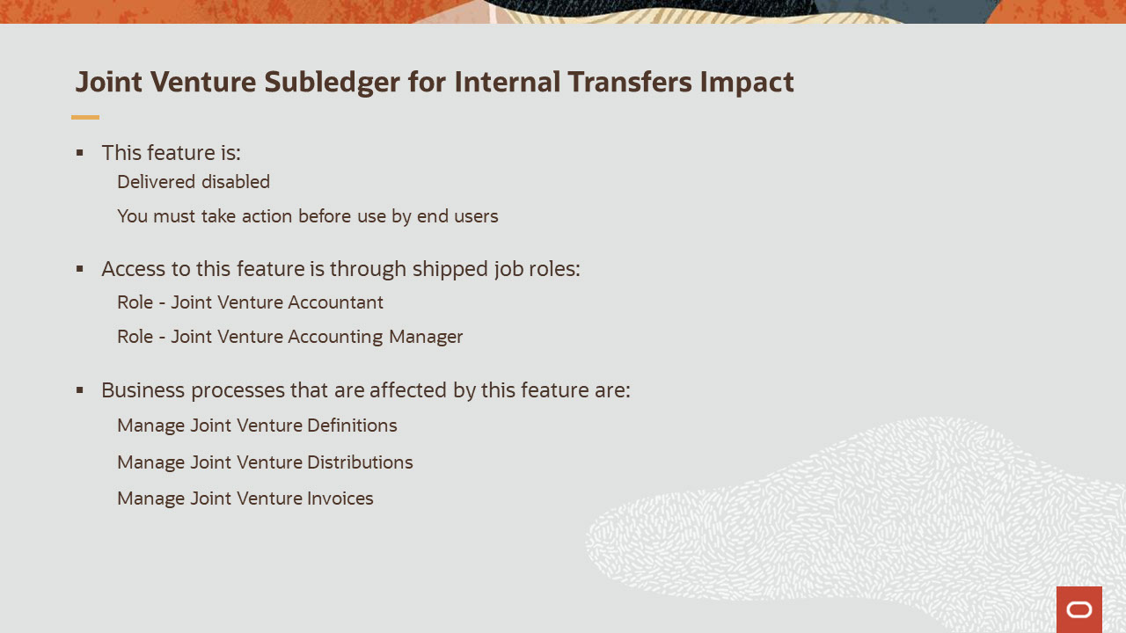
Slide notes
Joint Venture Subledger for Internal Transfers feature is delivered disabled.
Before you can automatically create internal transfer journals for an internal stakeholder, you must enable the "Create journals" option for the internal stakeholder in the joint venture definition.
Your current business processes might be impacted, as you no longer need to create these journal entries manually.
This new functionality can be accessed using the Joint Venture Accountant and Joint Venture Accounting Manager roles.
The business processes associated with this feature are Manage Joint Venture Definitions, Manage Joint Venture Distributions, and Manage Joint Venture Invoices.

Notes

Slide 106 - Summary of Actions Needed to Use Joint Venture Subledger for Internal Transfers
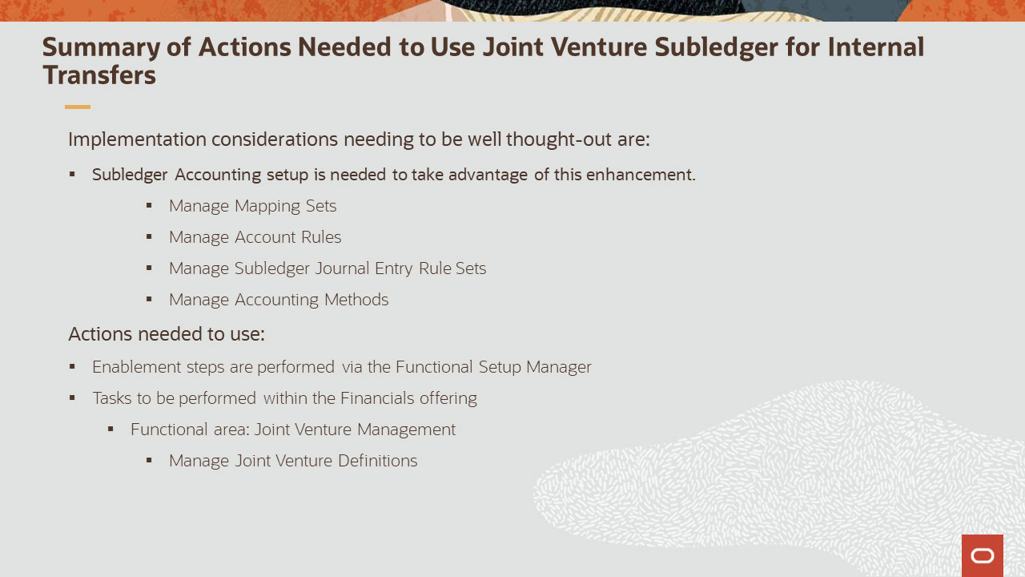
Slide notes
Before enabling this functionality, there are implementation considerations that need to be taken into account, which are:
Subledger Accounting setup for Mapping Sets, Account Rules, Subledger Journal Entry Rule Sets, and Accounting Method needs to be completed to create joint venture subledger journal entries.
Invoicing preference must be set up to create journals for the internal stakeholder in Manage Joint Venture Definitions. This task is in the Joint Venture Management functional area under Financials offering.

Notes

Slide 107 - Enablement Detail for Joint Venture Subledger for Internal Transfers
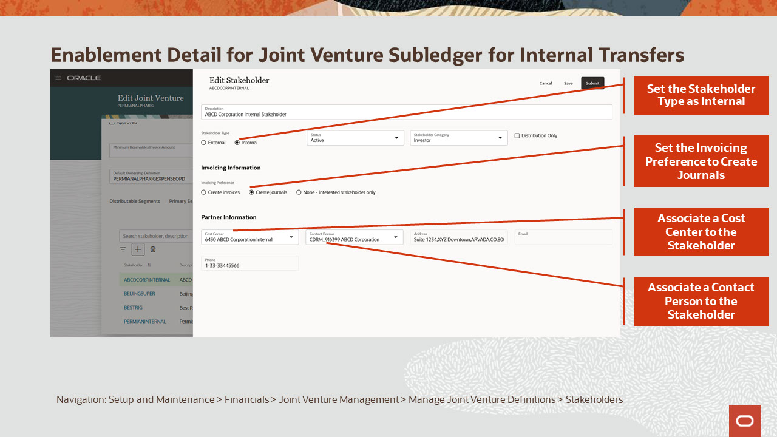
Slide notes
Specify the stakeholder type as Internal and set the invoicing preference to Create journals. Associate a cost center to the stakeholder and add a contact person.

Notes

Slide 134 - Associated Training
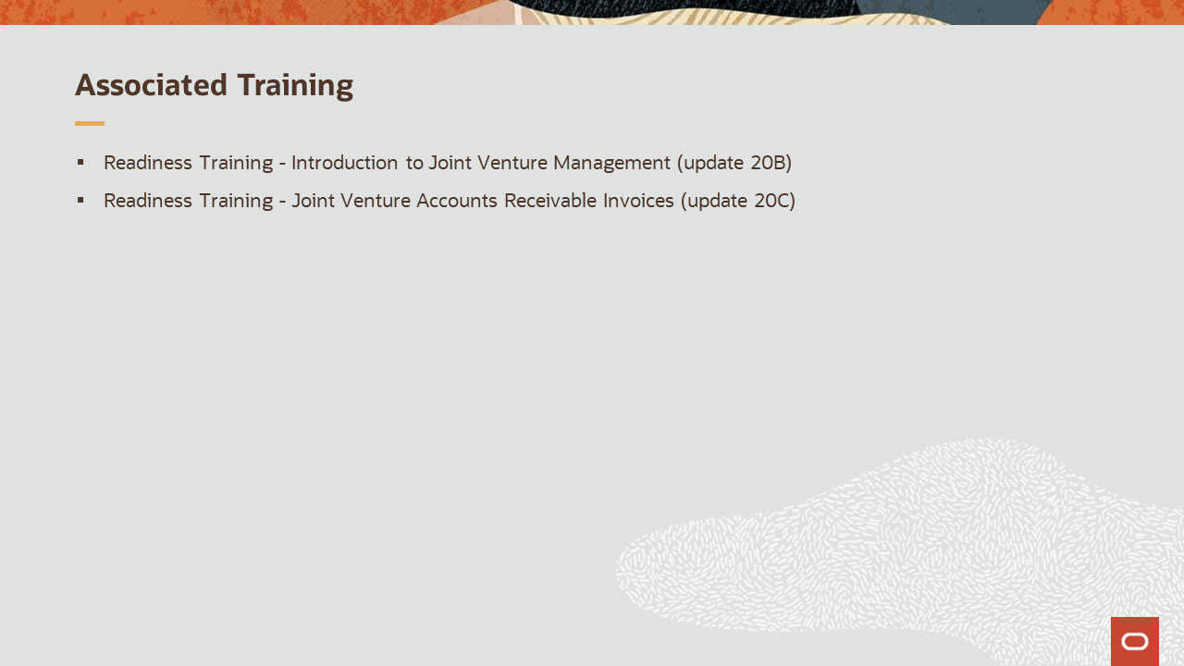
Slide notes
Other training modules that are related to these new capabilities and are recommended viewing are
Introduction to Joint Venture Management and
Joint Venture Accounts Receivables Invoices

This concludes this presentation, thank you for listening. You can easily pause and rewind any of these slides if you require additional time to take in the detail.

Notes

