Slide 3 - Oracle Cloud Human Capital Management

Slide notes

Hello, my name is Gail. Welcome to training for Cloud Compensation Enhancements in Oracle Cloud Human Capital Management. In this session we will talk about Market Data.

Notes

Slide 4 - Agenda

Slide notes

For the capabilities covered in this training, we’ll give an overview, followed by more detail to explain how you can use them, and what business value they bring.
Then we’ll walk you through a demonstration.
Next we’ll explain what you need to consider before enabling these features in your business, and what you need to know to set them up.

Notes

Slide 5 - Capabilities Overview

Slide notes

The capabilities covered in this training will provide you with the ability to map survey jobs and locations, with internal jobs and locations. Following that, you can import surveys and use the Market Data subject area in O.T.B.I.
Once you have created composites of your survey data, then you can import these composites. Finally you can display composites in the worksheet in Workforce Compensation.

Notes

Slide 6 - Compensation Surveys
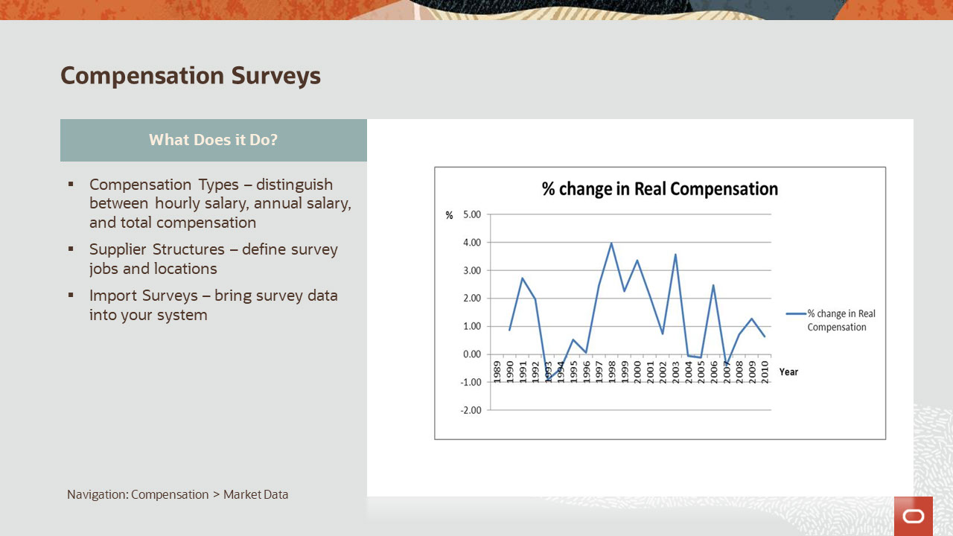
Slide notes

First let’s go over some basics about market data in the Compensation Work Area.
The first available task is called Compensation Types. We deliver a number of typically used types, such as Base Salary and Bonus. Here you can also identify the market target for each type, such as the fiftieth percentile for Base Salary.
The Supplier Structures task is where you can match your jobs and locations to survey jobs and locations.
Also there is a task to Import Surveys. We’ll cover these and the remaining tasks later.

Notes

Slide 7 - Compensation Surveys
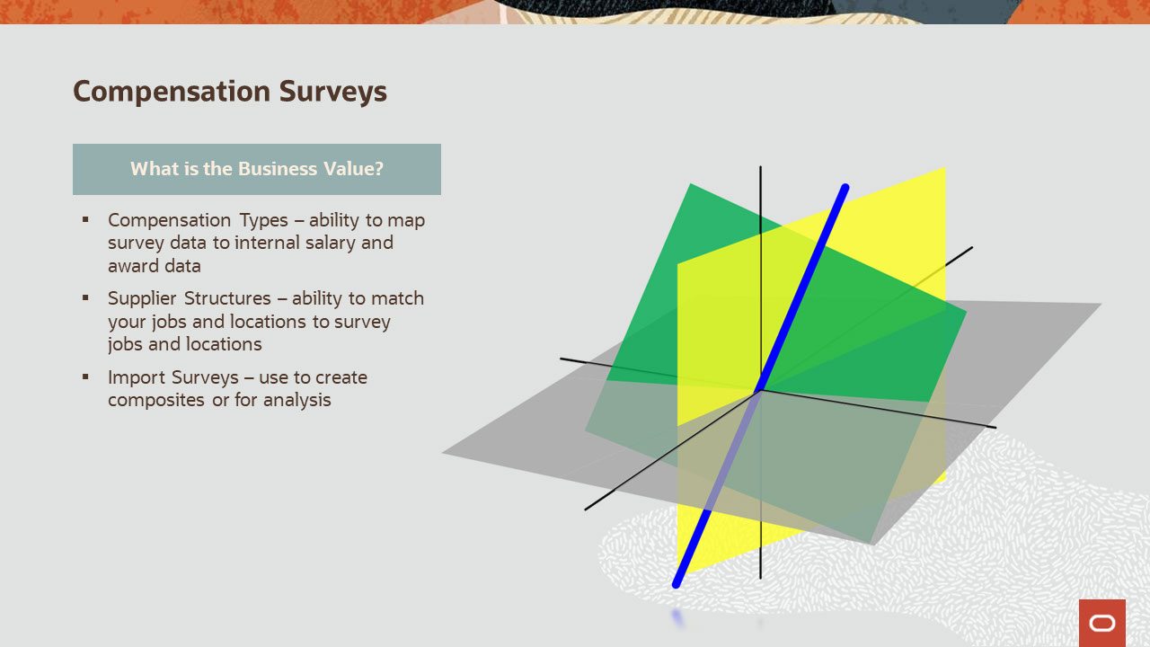
Slide notes

Having compensation types allows you to identify different kinds of pay, such as base salary and bonus, and to import survey data for each type.
Using the market targets by compensation type, will enable you to follow your compensation philosophy, aligned with your company mission and goals.
Matching survey jobs and locations to internal equivalents, will enable comparison and corrective action.
The ability to have survey data within your application, facilitates analysis of this data, and also allows the aggregation of survey data into composites.

Notes

Slide 111 - Additional Information for Compensation Surveys
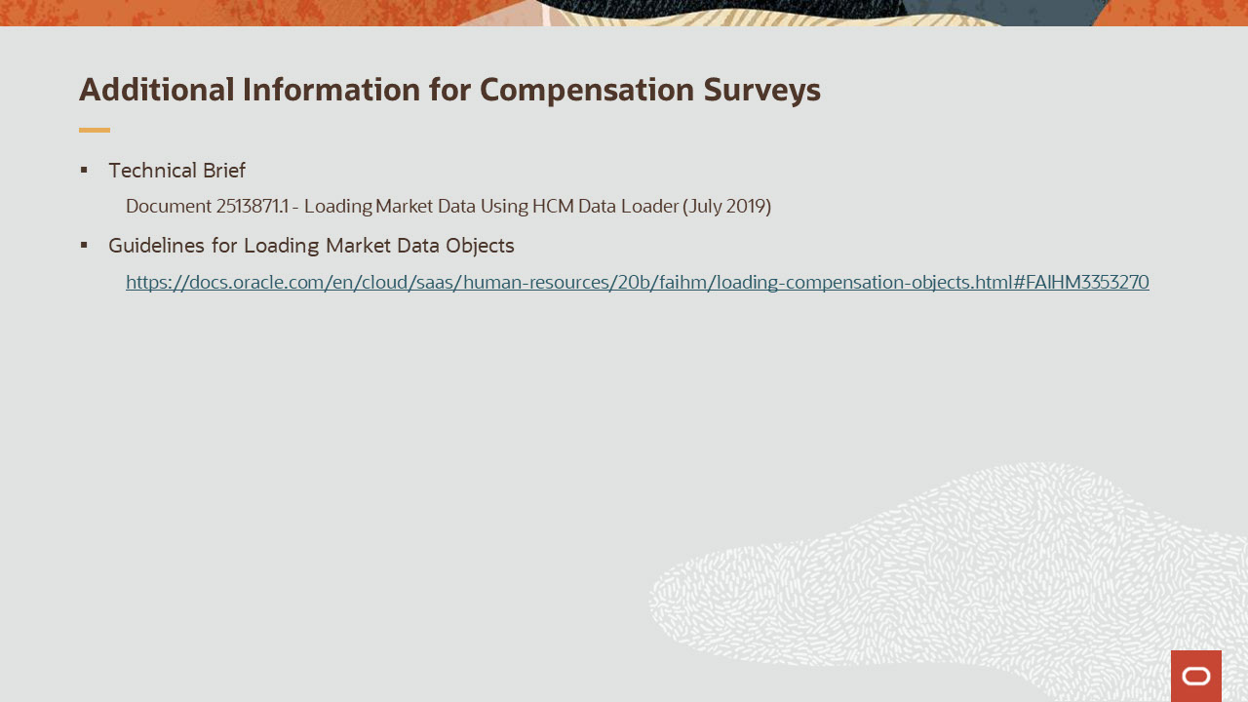
Slide notes

The technical brief explains loading data with details and sample rows, using H.S.D.L.
The guideline documentation provides more information on using H.D.L.

Guidelines for Loading Market Data Objects.
https://docs.oracle.com/en/cloud/saas/human-resources/20b/faihm/loading-compensation-objects.html#FAIHM3353270

Notes

Slide 112 - Compensation Composites

Slide notes

What are segments? They are groups of locations. Segments are not required. Review your survey and internal locations and choose segments or locations based on geographic labor market pay differences.
What are composites? Composites are aggregated survey data. If you participate in five surveys then you will want to summarize that data into a finished product.

Notes

Slide 113 - Compensation Composites

Slide notes

Market Segments:
Using segments can be very helpful. You can decide for example, that some of your market data should use internal location for market comparisons, while other portions of your organization, will need segmentation. You may want to consolidate internal locations into market segments, if your composites in some locations are all the same. Let’s say you have three offices in the San Francisco Bay Area, and the market data for those is the same. Rather than loading the same data three times into three locations, you can create a market segment including your three locations and simply load the composites once. You can decide that administrative jobs data, differs enough locally in the bay area, where you will use internal locations for those jobs, while manager jobs, don’t have such local differentiations. Load the administrative jobs using internal locations, and load the managerial jobs using segments.

Import Composites:
When you aggregate your raw survey data, for example, if you have an Accountant job in New York City, you will combine all the data points from possibly five surveys into single consolidated data points. There are many ways to do this. You can take the survey data from the fiftieth percentiles of five surveys and average them. Note that there isn’t a way to determine if certain employers exist in one or all of the surveys, hence no way to prevent potential duplication of data. Composites are often more an art than a science, and statistician purists may lament this. You can use the O.T.B.I Market Data subject area to help you create composites from the survey data. Report samples are included in the links sections. The completed composites are deemed worthy of exposing to line managers, whereas the raw survey data is typically not.
Slide 122 - Additional Information for Market Data Composites
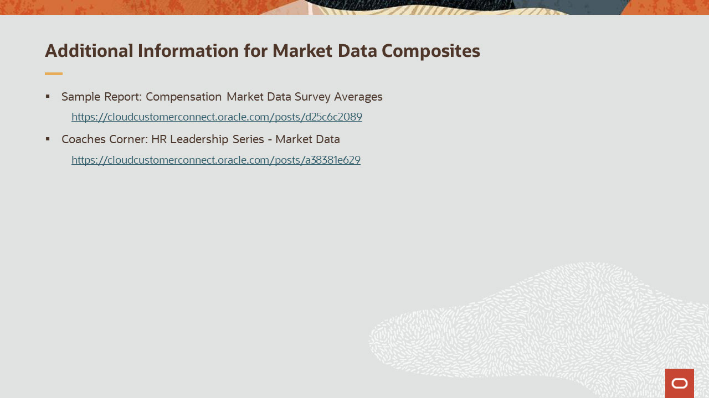
Slide notes

The sample report located here will help you to create composites from raw survey data. Also see the “Report and Analyze” section in this presentation.
In the coachers corner, you will learn more about market composites.
Sample Report: Compensation Market Data Survey Averages
https://cloudcustomerconnect.oracle.com/posts/d25c6c2089
Coaches Corner: HR Leadership Series - Market Data
https://cloudcustomerconnect.oracle.com/posts/a38381e629
Notes

Slide 123 - Display in Workforce Compensation
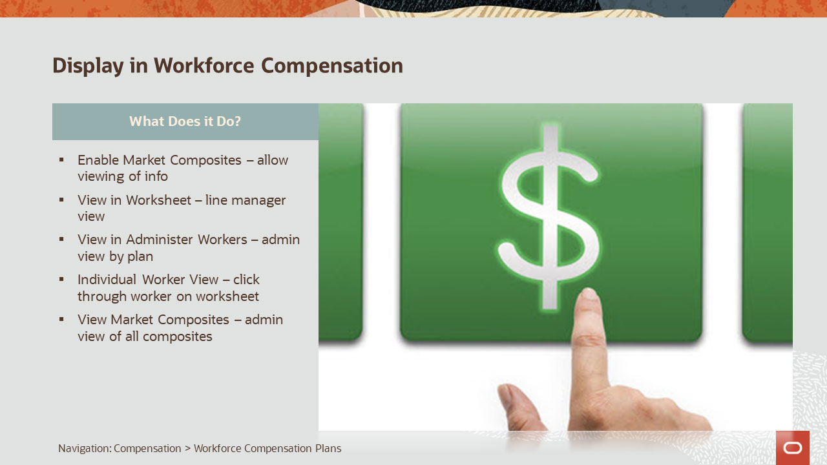
Slide notes

This capability will provide you with the ability to display market composites in the worksheet, for use by line management or compensation managers when awarding allocations within a Workforce Compensation plan.

In addition the composites will appear in “Administer Workers”, the “Individual Worker View” if you have enabled it, and also in the Market Data task, called “View Market Composites”.

Notes

Slide 124 - Display in Workforce Compensation

Slide notes

By displaying composites in the worksheet, you enable line managers and compensation managers, the ability to compare the employee to the market during the allocation process. They can determine if any action should be taken to better align the employee with the market.
For example, if you enabled a market target of the fiftieth percentile for base salary, and the amount for that compensation type is “85,000” (for the job in that location), but the employee is only paid “80,000” - then this helps the manager to determine an increase amount for that employee.
Managers can also see composites in the “Individual Worker View”.
Administrators can view the composites by plan, in “Administer Workers” and by employee, in “View Market Composites”.
Notes

Slide 159 - Additional Information for Display in Workforce Compensation
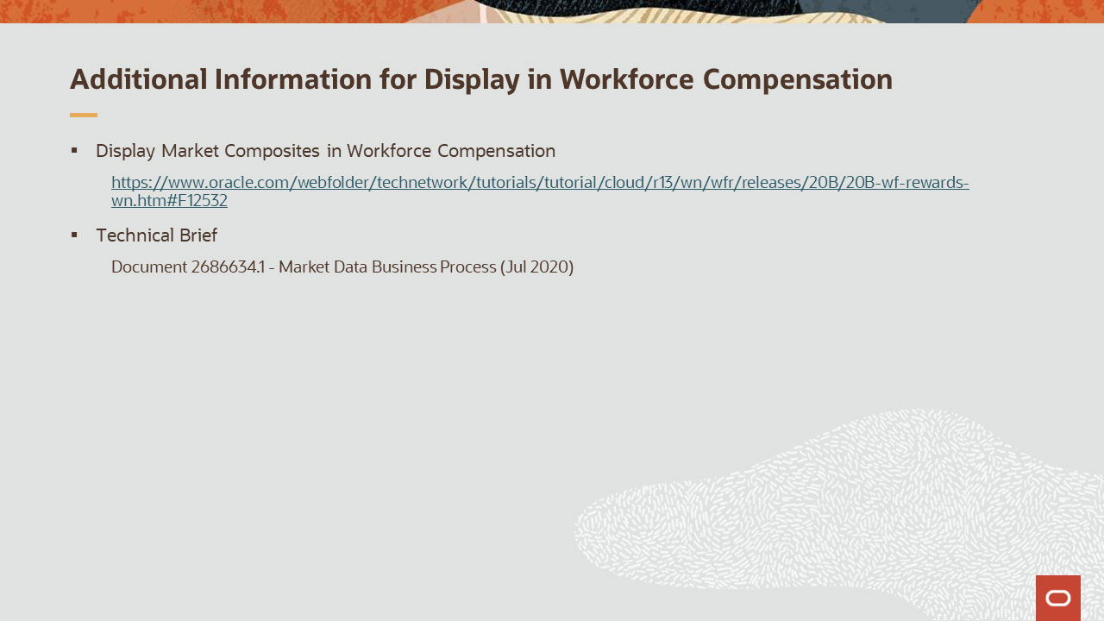
Slide notes

The documentation references the release readiness content for this new feature.
The technical brief explains the business process from start to finish for displaying composites:
Display Market Composites in Workforce Compensation.
https://www.oracle.com/webfolder/technetwork/tutorials/tutorial/cloud/r13/wn/wfr/releases/20B/20B-wf-rewards-wn.htm#F12532

Notes

Slide 160 - Report and Analyze
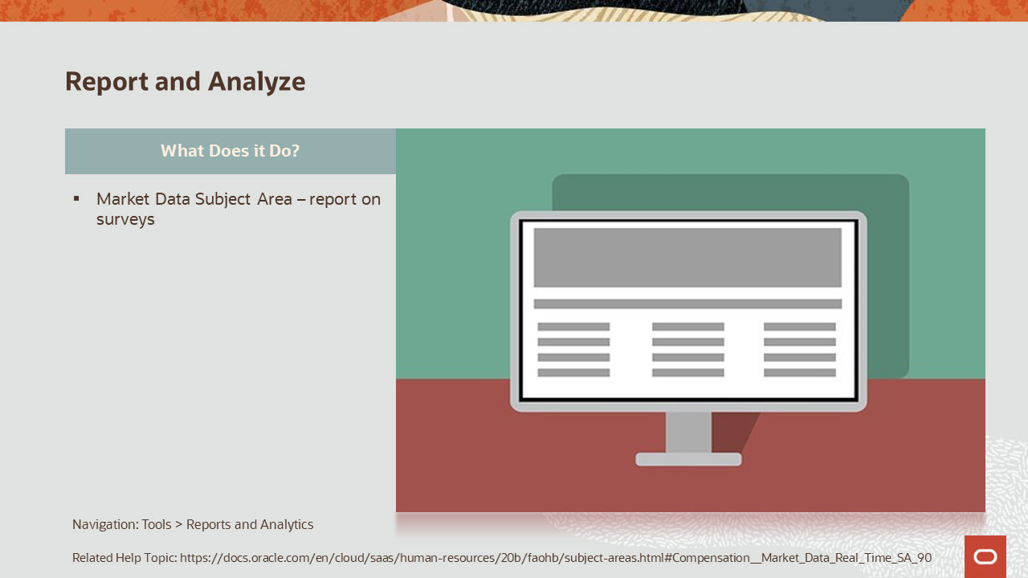
Slide notes

This capability will provide you with the ability to report on raw survey data. You can use this data to analyze the labor market for jobs in locations. This can be useful for determining rates, ranges, and differentials.
Related Help Topic
https://docs.oracle.com/en/cloud/saas/human-resources/20b/faohb/subject-areas.html#Compensation__Market_Data_Real_Time_SA_90

Notes

Slide 161 - Report and Analyze

Slide notes

Benefits of reporting on this data include the ability to aggregate survey data into composites.
You can also use this data to compare market data with people, by cross joining it with other subject areas, such as Salary, Stock, and Individual Compensation.
Sample reports have been created for this purpose, and are listed in the “Additional Information” for “Report and Analyze” presentation slide.

Notes

Slide 220 - Additional Information for Report and Analyze
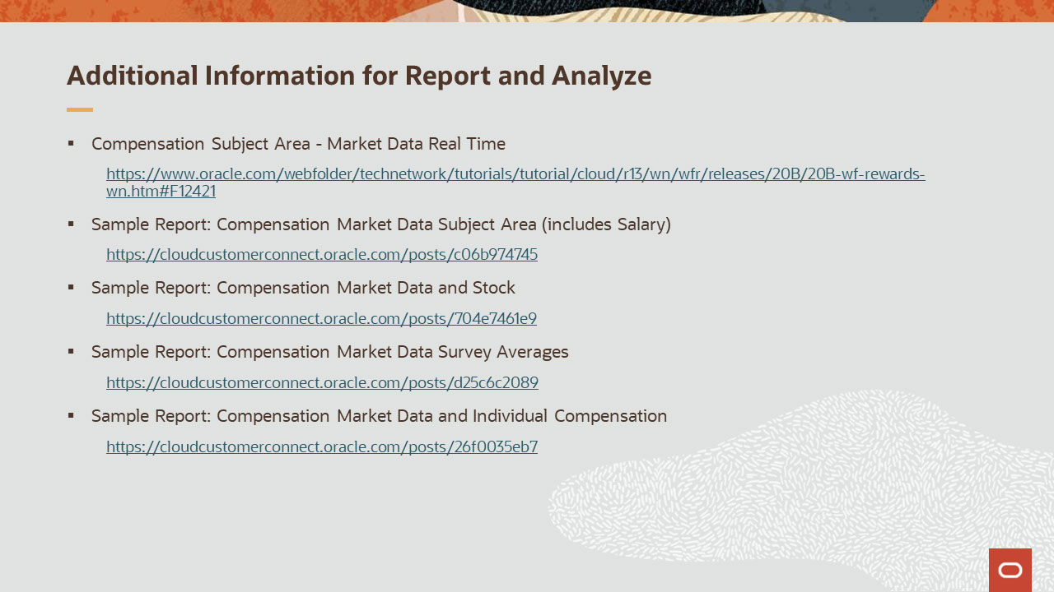
Slide notes

The documentation in the first link provides information about the subject area.
https://www.oracle.com/webfolder/technetwork/tutorials/tutorial/cloud/r13/wn/wfr/releases/20B/20B-wf-rewards-wn.htm#F12421
The sample report for Compensation Market Data Subject Area, includes a report on the subject area alone, and a cross join analysis with Salary.
https://cloudcustomerconnect.oracle.com/posts/c06b974745
The sample report for Compensation Market Data and Stock includes a cross join analysis with Stock.
https://cloudcustomerconnect.oracle.com/posts/704e7461e9
The sample report for Compensation Market Data Survey Averages, will help you to create composites from raw survey data.
https://cloudcustomerconnect.oracle.com/posts/d25c6c2089
The sample report for Compensation Market Data and I.C. includes a cross join analysis with Individual Compensation.
https://cloudcustomerconnect.oracle.com/posts/26f0035eb7
Notes

Slide 221 - Implementation Advice

Slide notes

In this section we provide implementation considerations and set up instructions for the features covered.

Notes

Slide 222 - There are 2 Approaches for Implementation
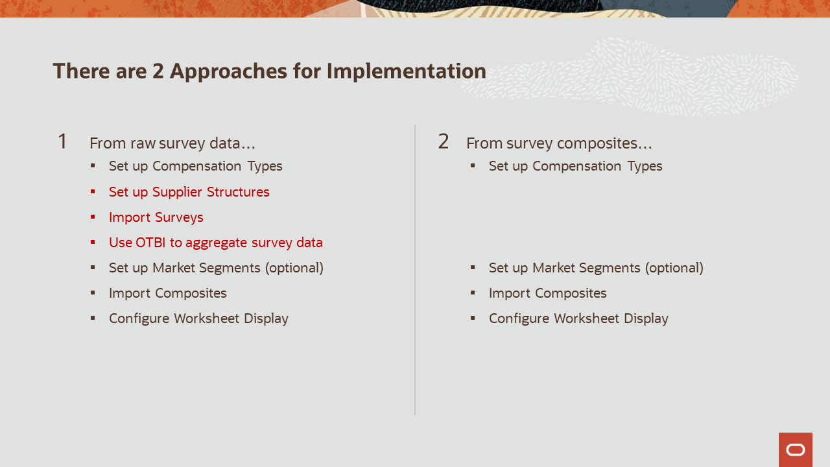
Slide notes

There are two paths you can take to start and complete this business process.
In the first approach, we assume that you are loading raw survey data from various suppliers. All the demos here focus on this method.
In the second approach, if you already have composites, then that will potentially eliminate steps in the process, indicated in red.
Why would you entertain the second approach? Maybe you have already combined your raw survey data into composites this year. This is typically done in spreadsheets.
(If that is the case then perhaps next year you may find it easier to load the raw survey data and use O.T.B.I to help you average data, as previously demonstrated.)
If you receive composites of surveys already aggregated, then while the steps are simpler, your raw survey data will not be available within O.T.B.I for reporting and analysis.
Notes

Slide 223 - Market Data Impact
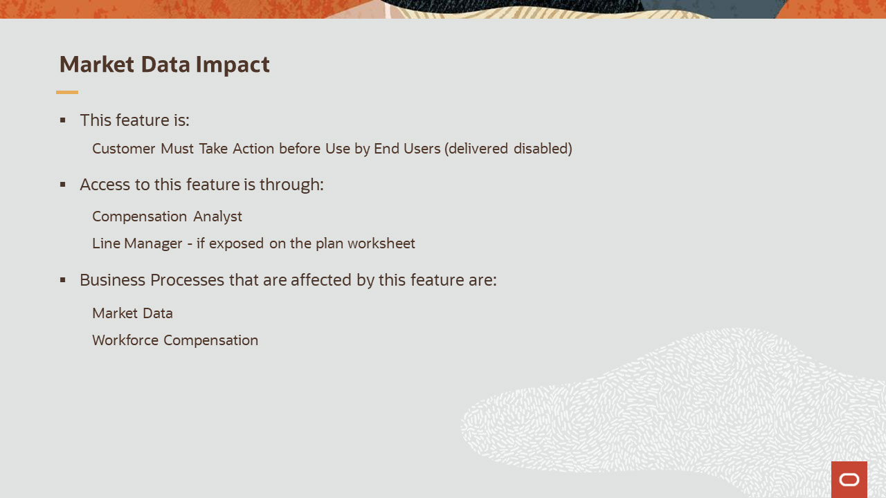
Slide notes

Market Data:
-has actions to be taken before it is available to your end users.
-see the previous slide for your list of actions that need to be taken.
Market Data can be accessed using Compensation Analyst.
The business processes associated with this feature are Market Data and Workforce Compensation.
This concludes this presentation, thank you for listening. You can easily pause and rewind any of these slides if you require additional time to take in the detail.
Notes

