Slide 3 - Oracle Supply Chain Management Cloud
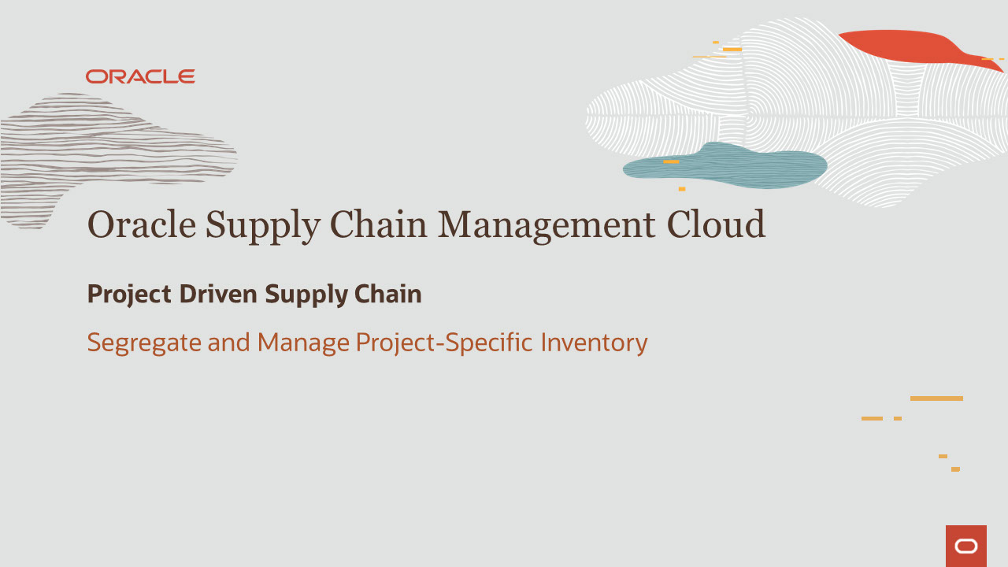
Slide notes
Hello, my name is Rohit. Welcome to training for Inventory Management in Oracle Supply Chain Management Cloud.
In this session, we talk about the feature Segregate and Manage Project-Specific Inventory in Inventory Management.

Notes

Slide 4 - Agenda

Slide notes
For the capabilities covered in this training, we’ll give an overview, followed by more detail to explain how you can use them, and what business value they bring. Then, we’ll walk you through a demonstration. Next, we’ll explain what you need to consider before enabling these features in your business, and what you need to know to set them up.

Notes

Slide 5 - Segregate and Manage Project-Specific Inventory - Overview
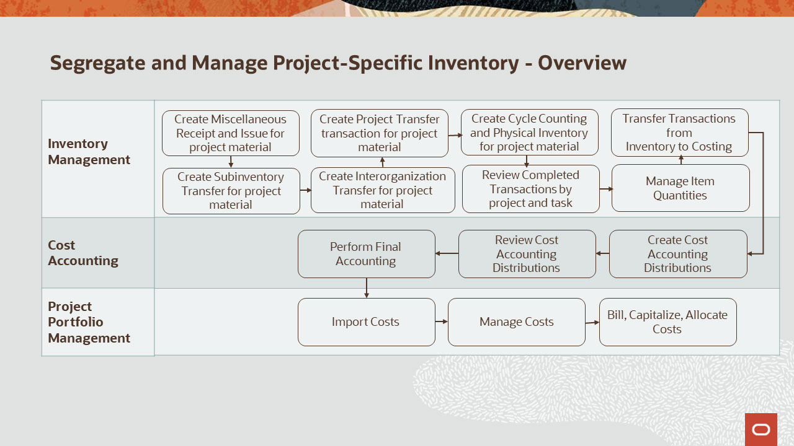
Slide notes
Project-Driven Supply Chain is an end-to-end, integrated solution across supply chain and project management cloud applications. This solution supports business processes of both manufacturing and asset-intensive companies. It provides the ability to execute project-specific inventory management by inventory transactions, counting and re-classification of project-specific inventory.
The diagram you see here represents a high level process flow to segregate and manage project-specific inventory. You can perform inventory transactions like Miscellaneous Transactions, Subinventory transfers, Interorganization transfers, counting like cycle counting and physical inventory and reclassification of project inventory by using Create Project Transfer in Inventory Management. You can then view the completed transactions on the Review Completed Transactions page. You can also view the changes in project inventory using Manage Item Quantities page. Inventory transactions are enriched with project costing details in inventory management and are transferred to costing through the “Transfer Transactions from Inventory to Costing” program. Cost accounting distributions are created in costing and the project details are reviewed for the accounting distributions.
Costed and Accounted transactions from supply chain can be imported as project expenditures into Project Management. If the cost incurred against the project is a billable cost, you can bill your customer based on the percentage of completion or milestones achieved on the project. If it is a capitalizable cost you can proceed to execute the capitalization flow. You may choose to also allocate costs to other projects, project tasks or accounts as appropriate.
Now, let’s get into the details of the enhancements.

Slide 6 - Enhancements Overview
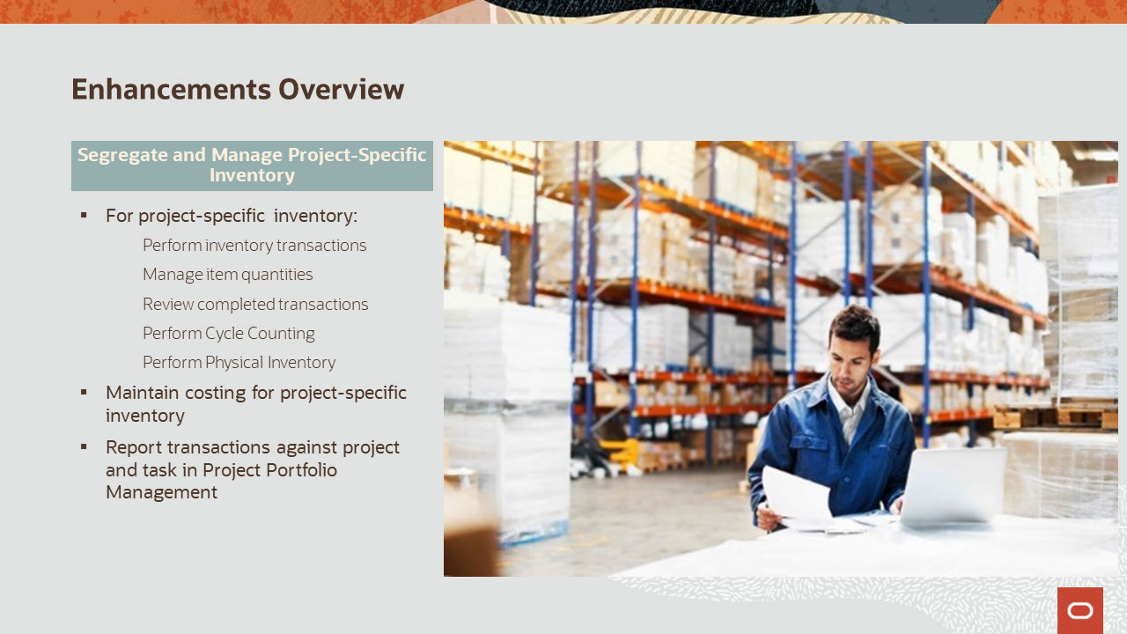
Slide notes
The capabilities covered in this training will provide you with the ability to:
- Segregate inventory at a location by project and task in your warehouse
- Maintain valuation of inventory by project and task
- Provide visibility into on-hand supplies by project and task
- Maintain the integrity of material ownership within a project across warehouse operations, and
- Perform inventory transactions such as cycle counting, physical inventory, issue, receipt and reclassify material by project and task

Notes

Slide 7 - Segregate and Manage Project-Specific Inventory
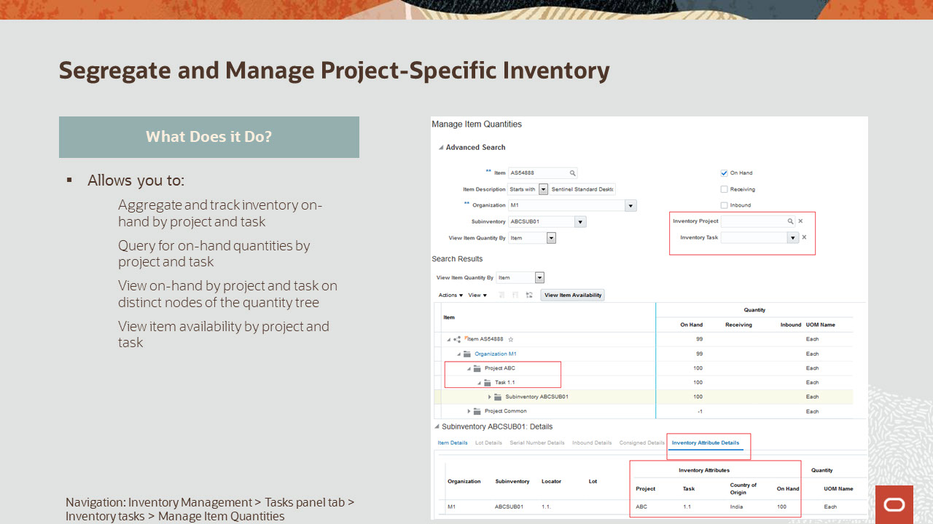
Slide notes
This capability will provide you with the ability to track on-hand inventory by project and task for inventory organizations enabled for tracking inventory by projects. You can query for on-hand quantities by project and task and view them as distinct project and task nodes on the quantity tree,
Item availability can also be checked for project and task.

Notes

Slide 8 - Segregate and Manage Project-Specific Inventory
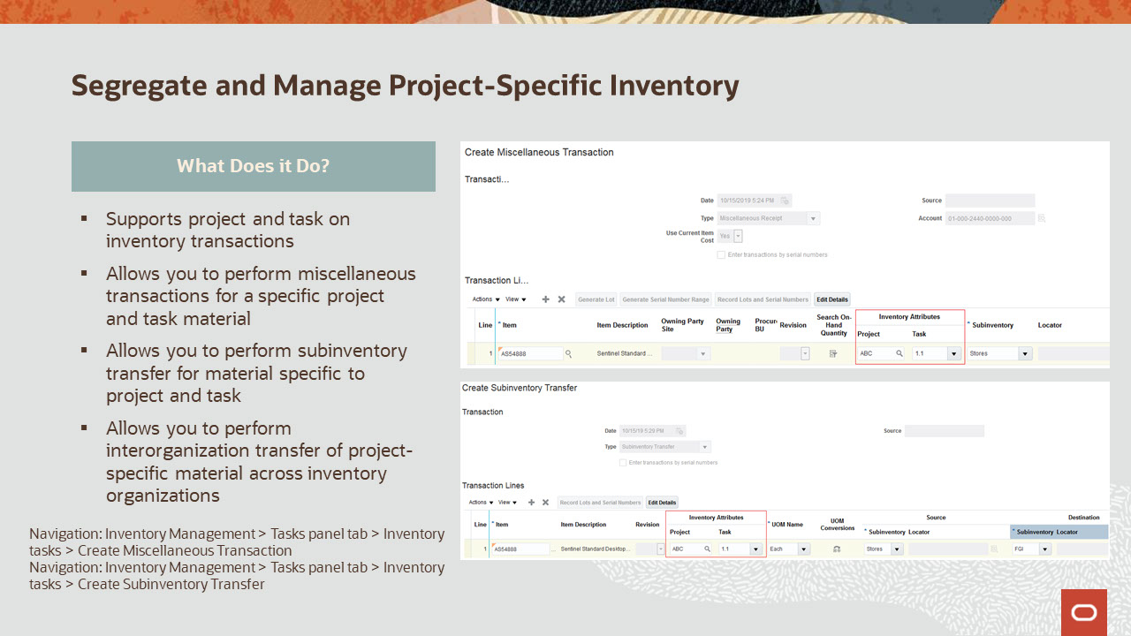
Slide notes
You will have the ability to perform Inventory transactions like miscellaneous transactions, both issues and receipts, subinventory transfer and interorganization transfer, both direct organization transfer and intransit shipment and receipt for the project-specific material, if the organization is enabled for tracking inventory for projects.

Notes

Slide 9 - Segregate and Manage Project-Specific Inventory
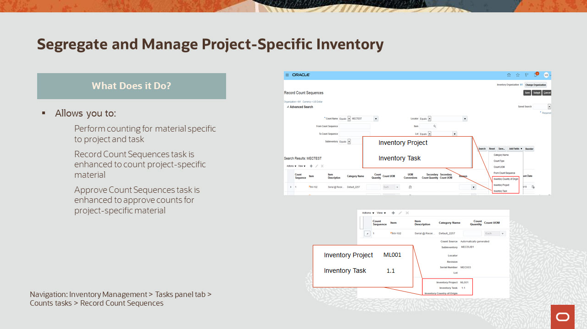
Slide notes
You will have the ability to count by using both the cycle counting and physical inventory processes for project and task specific inventory.
For cycle counting, you can record count sequences and approve count sequences for project and task specific material.

Notes

Slide 10 - Segregate and Manage Project-Specific Inventory
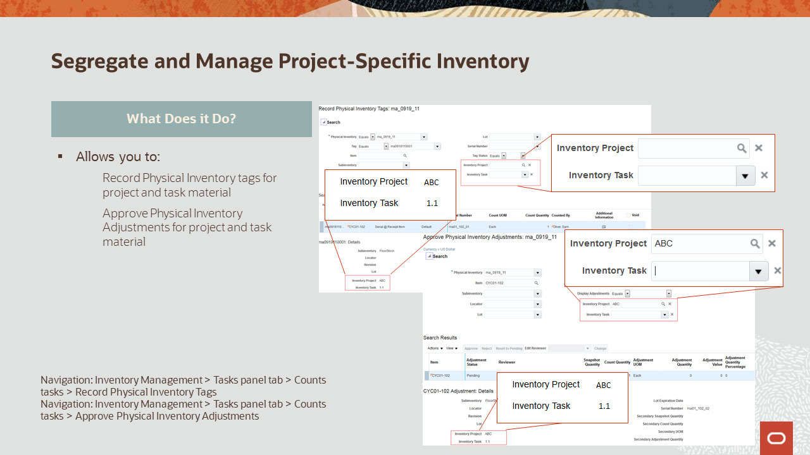
Slide notes
During physical inventory you can record physical inventory tags for project and task specific inventory.
Once recorded you can approve physical inventory adjustments for project and task specific material.

Notes

Slide 11 - Segregate and Manage Project-Specific Inventory
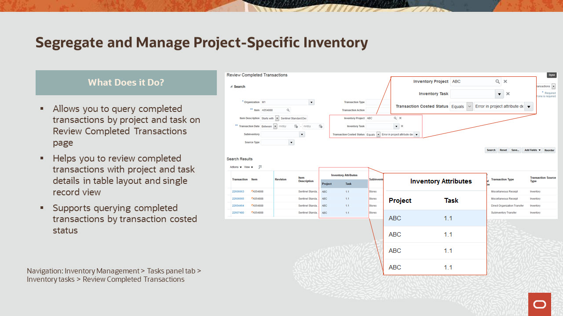
Slide notes
Segregate and Manage Project-Specific Inventory provides you with the ability to view the project related transactions performed using the review completed transactions.
You can also query for different costed status for the transactions.
The Project and Task columns under the Inventory Attributes group, refer to the project and task associated to the on-hand inventory from where the material is issued or received.
These attributes are also available as search criteria to filter and display the completed transactions.

Notes

Slide 12 - Segregate and Manage Project-Specific Inventory
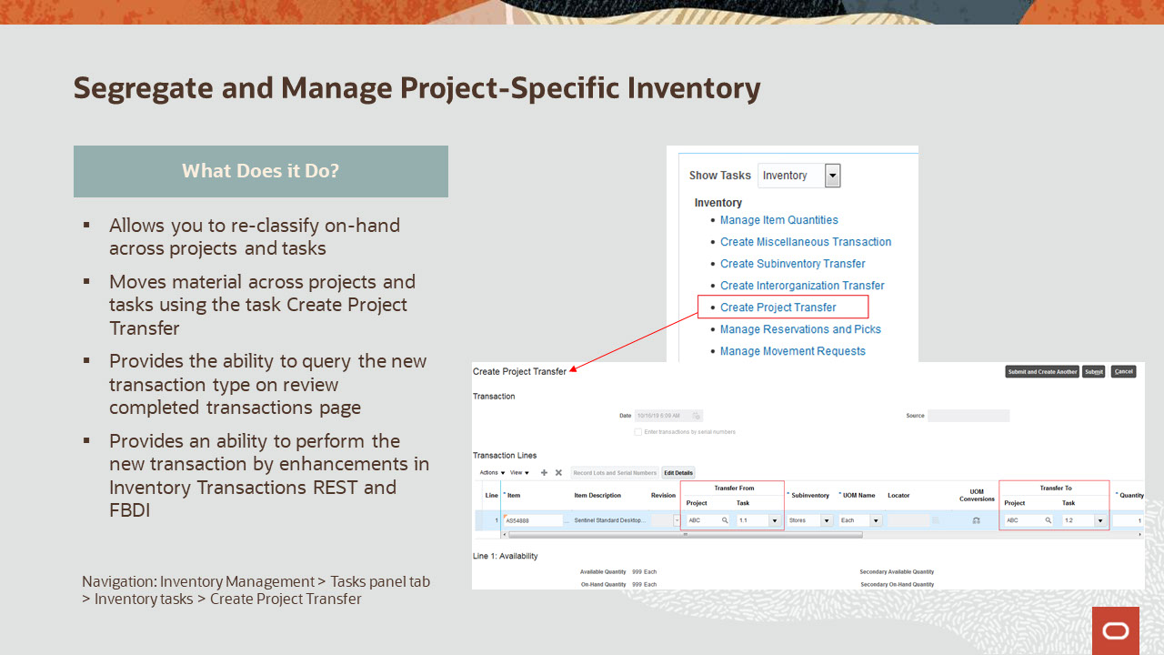
Slide notes
This capability also provides you with the ability to re-classify material to another project and task using transaction type as project transfer and corresponding accounting adjustments happen both for source and destination project and task in project costing.
Create Project Transfer task can be used to transfer material across different project and tasks or across common and specific projects. These transactions can be queried and reviewed in Review Completed Transactions page. Inventory transactions REST and FBDI spreadsheets are enhanced to perform project transfer transactions.

Notes

Slide 13 - Segregate and Manage Project-Specific Inventory – Create Reservations
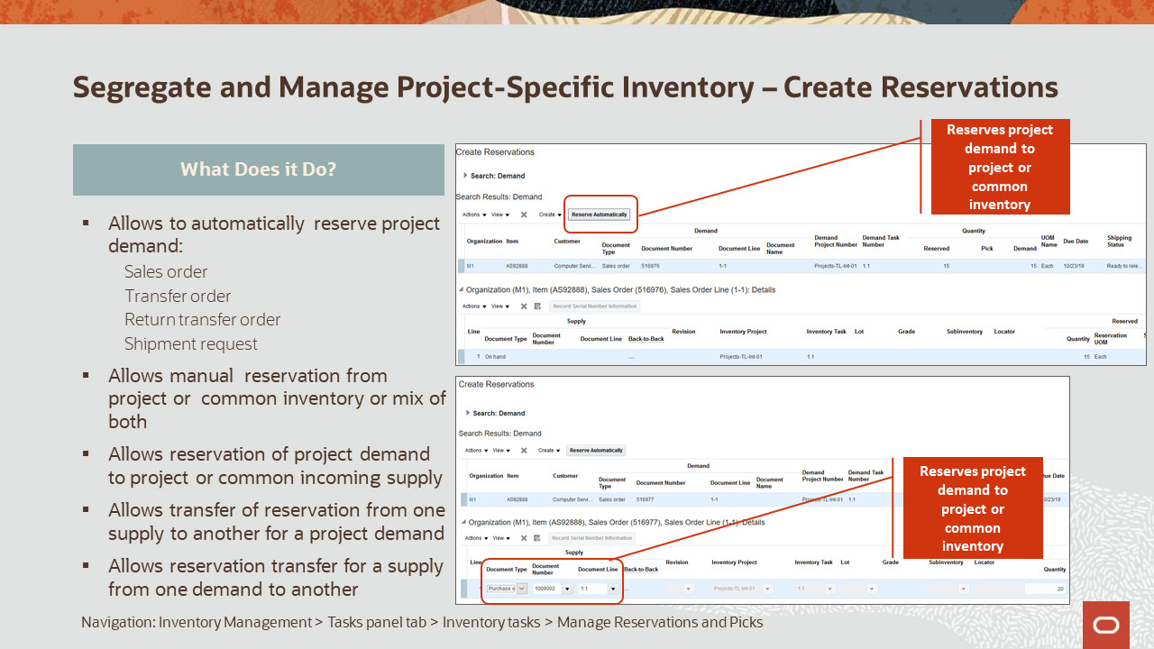
Slide notes
With this capability you can automatically create reservation for project demand. You can use the ‘Reserve Automatically’ button on Create Reservation UI to reserve sales order, transfer order, return transfer order or shipment request to either project or common inventory or a mix of both project and common inventory. The item can be reserved to common inventory only when the item is enabled to use common supplies attribute in inventory management.
You can also manually reserve project demand to either project or common on-hand or to incoming project supply like a work order, transfer order, return transfer order, purchase order or requisition. The project demand can be reserved to the incoming supply without project reference when the item is enabled for use common supplies.
You can create a user-defined, account or account alias reservation to reserve project on-hand when you do not have a demand document to reserve project material. It also lets you reserve a project based purchase order, requisition, transfer order, return transfer order or work order to a user defined demand, account or account alias. This reservation is transferred to the on-hand when the incoming project-based supply is received in inventory and it is relieved when the miscellaneous issue is performed on a project enabled transaction type.
The reservations can be edited using the Edit Reservation and picks button on the Manage Reservations UI.
You can also transfer reservation from one document type to another using the transfer supply. This allows you to transfer reservation for a sales order, initially reserved to a project purchase order to project or common on-hand or to another type of incoming supply like a transfer order, work order, requisition or return transfer order.
Along similar lines, the transfer demand lets you transfer reservation for a supply from one demand document to another.

Additionally, you can also create reservation using FBDI and Reservations REST service. The reservation creations through FBDI lets you reserve the project demand to the project or common on-hand. You can reserve the project demand only to a purchase order with or without project reference. The reservation of project demand to other incoming supply documents like work order, transfer order, requisition or return transfer order is not supported through FBDI. The validations in FBDI and REST prevent you to reserve project inventory to a demand without project reference.
The ADFDi can be used to modify or delete an existing reservation. You can’t create a new reservation using ADFDi.

Notes

Slide 14 - Segregate and Manage Project-Specific Inventory
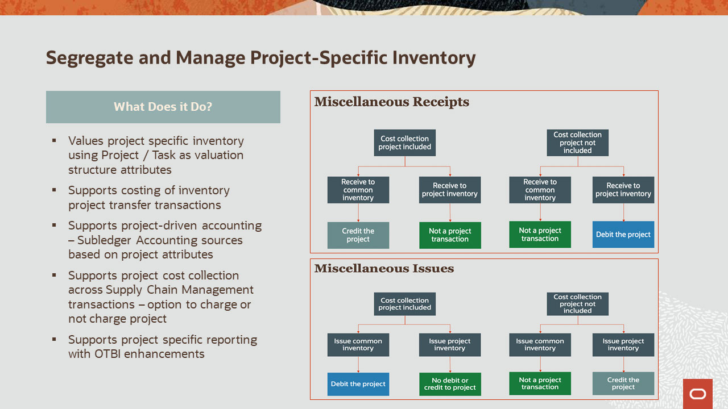
Slide notes
Segregate and Manage Project-Specific Inventory, will provide you with the ability to cost, project specific inventory transactions and transactions of type project transfer.
Use project and task as additional valuation structure attributes to enable maintaining and tracking cost at the granular level.
The option to send or not send an expenditure to a project is managed by setting up an exclusion for project cost collection, by project types using functional setup manager. Accordingly, the miscellaneous receipts or issue transactions costed amounts would be send as a credit or debit charge to the project.
Lastly, you can also manage project specific accounting based on project attributes that are available as accounting sources. The existing subject areas in Oracle Transactional Business Intelligence have been enhanced to include project-specific attributes.

Notes

Slide 15 - Manage Project-Specific Inventory Costs
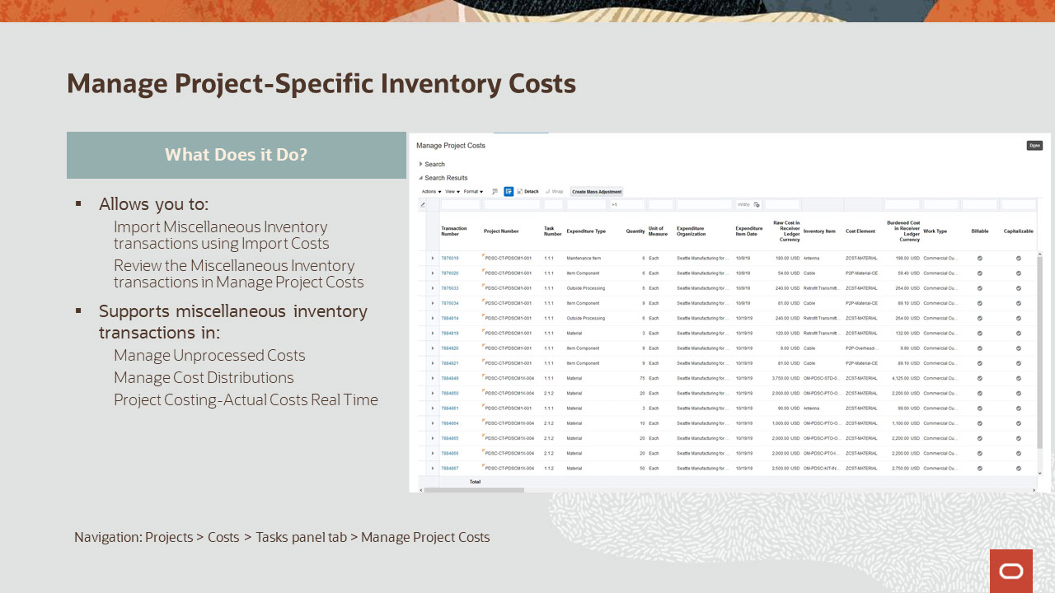
Slide notes
You can import miscellaneous inventory transactions using the Import Costs process. This may include miscellaneous inventory transactions such as miscellaneous receipt or issue of project inventory, Issue to project of project-specific inventory, receipt from project of project-specific inventory, project reclassification using Project Transfer transactions, inter-organization transfer of project-specific inventory.
Depending on the source transaction and the destination type, one or more of the following document entries for Miscellaneous Inventory document will be created in Project Portfolio Management:
- Item Cost, and
- Overhead
Use the Manage Project Costs task in Costs work area in PPM to search and view expenditure item and project costing details associated to the Miscellaneous Inventory transactions.

Notes

Slide 16 - Manage Project-Specific Inventory Costs
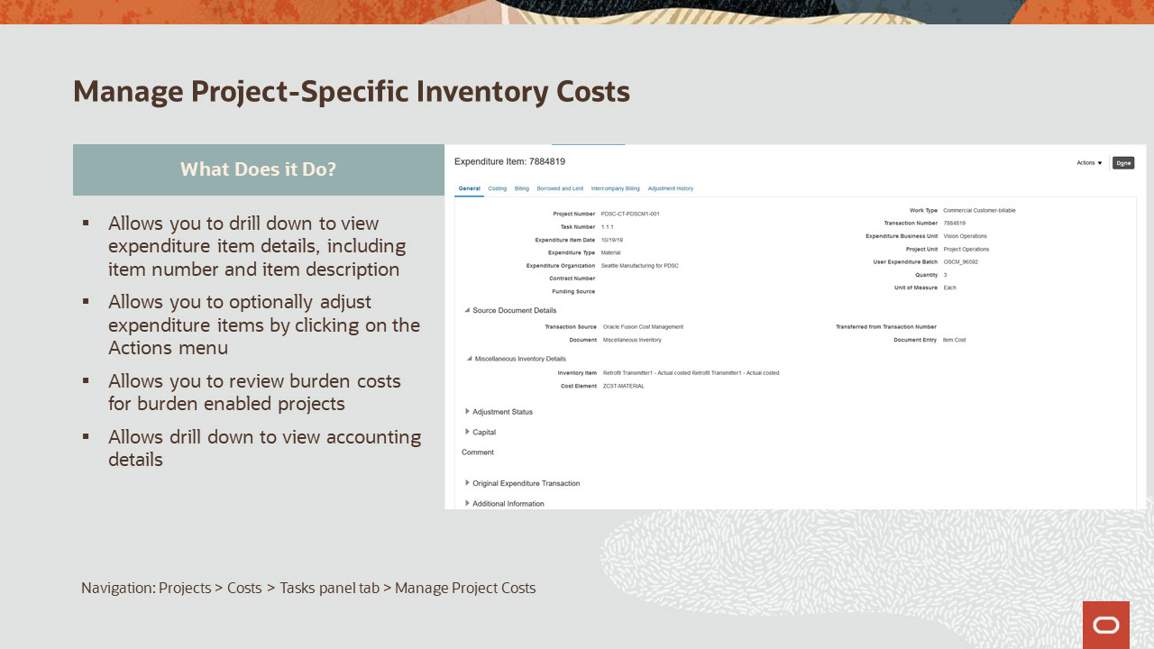
Slide notes
Click on the transaction to open expenditure item details, including item number and description. Besides the specific attributes, supply chain transactions may also include Cost Element that identifies the type of cost in the source system.
You can perform adjustments using the Actions menu. Adjustments performed in PPM will not be reflected in the source transaction. Also, note that you cannot perform reverse type of adjustment for these transactions.
These costs can also be viewed and adjusted in the Manage Cost Distributions task. Any cost exceptions can be resolved using Manage Unprocessed Costs task.
If the project is enabled for same line burden, the transaction will have the burden cost calculated.
If it is a separate line burdened, a new expenditure item will be created for the burden cost.
On the Costing tab, you can view the distributions and drill down to view the journal entries.

Notes

Slide 17 - Analyze and Resolve Project Period Close Exceptions
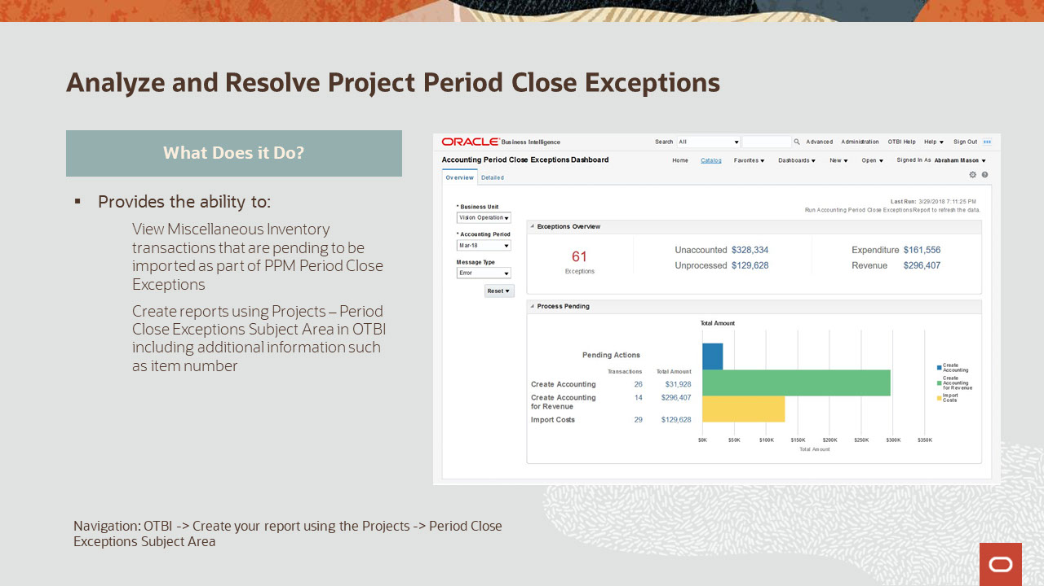
Slide notes
View Miscellaneous Inventory transactions that are pending to be imported as part of PPM Period Close Exception Reports.
Projects – Period Close Exceptions Subject Area has been enhanced to display the transaction details including item number and description when miscellaneous inventory transactions are pending.
Here is a sample dashboard that has been created in OTBI to show pending transactions that impact period close which includes miscellaneous inventory transactions.

Notes

Slide 18 - Segregate and Manage Project-Specific Inventory
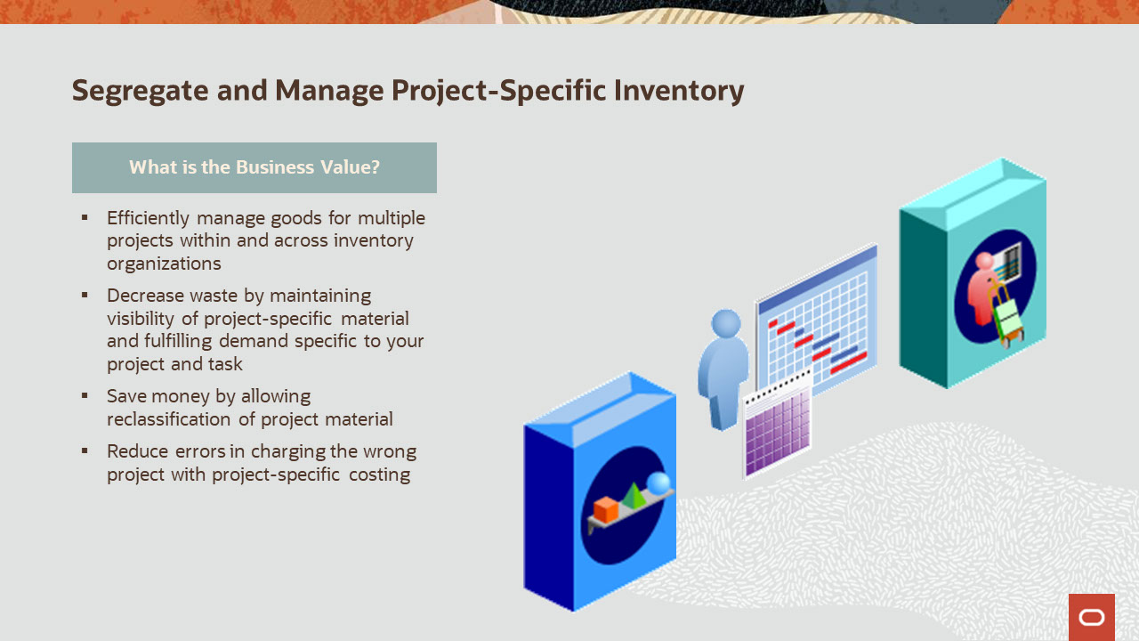
Slide notes
Company A builds and installs solar panels for residential and business customers. Each installation is tracked as a project, and the solar panels are only built once an installation project is booked.
To accurately track project costs and ensure each project stays on time and budget, Company A needs a way to track, manage, and segregate material that is procured and manufactured for each project. Additionally, as each project reaches specific milestones, Company A needs the ability to capture and review project specific costs.
With segregate and manage project-specific inventory, they can now efficiently separate and manage the goods bound for specific projects within and across their inventory organizations. They can also decrease waste and save money by maintaining visibility of project-specific material, fulfilling demand for specific projects, and reclassifying project material when unforeseen events arise. Finally, they can reduce errors caused by charging the wrong project using project-specific costing.

Notes

Slide 19 - Segregate and Manage Project-Specific Inventory - Overview
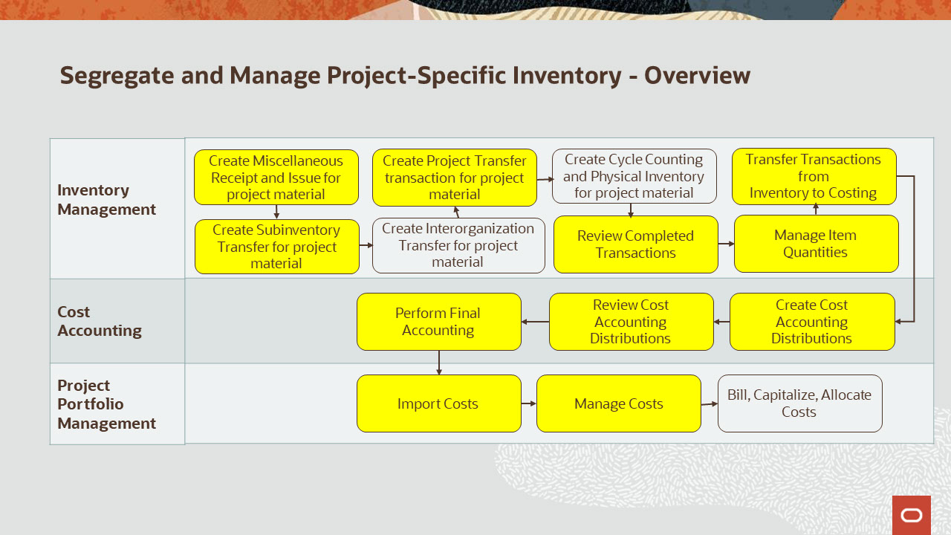
Slide notes
The diagram you see here describes the project-specific inventory related tasks and highlights the ones that would be covered as a part of the demonstration.
As a Warehouse Manager, we will perform inventory transactions and review on-hand quantities and transactions and then also run the Transfer Transactions from Inventory to Costing process.
Next, as a Cost Accountant we will run the processes to create accounting distributions, review the distributions with project details, and perform final accounting. Finally, we will assume the role of a Project Accountant to import the manufacturing costs and further manage the costs in Project Portfolio Management.
With this, let’s get into the demonstration.

Notes

Slide 359 - Summary of Enhancement Capabilities
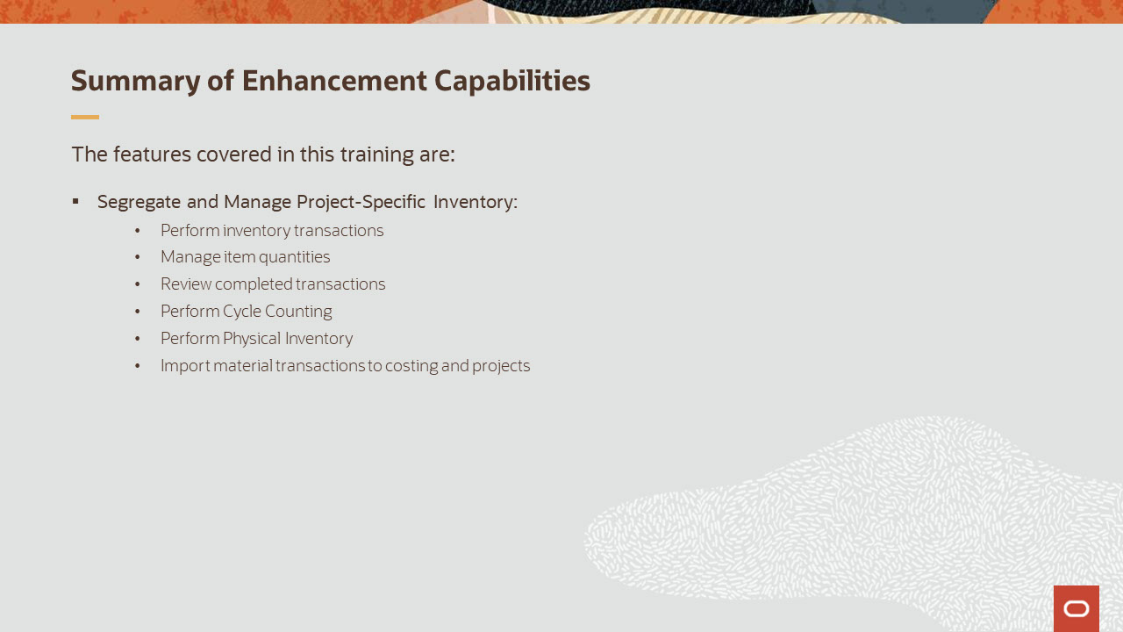
Slide notes
Here is the summary of the features I have talked about today:
With this feature, you can segregate and manage project-specific inventory by performing inventory transactions and counting – both cycle counting and physical inventory, for project specific material.
You can review on-hand quantities and completed transactions by project and task. You can also import the material transactions to costing and projects to review and analyze the project specific data.

Notes

Slide 360 - Additional Information for Segregate and Manage Project-Specific Inventory
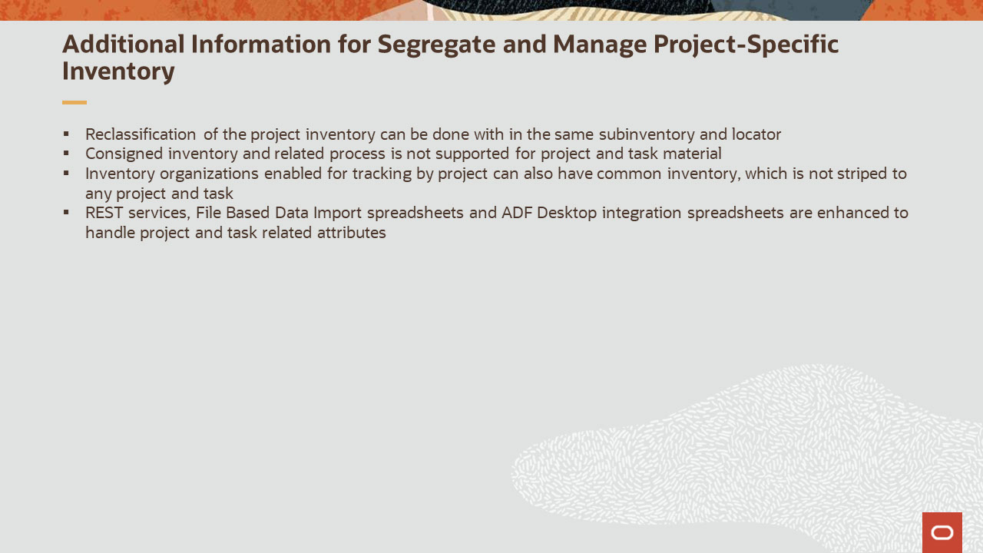
Slide notes
A few things for you to keep note of while using this feature are:
Reclassification of the project inventory can be done with in the same physical or logical location.
Consigned inventory cannot be project tracked. This is a limitation in the current release.
Inventory organizations enabled for tracking by project can have both common and project specific inventory.
To support project-specific inventory feature, REST services, File Based Data Import spreadsheets and ADF desktop integration spreadsheets in Supply Chain Management and Project Portfolio Management Cloud applications have been enhanced. Please refer to Cloud Documentation to know more about these enhancements.

Notes

Slide 361 - Implementation Advice

Slide notes
In this section, we provide implementation considerations and setup instructions for the enhancements covered.

Notes

Slide 362 - Feature Impact Guidelines
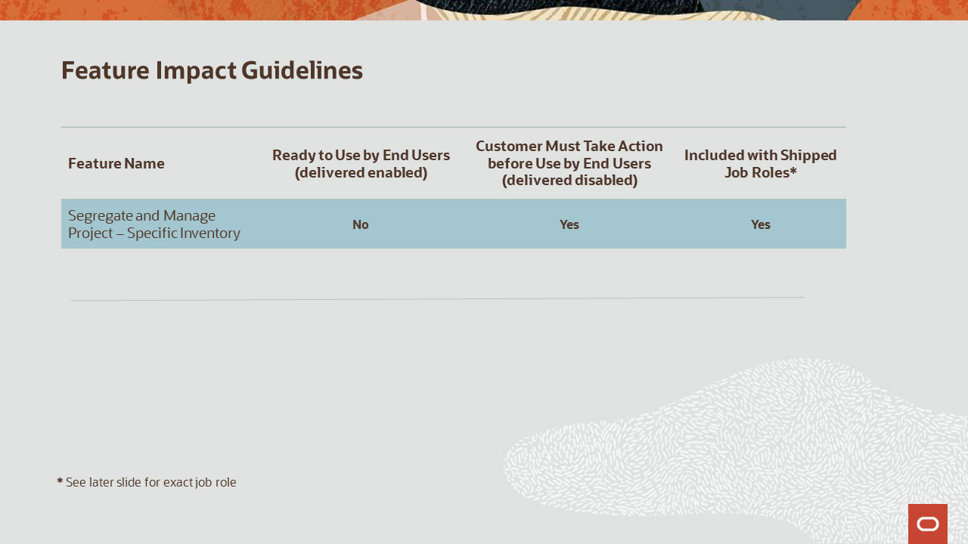
Slide notes
This table depicts key update information for the feature covered in this training.
There is an opt-in associated with this feature and the details are provided in subsequent slides. This feature can be accessed through existing shipped job roles.

Notes

Slide 363 - Implementation Decision Points
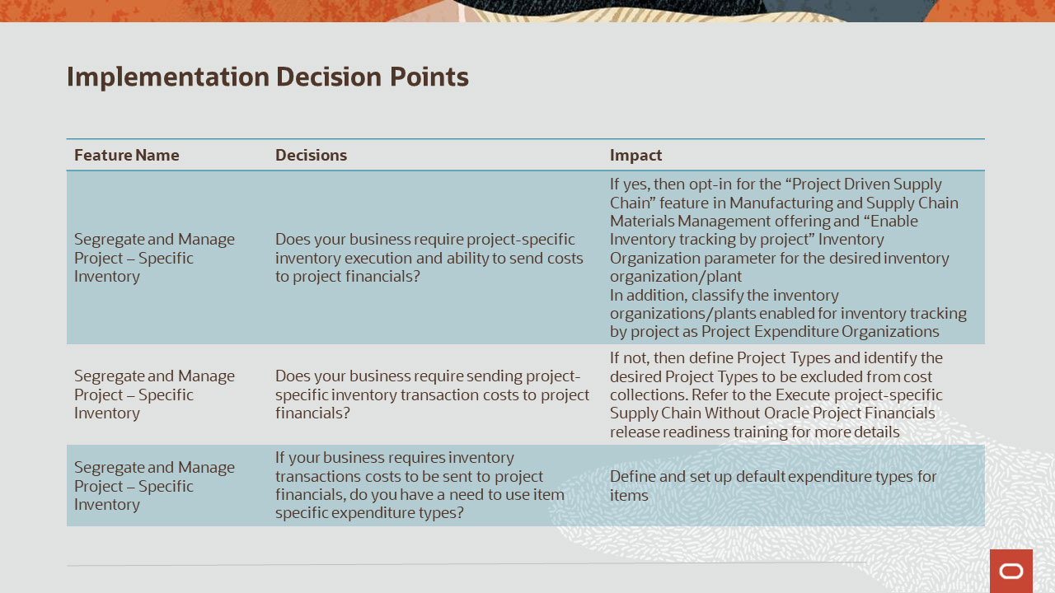
Slide notes
Now, let’s talk about some of the decision points regarding the implementation of this feature.
If your business requires to segregate and manage project–specific inventory , then you need to opt-in for the “Project Driven Supply Chain” feature in Manufacturing and Supply Chain Materials Management offering and “Enable Inventory tracking by project” Inventory Organization parameter for the desired inventory organization or plant. In addition, you need to classify the inventory organization or plant enabled for inventory tracking by project as Project Expenditure Organizations and also include them in the project hierarchy in Project Portfolio Management.
If not, then you need to define Project Types in Project Portfolio Management and identify the desired Project Types to be excluded from cost collections in Supply Chain Management. Please refer to the Execute Project-Specific Supply Chain Without Oracle Project Financials release readiness training to know more about this capability.
If your business requires material transaction costs to be sent to project financials, then you need to define and set up default expenditure types.

Notes

Slide 364 - Summary of Actions Needed to Use Segregate and Manage Project-Specific Inventory
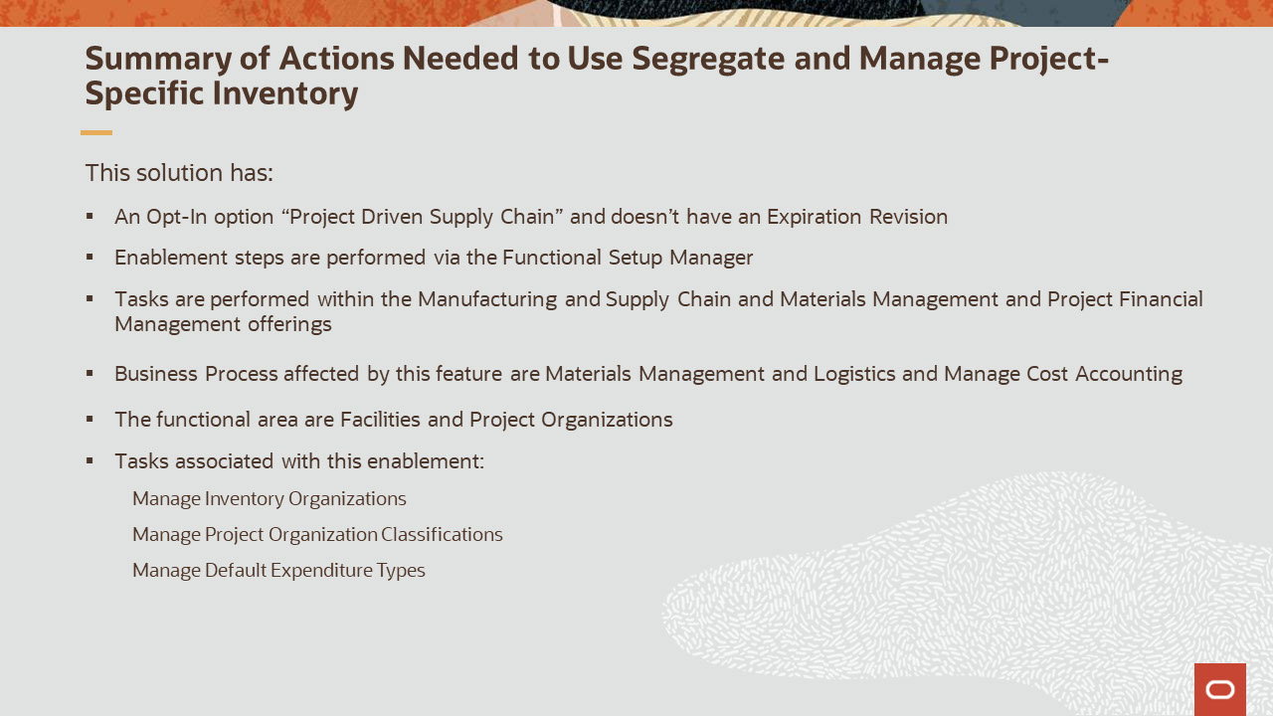
Slide notes
The enablement for the execute Segregate and Manage Project-Specific Inventory solution is achieved by opting in for the Project Driven Supply Chain feature. This Opt-In does not have an Expiration Revision and this feature is a child of the Manufacturing and Supply Chain Materials Management offering.
The enablement steps are performed via the Functional Setup Manager through the Manage Inventory Organizations task in the Facilities functional area under the Manufacturing and Supply Chain Materials Management offering and through the Manage Project Organization Classifications task in the Project Organizations functional area under the Project Financial Management offering.
For each inventory organization, you must independently enable inventory tracking by project.
Tracking inventory by project allows system to ensure you identify the project and task for material upon receipt and those details are tracked by the various inventory functions that can handle the material with in a warehouse.
And lastly, each inventory organization that is enabled for project driven supply chain, must be classified as a Project Expenditure Organization using the Manage Project Organization Classifications task. Using Manage Default Expenditure Types task, default expenditure types should also be defined.

Notes

Slide 365 - Enable Project-Driven Supply Chain
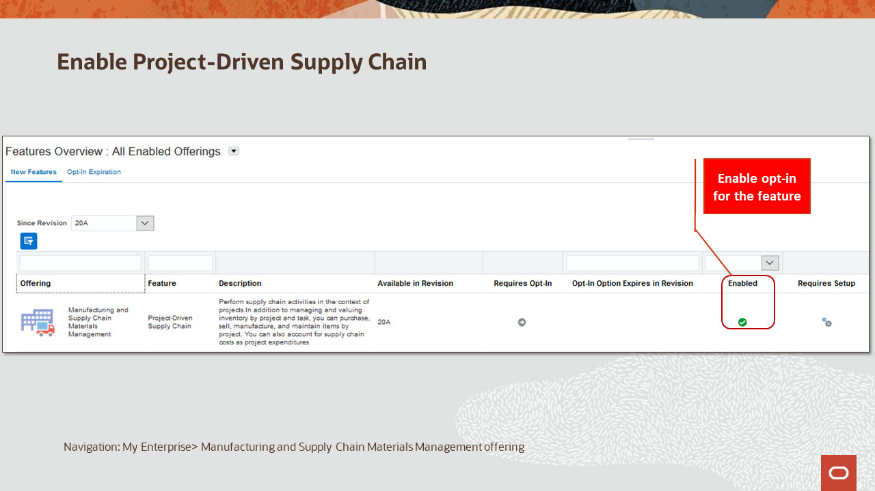
Slide notes
You need to enable the opt-in, project-driven supply chain, to be able to stripe inventory organization by project.

Notes

Slide 366 - Enablement Inventory Organizations for Project
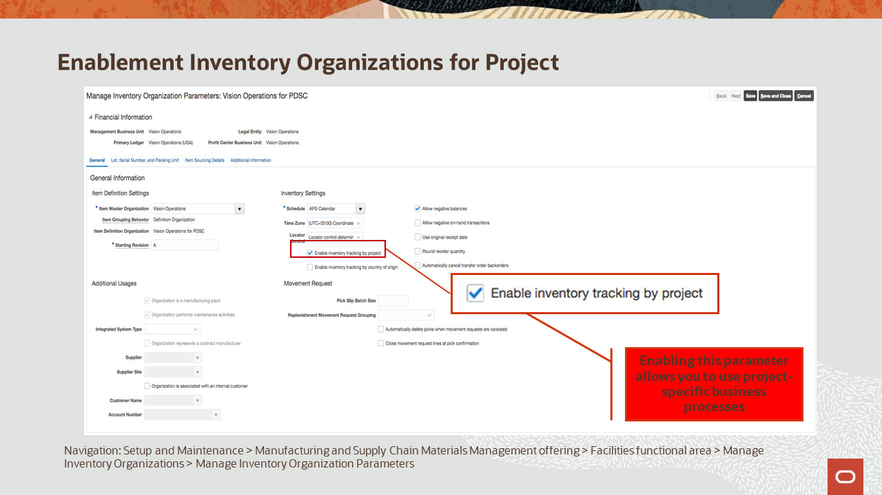
Slide notes
You must independently enable each organization where project specific activities will be performed for tracking by project. To enable this feature for a plant, you must check the enable inventory tracking by project parameter.

Notes

Slide 367 - Set Up Default Expenditure Types
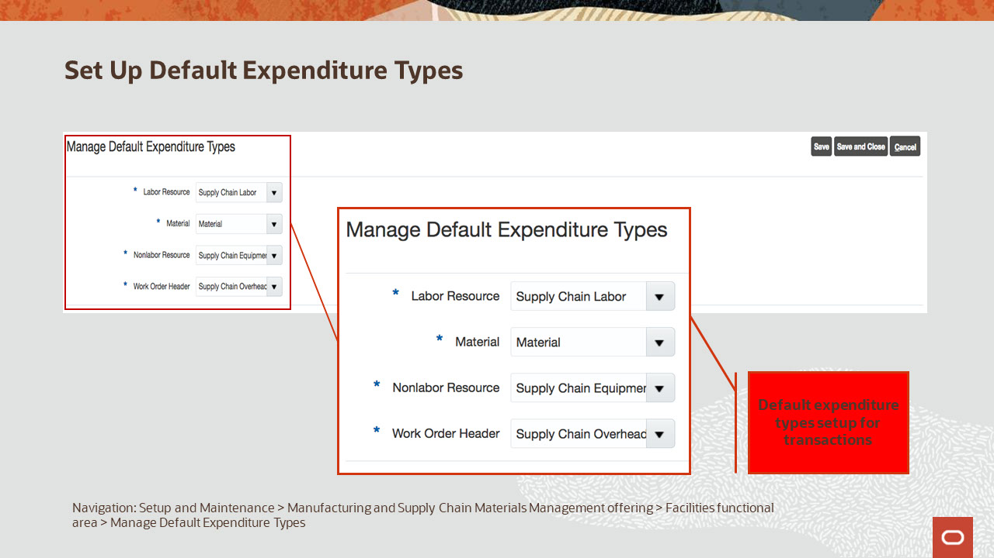
Slide notes
Now, you need to set up the default expenditure types, that would be defaulted on material and resource transactions that are collected for cost integration to the project.

Notes

Slide 368 - Enablement Best Practices
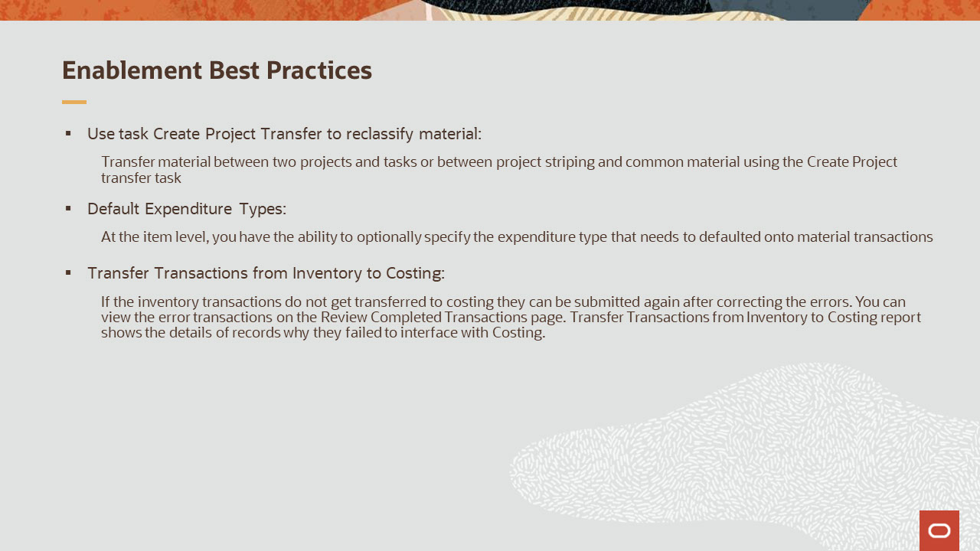
Slide notes
Now, let’s talk about some of enablement best practices that you can consider implementing.
Transfer material between two projects and tasks or between project striped and common material using the Create Project Transfer task.
At the item level, you have the ability to optionally specify the expenditure type that would default on the material transactions.
If the inventory transactions do not get transferred to costing they can be submitted again after correcting the errors. You can view the error transactions on the Review Completed Transactions page. Transfer Transactions from Inventory to Costing report shows the details of records why they failed to interface with Costing.

Notes

Slide 369 - Job Roles
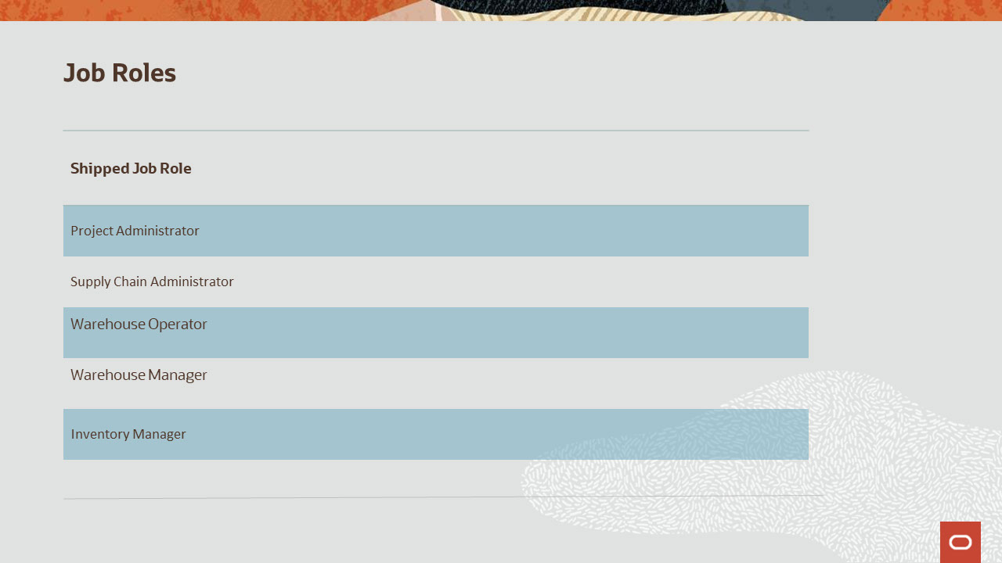
Slide notes
This table details the shipped job roles that will access the new capabilities covered in this training.
The Project Administrator role is used to manage the project definition.
The Supply Chain Administrator role is used to enable the feature project driven supply chain, setup default expenditure types and other project costing attributes.
The Warehouse Operator, Warehouse Manager and Inventory Manager roles are used to create and manage inventory transactions, reclassify project inventory, review completed transactions and other inventory processes.

Notes

Slide 370 - Job Roles
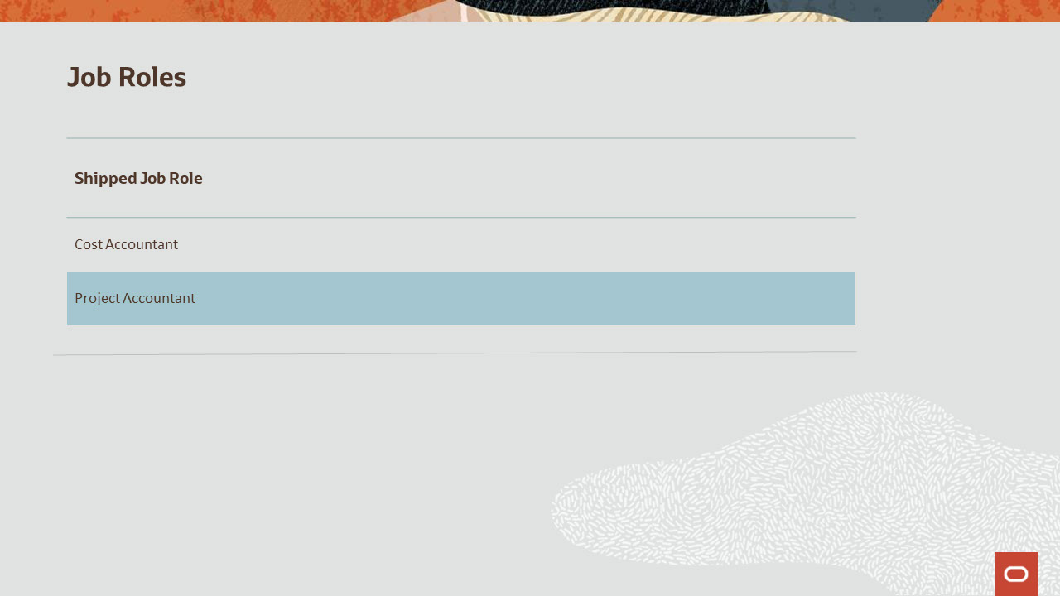
Slide notes
Continuing on, the Cost Accountant role is used to transfer transactions from inventory to costing and verify cost distributions.
The Project Accountant role is used to access the Projects Cost work area to import, review and process the project costing transaction, commonly known as Project expenditure.

Notes

Slide 371 - Business Process Information – Inventory Management
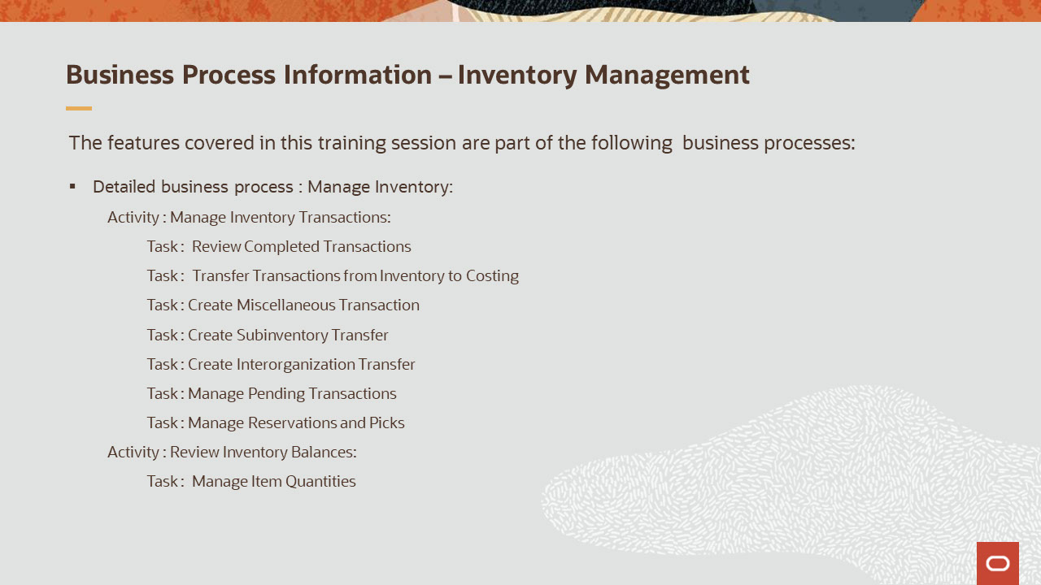
Slide notes
The business processes associated with the new capabilities covered in this training for Inventory Management are detailed here. For the high-level business process, “Manage Inventory,” the associated activities are Manage Inventory Transactions and Review Inventory Balances. The associated tasks are listed here.

Notes

Slide 372 - Business Process Information – Inventory Management
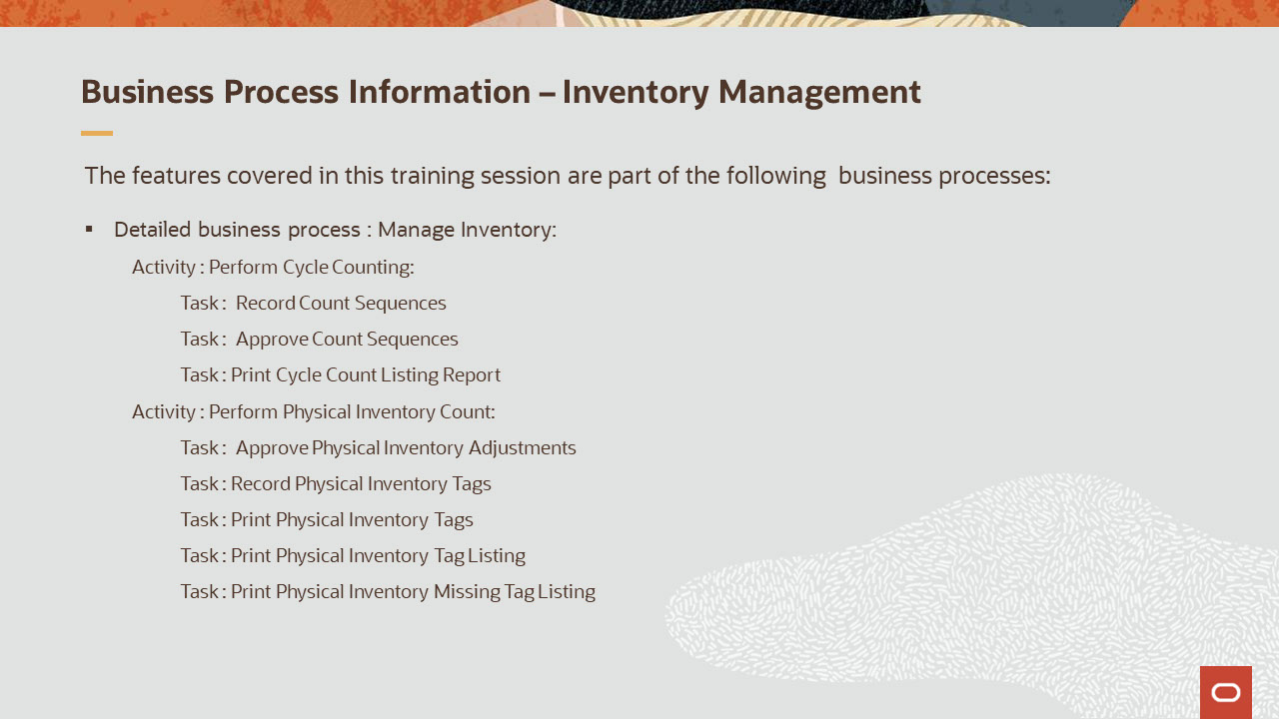
Slide notes
Continuing on, for the high-level business process, “Manage Inventory,” the associated activities are Perform Cycle Counting and Perform Physical Inventory Count.
Tasks include recording, approving, and printing reports and inventory tags.

Notes

Slide 373 - Business Process Information – Cost Management
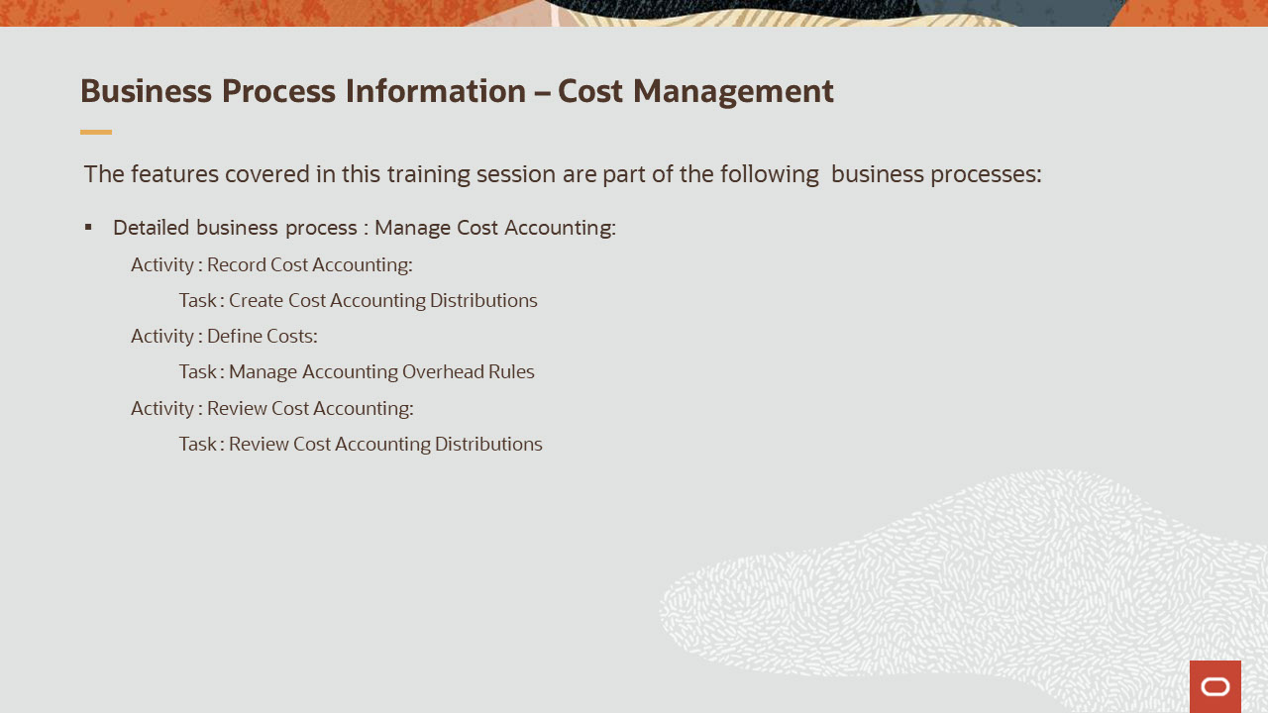
Slide notes
For the high-level business process Manage Cost Accounting, the activities include Record Cost Accounting, Define Costs and Review Cost Accounting. Tasks related to these activities include recording, creation, management and review tasks.

Notes

Slide 374 - Business Process Information – Project Portfolio Management
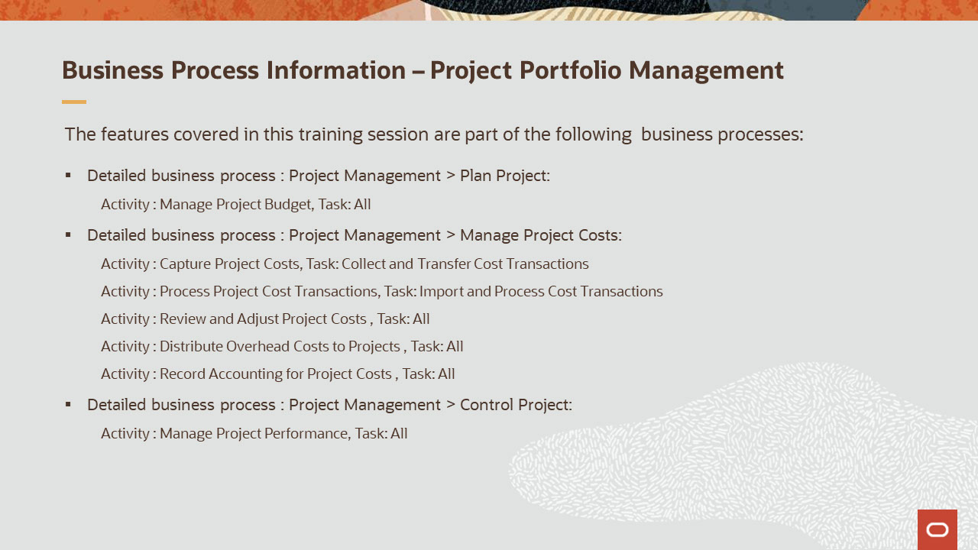
Slide notes
And lastly, for the business processes associated with Project Management, the activities and the associated tasks are listed here. Please take a moment to review them.

Notes

Slide 375 - Related Reports & BI Analytic Information
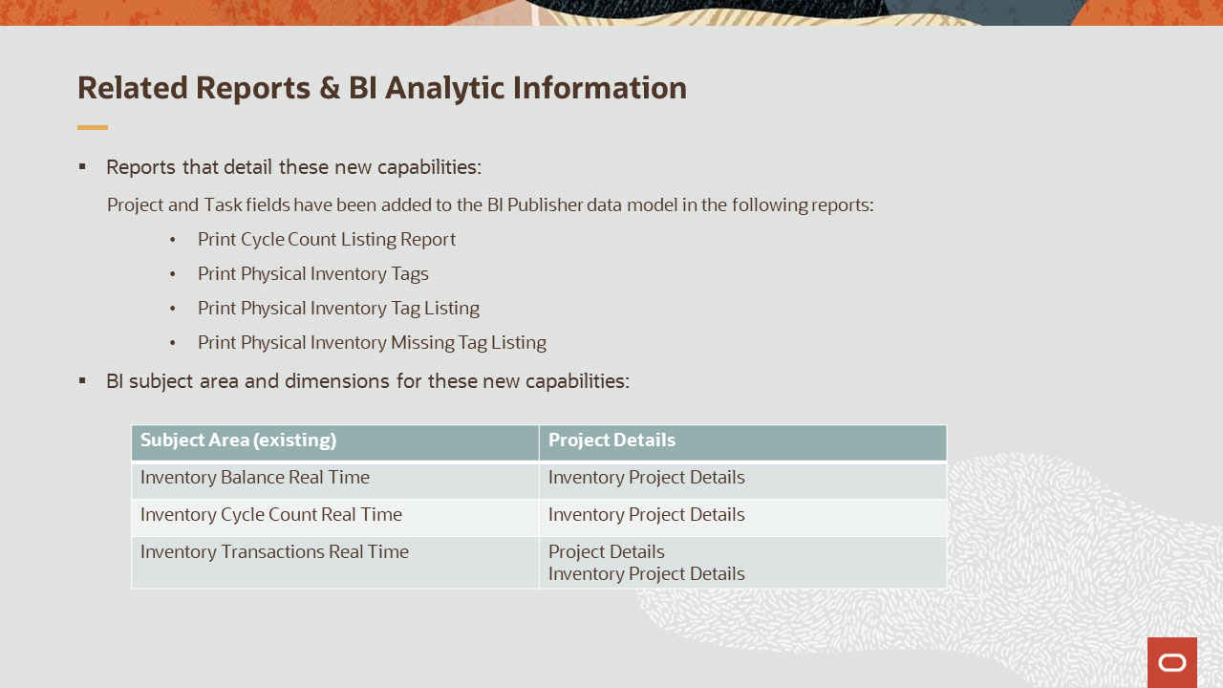
Slide notes
Now, let’s talk about the reports and BI Analytics information that cover the new features. They are as follows:
The existing reports: Print Cycle Count Listing Report, Print Physical Inventory Tags, Print Physical Inventory Tag Listing, Print Physical Inventory Missing Tag Listing have been enhanced to additional display the project and task details.
And as far as the Oracle Transactional Business Intelligence (OTBI) subject areas for Inventory Management are concerned, they have been enhanced with new PDSC related dimensions as shown here.
Project Details folder represents the project, task and other information referenced on the transactions. The subfolders under this dimension are Project, Task, Expenditure Type, Expenditure Organization, Expenditure Item Date, Work Type, and Award.
It’s important to note that awards are applicable only for sponsored projects.
The Inventory Project Details represent the inventory striping attributes for on-hand, cycle count sequences and material transactions. The subfolders under this dimension are Inventory Project, and Inventory Task.
To know more about OTBI enhancements related to other applications please refer to the other project-driven supply chain release readiness trainings that are discussed in the next slide.

Notes
Slide 376 - Related Reports & BI Analytic Information
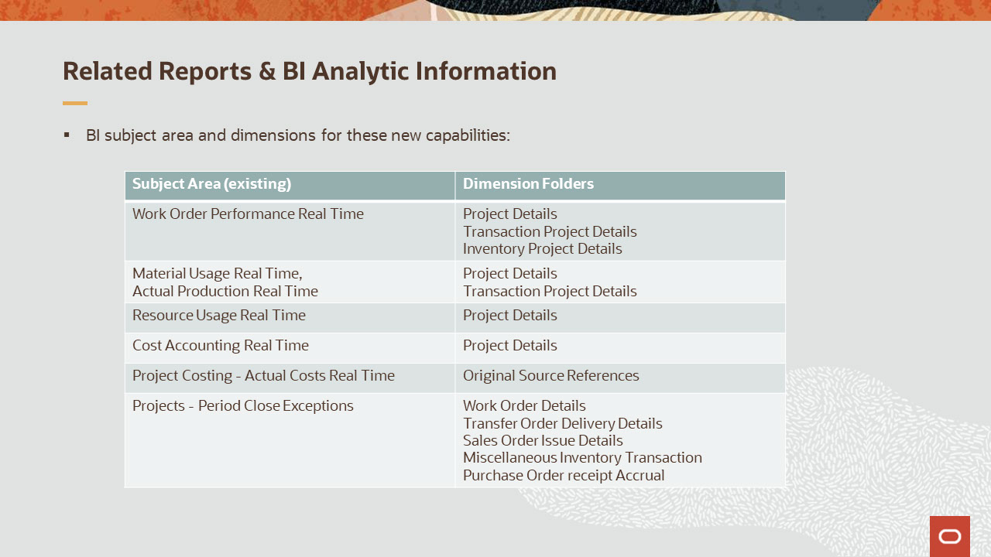
Slide notes
Continuing on, here are the subject areas of other applications they have been enhanced with the new PDSC related dimensions. Please take a moment to review them.

Notes

Slide 377 - Associated Training
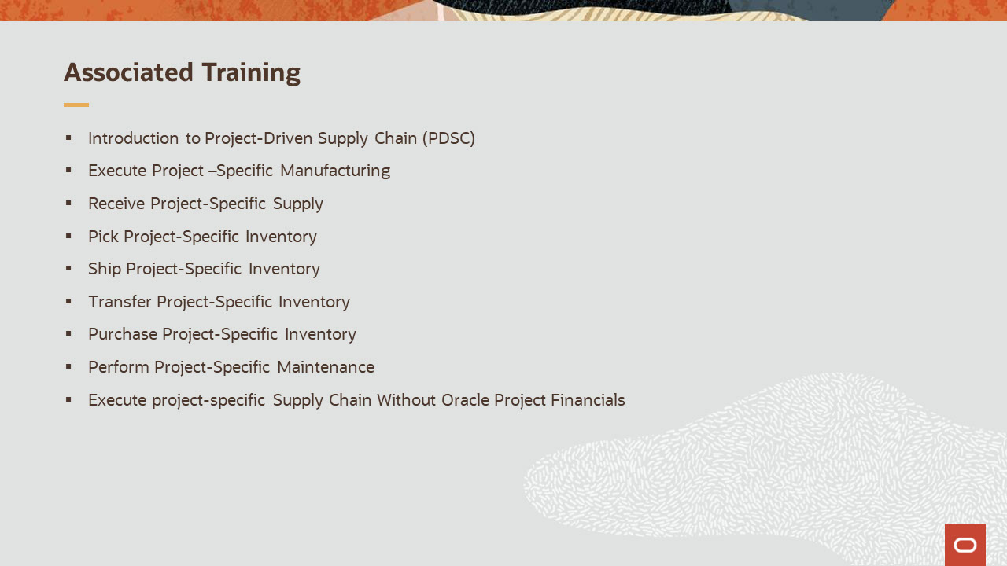
Slide notes
Other training modules that are related to these new capabilities and recommended for viewing are:
- Introduction to Project-Driven Supply Chain (PDSC)
- Execute Project –Specific Manufacturing
- Receive Project-Specific Supply
- Pick Project-Specific Inventory
- Ship Project-Specific Inventory
- Transfer Project-Specific Inventory
- Purchase Project-Specific Inventory
- Perform Project-Specific Maintenance, and finally,
- Execute project-specific Supply Chain Without Oracle Project Financials

Slide 378 - Additional Resources
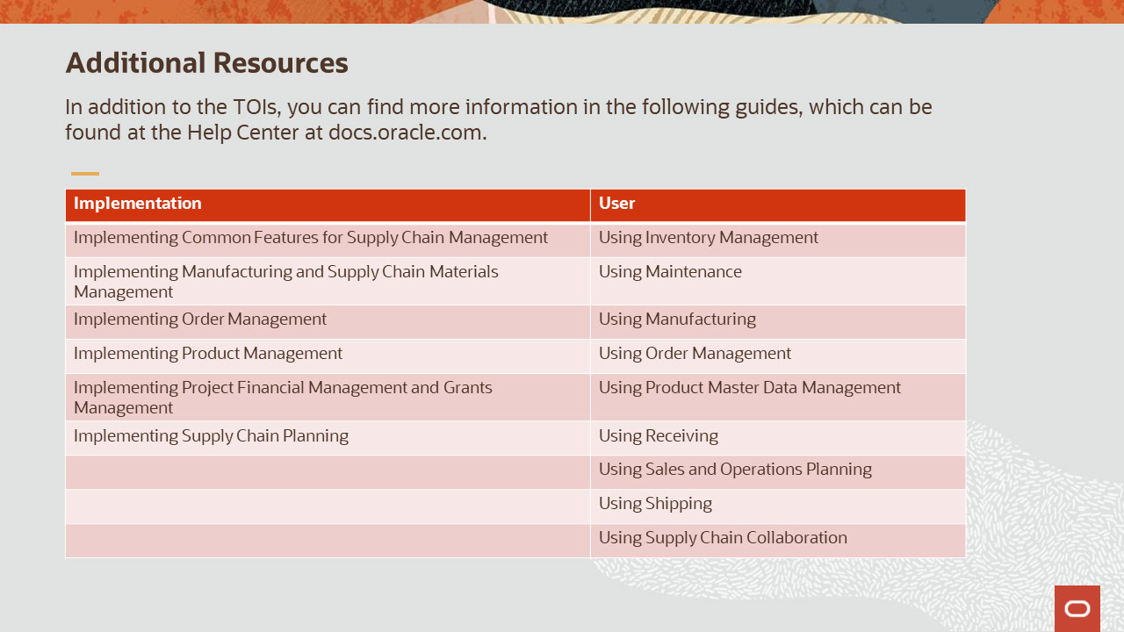
Slide notes
This concludes this presentation. Thank you for listening. You can easily pause and rewind if you require additional time to take in the detail.

Notes

