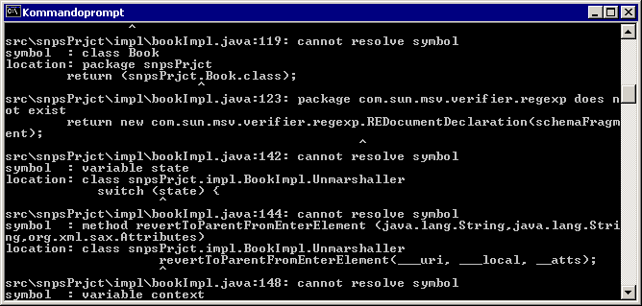
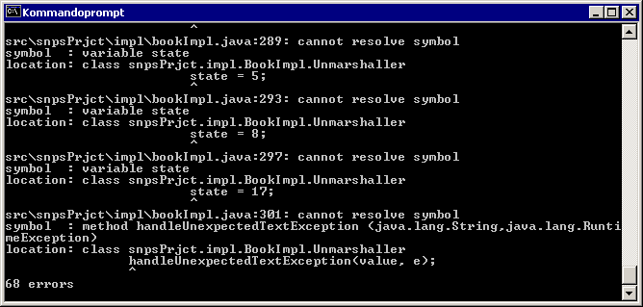
Javac
68 errors that’s somethin! But to begind somewhwre – what is the directory com.sun.msv. MSV?:

