User :- zalak pwd :- zalak
quality@glassfish.dev.java.net
Uninstallation:-

- After installing Glassfish when doing unstallation, uninstallation Icon is not removing from folder.
- After uninstaalation once, if we click on it then uninstallation process starts again.
- System creates new Text file every time when we do installation in Glassfish folder.
- After UnInstallation, Glassfish folder does not remove any files or subfolders.

Installation:-
- Its stops process at 75%...and installation cannot complete.
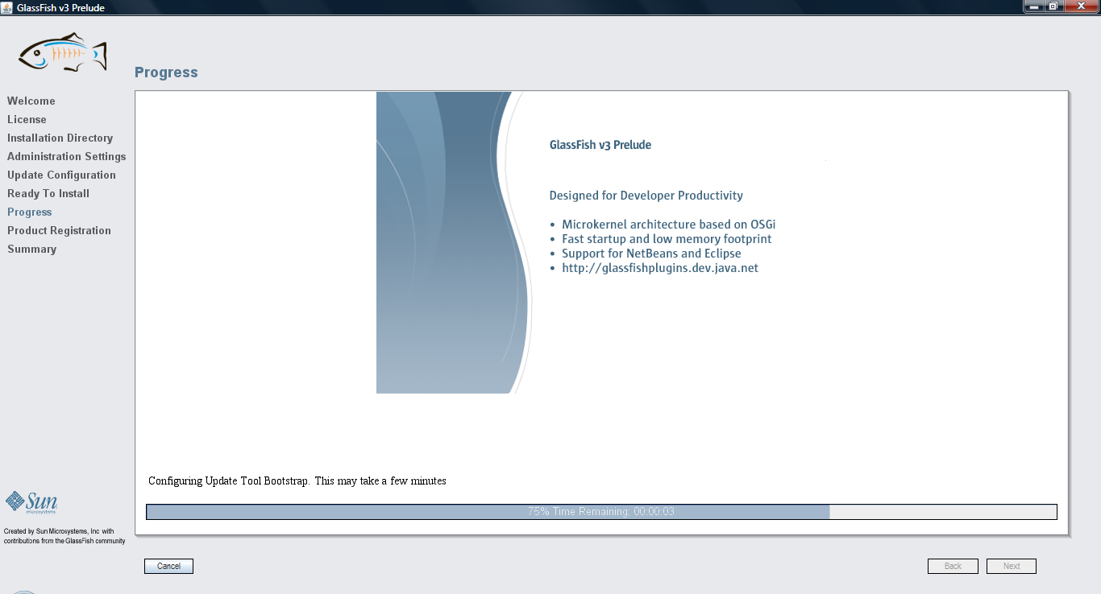

- After Uninstallation, when doing reinstall Glassfish shows error. We need to delete all files and folders and restart computer every time whenever we do reinstall and uninstall.
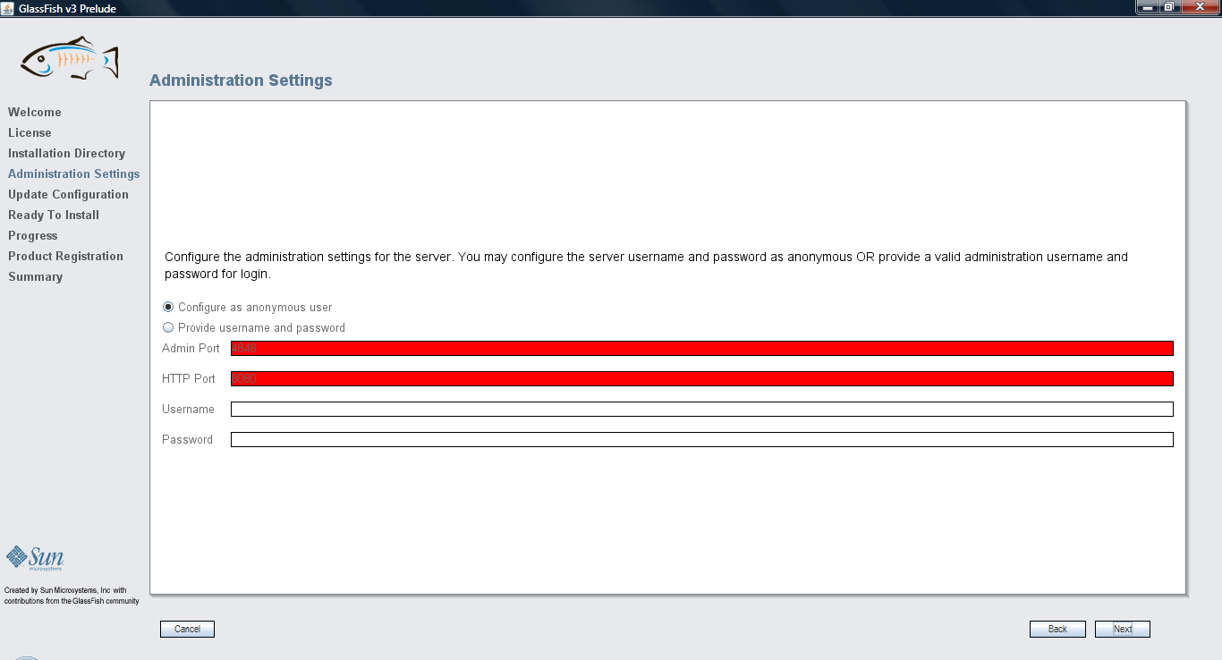

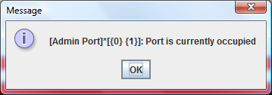

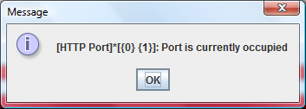

- It shows error while creating sun online Account
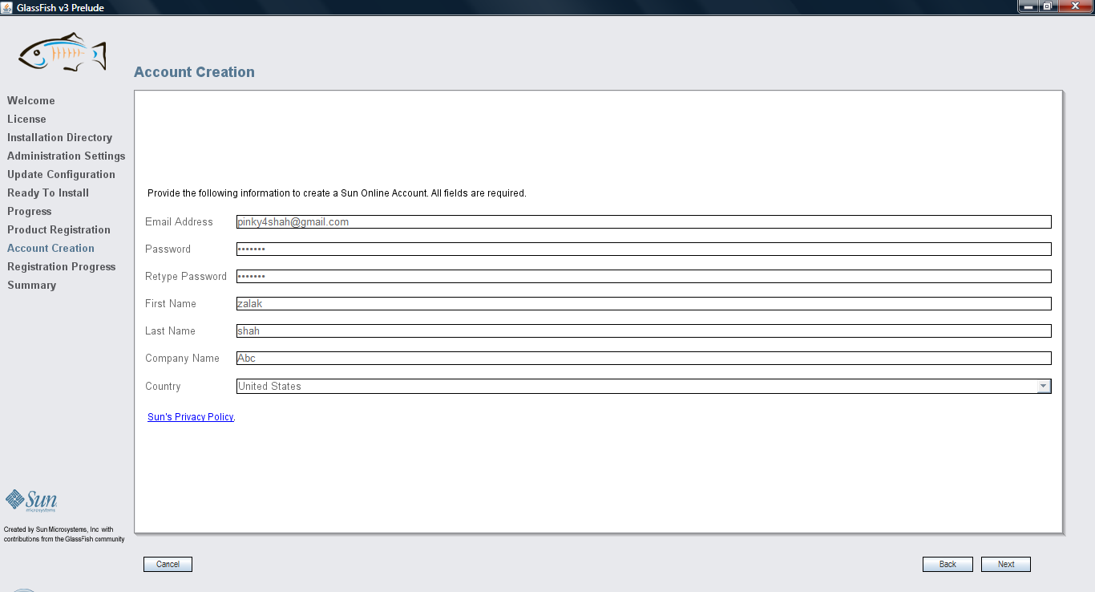

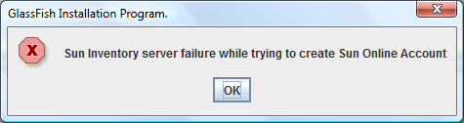

- Installation is not completed successfully then also, Start Applcation Sever shows in program files and it work when we run it.

