Main Landing Page (Should we show the live dashboard here ?)

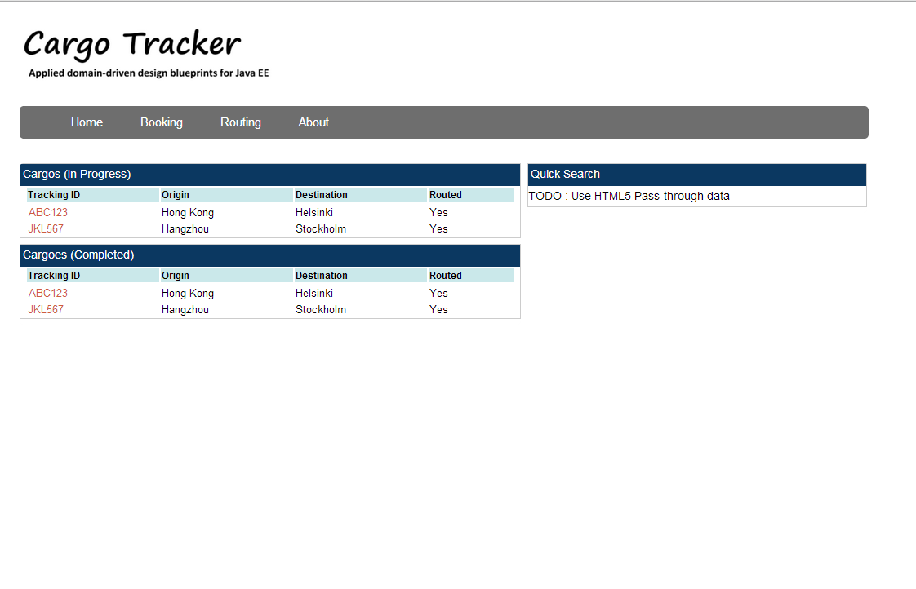

Clicking on a tracking ID takes it to the next page (Should we show live status update here ?)

