Using Oracle Warehouse Builder to create OLAP Warehouses
Chris Claterbos, Vlamis Software Solutions, Inc.
Dan Vlamis, Vlamis Software Solutions, Inc.
Introduction
With the use of the new features found in Oracle’s Warehouse Builder(OWB) 9i and Oracle 9i we can now design, construct and load a data warehouse that is fully OLAP ready. This presentation will introduce the attendee to OWB 9i and Oracle 9i OLAP and how to design and construct an Oracle 9i database that can be used for OLAP analysis and presentation. Implementation and design issues will also be addressed. A step-by-step guide will be presented with the end result being a completed OLAP ready datamart.
What is OWB?
The major functional areas of data warehousing from ETL tools to data storage is contained within the OWB framework. OWB is a key component in Oracle’s Intelligent Webhouse initiative, enabling the design and deployment of data warehousing and business intelligence solutions. The core of OWB is the Common Warehouse Metadata, which is the open metadata interchange standard driven by the OMG partners such as Oracle, IBM, NCR, and Unisys.
OWB provides a comprehensive framework for designing and deploying data warehousing and business intelligence applications across the enterprise. It consists of the following functional components:
Repository
All of the user’s work is stored in an Oracle 9i based repository. The repository is based upon an interim release of the Common Warehouse Metadata (CWM) standard. This repository consists of a set of tables that are stored in the Oracle 9i database that all OWB users and runtime applications share.
Graphical User Interface
The OWB client is used to perform all tasks necessary for the design and administration of the OWB project. It is written entirely in Java and can be run from any machine that can run the Java runtime environment.
Code Generation
OWB generates the code for creation of the database objects as well as the code to transform and load the data into the data warehouse.
Integration
There are several components within OWB that function as data integrators. A majority of these integrators are dedicated to the extraction of data from a particular type of data source. The primary integrator provides support for Oracle relational data sources. Other relational, non-relational and flat file sources are also supported. Specialized integrators are also supplied to support Oracle Applications as well as SAP R/3. In addition to the data extraction integrators there is also integration with Oracle Business Intelligence applications, Discoverer and Oracle OLAP. It is the use of this functionality that will be addressed in this paper.

OLAP Integration
Warehouse Builder enables you to prepare your data stores for Oracle9i OLAP processing. Using Warehouse Builder, you can design, deploy, and load online analytical processing (OLAP) objects that provide complex analytic power to your data warehouse. The integration of OWB and Oracle OLAP is performed through the use of the CWMlite repository contained in the Oracle 9i Enterprise Edition, which is part of the 9i OLAP Option.

EXAMPLE SCENARIO
One of the easiest ways to illustrate how to build an OLAP database with OWB is to show the process using an example application. The following sections show the process that is used to create a database design, validate the design, create the tables in Oracle 9i, transfer the design to OLAP and create the OLAP database.
Create the Database Design
Once the main screen is loaded, you then select the module that you will work with. OWB uses a concept of a module, which is a logical grouping of related objects. The warehouse module is a collection of the definitions of the objects comprising the data warehouse. When this is selected the Module Edit screen will display the objects that are part of the module. Definitions for such things as dimensions, facts, staging tables are all contained in the warehouse module and are shown in Figure 2.

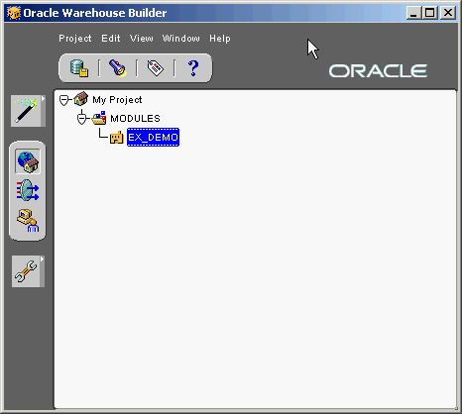
Figure 1. OWB Main Screen
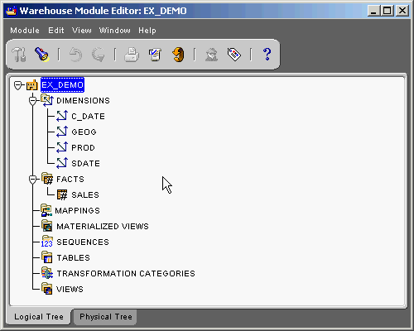
Figure 2. Module Editor

The first thing that is created in the design are the various dimensions that will be used by the fact tables. Once the dimensions are defined then the facts can be specified.
When you create a dimension, use the extensions listed in the table below while defining the implementing column for the dimension level attributes. Table 1 lists the level attribute names that are generated as OLAP compliant level descriptors when you deploy the dimension to the Oracle9i OLAP catalog using the Warehouse Builder Transfer Wizard.
The generated Warehouse Builder level attribute named ID (created when a level is created) should not be used for the dimension attribute. Because no database dimension level attribute is created for this column, make sure that this level attribute does not follow this naming practice.

Table 1 Dimension Attribute Suffixes
Physical Level Attribute Name Suffixes in Warehouse Builder | Dimension Attribute Created
_NAME or NAME | Short_Description or Long_Description
_END_DATE or END_DATE | End_Date
_TIME_SPAN or TIME_SPAN | Time_Span
_PRIOR_PERIOD or PRIOR_PERIOD | Prior_Period
_YEAR_AGO_PERIOD or YEAR_AGO_PERIOD | Year_Ago_Period

Once the dimensions are defined then the facts can be specified. Warehouse Builder enables you to define a cube using the New Cube Wizard. The fact contains all of the related measures that will have the same dimensionality. Figure 3. Illustrates a simple sales fact table design with two measures, actual and budget, and three dimensions.

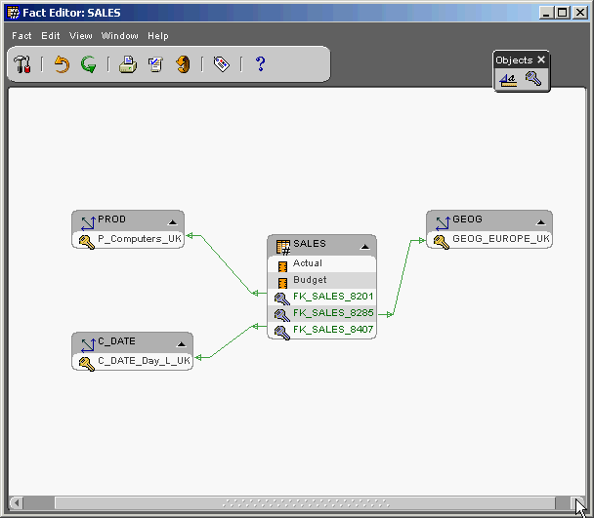
Figure 3. Fact Editor

When the design is complete the work is saved to the repository and if desired the design can be validated to make sure that the specifications are correct and consistent. The physical database scheme DDL can now be generated as well creation of all of the physical database objects. After all of this has been completed the design is now ready to create a database that can be made OLAP aware. The relational database is now generated and the relational tables populated with data.
OWB and 9i OLAP Integration
The integration of OWB and 9i OLAP is performed through the use of the One Meaning Bridge or CWM Bridge. This bridge allows for the transfer of the database design in OWB to the metadata tables of the 9i OLAP Services The bridge creates entries in the CWM metadata that matches the design in OWB. Once the metadata is created/updated the OLAP Cube is visable via the OLAP management facilities provided by OEM and also available to be viewed via 9i OLAP enabled applications.
OEM OLAP Management
Once OWB and the OLAP Bridge have accomplished their tasks the design can be viewed and modified as required the OLAP Management functions in Oracle Enterprise Manager (OEM).
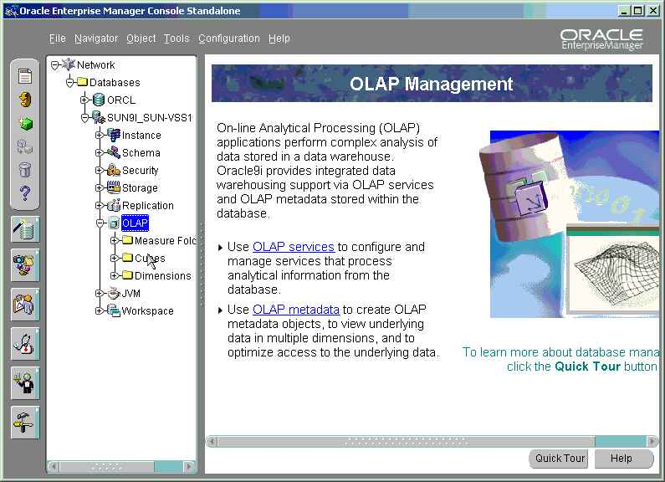
Figure 4. OLAP Management in OEM

Once in the OLAP Manager the dimensions that were created by OWB can be seen by selecting the Dimensions area of the tool (figure 5).
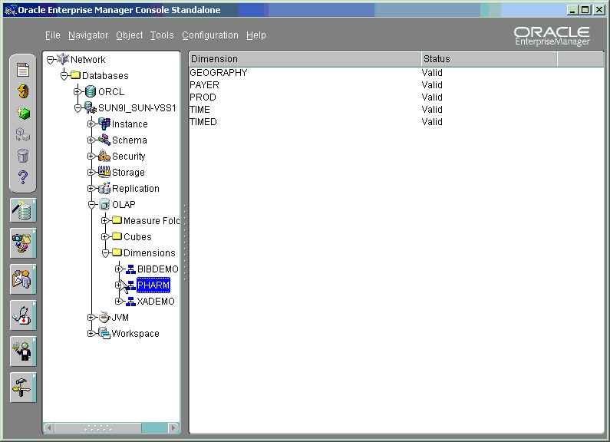
Figure 5. List of Dimensions available

The user now view what are called Cubes, which represent the tying of the Fact Tables and the Dimensions together. The completed Cube contains measures that are ready to be viewed via OLAP front ends such as BI Beans. OEM has a simple viewer, called Cube Viewer, that can be use to view the data within OEM allowing the user to make sure that all the definitions worked correctly.

Additionally, the user can group the data into Folders that allow multiple cubes of data to be presented to users as in a single folder. This makes it much easier to present measures and other objects to users in a more organized fashion as well as implement various security models. Figure 6. shows an example of what the Measure Folders looks like.

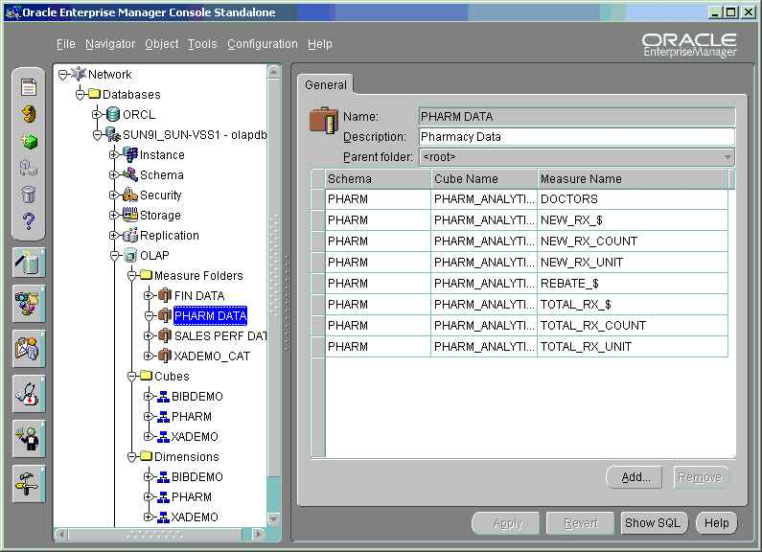
Figure 6. Measure Folders

After the data has been loaded into the relational fact and dimension tables it is immediately available to be viewed using any of the various OLAP front-end Query tools like BI Beans and VSS’s BI Analyzer.

Conclusion

OWB and the CWM are the cornerstones of Oracle’s current and future data warehouse and business intelligence initiatives. The future promises more integration and tools that will make the designer and applications developer easier and provide a fully integrated view of enterprise data.

The current implementation of OWB supports limited integration with the OLAP analytical engine. It now includes creation of Analytic Workspaces in addition to the creation of relational dimensions and cubes. Warehouse designers can now use one design tool to design, build, populate and maintain the entire enterprise data warehouse and data mart.

