Oracle9iAS Tuning Techniques
Donald K. Burleson, John Garmany, BEI Oracle Consulting

This paper deals with the most important areas of Oracle9iAS administration, optimization and high availability. Even if you have done a superb job in installing and configuring Oracle9iAS, if the system is not always available or if the performance is poor, then you have not succeeded in your job. This presentation will cover the following topics:
- Overview of Oracle9iAS performance
- Monitoring Oracle9iAS
- Oracle9iAS tuning with component parameters
- Tuning the Oracle HTTP Server (OHS)
- Tuning the Oracle9iAS Web Cache
- Load balancing of Oracle9iAS components
- Oracle9iAS server monitoring and load balancing
Overview of Oracle9iAS Performance Tuning

Being complex, an Oracle9iAS environment has a huge amount of tuning opportunities. For example, the Oracle database back-end has more than 250 initialization parameters, each Oracle9iAS component has many interrelated parameter and configuration settings, and each server has dozens of tuning options. Tuning any one of the Oracle9iAS components is challenging by itself, but when we consider the complex interactions between Oracle9iAS components, there can be an overwhelming amount of tuning activity.
We must start by noting that every Oracle9iAS system has a bottleneck. Even a well-tuned Oracle9iAS system will have some resource that comprises the majority of the response time. The best approach is to identify the component that is the bottleneck and then drill-down and identify the component resource that is responsible for the latency. The bottleneck may be hardware related (CPU, RAM, Disk I/O, or Network shortages), or software related (locks, latches or contention).
There are two approaches to Oracle9iAS tuning, the reactive and proactive approach. In the reactive approach, we receive a response time complaint from the end-user community and we use tools such as OEM to ascertain the cause of the performance problem. In the proactive tuning approach we collect detailed statistics from all Oracle9iAS components, analyze the data, and develop predictive models that can predict those conditions that will impede performance.
Let’s start by examining the tuning “knobs”. By altering a knob, we adjust the configuration and resources for the Oracle9iAS farm and change the processing characteristics. Common knobs or Oracle9iAS include three areas, server tuning, parameter tuning and RAM cache tuning:
Server tuning
- Hardware configuration – Adding RAM of CPU resources to existing servers will improve the throughput on the server
- Hardware load balancing – The addition of new servers to the Oracle9iAS farm and relocating Oracle9iAS components onto the servers allows for scalability during times of peak usage. Spare servers can be configured with both Web Cache and App Server, and the appropriate components can be started as-needed.
- Server parameter tuning – Adjusting the parameters on your server can have a huge impact on the performance of the Oracle9iAS components running on that server
Parameter tuning
- Oracle9iAS parameters - Adjusting the Oracle9iAS configuration parameters for each Oracle9iAS component has influence performance and throughput.
- Database parameters – Because most Oracle9iAS systems are disk I/O intensive, adjusting the Oracle database parameters for the Infrastructure database (iasdb) and the back-end database can heavily influence performance.
RAM cache tuning
- Data buffer tuning – Adding RAM to the database db_cache_size on the Oracle Infrastructure and back-end database can greatly reduce disk I/O and improve throughput.
- Web cache tuning – Adding RAM to the Oracle9iAS web cache can improve the delivery rates of HTML and XML though the Oracle HTTP Server (OHS).
As we mentioned, proactive tuning is the best approach for the tuning of Oracle9iAS because we can analyze historical database and observe trends and identify performance thresholds. In order to do proactive monitoring we must develop data collection mechanisms for the servers and each Oracle9iAS component. Let’s take a look at Oracle9iAS monitoring.

Monitoring Oracle9iAS

In order to develop a coherent picture of overall Oracle9iAS performance we must collect data from a variety of sources. Things to monitor and adjust:

- Resource usage monitoring – Assuming that each Oracle9iAS component is optimally tuned, any hardware-related overload must be addressed with more hardware. The solutions may be to add a new app server, add RAM or CPU to existing servers, or install faster disks. In UNIX or Linux you can monitor Oracle9iAS servers with the vmstat utility, top, glance or iostat, and store the data into Oracle tables for time-based resource analysis. In a Windows environment you can use the Windows performance monitor to measure hardware usage. We will explore Oracle9iAS hardware monitoring & tuning later in this chapter.
- Response time monitoring – Several components within Oracle9iAS allow you to track overall response time and the components of response time. For example, web applications using the Oracle9iAS forms Server can use the Forms Server log to generate detailed response time report. We will address this in greater detail later in this chapter.
- Wait event monitoring – Perform a wait even analysis on each component of Oracle9iAS can provide insights into the main source of latency for each Oracle9iAS component. For example, in the Oracle database, a STATSPACK report will show the top-5 database wait events (Listing 1):

Top 5 Timed Events
~~~~~~~~~~~~~~~~~~ % Total
Event Waits Time (s) Ela Time
------------------------------ ----- -------- --------
CPU time 30 91.43
direct path read 95 1 3.53
control file sequential read 54 1 2.33
log file parallel write 62 0 .95
db file parallel write 20 0 .68
Listing 1: STATSPACK report of top-5 wait events

Oracle9iAS Forms Server Monitoring

Oracle Forms Server provides a flat file log that contains all of the information required to measure end-to-end Oracle response time. This response time monitoring mechanism can be used for end-user applications using SQL*Forms (Forms Server 6i) and Oracle 9iAS (Oracle9i Internet Application Server). This approach works with any application that uses the Forms Server, including SQL*Forms or web apps that use the Oracle9iAS Forms Server. This makes this approach perfect choice for web-based Oracle applications.

The forms server log is a flat file that contains details for all transactions (Listing 2). Note that the statistics are displayed on separate lines, requiring a program to read and summarize the performance data.

Forms Runtime Performance Collection Log
File Name: perf_392
Process ID: 392
Client IP: 172.16.1.76:1789
Forms 6.0 (Forms Runtime) Version 6.0.8.14.1 (Production)
PL/SQL Version 8.0.6.3.0 (Production)
Oracle Virtual Graphics System Version 6.0.5.37.0 (Production)
Oracle Multimedia Version 6.0.5.34.0 (Production)
Oracle Tools Integration Version 6.0.8.13.0 (Production)
Oracle Tools Common Area Version 6.0.5.32.1
Oracle CORE Version 4.0.6.0.0 - Production
TSE Startup Time : 43574343
TSE Handshake Duration : 43574343
##### CTIME STARTS HERE
# C
WINDOW NONAME START START
Opened file: d:\hri1\forms\F_main.fmx
TSE FSERVER_START 0 0 43574828
TSE DBLOGON_START 0 0 43574828
TSE DBLOGON_END 0 0 43575093
Opened file: d:\hri1\forms\F_LOGIN.fmx
TSE FSERVER_END -1 0 43576343
IXPROP_VIEW_OUTERSIZE
IXPROP_VIEW_OUTERSIZE
# 1 - F_LOGIN:DISCLAIMER.DISAGREE_BTN.43577156
WINDOW F_LOGIN DISCLAIMER_WINDOW ACTIVATE 3
TSE FSERVER_START -1 1953 43577156
TSE FSERVER_END -1 0 43577156
##### CTIME STARTS HERE
TSE FSERVER_START -1 1182 43578359
TSE FSERVER_END -1 0 43578359
# 2 - F_LOGIN:DISCLAIMER.DISAGREE_BTN.43578500
CLICK F_LOGIN DISCLAIMER AGREE_BTN 1 MOUSE
IXPROP_VIEW_OUTERSIZE
# 3 - F_LOGIN:CNTL.USER_LOGIN.43578515
WINDOW F_LOGIN DISCLAIMER_WINDOW DEACTIVATE 3
# 4 - F_LOGIN:CNTL.USER_LOGIN.43578515
WINDOW F_LOGIN LOGWINDOW ACTIVATE 3
TSE FSERVER_START -1 140 43578500
TSE FSERVER_END -1 0 43578515
##### CTIME STARTS HERE
TSE FSERVER_START -1 390 43578921
TSE FSERVER_END -1 0 43578921
TSE FSERVER_START -1 591 43579531
TSE FSERVER_END -1 0 43579531
TSE FSERVER_START -1 1362 43580890
TSE FSERVER_END -1 0 43580890
# 5 - F_LOGIN:CNTL.USER_LOGIN.43582031
VALUE F_LOGIN CNTL USER_LOGIN 1 PLK
# 6 - F_LOGIN:CNTL.USER_LOGIN.43582031
KEY Next_item
Opened file: d:\hri1\forms\F_DIARY.fmx
TSE FSERVER_START -1 80 43589890
TSE DB_START 0 0 43589968
TSE DB_END 0 0 43589968
TSE DB_START 0 0 43590046
TSE DB_END 0 0 43590250
TSE FSERVER_END -1 0 43591031

Listing 2: A sample from the Oracle9iAS Forms Server log

As we can see, the Oracle9iAS Forms Server log produces transaction-level response time details for all transactions. Hence, this log file can get very large on highly active systems. Once your program gathers the data and stores the summaries into an Oracle tables, many Oracle9iAS administrators will delete the Forms log to keep the disk from become full.

While the programmatic details are beyond the scope of this text, you can write a summarization program using C, Perl or Java. As we can see, the Oracle9iAS Forms Server performance log produces transaction-level response time details for all transactions. The Forms Server creates a log for each connection and logs timing marks at the transaction enters and exits the Forms Server. Hence, these log files can be numerous and quite large on highly active systems. Once your program gathers the data and stores the summaries into an Oracle tables, many Oracle9iAS administrators will delete the Forms log to keep the disk from become full.

Forms Server contains a Perl script to analyze a single performance log which is very useful during development; however it does not scale to provide performance statistics for a production system. By automating the analysis for the entire performance log over an extended period of time you can produce extensive statistics of actual system performance. While the programmatic details are beyond the scope of this text, you can write a summarization program using C, Perl or Java. The programs reads each line for the Forms Server performance log, and sums the time spent in each tier; Client, Network, Forms Server and Database. The Client tier is time spent in the Forms client that involves user interaction. Network tier is time in the client tier that does not involve user interaction.
Note: the writing of custom log analysis programs is a critical part of Oracle9iAS tuning because the format of the Oracle9iAS logs do not lend themselves to easy time-based analysis.
One you write a simple program to read this information you can collect the response time in the database, Forms Server client and network.

Summarizing Forms Server Log Information

The collected data is stored in an Oracle table with the following code (Listing 3). This is the same approach that you will use to capture and analyze other Oracle9iAS logs, so the principles in this section will apply to all areas of Oracle9iAS performance collection.

create table FormStats (
FORM_ID VARCHAR2(120),
EVENT VARCHAR2(120),
FSERVER_TIME NUMBER,
DBASE_TIME NUMBER,
NWORK_TIME NUMBER,
CLIENT_TIME NUMBER,
DATE DATE)
;

Listing 3: An iasdb table to hold Forms Server information

Here we see that the FormsStats table contains these columns, which can be easily populated by a procedural program:

- A unique Form ID – This is unique to each transaction and corresponds to the Form name in the Form Server. Unfortunately, you cannot capture the exact Form name and track response time by Form name.
- The event – This is a response process on the Form. This are named events (e.g. add New Item), and correspond to buttons on the Form.
- Forms server response time - You can monitor the response time within the Forms Server.
- Database response time - You can monitor the total time the transaction spent inside the Oracle9i database.
- Network response time – You can monitor the time in the network and in the client processing information, but not interacting with the user.
- Client response time - You can monitor the response time within the client layer.
- Date – This is the exact date that the transaction was invoked.

You can populate the file with a program snippet (usually written in Perl or Java) to process the Forms Server log, one line at a time, extract the event and Form name, and store the data into your table (Listing 4). This pseudocode shows the basic follow of the code snippet:

while (((str = in.readLine()) != null)
if (str.startsWith("TSE")) { Add time to appropriate tier}
if (str.startsWith("# "))
{ Extract Event and Form Name;
Load record into database;
Clear times;
}
}

Listing 4: The pseudocode for a Oracle9iAS Forms Server log extract
This task is normally scheduled via dbms_job or cron to run daily and then re-initialize the Forms Server log file. Once collected, you can use SQL to do easy reporting from your FormsStats table. For example, here we find the number of Events with database access time greater than 4 secs:

SELECT
COUNT(*)
FROM FormStat
WHERE ((DBASE)/1000) > 4
AND DATE >= SYSDATE-1
AND DATE <= SYSDATE
;

You can also use the data in the FormsStats table to locate those Forms with the greatest total response time. The example below finds the Form with the greatest time in the Forms Server:
SELECT
form_id,
fserver
FROM
FormStat
Where
fserver = (SELECT MAX(fserver) FROM FormStat)
;

Once extracted and summarized, this response time data can be easily pasted into a spreadsheet and plotted to produce valuable trend reports (Figure 1). This was done by using the MS-Excel chart Wizard. For details on this techniques, see Oracle9i High-Performance Tuning with STATSPACK by Oracle Press, page 600.

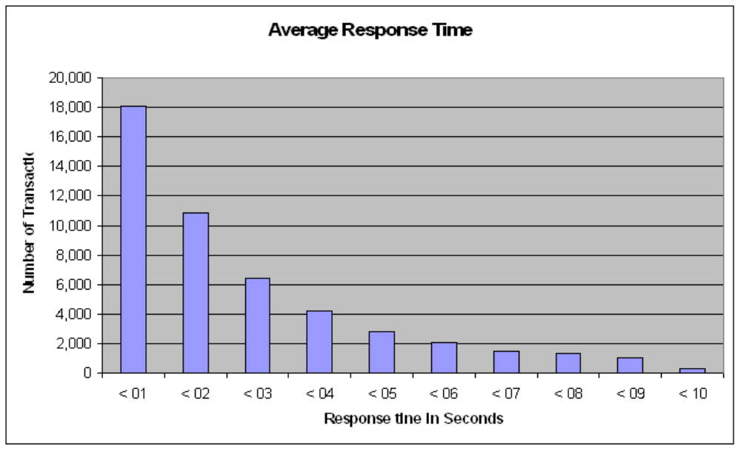

Figure 1: Forms Server aggregation of total application response time

We can also use this data to show average total response time and the components of total response time for the Oracle9iAS Forms application (Figure 2).

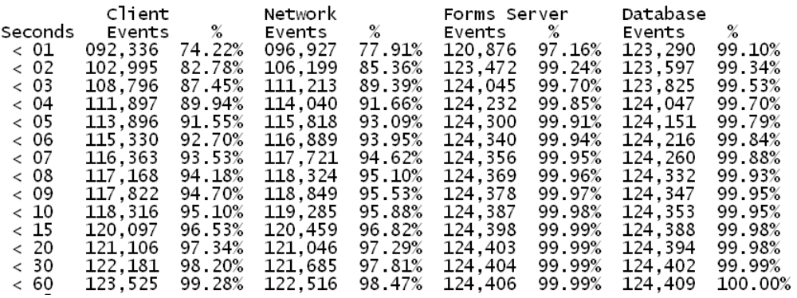

Figure 2: Breakdown of response time components
As we can see, the Forms Server data can be aggregated to provide very specific response time information. This is very useful for Oracle9iAS shops that have Service Level Agreements (SLA), guaranteeing good response time for all Oracle9iAS transactions.

Transaction-level response time monitoring

The data in the Oracle9iAS Forms Server file can also be used to get the average response time for all Forms Server transactions (Figure 3). Here we produce a top-ten report showing the slowest transactions in the system.

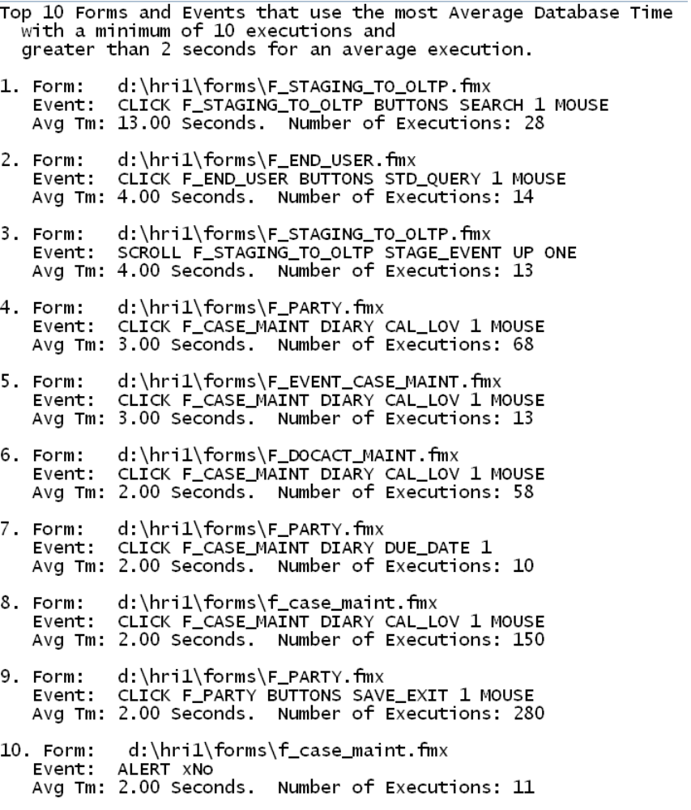

Figure 3: A top-ten list of slowest Oracle9iAS Forms Server Transactions

Oracle9iAS component response time breakdown

The Oracle9iAS Forms Server data also provides details about the amount of time spent in the Forms Server and the amount of time spent in the back-end Oracle database (Figure 4). This information can provide critical clues about the best place to start tuning Oracle9iAS forms Server transactions.

Total
Response Time
Response # of
Time Trans
======= ======
<01 secs 177,013
1-2 secs 48,851
2-3 secs 34,033
3-4 secs 21,974
4-5 secs 15,894
5-6 secs 10,084
6-7 secs 7,608
7-8 secs 5,366
8-9 secs 4,087
9-10 secs 3,160
Database
Response Time
Response # of
Time Trans
======= ======
<01 secs 346,528
1-2 secs 2,037
2-3 secs 3,853
3-4 secs 2,982
4-5 secs 486
5-6 secs 366
6-7 secs 321
7-8 secs 234
8-9 secs 160
9-10 secs 163
Forms Server
Response Time
Response # of
Time Trans
======= ======
<01 secs 345,934
1-2 secs 8,116
2-3 secs 2,857
3-4 secs 648
4-5 secs 240
5-6 secs 133
6-7 secs 50
7-8 secs 39
8-9 secs 30
9-10 secs 2

Figure 4: A breakdown of Oracle9iAS Forms Server transactions with database time

While the complete coding details are beyond the scope of this text, the concepts should be clear about how you can extract the raw from the Forms Server log file and provide accurate response time reports. Next, let’s examine some of the Oracle9iAS log tools for providing performance statistics.

Monitoring and Load Balancing the Oracle HTTP Server (OHS)

The HTTP server is an important part of the Oracle9iAS architecture because a delay at this level will delay initial connection to your Oracle9iAS system and also cause delays in the generation and dispatch of outgoing HTML and XML documents.
Connections to OHS required several round-trips while establishing connectivity (Figure 5).

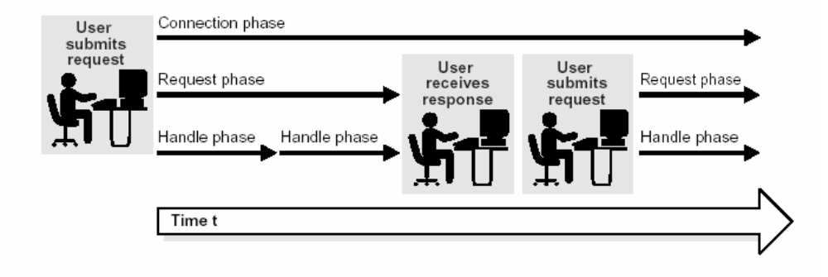

Figure 5: OHS entry procedure

Because OHS is used at least twice during for every web transaction, we must be able to identify the components of OHS processing and find a way to track each component process. Next, let’s examine the common tools used to monitor the OHS server and report on performance metrics.

Monitoring Oracle9iAS with Dynamic Monitoring Service (dmstool)

The Dynamic Monitoring service dmstool utility is a command line program that is used to display elapsed time performance metrics. The dmstool utility can be used to view metrics on several Oracle9iAS components:
- OC4J – dmstool can measure the time required to parse incoming requests and the total free RAM in the JVM.
- Oracle9iAS Portal – Important Portal metrics can be easily displayed.
- Servlet code – You can add dms metrics of any Java code to capture additional statistics.
- Oracle HTTP Server (OHS) – dmstool can measure the current active requests in the HTTP server.

Before we explore the command syntax for dmstool we need to note that you can use your browser to quickly look at detailed dms statistics.
Using dmstool commands

When using the dmstool list option (-l), you will generate a list of over 300 monitoring metrics for Oracle9iAS. In the example below, we constrain the dmstool output to only those lines that contain the “completed” string:

#!/bin/ksh
PATH=$PATH:/home/oracle/oraportal904/bin
export PATH
dmstool -l |grep completed

The output of this script (Listing 5) will show us all of the available metrics containing the word “completed”. We will use this list as input to a more detailed dmstool command in the next step.

/appsvr.lcldm.com/OC4J:3303:6004/oc4j/default/WEBs/parseRequest.completed
/appsvr.lcldm.com/OC4J:3303:6004/oc4j/default/WEBs/processRequest.completed
/appsvr.lcldm.com/OC4J:3303:6004/oc4j/default/WEBs/resolveContext.completed
/appsvr.lcldm.com/OC4J:3303:6004/oc4j/portal/WEBs/parseRequest.completed
/appsvr.lcldm.com/OC4J:3303:6004/oc4j/portal/WEBs/processRequest.completed
/appsvr.lcldm.com/OC4J:3303:6004/oc4j/portal/WEBs/resolveContext.completed
/appsvr.lcldm.com/OC4J:3303:6004/oc4j/syndserver/WEBs/parseRequest.completed
/appsvr.lcldm.com/OC4J:3303:6004/oc4j/syndserver/WEBs/processRequest.completed
/appsvr.lcldm.com/OC4J:3303:6004/oc4j/syndserver/WEBs/resolveContext.completed

Listing 5: Sample dmstool listing for completed requests

Note: the Oracle9iAS parameters are generally specified in “Camel” notation. This is the convention where the words are concatenated together, and all words after the first are Capitalized, creating the “humps” which characterize Camel notation.
We can use this listing of completed operations to get counts of the total operations over a specific period of time. Let’s use this list as input parameters for more advanced dmstool commands.

Summarizing dmstool data by time intervals

Using the dmstool with the interval option (-i) and the collection option (-c). The dmstool command specifies the collection of 100 sets of data at 60-second intervals.

#!/bin/ksh
PATH=$PATH:/home/oracle/oraportal904/bin
export PATH
dmstool -i 60 -c 100 \
/appsvr.localdomain.com/Apache:2534:6004/Apache/handle.completed \
/appsvr.localdomain.com/Apache:2534:6004/Apache/request.completed \
/appsvr.localdomain.com/Apache:2534:6004/Apache/handle.completed \
/appsvr.localdomain.com/Apache:2534:6004/Apache/request.completed > t1.lst

Here is the output from this script. Here we see the cumulative number of operations, displayed every minute, for each handle, request and completion operation:

Sun Jul 13 20:19:43 MDT 2003
/appsvr.localdomain.com/Apache:2534:6004/Apache/handle.completed 240320 ops
/appsvr.localdomain.com/Apache:2534:6004/Apache/request.completed 146504 ops
/appsvr.localdomain.com/Apache:2534:6004/Apache/connection.completed 56908 ops
Sun Jul 13 20:20:43 MDT 2003
/appsvr.localdomain.com/Apache:2534:6004/Apache/handle.completed 240474 ops
/appsvr.localdomain.com/Apache:2534:6004/Apache/request.completed 146598 ops
/appsvr.localdomain.com/Apache:2534:6004/Apache/connection.completed 56948 ops
Sun Jul 13 20:21:43 MDT 2003
/appsvr.localdomain.com/Apache:2534:6004/Apache/handle.completed 240668 ops
/appsvr.localdomain.com/Apache:2534:6004/Apache/request.completed 146732 ops
/appsvr.localdomain.com/Apache:2534:6004/Apache/connection.completed 56978 ops
Sun Jul 13 20:22:43 MDT 2003
/appsvr.localdomain.com/Apache:2534:6004/Apache/handle.completed 240825 ops
/appsvr.localdomain.com/Apache:2534:6004/Apache/request.completed 146829 ops
/appsvr.localdomain.com/Apache:2534:6004/Apache/connection.completed 57028 ops

As we have noted, you can capture you own dms diagnostics. Let’s look at how you can add dms metrics to a servlet. In the example below we see a small servlet that simply prints “This is a test”.
import java.io.*;
import javax.servlet.*;
import javax.servlet.http.*;
public class Test extends HttpServlet
{
public void doGet(HttpServletRequest request, HttpServletResponse response )
throws ServletException, IOException
{
responce.getWriter().println("This is a Test. " );
}
}

Listing x: Java servlet without dms

Now we can take this code and add a dms metric by importing the oracle dms instrument library and adding a display message each time the servlet is executed:

import java.io.*;
import javax.servlet.*;
import javax.servlet.http.*;
import oracle.dms.instrument.*;
public class TestA extends HttpServlet
{
public void doGet(HttpServletRequest request, HttpServletResponse response )
throws ServletException, IOException
{
Event beginAccess = Event.create("/ oracle / TestA / dms ",
" TestA Write Succeded");
res.getWriter().println(" This is a test of TestA. ");
begin Access.occurred();
}
}

Now that we have reviewed the basics we are ready to take a close look at issuing native dmstool commands to extract Oracle9iAS performance data.

Getting dump details from dmstool

By using the –dump option of dmstool we can collect all metrics from an Oracle9iAS instance. Most Oracle9iAS administration use a small shell script like the one below and schedule it to run every hour:
#!/bin/ksh
PATH=$PATH:/home/oracle/oraportal904/bin
export PATH
dmstool -dump >> dumparch.lst

You can use the -dump option to store dmstool performance metrics for later analysis (Listing 6). However, note that the –dump option does not display the metrics is an easy to summarize format, and a code snippet is required to gather the information and place it inside a metadata table.

/DMS-Internal/Measurement [type=n/a]
createNoun.count: 136 ops
createSensor.count: 591 ops
destroyNoun.count: 4 ops
destroySensor.count: 25 ops
lastTreeNodeID.value: 0
sampleMetric.count: 5531850 ops
sensorWeight.value: 5
treeNodes.maxValue: 1635.0
treeNodes.value: 1635
/JDBC/OracleConnectionCacheImpl [type=JDBC_ConnectionSource]
CacheFreeSize.count: 18 ops
CacheFreeSize.maxValue: 5.0 connections
CacheFreeSize.minValue: 0.0 connections
CacheFreeSize.value: 2 connections
CacheGetConnection.active: 0 threads
CacheGetConnection.avg: 0.42857142857142855 msecs
CacheGetConnection.completed: 7 ops
CacheGetConnection.maxTime: 1 msecs
CacheGetConnection.minTime: 0 msecs
CacheGetConnection.time: 3 msecs
CacheHit.count: 7 ops
CacheMiss.count: 2 ops
CacheSize.count: 3 ops
CacheSize.maxValue: 5.0 connections
CacheSize.minValue: 1.0 connections
CacheSize.value: 1 connections

Listing 6: Detailed dmstool dump output

While this listing may be cumbersome, it is a trivial matter to write a program to parse and summarize this output, storing the metrics inside special iasdb tables. For details on this techniques, see the preceding section on Forms Servers performance analysis.
Next let’s look at using dmstool to gather load balancing performance information on your Oracle HTTP servers.

Using dmstool to monitor and load balance Oracle HTTP Servers

You can use the dmstool command with the –table ohs_server option to gather detailed information about the performance of all of the components of the OHS server.

Most Oracle9iAS administrators automate this collection task by placing the dmstool command inside a shell script and directing the output to a flat file for later analysis.
#!/bin/ksh
PATH=$PATH:/home/oracle/oraportal904/bin
export PATH
dmstool -table ohs_server >> ohs.lst

Here is a small sample of the output from this script (Listing 7). The output is very voluminous because it performs a snapshot of the values every ten seconds, and the output provides details on the number of operations (ops), and timing information on all OHS components.

Sun Jul 13 21:01:45 MDT 2003
----------
ohs_server
----------
busyChildren.value: 16
childFinish.count: 24703 ops
childStart.count: 24748 ops
connection.active: 24 threads
connection.avg: 116999118 usecs
connection.completed: 58559 ops
connection.maxTime: 120275397680 usecs
connection.minTime: 1437 usecs
connection.time: 6851351400020 usecs
error.count: 138 ops
get.count: 150940 ops
handle.active: 1 threads
handle.avg: 8620 usecs
handle.completed: 247278 ops
handle.maxTime: 32791802 usecs
handle.minTime: 2 usecs
handle.time: 2131602896 usecs
internalRedirect.count: 7650 ops
lastConfigChange.value: 1057965990
numChildren.value: 44
numMods.value: 0
post.count: 2 ops
readyChildren.value: 27
request.active: 1 threads
request.avg: 15321 usecs
request.completed: 150942 ops
request.maxTime: 32792567 usecs
request.minTime: 533 usecs
request.time: 2312728152 usecs
responseSize.value: 1622607150
Host: appsvr
Name: Apache
Parent: /
Process: Apache:2534:6004
Listing 7: dmstool ohs_server output

The most useful part of the ohs_server listing are the details on OHS child server processes. The values for the child servers are specified in the httpd.conf file by the MaxSpareServers and MinSpareServers parameters, and OHS will create and destroy child server processes based upon the volume of incoming requests. It is important to know the number of OHS child server in-use and the number of child servers that are processing HTTP requests.
Referring to the bold lines of Listing 7, we see that numChildren.value is 43, indicating that there are 43 OHS child servers active. Of these 43 server, busyChildren.value is 16, indicating that there are currently 27 child server ready to accept work, as verified by the readyChildren.value metric. We also see that the childStart.count is 24,748, showing the number of invocations of OHS child processes since startup time. The most important of these metrics is request.avg, which shows that the average time spent in the HTTP server is 15,321 milliseconds, or about one-tenth of a second for connection.active = 24 transactions. Taken together, these metrics give us a good idea about the volume of transactions experienced on each OHS server.
Remember, when the demand on the OHS server exceeds the number of child servers defined in the httpd.conf parameter file, OHS will spawn more child processes, but it is a good idea to determine the peak load for each OHS server and perform load balancing from the web cache to ensure that no single OHS server becomes overloaded.
Now that we see the concept, let’s expand this concept and write a short script to filter through the voluminous OHS server statistics and extract information on active requests and the status of the OHS child processes.
extract_ohs_time_series.ksh
#!/bin/ksh
PATH=$PATH:/home/oracle/oraportal904/bin
export PATH
dmstool -table ohs_server > ohs.lst
cat ohs.lst|grep connection.active > con_active.lst
cat ohs.lst|grep request.active > req_active.lst
cat ohs.lst|grep busyChildren.value > busy_child.lst
cat ohs.lst|grep readyChildren.value > readyChild.lst
cat ohs.lst|grep numChildren.value > det.lst

From extracting and plotting the data in these files (MS-Excel chart wizard works great), you should carefully monitor the volume of transactions (connection.active) and the average response time (request.avg) to determine the threshold where performance drops.

Note: This type of chart is critical to OHS load balancing. As we recall from previous chapters, the Web Cache performs automatic load balancing between the active OHS servers. However, the Oracle9iAS administrator can keep a “pool” of servers in standby mode with Web Cache and OHS installed on them. Depending on need, you can add them into the Oracle9iAS architecture as an OHS server or a Web cache server.
Again, most Oracle9iAS administrators will collect this information on a scheduled basis and write programs to gather summary information to store in iasdb extension tables. This builds the framework for time-series analysis of this important performance data. Next let’s look at using the dmstool command to show statistics for active requests.

Tracking errors with dmstool

The dmstool utility is also useful for tracking important internal errors within OHS. In the example below we use dmstool with the ohs_responses argument to see detailed error information.
#!/bin/ksh
PATH=$PATH:/home/oracle/oraportal904/bin
export PATH
dmstool -table ohs_responses > resp.lst

Here is wee a listing of all OHS errors, reported in 10-minute intervals (Listing 8).

Mon Jul 14 14:56:22 MDT 2003
-------------
ohs_responses
-------------
CltErr_Authorization_Required_401.count: 0 ops
CltErr_BadRange_416.count: 0 ops
CltErr_Bad_Request_400.count: 0 ops
CltErr_Conflict_409.count: 0 ops
CltErr_ExpectFailed_417.count: 0 ops
CltErr_Failed_Dependency_424.count: 0 ops
CltErr_Forbidden_403.count: 0 ops
CltErr_Gone_410.count: 0 ops
CltErr_LengthRequired_411.count: 0 ops
CltErr_Locked_423.count: 0 ops
CltErr_Method_Not_Allowed_405.count: 0 ops
CltErr_Not_Acceptable_406.count: 0 ops
CltErr_Not_Found_404.count: 14 ops
CltErr_Payment_Required_402.count: 0 ops
CltErr_PreCondFail_412.count: 0 ops
CltErr_ProxyAuthReq_407.count: 0 ops
CltErr_ReqEntityTooLarge_413.count: 0 ops
CltErr_Timeout_408.count: 0 ops
CltErr_URITooLarge_414.count: 0 ops
CltErr_Unprocessable_Entity_422.count: 0 ops
CltErr_UnsuppMediaType_415.count: 0 ops
Info_Continue_100.count: 0 ops
Info_Processing_102.count: 0 ops
Info_ProtoSwitch_101.count: 0 ops
SvrErr_NotImplemented_501.count: 0 ops
SvrErr_Not_Extended_510.count: 0 ops
SvrErr_SvcUnavail_503.count: 0 ops
SvrErr_Variant_Also_Negotiates_506.count: 0 ops
SvrErr_VersionNotSupp_505.count: 0 ops
Host: appsvr
Name: Responses
Parent: /Apache
Process: Apache:2534:6004
ohs_server: Apache

Listing 8: dmstool error report for OHS

This listing shows all possible errors in the OHS server. The most common is the “404 Not Found” message when an invalid URL is encountered. Most Oracle9iAS administrators write automated scripts to review these logs and report on the important internal errors such as the SvrErr_InternalError_500.count error line.

#!/bin/ksh
PATH=$PATH:/home/oracle/oraportal904/bin
export PATH
dmstool -table ohs_responses|grep SvrErr_InternalError_500.count|cut –d’ ‘ –f1

Here we can get the numerical lists of the internal errors at 10 minute intervals. When we see a large number of internal errors we will want to check the OHS error_log file to see the URL that is causing the internal error. This output can be easily charted and graphed for time-series analysis (Listing 9).

34
1
1
5
61
77
12
3

Listing 9: OHS internal errors in 10-minute intervals

Capturing detailed module performance data in OHS

The dmstool interface also allows us to gather drill-down details for all modules with OHS. The default OHS installation includes these modules (Table 1), and you can get detailed performance values on each of these components:

http_core.c | mod_access.c | mod_actions.c | mod_alias.c
mod_asis.c | mod_auth.c | mod_auth_anon.c | mod_auth_dbm.c
mod_autoindex.c | mod_cern_meta.c | mod_cgi.c | mod_dav.c
mod_define.c | mod_digest.c | mod_dir.c | mod_dms.c
mod_env.c | mod_example.c | mod_expires.c | mod_fastcgi.c
mod_headers.c | mod_imap.c | mod_include.c | mod_info.c
mod_log_agent.c | mod_log_config.c | mod_log_referer.c | mod_mime.c
mod_mime_magic.c | mod_mmap_static.c | mod_negotiation.c | mod_oc4j.c
mod_onsint.c | mod_ossl.c | mod_osso.c | mod_perl.c
mod_plsql.c | mod_proxy.c | mod_rewrite.c | mod_setenvif.c
mod_so.c | mod_speling.c | mod_status.c | mod_unique_id.c
mod_userdir.c | mod_usertrack.c | mod_vhost_alias.c | mod_wchandshake.c

Table 1: All default modules within the OHS server

While each of these modules server important functions, there are some that are especially noteworthy, namely the http_core.c and mod_oc4j.c modules. We will take a close look at these in just a minute.
Here is a small script to generate the performance details for each module.
#!/bin/ksh
PATH=$PATH:/home/oracle/oraportal904/bin
export PATH
dmstool -table ohs_module -c 1

Here we get a huge listing showing a verbose record of detailed performance metrics for all OHS modules (Listing 10). Here we see the details for the http_core.c and the mod_oc4j.c OHS process.

Name: mod_oc4j.c
Parent: /Apache/Modules
Process: Apache:2534:6004
ohs_server: Apache
decline.count: 13487 ops
handle.active: 0 threads
handle.avg: 3 usecs
handle.completed: 13487 ops
handle.maxTime: 8 usecs
handle.minTime: 2 usecs
handle.time: 43710 usecs
Host: appsvr
Name: http_core.c
Parent: /Apache/Modules
Process: Apache:2534:6004
ohs_server: Apache
decline.count: 0 ops
handle.active: 0 threads
handle.avg: 0 usecs
handle.completed: 0 ops
handle.maxTime: 0 usecs
handle.minTime: 0 usecs
handle.time: 0 usecs
. . .

Listing 10: ohs_response listing for OHS modules

The above listing we see execution time details for the mod_oc4j.c and http_core.c modules, including the number of executions (handle.completed), the max time, min time and average time for execution in milliseconds. The most important metric is the handle.avg statistic because it shows the average time for execution. Let’s see why these are important modules:
- http_core.c – This module handles every request for static pages in OHS and warrants special attention. Monitoring http_core.c is critical because the Web Cache layer should be preventing static pages from reaching the OHS server. Hence, processing values for http_core.c usually indicate a problem at the Web Cache level. In Listing 10 we see that http_core.c has very little activity, indicating a properly configured Web Cache.
- mod_oc4j.c – This module processes all J2EE requests (OC4J), and will be one of the most important modules in OHS. This value will give you a good idea about the number of transactions that have been forwarded to OC4J.
Now let’s take a close look at this data and see how to compute the real response time for a OHS module.

Computing real response time for OHS Modules

One of the problems with the OHS statistics is that the one-time operations will skew the overall averages in the ohs_response listings. To remove these factors, Oracle recommends computing the real response time as follows:

(time – min – max)
real_average = ------------------------
(completed – 2)

Using the data from the above mod_oc4j.c listing, we can compute the real response time:

(43,710 – 2 – 8)
real_average = ------------------------
(13,487 – 2)

(43,700)
real_average = ------------------ = 3.24 milliseconds
(13,485)

Now that we understand dmstool and OHS performance, let’s take a quick look at the aggrespy online interface. The aggrespy utility provides a quick summary of important performance information.

Monitoring Oracle9iAS with aggrespy

The Oracle9iAS aggrespy utility is a Java servlet that is used with standalone OC4J instances. The aggrespy utility can be used to display metrics for many Oracle9iAS processes including:
- HTTP Server processes
- OC4J processes
- OPMN processes
Unlike the dmstool utility which provides statistics in time intervals, the aggrespy web pages only provide a real-time summary of overall performance.

Note: Many beginners misinterpret the aggrespy output, attempting to use it to diagnose a current performance problem. Remember, aggrespy contains roll-up information since startup time, and is NOT useful for spotting current performance bottlenecks. For acute performance troubleshooting, you should use the dmstool utility to get time-slice summaries.
The aggrespy utility is a fast way to examine specific real-time performance metrics within your Oracle9iAS architecture, but for time-series analysis most Oracle9iAS administrations will use the dmstool utility to capture time-based data for trend analysis.
Now that we have covered OHS monitoring and tuning, let’s take a quick look at tuning the iasdb and back-end Oracle database. For in-depth details on Oracle database tuning, see Oracle9i High-Performance Tuning with STATSPACK by Oracle Press.

Oracle9iAS Web Cache Tuning

The Oracle Web Cache is one of the most important areas of Oracle9iAS tuning because of its important role in reducing cross-layer traffic. Because the Web Cache can keep HTML pages in RAM, the Oracle9iAS administrator can define sophisticated rules to govern the amount of RAM storage, the cacheability rules, and control Web Cache invalidations. Oracle-sponsored studies have shown the a beefy Web Cache can reduce load on the back-end database by as much as 95%, reducing repetitive queries for common information. Most Oracle9iAS installation use inexpensive hardware (Intel-based servers), and add more servers as system load increases.
Oracle provides detailed instructions for the configuration of the Web Cache parameters and components, but the overall tuning is relatively simple, involving adding new Web Cache servers, and adjusting the size of the data buffers, cacheability rules and parameters for each Web Cache instance.

Cacheability rules

The Oracle9iAS Web cache allows you to specify cacheability rules for both static and dynamic page content. It also allows the Oracle9iAS administrator to specify multi-version HTML, where the same page format is used, but with slightly different text content. You can also specify personalization rules whereby standard HTML pages are cached, but dynamically modified to include custom messages, depending upon the user ID of the invoking URL.
For web content that is segmented into included components (e.g. header, footer, table of contents) sections,, the Oracle9iAS Web Cache allows you to specify cacheability rules for each page component. This is similar to the MS-FrontPage concept of “include pages”, whereby pages are dynamically assembled at invocation by including separate HTML files. This allows for highly dynamic content and the effective re-user of components. For example, if you need to change you web page header, you can change the HTML and the Oracle9iAS Web Cache will invalidate the old copy, immediately reloading it into the Web Cache and quickly including the new content in all outgoing requests.

The Oracle9iAS web cache allows you to define the web cache to service multiple HTTP servers, providing both load balancing and failover. Please see the later section on web cache load balancing for complete details on load balancing. The Web Cache tuning is generally performed by adding data buffers to the cache and adjusting the Web cache parameters using the Oracle9iAS OEM Web Cache manager.

Oracle OHS and web cache

The Oracle WebServer and OHS work together to allow the Oracle9iAS administrator to implement Web-based interactive applications that works closely with the Oracle database. At first glance, the architecture of Web cache and OHS may seem confusing. Since the Oracle OHS is a very powerful product, there is a plethora of ways that Web Cache and OHS can be configured and implemented.
The Web Cache resides in front of the OHS server and is the first point of entry for incoming requests. Each Web Cache can be made to automatically load-balance with up to 100 Oracle HTTP servers (Figure 6). The HTTP requests are them passed to the Oracle HTTP servers, where OHS may access the Oracle database back-end. On the outgoing side, the OHS server communicates outgoing HTML to the web cache.
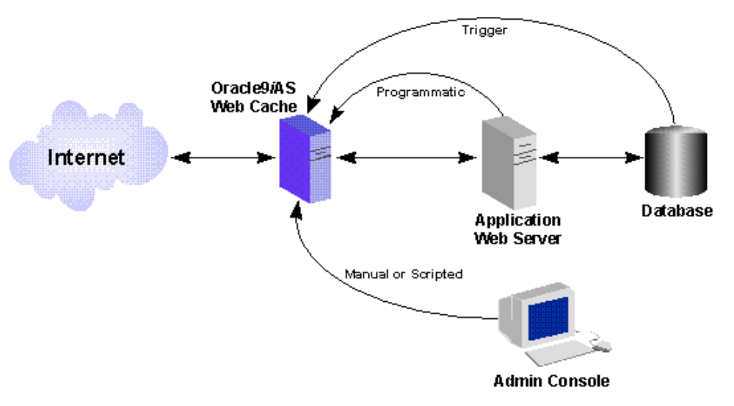

Figure 6: The Oracle9iAS Web Cache Architecture

At the top-level the OHS listener runs at the web server level (sometimes on a separate server) and polls its port for incoming HTTP requests. As each is received, the OHS directs the request to through the payers, where Oracle9iAS extracting the required information from the HTTP request, creates and executes an Oracle database query, prepares an outgoing HTML or XML document, and passed the result set back to OHS for transmission to the requesting client.
At the top-end we see the Oracle9iAS web cache and its’ association with the Oracle HTTP Server (OHS). The OHS components is generally configured first, and is assigned a specific port (usually port 81). Next we configure the web cache and assign it to a port (usually port 80) and configure it to communicate with the OHS on port 81.
The Oracle9iAS web cache us used to speed the delivery of static and dynamic web pages to users over the internet. By employing RAM storage, the web cache is able to keep important web page data instantly available. In the real-world, the web cache stored images (gif’s and jpg’s that are embedded into the outgoing page immediately before transmission.
In a sense, the web cache is analogous to the Oracle databases’ data buffer cache because they both server to store frequently-referenced information. However, unlike the data buffer cache, the web cache only stores information about its current transactions. Hence it must be in constant communication with OHS to create and destroy cached objects as transactions are processes.
Also the Oracle9iAS web cache has built-in compression technology to make the most effective use of RAM storage, and includes Apache extensions that allow you to perform load balancing between the OHS servers.
The web cache content is usually images (gif, jpg) that are included inside the HTML content (via the IMG tag). Initially, these images may be stored inside the Oracle database using the BFILE OR BLOB datatypes, but once fetched from Oracle they will remain cached for subsequent invocations. This initial latency is why many Oracle9iAS users report that the initial loads of their pages are far slower than subsequent transactions. It is important to note that these cached images are shared between instances of the OHS. In other words, once an OHS has loaded the page header and footer images, they remain in the cache where they can be used by transactions inside other OHS instances. This sharing of the web cache is a very important tuning areas for the Oracle9iAS administrator.
The most important of these tasks is the association between the web cache and the OHS. Of course, the Oracle9iAS administrator may change these configurations based on current processing needs. The association between web cache and OHS instances can have a dramatic effect on your performance and you should pay careful attention to the web cache monitoring statistics and make appropriate adjustments. There are pros and cons to each association:
- Many OHS instances per web cache – This is the typical configuration for small and medium-sized systems. The benefits of sharing a web cache is the sharing of common items (e.g. page header jpegs), while the downside is the lack of control over the RAM allocations for a specific OHS. Small and medium sized shops will run all of the web cache instances and the web cache on a single server.

- One web cache per OHS – This isolates the web cache to the specific OHS. The positive are more granular management of the RAM cache, and the downside is the non-sharing of web cache between OHS instances. Many large Oracle9iAS sites give each OHS has its own web cache, both on a separate server from the other OHS instances.

As we recall from Chapter 1, the Oracle9iAS Web Cache performs automatic load balancing between the active OHS servers. However, the Oracle9iAS administrator can keep a “pool” of servers in standby mode with Web Cache and OHS installed on them. Depending on need, you can add them into the Oracle9iAS architecture as an OHS server or a Web cache server.

Oracle9iAS load balancing

Oracle9iAS has several points where load balancing occurs. Within this architecture we have the following areas of load balancing:

- Web cache to HTTP server – The web cache interrogates HTTP server statistics and routes transaction to the least-loaded HTTP server.
- HTTP server to database listener – The HTTP server load balances transactions to multiple database listeners.
- Database Listener to MTS Dispatcher – When using the Oracle multithreaded server (MTS), numerous dispatcher processes funnel transactions to the database. The listener will route an incoming database transaction to the least loaded dispatcher.
- MTS dispatcher to database instance – When using Oracle real application clusters (RAC), the dispatcher can route a database transaction to the least loaded Oracle instance. Each instance in the RAC cluster accesses the same back-end database files.

In addition, we also have the ability to perform hardware load balancing by defining a pool of spare servers and starting either a web cache or an app server on these servers. This allows the Oracle9iAS administrator to re-allocate processing resources depending on the nature of the system load.

For details, see Oracle9i High-Performance Tuning with STATSPACK.

Oracle9iAS Server Load Balancing

Measuring server stress (RAM and CPU) is a critical part of Oracle9iAS tuning. Most Oracle9iAS administrators use the common vmstat utility to monitor server stress because it is common to all dialects of UNIX and easy to invoke and interpret.
When capturing server metrics it is important to note that server-level resource contention is transient and fleeting, and it is often very easy to miss a bottleneck unless we are constantly vigilant. For this reason, we can create an Oracle table that will accept vmstat data from all of our Oracle9iAS servers and collect all data relating to resource contention. The concept behind this collection is to execute the vmstat utility and capture the performance information within an Oracle table called stats$vmstat. While this technique works very well for monitoring the Oracle database server, these operating system statistics can also be used to monitor all of the Oracle9iAS servers in your farm.
If you want to monitor vmstat data on your Oracle database of Infrastructure server, it is quite easy to writer a vmstat scripts that will collect elapsed-time vmstat information and store it inside the oracle database.
Note: You must install the Oracle*Net client software on all of the Oracle9iAS servers with a tnsnames.ora file pointing to the Infrastructure database (iasdb). This establishes connectivity for the vmstat scripts to place entries into your centralized Oracle9iAS repository.

Oracle9iAS Server Load Balancing

Tracking the performance of the UNIX server is critical for the Oracle9iAS administrator because no amount of tuning is going to solve a server-related performance problem. Of course, Oracle9iAS parameter changes may reduce server load, but we always need to pay careful attention to the performance of every server in our Oracle9iAS enterprise.
When tuning an UNIX Oracle9iAS server, we must always remember the goal of fully loading the CPUs and RAM on the server. Unused processing and RAM power can never be reclaimed, and with the significant depreciation of the value of most servers, maximizing the utilization is a noble goal. On any server that is dedicated to a Oracle9iAS component, we want to dedicate as much hardware resources to Oracle as possible without causing a server-related slowdown.
This section will cover the following topics.
- UNIX Monitoring Goals?This section to examine the goals of UNIX server tuning and show tools for displaying UNIX performance metrics.
- Extending vmstat to capture server statistics?Here we will review a method for capturing vmstat data inside tables on the Infrastructure (iasdb) database.
- Reporting on server statistics?This section will look at some handy scripts that will alert you to server exceptions and show you how to create trend and usage reports for your server.
Let’s begin with a brief review of the goals of UNIX server monitoring.

UNIX Monitoring Goals

The monitoring of Oracle9iAS servers involves monitoring disk, RAM, CPU and network components. CPU consumption on an Oracle server is a simple matter because the server manages all CPU transactions automatically. All servers are configured to use CPU cycles on an as-needed basis, and all Oracle9iAS components will use CPU resources freely. The internal machine code will manage the assignment of processors to active tasks and ensure that the maximum amount of processing power is applied to each task.
CPU shortages are evidenced in cases where the CPU run queue is greater than the number of CPUs. In these cases, the only solutions are to increase the number of CPUs on the processor or reduce the CPU demands on the server, mainly by changing configuration parameters or adding another app server. You can also decrease CPU demands on the Oracle database and Infrastructure by turning off Oracle Parallel Query, replacing the standard Oracle listener with the multithreaded server (MTS), and other actions that would reduce the processing demands on the hardware.
Tasks are serviced in UNIX according to their internal dispatching priority. Important tasks such as the UNIX operating system tasks will always have a more favorable dispatching priority because the UNIX system tasks drive the operating system
CPU overload is usually evidenced by high values in the vmstat runqueue column. Whenever the runqueue value exceeds the number of CPUs of the server, some task may be waiting for service. When we see a CPU overload, we have several alternatives:
- Add additional CPUs? This is usually the best solution, because an Oracle9iAS server that is overloading the CPU will always run faster with additional processors.
- Reduce server load/Add more Oracle9iAS servers? If the CPU overload is not constant, task load balancing may be the solution. For example, it is not uncommon to see a server overloaded during peak work hours, and then return to 80-percent idle in the evenings. In these cases, batch tasks can be rescheduled to execute when there are more idle CPU resources available.
- Alter task dispatching priorities? Almost all UNIX operating systems allow the root user to change the dispatching priority for tasks. As a general rule, the online database background tasks are given more priority (a smaller priority value), while less critical batch processes are placed with less priority (a higher priority value). However, altering the default dispatching priorities is not a good long-term solution, and it should only be undertaken in emergency situations.

Upgrading an Entire Server

On mission-critical databases where speed is a primary concern, adding additional processors may not be the best solution. Oracle tuning professionals will sometimes recommend upgrading to faster server architecture. For example, many of the new 64-bit CPU processors will handle Oracle9iAS transactions an order of magnitude faster than their 32-bit predecessors. For example, in the IBM AIX environment, the IBM SP2 processors run on 32 bits. IBM's next generation of processors utilize a 64-bit technology, and these systems can process information far faster than their 32-bit ancestors.
When making recommendations for upgrades of entire servers, many Oracle9iAS tuning professionals use the analogy of the performance of a 16-bit PC compared to the performance of 32-bit PC. In general, moving to faster CPU architecture can greatly improve the speed of Oracle applications, and many vendors such as IBM will allow you to actually load your production system onto one of the new processors for speed benchmarks prior to purchasing the new servers.

Adding Additional CPU Processors

Most symmetric multiprocessor (SMP) architectures for Oracle9iAS servers are expandable, and additional processors can be added at any time. Once added, the processor architecture will immediately make the new CPUs available to the Oracle database.
The problem with adding additional processors is the high cost that can often outweigh the cost of a whole new server. Adding additional processors to an existing server can commonly cost over $100,000, and most managers require a detailed cost-benefit analysis when making the decision to buy more CPUs. Essentially, the cost-benefit analysis compares the lost productivity of the end users (due to the response time latency) with the additional costs of the processors.
Another problem with justifying additional processors is the sporadic nature of CPU overloads. Oracle9iAS servers often experience “transient” overloads, and there will be times when the processors are heavily burdened and other times when the processors are not at full utilization. Before recommending a processor upgrade, most Oracle9iAS administrators will perform a load-balancing analysis to ensure that any batch-oriented tasks are presented to the server at non-peak hours.
Next, let’s look at some of the tools that we can use to monitor server usage.

What to look for in vmstat output

As you can see, each dialect of vmstat reports different information about the current status of the server. Despite these dialect differences, there are only a small number of metrics that are important for server monitoring. These metrics include:
- r (runqueue) The runqueue value shows the number of tasks executing and waiting for CPU resources. When this number exceeds the number of CPUs on the server, a CPU bottleneck exists, and some tasks are waiting for execution.
- pi (page in) A page-in operation occurs when the server is experiencing a shortage of RAM memory. While all virtual memory server will page out to the swap disk, page-in operations show that the server has exceeded the available RAM storage. Any nonzero value for pi indicates excessive activity as RAM memory contents are read in from the swap disk.
- us (user CPU) This is the amount of CPU that is servicing user tasks.
- sy (system CPU) This is the percentage of CPU being used to service system tasks.
- id (idle) This is the percentage of CPU that is idle
- wa (wait—IBM-AIX only) This shows the percentage of CPU that is waiting on external operations such as disk I/O.
Note that all of the CPU metrics are expressed as percentages. Hence, all of the CPU values (us + sy + id + wa) will always sum to 100. Now that we have a high-level understanding of the important vmstat data, let’s look into some methods for using vmstat to identify server problems.
In the example below, we run the vmstat utility. For our purposes, we are interested in the first two columns: the run queue “r”, and the kthr wait “b” column. In the listing below we see that there are an average of about eight new tasks entering the run queue every five seconds (the “r” column), while there are five other tasks that are waiting on resources (the “b” column). Also, a nonzero value in the (“b”) column may indicate a bottleneck.
root> vmstat 5 5
kthr memory page faults cpu
----- ----------- ------------------------ ------------ -----------
r b avm fre re pi po fr sr cy in sy cs us sy id wa
7 5 220214 141 0 0 0 42 53 0 1724 12381 2206 19 46 28 7
9 5 220933 195 0 0 1 216 290 0 1952 46118 2712 27 55 13 5
13 5 220646 452 0 0 1 33 54 0 2130 86185 3014 30 59 8 3
6 5 220228 672 0 0 0 0 0 0 1929 25068 2485 25 49 16 10

The rule for identifying a server with CPU resource problems is quite simple. Whenever the value of the runqueue “r” column exceeds the number of CPUs on the server, tasks are forced to wait for execution. There are several solutions to managing CPU overload, and these alternatives are presented in their order of desirability:
- Add more processors (CPUs) to the server.
- Load balance the system tasks by rescheduling large batch tasks to execute during off-peak hours.
- Adjust the dispatching priorities (nice values) of existing tasks.
To understand how dispatching priorities work, we must remember that incoming tasks are placed in the execution queue according to their nice value. Tasks with a low nice value are scheduled for execution above those tasks with a higher nice value. Now that we can see when the CPUs are overloaded, let’s look into vmstat further and see how we can tell when the CPUs are running at full capacity.

Remember, it is not a cause for concern when the user + system CPU values approach 100 percent. This just means that the CPUs are working to their full potential. The only metric that identifies a CPU bottleneck is when the run queue (“r” value) exceeds the number of CPUs on the server.
root> vmstat 5 1
kthr memory page faults cpu
----- ----------- ------------------------ ------------ -----------
r b avm fre re pi po fr sr cy in sy cs us sy id wa
0 0 217485 386 0 0 0 4 14 0 202 300 210 20 75 3 2
The approach of capturing server information along with Oracle information provides the Oracle9iAS administrator with a complete picture of the operation of the system.
Monitoring RAM Memory Consumption

In the UNIX environment, RAM memory is automatically managed by the operating system. In system with “virtual” memory, a special disk called swap is used to hold chunks of RAM that cannot fit within the available RAM on the server. In this fashion, a virtual memory server can allow tasks to allocate memory above the RAM capacity on the server. As the server is used, the operating system will move some memory pages out to the swap disk in case the server exceeds its physical capacity. This is called a page-out operation. Remember, page-out operations occur even when the database server has not exceeded the RAM capacity.
RAM memory shortages are evidenced by page-in operations. Page-in operations cause Oracle9iAS slowdowns because tasks must wait until their memory region is moved back into RAM from the swap disk. There are several remedies for overloaded RAM memory:
- Add RAM - Add additional RAM to the server
- Reduce Oracle9iAS RAM - Reduce the size of the RAM regions by adjusting the parameters for each Oracle9iAS component

(3)Hourly vmstat Trend Reports

We can average vmstat information by the hour of the day. An average by hour of the day can provide very valuable information regarding times when the server is experiencing stress:
connect perfstat/perfstat;
set pages 9999;
set feedback off;
set verify off;
column my_date heading 'date' format a20
column c2 heading runq format 999
column c3 heading pg_in format 999
column c4 heading pg_ot format 999
column c5 heading cpu format 999
column c6 heading sys format 999
column c7 heading idl format 999
column c8 heading wt format 999
select
to_char(start_date,'day') my_date,
-- avg(runque_waits) c2
-- avg(page_in) c3,
-- avg(page_out) c4,
avg(user_cpu + system_cpu) c5,
-- avg(system_cpu) c6,
-- avg(idle_cpu) c7,
avg(wait_cpu) c8
from
stats$vmstat
group BY
to_char(start_date,'day')
order by
to_char(start_date,'day')
;
Here we see the output from this script and we get the average runqueue and user + system CPU values and wait CPU values, aggregated by hour of the day:
SQL> @rpt_vmstat_hr
Connected.
date runq cpu wt
-------------------- ---- ---- ----
00 0 4 0
01 0 5 0
02 0 3 0
03 0 1 0
04 0 1 0
05 0 1 0
06 0 1 0
07 0 1 0
08 0 1 0
09 0 1 0
10 0 1 0
11 0 1 0
12 0 11 0
13 0 21 0
14 0 23 0
15 0 20 0
16 0 15 0
17 0 20 0
18 0 12 0
19 0 10 0
20 0 5 0
21 0 1 0
22 0 1 0
23 0 1 0
This hourly information can also be extracted into MS-Excel for graphical plotting charts that show trends that may not be evident from a raw observation.

Long-Term Server Analysis and Trending

You can also use the data from stats$vmstat to gather information for long-term trend analysis. This long-term trend analysis is very useful for the Oracle9iAS administrator who must plan for additional app server resources. Knowing the rate at which CPU and memory are being consumed on the server is critical, since there is often a lag time of several weeks between ordering and installing new hardware resources. If you want more detail on using STATSPACK information for management planning, please see my books Oracle High Performance Tuning with STATSPACK, and The Oracle9i UNIX Administration Handbook by Oracle Press.

Daily Server Alert Report

As we have repeatedly noted, the Oracle9iAS administrator is very interested in monitoring conditions on the Oracle database servers, App Servers and the Oracle HTTP servers. This script is generally run daily to report on exceptional conditions within any server in the Oracle environment. The data is collected in five-minute intervals and reported with hourly averages. When the Oracle9iAS administrator finds an out-of-bounds server condition, they can run detailed reports that display the data in five-minute intervals. These scripts from the code depot will produce the vmstat reports on all Oracle9iAS servers.
- run_vmstat.ksh - This is the driver script that submits the vmstat alert report and e-mails the output to the appropriate staff members.
- vmstat_alert.sql - This report provides information on the server conditions that may contribute to poor performance.

Conclusion on server monitoring

The focus of this section has been on the use of the vmstat utilities to monitor the performance of the Oracle9iAS UNIX and Linux servers. The main points of this section include:
- The UNIX vmstat utility provides a wealth of information about the ongoing performance of the Oracle9iAS server.
- The vmstat run queue value (r) can indicate a CPU shortage whenever the run queue exceeds the number of CUs on the server.
- The vmstat page in values (pi) can indicate a RAM memory shortage.
- You can easily define vmstat extension table to hold historical server information and use a UNIX shell script to periodically collect server performance information.
- The UNIX server information can be used to generate alert reports and long-term trend reports.
Paper Conclusion

Oracle9iAS is an extremely complex combination of inter-related servers, programs and database, and the successful Oracle9iAS administrator will automate much of their monitoring and tuning tasks. The main points of this chapter include:
- Hardware resources (server) load balancing is critical to a properly scalable Oracle9iAS environment. The savvy Oracle9iAS administrator will carefully watch system load and add Web Cache of HTTP servers as demand changes.
- You can easily monitor the CPU, RAM and network demands on all of your Oracle9iAS servers and store the details in iasdb extension tables. This allows you to analyze past usage patterns and predict future processing needs.
- Most Oracle9iAS administration in a UNIX environment will use a third-party server monitoring suite, or they can write custom vmstat scripts to capture server performance for Web Cache servers, HTTP Servers, and infrastructure server, and the back-end database servers.
- The dmstool utility provides a great way to capture elapsed-time metrics for detailed performance analysis.
- Oracle9iAS has several GUI-based tools to view performance metrics (aggrespy, web cache administrator), but these tools are not useful for long-term trend analysis.
As an Oracle Press author, I am always looking for interesting comments, feedback and tips. Please feel free to contact me at Don@Burleson.cc.

Donald Burleson Biography

Don Burleson is one of the world’s top Oracle Database experts with more than 20 years of full-time DBA experience. He specializes in creating database architectures for very large online databases and he has worked with some of the world’s most powerful and complex systems. A former Adjunct Professor, Don Burleson has written 20 books, published more than 100 articles in National Magazines, and serves as Editor-in-Chief of Oracle Internals. Don is a popular lecturer and teacher and is a frequent speaker at OracleWorld and other international database conferences.

As a leading corporate database consultant, Don has worked with numerous Fortune 500 corporations creating robust database architectures for mission-critical systems. Don is also a noted expert on eCommerce systems, and has instrumental in the development of numerous Web-based systems that support thousands of concurrent users.

Don’s professional web sites include www.dba-oracle.com and www.remote-dba.net.

In addition to his services as a consultant, Don also is active in charitable programs to aid visually impaired individuals. Don pioneered a technique for delivering tiny pigmy horses as guide animals for the blind and manages a non-profit corporation called the Guide Horse Foundation dedicated to providing Guide horses to blind people free-of-charge. The Web Site for The Guide Horse Foundation is http://www.guidehorse.org/.

Don Burleson’s books include:

- Oracle9iAS Administration Handbook, Donald Burleson & John Garmany, Oracle Press, 2003.

- Creating a self-tuning Oracle database, Donald Burleson, Rampant TechPress, 2003.

- Conducting the Oracle Job Interview, Donald Burleson & Mike Ault, Rampant TechPress, 2003.

- Oracle9i UNIX Administration Handbook, Donald K. Burleson, Oracle Press, 2002, ISBN: 0072223049

- Oracle9i High Performance Tuning with STATSPACK, Donald K. Burleson, Oracle Press, 2002, ISBN: 007222360X

- Oracle Internals, Donald K. Burleson, CRC Press, 2001, ISBN: 084931139X

- Oracle High Performance SQL Tuning, Donald K. Burleson, Oracle Press, 2001, ISBN: 0072190582

- Oracle High Performance Tuning with STATSPACK, Donald K. Burleson, Oracle Press, 2001, ISBN: 0072133783

- Unix for Oracle DBAs, Donald K. Burleson, O’Reilly & Associates, 2000, ISBN: 0596000669

- Oracle SAP Administration, Donald K. Burleson, O’Reilly & Associates, 1999, ISBN: 156592696X

- Inside the Database Object Model, Donald K. Burleson, CRC Press, 1998, ISBN: 0849318076

- High Performance Oracle Data Warehousing, Donald K. Burleson, Coriolis Publishing, 1997, ASIN: 1576101541

- High Performance Oracle 8 Tuning, Coriolis Publishing, 1997

- High Performance Oracle Database Applications, Coriolis Publishing, 1996

- Oracle Databases on the Web, Coriolis Publishing, 1996

- Managing Distributed Databases, Donald K. Burleson, John Wiley & Sons, 1995, ISBN: 0471086231

- Practical Application of Object-oriented Techniques to Relational Databases, Donald K. Burleson, John Wiley & Sons, 1994, ISBN: 0471612251

John Garmany Biography

Colonel John Garmany is a graduate of West Point, an Airborne Ranger and a retired Lt. Colonel with 20+ years of IT experience. John is an OCP Certified Oracle DBA with a Master Degree in Information Systems, a Graduate Certificate in Software Engineering, and a BS degree (Electrical Engineering) from West Point. A respected Oracle expert and author, John was chosen by Oracle Press to write the Oracle9iAS Administration Handbook. John also serves as a writer for DBAZine and Oracle Internals and is the author these popular books:

- Oracle Replication, Rampant TechPress
- Oracle SQL*Plus Reports, Rampant TechPress
- Logical Database Design - Principles & Practices, by CRC Press.
- Oracle9iAS Administration Handbook, by Oracle Press

