Slide 3 - Oracle Field Service Cloud Release 16.2
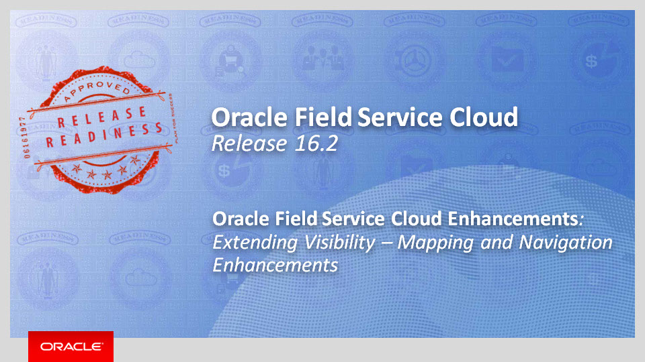
Slide notes
Hello, and welcome to training for Oracle Field Service Cloud, Release 16.2.
In this session, we'll cover the enhancements to OFSC's Mapping and Navigation capabilities.

Notes

Slide 4 - Agenda
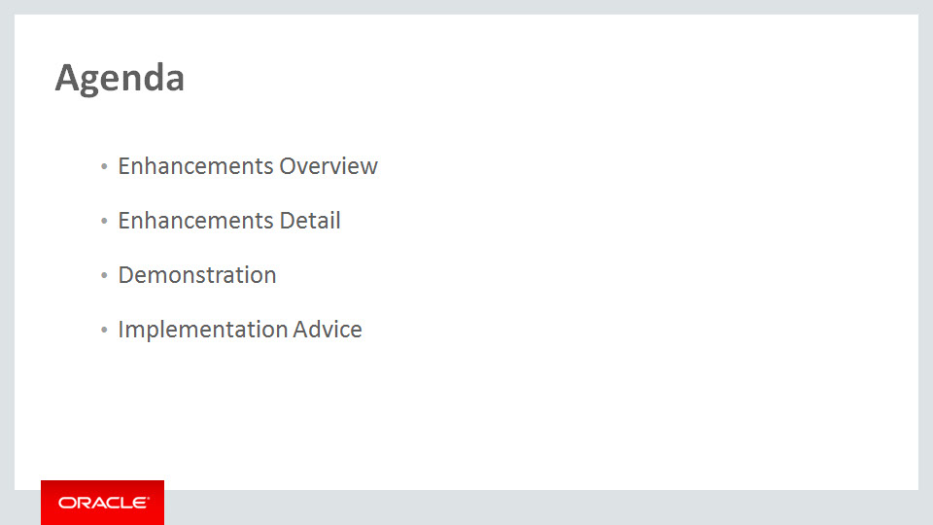
Slide notes
For the enhancements covered in this training, we'll give an overview, followed by more detail to explain how you can use them, and what business value they bring.
Then we'll walk you through a demonstration.
Next we'll explain what you need to consider before enabling these features in your business, and what you need to know to set them up.

Notes

Slide 5 - Enhancements Overview

Slide notes
In Release 16.2 we've introduced several enhancements to the mapping capabilities of Oracle Field Service Cloud (or OFSC).
Oracle Maps and Oracle eLocation Services are now the mapping and geocoding providers for OFSC.
The ability to display custom map layers in OFSC is another new feature enhancing mapping capabilities. These layers can include client-specific locations, assets, or infrastructure.
We've also added the new Metadata API, which introduces a new approach to work zone functionality. This includes allowing customers to create and update Work Zones and to upload Shapefiles of work zones based on customer-designed shapes into OFSC.
Finally, the new Mobility: Team Map includes several new features, including a group map screen where a user, such as a field supervisor, can see locations for groups of resources.

Notes

Slide 6 - Oracle Maps and Geocoding
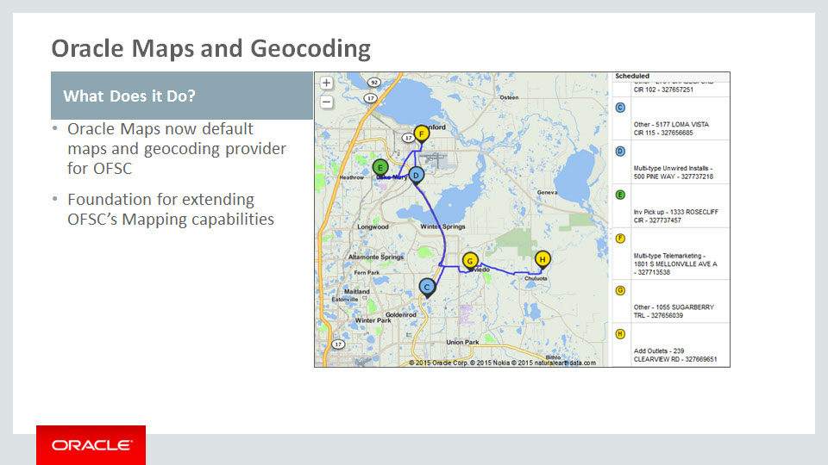
Slide notes
As of release 16.2 Oracle Maps is the provider for OFSC for mapping and geocoding.
This change allows us to create a foundation for future Map-related features that will extend OFSC's mapping capabilities by switching to Oracle MapViewer HTML5.
The additional enhancements we'll cover in this training are part of that foundation.

Notes

Slide 7 - Custom Map Layers
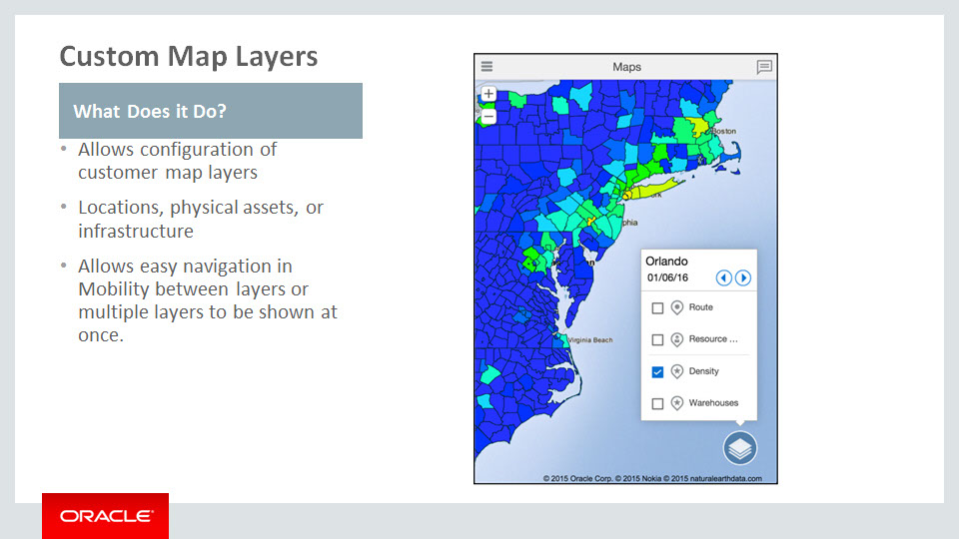
Slide notes
The second feature we'll cover is the Custom Map Layers functionality. It allows remotely hosted MapViewer instances to be used as the source for custom maps that detail specific points of interest, which are then displayed in OFSC.
This includes not only locations, such as warehouses where supplies can be picked up but also physical assets like transformers or poles, and infrastructure such as pipelines and communication networks.
Custom Map Layers can be turned on or off in Mobility for the Activity Details map, the Activity List map, and the Team Map.
All configured external layers are presented on the map, and users can select one or more layers easily. This allows resources to dynamically control their map view as needed, depending on the circumstances

Notes

Slide 8 - Custom Map Layers

Slide notes
The primary benefit of Custom Map Layers is that it empowers field personnel with custom map data. Resources and field managers can see customer-specific points of interest instead of or in addition to geographic location-based maps.
This can be used in conjunction with the new Team Map, which we'll cover shortly, to identify where personnel are relative to specific points of interest.
Resources and field managers can also adjust which map layers are displayed as needed. This allows users to switch between maps or add additional layers to the map display as the situation requires, for even greater versatility.

Notes

Slide 9 - Work Zone Configuration – Metadata API
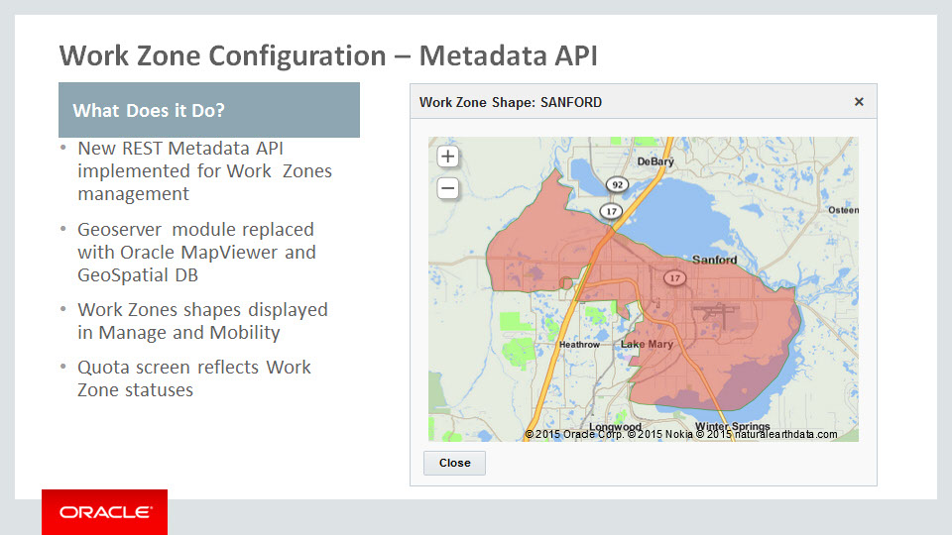
Slide notes
The next feature is the new Metadata API, which has been implemented in order to improve Work Zone functionality. It is a REST-based API that allows customers to create and update Work Zones and to upload Shapefiles into OFSC.
The Geoserver module has been replaced with Oracle MapViewer and Oracle Database with Spatial and Graph extension. These are used as a storage layer for spatial information of work zones.
Work Zone shapes can now be displayed in both the Core Manage and Mobility interfaces.
In the Resource Info screen of the Mobility interface, users will be able to see all assigned work zones for a selected resource as one shape on the Work Zones dashboard card. This allows a manager or field supervisor to get a quick visual representation of the work zones to which an individual resource has been assigned.
In Manage, work zone shapes can be viewed and configured manually in the Work Zone configuration screen. The Resource Work Zone screen shows shapes of assigned work zones, and new zones can be assigned or existing ones removed as needed.
On the Quota screen, work zones with different statuses will be shown in different colors, based on whether the work zones are open or closed as well as the percentage of activities within them.

Notes

Slide 10 - Work Zone Configuration – Metadata API
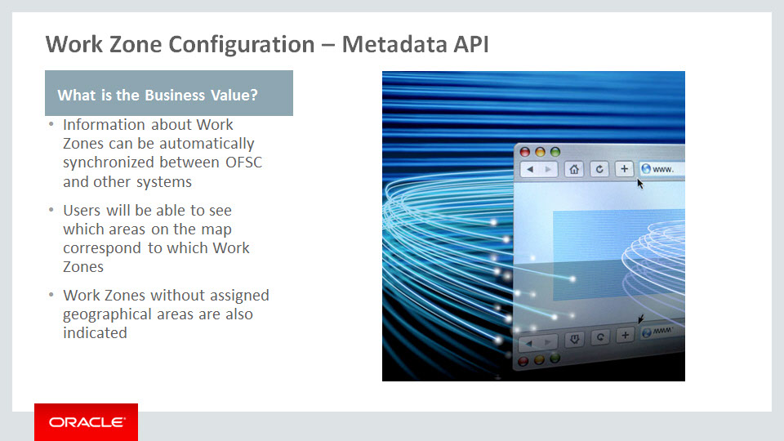
Slide notes
One of the key benefits of the Metadata API is that the information about work zones can automatically be synchronized between OFSC and other client systems. Updates can include adding new work zones or modifying existing ones, changing relationships between work zones and work zone keys, or changing relationships between work zones and shapes.
In addition, users in the Work Zone configuration screen can see indications for each work zone whether it has a geographic area associated with it or not.

Notes

Slide 11 - New Screen in Mobility: Team Map
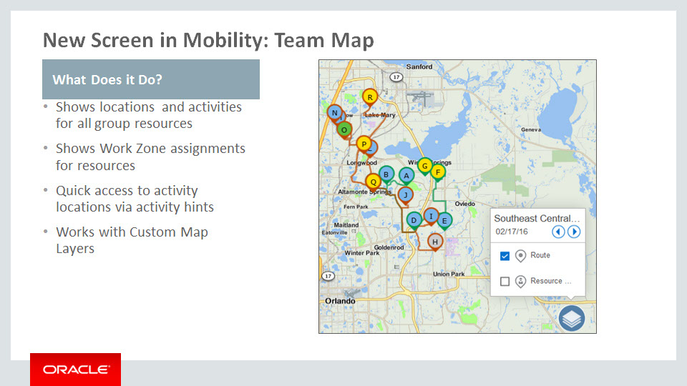
Slide notes
The final map enhancement we'll cover is a new screen in Mobility, called the Team Map.
Available via the Map action link in Mobility, the Team Map provides a supervisor or field manager the ability to see location-related information for a specific group of resources.
Groups can be created from any of the resources the user can see.
A supervisor can see current resource location as well as all activities on a route for each resource. A supervisor can see where in a route's progression a particular resource is, which activities have been completed and in what order, which are active, and which are still pending. Home zones, as well as starting and ending locations and for each resource can now be viewed in Mobility as well.
Graphic representations of work zone assignments can be found on the Resource Info dashboard.
Users can also view an activity's position through an activity hint.
And the new Team Map screen works with the Custom Map Layers functionality as well, so a supervisor can see where resources are relative to the client's infrastructure as well as geographically.

Notes

Slide 12 - New Screen in Mobility: Team Map
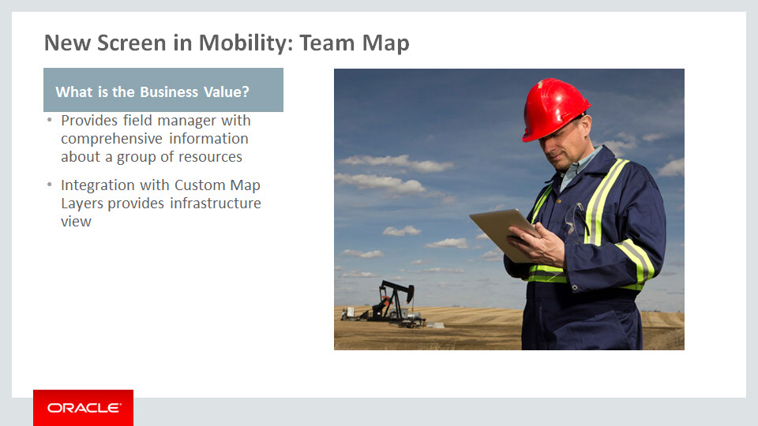
Slide notes
The main value of this feature is that it provides field managers with a map where they can see comprehensive information about a group of resources. Armed with that information, they can make better-informed decisions.
Lastly, given that the Custom Map Layers feature works with the new Team Map, it's possible for a field manager to review resource location and activities based on a client's own infrastructure as well as geographically. If a client had a custom map layer based on a network of pipes, for example, resource locations could be identified by the network standards.

Notes

Slide 60 - Summary of Enhancement Capabilities
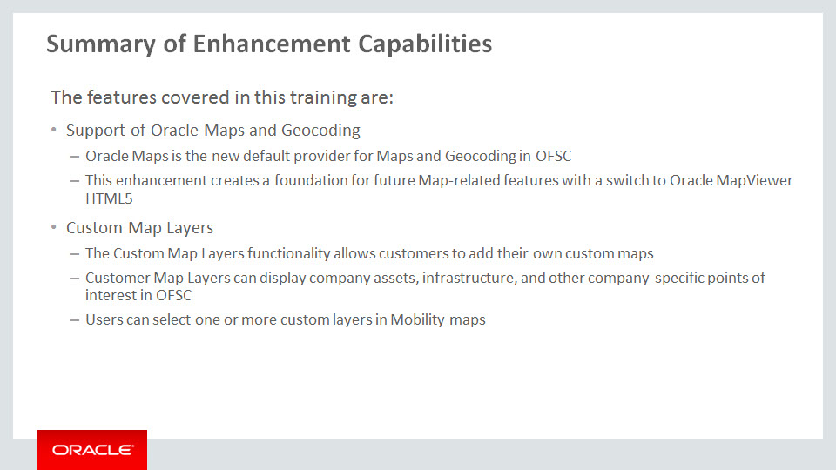
Slide notes
Here is a summary of the features we’ve covered today:
With Release 16.2, Oracle Maps is the new default Maps and Geocoding provider. This enhancement creates a foundation for future Map-related features that will extend OFSC's mapping capabilities by switching to Oracle MapViewer HTML5.
The Custom Map Layers functionality allows customers to add their own maps, to display company assets and infrastructure as well as other company-specific points of interest.
The custom layers are viewable in Mobility and users can select one or more layers easily for full control.

Notes

Slide 61 - Summary of Enhancement Capabilities
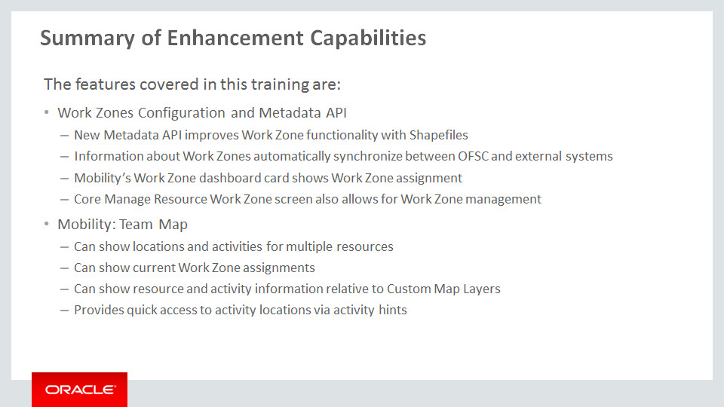
Slide notes
Work Zone functionality has been improved and it is supported by the new Metadata API. Customers can now create and update Work Zones and upload Shapefiles to OFSC via API. Information about work zones can also be automatically synchronized between OFSC and external client systems.
The new approach to Work Zones Configuration allows Work Zone shapes to be displayed in both the Core Manage and Mobility interfaces.
Assigned work zones for a selected resource are shown on the Work Zones dashboard card in Mobility.
Work Zone assignments can also be managed on the Core Manage Resource Work Zone screen.
The New "Team Map" screen in Mobility can also show Field Managers locations and activities for multiple resources.
It can also show current work zone assignments for resources and allow new work zone assignments.
Working in conjunction with Custom Map Layers, it can also show resource and activity information relative to company-specific maps.
Finally, quick access to activity locations is available via activity hints.

Notes

Slide 62 - Additional Information
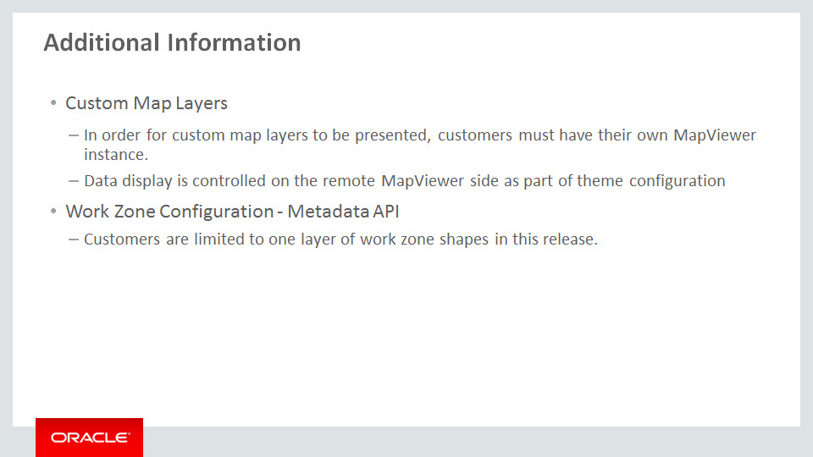
Slide notes
Please be aware that in order for custom map layers to be presented, customers must have their own MapViewer instance.
How the data will display is controlled on the remote MapViewer side, as part of theme configuration. For example, the thickness and color of the lines in the case of pipelines or pins or icons in the case of Points of Interest.
In release 16.2, customers may only have one layer of work zone shapes. The ability to have additional layers will be added in a future release.

Notes

Slide 63 - Implementation Advice

Slide notes
In this implementation advice section we will go through what you need to consider before enabling these features in your business, and what you need to know to set them up.

Notes

Slide 64 - Feature Impact Guidelines
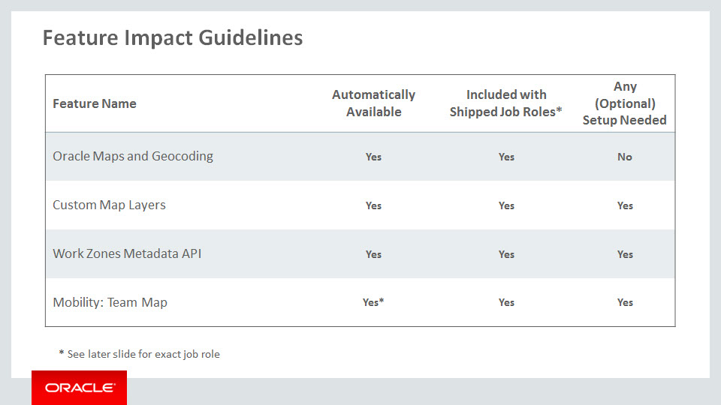
Slide notes
This table lists key upgrade information for the new features covered in this training.
Oracle Maps and Geocoding is automatically set as the Mapping and Geocoding provider. The feature is accessible by the shipped job role but no additional set up is required or available.
The Custom Map Layers functionality is automatically available and accessible by the shipped job role. Additional setup is required to add individual Custom Map Layers.
While the Work Zone Metadata API is inherently available with the 16.2 release, minor configuration is required to enable access to it via the Core Manage interface.
The shipped job role does have the necessary access for this configuration. Additional setup tasks are required for integrating the Work Zone Metadata API with external systems. Integrators should refer to the SDK for instructions on how to use it to address specific use cases or workflows.
The Mobility: Team Map is automatically available as part of the Mobility module. Minor configuration changes are required to make the Team Map available to individual user types. The shipped job role is able to make those necessary changes.

Notes

Slide 65 - Job Roles
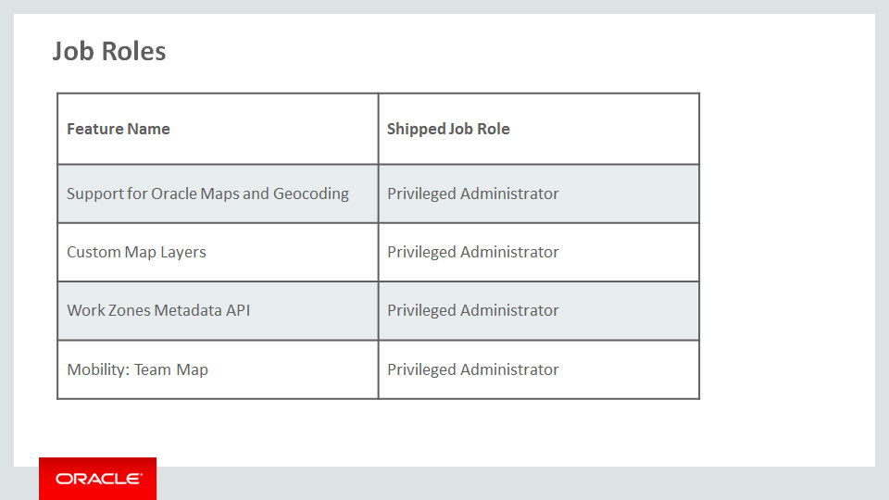
Slide notes
This table details the shipped job roles that will access the new capabilities covered in this training.
The single job role that every instance of OFSC will have is the Privileged Administrator role.
Customers can create additional job roles that will have access to either or both features, provided the role has access to the company Business Rules screen and the appropriate configuration.
Security roles have not changed as a result of these enhancements.

Notes

Slide 66 - Business Process Model Information
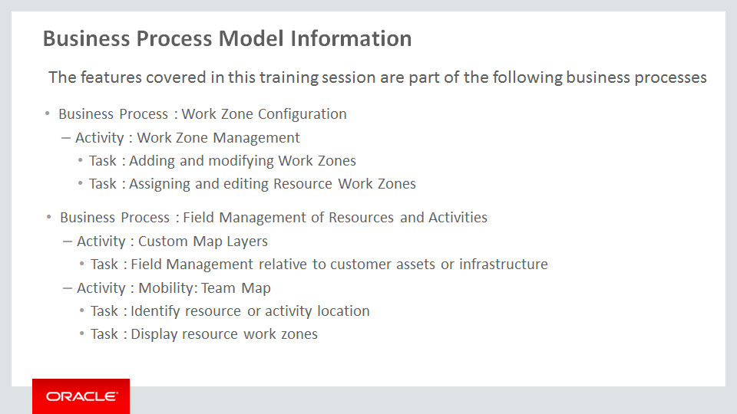
Slide notes
The business processes associated with the new capabilities covered in this training are detaiThe business processes associated with the new capabilities covered in this training are detailed here.
The Metadata API can be used as part of the Work Zone configuration process. The specific tasks involved would be adding and modifying customer-specific Work Zones, and assigning and editing the Work Zones assigned to Resources.
Custom Map Layers and the new Mobility: Team Map are used in the management of resources and activities in the field.
Custom Map Layers would be used to manage field resources relative to specific customer assets or infrastructure.
The Mobility: Team Map can be used to identify resource or activity location and to display resource work zones.

Notes

