Slide 3 - Oracle Project Portfolio Management Cloud Release 9
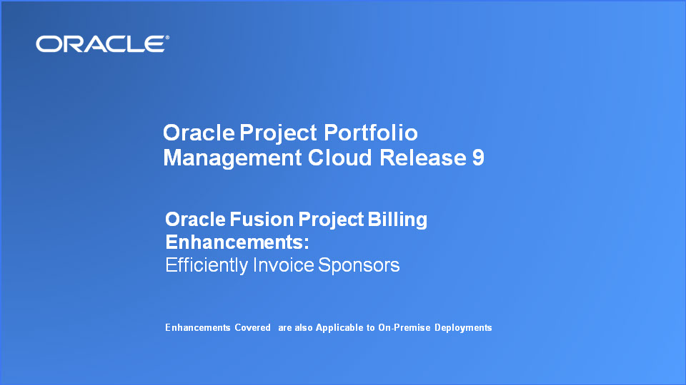
Slide notes
Hello, my name is Shawn. Welcome to the Release 9 Training for Oracle Project Portfolio Management Cloud Project Billing Enhancements. In this session, I’ll cover the revenue recognition and invoice generation for awards and Contract Amendment enhancements we have made in this release.

Notes

Slide 4 - Agenda

Slide notes
For the enhancements covered in this training, I'll give an overview, followed by more detail to explain how you can use them, and what business value they bring.

Then I'll walk you through a demonstration of the features being presented.

Notes

Slide 5 - Enhancements Overview

Slide notes
In this presentation, I’ll show you how you can efficiently manage award billing and continue to bill your customers even though their contract is under amendment.
The new invoice and revenue method simplifies billing and recognizing revenue, at cost. This ensures that sponsors are billed accurately and saves time to manually reconcile cost with billed and revenue recognized amounts
You can also set up awards to bill sponsors by their letter of credit number and document number, thus enabling you to analyze letter of credit drawdown by a particular letter of credit number
The application automatically creates federal SF270 forms by calculating and appropriately formatting invoices for federal sponsors
Lastly, you can invoice and recognize revenue on contracts which are under amendment

Notes

Slide 6 - Invoice and Recognize Revenue at Cost Accurately
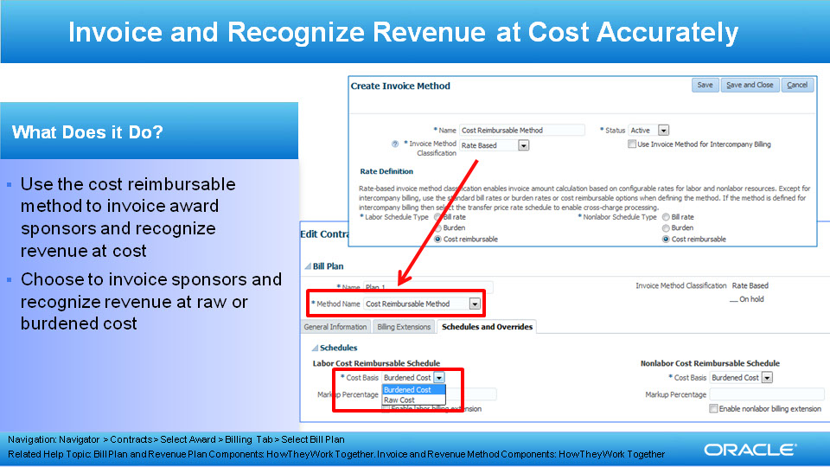
Slide notes
Grants administrators can set up award contracts to invoice sponsors at cost using the new cost reimbursable option in the rate-based invoice and revenue method.

This feature is also available for use in non-Grants management implementations.

Notes

Slide 7 - Drawdown Funds Efficiently Using Letter of Credit
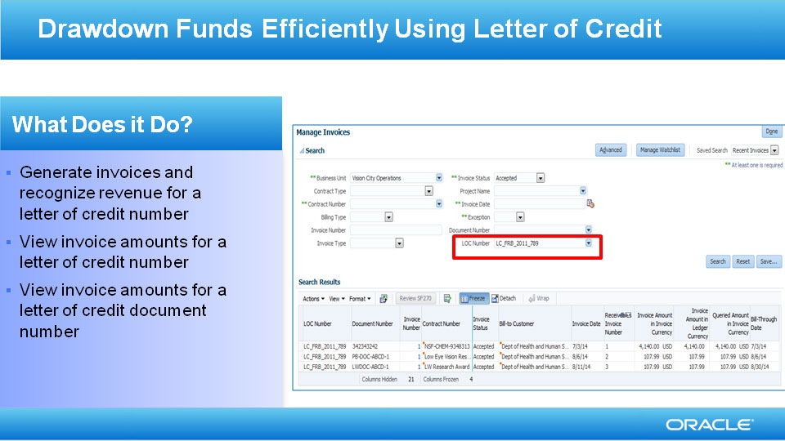
Slide notes
We have streamlined the setup and processing projects being funded by a letter of credit.

Invoices and revenue for awards which need to bill by letter of credit will be identified with the sponsor’s letter of credit and document number, thus providing billing accuracy and enabling you to perform letter of credit drawdown using the letter of credit number.

Notes

Slide 8 - Create Federal Standard Form 270 Automatically
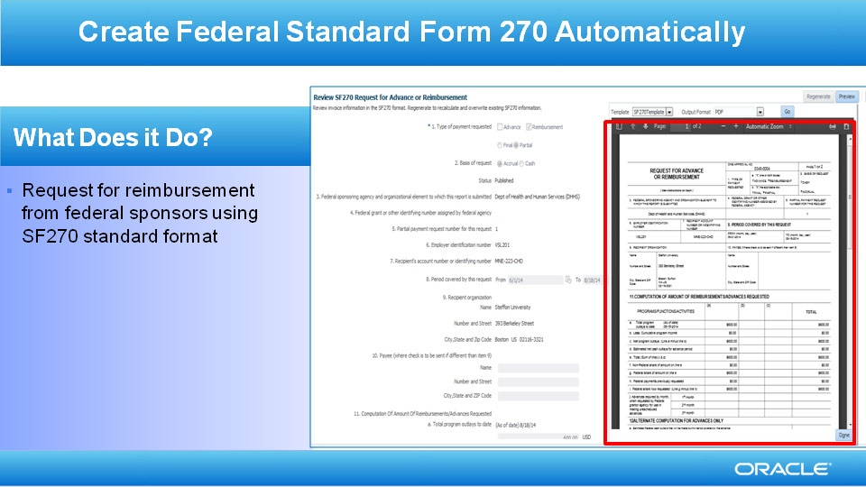
Slide notes
Grants administrators can confidently produce accurate SF270 forms because data from Oracle Fusion Project Costing seamlessly integrates with the form. Productivity is also improved because the form is automatically created with the ability to review the content before final creation. Once reviewed the document Grants administrators can simply export the preformatted document to PDF or print it.

Notes

Slide 9 - Bill Contracts Under Amendment

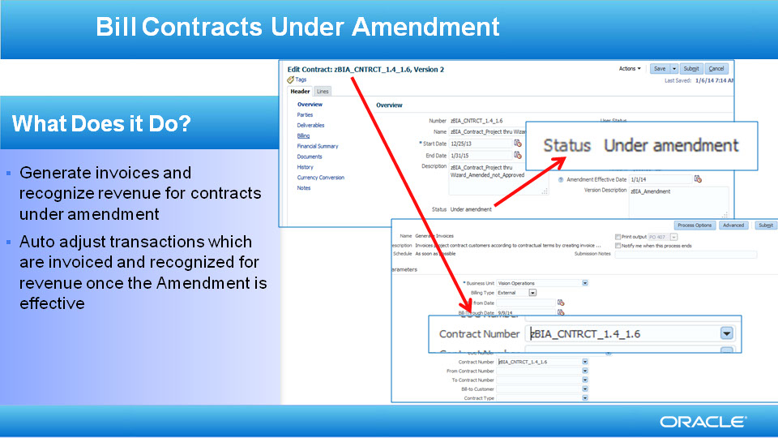
Slide notes
Invoicing and revenue recognition processes have been enhanced to include contracts which are being amended, thus ensuring that you can continue billing your customers while their contracts are being negotiated.

Cost transactions which have been invoiced or revenue recognized but whose transaction date are after the amendment effective will automatically be marked for adjustment. These transactions will re-invoiced and recognized for revenue based on the billing details in the amended contract.

Notes

Slide 10 - Efficiently Invoice Sponsors

Slide notes
In summary, the enhancements made to Oracle Fusion Project Billing enables Grants Administrators, Accountants and Project Billing Specialists to have better control of Grants Award Billing. The enhanced control over billing and the simplicity of setting it up ensures accuracy and increases the efficiency of generating invoices and recognizing revenue.

Since the application automatically uses the cost reimbursable option to create award contracts and ensures sponsors are billed at cost, grants administrators don't have to do any rate configurations. They can track all invoices and also perform letter of credit analysis using Microsoft Excel. The application automatically generates SF270 documents that can be printed and sent to sponsors.

Notes

Slide 19 - Summary of Enhancement Capabilities
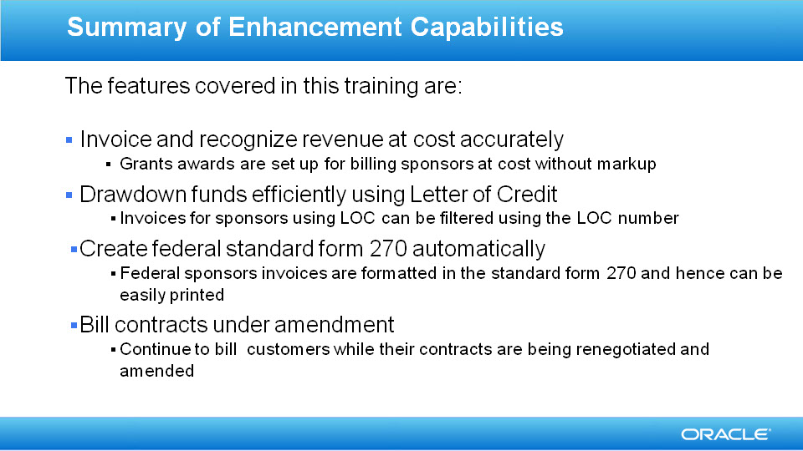
Slide notes
In summary, Oracle Fusion Project Billing has the following enhancements to manage award billing in Release 9:
With the help of the new cost reimbursable billing method you can invoice and recognize revenue at cost accurately without the need of elaborate rate configuration
Efficiently track your award billing by letter of credit
Easily print invoices in the federal standard format
Bill your customers even while their contracts are being renegotiated

Notes

Slide 20 - Implementation Advice

Slide notes
So that concludes the audio portion of this presentation, thank you for listening. There is no audio in the implementation advice section.

You can easily pause and rewind any of these slides if you require additional time to take in the detail.

Notes

Slide 21 - Feature Impact Guidelines
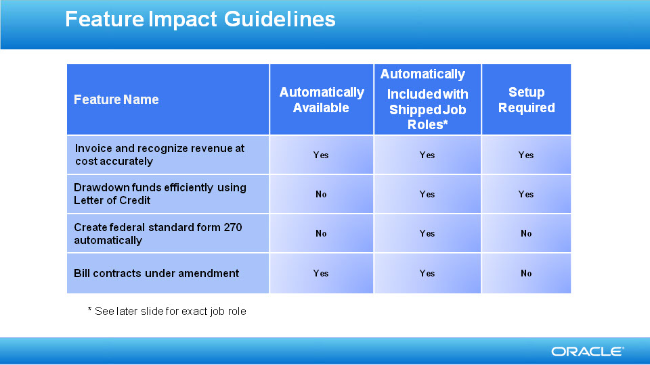
Slide notes

Notes

Slide 22 - Setup Summary
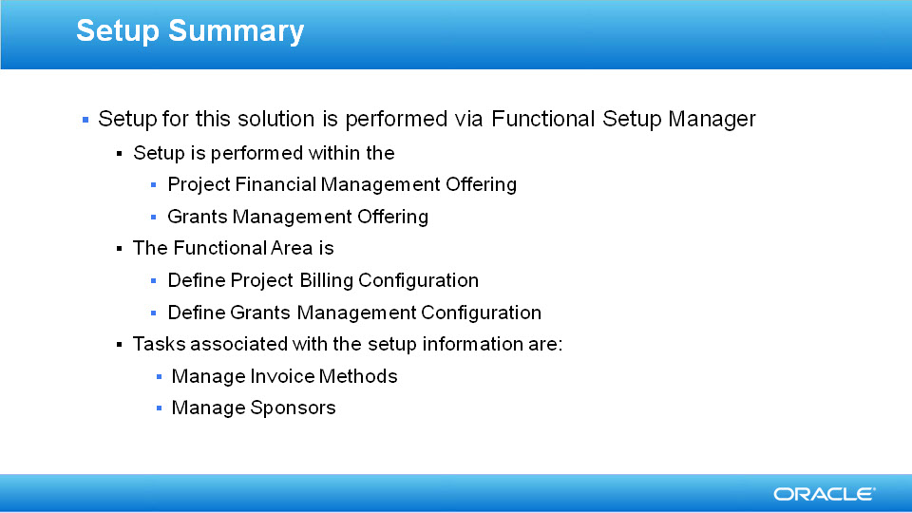
Slide notes

Notes

Slide 23 - Billing and Revenue Recognition at Cost Setup Detail

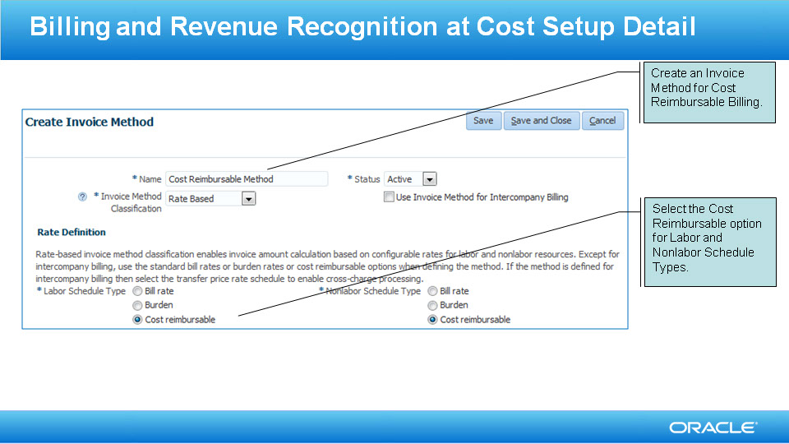
Slide notes

Notes

Slide 24 - Drawdown Funds using Letter of Credit Setup Detail
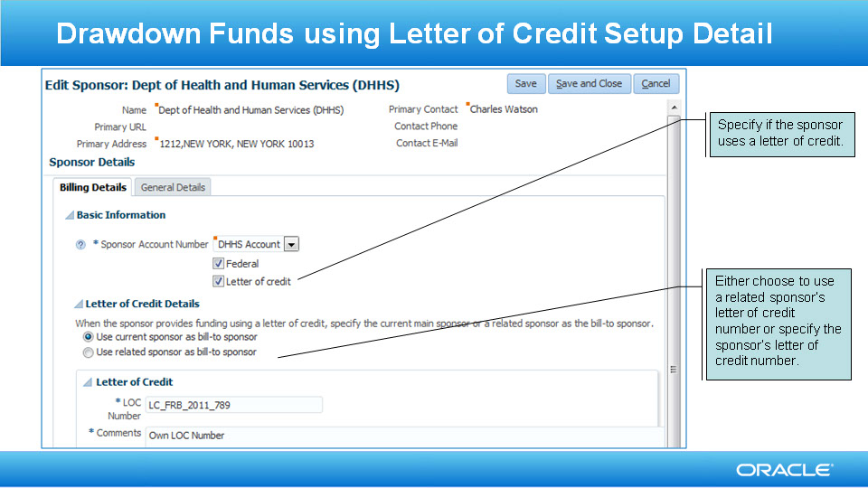
Slide notes

Notes

Slide 25 - Job Roles & Associated Duty Roles
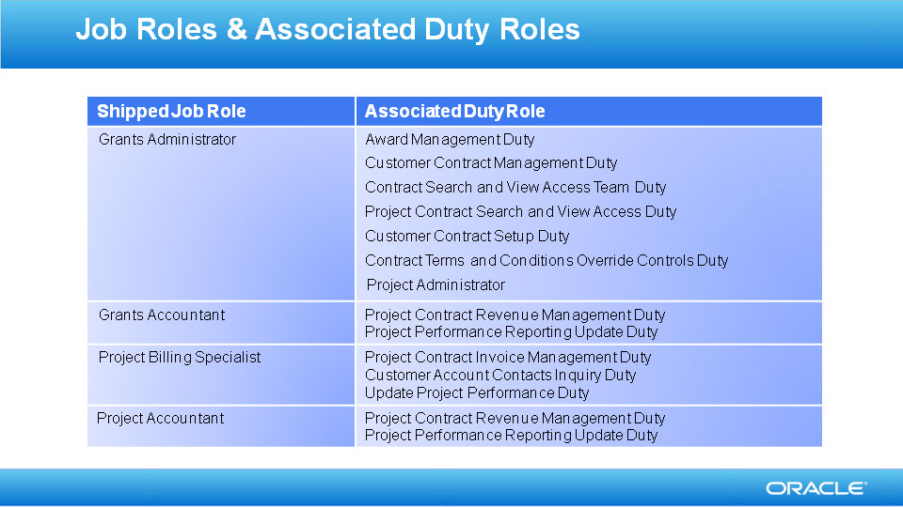
Slide notes

Notes

Slide 26 - Business Process Model Information

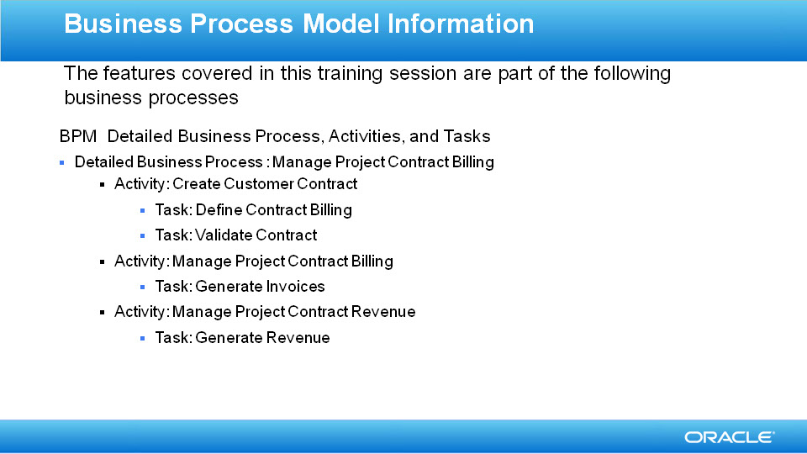
Slide notes

Notes

Slide 27 - Business Process Model Information

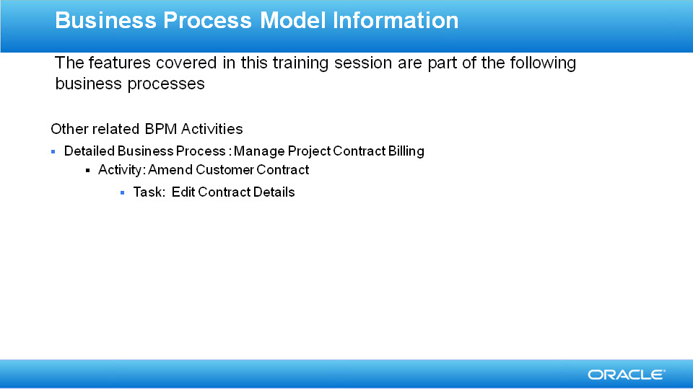
Slide notes

Notes

Slide 28 - Associated Release Training
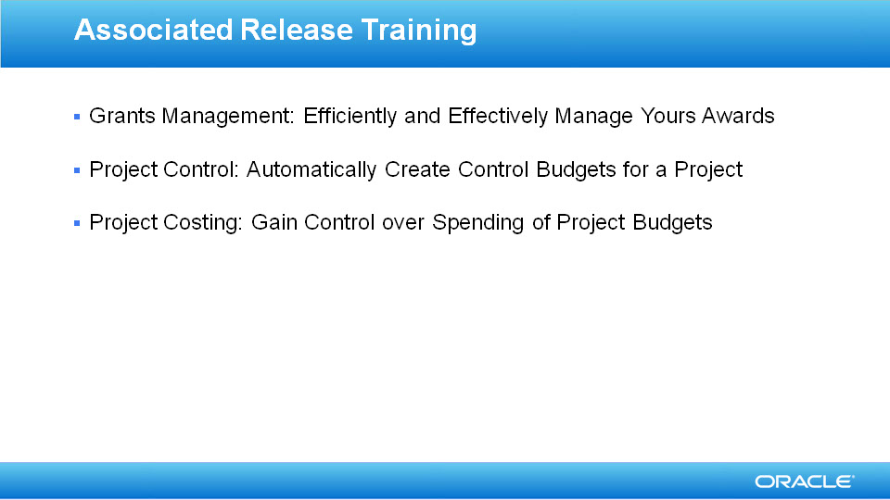
Slide notes

Notes

