Slide 4 - Oracle Project Portfolio Management Cloud Release 9
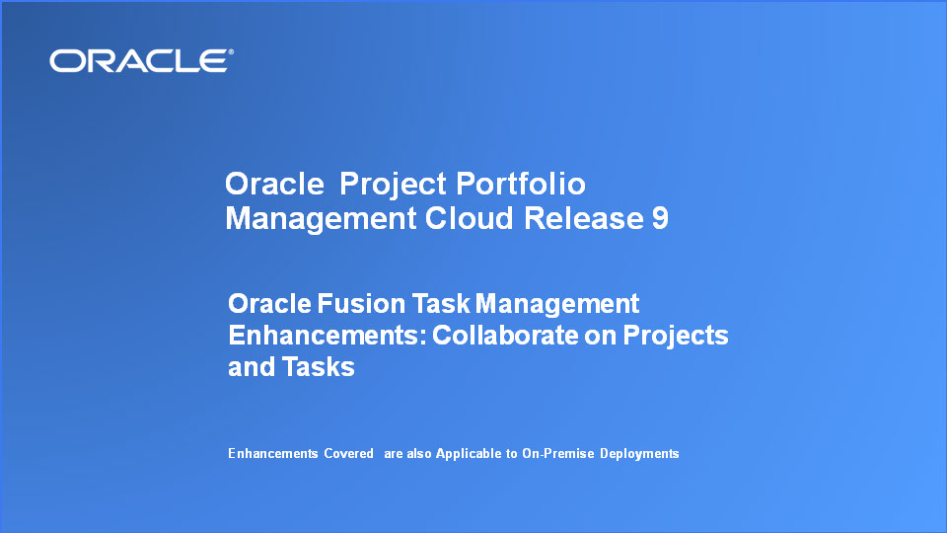
Slide notes
Hello, my name is Alice. Welcome to the Release 9 Training for Oracle Fusion Project Portfolio Management Cloud - Oracle Fusion Task Management Cloud Service Enhancements. In this session, we’ll cover the Collaborate on Projects and Tasks enhancements we have made in this release.

Notes

Slide 5 - Agenda
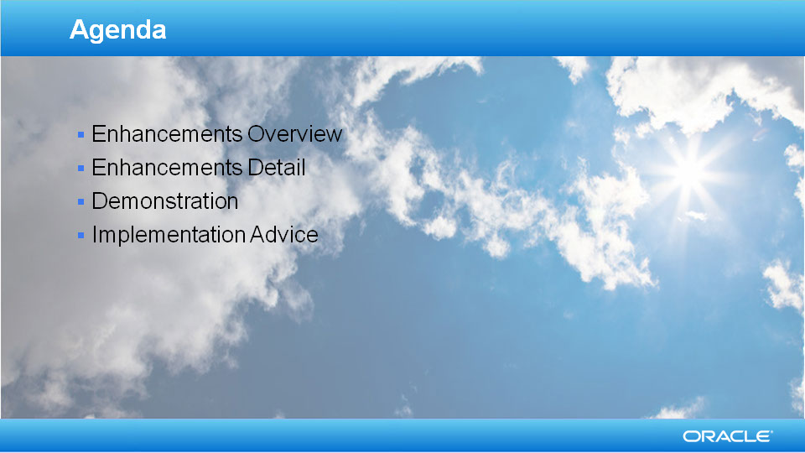
Slide notes
For the enhancements covered in this training, I’ll give an overview, followed by more detail to explain how you can use them, and what business value they bring.

Then I’ll walk you through a demonstration.

Next I’ll explain what you need to consider before enabling these features in your business, and what you need to know to set them up.

Notes

Slide 6 - Enhancements Overview
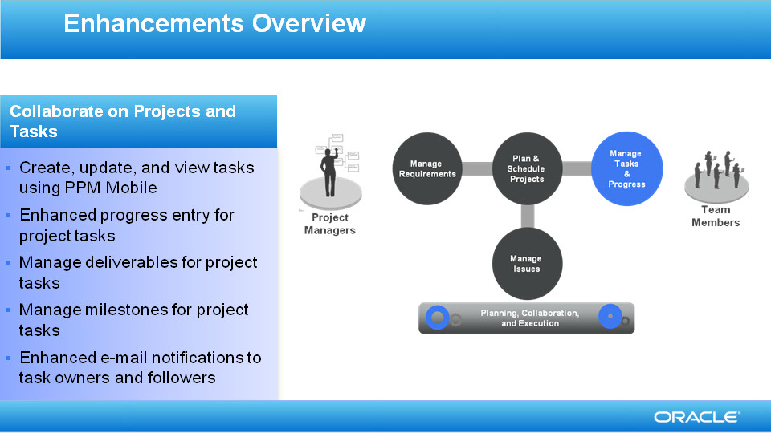
Slide notes
I will show you how the new features in Oracle Fusion Task Management Release 9 help you to collaborate more efficiently on projects and tasks, anywhere and anytime. You can now manage your tasks on the go, with the PPM Mobile application.
You can view your task list on your iPhone to decide what you should do next, update tasks while you're waiting for an elevator, or create tasks while you walk between meetings so you won't forget a thing. We put a lot of focus on simplicity and usability, and we hope the mobile application will greatly improve your productivity as a team member.
We also added support for different ways for you to enter progress for project tasks. You can enter progress by percent complete, actual hours or remaining hours. You can also propose new total hours.
Additionally, you can manage deliverables for project tasks, and manage milestones as a new task type.

We also improved e-mail notifications so you can benefit more from the messages. The more detailed e-mail subject headers help you to understand what the e-mails are about without even opening them.

Notes

Slide 7 - View Task List from Mobile Devices
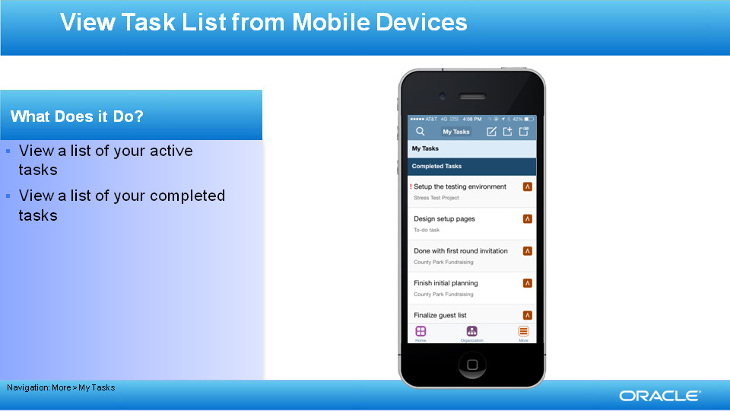
Slide notes
First of all, let’s take a look at the PPM Mobile application. You can install it from the Apple App Store by searching for “Oracle Tap”. Sign into the application, then navigate to My Tasks. From there you can see what tasks you are assigned to work on. By default, you'll see a list of active tasks that you need to work on, and you can also switch to see a list of your recently completed tasks.

Notes

Slide 8 - Filter and Search for Tasks on Mobile Devices
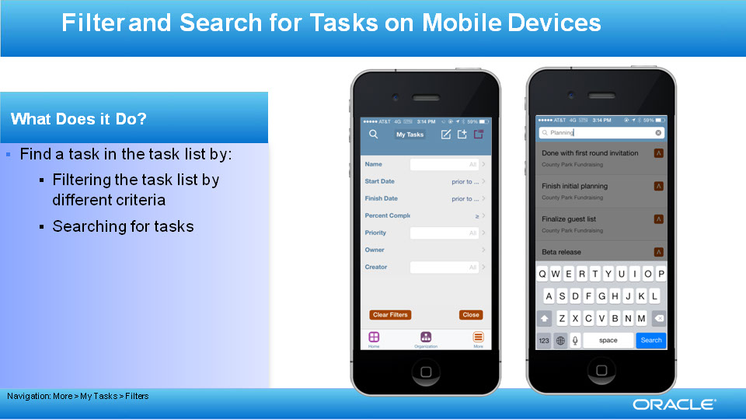
Slide notes
Sometimes if you have too many tasks, it is hard to find the task you want. PPM Mobile makes it easy for you in these two ways: either narrow down the list by applying different filters in the filters pop-up, or search for it in the search bar. You can filter by task name, project name, start date, finish date, priority and creator. You can filter by percent complete if you are looking for project tasks. You can also turn on the Exceptions filter so only tasks with schedule exceptions such as overdue will show up. You can search for tasks by task, project or creator.

Notes

Slide 9 - View Task Details from Mobile Devices
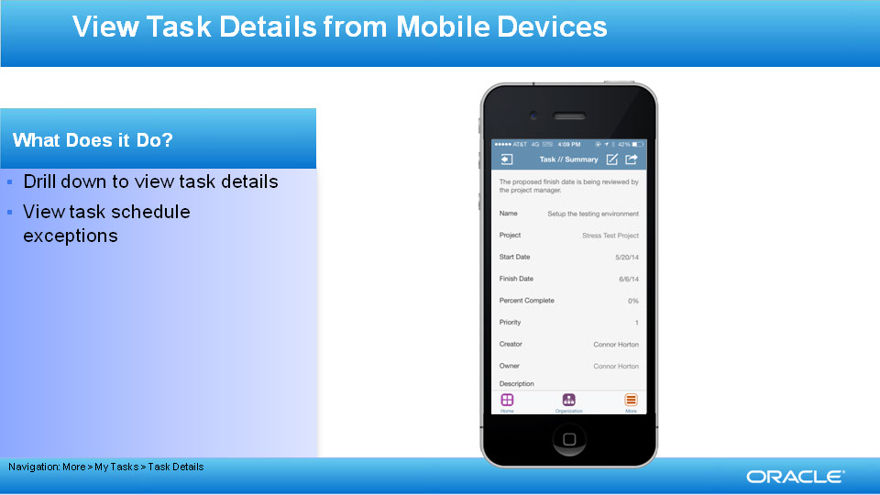
Slide notes
You can find more detailed information about the tasks by drilling into them to see the task details. You can see task name, project name, start date, finish date, priority, creator, owner and description of the task. You will also see the percent complete for project tasks. Schedule exceptions appear at the top of the task details page to remind you if the task is past the start date, is overdue or has some fields that are awaiting the project manager’s approval.

Notes

Slide 10 - Update Tasks from Mobile Devices
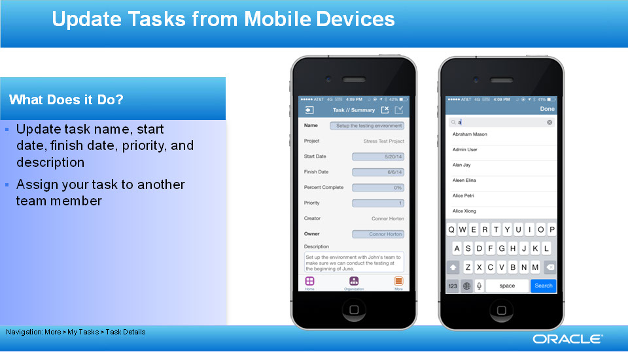
Slide notes
Apart from being able to view the information, you can also make updates conveniently from the mobile application. You can update the task name, start date, finish date, priority, and description. The task description field expands for long descriptions. You can also assign a task to another team member.

Notes

Slide 11 - Enter Task Progress from Mobile Devices
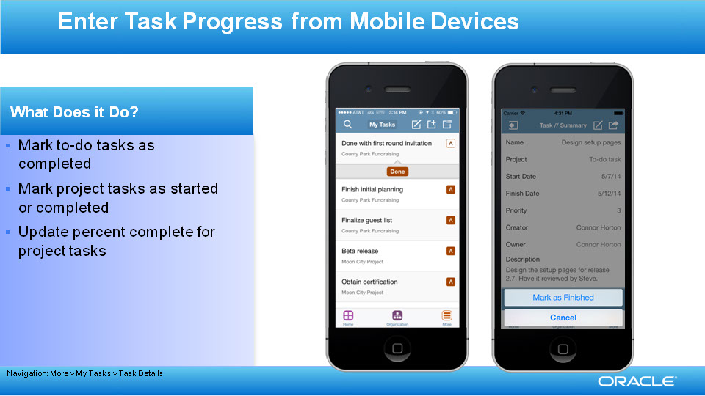
Slide notes
Reporting progress on your tasks becomes easier than ever as you do it directly from your phone. You can mark To-Do tasks as completed through the actions pop up window within the task details, or through the actions drop down in the task list. You can mark project tasks as started, and mark project tasks that are already in progress as completed. You can also directly update percent complete for project tasks if you want to give a more precise estimation of progress on your project tasks.

Notes

Slide 12 - Create To-Do Tasks
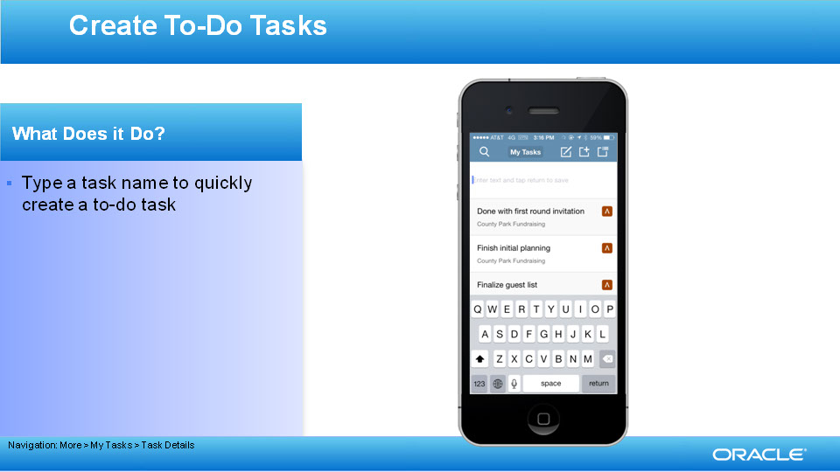
Slide notes
When you’re on the go, you can create a to-do task for yourself very conveniently by typing the task name. You can quickly create multiple tasks at once. You can go into the task details of these new tasks later to update more information if you want to.

Notes

Slide 13 - Create, Update, and View Tasks Using PPM Mobile
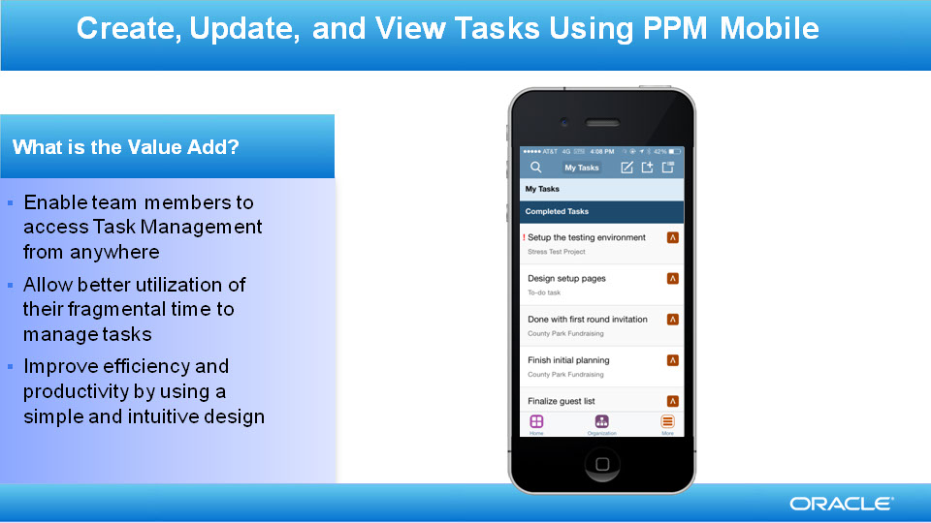
Slide notes
The PPM Mobile application takes collaboration to a new level. Team members can manage their tasks conveniently anywhere and anytime. They no longer have the obligation to turn on their computers to look at what they need to do next. Directly from their iPhones, they can find out what to do next, make updates, report progress, and create new tasks while waiting for meetings or the subway. The application is simple and intuitive, and improves work efficiency.

Notes

Slide 14 - Update Percent Complete for Project Tasks
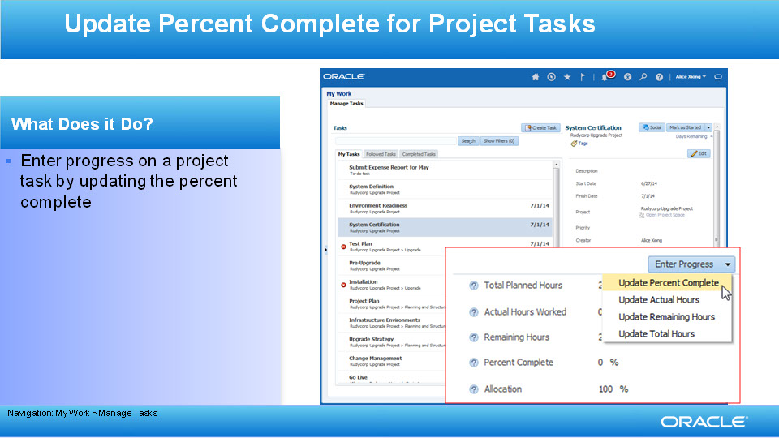
Slide notes
Next, I would like to talk about the enhancements we made to the Web application. In Release 9, we offer several different ways to enter progress on your project tasks. If you prefer to enter progress by estimating the percentage, you can update the Percent Complete. A task will be marked as completed if you update the Percent Complete to 100%.

Notes

Slide 15 - Update Actual Hours for Project Tasks
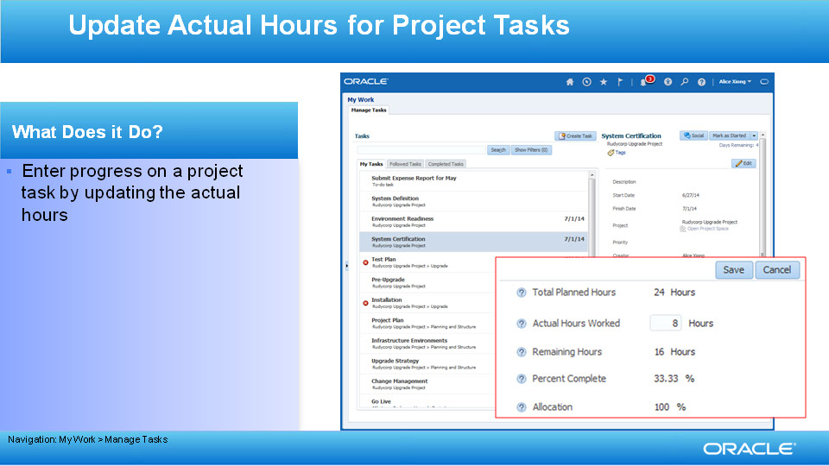
Slide notes
If you want to enter the actual number of hours that you worked on a task, you can update the Actual Hours Worked. A task will be marked as completed if you update the Actual Hours Worked to the same value as the Total Planned Hours.

Notes

Slide 16 - Update Remaining Hours for Project Tasks
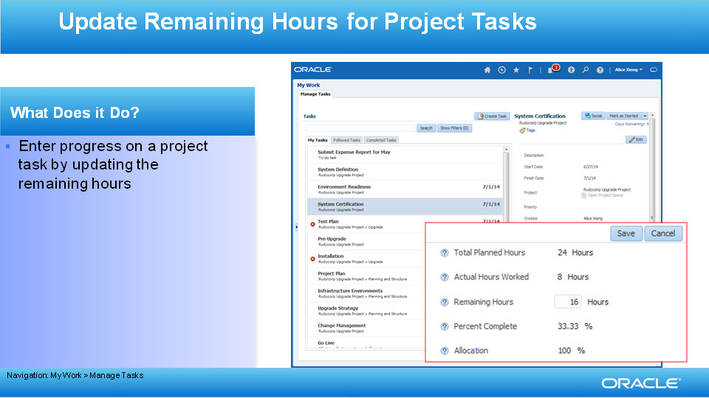
Slide notes
Alternatively, if you want to keep track of progress by the remaining hours left on a task, in a more agile way, you can update the Remaining Hours. The Actual Hours and Percent Complete fields will be updated automatically. A task will be marked as completed if you enter 0 hours in the Remaining Hours field.

Notes

Slide 17 - Propose Total Hours for Project Tasks
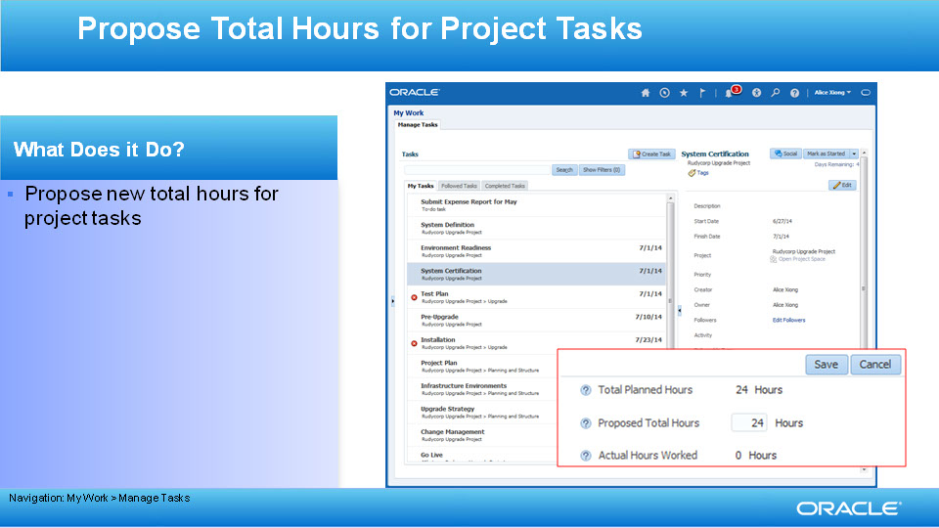
Slide notes
As a team member, often you have a better idea than the project manager about how much time a task will require. You can propose a new value for the total hours needed to work on a task by updating the Proposed Total Hours. If the newly proposed value is within the threshold set by the project manager, the proposed value will be accepted immediately. However, if the proposed change is out of the threshold, a schedule exception message will show up at the top saying: “The project manager is reviewing the proposed planned hours for the task.” This way you can share your knowledge of tasks with your project manager and contribute to the collaborative planning practice.

Notes

Slide 18 - Enhanced Progress Entry for Project Tasks
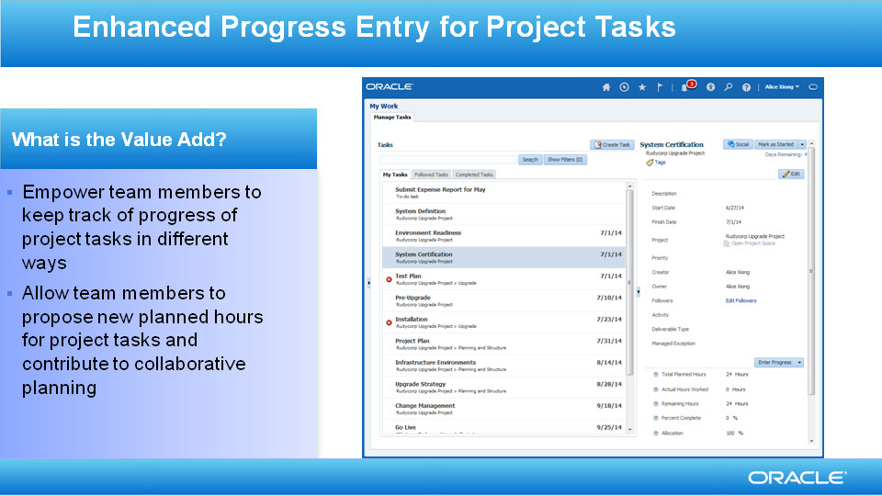
Slide notes
The enhanced progress entry methods for project tasks empowers team members to keep track of progress of project tasks in a more flexible way depending on the need. Besides, team members can help project managers with work estimates by proposing the total hours needed to finish the tasks. This collaborative planning can increase your planning accuracy, and significantly improve your team's productivity.

Notes

Slide 19 - View, Update and Create Deliverables for Project Tasks
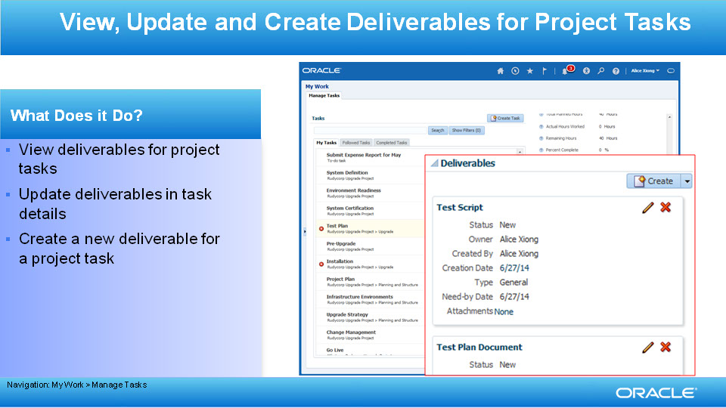
Slide notes
In Release 9, we have also introduced Deliverables for Task Management. Project deliverables are the output produced after completing a project or task. A deliverable can result from the need to satisfy an external contractual obligation, or the need to fulfill an internally-planned activity.

You can manage deliverables for project tasks. You can view the deliverables that are associated to a project task, and update deliverables. You can also create a new deliverable for a project task, or associate an existing deliverable to it by search-and-add.

Notes

Slide 20 - Manage Deliverables for Project Tasks
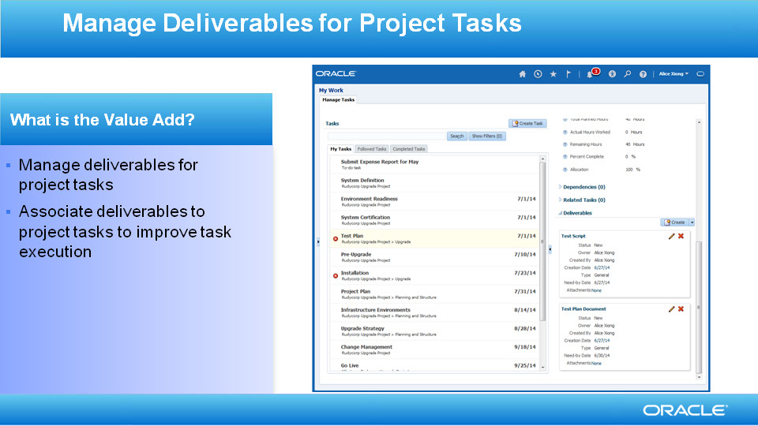
Slide notes
With this enhancement, team members can manage deliverables for their project tasks directly from Task Management. As a team member, you can work on deliverables that the project manager assigned to you, or you can associate deliverables to tasks, and improve the execution of your tasks.

Notes

Slide 21 - View Milestones for Project Tasks
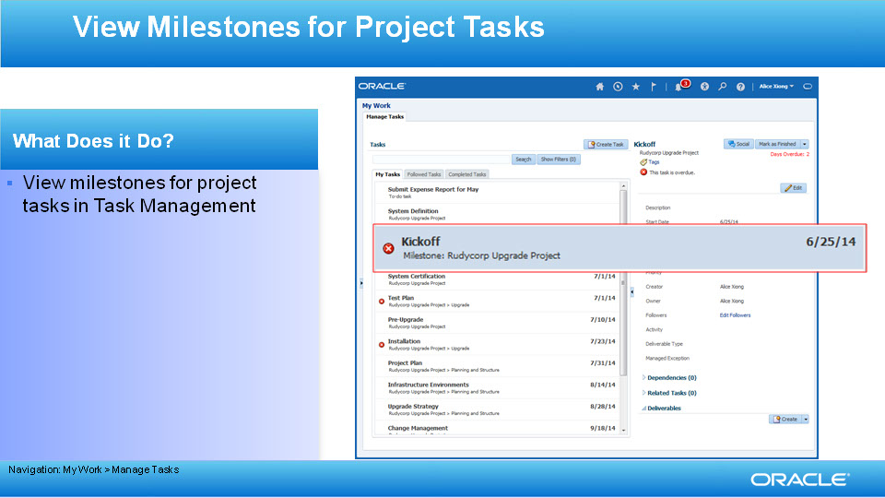
Slide notes
In Release 9, Task Management allows you to manage one more type of tasks: milestones. A milestone is an event marking a significant stage in a project. As a team member, you may be in charge of finishing some milestones for projects. You can manage these milestones conveniently in Task Management. You can see your milestones in the task list. You can see the Milestone label beneath the name to differentiate it from other task types. The label is followed by the project name.

Notes

Slide 22 - Filter by the Milestone Task Type
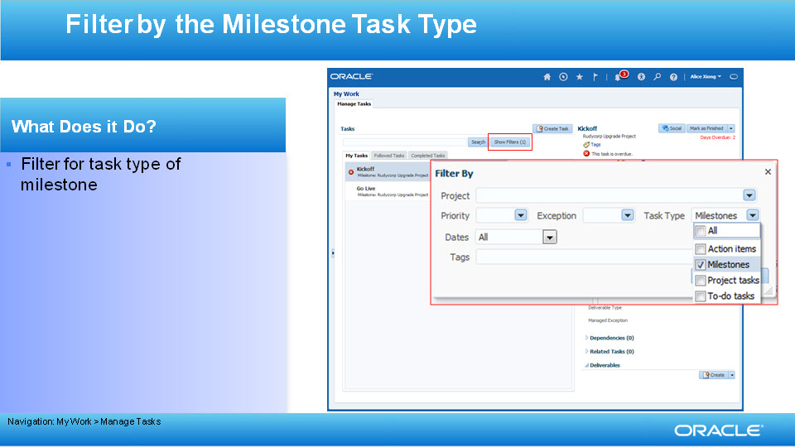
Slide notes
You can filter by the milestone task type in the task list filter.

Notes

Slide 23 - Update and Reassign Milestones
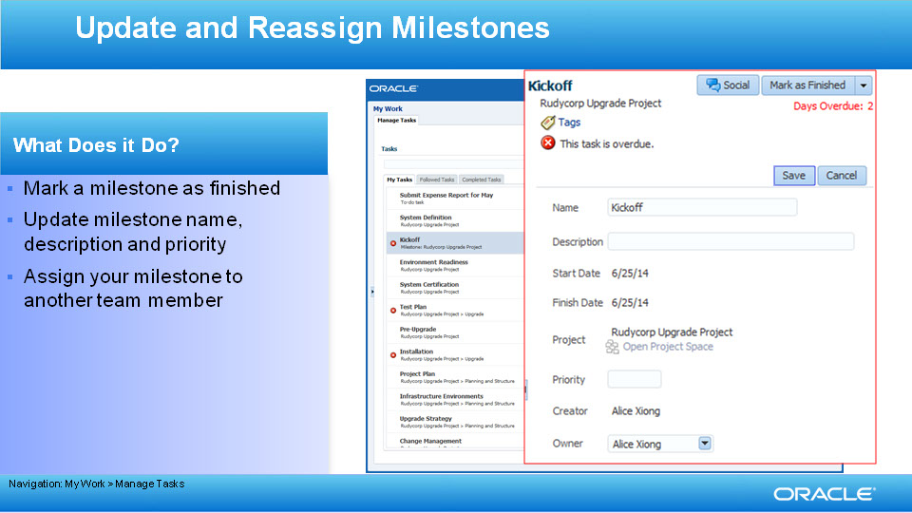
Slide notes
You can mark a milestone as finished after it is complete. You can also update the milestone name, description, and priority. However, only the project manager can change the dates. If another team member is in a better position to achieve the milestone, you can assign it to him or her by changing the owner.

Notes

Slide 24 - Manage Milestones for Project Tasks
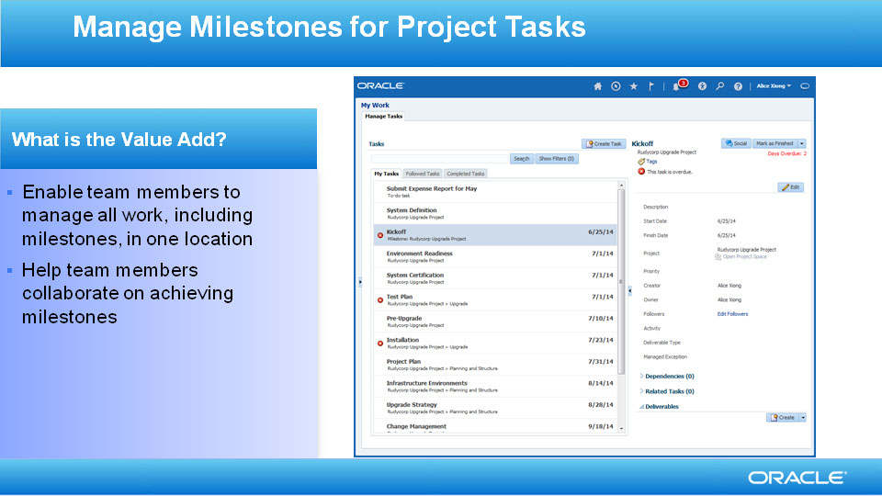
Slide notes
With the support for milestones in Task Management, team members can manage all their work in one place. They can collaborate with each other to achieve the project milestones.

Notes

Slide 25 - Show More Information in E-mail Subject Lines
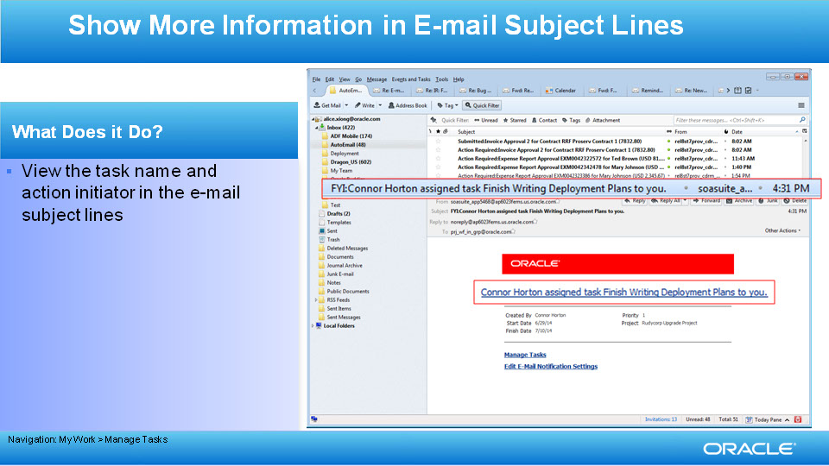
Slide notes
We also did some enhancements to the e-mail notifications. You can now see more information in the e-mail subject lines. You'll know the name of the task and the name of the person who assigned it to you.

Notes

Slide 26 - Enhanced E-mail Notifications to Task Owners and Followers
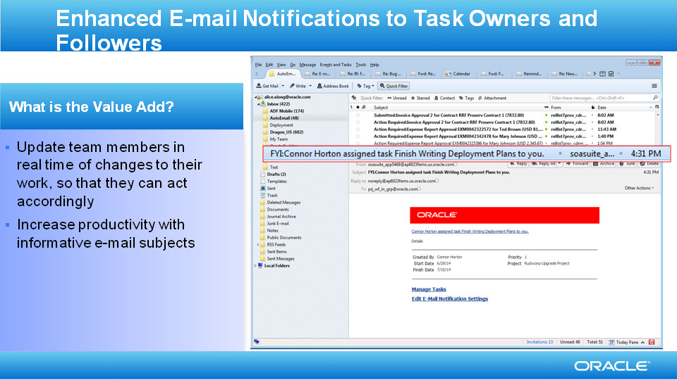
Slide notes
With this enhancement, team members are updated in real time as to changes to their work. You can understand the subject of a message without opening the message, then act accordingly. More informative e-mail subjects increases productivity.

Notes

Slide 29 - Summary of Enhancement Capabilities
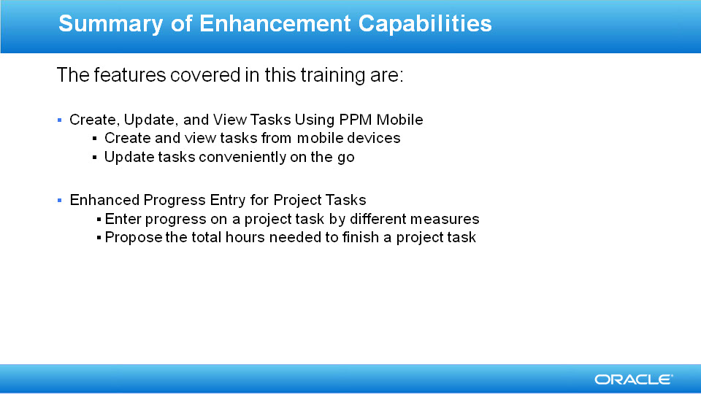
Slide notes
Here’s the summary of the features I have talked about today. First, we talked about the PPM Mobile application. It enables team members to create, view, and update tasks from their mobile devices. They can create tasks from the mobile application by entering a task name, or create multiple tasks simultaneously by entering a few names. They can view both active and completed tasks. They can apply a search filter to the task list, or search for a task with specific criteria to quickly locate desired tasks. They can update task attributes such as the start date, finish date, priority, and description. They can assign tasks to other team members. They can also mark to-do tasks as completed and enter progress on project tasks by marking them as started or completed, or by entering the percent complete. They can review exception messages on tasks, such as a past due date for a task.
Second, we talked about Enhanced Progress Entry for Project Tasks. Team members can enter progress on a project task by updating percent complete, actual hours or remaining hours. They can also propose the total hours needed to finish a project task.

Notes

Slide 30 - Summary of Enhancement Capabilities
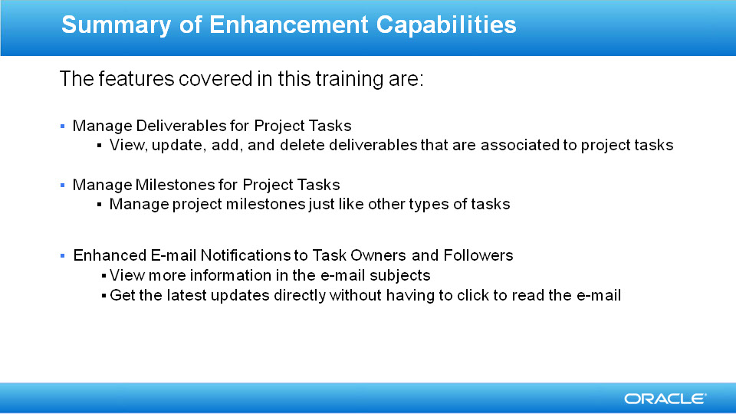
Slide notes
Third, we talked about Manage Deliverables for Project Tasks. Team members can manage deliverables for their project tasks. They can view the deliverables that are associated to project tasks, and update deliverables from the task details. They can also create and associate deliverables to a project task, and mark deliverables as complete.
Fourth, we talked about Manage Milestones for Project Tasks. Team members are responsible for the completion of some project milestones. Team members view milestones, enter progress for milestones, and collaborate on milestones with other team members. Team members can also apply a filter to their task lists, and view milestones in the list.
Last but not least, we talked about Enhanced E-mail Notifications. Team members receive e-mail notifications for important events, such as when another person assigns them to a task, adds them as a follower to a task, and when tasks they follow are completed. The awareness provided by the e-mail notifications makes it easier for team members to remain current on their work. Team members can read the e-mail header and easily identify the sender and reason for the e-mail. The body of the e-mail contains more information about the task. Team members can open the Manage Tasks page from an e-mail, and work on a task. They can also open the Team Member Dashboard from an e-mail, and edit the e-mail notification settings.

Notes

Slide 31 - Additional Information
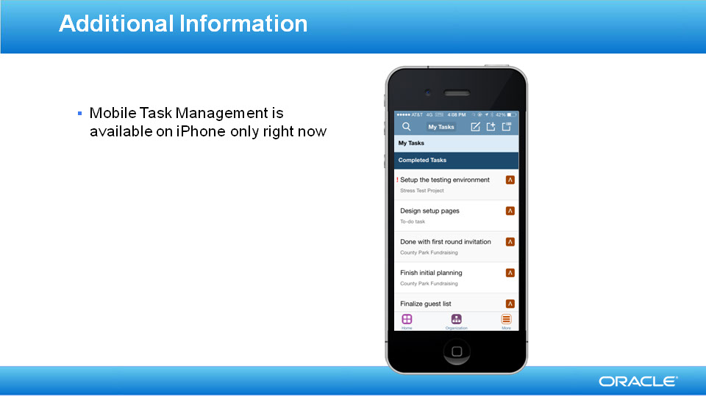
Slide notes
I would like to point out that Mobile Task Management is available on iPhone only right now.

Notes

Slide 32 - Slide 32
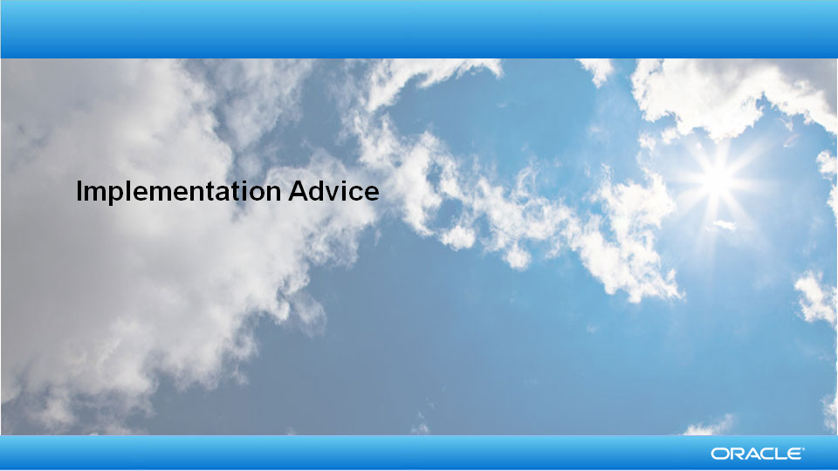
Slide notes
So that concludes the audio portion of this presentation, thank you for listening. There is no audio in the implementation advice section.

You can easily pause and rewind any of these slides if you require additional time to take in the detail.

Notes

Slide 33 - Feature Impact Guidelines
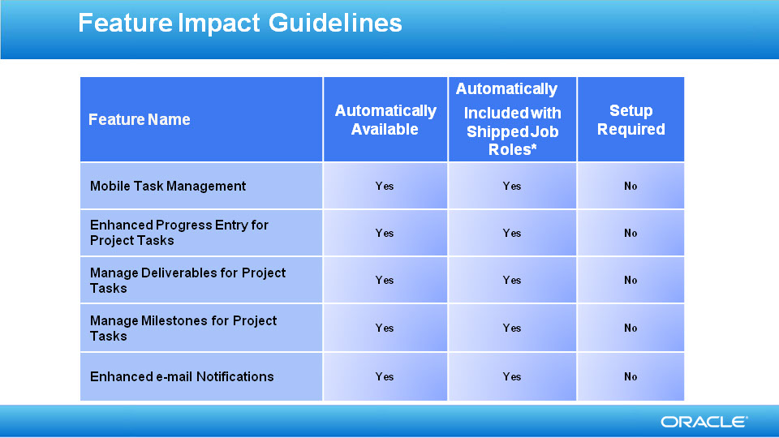
Slide notes

Notes

Slide 34 - Business Process Model Information

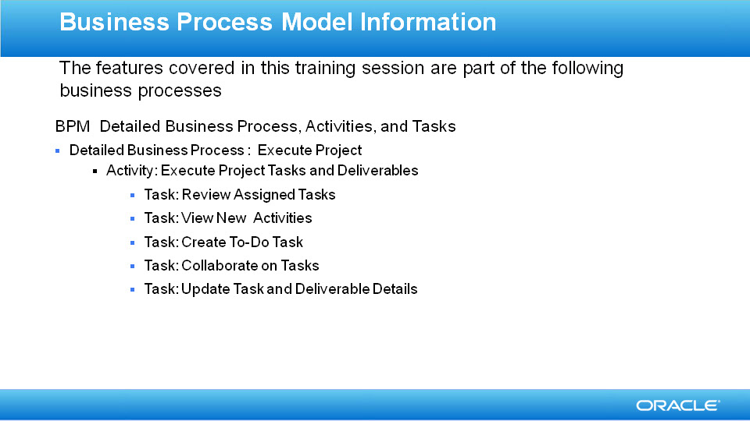
Slide notes

Notes

