Slide 3 - Oracle Human Capital Management Cloud Release 9
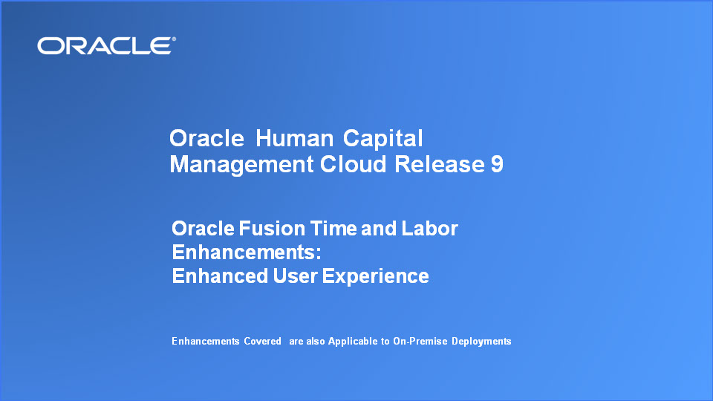
Slide notes
Welcome to the Release 9 Training for Oracle Fusion HCM Cloud Time and Labor Enhancements. In this session, we’ll cover the enhanced user experience enhancements we have made in this release.

Notes

Slide 4 - Agenda

Slide notes
For the enhancements covered in this training, we’ll give an overview, followed by more detail to explain how you can use them, and what business value they bring.

Next we’ll explain what you need to consider before enabling these features in your business, and what you need to know to set them up.

Notes

Slide 5 - Enhancements Overview
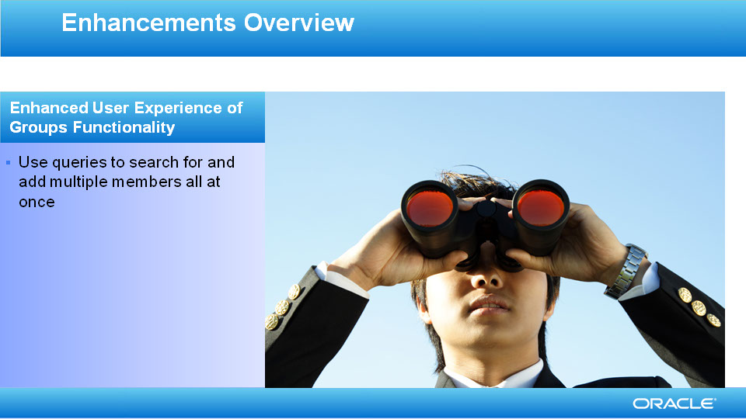
Slide notes
The Groups functionality is now even easier to use. In addition to the option of adding members one at a time, you can now add multiple group members at a time to include or exclude from the group.

Notes

Slide 6 - Enhancements Overview
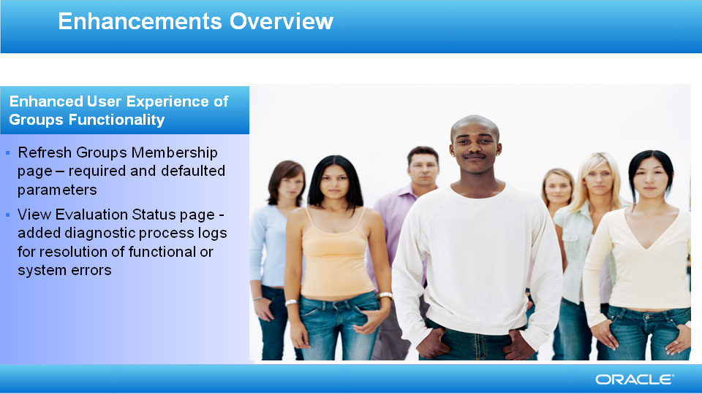
Slide notes
To ensure that you do not miss entering important criteria when refreshing groups, on the Refresh Group Membership page, all parameters are now required and have default values. It also saves you from receiving an error message about blank values.

Also, the administrator can analyze the diagnostic process logs to view any functional or system errors, enabling them to resolve the issue or provide further troubleshooting feedback.

Notes

Slide 7 - Enhancements Overview
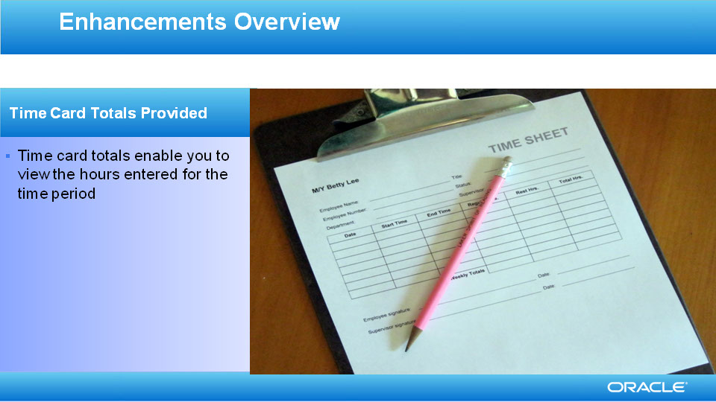
Slide notes
Time card totals are now provided to enable you to quickly and easily view the hours you have entered for the time period – you can see how many hours you have entered for each day, each line and the entire time card for the week.

Notes

Slide 8 - Enhancements Overview
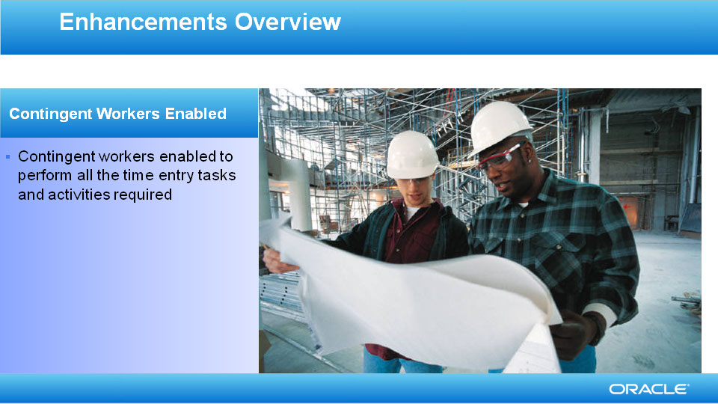
Slide notes
We’ve enabled contingent workers, also known as contractors or temporary workers, to be able to perform all the tasks and activities they require in Oracle Fusion Time and Labor, such as entering time and absence information. Contingent workers, when performing management, administration or other roles, are also able to setup Oracle Fusion Time and Labor, approve time, and perform any of the other tasks relating to time entry management.

Notes

Slide 9 - Enhancements Overview

Slide notes
We have enhanced the filtering of project values for project workers. A limited list of project values is available for time entry, based on project team membership.

Notes

Slide 10 - Enhancements Overview
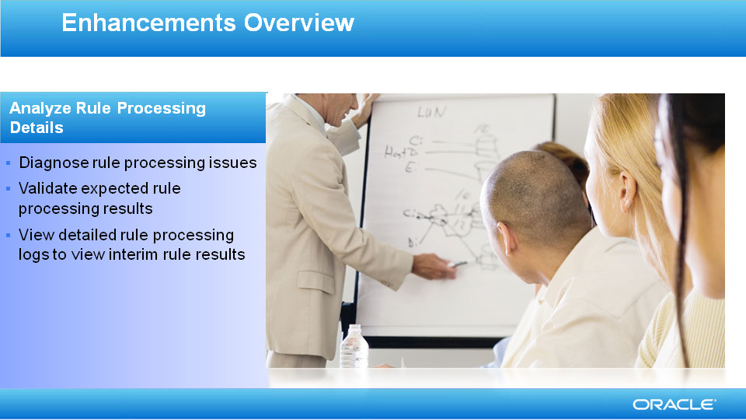
Slide notes
We’ve delivered pages to analyze rule processing details for workers’ time entries. You can now search for either a rule, rule set or worker time card to view the rule processing details. Processing details include the time card action that calls the rule set, information related to the rule setup and the formula used in the rule. Along with rule set and rule setup information, you can also view the rule set processing log or the individual rule processing logs within the rule set.

Notes

Slide 11 - Enhancements Overview
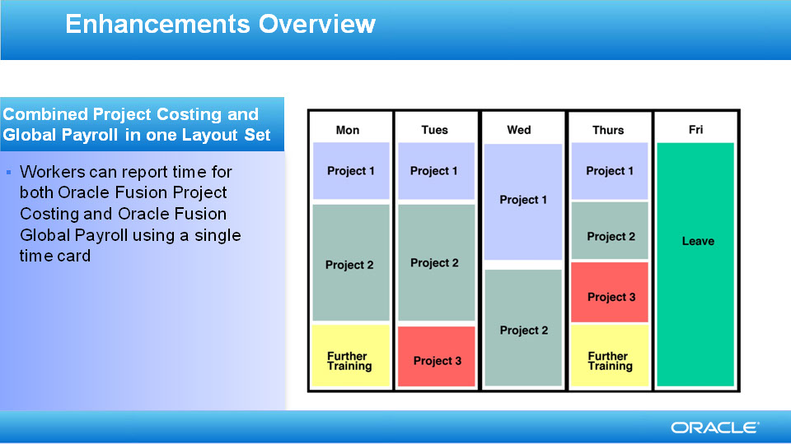
Slide notes
We’ve delivered the ability for workers to enter time card data that transfers to both Oracle Fusion Project Costing and Oracle Fusion Global Payroll. A delivered combined layout set uses an updateable, multiple-attribute time card field to combine the payroll time type and expenditure type name attributes in one selection. In addition, the project entries use time card fields that enable optional entry by the worker, controlled by time entry rules. To enable the combined time entry to Oracle Fusion Project Costing and Oracle Fusion Global Payroll, we’ve also delivered a combined time entry profile, and combined time processing profile.

Notes

Slide 12 - Refreshing Group Membership
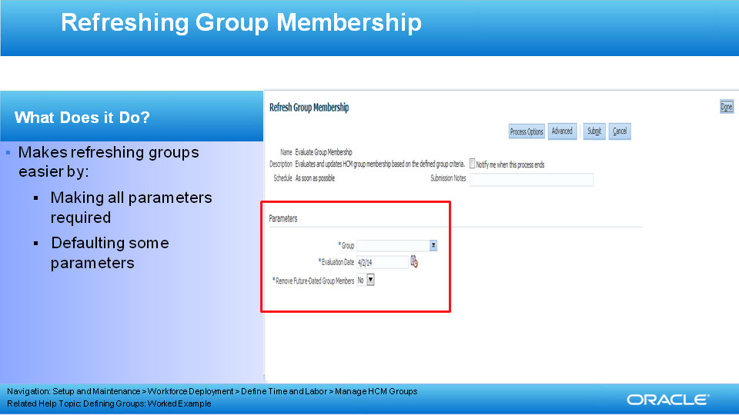
Slide notes
The Groups functionality enables administrators to set up groups of people for a variety of different reasons, such as a way of assigning profiles to workers for flexible time entry displays in Oracle Fusion Time and Labor.
Groups can be updated, refreshed or frozen as required.
The Refresh Group Membership functionality has been enhanced to make it easier to use. Once you’ve created or updated your group, and you want to refresh it, you select the Refresh Group Membership tab, and the page displays. You select your group to refresh, the Evaluation Date defaults to the system date but you can change the date, if required. The Remove Future Dated Group Members parameter is a required parameter and has a default value of No.

Notes

Slide 13 - Refreshing Group Membership
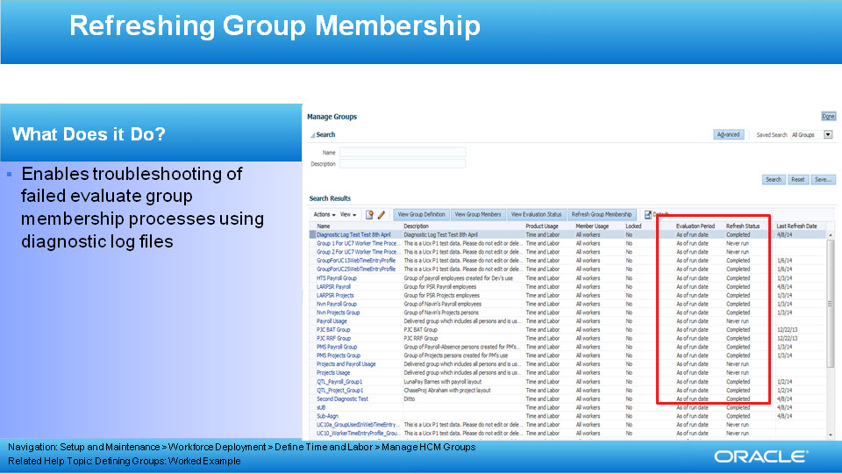
Slide notes
We also provide a diagnostic log file for each process run to evaluate group membership, both those that complete and those that fail. If processes fail, it can be because of functional or system errors, but whatever the error, the diagnostic log files enable administrators to resolve the issue, or to get back to Oracle Human Capital Management Development for review. An example of when a functional error can occur is when the user runs the Evaluation process, with a date of '01-Dec-2014' (future date) and the Delete Future Evaluation Results parameter is set to No. Then, if the user tries to re-evaluate on '01-Nov-2014', the process doesn’t run. (We do not want to delete any evaluation results that already exist.) The process would fail. and the administrator would need the log file to understand the errors.
Occasionally, technical errors can occur that cause the process to fail.
The log files are useful for administrators to view processes that complete successfully too, because the logs enable administrators to see the number of people included in the group.

After processes complete, you can see the process status in the Refresh Status column, highlighted. To view the log files, highlight the process you want to check and select the View Evaluation Status tab.

Notes

Slide 14 - Refreshing Group Membership
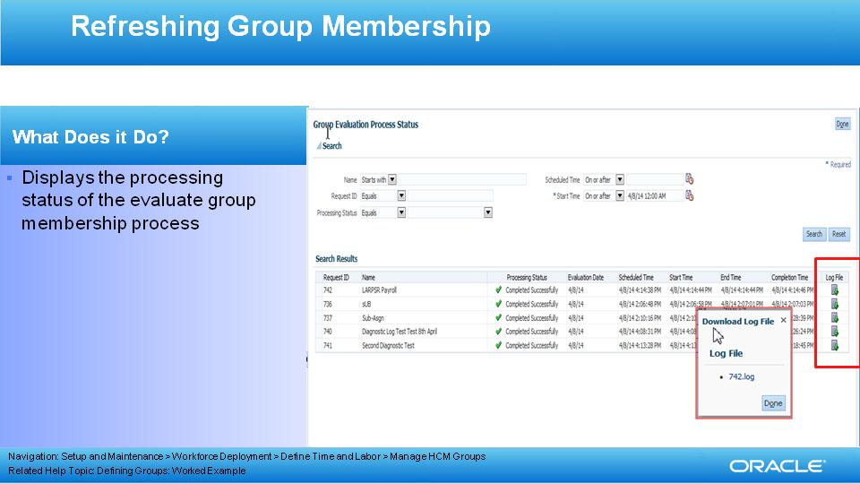
Slide notes
The Group Evaluation page displays the processes run to evaluate group membership. You can view the job number, the name of the group, the processing status, the evaluation date and other run time details. You can now also view the Log file column, where you can select the log file to view.

Select the log file, and you receive a popup to download the log file.

Notes

Slide 15 - Refreshing Group Membership
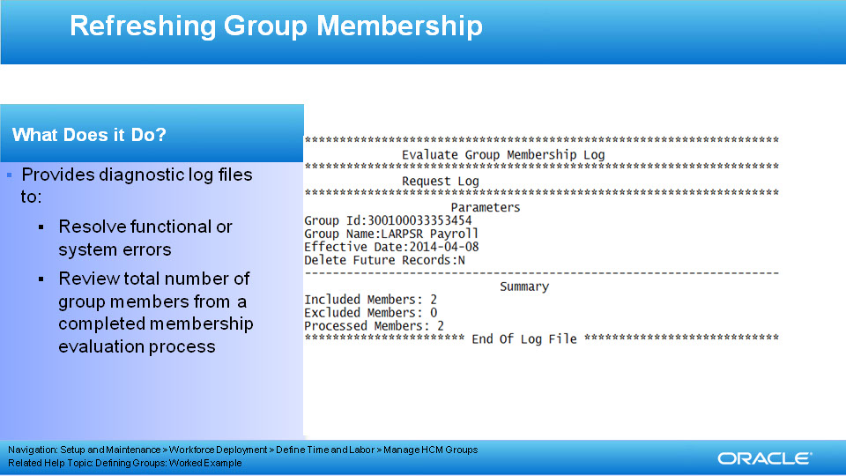
Slide notes
The log file includes the parameters you entered when you refreshed the group membership, for example, the group, the effective date and whether to delete future records.

In our example, the process completed successfully, so it includes the number of members included in the group, whether any members were excluded and the number of members processed.

Notes

Slide 16 - Enhancements to HCM Groups Functionality
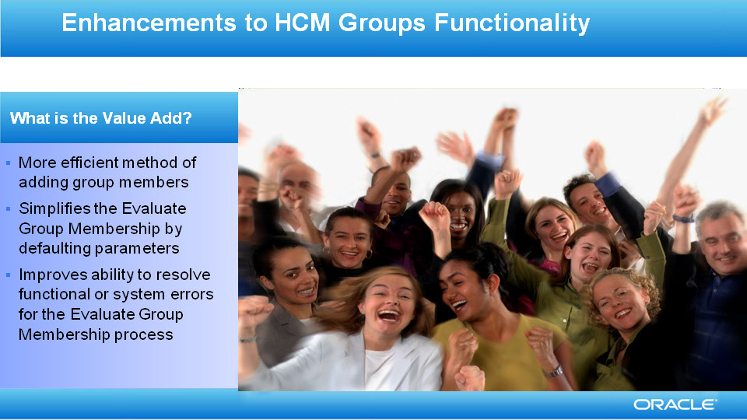
Slide notes
The enhancements to the HCM Groups functionality provide the following added value:
Increased efficiency in adding multiple group members at once, for inclusion or exclusion from the group
Quicker initiation of the Evaluate Group Membership process with defaulted values for the process parameters
Timeliness in resolving functional or system errors using the diagnostic log files.

Notes

Slide 17 - Enhancements to Contingent Workers Enabled
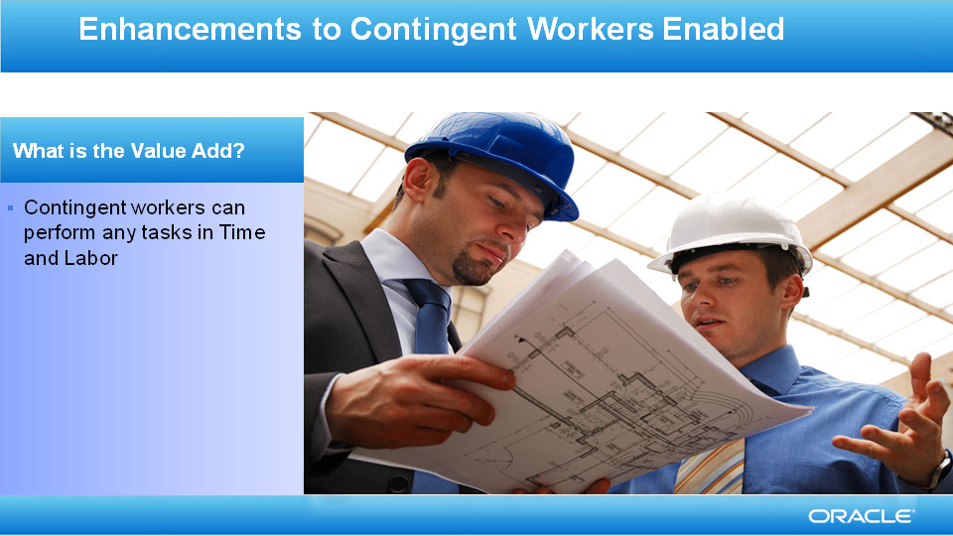
Slide notes
We’ve enabled contingent workers to be able to perform all the tasks and activities they require in Oracle Fusion Time and Labor, such as entering time and absence information. Contingent workers, when performing management or administrative roles, are also able to setup Oracle Fusion Time and Labor, approve time, and perform any of the other managerial or administrative tasks related to time entry management.

Notes

Slide 18 - Providing Time Card Row and Column Totals
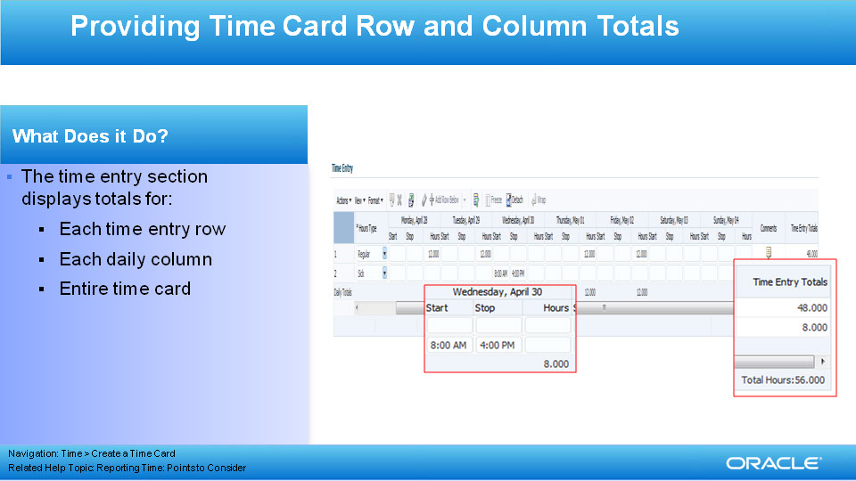
Slide notes
The column and row totals in the time card enable you to quickly and easily view the total hours entered for each day, each line and for the entire time card for the time period. If you enter hours (for example, 8 hours), then the total is the sum of the hours entered. However, if you enter "In" and "Out" times, the total is the number of hours based on the In and Out times. For example, In at 8:00 AM and Out at 5:00 PM results in 9 hours.

For biweekly or fortnightly time cards, the row and column totals are available for all the days in the period, along with the time card total.

Notes

Slide 19 - Enhancements to Time Cards Totals Functionality
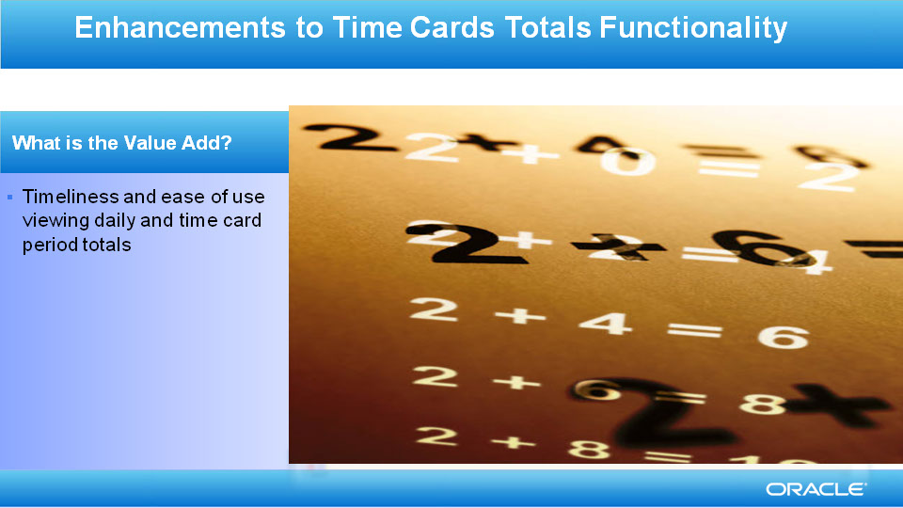
Slide notes
The enhancements to the Time Cards Totals Functionality enable you to quickly and easily view the number of hours entered for each day, each line and the entire time card for the period.

Notes

Slide 20 - Filtering Project List by Project Team Membership
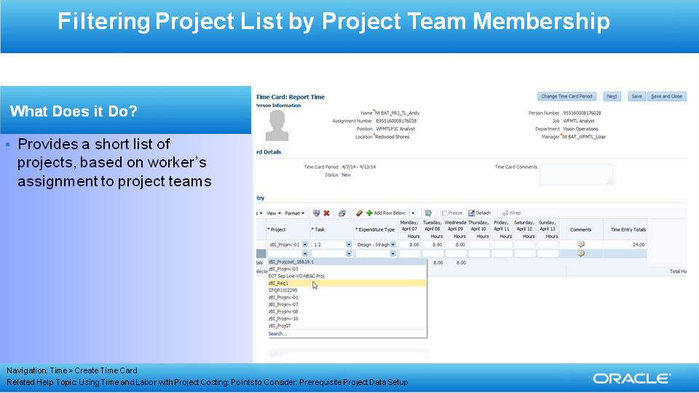
Slide notes
The display of the Project time card field on both the time card and Report Time dialog only displays projects for which a worker is a project team member. This shortens the display of project values to only those that are valid for the worker.

Notes

Slide 21 - Enhancements to Project List for Time Entry
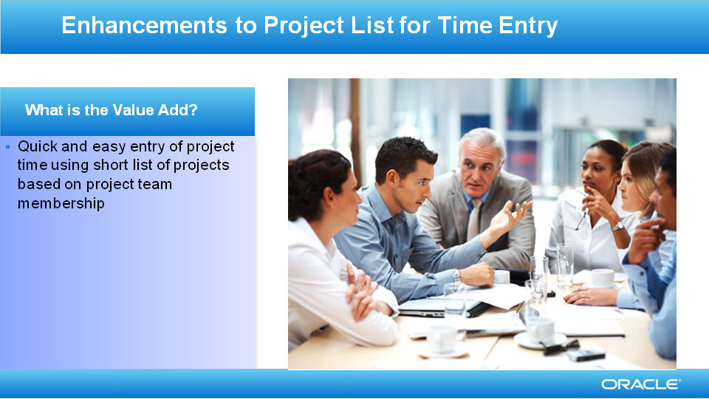
Slide notes
Project lists for time entry using a short list of valid projects for a worker enable you to enter project time entries quickly. If project team membership is enabled on the worker’s layout set, the project time card fields are enabled for project team membership. As a result, project numbers or project names only display if a worker is a member of the project team associated to that project.

Notes

Slide 22 - Analyze Rule Processing Details
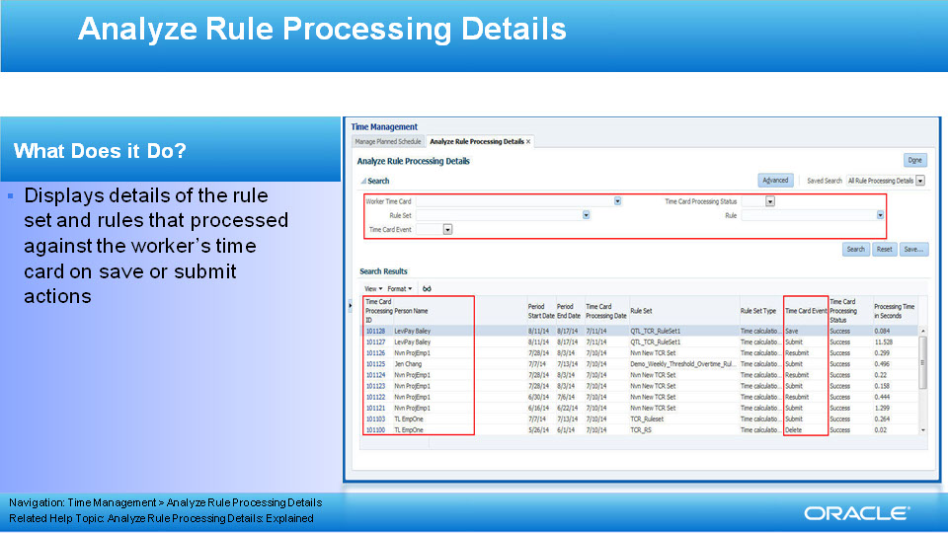
Slide notes
Within Time and Labor, Time Entry and Time Calculation rules are used for validation of time entries or updates to entries to produce calculated results. Rules are placed in rule sets and assigned to workers using the Worker Time Processing Profile. The assigned rules are configured to execute on time card actions when the worker Saves, Submits or Resubmits the time card. The Analyze Rule Processing Details pages allow the administrator or manager to view detailed rule logs. The logs display useful information to ensure the assigned rules process correctly. For the rules that do not process correctly, the administrator or manager can view detailed information and resolve the rule setup issues.
The administrator can search for an individual worker’s time card for a specific time card period or search for a specific rule or rule set by name. Searching for a worker’s time card limits the list of rule processing results to one worker. Searching for a rule or rule set by name may return many time cards that processed with the rule or rule set. The administrator makes the final selection of the rule and rule set against the workers’ individual time card for a specific time card action. The time card actions to select are Save or Submit, whereas resubmission of the time card is considered a Submit action.
Notes

Slide 23 - Analyze Rule Processing Details
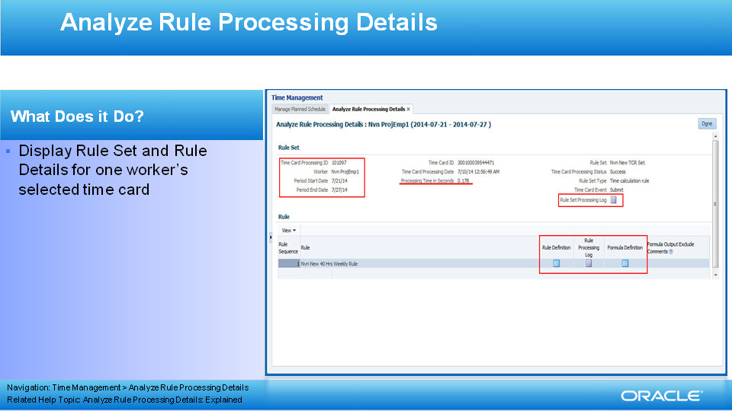
Slide notes
Once the administrator selects the worker time card using the time card’s time processing ID, the rule set and list of rules are displayed on a separate page. Detailed information related to the Rule set is displayed in the Rule Set region. You can see the processing time in seconds, the time card period start and end dates, type of rule set, time card id and additional information. A link to the rule set processing log is also provided in the Rule Set region.

The bottom section of the page, the Rule region, displays the individual rules within the rule set together with links to view the rule definition, the Rule Processing log or the Fast Formula definition that processed when the rule executed.

Notes

Slide 24 - Analyze Rule Processing Details
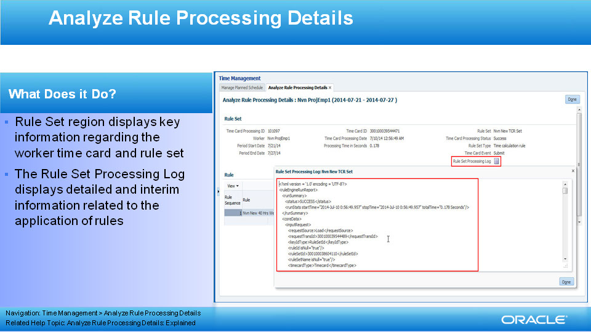
Slide notes
The Rule Set processing log displays log information that contains time period information, processing times and intermediate rule set processing detailed information useful in researching and resolving processing issues. In addition to using the rule set log information to resolve issues, the administrator can use the log information to develop new rules and assign them to rule sets.

Notes

Slide 25 - Analyze Rule Processing Details
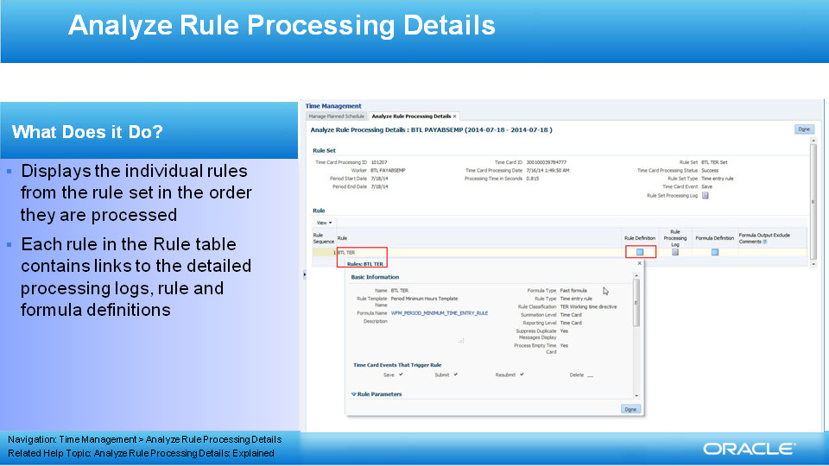
Slide notes
The Analyze Rule Processing Details provides individual rule information including dialog boxes that display either the rule definition, the rule log for each rule in the set or the formula definition assigned to each rule. The rule set may contain 1 or more rules, displayed in the same processing order as used against the time card.

Notes

Slide 26 - Enhancements to Analyze Rule Processing Details
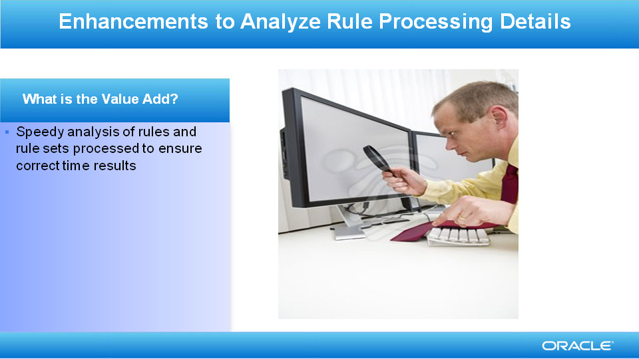
Slide notes
Rule processing details enable you to analyze results in a delivered set of pages by selecting individual worker’s time cards or specific rule or rule sets and viewing the detailed rule logs. Allowing the administrator easy access to the rule logs in a delivered page ensures rule processing against time cards are delivering expected results.

Notes

Slide 27 - Combined Projects and Payroll Time Entry
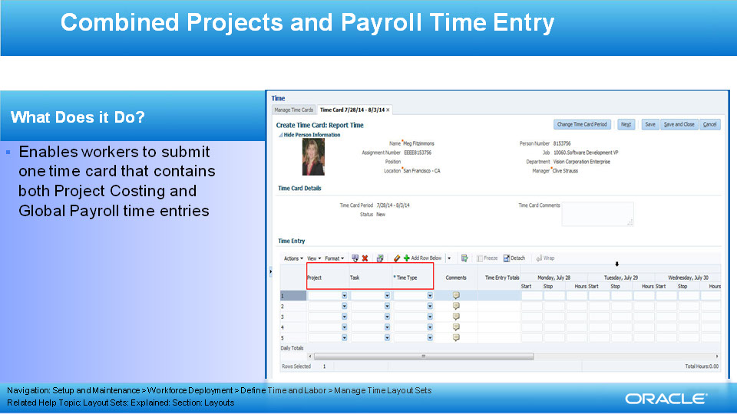
Slide notes
The combined Oracle Fusion Project Costing and Oracle Fusion Global Payroll time entry solution enables workers to enter both project time attributes and payroll time attributes using one layout set. Project entries are optional, while the defined multiple-attribute time card field requires an entry that routes to either Project Costing, Global Payroll or both applications. In addition to Global Payroll, Oracle Fusion Absence Management entries can be configured for worker entries that route to Global Payroll.

Notes

Slide 28 - Combined Projects and Payroll Time Entry
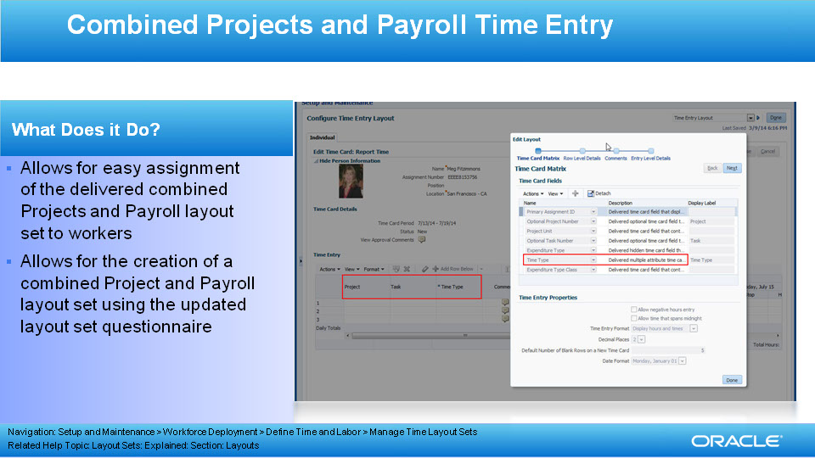
Slide notes
The combined Oracle Fusion Project Costing and Oracle Fusion Global Payroll time entry solution delivers a predefined layout set that contains the Projects Costing and Global Payroll time card fields. The layout set is delivered based on Project Costing and Global Payroll application’s best practices. Time and Labor’s Manage Layout Set functionality allows for the configuration of a layout set to meet your company’s specific requirements. The Layout Set questionnaire allows you to select both the Project Costing and Global Payroll predefined layouts, resulting in a combined, comprehensive layout set which you can refine for your needs.

Notes

Slide 29 - Combined Projects and Payroll Time Entry
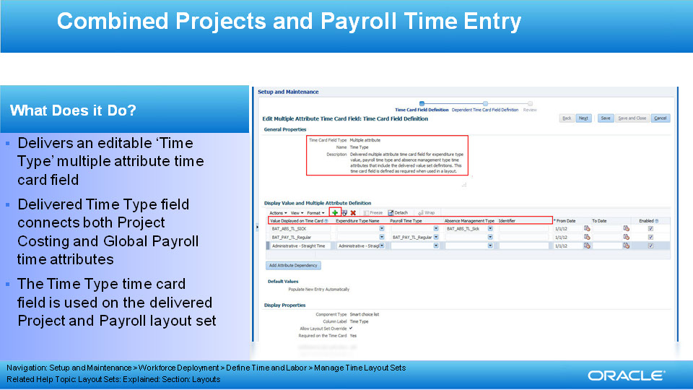
Slide notes
The combined Oracle Fusion Project Costing and Oracle Fusion Global Payroll time entry solution delivers a new time card field, defined as a multiple attribute time card fields that contains the Payroll Time Type, Absence Management Type, Expenditure Type and Identifier time attributes. Specific values are not defined, but the delivered time card field can be updated with customer specific values. The delivered ‘Time Type’ time card field is configured in the delivered Project and Payroll Layout Set enabling quick access to assign the layout set with updated list of Time Types that can be selected and transferred to time consumers.

Notes

Slide 30 - Enhancements to Combined Projects and Payroll Time Entry
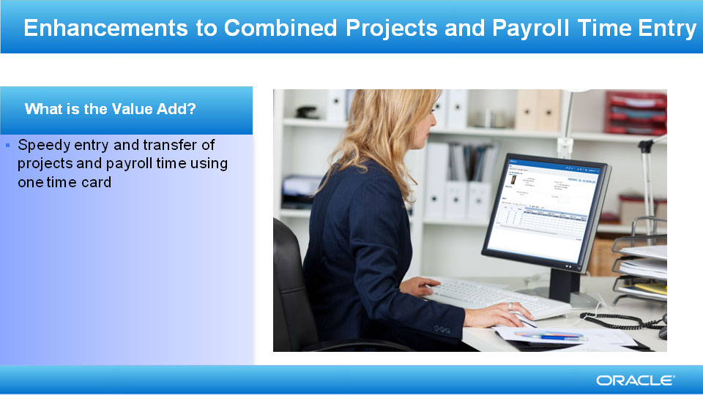
Slide notes
Workers can enter time using one time card to transfer information to both Oracle Fusion Project Costing and or Oracle Fusion Global Payroll, if required. They can do this by using the delivered ‘Combined Layout‘functionality, which saves time and reduces entry errors.

Notes

Slide 31 - Summary of Enhancement Capabilities
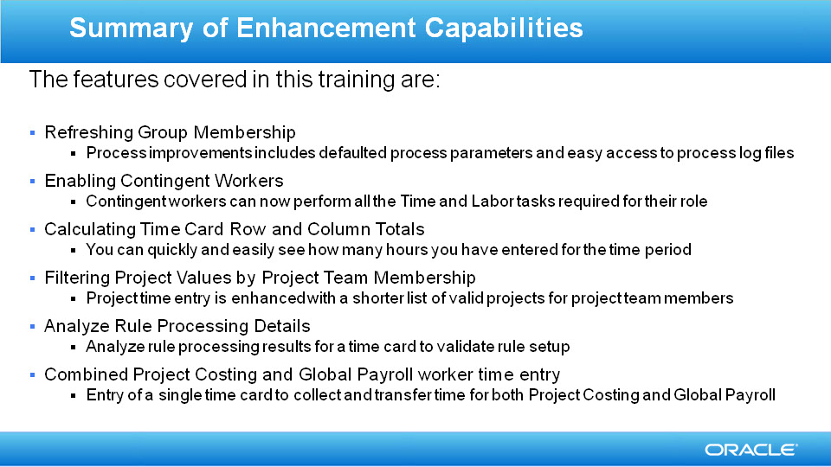
Slide notes
Here is the summary of the features I have talked about today.

Refreshing Groups Membership

Makes refreshing groups easier by making all parameters required, defaulting some parameters and providing diagnostic log files to resolve functional or system errors

Contingent Workers enabled

Contingent workers can now perform all the tasks required for their job within Time and Labor

Providing Time Card Row and Column Totals

You can quickly and easily see how many hours you have entered for the time period.

Analyze Rule Processing Details
View rule results for a worker’s time card or for a specific Rule or Rule Set

Combined Project Costing and Global Payroll Worker Time Entry

Workers can enter time using one time card to transfer information to both Oracle Fusion Project Costing and Oracle Fusion Global Payroll, if required.

Notes

Slide 32 - Slide 32

Slide notes
So that concludes the audio portion of this presentation, thank you for listening. There is no audio in the implementation advice section.
You can easily pause and rewind any of these slides if you require additional time to take in the detail.
There is no associated setup required for the Release 9 HCM Groups functionality enhancements. Nor is there any setup required for the enablement of contingent workers, or totals on time cards. Please refer to the Release 8 Oracle Fusion Time and Labor Release training if you want to see more information about the baseline Oracle Fusion Time and Labor functionality.

Notes

Slide 33 - Feature Impact Guidelines
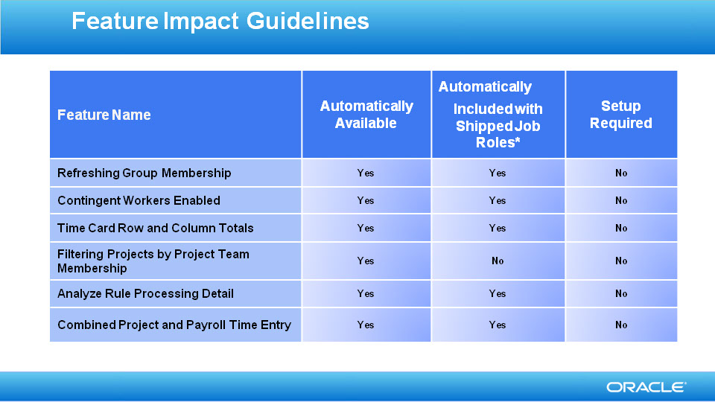
Slide notes

Notes

Slide 34 - Job Roles & Associated Duty Roles
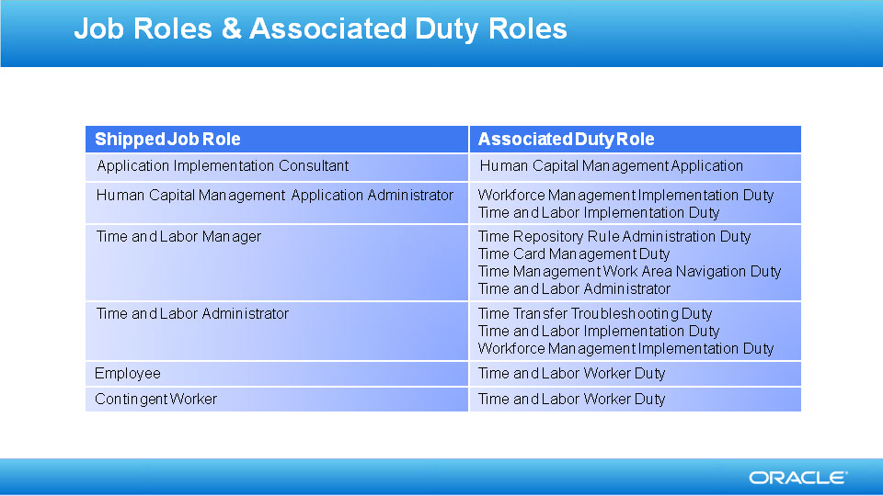
Slide notes

Notes

Slide 35 - Business Process Model Information

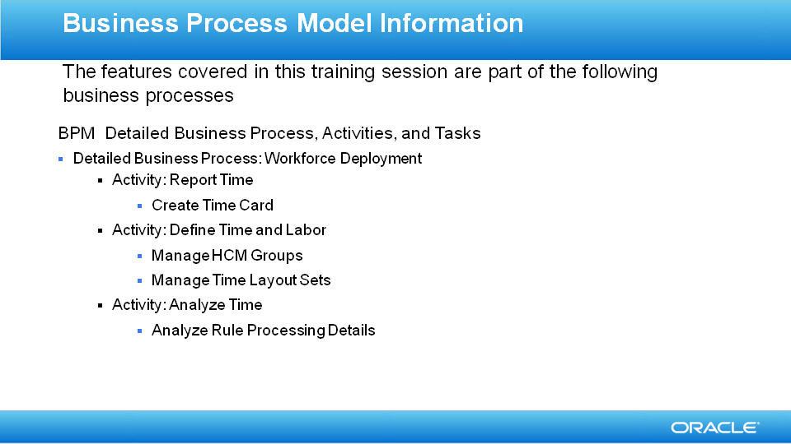
Slide notes

Notes

Slide 36 - Associated Release Training
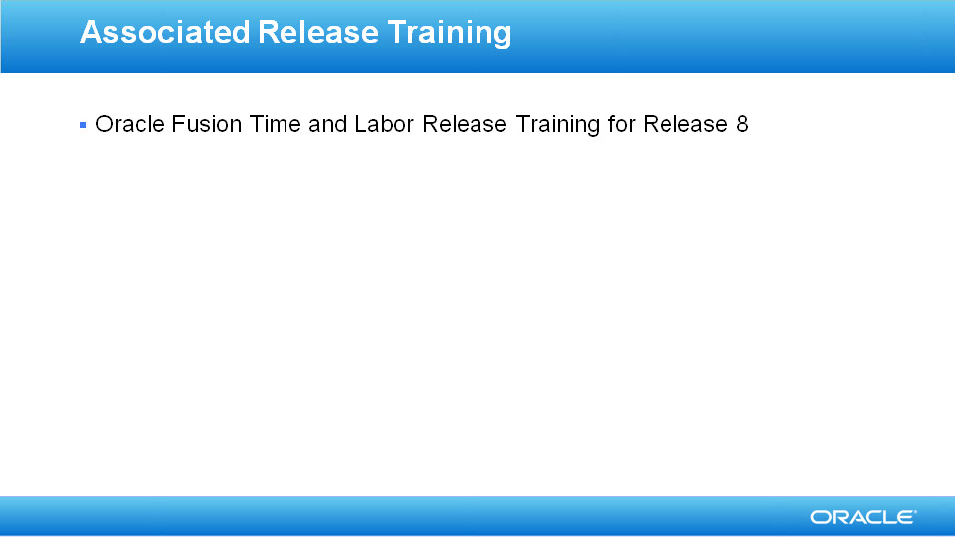
Slide notes
The Oracle Fusion Time and Labor training for Release 8 provides you with the background to the product and functionality, demonstrations to use the functionality, and setup information.

Notes

