Slide 3 - Oracle Financials Cloud
Release 9
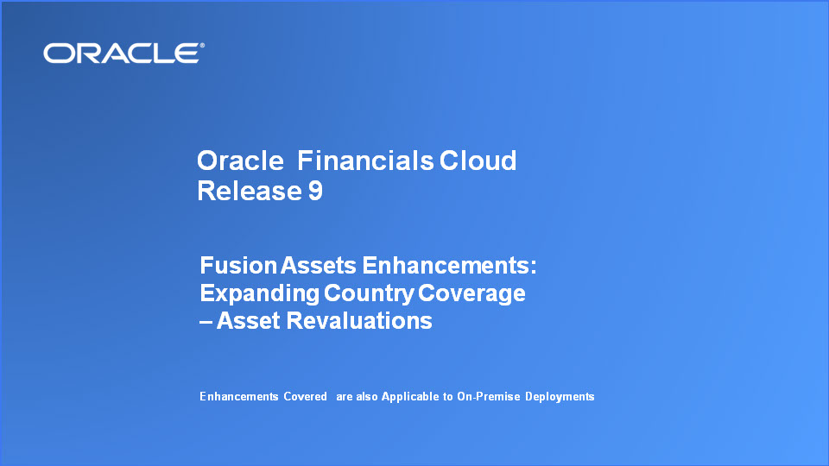
Slide notes
Hello, my name is Klax. Welcome to the Release 9 Training for Oracle Financials Cloud Enhancements. In this session, we’ll cover the Expand Country Coverage enhancements we have made in this release to Fusion Assets. The enhancement is called Asset Revalautions.

Notes

Slide 4 - Agenda

Slide notes
For the enhancements covered in this training, we’ll give an overview, followed by more detail to explain how you can use them, and what business value they bring.

Then we’ll walk you through a demonstration.

Next we’ll explain what you need to consider before enabling these features in your business, and what you need to know to set them up.

Notes

Slide 5 - Enhancements Overview
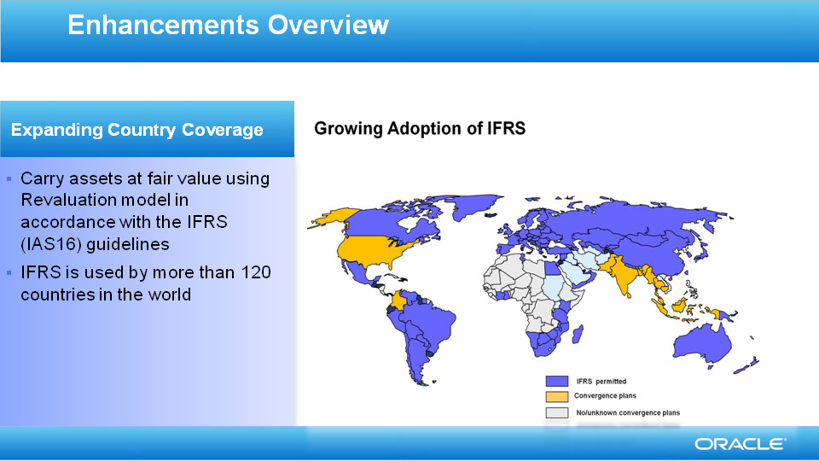
Slide notes
IFRS survey in Dec 2013 found more than 122 countries follow the IFRS accounting standard across the world and this is growing.

IAS16 revaluation model, as the global standard for asset revaluation, allows you to restate your assets using the fair values on a regular basis.

Assets Revaluations feature help you to comply with the IFRS’s IAS 16 guidelinesfor your asset books. Wheter you choose to drive revaluations using cost basis or net book value, you can accurately assess the accounting impact of your asset revaluations.

Notes

Slide 6 - Asset Revaluations
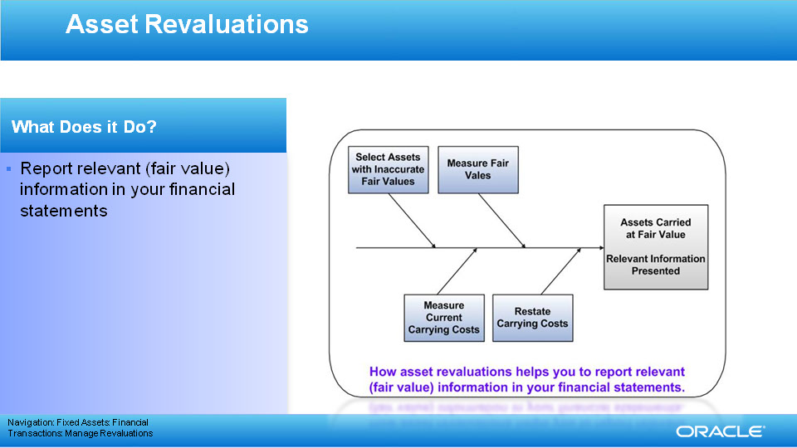
Slide notes
To comply with IAS16 guidelines, at regular intervals, you restate the carrying costs of tangible assets to their fair values less subsequent depreciation and subsequent accumulated impairments.

By doing so, you present relevant information for investors in your financial statements.

Notes

Slide 7 - Asset Revaluations
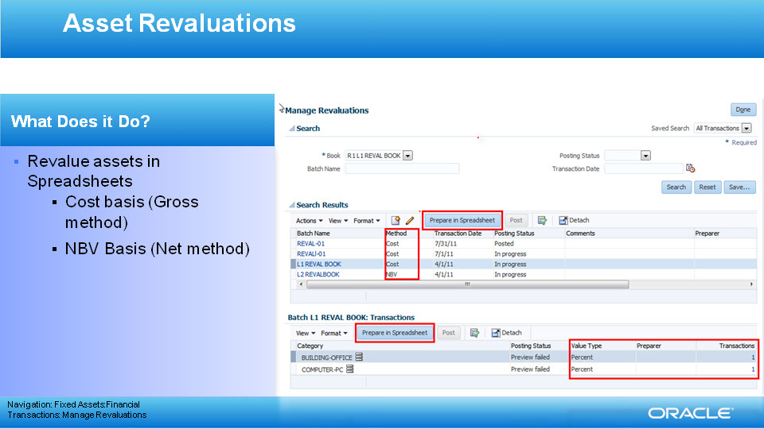
Slide notes
Use spreadsheets to revalue using either Gross method (Asset cost drives the calculations) or Net method (Asset NBV drives the calculations).

Gross method supports the following value types or modes:

Percent, Fair Value

Amount, Fair value

Price Index

Net Method – supported value types are:

Percent

Amount

Fair Value

Notes

Slide 8 - Asset Revaluations
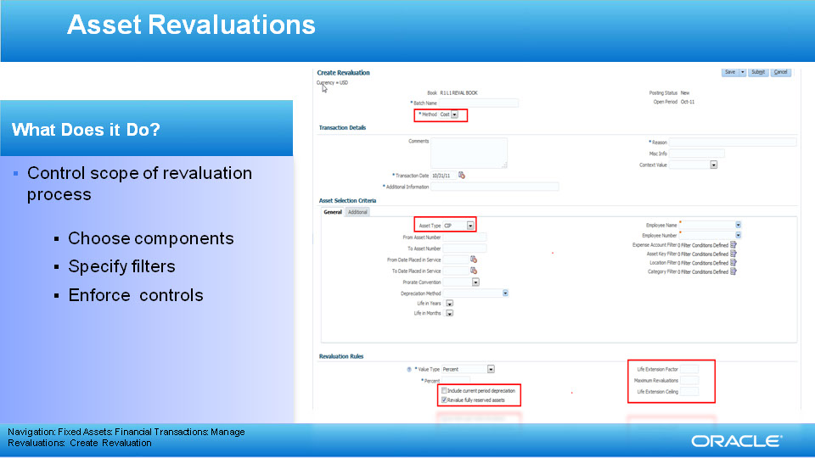
Slide notes
You can choose the components to revalue (cost, depreciation reserve, NBV), include assets by their type (CIP or Capitalized) or state (fully reserved) when you specify the batch selection criteria to guide your revaluation process. In addition, you can choose to include or exclude the depreciation for the period you are revaluing. Finally, you can specify business controls such as cost or life extension ceilings, maximum number of revaluations.
You have full control of the revaluation process.
When you opt to revalue assets that are fully reserved, you should specify the default life extension factor that will be used to derive new life for the life-based assets.

Notes

Slide 9 - Asset Revaluations
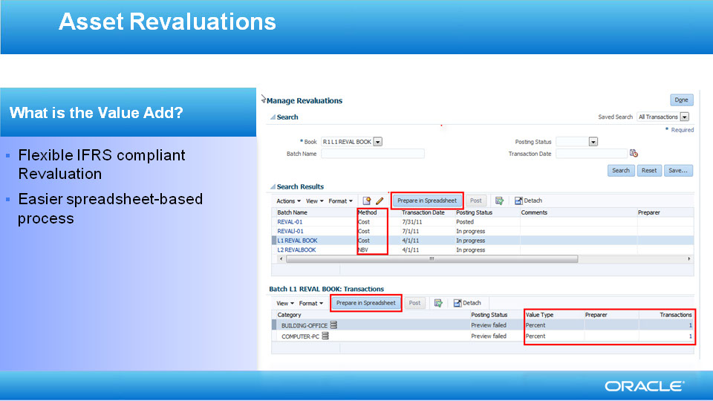
Slide notes
Using spreadsheets, you decide all the options, filters and components. You control the revaluation process from the spreadsheets. Whatever approach you decide, you stay IFRS compliant.

Revaluations can now be performed simply and efficiently harnessing spreadsheet efficiencies like cut and paste, drag and drop, saving processing time and effort. You can open a spreadsheet, supply the required assets or supply search criteria and prepare the revaluation for the selected assets. You have the total control of the process. You review and confirm the revalued figures in the spreadsheet itself.

Notes

Slide 206 - Summary of Enhancement Capabilities
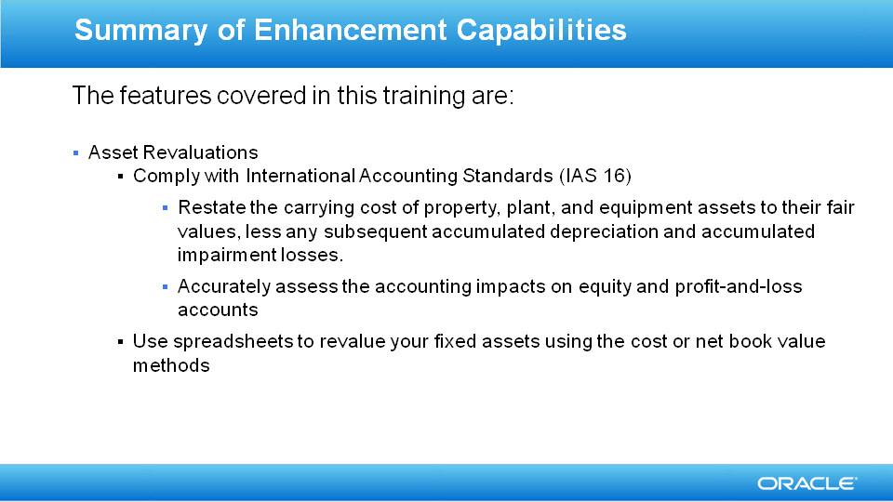
Slide notes
Here is the summary of the features I have talked about today..........................

Revaluations helps you restate the carrying cost of your tangible assets to their fair values less subsequent accumulated depreciation and subsequent accumulated impairment losses as required by IAS16. This ensures comparability, timeliness and reliability of the financial statements.

Very simply, your IAS16 compliance is made easy, flexible through spreadsheets.

Notes

Slide 207 - Slide 207
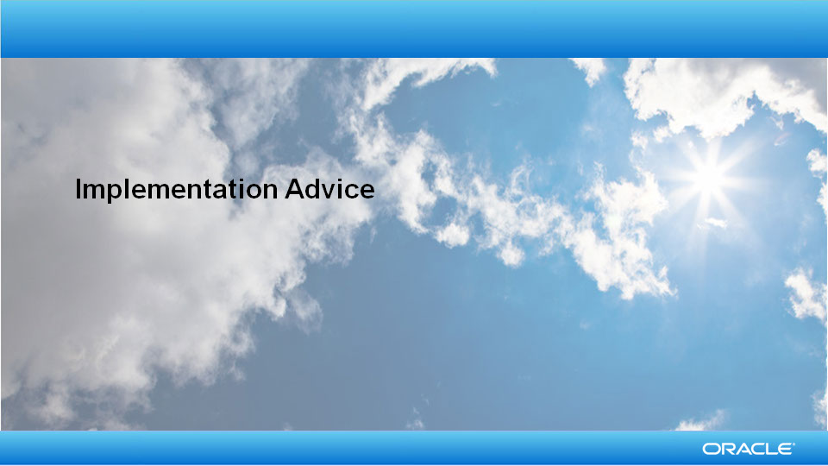
Slide notes
So that concludes the audio portion of this presentation, thank you for listening. There is no audio in the implementation advice section.

You can easily pause and rewind any of these slides if you require additional time to take in the detail.

Notes

Slide 208 - Feature Impact Guidelines
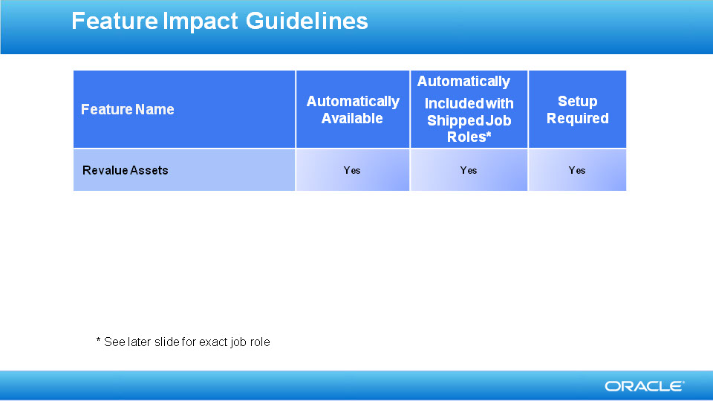
Slide notes

Notes

Slide 209 - Revalue Assets Setup Summary

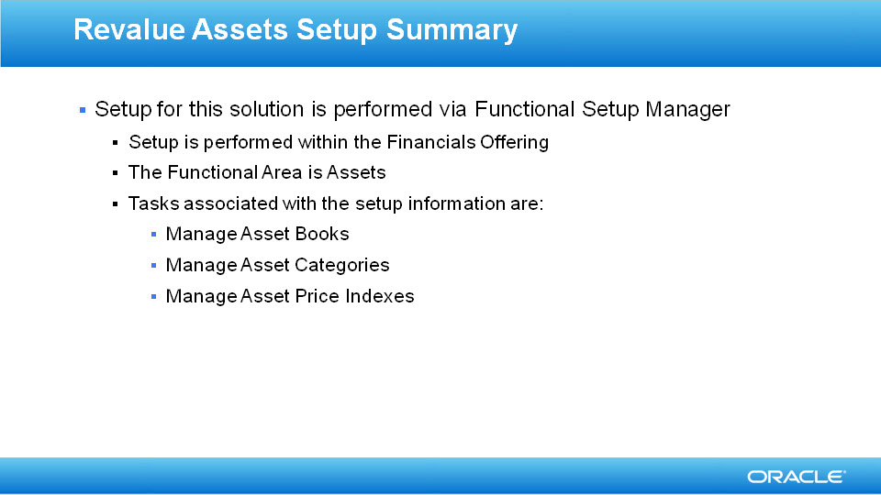
Slide notes

Notes

Slide 210 - Revalue Assets Setup Detail

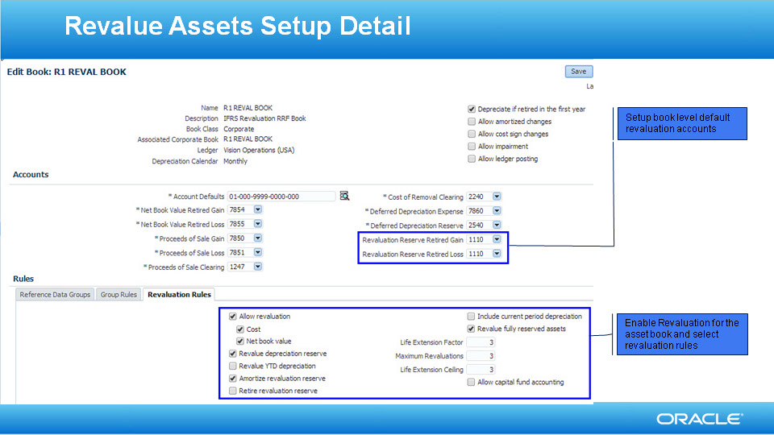
Slide notes
Once you decide to enable revaluation for a book, you need to specify revaluation rules and accounts as well.

Revaluation Rules simplify the revaluation process and intelligently adapts the revaluation process based on the options you specify. Revaluation Accounts are set up in tandem with your Revaluation Rules.

First, you decide the most common basis you use for revaluation. Cost basis revaluation uses asset cost while the net book value basis is driven using the asset’s NBV.

Second, you need to specify if you want to revalue your depreciation reserve and YTD depreciation. If you don’t revalue your depreciation reserve, the balance is cleared out at the time of revaluation and is transferred to the revaluation reserve. Revaluation of YTD depreciation is possible only if you choose to revalue your depreciation reserve.

Third, you specify how you intend to treat revaluation reserve. Do you intend to amortize this over the remaining life? Do you want to retire revaluation reserve proportionate to the cost retired during retirement?

To ensure revaluation accounting entries can be generated when you retire an asset, you need to set up the Revaluation reserve retired gain or loss. If you choose to retire the relevant portion of revaluation reserve, Fusion Assets creates journal entries for the remaining reserve to the revaluation reserve retired gain or loss accounts. If you have opted not to retire the revaluation reserve, then there is no need to supply revaluation reserve retired gain or loss accounts.

Fourth, you can choose to take into account the current period depreciation at the time of revaluation. If you choose to do so, then the current period depreciation is processed for the asset before the revaluation.

Finally, you choose to control the revaluation process to include fully reserved assets, provide defaults for the life extension factor, maximum revaluations and life extension ceiling. In addition, you can choose to enable capital fund accounting when needed.

Notes

Slide 211 - Revalue Assets Setup Detail

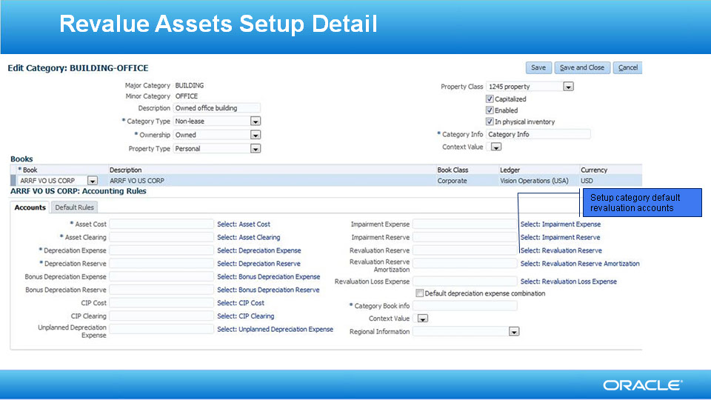
Slide notes
Once you have enabled revaluation and setup the Revaluation rules for the book, you need to specify the accounts for each asset class. So for each category associated with the book, you should specify a revaluation reserve and revaluation loss accounts.

When an asset that belongs to the this category is processed for revaluation, the accounting entries are created using the supplied defaults.

Notes

Slide 212 - Revalue Assets Implementation Decision Points

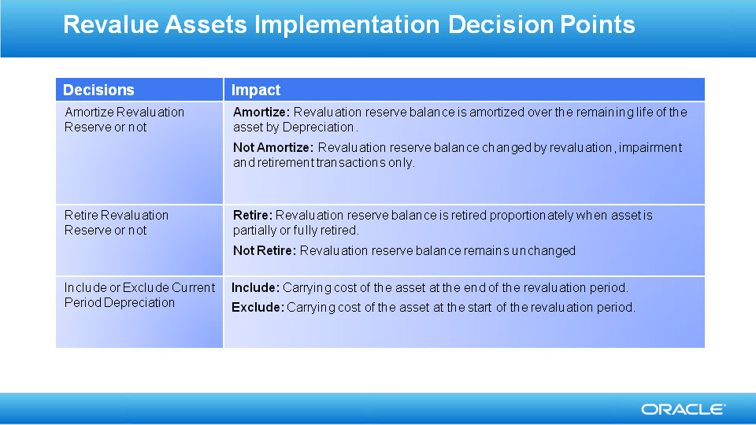
Slide notes

Notes

Slide 213 - Revalue Assets Implementation Decision Points
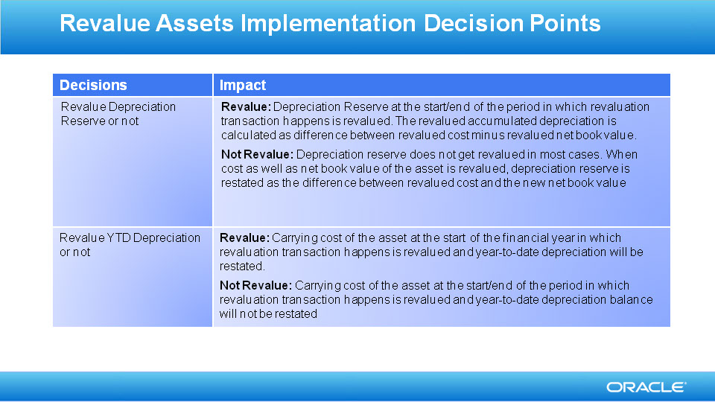
Slide notes

Notes

Slide 214 - Job Roles & Associated Duty Roles
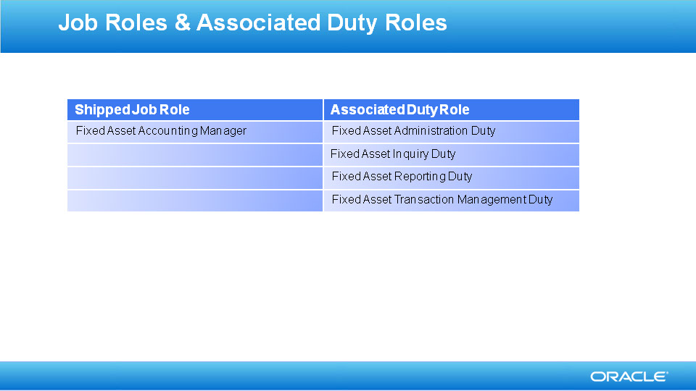
Slide notes

Notes

Slide 215 - Business Process Model Information

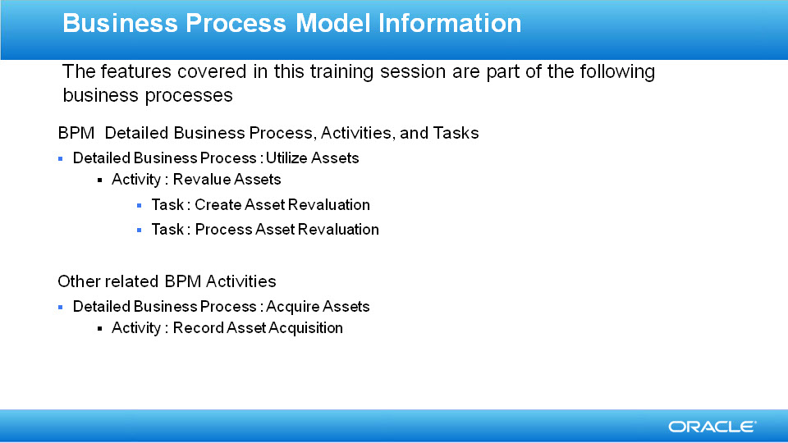
Slide notes

Notes

Slide 216 - Related Reports & BI Analytic Information

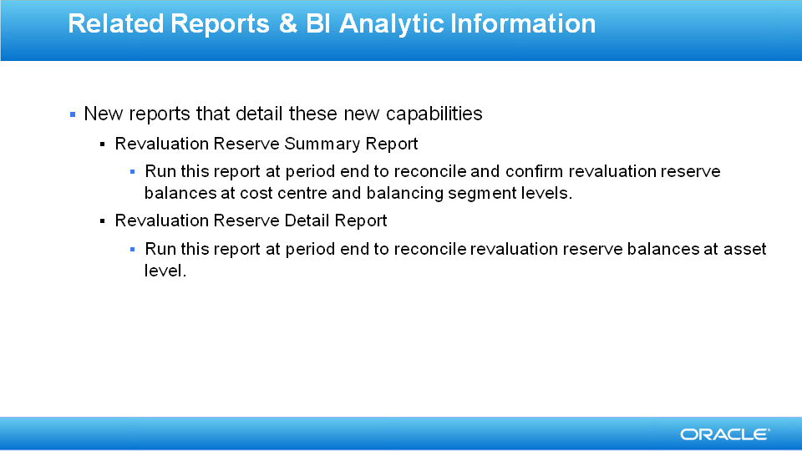
Slide notes

Notes

