Slide 3 - Oracle Order Management Cloud
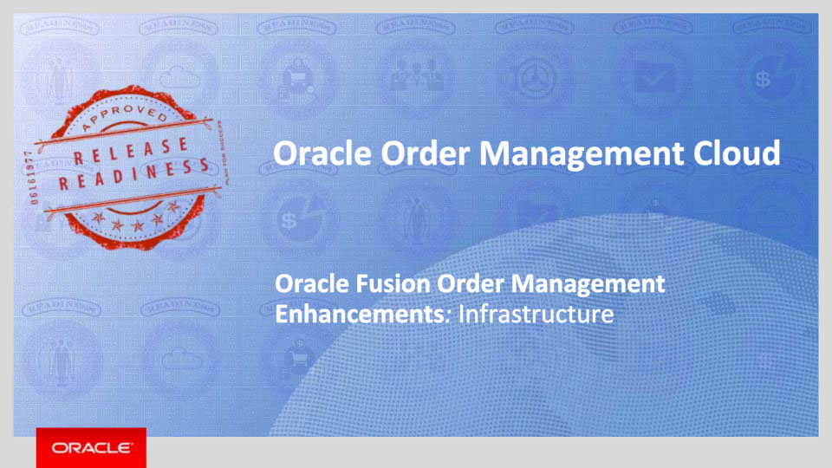
Slide notes
Hello, my name is Shrikant. Welcome to training for this release.
In this session we will talk about what’s coming in Oracle Order Management Cloud for Infrastructure.

Notes

Slide 4 - Agenda
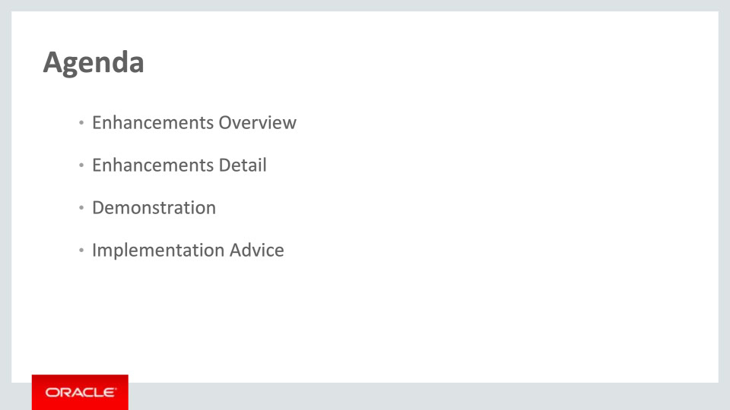
Slide notes
For the enhancements covered in this training, we’ll give an overview, followed by more detail to explain how you can use them, and what business value they bring.
Then, we’ll walk you through a demonstration.
Next, we’ll explain what you need to consider before enabling these features in your business, and what you need to know to set them up.

Notes

Slide 5 - Enhancements Overview
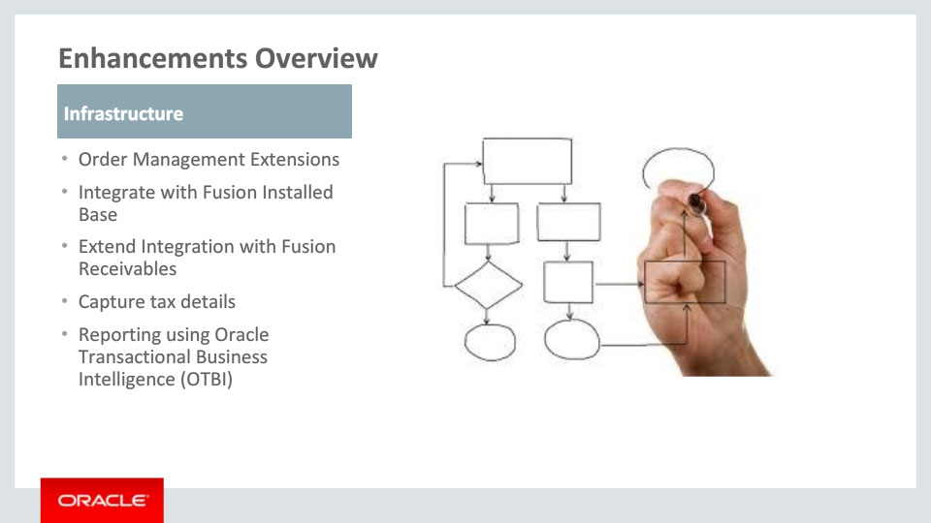
Slide notes
The release adds significant capabilities in Order Management Infrastructure.
The new Order Management Extensions framework allows customers to write complex validation and defaulting rules as part of the order capture and submission process.
Next, a pre-built integration with Fusion Installed Base allows you to track and manage fulfilled items as assets.
This release also extends the integration with Fusion Receivables by passing additional attributes to the Fusion Receivables. It allows you to send different description for the product than the one that is obtained from the product master. You can also pass values to the descriptive flexfields defined in Fusion Receivables.
In addition, Order Management now captures the tax detail returned by the tax engine in addition to the charge and tax amount. The tax detail of an order can be used by business for various purposes, for instance, reporting tax, creating commercial invoice, etc.
Finally, a set of comprehensive enhancements to the Order Headers and Fulfillment Lines subject areas in Oracle Transactional Business Intelligence allows you to build reports to meet your business needs.

Notes

Slide 6 - Order Management Extensions
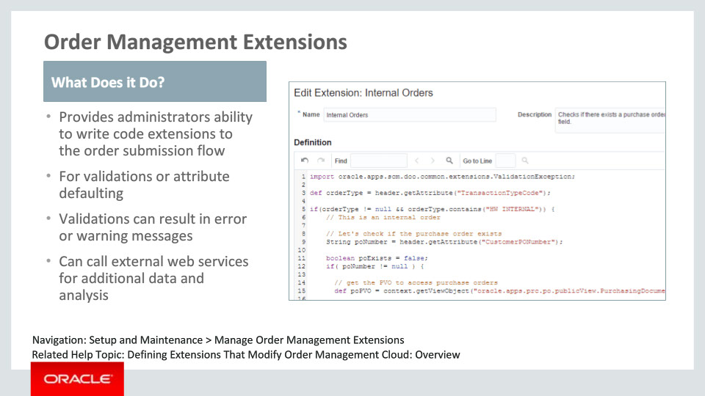
Slide notes
Order Management Extensions provide a powerful new tool for administrators to write complex logic into the order submission flow within order management. Extensions can be used to write order validation logic to prevent invalid orders from flowing through the system. Additionally, extensions can be written to default order and line attributes as well as extensible flex fields. Custom extension code can also be used to call out to web services providing additional flexibility and capability.

Notes

Slide 7 - Order Management Extensions – Event Points
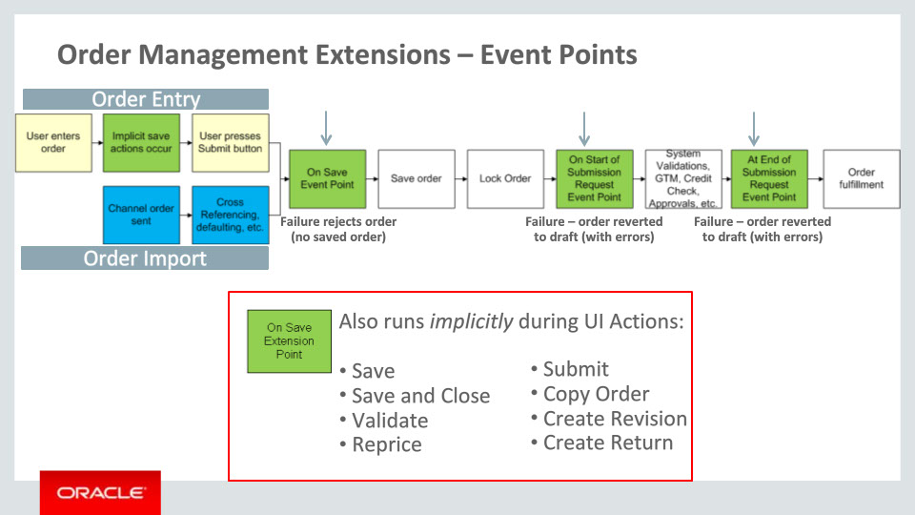
Slide notes
In the order submission flow, there are 3 specific event points where administrators can add extensions. They are On Save, at the beginning of the submission request, and at the end of the submission request just before order fulfillment begins.
Regardless of whether the order is coming in from a channel through order import, or whether the order is being entered through the Order Management work area, these 3 event points will work in similar ways.
The On Save event fires anytime the order is attempting to be saved. This applies to the explicit “Save” action in the UI, the save that occurs as part of order import, as well as during all the implicit saves that occur during the user flow. For example, when the user clicks Reprice, the extensions that run as part of the On Save event will be triggered when the order is saved before repricing the order.
If any validations return with errors as part of the On Save event, the order cannot be saved. In the case of Order Import, the orders will be rejected.
During the other 2 events, any validation errors will cause the order to revert back to Draft status where the messages can be viewed.

Notes

Slide 8 - Order Management Extensions – Validations
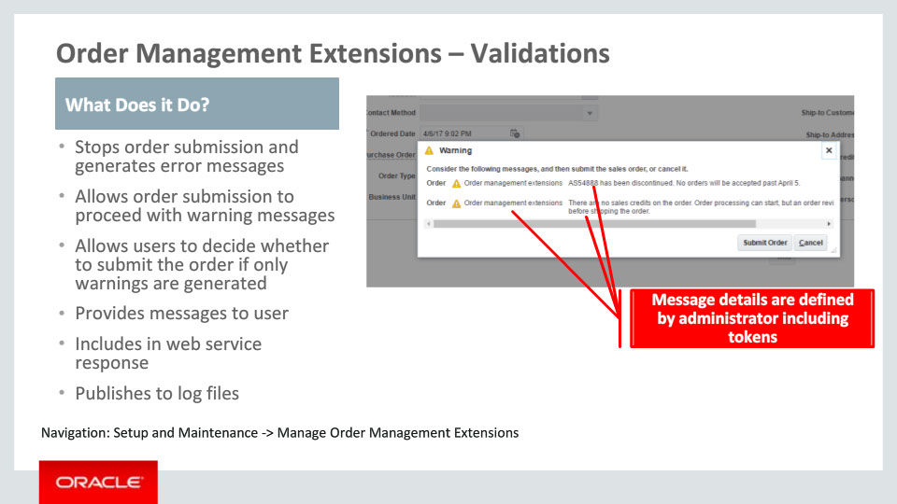
Slide notes
When extensions are used to raise error messages, the effect is to stop the order from progressing further and provide information why the order was stopped. It is also possible to write extensions that generate warning messages. In the scenario where the user is manually entering the order, if only warning messages are triggered as part of the On Beginning of Order Submission event, a dialog will let the user know of the problems and give them the choice to proceed or not.
All messages are available to users and channel systems. For users, they appear as error and warning icons on the order pages. For channel orders, information is sent through responses to web services as well as in log files for file based import.
Within the Order Management extension code, administrators have complete control over how the message appears. This includes the message text itself which can be translated into other languages using the FND message definition, data that is dynamically added to the message using tokens, and the Message Type which is a way to categorize and search for messages within the Order Management work area.

Notes

Slide 9 - Order Management Extensions – Setup
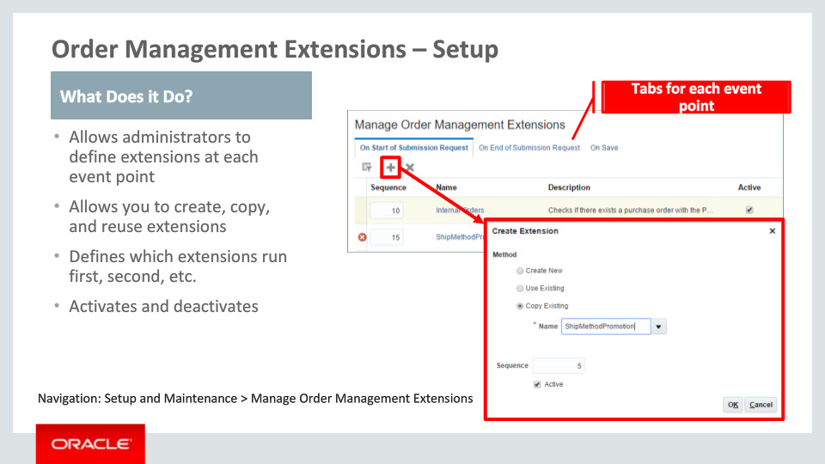
Slide notes
To setup an order management extension, navigate through Functional Setup Manager to the new task called Manage Order Management Extensions. On this page, there are 3 tabs that correspond to the 3 event points that administrators can add custom logic to.
On each event point, it is possible to create new extensions, reuse existing extension definitions across multiple event points, as well as make a copy of an existing extension definition.
Once the extensions are defined, administrators can control the sequence in which they fire during order submission. Extensions can also be activated and deactivated.

Notes

Slide 10 - Order Management Extensions – Create Extension
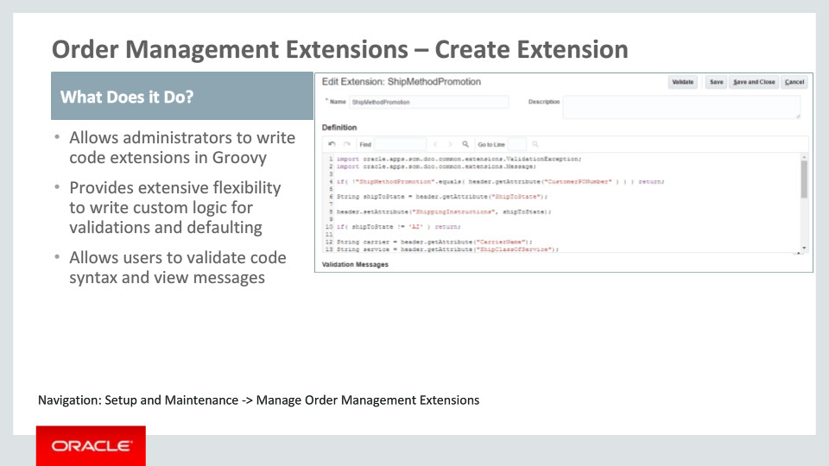
Slide notes
As you might have noticed, these extensions are intended to be used by administrators that have technical skills to code custom logic. The coding language is Groovy, which is Java based, and is used throughout the Fusion product suite like in products such as Pricing where it is used to define pricing algorithms, and in App Composer where CRM products extend their functionality.
Within the create extension page, we provide administrators with a canvas upon which they can write their custom rules. This setup page provides syntax validation so that administrators can quickly find mistakes and correct them.

Notes

Slide 11 - Order Management Extensions – Data Access
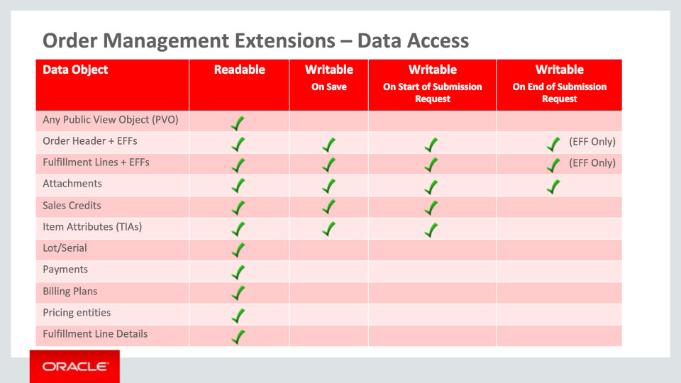
Slide notes
When writing custom logic, administrators have the ability to read in data from a number of different sources. If the data resides in Order Management like in the order header or lines, it is readily available for use within the extensions framework as you can see in the Readable column.
If the data needed is not in Order Management, there are 2 ways of accessing it. First, using Public View Objects, or PVOs, administrators can access data from any other Fusion product that has provided this type of access. Alternately, administrators can call web services to send and receive data from other sources.
When it comes to writing data to the order management objects, the capabilities of Order Management Extensions will differ depending on the event. During the On Save and On Start of Submission Request, extensions can write to the order header and order header extensible flexfields or EFFs, fulfillment lines and fulfillment line EFFs, attachments, sales credits, and Transactional Item Attributes.
During the On End of Submission Request event, the writable objects are restricted as the order has already been through a great deal of validation as well as additional checks such as credit check, global trade compliance check, and approvals. For this reason, the objects that can be updated during this event are limited to the extensible flexfields on the order and the fulfillment lines as well as attachments.

Notes

Slide 12 - Order Management Extension – Calling Web Services
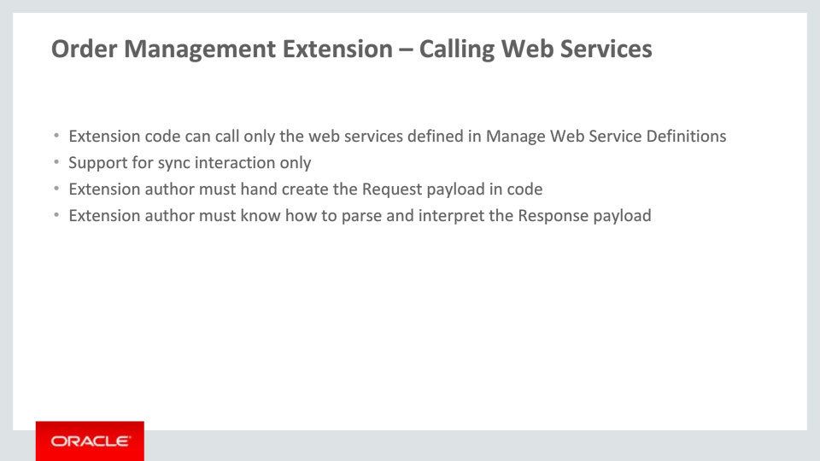
Slide notes
Order Management extensions can send and receive additional data within the order submission process by calling web services external to order management. In order to call these web services from within the extensions code, the web services need to be defined in the existing order management setup called Manage Web Service Definitions.
Only synchronous web services are supported.
When an extension author is writing code to call a web service, it is necessary for the author to assemble the request payload within the extension. Similarly, when the response from the web service is returned, the code in the extension needs to parse through response object in order to use the information.

Notes

Slide 133 - Order Management Extensions – More Information
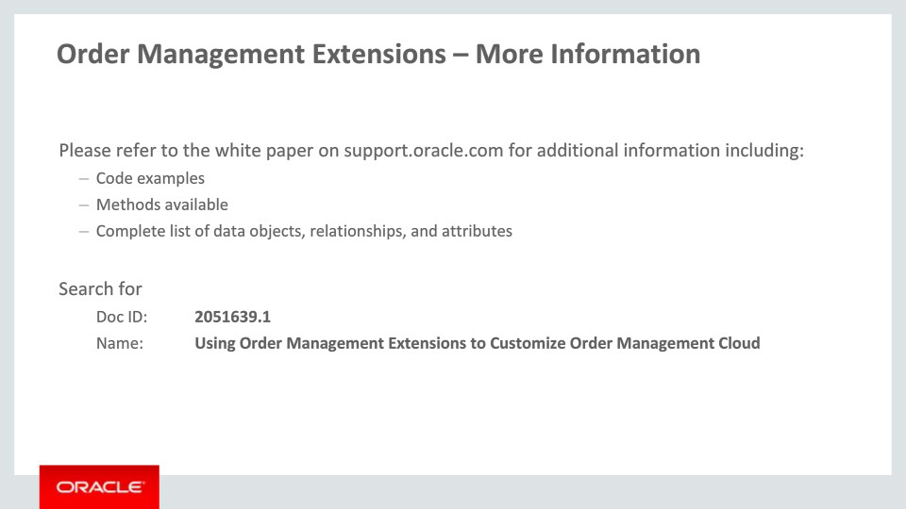
Slide notes
There are a lot of details to understand before an administrator is able to write their first extension. Please refer to the white paper on support.oracle.com to see code examples, a list of the methods available within order management and how to use them, as well as a complete list of the data objects, their relationships, and the attributes within each object.

Notes

Slide 134 - Integrate with Fusion Installed Base
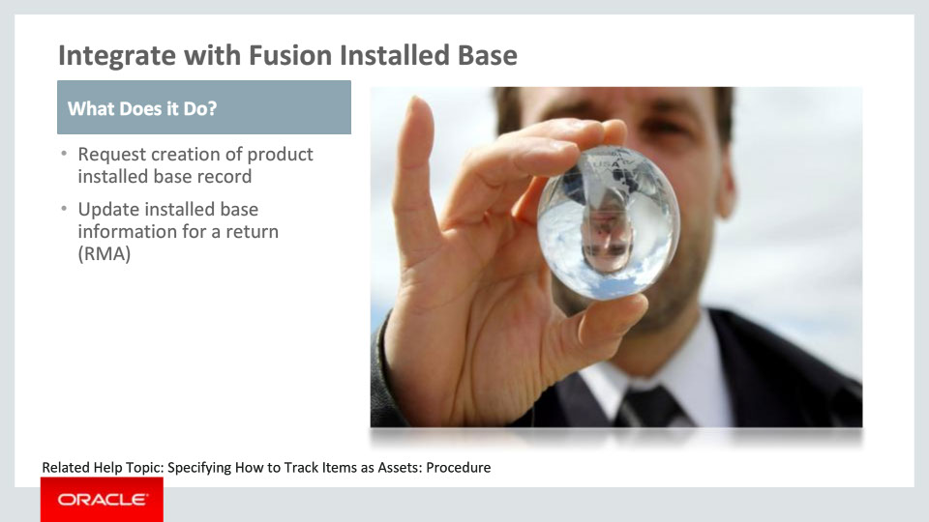
Slide notes
Next, a pre-built integration between Order Management and Fusion Installed Base is available in this release. This allows you to create business flows where assets can be created or updated in the fulfillment and return scenarios respectively.

Notes

Slide 135 - Request Creation of Product Installed Base Record
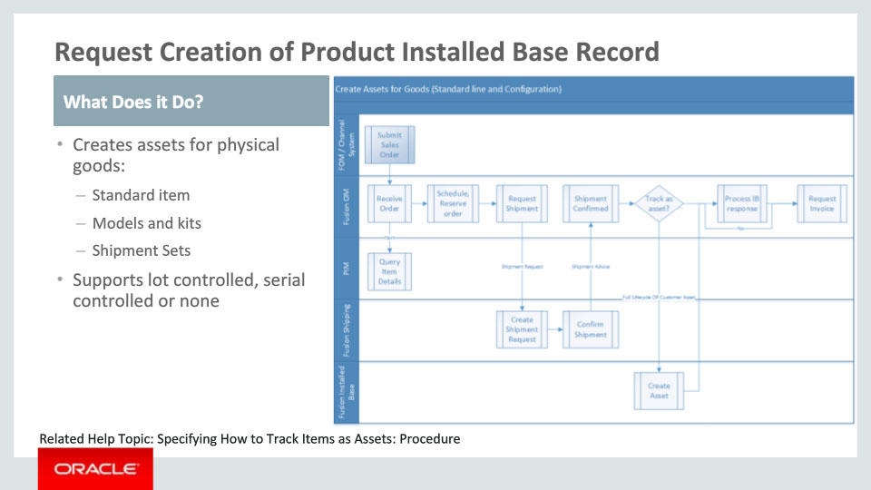
Slide notes
Order Management has made available a new task type in the Order Orchestration infrastructure that provides a pre-built integration with Fusion Installed Base. A connector to Fusion Installed Base has been seeded along with a routing rule such that the usage of this task type automatically routes the request to Fusion Installed Base system.
You may define an orchestration process with a step that uses this seeded task type. For items that have the “Enable Asset Tracking” attribute as either “Customer Asset” or “Full Lifecycle” in Product Management, a request to create an asset will be sent to Fusion Installed Base. This step is generally expected after the shipping step as shown in the process flow diagram. Thus, for serial or lot number controlled items, the serial number or lot number information, as appropriate, is passed down from Order Management to Fusion Installed Base. Types of physical goods for which assets can be created include standard items, as well as items that are part of a model structure, kit or shipset. It is not necessary for items to be lot or serial number controlled to create asset.
The information captured by Fusion Installed Base for the customer asset includes Item or Part Number, Serial and Lot numbers, Customer, Customer location, Bill to account information, Selling BU, Sales order references, Pricing details, and the Parent/child relationships for models and kits.

Notes

Slide 136 - Request Creation of Product Installed Base Record
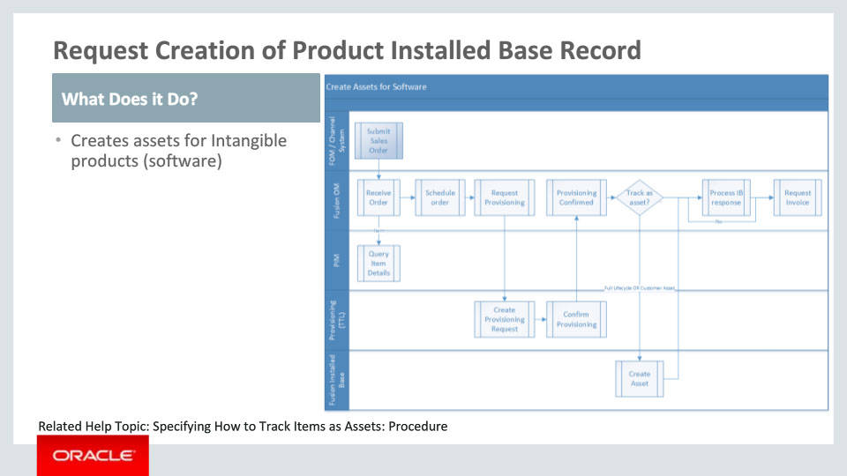
Slide notes
Similar to physical goods, assets may be created for intangible products where the sales product type has a value of Software. Intangible products other than software are suited for service contracts and therefore do not support asset creation.

The flow shown here is similar to that for physical goods. The difference is that instead of a shipping step, one expects to have a provisioning step followed by asset creation for the provisioned service. The process shown here is a sample but it illustrates the expected pattern. You would need to define your own orchestration process that could include the new task type to create an asset. Other than lot and serial number which don’t apply to intangible products, Installed Base captures the same information as that for physical goods.

Notes

Slide 137 - Update Installed Base Information for a Return
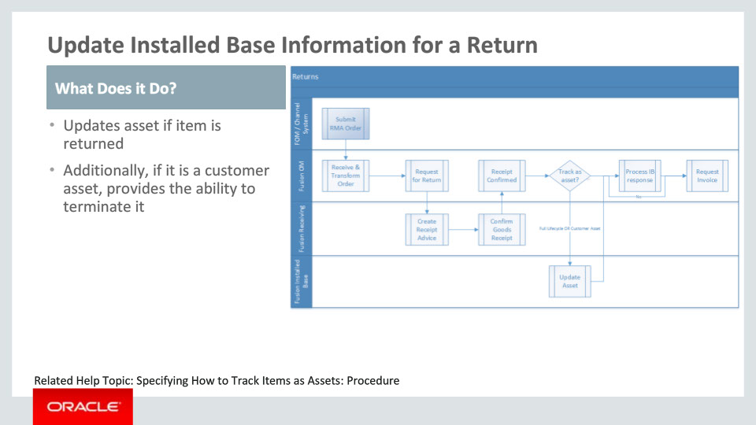
Slide notes
For return of items where assets were previously created in Fusion Installed Base, a step to update the asset can be included after the Receiving step. The flow diagram shows a sample flow and you can create a similar orchestration process for returns. Fusion Installed Base terminates the asset if it’s a Customer Asset once the item is received and Order Management confirms the same. For an asset which is Full Lifecycle tracked, the customer association is end-dated and the location change is updated against the asset.

The lot and serial numbers recorded by Order Management when Fusion Receiving notifies the receipt confirmation are passed to Fusion Installed Base to update the correct asset records.

Notes

Slide 138 - Display Asset Information
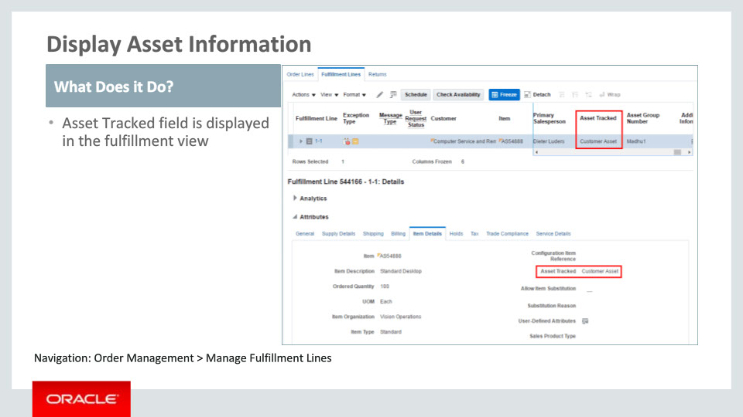
Slide notes
In the fulfillment view within Order Management, the attribute “Asset Tracked” has been added to both the fulfillment lines table and the Item Details section.

Notes

Slide 139 - Integrate with Fusion Installed Base
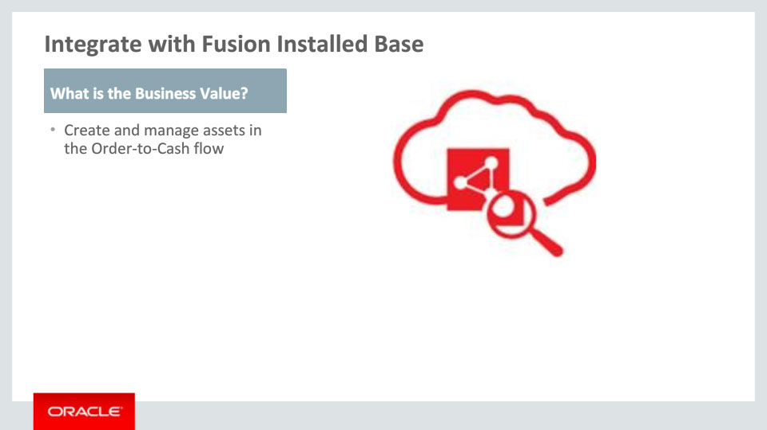
Slide notes
To summarize, in this release, a pre-built integration with Fusion Installed Base allows you to build flows where assets are created in Fusion Installed Base at the time of sales order fulfillment and those assets are updated if the items are returned.

Notes

Slide 140 - Extend Integration with Fusion Receivables
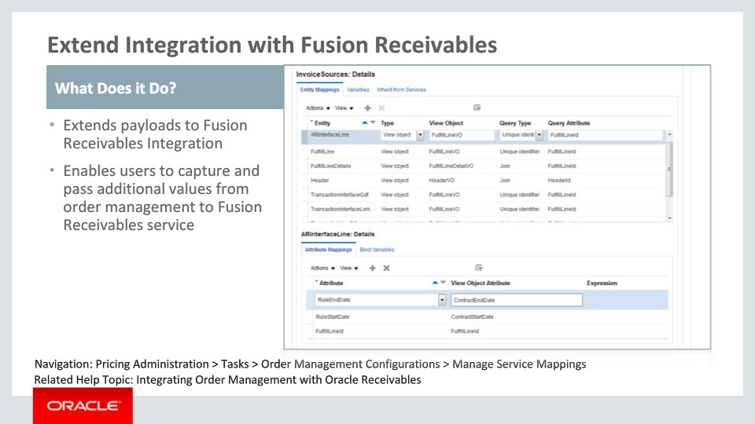
Slide notes
Now, I will talk about the enhancement that extends the integration with Fusion Receivables in this release. This enhancement allows you to pass additional attributes to the Fusion Receivables. For example, there may be need to send different description for the product than the one that is obtained from the product master. This enhancement allows you to pass that information. You may have defined descriptive flexfields in the Fusion Receivables application. This enhancement can be used to pass values to those descriptive flexfields.
You can map the order attributes to Fusion Receivables servicing using the Manage Service Mappings page and the Manage Algorithms page. These are setup tasks. You can navigate to these pages via Pricing Administration work area. They are listed in the Tasks pane under Order Management Configuration.

Notes

Slide 141 - Extend Integration with Fusion Receivables
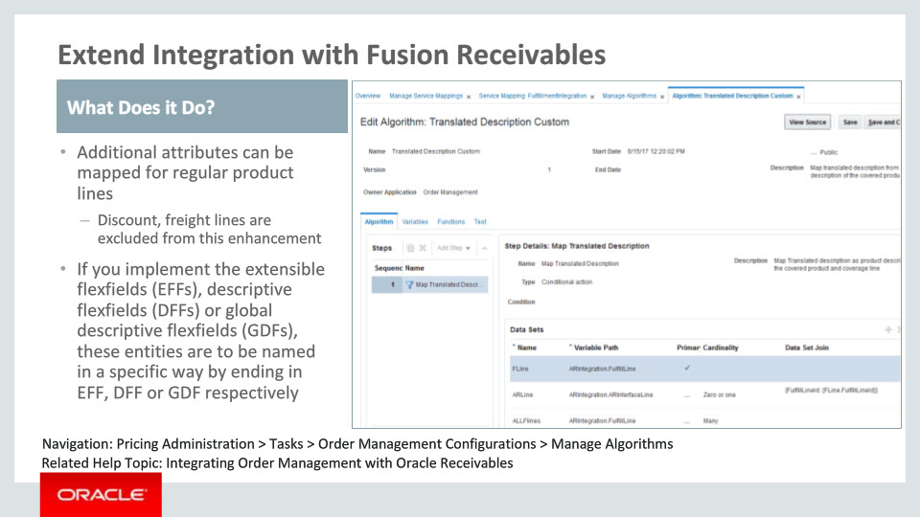
Slide notes
There are limitations on which lines are going to be extended while integrating with Fusion Receivables. As noted, Discount lines, freight lines and sales credit lines are excluded from this enhancement.
If you have implemented descriptive flexfield and global descriptive flexfield, also known as DFF and GDF, on the invoice objects or extensible flexfield, also known as EFF, on the order object, then these need to be named specifically ending with Dff, Gdf and Eff respectively while defining in the Manage Service Mappings page. You should also have all the information needed to implement the mapping from or to these objects.

Notes

Slide 142 - Capture Tax Detail
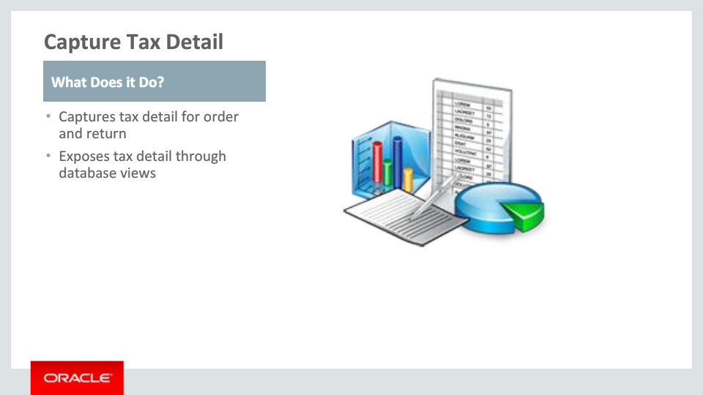
Slide notes
We also enhance the support for tax in this release. Tax detail is the information that is used to calculate the amount of tax to be charged for an order. It includes that tax rate that is applied, the tax type (inclusive tax versus exclusive tax), the tax exemption certificate number and exemption reason, the tax amount, and the taxable amount that is the basis used to calculate the tax amount according to the definition of the tax rate. Business needs the tax detail of an order for various purposes, for instance, reporting tax, or creating commercial invoice.
Starting in this release, Order Management will capture the tax detail returned by the tax engine in addition to the charge and tax amount. Multiple taxes may be applied to one order line. Please note that orders from channels will not have tax details captured unless the orders are priced in Order Management.
Order Management exposes tax detail along with the other order information through database views that can be accessed and consumed by the other applications. There is no change to the display of tax information in the Order Management UI, where only the tax amount is displayed but not the breakdown of tax detail. There is no change to the integration with the downstream fulfillment system either. Tax detail is not part of the fulfillment request that is sent to the downstream system.
Order Management captures tax detail for return as well. However, if the original sales order line was from channel and was not priced in Order Management, the return will not have tax detail captured.

Notes

Slide 143 - Enhance Tax Calculation
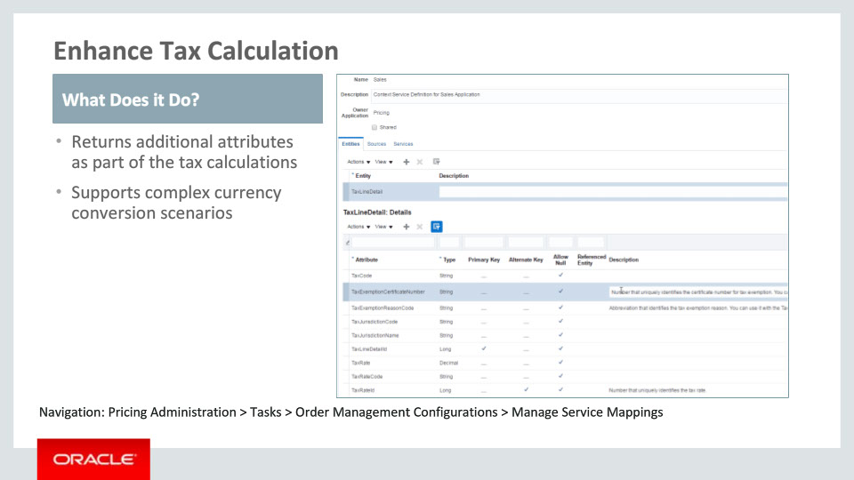
Slide notes
To support tax detail, Oracle Pricing also enhances the tax calculation by modifying the algorithm for calculating the sales tax and adding several attributes on the tax line detail, including Header Currency Code, Header Currency Tax Amount, Header Currency Taxable Amount, Tax Rate Identifier, Tax Exemption Reason Code, and Tax Exemption Certificate Number. Pricing also supports complex currency conversion scenarios for both outbound and inbound orders.

Notes

Slide 144 - Reporting using Oracle Transactional Business Intelligence (OTBI)
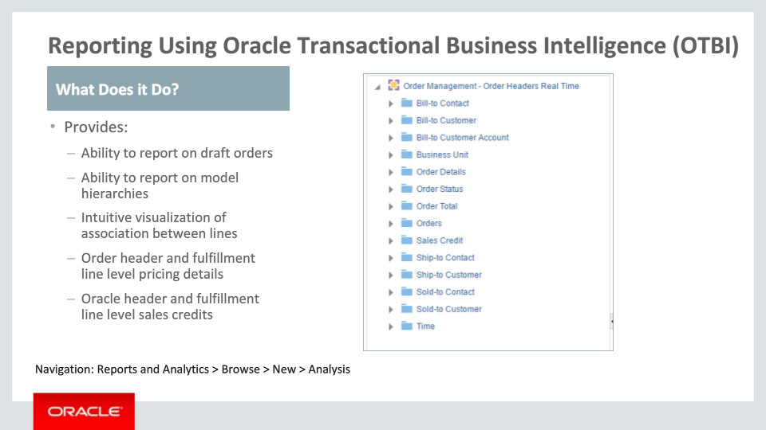
Slide notes
Lastly, this release also adds major capabilities in the Order Management subject areas in Oracle Transactional Business Intelligence or OTBI. It includes the following enhancements:
• You are now able to create reports on draft or un-booked orders.
• You can also create reports showing model hierarchies.
• Reports that require the main attributes of related fulfillment lines in a single row can now be built. The specific relationships that are supported are explained later in this training.
• Next, pricing details at the order header and fulfillment line levels are now exposed in the respective subject areas.
• Further, sales credits are exposed both at the order header level as well as the fulfillment line level.

Notes

Slide 145 - Reporting using Oracle Transactional Business Intelligence (OTBI)
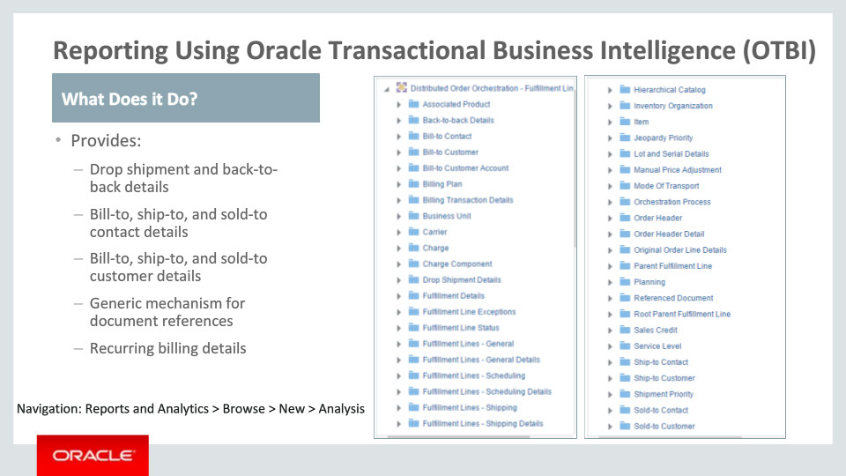
Slide notes
In addition, attributes related to drop shipment and back-to-back fulfillment mechanisms are exposed and available for reporting.
Details for bill-to, ship-to, and sold-to contact and customer are also available to be displayed on reports.
Next, business and user keys of documents in other systems that are associated with fulfillment line are available to be shown on reports.
Further, you can now include billing details where there are recurring charges in reports.

Notes

Slide 146 - Reporting using Oracle Transactional Business Intelligence (OTBI)
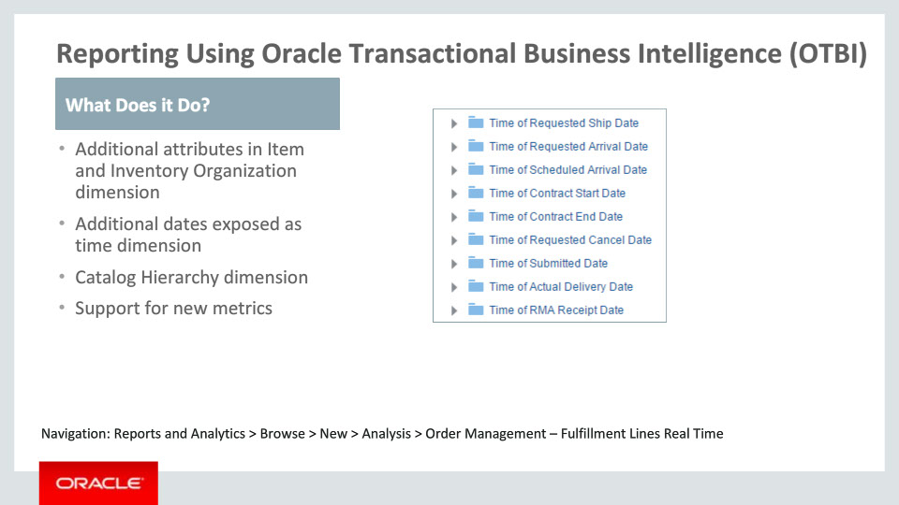
Slide notes
Starting in this release, Order Managements subject areas now include additional useful attributes under the Item and Inventory Organization dimensions.
New date attributes as well as some of the previous date attributes are exposed as a time dimension and is described later in this training.
In addition, you now have the ability to create reports that include attributes from the Hierarchical Catalog dimension.
Finally, new planning metrics have been included to make it easy to perform plan versus actual reporting.

Notes

Slide 147 - Ability to Report on Draft Orders
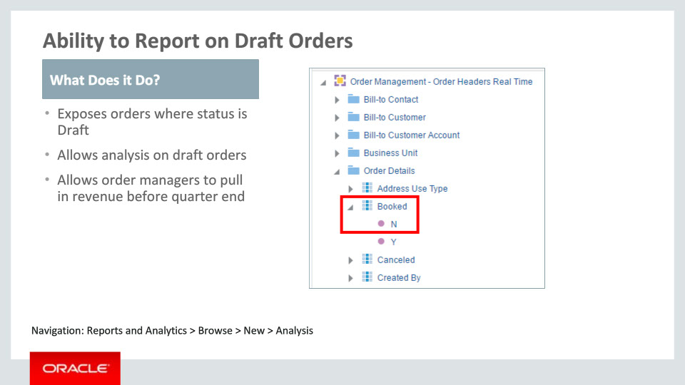
Slide notes
The objective of this enhancement is to allow you to create reports that include orders that have not yet been booked meaning draft orders. This allows stakeholders to know upfront about new orders that are on the way to getting booked. It serves as a means to expedite the resolution of the underlying cause that keeps the order from getting booked and thus helps boost the revenue in time, as an example before the close of the quarter. Report authors can include and apply a filter on the Booked attribute to show just draft orders or just booked orders.

Notes

Slide 148 - Ability to Report on Model Hierarchies
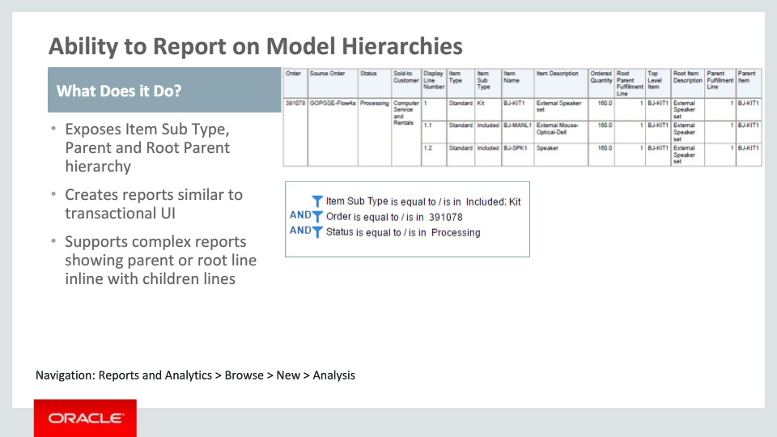
Slide notes
This enhancement gives you the ability to create reports that show the main attributes of the top level model and the parent fulfillment line alongside the attributes of the children lines that represent included items, option items, etc. Thus it helps you build a report that looks similar to the lines in Order Management application. In prior releases, one could not see the top level model line or parent fulfillment line alongside the children fulfillment lines.

Notes

Slide 149 - Intuitive Visualization of Association between Lines
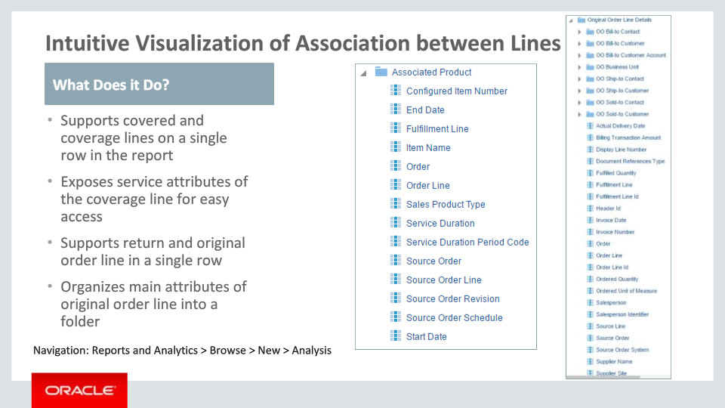
Slide notes
With intuitive visualization of association between lines, you can build reports that depict the main attributes of related fulfillment lines together on the same row. The relationships include those between a covered and coverage fulfillment line as well as that between a return fulfillment line and the corresponding original order line. New folders have been created for “Associated Product” that exposes the covered and coverage line association and for “Original Order Line Details” that exposes the original order line corresponding to a return fulfillment line.

Notes

Slide 150 - Order Header and Fulfillment Line Level Pricing details
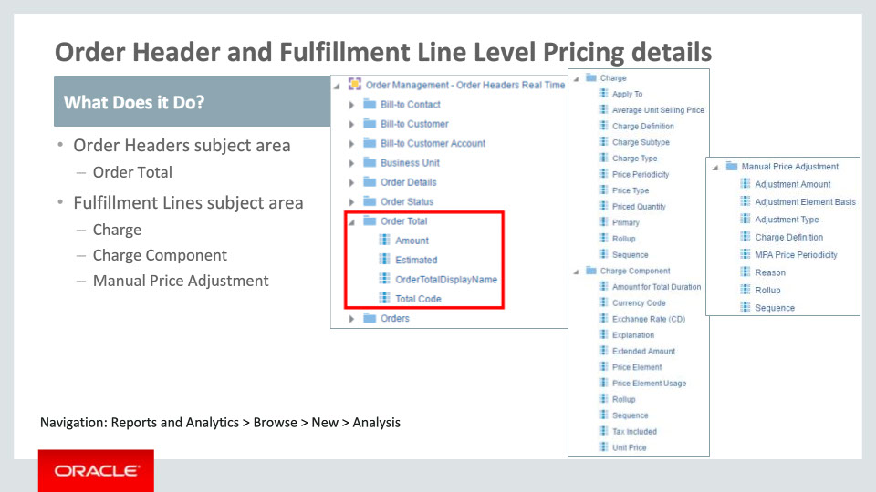
Slide notes
Order Management now allows you to show the breakup of pricing data that determines what the customer pays for each line as well as at the order header level in the Fulfillment Line and Order Header subject areas respectively. You should note that the grain of the report would have to be at the break-up level. Thus, for Order Headers, there would be multiple records in Order Totals and the grain of the report would be Order Totals. Likewise, for a given fulfillment line there would be multiple charge components and the grain of the report that includes these would be Charge Component.

Notes

Slide 151 - Order Header and Fulfillment Line Level Sales Credits
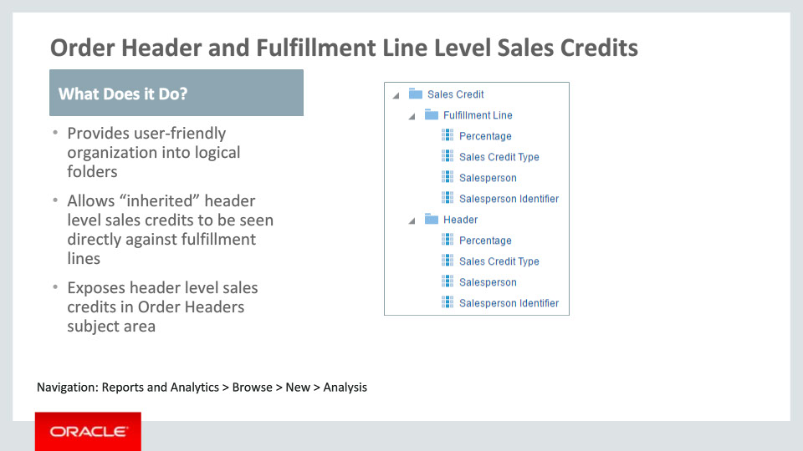
Slide notes
Order Management allows capture of sales credit at the order level and to override that at the line level. This enhancement allows you to build a report in the Fulfillment Lines subject area where you can see the header level sales credits against fulfillment lines along with any overrides at the fulfillment line level.

In the Order Headers subject area, the header level sales credit has been added to allow order level reports to show this data.

Notes

Slide 152 - Drop Shipment and Back-to-back Details
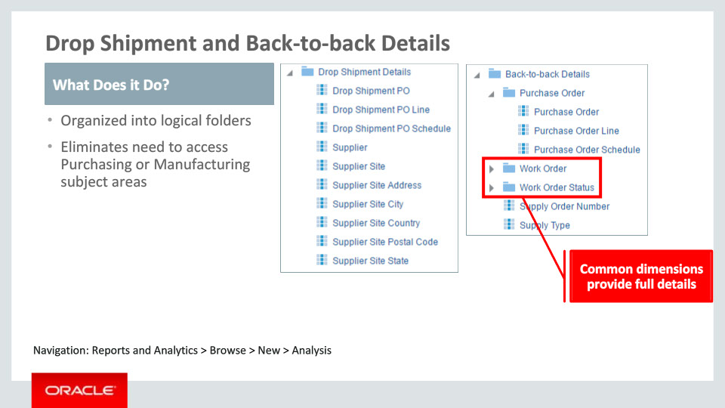
Slide notes
This enhancement allows you to include details about the drop shipment purchase order as well as the supplier. Further, for back-to-back fulfillment, it allows you to include details that include the Supply Order Number and Supply Type which indicates whether it is a Buy or a Make. For supply type of Buy, you can include the Purchase Order details and for supply type of Make, you can include the Work Order details in your report.

Notes

Slide 153 - New and Enhanced Entities
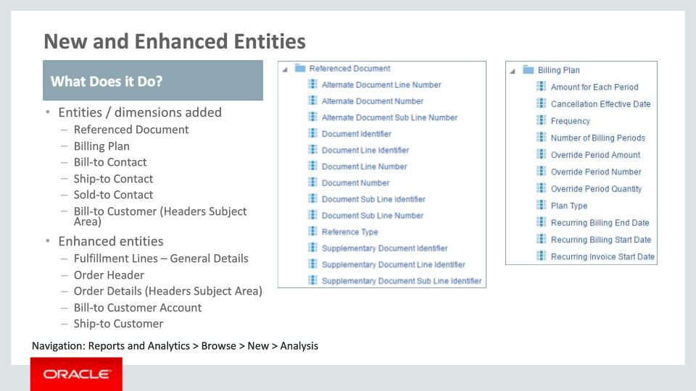
Slide notes
Here is a listing of other entities and dimensions that have now been exposed as well as existing entities and dimensions with enhancements. Please take a moment to review the list. Unless specified otherwise, these entities and dimensions are available in the Fulfillment Lines subject area.

Notes

Slide 154 - New Attributes in Item and Inventory Organization Dimension
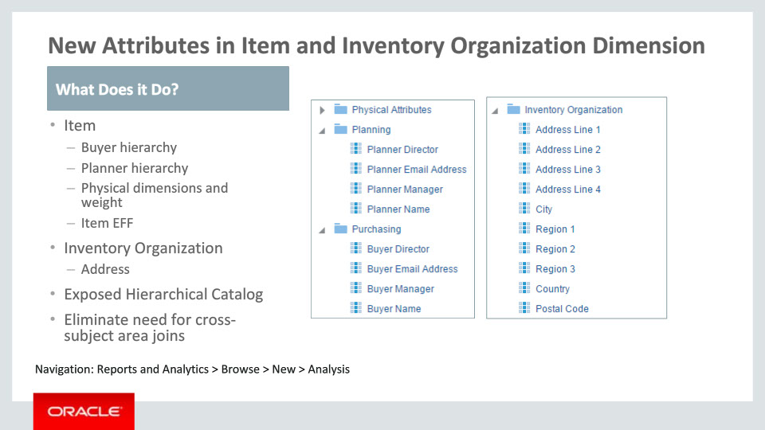
Slide notes
Item and Inventory Organization are dimensions that were already included in the Fulfillment Lines subject area. Additional attributes have been included in these dimensions in this subject area as shown here. Additionally, Hierarchical Catalog dimension has been included in this subject area. These enhancements eliminate the need to create cross-subject area joins for reports that include newly added details from these dimensions.

Notes

Slide 155 - New Metrics
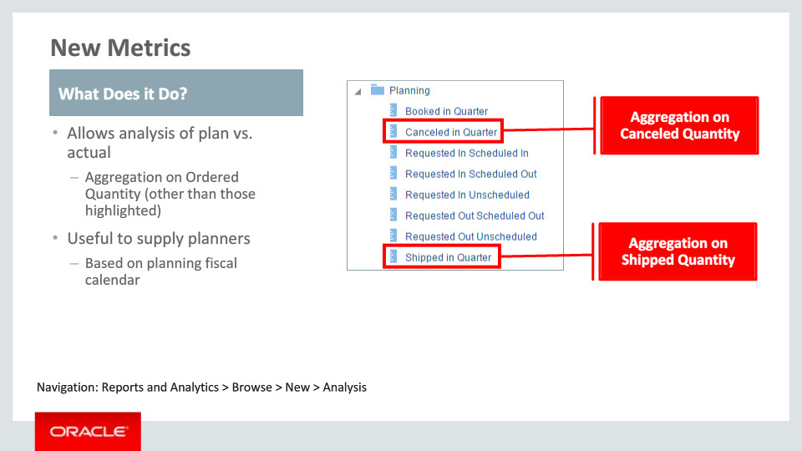
Slide notes
Lastly, new metrics have been incorporated in the Fulfillment Lines subject area. These are meant to support plan versus actual comparisons that are useful to supply planners. This folder will only be visible to users with job roles to which the duty role Supply Chain Planning Transaction Analysis Duty has been assigned.

Notes

Slide 156 - Summary of Enhancement Capabilities
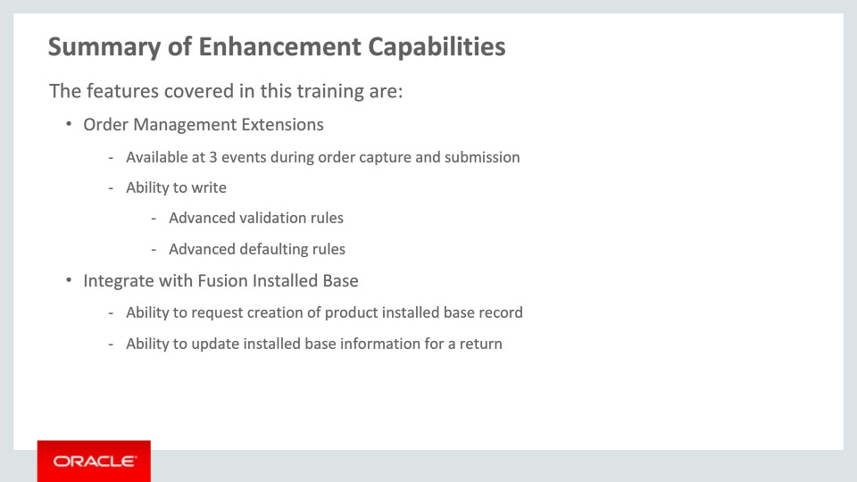
Slide notes
Here is the summary of the features I have talked about today.
At first, Order Management Extensions allow customers to write groovy code to enhance order submission at 3 event points. In the extensions, customers can call web services, run complex validation rules, and default values in the order.
Next, a pre-built integration between Order Management and Fusion Installed Base is available in this release. This allows you to create business flows where assets can be created at the time of order fulfillment and updated if the products that are asset tracked are returned.

Notes

Slide 157 - Summary of Enhancement Capabilities, Continued
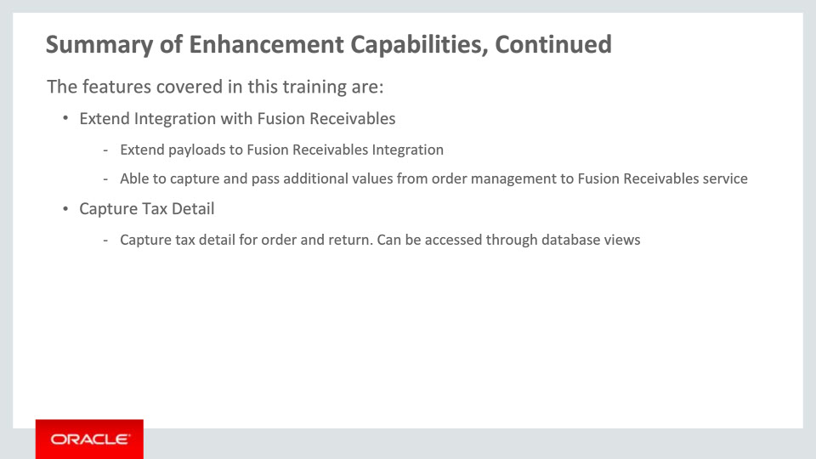
Slide notes
To review, the extended integration with Fusion Receivables allows you to pass additional attributes to the Fusion Receivables. These can either be first class attributes on order header, fulfillment lines or fulfillment line details, or extensible flexfield attribute captured for these entities.
Next, Order Management captures the tax detail returned by the tax engine in addition to the charge and tax amount. Business can leverage this information for reporting tax, creating commercial invoice, or other purposes.

Notes

Slide 158 - Summary of Enhancement Capabilities, Continued
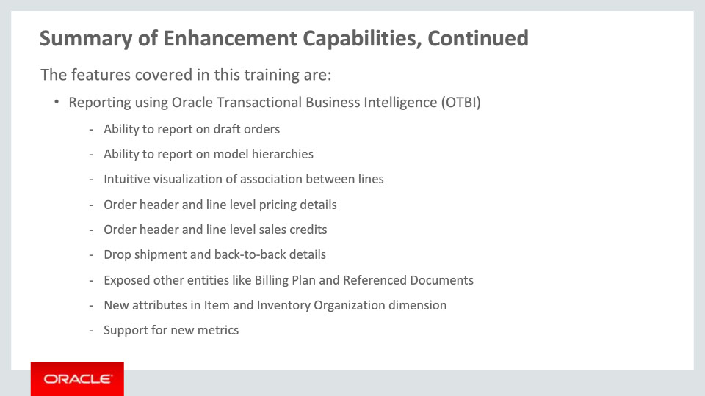
Slide notes
Lastly, the Fulfillment Lines subject area and Order Headers subject area under Order Management have been expanded. To review, the broad areas of expansion are:
• Inclusion of draft orders
• Model hierarchy
• Association between covered and coverage lines
• Association between return and original order lines
• Inclusion of pricing entities
• Inclusion of header and line level sales credit
• Details on drop shipment and back-to-back fulfillment
• Exposed other entities like billing plan and referenced documents
• Expansion of attributes under Item and Inventory Organization dimensions and inclusion of Hierarchical Catalog dimension
• Finally, metrics to perform Plan vs. Actual analysis

Notes

Slide 159 - Implementation Advice
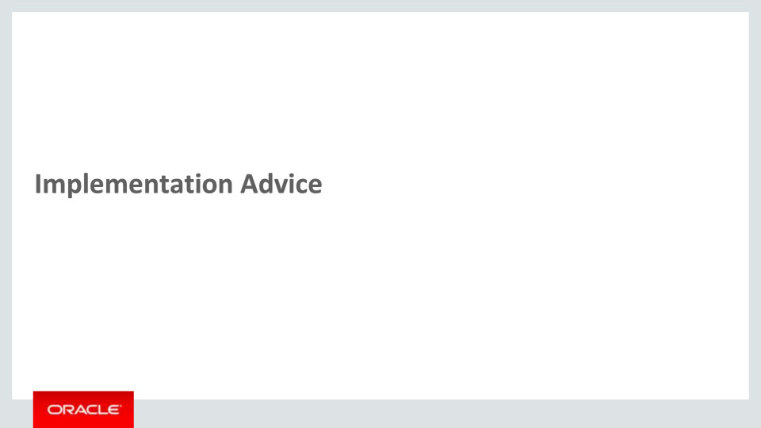
Slide notes
In this implementation advice section, we will go through what you need to consider before enabling these features in your business, and what you need to know to set them up.

Notes

Slide 160 - Feature Impact Guidelines
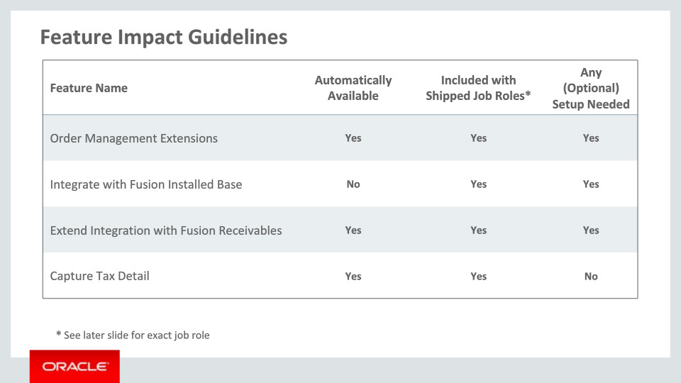
Slide notes
This table depicts key upgrade information for the new features covered in this training.

All features listed in this table except feature Integrate with Fusion Installed Base are automatically available after upgrade. All features can be accessed through existing shipped job roles. In addition, features except feature Capture Tax Details have setups associated with them – setup specifies are covered later in this section.

Notes

Slide 161 - Feature Impact Guidelines, Continued
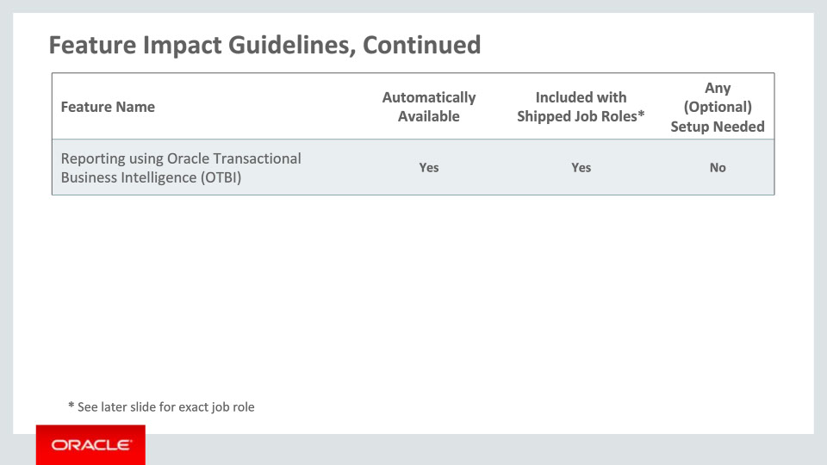
Slide notes
The Reporting using Oracle Transactional Business Intelligence feature is automatically available after upgrade. There is no setup needed, and it can be accessed through existing shipped job roles.

Notes

Slide 162 - Setup Summary
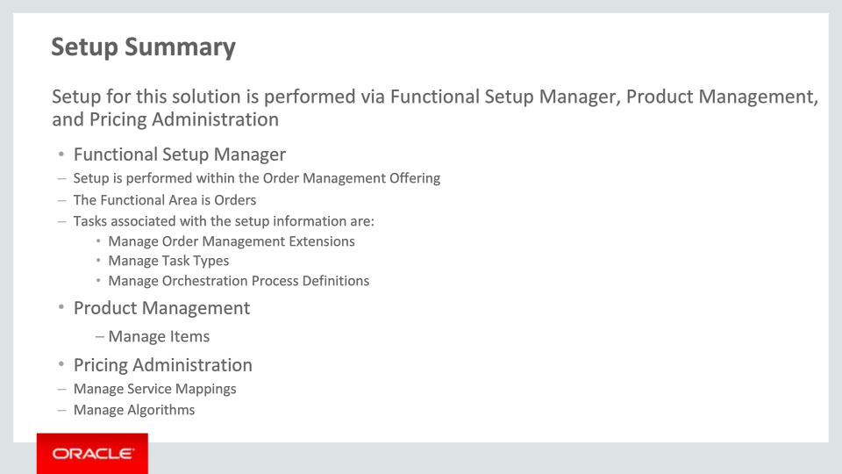
Slide notes
The setup for the enhancements covered in this training requires accessing Functional Setup Manager, Pricing Administration, and Product Management.
Through Functional Setup Manager, setup is performed within Order Management Offering. The functional area is Orders. The tasks that are associated with the setup information are detailed here.
In Product Management, you can use the “Manage Items” task to enable asset tracking.
In Pricing Administration, you can use the “Manage Service Mappings” and “Manage Algorithms” tasks to manage the mapping of order attributes to the Fusion Receivables service.

Notes

Slide 163 - Setup Detail: Order Management Extensions
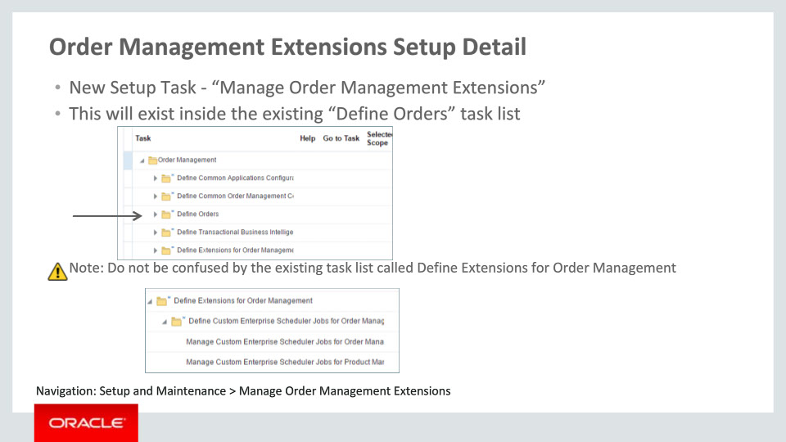
Slide notes
To navigate to the setup page where administrators can create new order management extensions, go into Fusion Setup Manager and search for Manage Order Management Extensions.
Alternately, look within your order management implementation project under the task list Define Orders.
Do not be confused by the other task list called Define Extensions for Order Management, this is related to functionality pertaining to setting up Enterprise Scheduling Service.

Notes

Slide 164 - Setup Detail: Integrate with Fusion Installed Base Setup Detail
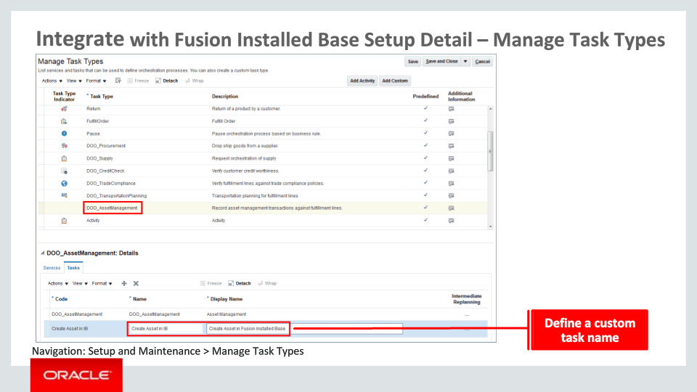
Slide notes
Next, I will talk about the setup for integration with Fusion Installed Base. A task type called “DOO_AssetManagement” has been seeded that you need to use if you would like Order Management to send a request to Fusion Installed Base for creating or updating assets. If you would like to use a custom task name for this task, type in the orchestration process that you plan to create, you may define that as illustrated here. You would then choose this custom task name when you define the step in the orchestration process definition.

Notes

Slide 165 - Integrate with Fusion Installed Base Setup Detail – Define Orchestration Process
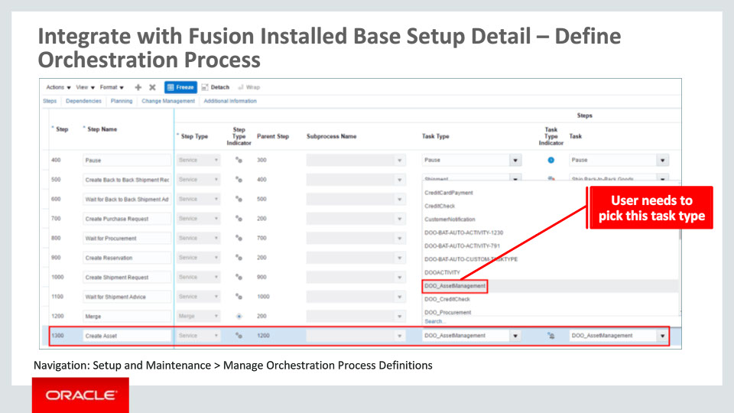
Slide notes
The detail of an orchestration process including asset management step is shown here. You need to choose “DOO_AssetManagement” as the task type while defining the step. If you defined a custom task name, you could choose that task name from the drop down list for Task attribute. Or you may choose the seeded task name as displayed here.
Further, a connector to Fusion Installed Base has been seeded and is used in the seeded External Interface Routing Rule called “DOO Asset Rule.”

Notes

Slide 166 - Integrate with Fusion Installed Base Setup Detail – Manage Items
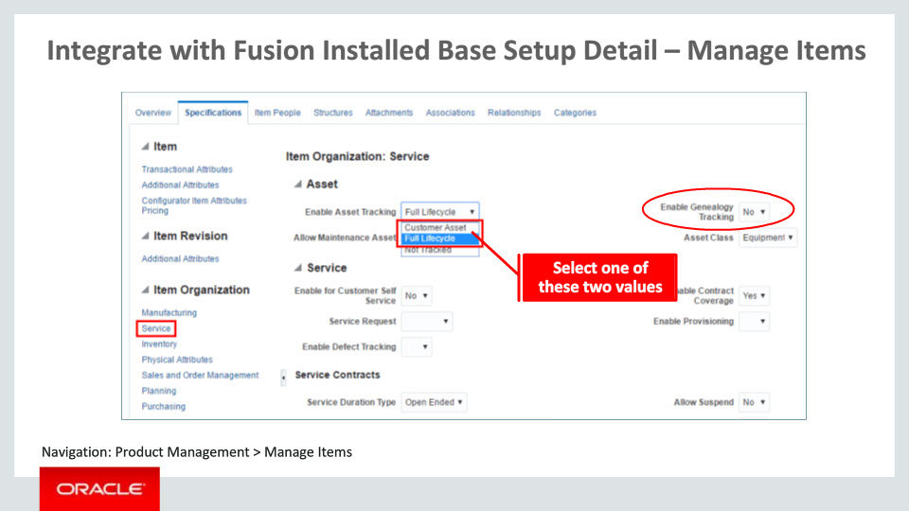
Slide notes
In Product Management, you can use the “Manage Items” task to enable asset tracking. First, you search the item in the relevant inventory organization on the Manage Items page. Next, click the Specifications tab and then the Service menu item under Item Organization on the left menu bar. A section of the Manage Items page is shown here. Set the appropriate value for the attribute Enable Asset Tracking if you would like assets to be created for this item. There are two possible values to track the item as an asset – Customer Asset and Full Lifecycle.

Notes

Slide 167 - Setup Detail: Extend Integration with Fusion Receivables Setup Detail
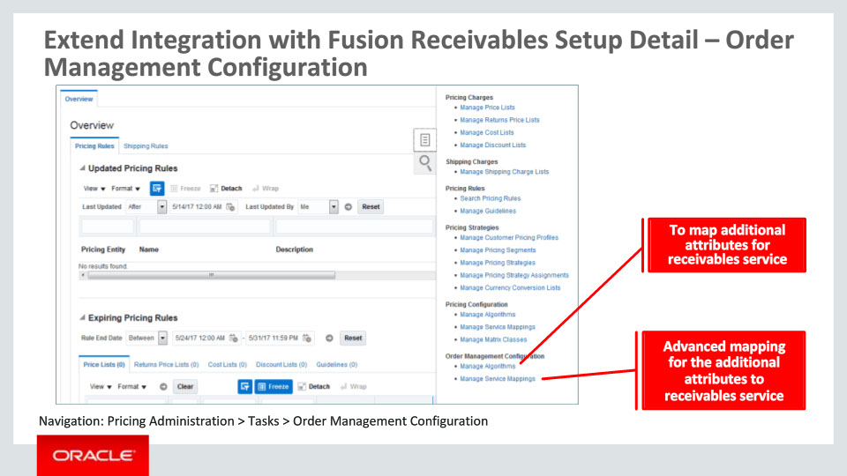
Slide notes
In order to extend the payload sent to Fusion Receivables service, you need to navigate to the Manage Service Mappings task and the Manage Algorithms task under the Pricing Administration work area. Number of entities and attributes are seeded for this extension to work. You need to select appropriate attributes that you want to send data for in the ARInterfaceLine Entity and then select the appropriate attributes form the order objects to get the values.
You may have to add extensible flexfields for the order header, Fulfillment Line and Fulfillment Line Details objects. You need to use the task Manage Algorithms in addition to Manage Service Mappings, if there are complex requirements for sending attributes to Fusion Receivables Service.

Notes

Slide 168 - Extend Integration with Fusion Receivables Setup Detail – Manage Service Mappings
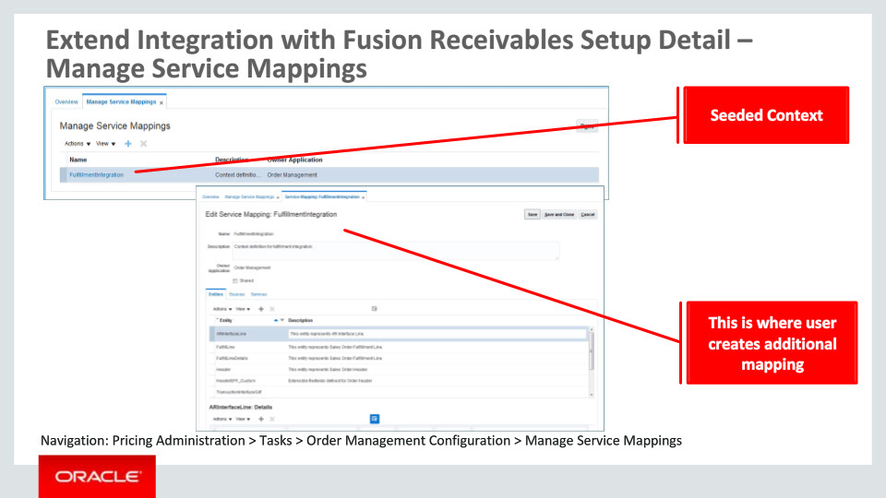
Slide notes
The Manage Service Mappings page can be used to define additional attribute mapping from Order Management to Fusion Receivables.
Most of the entities and attributes are seeded. You need to detail the DFF, GDF if you want to pass values to these on the Invoice object. You will need to define the EFF and attributes that you want to use from the Order object.

Notes

Slide 169 - Extend Integration with Fusion Receivables Setup Detail – Manage Algorithms
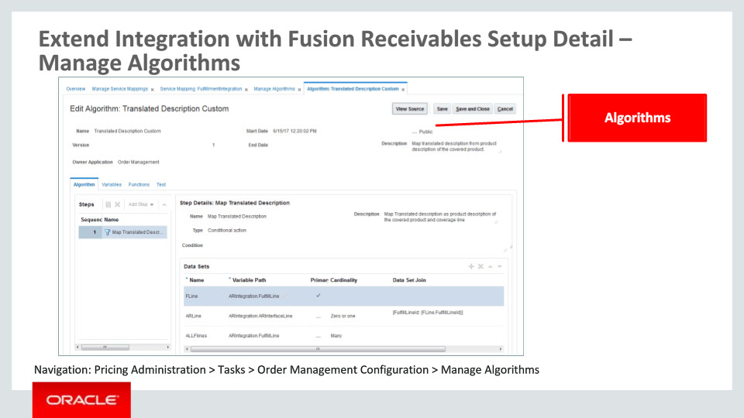
Slide notes
The Manage Algorithms page can be used to map complex attribute across levels. For example, if you wish to map and order header attribute to the Invoice Interface line, then you will need to use the Algorithms.

Notes

Slide 170 - Extend Integration with Fusion Receivables Setup Best Practices
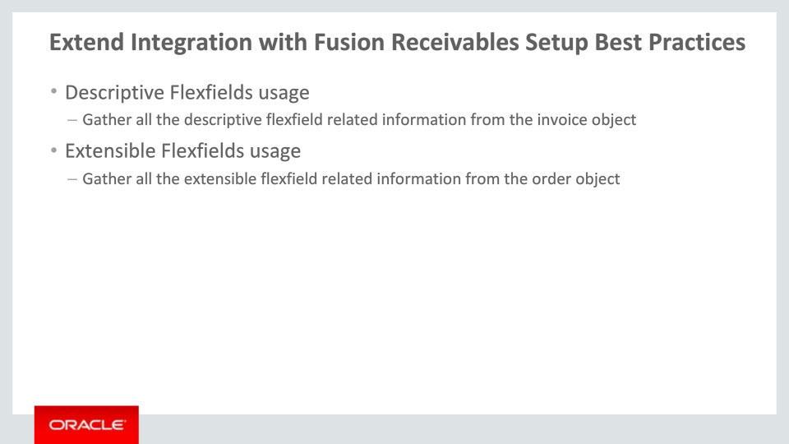
Slide notes
If the extensible flexfields are used to capture additional information about the Order objects that needs to be passed to Fusion Receivables service, then you need to gather that information like VO Name, Segment Name, Context name etc in advanced that can be used in the Manage Service Mappings Task.
If descriptive flexfields are used on the Invoice objects, then you need to gather that information like context name, segment name, and namespaces that can be used in the Manage Service Mappings task.

Notes

Slide 365 - Slide 365
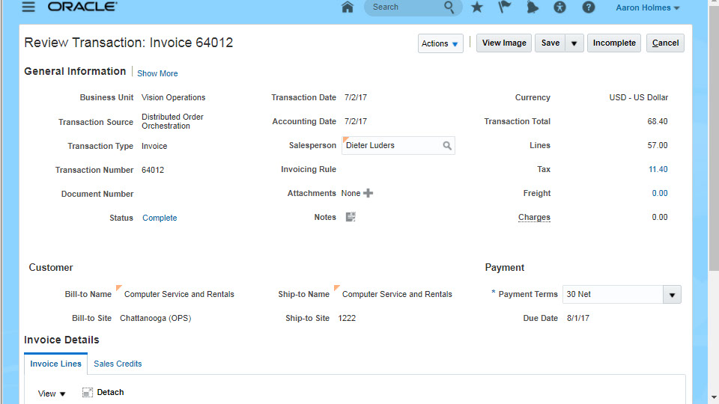
Slide notes

Notes

Slide 366 - Job Roles
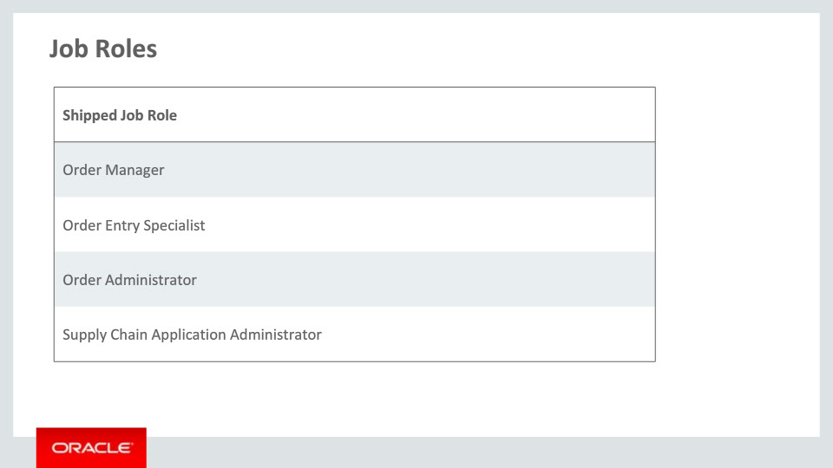
Slide notes
This table details the shipped job roles that will access the new capabilities covered in this training. Shipped job roles include order manager, order entry specialist, order administrator, and supply chain application administrator.

Notes

Slide 367 - Business Process Information
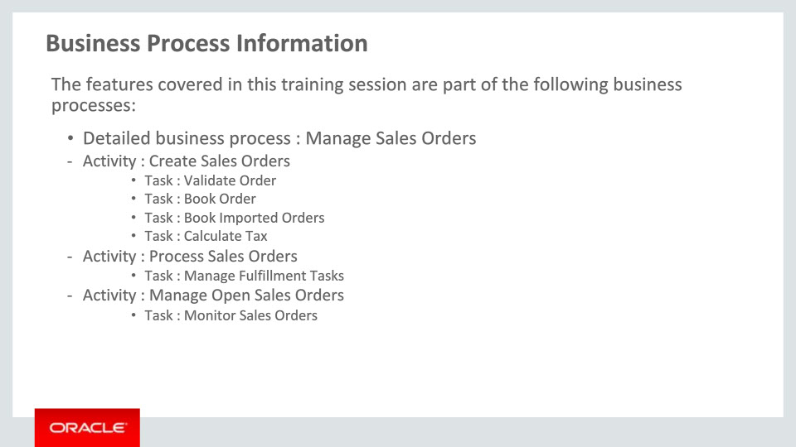
Slide notes
The business processes associated with the new capabilities covered in this training are detailed here. The high-level business process is Manage Sales Orders, with the activity Create Sales Orders, Process Sales Orders, and Manage Open Sales Orders. There are multiple associated tasks as you see here.

Notes

Slide 368 - Associated Release Training
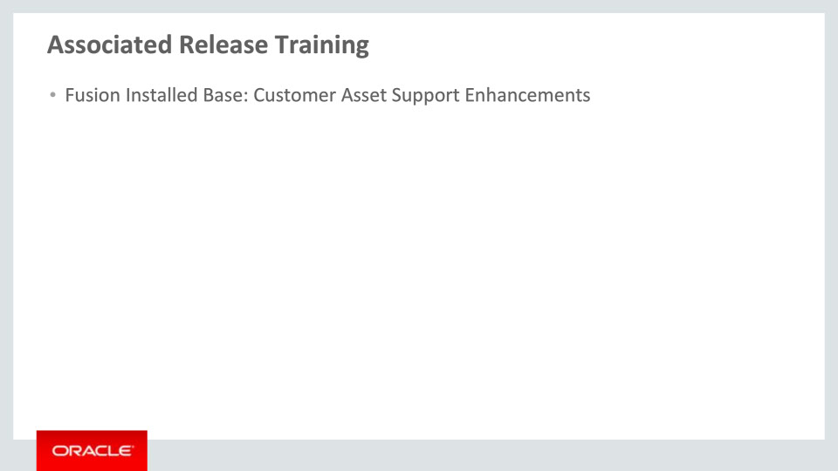
Slide notes
The release training Customer Asset Support Enhancements from Fusion Installed Base is related to one of the new capabilities reviewed and is recommended viewing.

This concludes this presentation, thank you for listening. You can easily pause and rewind any of these slides if you require additional time to take in the detail.

Notes

