Slide 3 - Oracle Order Management Cloud
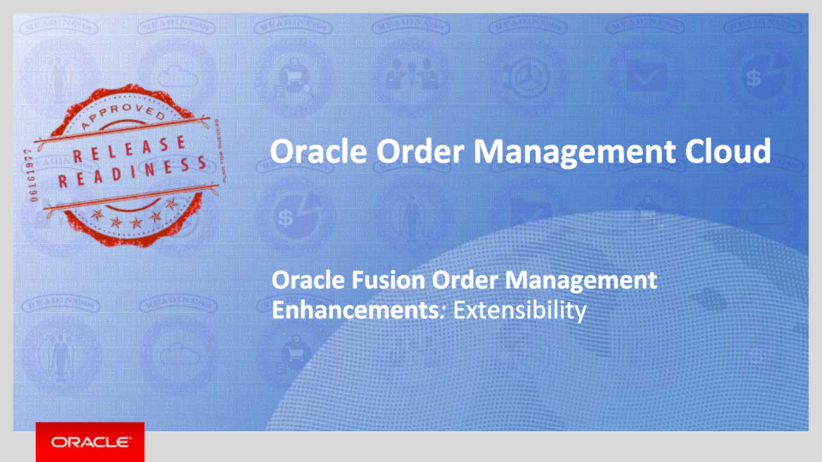
Slide notes
Hello, my name is Shrikant. Welcome to training for this release. In this session, we will talk about what’s coming in Oracle Order Management Cloud for Extensibility enhancements.

Notes

Slide 4 - Agenda
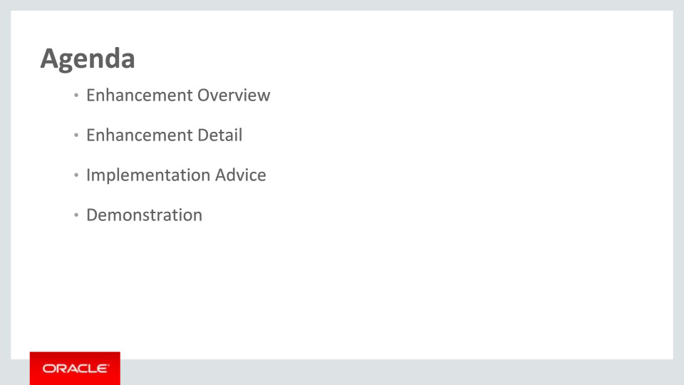
Slide notes
For the enhancements covered in this training, we’ll give an overview, followed by more detail to explain how you can use them, and what business value they bring.
Then, we’ll walk you through a demonstration.
Next, we’ll explain what you need to consider before enabling these features in your business, and what you need to know to set them up.

Notes

Slide 5 - Overview
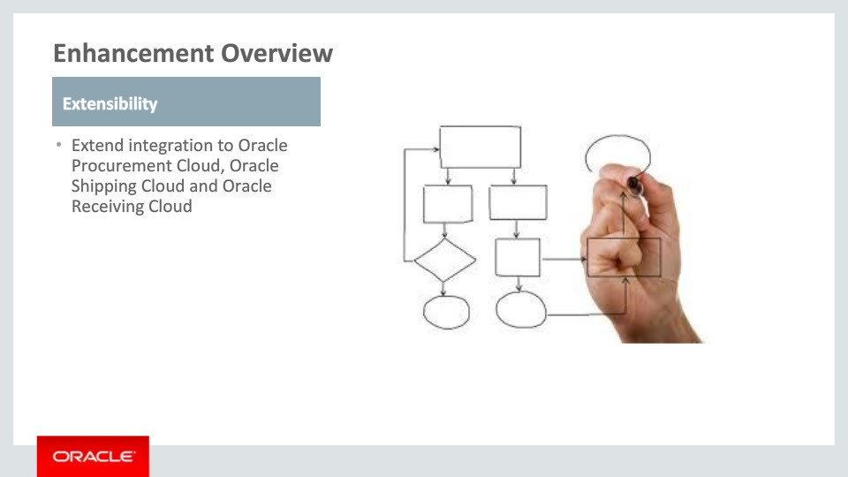
Slide notes
The release adds significant capabilities in Order Management Extensibility.
It extends the integration with Oracle Procurement, Oracle Shipping and Oracle Receiving by passing additional attributes to these applications. For example, it allows you to send different description for the product than the one that is obtained from the product master, or to send a different price of the item to Procurement. You can also pass values to the descriptive flexfields defined in these applications.

Notes

Slide 6 - Enhancement Detail
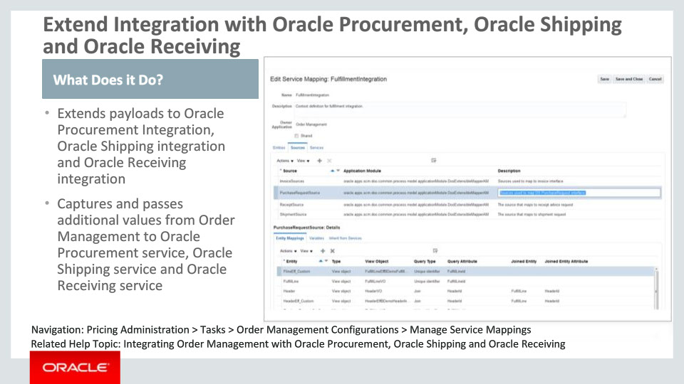
Slide notes
This enhancement allows you to pass additional attributes to the Oracle Procurement, Oracle Shipping and Oracle Receiving. For example, there may be need to send different description for the product than the one that is obtained from the product master. This enhancement allows you to pass that information. You may have defined descriptive flexfields in the Procurement, Shipping or Receiving application. This enhancement can be used to pass values to those descriptive flexfields. For example, you can capture price for the items in extensible flexfields and pass that to supplier, as oppose to negotiated price, or capture lot numbers in extensible flexfields and pass those to Oracle Receiving application.
You can map the order attributes to All these Fusion services using the Manage Service Mappings page and the Manage Algorithms page. These are setup tasks. You can navigate to these pages via Pricing Administration work area. They are listed in the Tasks pane under Order Management Configuration.

Notes

Slide 7 - Extend Integration with Oracle Procurement, Oracle Shipping and Oracle Receiving
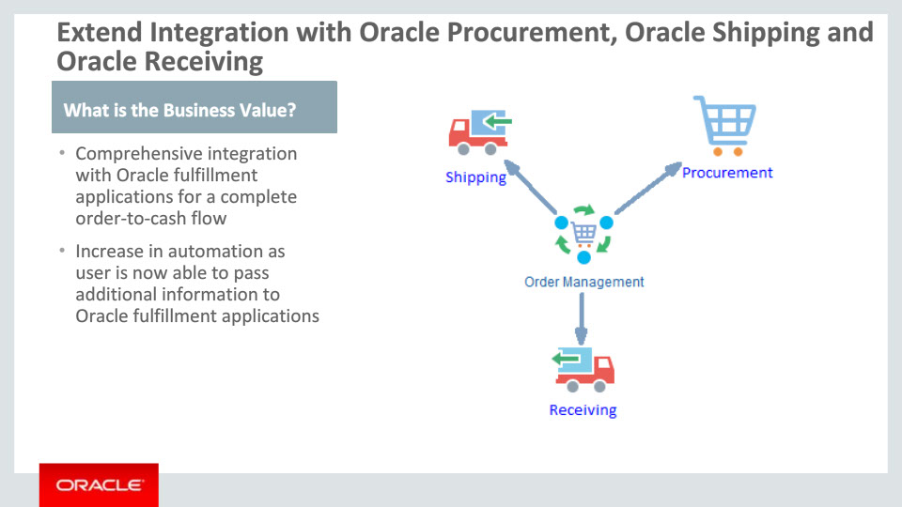
Slide notes
Order Management includes integration with multiple fulfillment systems to enable a complete order-to-cash process flow. While this integration is comprehensive, there may be additional information that must be passed from an order to meet a specific business need. For example, customers may want to send the prices to supplier when there are no blanket purchase agreements. In another instance customer may want to sent the lot number to the receiving application for return orders. This feature allows users to pass additional information captured in extensible flexfields or other attributes from the order object to these applications.

Notes

Slide 8 - Additional Information
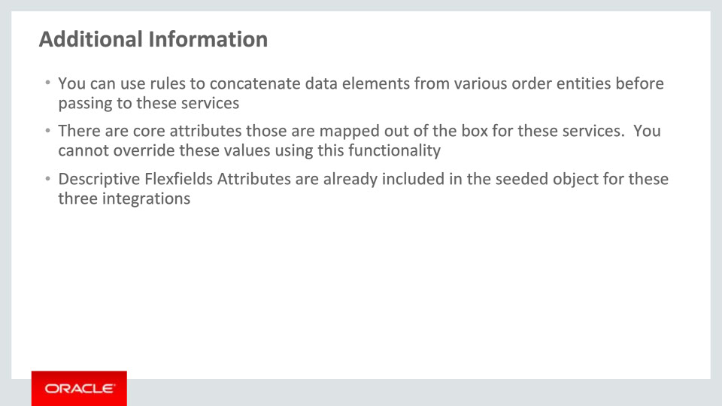
Slide notes
There are number of attributes mapped for these services out of the box. These values cannot be overridden using this feature. A list of attributes mapped out of the box is listed in the documentation for this feature.
If you have implemented EFF on the order object, then these need to be named specifically ending with “Eff” while defining in the Manage Service Mappings page.
You should also have all of the information needed to implement the mapping from these objects.

Notes

Slide 9 - Summary of Enhancement Capabilities
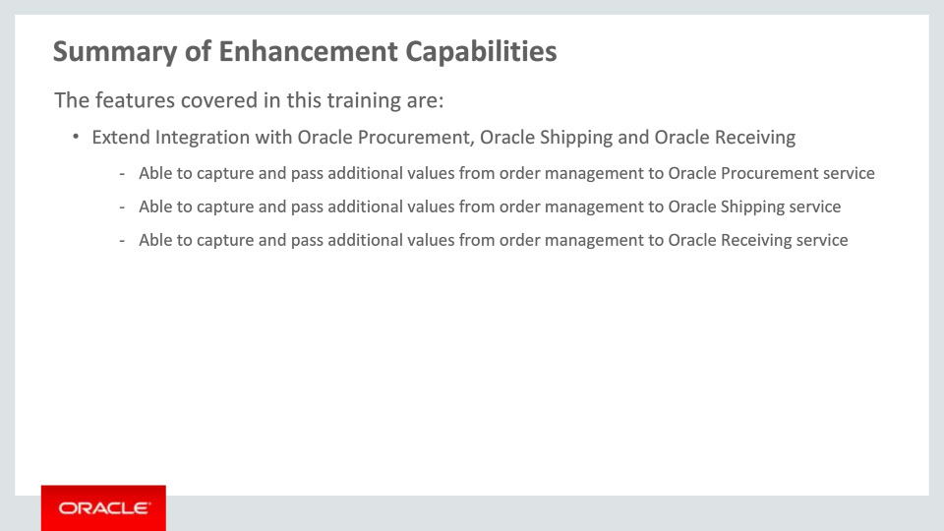
Slide notes
Here is the summary of the features I have talked about today.

This enhancement allows you to pass additional attributes to the Oracle Procurement, Oracle Shipping and Oracle Receiving. These can either be first-class attributes on the order header, fulfillment lines or fulfillment line details, or an extensible flexfield attribute captured for these entities.

Notes

Slide 10 - Implementation Advice
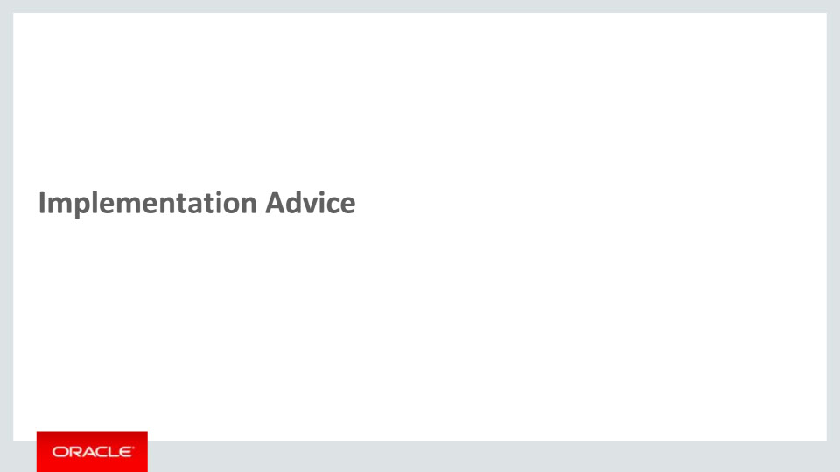
Slide notes
In this implementation advice section, we will go through what you need to consider before enabling these features in your business, and what you need to know to set them up.

Notes

Slide 11 - Feature Impact Guidelines
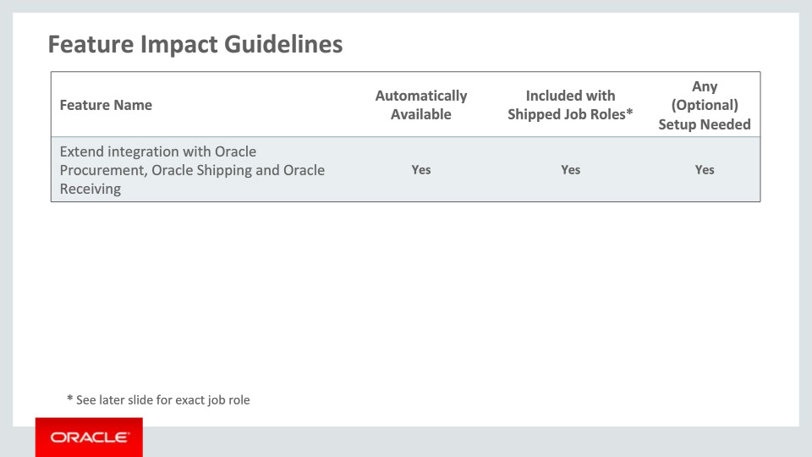
Slide notes
This table depicts key upgrade information for the new features covered in this training.
The feature listed in this table is automatically available after upgrade. This feature can be accessed through existing shipped job roles. In addition, the feature has setup associated with it – setup specifics are covered later in this section.

Notes

Slide 12 - Setup Summary
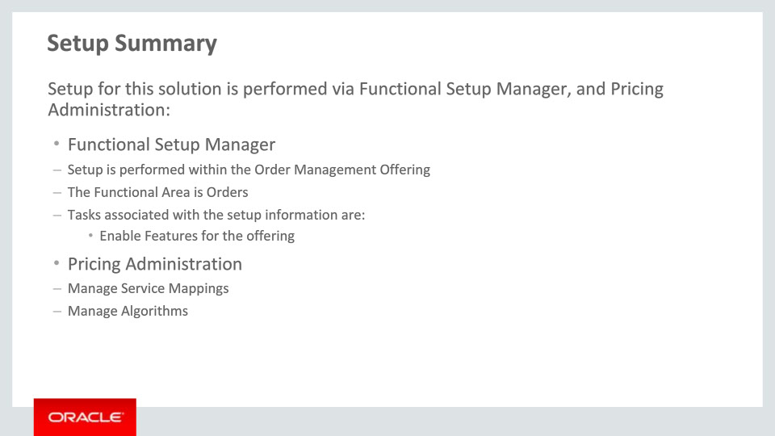
Slide notes
The setup for the enhancements covered in this training requires accessing Functional Setup Manager and Pricing Administration
Through Functional Setup Manager, setup is performed within the Order Management Offering. The functional area is Orders.
In Pricing Administration, you can use the “Manage Service Mappings” and “Manage Algorithms” tasks to manage the mapping of order attributes to the Oracle Procurement, Oracle Shipping and Oracle Receiving service.

Notes

Slide 13 - Setup Detail
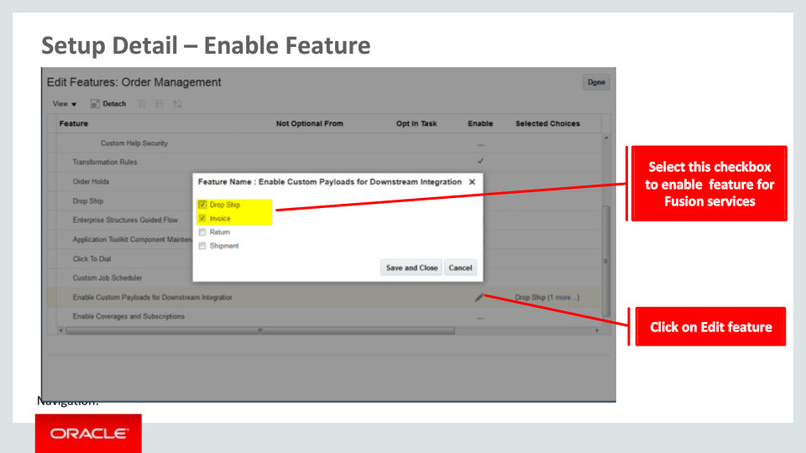
Slide notes
You need to enable the feature option to use this enhancement. Navigate to Functional setup manager. Configure Order Management offerings. Edit the feature selection and choose the “Enable Custom payloads for Downstream Integration’ feature. You will select the checkbox for Drop Ship, Invoice, or other available integrations that you want to enable.

Notes

Slide 14 - Setup Detail – Manage Service Mappings
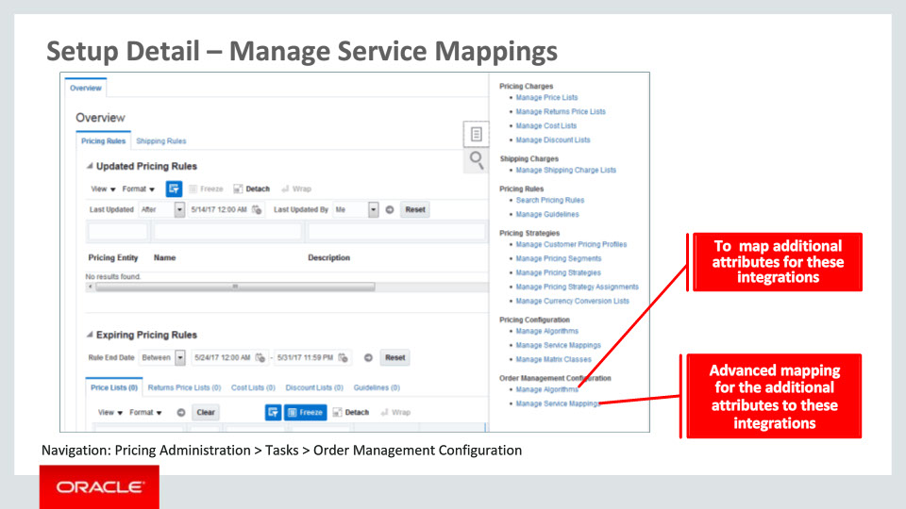
Slide notes
In order to extend the payload sent to Oracle Procurement service, Oracle Shipping service or Oracle Receiving service, you need to navigate to the Manage Service Mappings task and Manage Algorithms task under Pricing Administration work area. Number of entities and attributes are seeded for this extension to work. You need to select the appropriate attributes that you want to send data for in the following entities:
• For Oracle Procurement: PurchaseRequestHeader, PurchaseRequestLine, PurchaseRequestConfig
• For Oracle Shipping: ShipmentRequestHeader, ShipmentRequestLine, and
• For Oracle Receiving: ReceiptAdvice, ReceiptAdviceLine, ReceiptAdviceLineLot, ReceiptAdviceLineLotWithSerials.
Then, select the appropriate attributes form the order objects to get the values.
You may have to add extensible Flexfields for the Order Header, Fulfillment Line and Fulfillment Line Details objects. You need to use the task Manage Algorithms in addition to Manage Service Mappings if there are complex requirements for sending attributes to afore mentioned Fusion Services.

Notes

Slide 15 - Setup Detail – Manage Service Mappings
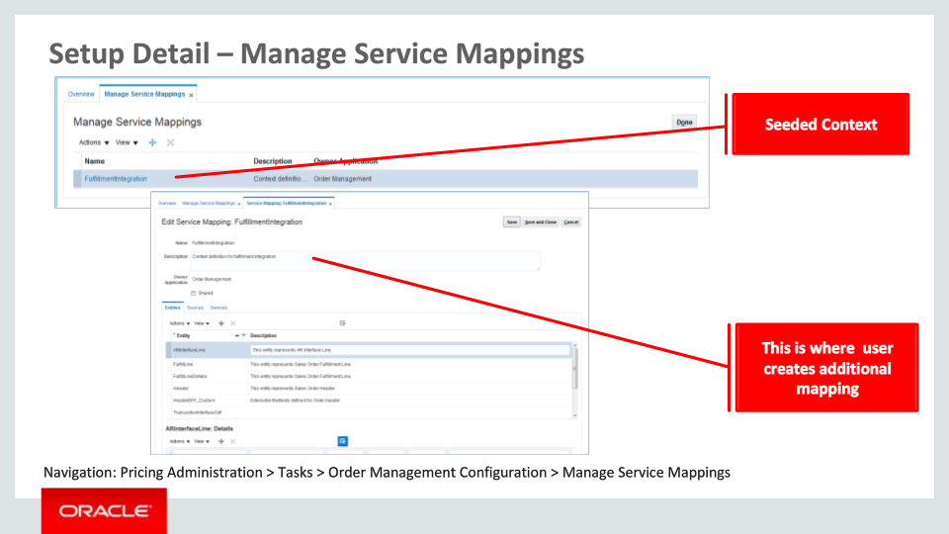
Slide notes
The Manage Service Mappings page can be used to define additional attribute mapping from Order Management to Oracle Procurement, Oracle Shipping and Oracle Receiving.
Most of the entities and attributes are seeded. You will need to define the EFF attributes that you want to use from the Order object.

Notes

Slide 16 - Setup Detail – Manage Algorithms
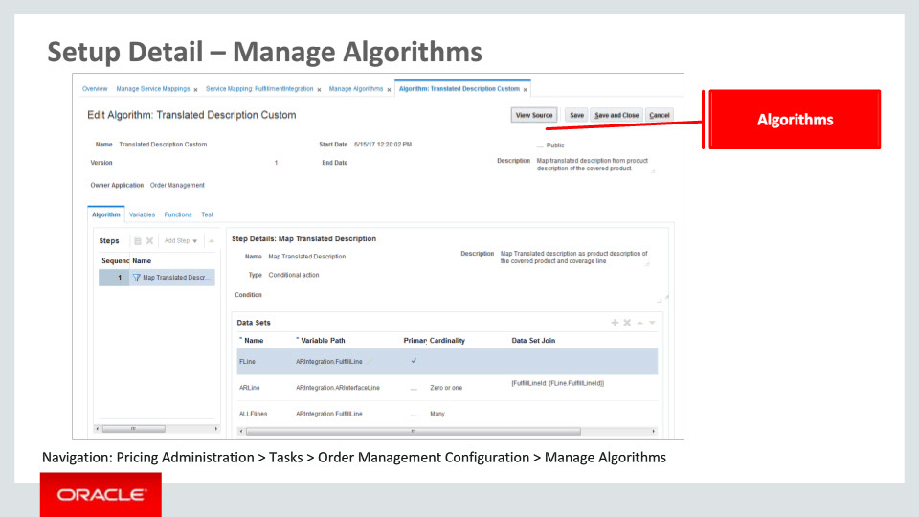
Slide notes
The Manage Algorithms page can be used to map complex attribute across levels. For example, if you wish to map an order header attribute to the Purchase Request Line, then you will need to use the Algorithms.
Algorithms can be used to do much more, like concatenate elements, have conditional logic, sum up elements from child level entities.

Notes

Slide 17 - Setup Best Practices
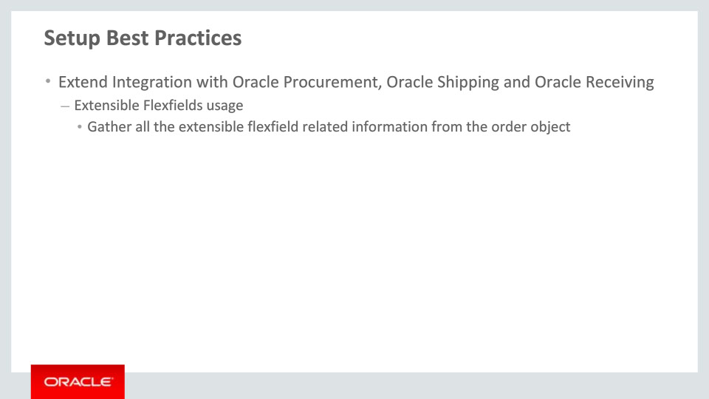
Slide notes
If the extensible flexfields are used to capture additional information about the Order objects that needs to be passed to Oracle Procurement, Oracle Shipping or Oracle Receiving service, then you need to gather that information like VO Name, Segment Name, Context name etc., in advance that can be used in the Manage Service Mappings Task.

Notes

Slide 635 - Job Roles
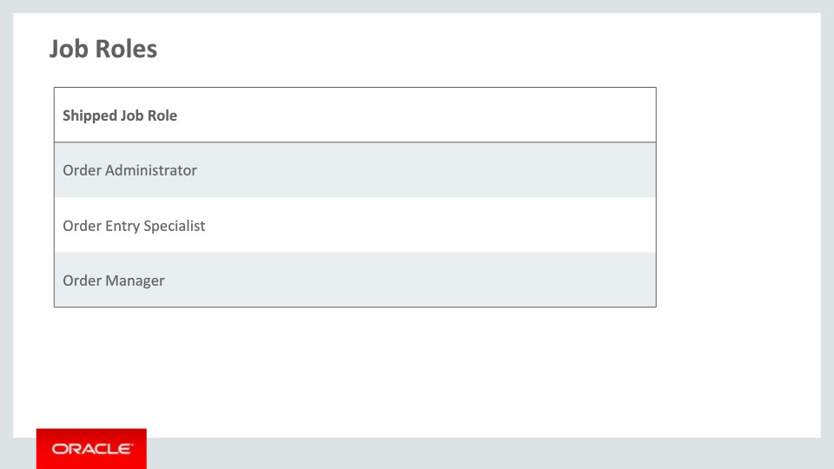
Slide notes
This table details the shipped job roles that will access the new capabilities covered in this training. Shipped job roles include Order Administrator, Order Entry Specialist, and Order Manager.

Notes

Slide 636 - Business Process Information
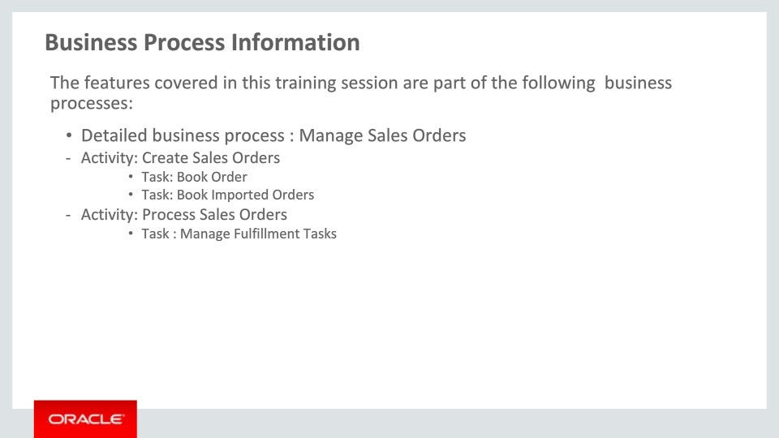
Slide notes
The business processes associated with the new capabilities covered in this training are detailed here. The high-level business process is Manage Sales Orders, with the activities Create Sales Orders, Process Sales Orders, and Manage Open Sales Orders. There are multiple associated tasks as you see here.

Notes

