Slide 3 - Oracle SCM Cloud Release 11
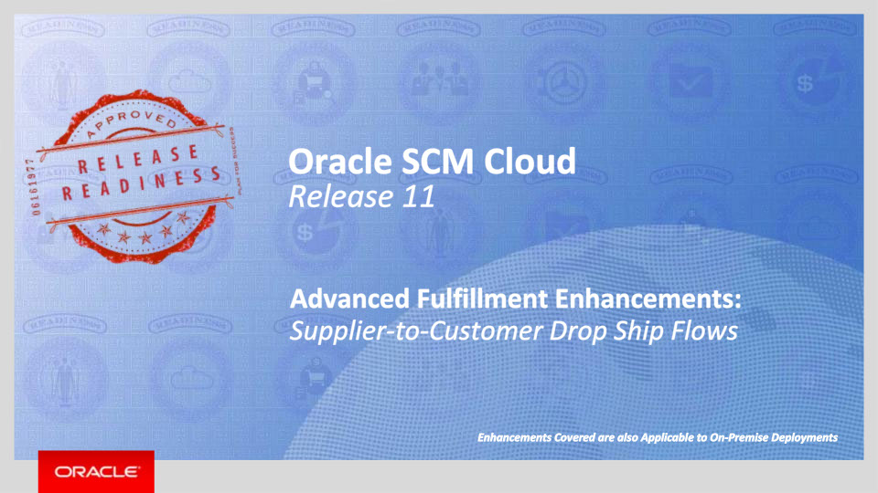
Slide notes
Hello, my name is Pankaj. Welcome to training for Release 11. In this session we will talk about what’s coming in Oracle Order Management Cloud Service, Oracle Global Order Promising Cloud Service, Oracle Procurement Cloud Service, and Oracle Inventory and Cost Management Cloud Service to support an end-to-end drop shipment business process. Please note that modules such as Supply Chain Financial Orchestration, Receiving and Cost Management that are all part of this integrated flow are all included within the umbrella of Oracle Inventory and Cost Management Cloud Service. We will be using these module names in today’s presentation to make it easier to understand the functional domain that we are referring to.

Notes

Slide 4 - Agenda
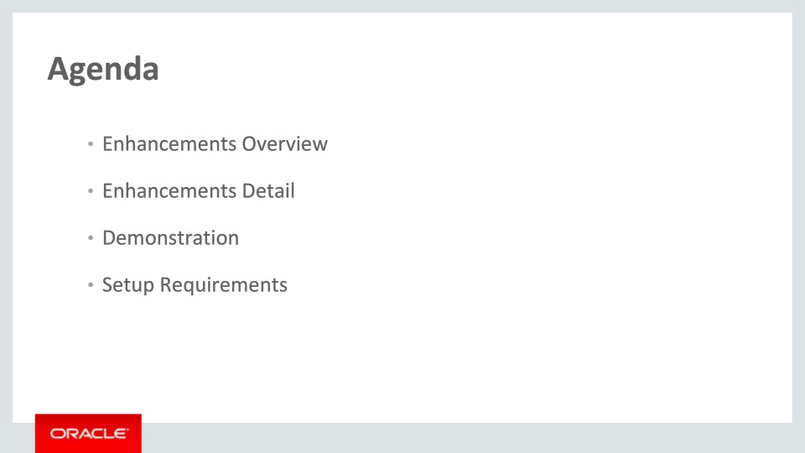
Slide notes
For the enhancements covered in this training, we’ll give an overview, followed by more detail to explain how you can use them, and what business value they bring.
Then, we’ll walk you through a demonstration.
Next, we’ll explain what you need to consider before enabling these features in your business, and what you need to know to set them up.

Notes

Slide 5 - Enhancements Overview
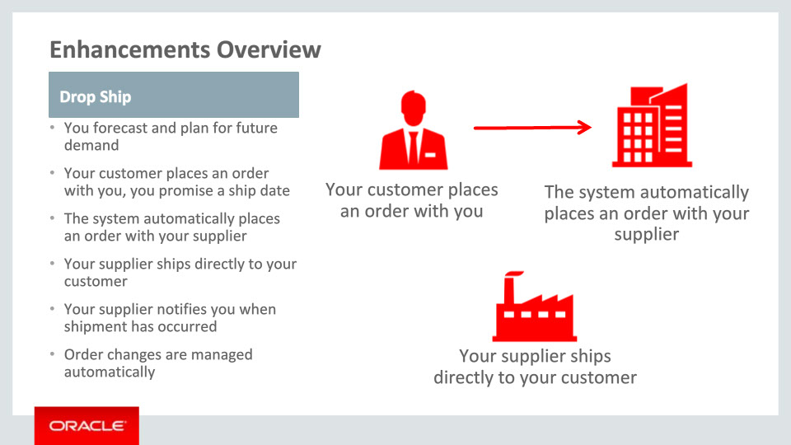
Slide notes
Drop shipping is an order fulfillment strategy where the seller does not keep products in inventory, but relies on suppliers or contract manufacturers to build, store and ship orders to customers. When a customer places an order for a drop shipped product, the seller issues a purchase order for the item and provides instructions for shipping directly to the customer. The supplier or contract manufacturer ships the product, and the seller earns a profit.
In the SCM Cloud, this process is fully automated – allowing you to focus your time and energy on your companies core competencies.

Notes

Slide 6 - Drop Ship Process Flow
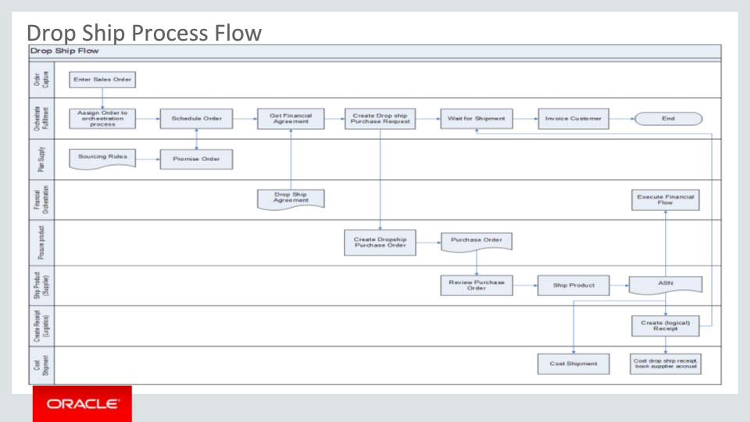
Slide notes
This process flow diagram shows the drop shipment process. Each swim lane represents a system or business function that is integral to this flow. This is a variation of an order-to-cash process where goods are shipped by the supplier rather than being shipped from an internal warehouse. Once a sales order is received from a capture system it goes through the steps required for fulfillment. In our out-of-the-box fully integrated flow, Order Management Cloud is the capture system as well as the system that orchestrates the fulfillment process.
• In the “Schedule Order” task or sub-process, a scheduling request is sent to Global Order Promising Cloud which considers the sourcing rules, supplier calendar, capacity etc. to determine how best to promise the order. In the context of drop shipment, the order is promised from a supplier (and a specific supplier site). Note that the customer order itself may specify a supplier – this will always be honored.
• The next swim lane is for the Supply Chain Financial Orchestration where the supplier-to-customer drop ship financial flow is defined and ultimately executed. The sub-process “Get Financial Agreement” is simply fetching the BU where the requisition will be created.
• Next, a Purchase Request is sent to Procurement Cloud. Here a requisition is created followed by a Purchase Order. The requisition may be sourced from a blanket purchase agreement if one exists. The PO is issued to the supplier.
• Once the supplier ships the goods to the customer, he enters an Advance Shipment Notice or ASN. As represented in this swim lane, the ASN is entered via the Supplier Portal. The ASN is broadcast to interested parties and intercepted by Supply Chain Financial Orchestration and Receiving.
• Receiving creates a logical receipt in the Receiving Org – there is no physical receipt since goods are shipped to the customer.
• Supply Chain Financial Orchestration executes the financial flow and Cost Management performs the receipt and cost accounting.
We will go into more depth when we go through the details of the new features.
Notes

Slide 7 - Business Value
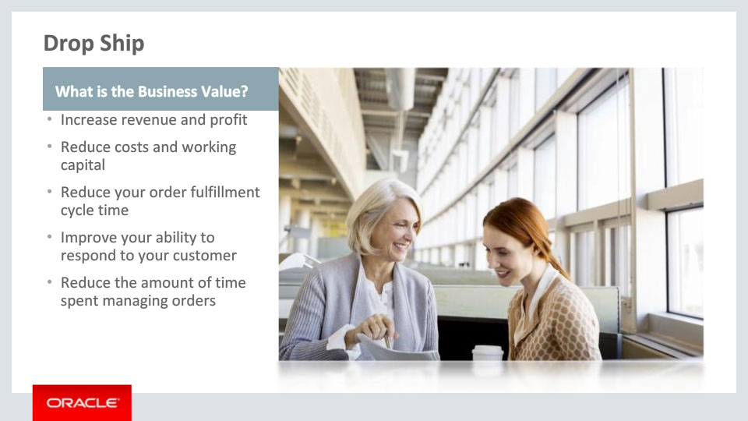
Slide notes
Since our drop ship process if fully automated – from taking the order, to managing changes, to managing the financial accounting – you can take advantage of the benefits of drop shipping without any of the pitfalls that occur when you attempt to do it manually. Business benefits include:
• Increase profit by selling a wide variety of products without the overhead of carrying and managing inventory
• Reduce costs and working capital by holding no inventory in house, and automating the drop ship ordering and payment process.
• Reduce your order fulfillment cycle time to make you more competitive in the marketplace
• Improve your ability to respond to customer changes
• Reduce the amount of time your order managers and buyers spend creating, changing & managing orders.
• Increase revenue due to reduced order fulfillment cycle time
Notes

Slide 8 - Fulfill a Customer Order via Drop Shipment: Seeded Process
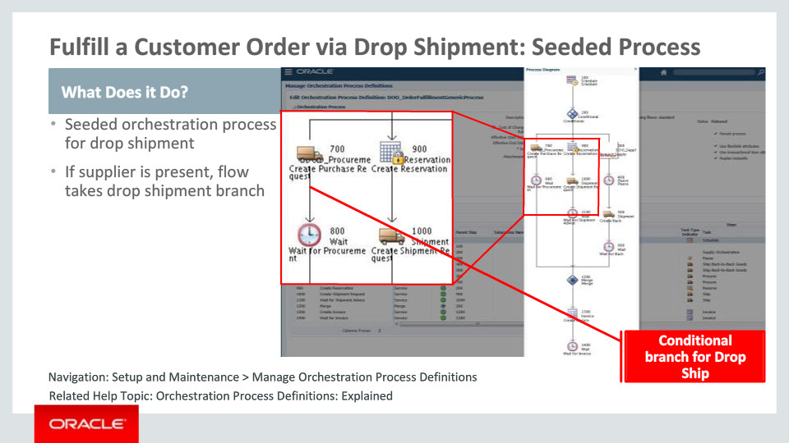
Slide notes
A new orchestration process DOO_OrderFulfillmentGenericProcess has been seeded for your benefit. It has conditional branches for drop shipment, fulfillment from internal warehouse and back-to-back. You may use this as the default process assignment in your Assign & Launch rule. If the supplier attribute is populated on a fulfillment line at the time when the condition is evaluated, the flow will proceed down the drop ship branch.

Notes

Slide 9 - Fulfill a Customer Order via Drop Shipment: Create Order
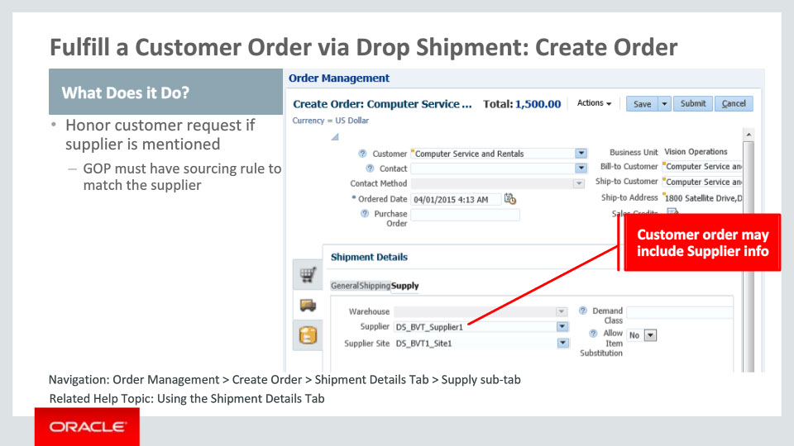
Slide notes
You may submit an order from Order Management, from an Order Capture or channel system that may be drop shipped by a supplier to the customer. The Order Import web service as well as Order Management allow you to specify a supplier and supplier site from where the goods should be drop shipped. This screenshot shows where to specify supplier on the Create Order page in Order Management. Global Order Promising must have sourcing rule for that item and supplier combination to source the item from the specified supplier. The item must be designated as Purchasable. This needs to be done in the Product Information Management (PIM) module in the Purchasing tab of the Item Specifications.
For source orders that do not specify a supplier or warehouse as a fulfillment preference, GOP decides the source of supply based on sourcing rules, capacity, lead time, shipping calendars and other criteria. GOP may select an order line to be fulfilled from a supplier.

Notes

Slide 10 - Fulfill a Customer Order via Drop Shipment: Promise Order
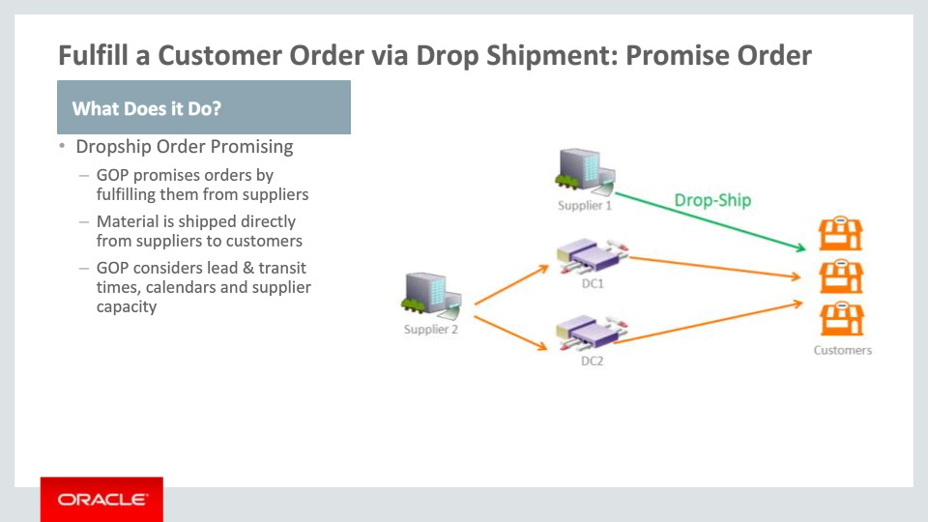
Slide notes
Through Drop Ship Order Promising you can promise an order by shipping it directly from a supplier to the customer location. This schematic shows several fulfillment options that GOP considers for order promising. For each of the supply options, GOP evaluates the ability to fulfill the order on time taking into consideration the priority ranking of the sourcing rules for the item.

Notes

Slide 11 - Fulfill a Customer Order via Drop Shipment: Get Requisition Org
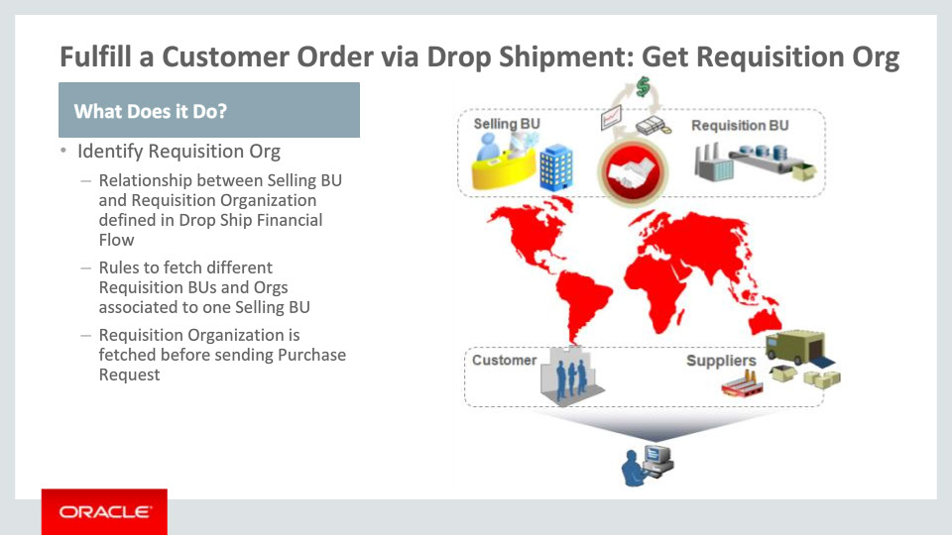
Slide notes
Fulfillment of a customer order via drop shipment requires identification of the requisition organization for creation of purchase requisitions.
Supply Chain Financial Orchestration allows you to configure the relationship between the Selling business unit and the Requisition business unit via the Manage Drop Ship Financial Flow task. You can define rules based on attributes such as item category, so that different requisition business units and organizations associated to one selling business unit are fetched for different drop ship sales orders. Once the requisition organization is fetched, it is sent for creation of drop ship purchase requisition.

Notes

Slide 12 - Fulfill a Customer Order via Drop Shipment: Process Requisition
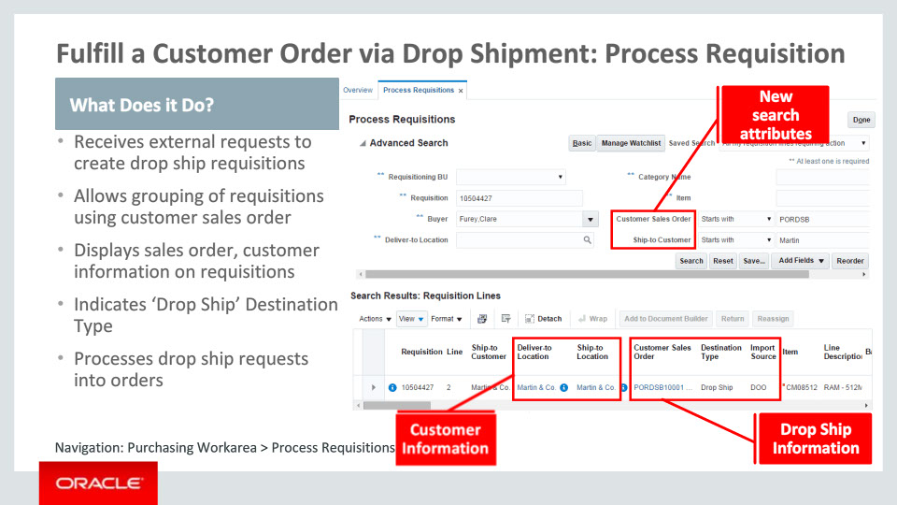
Slide notes
Oracle Procurement Cloud has the capability to accept drop ship requests originating from supply chain systems. Such requests will have a new destination type ‘Drop Ship’ and have sales order and customer information specified.
When a drop ship requisition is processed into a purchase order, either automatically or manually by the buyer, the customer and sales order information is copied over.
There is an option to group requisitions using sales order, specified at agreement level. This option will control whether system should group requisitions with the same sales order number to be placed on a single purchase order or not. Also, lines fulfilling sales orders from different customers are never grouped together.
We have added a set of new attributes in the requisitions and purchase orders that flows from sales order. Key attributes are customer sales order number, sales order line & schedule, customer item, customer PO, PO line & schedule, ship-to customer, deliver-to customer. Ship-to location and deliver-to location attributes are modified to display customer/external location and an informational icon is appended beside the value to indicate that it is a third party location. Ship-to location on the purchase order points to customer location from the sales order. To help you easily distinguish drop ship requisitions and PO schedules from others, an informational icon indicating fulfillment to a customer sales order is displayed.
Since there are no inventory transactions performed on drop ship schedules, introducing new destination type ‘Drop Ship’ helps distinguish drop ship requests from inventory replenishment requests.

Notes

Slide 13 - Fulfill a Customer Order via Drop Shipment: Purchase Order
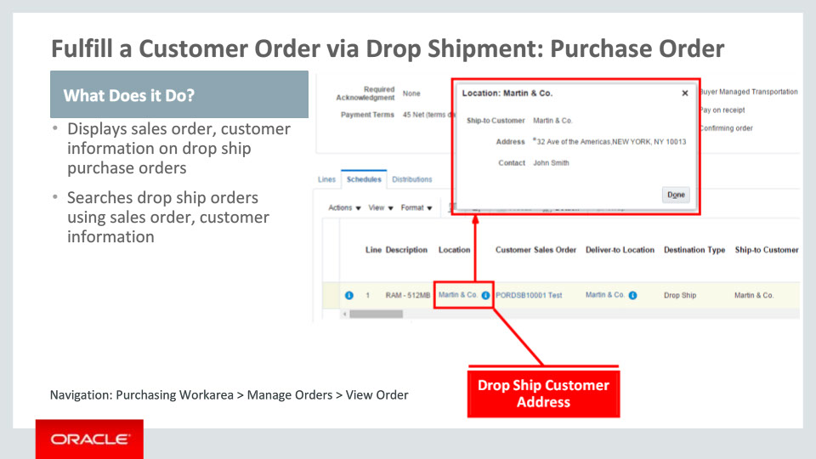
Slide notes
Your buyer or supplier can view the sales order and customer information on purchase orders and also have the ability to search purchase requisitions or purchase orders using sales order number and ship-to customer. Purchase requisitions are not visible to the supplier.

Notes

Slide 14 - Approve and Communicate Drop Ship Purchase Orders
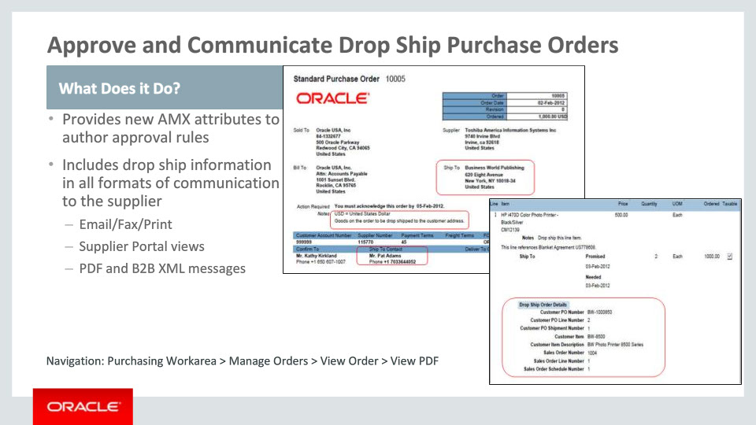
Slide notes
Since drop ship requests are externally managed from the standpoint of Oracle Procurement Cloud, originating from Order Management Cloud, the most common use case is that they would be auto-approved. Approval rules can be set to support auto-approving drop ship orders either by using ship-to customer name or destination type as ‘Drop Ship.’
Drop Ship information is included in all formats of communication to the supplier, including:
• Email/Fax/Print
• Supplier Portal Views
• And PDF and B2B Messages

Notes

Slide 15 - Fulfill a Customer Order via Drop Shipment: Fulfillment Visibility
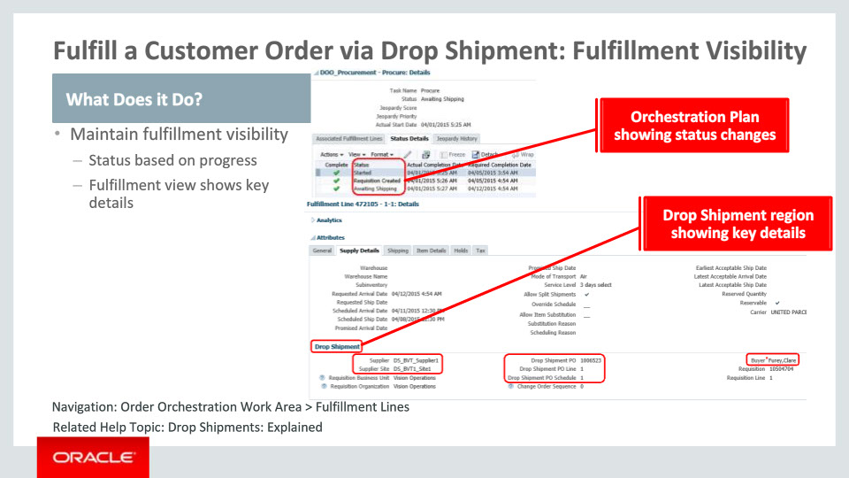
Slide notes
Within the context of drop ship fulfillment, Order Management Cloud maintains an up to date status from the time a purchase request is sent to Oracle Procurement Cloud to the time goods are shipped by the supplier to the customer. This gives your Order Manager visibility of the status of the request within Procurement.
It begins with the creation of a requisition. Next, a Purchase Order is created and issued to the supplier. And finally, the supplier indicates that goods have been shipped.
A new region has been added in the “Supply Details” tab of the Manage Fulfillment Lines page. This region appears only if a fulfillment line is drop shipped. It shows the supplier details, the buyer and references to the requisition and purchase order down to the line and schedule levels in Procurement. Thus if your Order Manager needs to contact the Buyer to understand any shipping delays or discuss any concerns about the PO, it provides all the references that will need to be mentioned.

Notes

Slide 16 - Fulfill a Customer Order via Drop Shipment: Shipment Notification
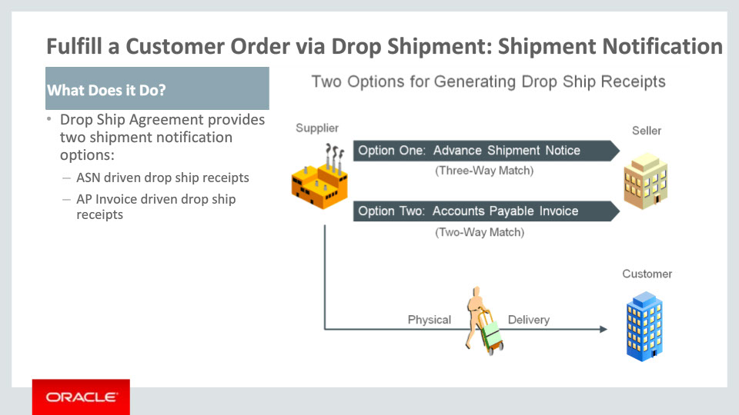
Slide notes
You have two options to seamlessly acknowledge delivery of the product and initiate downstream processes for costing and billing. These options are the ASN option and the Accounts Payable (AP) Invoice option. The Receiving module within Oracle Inventory and Cost Management Cloud has been enhanced to streamline the recording of the delivery for products drop shipped directly to your customer sites.
The ASN option is used for supplier sites that are generating ASNs. The arrival of the ASN automatically initiates downstream processes to cost and bill the shipment.
The AP Invoice option is used for sites that are not sending ASNs. The arrival and entry of the AP invoice automatically initiates downstream processes to cost and bill the shipment.
You need to identify one of these options for generating drop ship receipts when setting up financial flows using the Manage Drop Ship Financial Flows task. We will review this setup task in the Setup section of this presentation.

Notes

Slide 17 - Generate ASN Driven Drop Ship Receipts
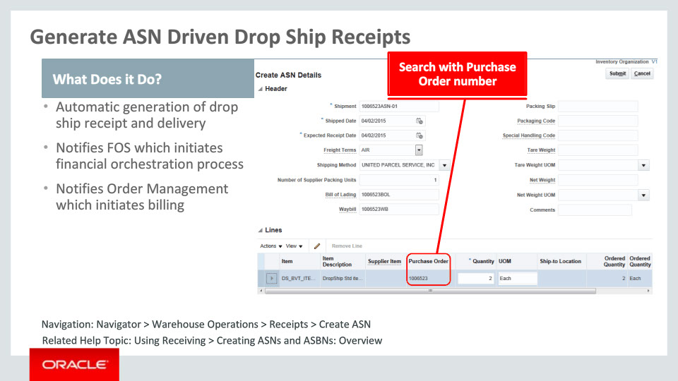
Slide notes
The ASN option allows the creation of an ASN to drive the automatic processing that generates drop ship receipts and initiates additional downstream processing. This includes the initiation of billing as well as financial orchestration processing for drop ship orders. In this process flow, the ASN is loaded into the Receiving module, automatically generating a “special” drop ship “receipt” and “delivery” to record the event. These events in Receiving are automatically communicated to financial orchestration, costing and order management processes. This provides status information and the details necessary to initiate the costing and billing processes.
The ASN can be loaded manually or electronically via XML or EDI. The manual option is available for the supplier, using the “Create ASN,” “Create ASBN” or “Upload ASN or ASBN” tasks on the Supplier Portal. These same options are now also available from the Receipts work area. This allows the warehouse manager to manually enter the ASN in cases where informal communication like e-mail is used by the supplier to report the shipment of drop shipped purchase orders.

Notes

Slide 18 - Generate AP Invoice Driven Drop Ship Receipts
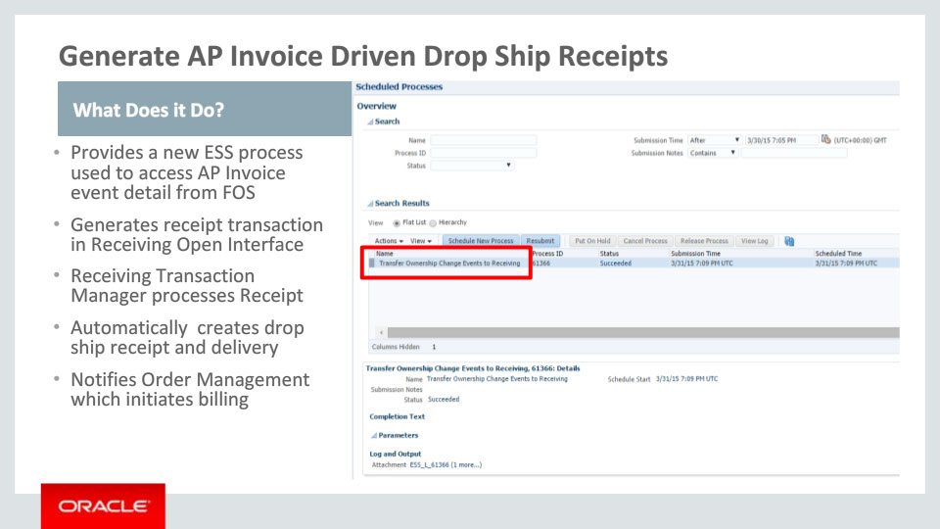
Slide notes
This option allows the creation of an AP Invoice to automatically drive the receiving process. The receiving process then works similar to that explained for the ASN option except an ASN is never generated. The special drop ship “receipt” and “delivery” are generated based on the creation of an AP invoice for the drop ship purchase order. These events in Receiving are automatically communicated to the costing and order management processes providing status information and the details necessary to initiate the costing and billing processes.
Processing to transfer details from the AP invoice is performed using a new scheduled process called “Transfer Ownership Change Events to Receiving." This process formats a receipt transaction from the details of the AP invoice and loads it into the Receiving Open interface table, where the “Receiving Transaction Manager” scheduled process picks it up and automatically generates the special drop ship receipt and delivery in the Receiving system.

Notes

Slide 19 - Fulfill a customer order via drop shipment: Create Invoice
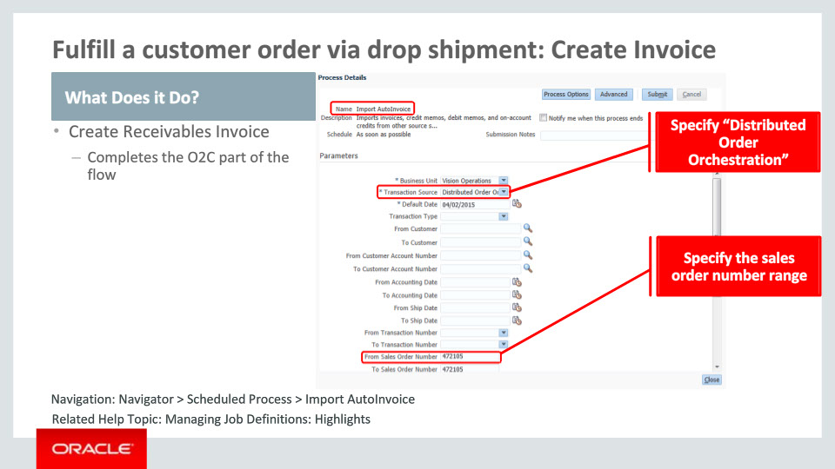
Slide notes
You will typically have the scheduled process “Import AutoInvoice” scheduled to run periodically. Once a fulfillment line has been shipped, it needs to be billed to the customer. All lines that have been shipped but not yet billed will be picked up by this program and interfaced into Account Receivables (AR) within the Oracle Financials Cloud as a batch. AR will send out the invoice to your customer.
You may run this program on a one-off basis as well.

Notes

Slide 20 - Automate Execution of Financial Flow
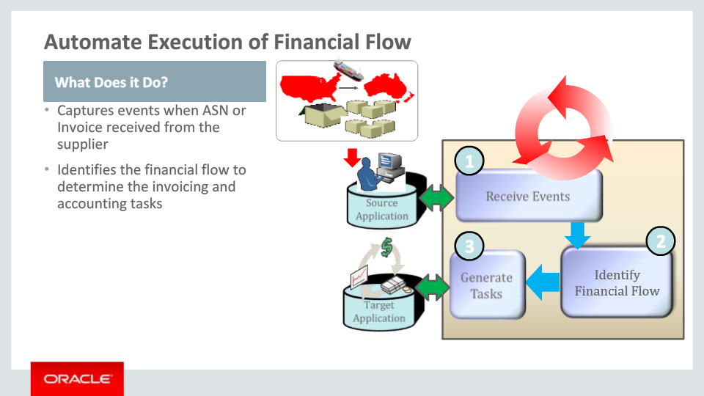
Slide notes
Supply Chain Financial Orchestration allows you to model and execute the financial flow based on the ownership transfers between parties involved in the customer drop shipment flow. The product has automated the process to capture the physical supply chain event as and when the events are raised in the drop shipment flow. Events are raised when the supplier sends the Advance Shipment Notice indicating shipment of goods to your customer or your Supplier Invoice is matched to the drop ship purchase order. We had talked about this preference in the context of the task Manage Drop Ship Financial flow.
Once the event is received, the financial flow is identified based on the drop ship purchase order and sales order information retrieved as source documents. The source document information, internal selling and buying business units, financial orchestration qualifiers and the priority of the financial orchestration flow forms the basis for identification of the financial flow.
The financial flow allows you to create cost accounting distributions and intercompany invoices for ownership transfers between parties which include supplier, one or more internal organizations and the customer. In case there is only one internal organization involved in the drop ship flow, which means the Selling and the Requisition BU is the same, there will only be drop ship financial flow. If multiple internal organizations are involved in the drop ship flow, there may be distinct procurement financial flow or shipment financial flow or both.

Notes

Slide 21 - Automate Execution of Financial Flow
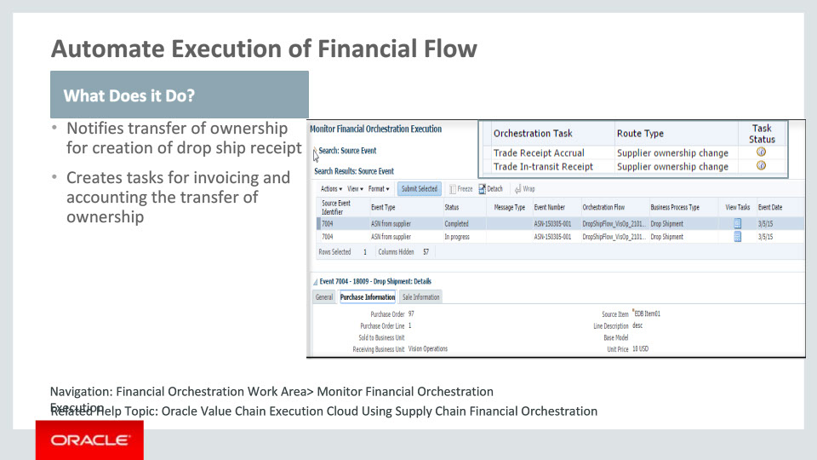
Slide notes
Drop ship sales order is assumed to be fulfilled either at the time Advance Shipment Notice (ASN) is received or when an invoice is received from the supplier.
Supply Chain Financial Orchestration notifies Receiving to create the ‘drop ship receipt’ on change of ownership when the supplier sends the invoice.
The automated process generates payload for the various tasks. This allows you to create the cost accounting distributions to track the costs and liability for ownership transfers between parties involved in the drop ship flow. It also creates intercompany invoices for internal ownership transfers whenever necessary. You can monitor the progress of the financial orchestration of the drop ship flow and track the task statuses in the Monitor Financial Orchestration Execution user interface.

Notes

Slide 22 - Financial Orchestration of Drop Ship Flow
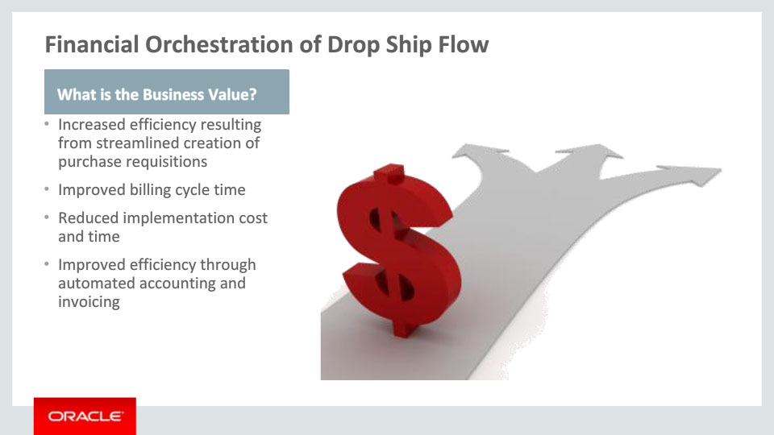
Slide notes
As part of the Manage Drop Ship Financial Flow setup task, we define the relationship between the requisition organization and selling BU. It provides a streamlined approach to the creation of purchase requisitions. It provides the flexibility to associate multiple requisition organizations for a single selling BU based on the qualifiers. This makes it an efficient way to manage the relationship between your requisition organization and selling BU.
A timely notification is sent to Receiving when the ownership change is identified upon receipt of supplier invoice. Receiving creates a logical receipt and, in turn, notifies Order Management where customer billing is initiated. Thus this automation helps in reducing the cycle time for customer billing.
The configurable and flexible setup allows you to react to corporate reorganizations including any acquisitions you make. It therefore reduces the implementation cost and time.
This gives improved efficiency, since the framework supports that when ownership change event occurs for a Drop Shipment flow, it triggers an automatic process requiring no human intervention. This gives you the benefit of automated accounting as well as automatic triggering of intercompany invoices.

Notes

Slide 23 - Process and Create Accounting for Drop Ship Transactions
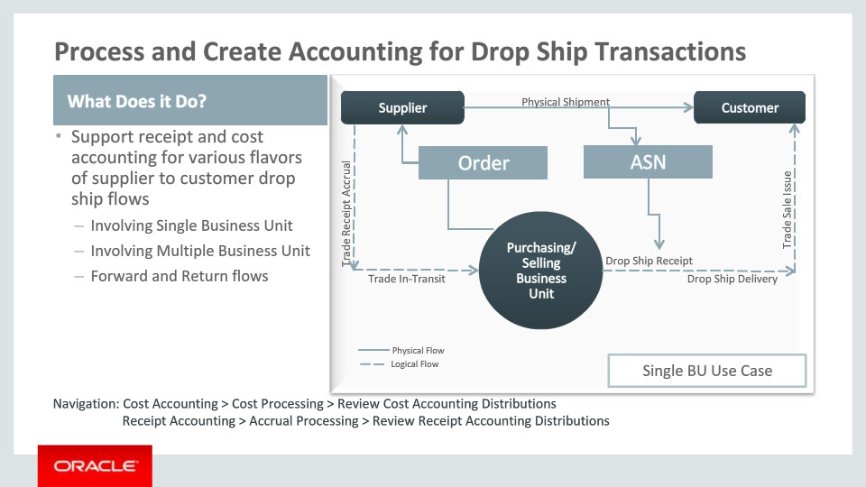
Slide notes
Cost Management has the infrastructure in place which triggers the costing and accounting of the Drop Ship flow automatically.
This automated process performs a sequence of steps for you in real-time:
• Interface new Drop Ship transactions like Drop Ship Receipt and Drop Ship delivery from Receiving
• Interface trade events that are based on the Drop Ship Agreement
• Receipt accounting processor to process receipt transactions and create relevant accruals
• Cost Accounting processor to process the delivery transactions and compute Cost of Goods Sold
This diagram is an accounting example of Single BU Drop Ship flow, showing different physical and logical events that are generated for which accounting will be done.

Notes

Slide 24 - Process and Create Accounting for Drop Ship Transactions Contd.
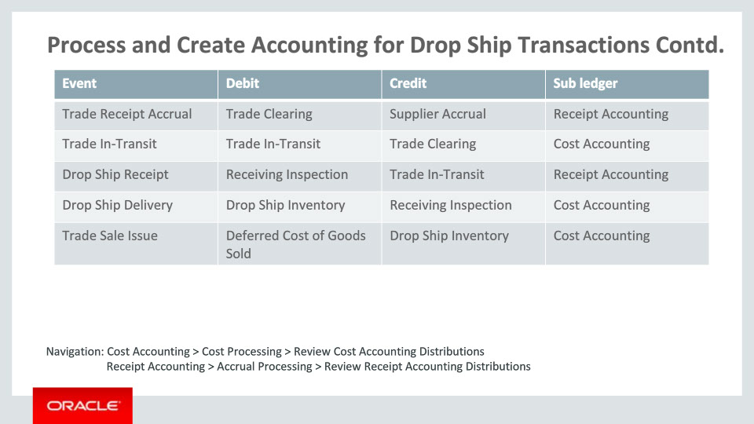
Slide notes
The following events are generated in the drop ship business flow:
Trade receipt accrual is always costed at the drop ship purchase order price. The accounting entry created will be to debit the Trade Clearing account and credit the Supplier Accrual account.
Trade in transit receipt is always costed using the cost from trade receipt accrual plus any overheads modeled in Costing . The accounting entry created will be to debit the Trade In-Transit account and credit the Trade Clearing Account.
The drop ship receipt event is processed after the corresponding trade receipt accrual event is processed. Drop ship receipt is costed using the cost at which the trade receipt accrual is booked. Additionally, any landed cost charges modeled on the drop ship PO are applied to the drop ship receipt by the landed cost allocation process. The accounting entry created will be to debit the Receiving Inspection account and credit the Trade In-transit Account.
The drop ship delivery is processed using the average Trade in Transit Receipt (TIR) cost plus the landed cost charges from the corresponding drop ship receipt. The accounting entry created will be to debit the Drop Ship Inventory account and credit the Receiving Inspection account.
The predecessor event for Trade Sales Issue transaction in a customer drop ship flow is a Drop ship delivery event. The trade sales issue transaction derives the cost from the cost structure of the drop ship delivery event. The accounting entry created will be to debit the Deferred Cost of Goods Sold account and credit the Drop Ship Inventory account.

Notes

Slide 25 - Model Landed Cost Charges for Drop Ship Receipts
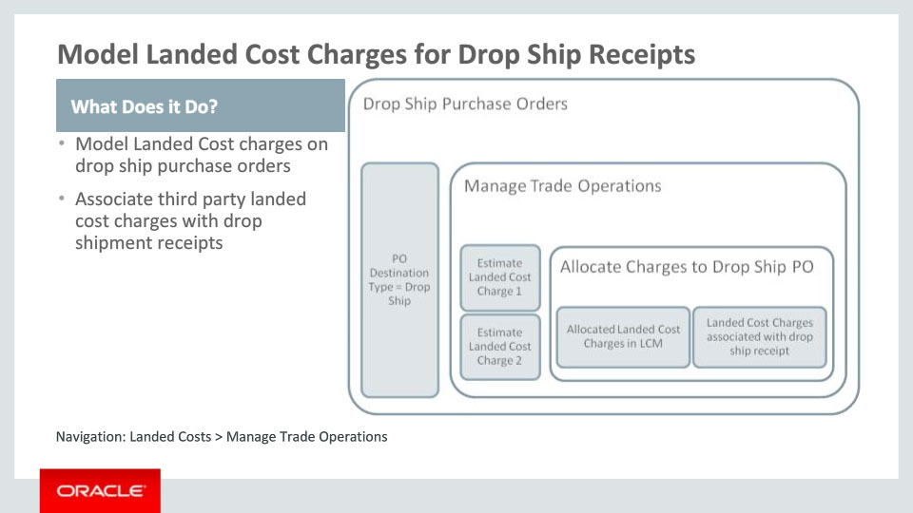
Slide notes
Cost Management gives you the ability to model third party charges or other trade charges as landed costs for Drop Ship receipts. These are charges that are part of physical shipment but not directly paid/incurred by either supplier or customer.
The landed cost management solution of Cost Management allows you to estimate these trade charges and assigned to the Drop Ship PO schedule. When such landed cost charges are allocated and absorbed on to the Drop Ship receipt, the cost of Drop Ship delivery will be calculated using the Purchase Price (or Incoming Transfer Price in case of a multiple business unit scenario), taxes, if any, on Drop Ship receipt, and Landed Cost Charges.

Notes

Slide 26 - Gross Margin Reporting for Drop Ship Orders
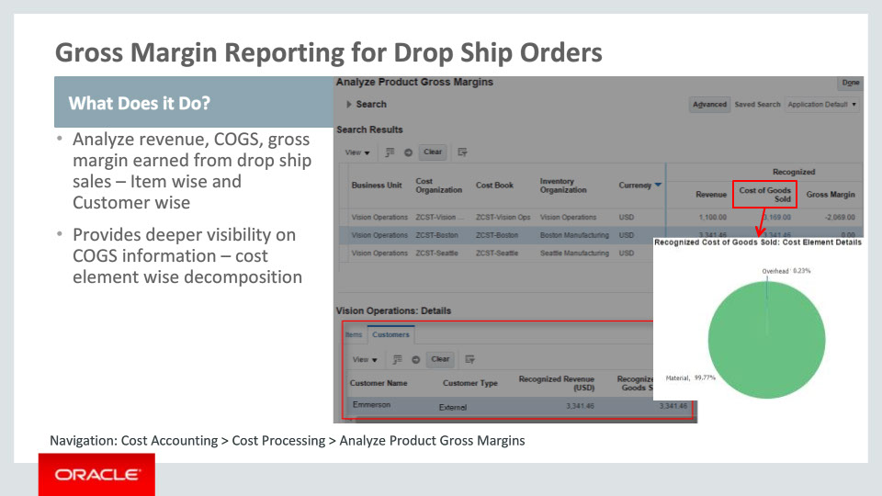
Slide notes
Further, Cost Management gives you the ability to analyze the gross margin earned on drop ship sales transactions separately with deeper visibility of cost of goods sold to facilitate decision making.

Notes

Slide 27 - In-Transit Inventory Reporting for Customer Drop Shipment flows
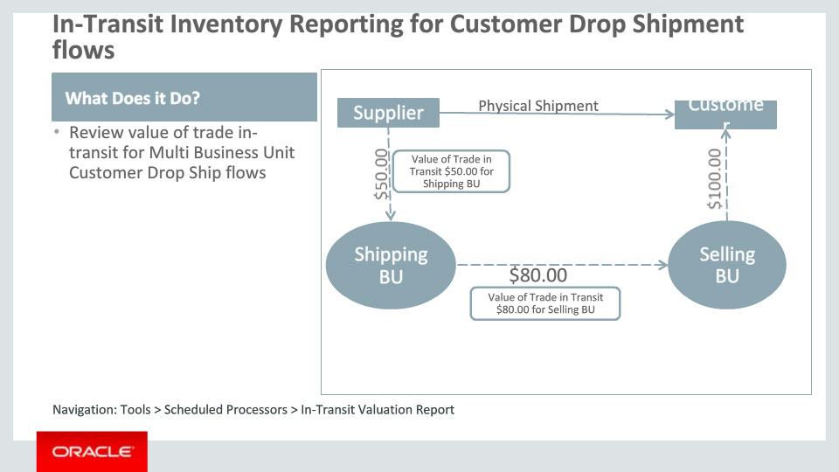
Slide notes
Cost management supports complex Drop Ship use cases where in multiple business units are involved. The in transit valuation report in costing helps enterprises to analyze the financial value of goods in transit at any given point of time.

Notes

Slide 28 - Costing and Accounting of Drop Ship Transactions
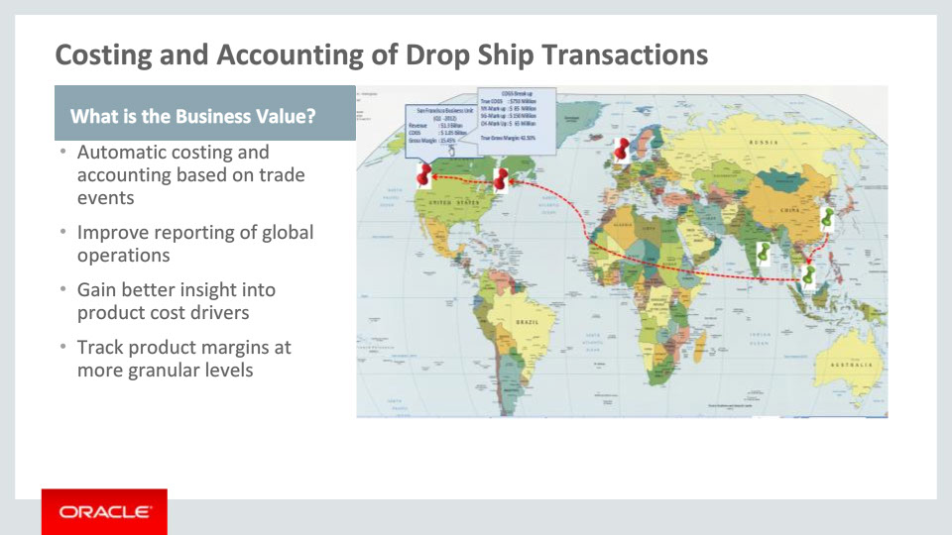
Slide notes
In terms of business value, the automated process in Cost Management for processing the transactions helps stremlining your Accounting. Next, your implementation cost and time is reduced as core infrastructure is already in place from previous releases. Additionally, the product improves your accuracy of product cost measurements, helping you gain better insight into product cost drivers. And finally, it helps you track product margins at more granular levels over time and helps improve reporting of global operations.

Notes

Slide 29 - Automatic Change Management on Drop Ship Orders
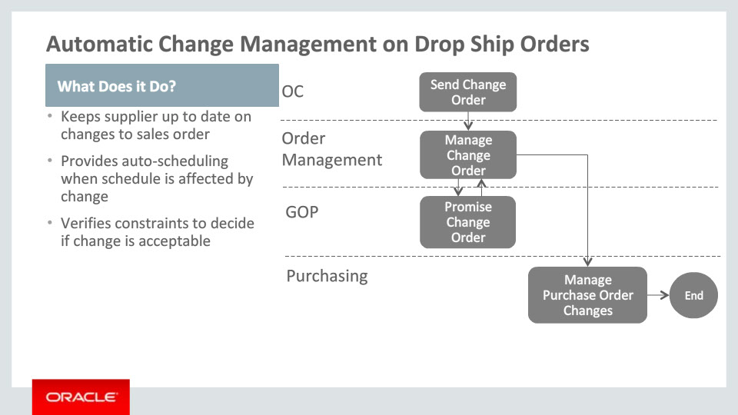
Slide notes
The next feature is “Automatic Change Management on Drop Ship Orders."
While an order is in the process of getting fulfilled, your customer may request changes to the order, such as pulling the requested ship date in or change of ship method. Depending on the progress of the order, there will be an impact to some of the tasks. If a Purchase Order was already created but goods have not yet been shipped by your supplier, you should generally be able to process the requested changes. If scheduling attributes such as requested ship date or requested arrival date or ship method are changed, the changes need to be sent to GOP and resulting changes to scheduled ship date or scheduled arrival date will need to be applied. Likewise, these changes need to be communicated to Purchasing so that the Purchase Order can be revised and your supplier honors those changes.

Notes

Slide 30 - Automatic Change Management on Drop Ship Orders
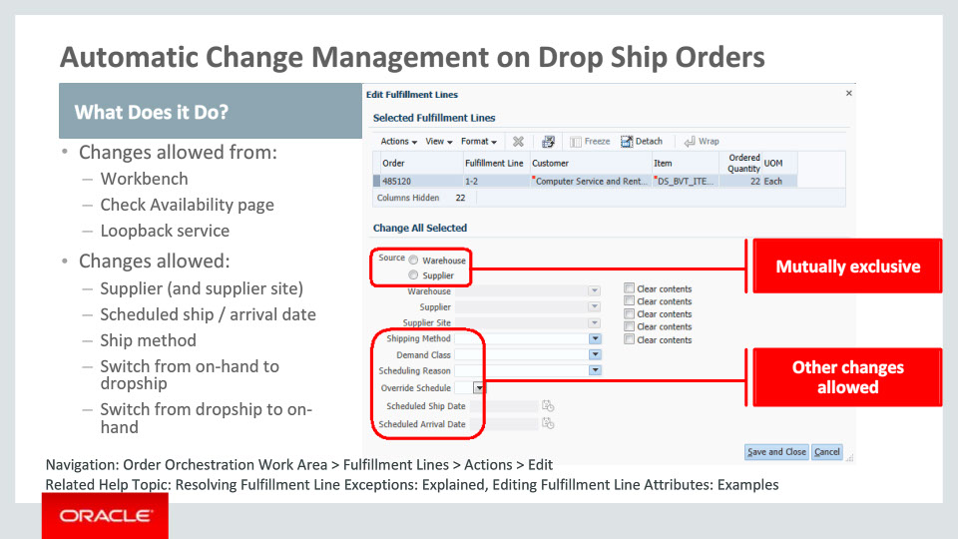
Slide notes
Alternatively, to overcome fulfillment bottlenecks, you may make changes from Order Orchestration Work Area. You can edit the selected fulfillment lines by choosing the edit action and then changing the attributes shown here. One of the allowable changes is to switch from drop shipment to on-hand. In such a case, Order Management will request Purchasing to cancel the Purchase Order and then send a shipment request to Shipping.
You may also click on the Check Availability button and select an alternate source. More on this will follow in a future slide.
Planning Central may recommend changes to planning related attributes via the loopback service. The processing of changes from all of these sources is similar to that of changes coming from the Order Capture system as requested by the customer.

Notes

Slide 31 - Automatic Change Management on Drop Ship Orders
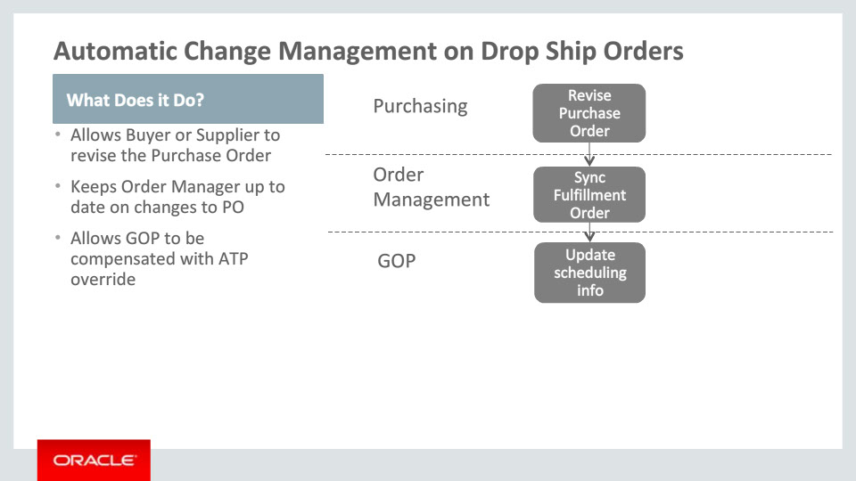
Slide notes
Your supplier may request some changes to the Purchase Order due to supply availability, order backlog or shipping issues. The supplier may submit a “change order” that applies to the purchase order. If that is approved, the Purchase Order will be revised. As an example, the Promised Delivery Date may be updated. Once the PO is revised, Order Management will be notified. Since the changes originating in Purchasing will be to the scheduling / planning attributes, an update is sent to GOP in Available To Promise, i.e., ATP override mode. What this means is that GOP will simply consume those changes and correct or improve their supply picture. This helps GOP perform more accurate promising on subsequent orders for the same item.
Buyer may also make changes to an open Purchase Order following the “change order” process that we just talked about. This is generally done in concert with the supplier. The other motivation may be where the buyer pre-empts fulfillment bottlenecks at the supplier.

Notes

Slide 32 - Automatic Change Management on Drop Ship Orders
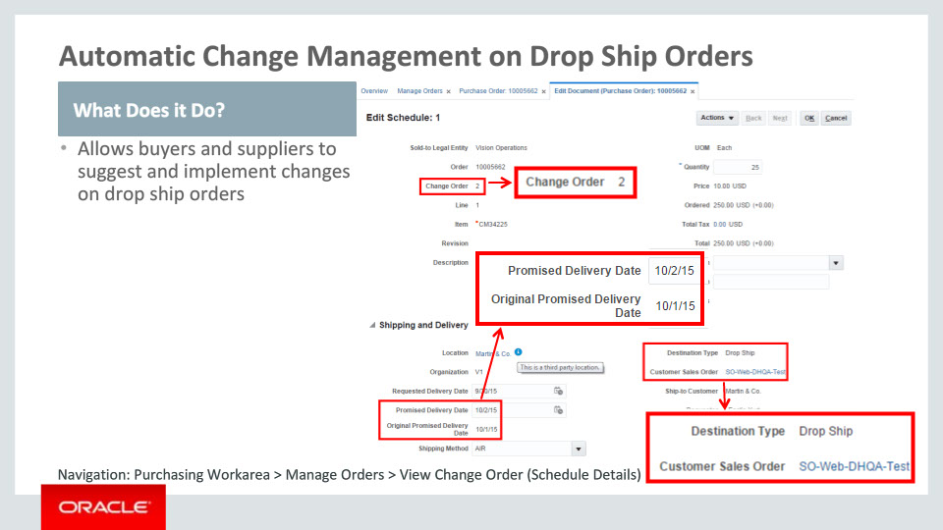
Slide notes
Upon a change to a customer sales order, fulfillment plan or planning recommendation, Order Management can request a change on the purchase order. Most common requests include quantity decrease, changes on requested dates, customer details, customer items, attachments, shipping and packing instructions, as well as order cancellation. This can be done via the Purchase Request Web Service change operation.
An order fulfillment line that is associated with a purchase order can be split based on recommendations from Planning or from Global Order Promising if the item property “Order Management Indivisible” is false. The split will be reflected on the purchase order. If the customer sales order is cancelled or modified, Order Management can send appropriate request to Procurement for changes/cancellation of a purchase order.
Before requesting for changes, Order Management can request Procurement to place the purchase order on hold. This is to prevent downstream activities being processed when the source document is placed on hold. The reason to place a hold instead of directly making a change is that there could be multiple related fulfillment lines being processed from different sources. The change will be carried out only if the same change can be made for all related lines. Hold functionality will be handled by the Purchase Request web service called with the ‘Hold’ and ‘Release Hold’ operations indicating whether the purchase order should be placed on hold or released from hold.
Buyers and suppliers are allowed to make changes to the implemented drop ship purchase order. Additionally, your buyers may make changes to a draft purchase order. Most common changes include quantity decrease, promised date change, cancellation of order/order line, split of schedules. The changes are supported via the purchasing UI pages or Purchase Order Web Service.
Purchasing will publish an event indicating that a new purchase order or change to an existing purchase order has been implemented. Order Management subscribes to the event and applies the changes to the backing fulfillment lines.

Notes

Slide 33 - Drop Ship Order Changes from Check Availability page
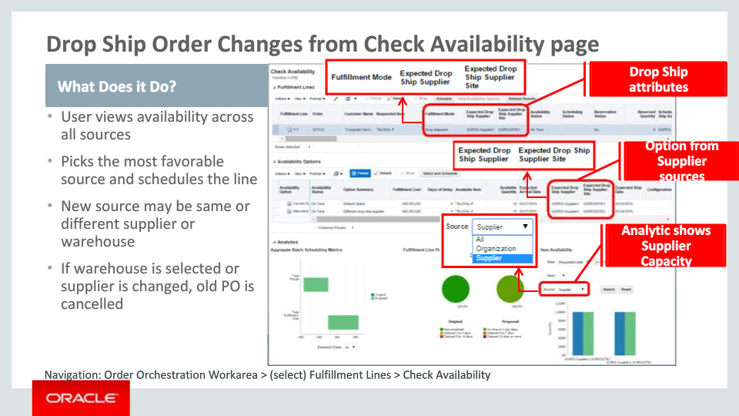
Slide notes
Earlier, we looked at the different sources from where changes may originate. One of those is the Check Availability page. On this page you will find all the availability options for the item. It also shows you the availability status (on-time or delayed), as well as the number of days of delay in the case of the latter for each of the availability options. This page has been enhanced and shows the fulfillment mode for the currently promised line. In the case of drop shipment, the value of fulfillment mode is drop shipment, as one would expect. Other changes include:
• Addition of attributes for drop ship supplier and supplier site on the fulfillment line as well as under the availability options
• And the item availability graph on the bottom right allows you to view item availability only for supplier sources or warehouse i.e., on-hand or across both types of sources
Collectively, these enhancements make it easy for your order managers to determine the best source to fulfill customer orders and address fulfillment bottlenecks.
Notes

Slide 34 - Handle Partial Shipment on Drop Ship Orders
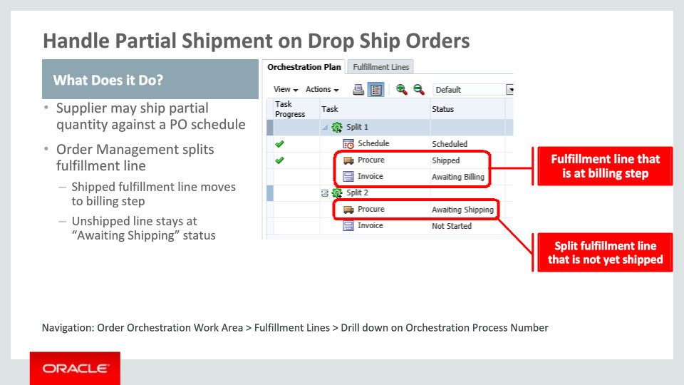
Slide notes
It is generally expected that the supplier will ship a PO schedule in full. However, if the supplier ships a PO schedule partially, Order Management splits the fulfillment line proportionally. The fulfillment line tracking the shipped quantity proceeds to the invoicing step. The other fulfillment line that now has the unshipped portion of the PO schedule stays on the procurement step with the status being “Awaiting Shipping."
The orchestration plan shows the split and the progress of each of the split fulfillment lines. At this stage, the only change allowed is to cancel the unshipped quantity which is the quantity being tracked by the fulfillment line whose status is “Awaiting Shipping." Any other change will be rejected by Order Management. Change Management handles this by requesting Purchasing to revise the PO schedule. Purchasing sets the “Canceled Quantity” on the PO schedule in the revised PO.

Notes

Slide 35 - Analytics with Supplier Source
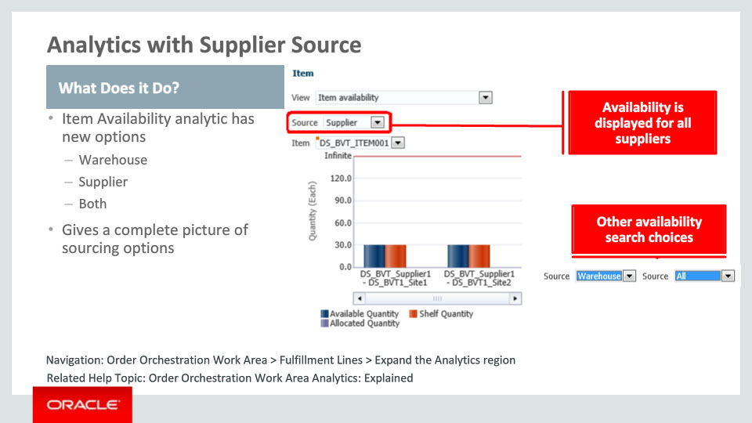
Slide notes
Your order managers now have the ability to get the complete item availability picture from the Item Availability analytic on the Order Orchestration Work Area page. In the past, fulfillment from your own warehouses was the only choice, and thus this graph displayed item availability at your warehouses. This graph has now been enhanced to display item availability from your drop ship suppliers as well. You have the option to decide whether you are interested in viewing item availability only for supplier sources or warehouse, meaning on-hand or across both types of sources. Thus, if you need to make a change, you have the knowledge of the alternate source from where you would like the item to be fulfilled.

Notes

Slide 58 - Summary of Enhancement Capabilities 1
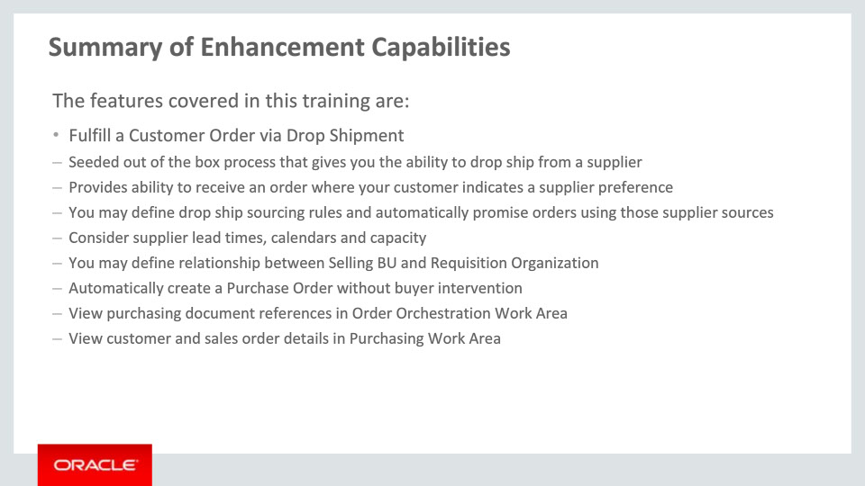
Slide notes
Here is the summary of the features I have talked about today:
Since the theme of this session is “Integrated Drop Shipment Flow,” the first feature that we have covered is to fulfill a customer order via drop shipment. Order Management has seeded an orchestration process that provides you the ability to do so. Your customer may enter their preference for a specific supplier when they submit an order and that is always honored by GOP. You can define sourcing rules in GOP that promise orders to be fulfilled from your suppliers that take into account the supplier lead time, calendar and capacity at the time of order promising.
You can define an association between the business unit responsible for creating the drop ship requisition and the selling business unit. This requisition organization is identified during the drop shipment flow before a purchase request is sent by Order Management to Procurement.
Most importantly, we have provided you a capability for a fully automated flow where a Purchase Order is issued to a supplier without any human intervention. You can view the references to the purchase requisition and purchase order in Order Orchestration Work Area in Order Management. In the Purchasing Work Area within Procurement, you can view the customer details as well as the reference to the customer sales order.

Notes

Slide 59 - Summary of Enhancement Capabilities 2
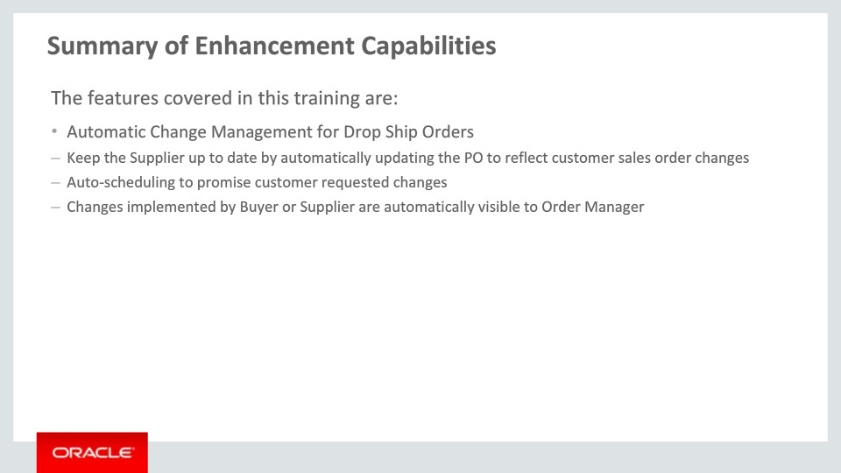
Slide notes
Your supplier is notified and kept up to date by automatically revising the Purchase Order to reflect changes on the customer sales order. As an example, if the sales order is canceled, the Purchase Order will be automatically canceled and supplier will see that cancelation.
Order Promising will evaluate and apply the impact of any changes to the sales order in auto-scheduling mode.
Further, under the situations where your buyer or supplier have to make changes to the purchase order, those changes are automatically applied to the customer order in Order Management.

Notes

Slide 60 - Summary of Enhancement Capabilities 3
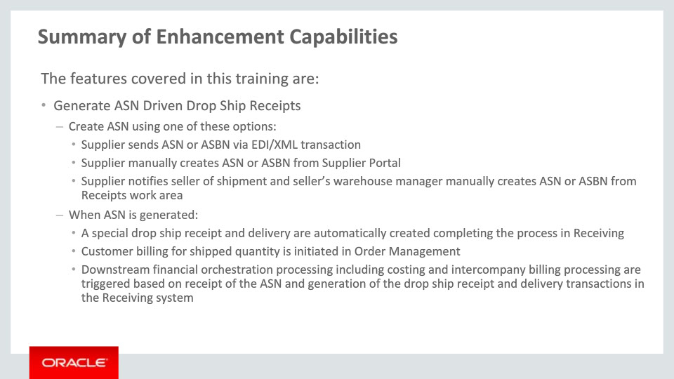
Slide notes
Two options are provided to seamlessly acknowledge delivery of the product and to initiate downstream processes for costing and billing.
The first option provided is the ASN option. With the ASN option there are multiple alternatives for generating the ASN. This can be done electronically using EDI or XML, manually by the supplier from the supplier portal or manually by warehouse personnel directly from the Receipts work area.
Once the ASN is generated, the drop ship receipt and delivery are automatically created to record the event in the Receiving system. As part of this processing, downstream process are automatically initiated for customer billing and financial orchestration including costing and intercompany billing processes.

Notes

Slide 61 - Summary of Enhancement Capabilities 4
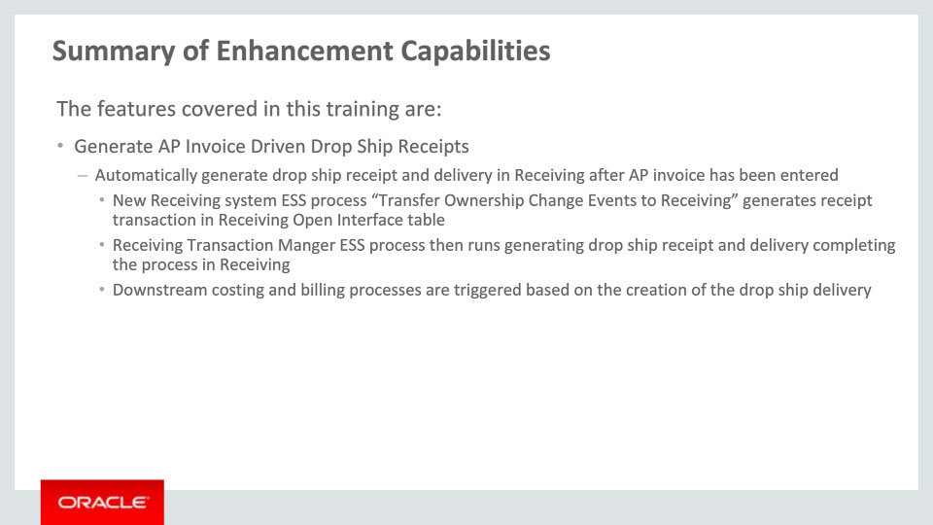
Slide notes
Now, we’ll cover how to Generate AP Invoice Driven Drop Ship Receipts. The full process from the point the AP invoice is received is as follows:
First, the supplier sends invoice to seller and seller’s Accounts Payable department enters or loads the invoice into the system.
Then, run ESS-based transaction processors to pass the invoice event into the Receiving module. These ESS processes would usually be scheduled to run automatically but can also be run manually on demand:
• Run the process “Transfer Invoice Details to Supply Chain Financial Flow Orchestration” to pass the invoice event to Supply Chain Financial Orchestration
• Run the process “Transfer Ownership Change Events to Receiving” to transfer orchestrated invoice event into a receipt format in the Receiving Open Interface
• Run the process “Manage Receiving Transactions” to generate a “special” drop ship “receipt” and “delivery” completing the processing in Receiving
Notes

Slide 62 - Summary of Enhancement Capabilities 5
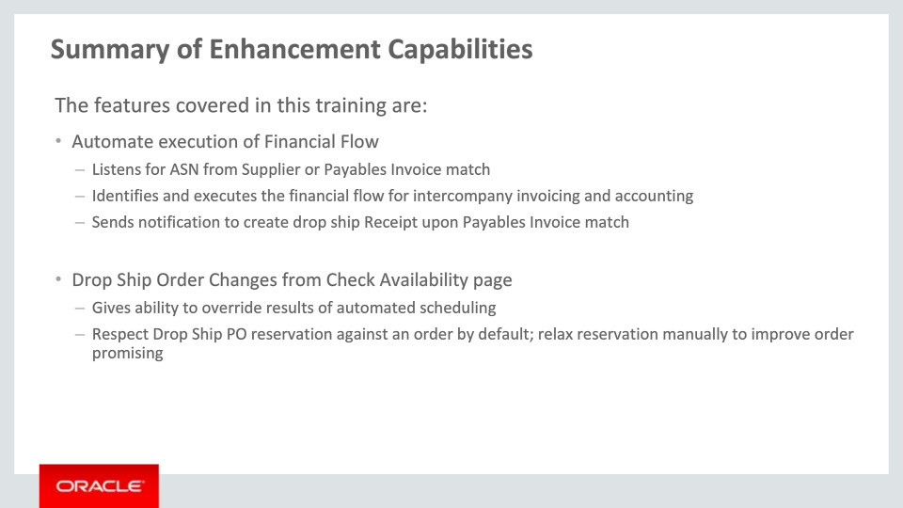
Slide notes
Supply Chain Financial Orchestration has the framework to listen for and capture events when Advance Shipment Notice (ASN) is sent by supplier or supplier invoice is matched to a purchase order. The automated process determines the corresponding financial flow and executes the flow. If ASN is not expected from supplier, it notifies Receiving upon Payable Invoice match so that a drop ship receipt may be created.
Order Management provides the ability to launch the Check Availability page where the results of auto-scheduling can be overridden and alternate sources of supply can be viewed and selected for scheduling. On this page, the default behavior is to respect the reservation of Drop Ship supply against the customer order. You can override this option to view alternate order promising results

Notes

Slide 63 - Summary of Enhancement Capabilities 6
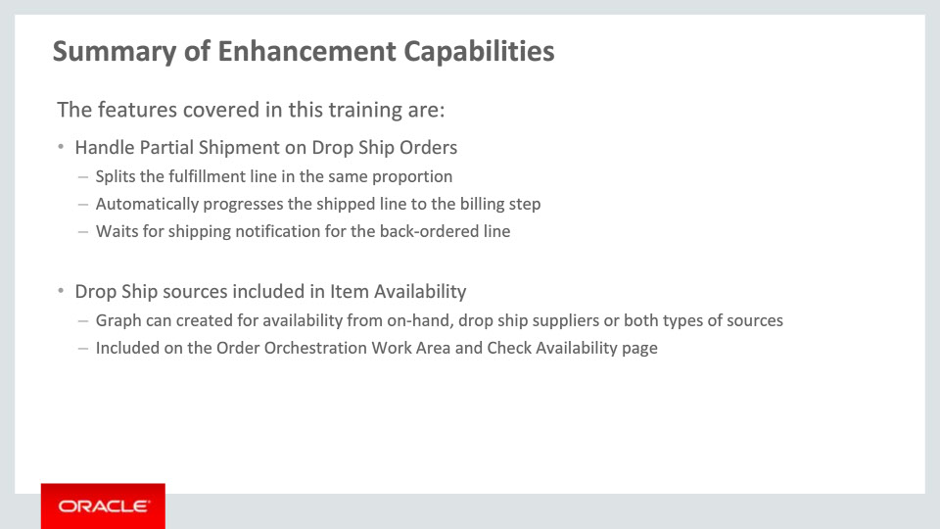
Slide notes
Order Management provides you the ability to handle partial shipment against a Drop Ship Purchase Order. The fulfillment line is automatically split in the same proportion with the shipped line automatically moving to the next step, which is the billing step in the seeded orchestration process. The back-ordered, unshipped line continues to await a new shipping notification for that quantity.
The Item Availability graph has been enhanced to include available supply from your suppliers in addition to on-hand quantities. You can refresh the graph to see the availability for either just suppliers or just on-hand or across both. The graph has been enhanced on both Order Orchestration Work Area and Check Availability pages.
That concludes the summary of enhancements on the transactional side.

Notes

Slide 64 - Additional Information 1
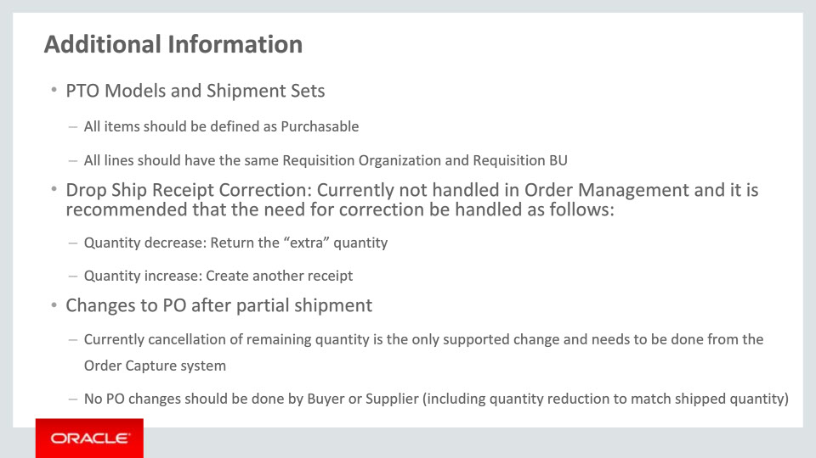
Slide notes
Here is some additional information to help you understand and use these enhancements.
You are required to define the items that are children of a Pick To Order (PTO) model as Purchasable. A Shipment Set is a grouping of items that need to be shipped together. All items that are part of a shipment set need to be purchasable, else they can’t be drop shipped.
For items under PTO models and Shipment Sets, you need to define the Drop Ship Financial Flow such that all of them will be sourced by the same Requisition Organization. Order Management Cloud will give an error at the procurement step of the process if this is not found to be true.
Order Management Cloud can’t handle corrections made to Drop Ship receipts after the fact. This is because the flow progresses to the next step (typically Invoicing) in Order Management for the quantity on the original receipt once Receiving notifies that the drop ship receipt has been created. Thus, to have the effect of reducing the shipped quantity, you need to create a return transaction for the delta, i.e., extra quantity on the original receipt. Likewise, rather than increasing the quantity on the receipt, create a new receipt for the shortfall on the original receipt.
After a PO schedule has been partially shipped, the fulfillment line in Order Management is split into two. The line tracking the shipped quantity moves to the invoicing step and the line tracking the unshipped quantity remains at the procurement step, awaiting the shipping notification. At this point, the only change that can be absorbed by Order Management is to cancel the unshipped quantity. This change needs to come from the Order Capture system. Any changes done on the Purchase Order (including cancelling the unshipped quantity) in Purchasing can’t be handled in Order Management. Thus, no changes should be done to a partially shipped PO in Procurement.

Notes

Slide 65 - Additional Information 2
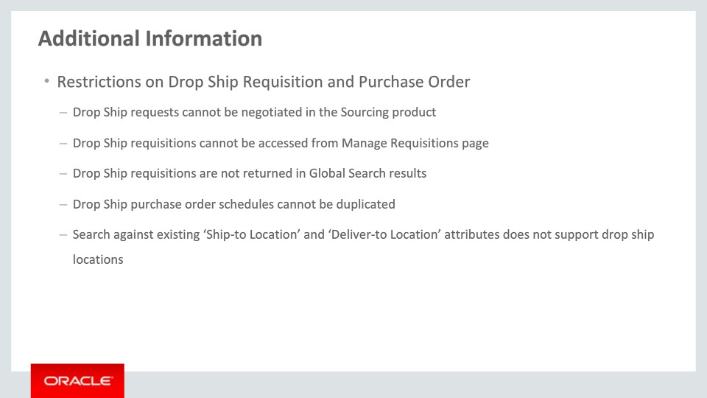
Slide notes
Requisitions created for drop shipments are flagged as externally managed requisitions, and therefore will not be available on Manage Requisitions in Self Service Procurement nor returned in Global Search. Such requisitions cannot be returned by the buyer to the requisition preparer.
Purchase order schedules with a backing sales order cannot be duplicated.
The existing ship-to location and deliver-to location search attributes in purchasing pages does not support drop ship (external/customer) locations.

Notes

Slide 66 - Additional Information 3
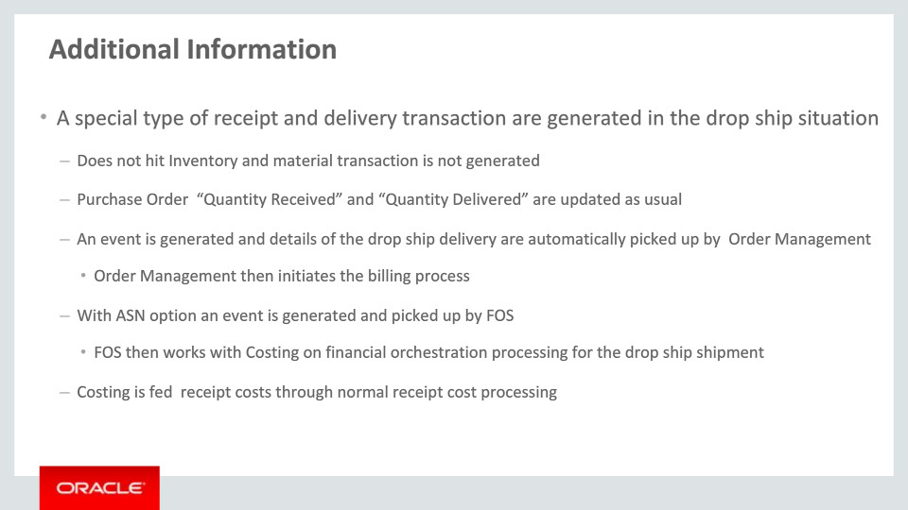
Slide notes
A special type of receipt and delivery transaction are generated in the drop ship situation.
Inventory balances are not updated because the product is shipped directly to your customer. For this reason the inventory material transaction that is usually generated when a delivery transaction is created in Receiving is not generated in the Inventory system.
The Receiving system does update the purchase orders “quantity received” and “quantity delivered” balances as would normally be expected for a purchase order receipt.
When the drop ship delivery is generated, Order Management is automatically notified so billing processing can be initiated.
In addition, if the drop ship receipt and delivery are generated based on an ASN, Supply Chain Financial Orchestration (SFO) is also notified. SFO then works with Costing on financial orchestration processing for the drop ship event.
Also note that these special drop ship transactions are fed to Costing through normal receipt cost processing.
Notes

Slide 67 - Additional Information 4
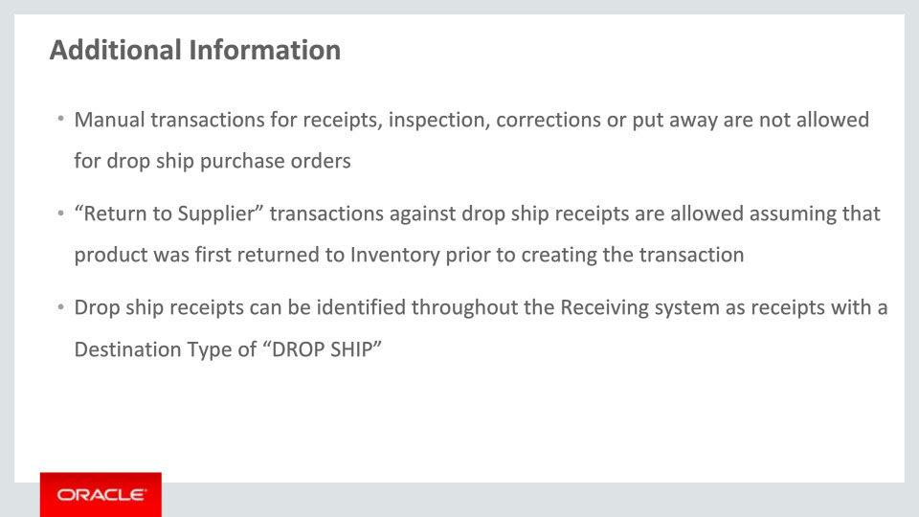
Slide notes
Since processing for the special drop ship receipt and delivery transactions are fully automated, the Receiving system does not allow manual transactions against drop ship purchase orders. This includes receipt, inspection, correction and put away transactions.
The one exception to this rule is for “Return to Supplier” transactions. “Return to Supplier” transactions against drop ship receipts are allowed assuming that product was first returned to Inventory prior to creating the transaction.
The Receiving system identifies a drop ship purchase order based on a Destination Type of “DROP SHIP." Drop Ship receipts can be identified throughout the Receiving system as receipts with a Destination Type of “DROP SHIP."

Notes

Slide 68 - Implementation Advice
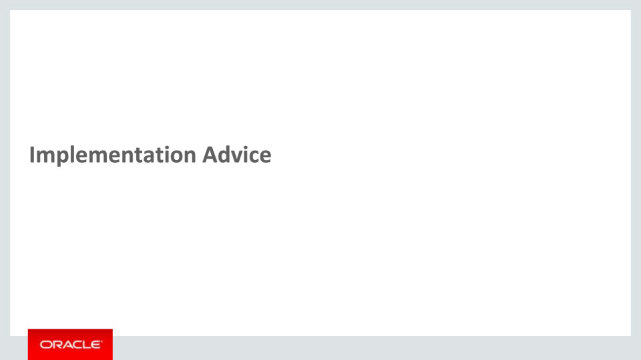
Slide notes
In this implementation advice section we will go through what you need to consider before enabling these features in your business, and what you need to know to set them up.

Notes

Slide 69 - Feature Impact Guidelines 1
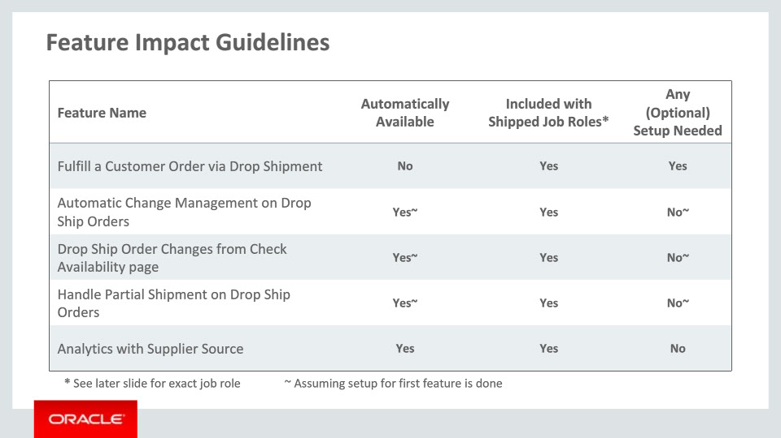
Slide notes
Here is key upgrade information for the new features covered in this training. It details:
• If a feature is automatically available after the upgrade
• If a feature can be accessed using the shipped job roles – the exact job roles are detailed later in this section, and
• If a feature has any setup associated with it – setup specifics are covered later in this section
Finally, the features where you notice a ~ on the availability and setup columns simply means that the setup for the first feature, “Fulfill a Customer Order via Drop Shipment,” has been performed.

Notes

Slide 70 - Feature Impact Guidelines 2
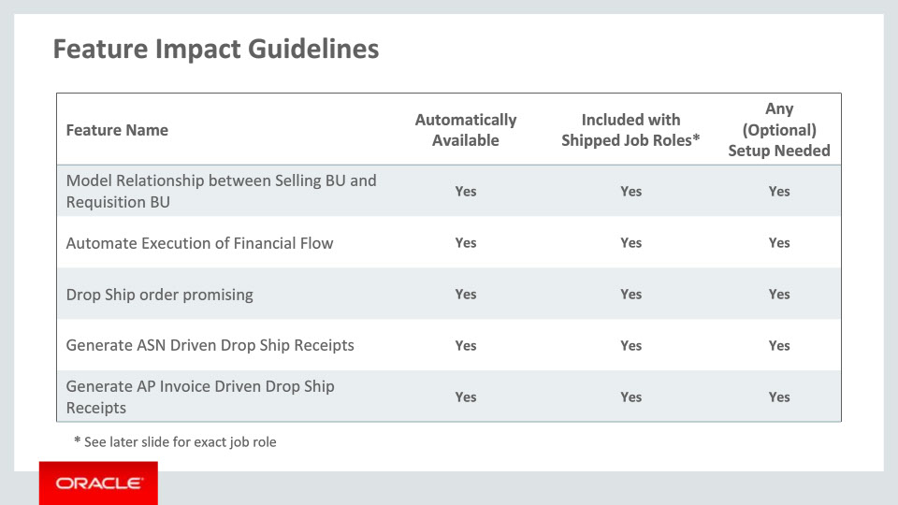
Slide notes
Here is additional feature impact information. Please take a moment to review it.

Notes

Slide 71 - Feature Impact Guidelines 3
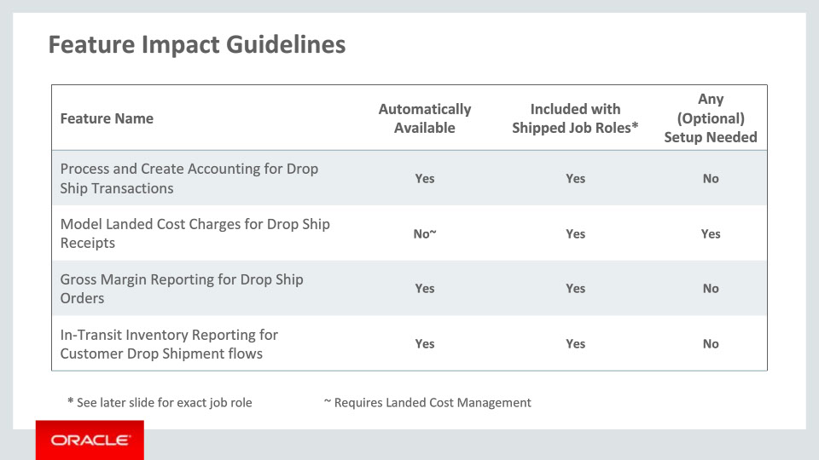
Slide notes
Here is the remainder of the feature impact information. Please note that the feature “Model Landed Cost Charges for Drop Ship Receipts” where you notice a ~ on the availability column means that Landed Cost Management functional area in Manufacturing and Supply Chain Materials Management offering needs to be enabled for this feature to be available.

Notes

Slide 72 - Setup Summary: Order Management
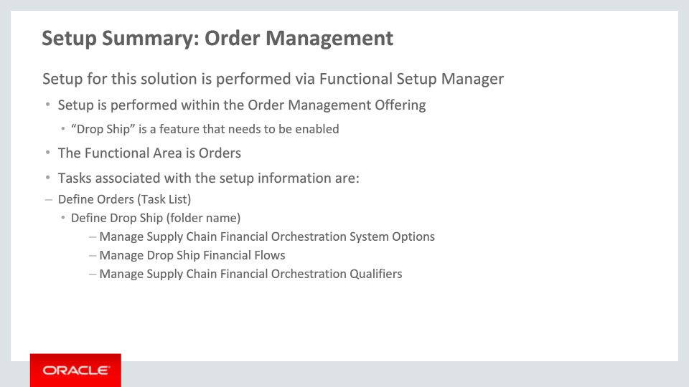
Slide notes
The setup for Drop Ship Enhancements is achieved by Order Management Offering. “Drop Ship” is a feature that needs to be enabled. The functional area is Orders. The tasks that are associated with the setup are listed here. Please take a moment to review them.

Notes

Slide 73 - Setup Summary: GOP and Planning Central
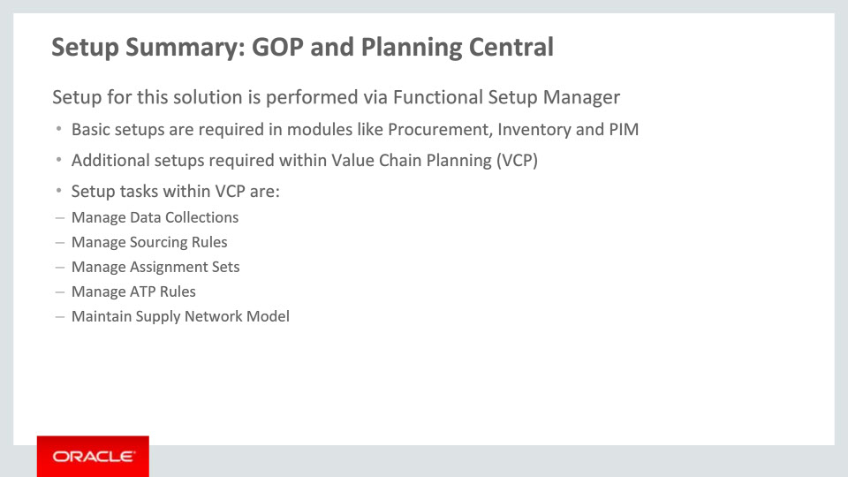
Slide notes
Extensive setups for “Advanced Fulfillment Scenarios” are required in other cloud products that are then collected into Value Chain Planning, or VCP, using the “Manage Data Collections” setup task. Within GOP service, you need to setup Sourcing Rules and ATP Rules to enable the additional functionality in this Release.

Notes

Slide 74 - Setup Summary: Purchasing
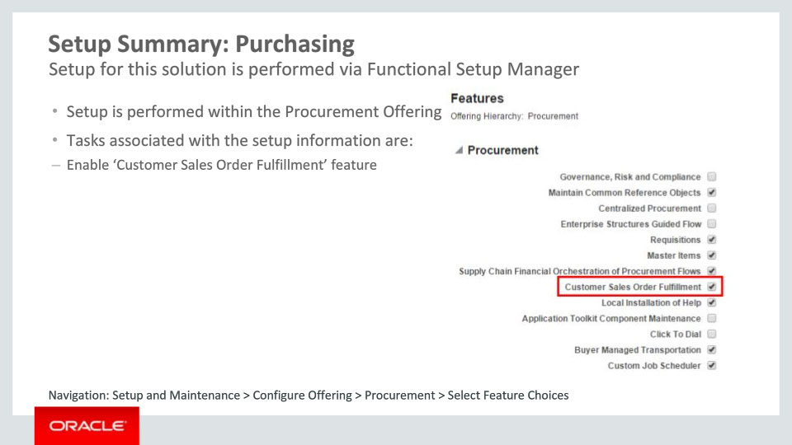
Slide notes
The setup for enabling drop ship flow in Procurement is achieved by enabling the ‘Customer Sales Order Fulfillment’ feature within the ‘Procurement’ offering.

Notes

Slide 75 - Define Items
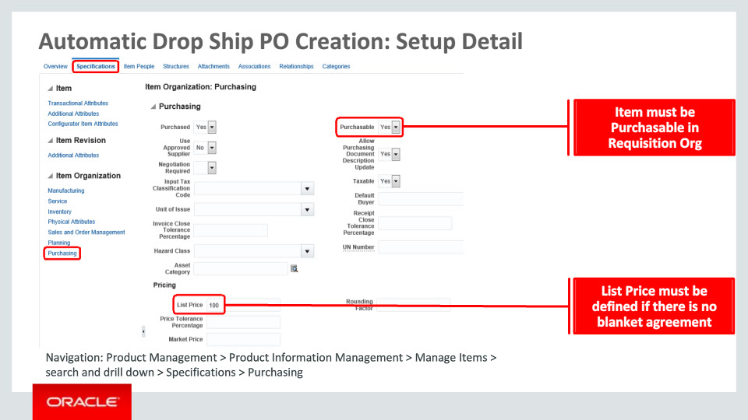
Slide notes
Now, we will go through the critical setups necessary for Drop Ship fulfillment to work.
In order for an item to be considered for Drop Ship fulfillment, it must be defined as “Purchasable” as shown here. The navigation to the “Manage Items” page as well as the specific region on this page where this attribute is defined are mentioned in the navigation section shown on the lower left.

Notes

Slide 76 - Manage Drop Ship Financial Flows
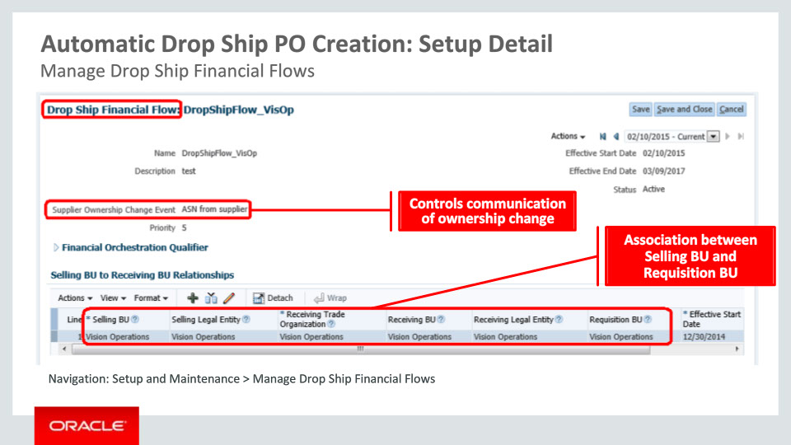
Slide notes
The next setup covers the relationship between selling and requisition BUs.
On the “Manage Drop Ship Financial Flows” UI, you specify the receiving trade organization for every selling business unit in your enterprise. The receiving trade organization is the organization that will place the requisition for the goods, that will act as the “receiving org” for the drop ship PO, and will be where the receipt and shipment accounting for the drop shipment is performed. The receiving BU and the receiving LE are defaulted based on the receiving trade organization. For example, in this screen, the system is setup to specify that any drop ship sales order that is taken in the Vision Operations BU creates a requisition in the Vision Operations inventory organization.
In some cases, you may need to define different requisition trade organizations for different drop ship orders that are sold out of the same selling business unit. To do this, you can add multiple drop ship financial flows with different orchestration qualifiers. For example, if I need to buy out of China if my supplier is in China, but buy out of the US if my supplier is in the US or Europe, then I can create a second drop ship financial flow, with a qualifier of the Chinese supplier site, and a receiving trade organization of my Chinese inventory org.
Finally, for each drop ship financial flow, you can determine whether the ASN or the supplier invoice should be used as the event that will trigger ownership change from the supplier to your company. If the selling BU and the receiving BU are different, then supply chain financial orchestration will determine if there any additional financial and accounting transactions that need to be performed based on procurement and shipping flows defined in the system.
Drop ship purchase requisitions are created by Order Management Cloud on external suppliers which requires the requisition organization. This is where Order Management Cloud derives the requisition organization and requisition BU from.

Notes

Slide 77 - Manage Order Management Parameters
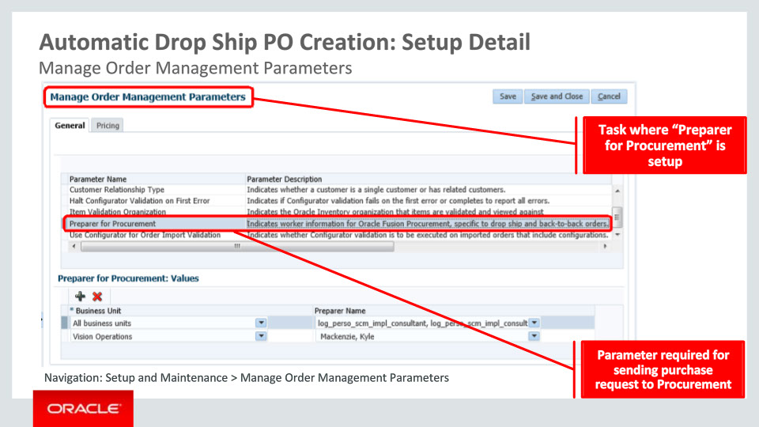
Slide notes
A new setup task titled “Manage Order Management Parameters” has been introduced in Order Management where your administrator can setup some preferences needed for Order Management implementation. You can search for this task from within the Order Management offering under Setup and Maintenance.
In order to successfully send a purchase request to Oracle Procurement Cloud, at least one value needs to be defined for the parameter “Preparer for Procurement." The default value applies across all business units. Specific values can be setup at the level of each Sales BU. The preparer is the person that your buyers are expected to reach out to if they need to discuss something within the context of fulfillment of the customer order. If a value is defined for the sales BU stamped on the order, that value will be picked up, otherwise, the default value across all business units will be picked. This attribute is mandatory for sending a purchase request to Procurement Cloud.

Notes

Slide 78 - Define Supplier and Supplier Site
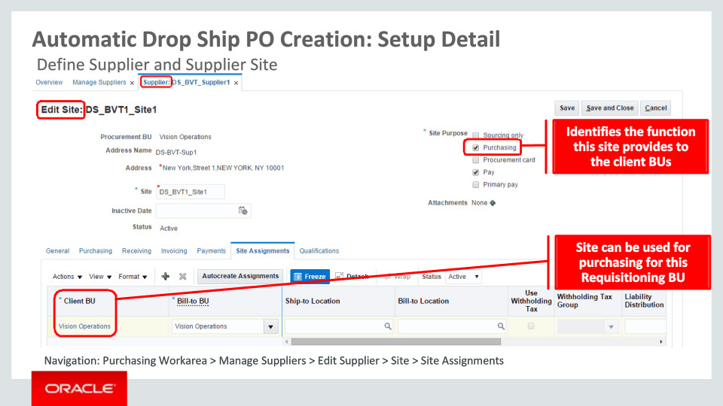
Slide notes
The setup for supplier, supplier site enablement is done in the Manage Suppliers area in Purchasing. You need to enable the site for Purchasing as shown for it to be considered a valid supplier site. Further, under the Site Assignments tab, you need to associate those Requisition Business Units as client BU for which the supplier site needs to be used for the purchasing function.

Notes

Slide 79 - Setup for GOP and Planning Central
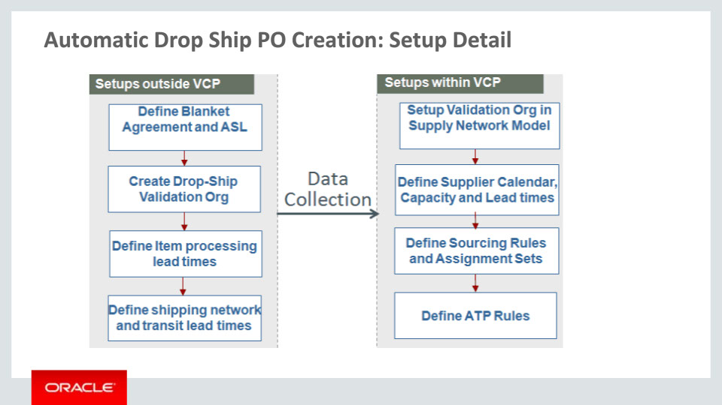
Slide notes
Here is a graphical representation of what we covered in the Setup Summary for GOP and Planning Central. The setups external to Value Chain Planning (VCP) are shown on the left side. Once those are done, the collections process pulls the relevant data into Planning Central.
Next, your Planner needs to perform the setups that are native to Planning which are shown on the right side. We will look at the key setups in the next two slides. An in-depth coverage of this area is provided in the TOI specific to VCP and GOP.

Notes

Slide 80 - Define Sourcing Rules
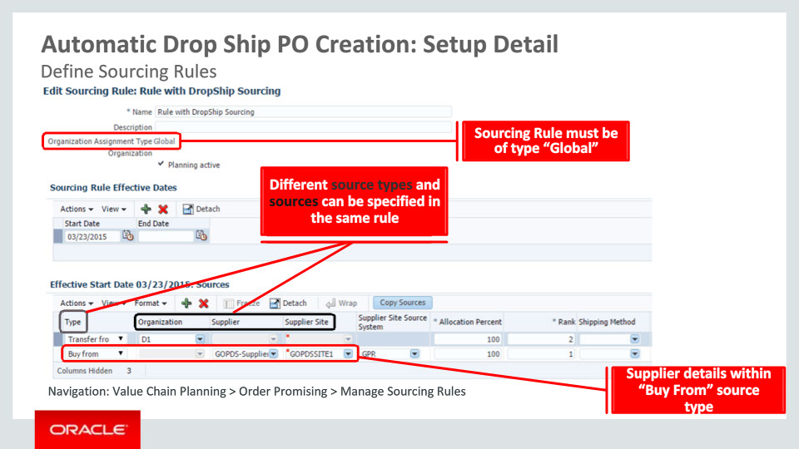
Slide notes
You may define a global “Buy from” type of sourcing rule with supplier and supplier site populated. At the time of order promising, GOP will evaluate this sourcing rule and take into consideration the supplier calendar, supplier capacity and supplier lead times.
Supplier Calendar defines working days for the supplier and it can be different by Supplier Site. GOP considers only working days when accounting for lead times.
You may specify supplier capacity by Item, Supplier and Supplier Site. Supplier capacity is assumed to be based on Arrival Date.
For Supplier Lead Times, item processing lead times are specified on the item master in PIM and collected. Supplier specific lead times can be specified within VCP.

Notes

Slide 81 - Define Assignment Set
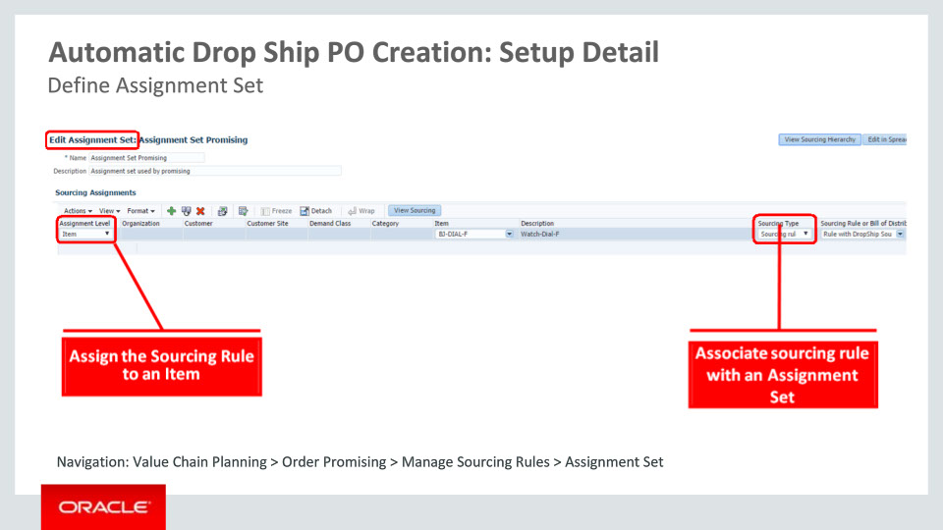
Slide notes
Next, you would go to the Assignment Set page to specify sourcing assignments. This is where you would associate the sourcing rule you have already defined with the item to be drop shipped. To tie an item to a sourcing rule, you would need to specify the Assignment Level as “Item” and then provide the value in the Item column.

Notes

Slide 82 - Define Agreement
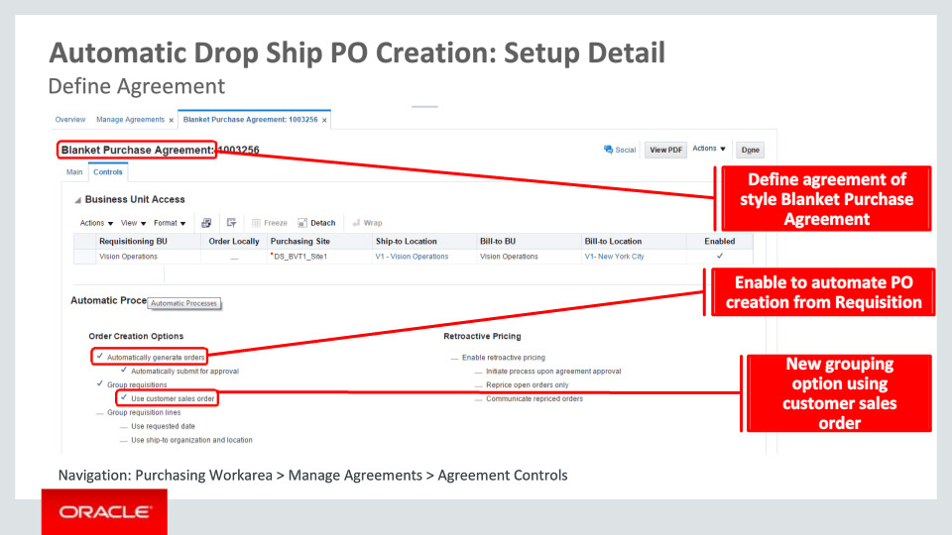
Slide notes
In Purchasing, your buyer can create blanket purchase agreements for the items to be drop shipped from a supplier. Each blanket purchase agreement is defined for a specific supplier and supplier site and associates one or more items with it. The prices mentioned in the agreement will be used for defaulting in the purchase documents.

If you select the option “Automatically generate orders,” any requisition that is sourced from this blanket purchase agreement will automatically get converted to a Purchase Order. Thus your buyer does not need to do so manually.

If you select the option to group requisitions using customer sales order, the system will enable grouping of requisition lines with the same sales order number to be placed on a single purchase order.
Notes

Slide 83 - Job Roles 1
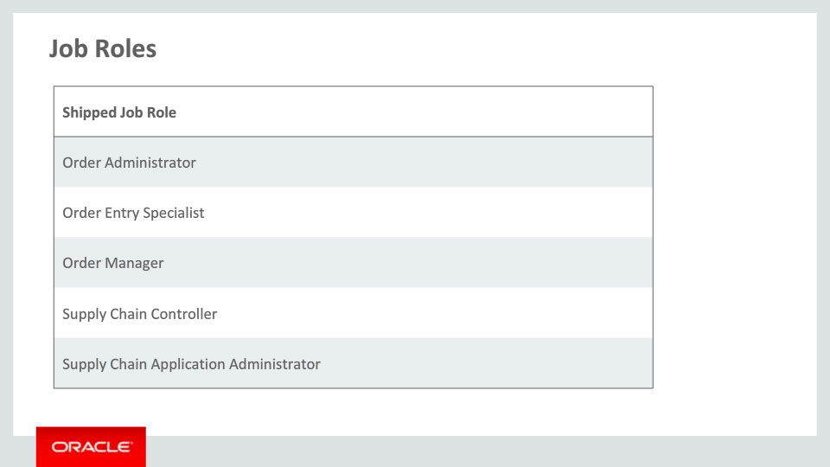
Slide notes
Here are the shipped job roles that are needed to access the new capabilities covered in this training.

Notes

Slide 84 - Job Roles 2
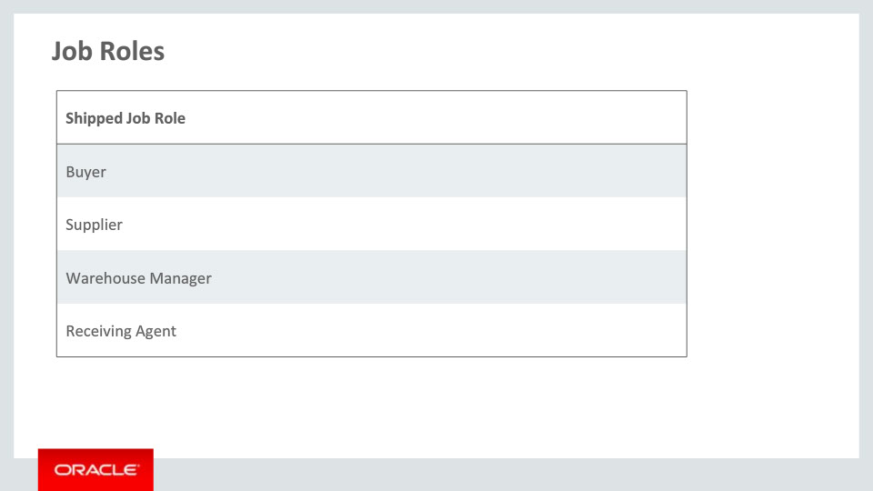
Slide notes
Here are the additional shipped job roles that are needed to access the new capabilities covered in this training.

Notes

Slide 85 - Business Process Model Information 1
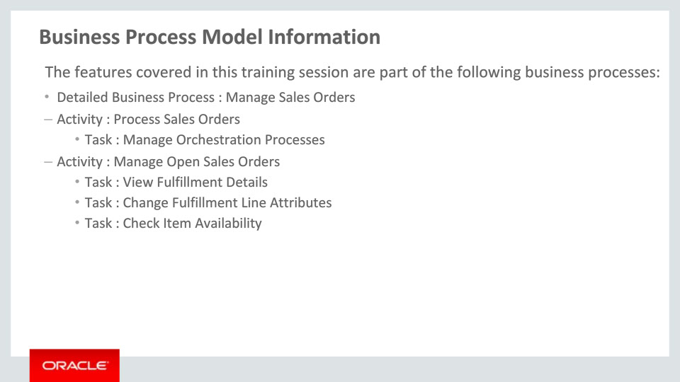
Slide notes
The business processes associated with the new capabilities covered in this training are detailed here. The high-level business process is Manage Sales Orders with activities Process Sales Orders and Manage Open Sales Orders.

Notes

Slide 86 - Business Process Model Information 2
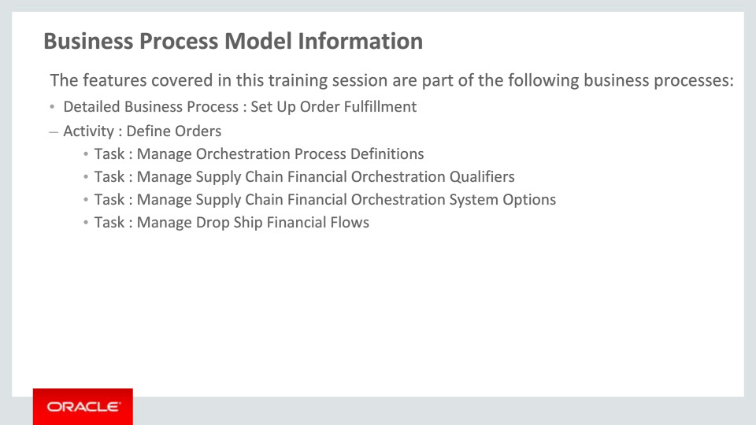
Slide notes
Here are additional business processes associated with the new capabilities covered in this training. The high-level business process is Set Up Order Fulfillment with activity Define Orders.

Notes

Slide 87 - Business Process Model Information 3
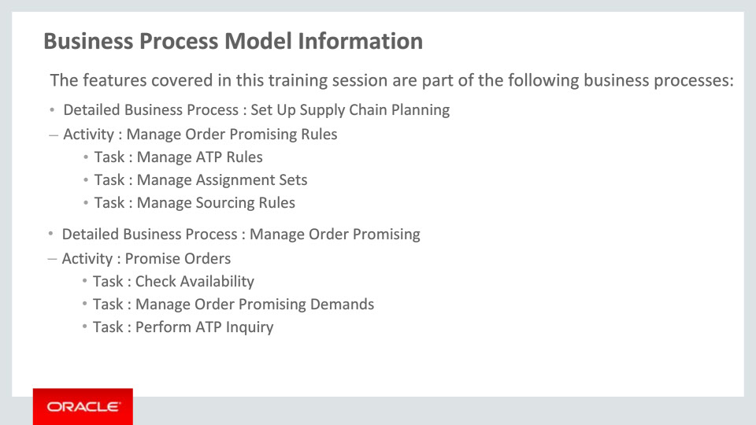
Slide notes
For these business processes, the first high-level business process is Set Up Supply Chain Planning with activity Manage Order Promising Rules. The second high-level business process is Manage Order Promising with activity Promise Orders.

Notes

Slide 88 - Business Process Model Information 4
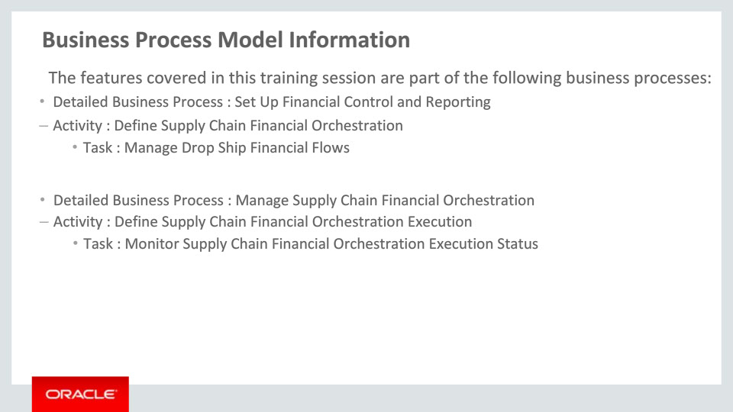
Slide notes
Here, the first high-level business process is Set Up Financial Control and Reporting with activity Define Supply Chain Financial Orchestration. The second high-level business process is Manage Supply Chain Financial Orchestration with activity Define Supply Chain Financial Orchestration Execution.

Notes

Slide 89 - Business Process Model Information 5
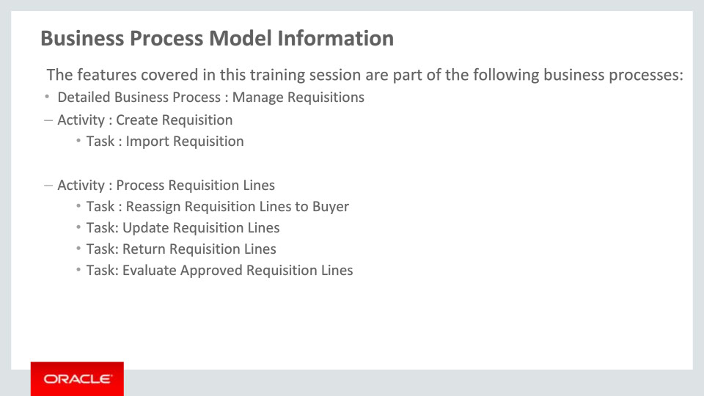
Slide notes
The high-level business process shown here is Manage Requisitions with activities Create Requisition, and Process Requisition Lines. Additional activities under this business process are mentioned next.

Notes

Slide 90 - Business Process Model Information 6
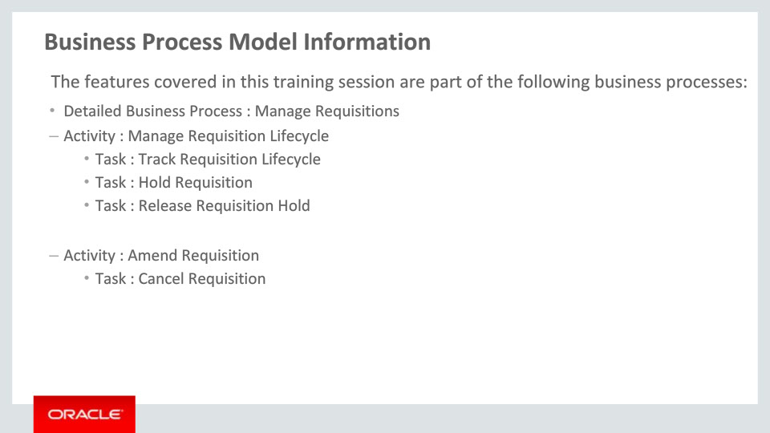
Slide notes
This is a continuation of the high-level business process on the previous slide Manage Requisitions with activities Manage Requisition Lifecycle and Amend Requisition.

Notes

Slide 91 - Business Process Model Information 7
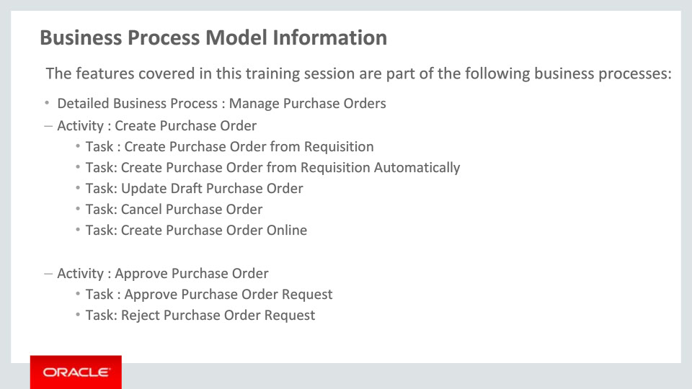
Slide notes
Here, the high-level business process is Manage Purchase Orders with activities Create Purchase Order and Approve Purchase Order. Additional activities under this business process are mentioned on the following slides.

Notes

Slide 92 - Business Process Model Information 8
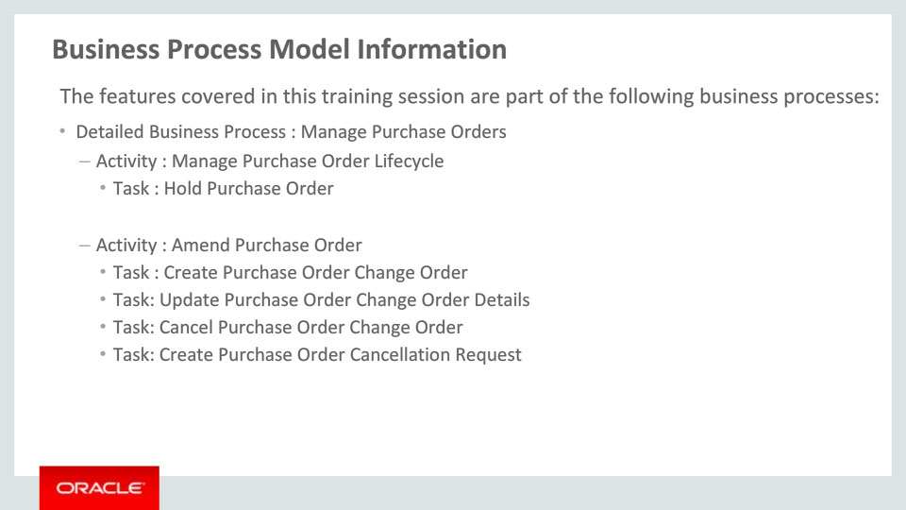
Slide notes
This is a continuation of the high-level business process on the previous slide Manage Purchase Orders with activities Manage Purchase Order Lifecycle and Amend Purchase Order. The remaining activities under this business process are mentioned next.

Notes

Slide 93 - Business Process Model Information 9
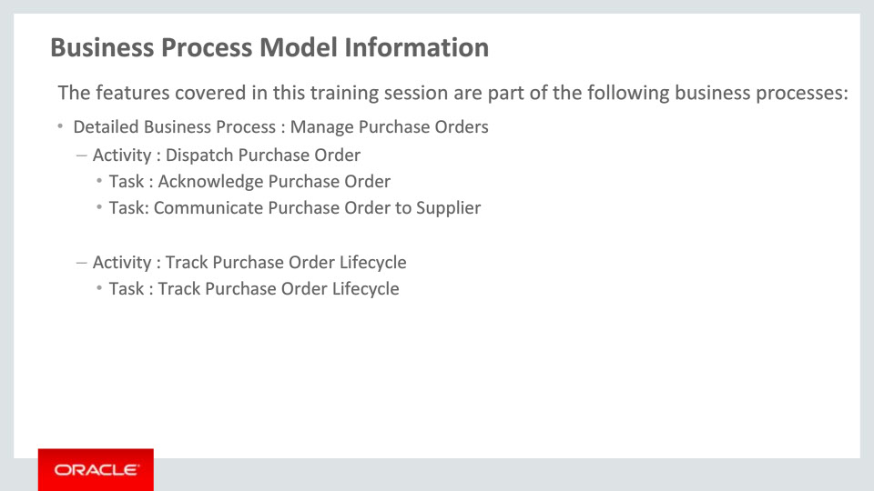
Slide notes
This is a continuation of the high-level business process on the previous two slides Manage Purchase Orders, with activities Dispatch Purchase Order and Track Purchase Order Lifecycle.

Notes

Slide 94 - Business Process Model Information 10
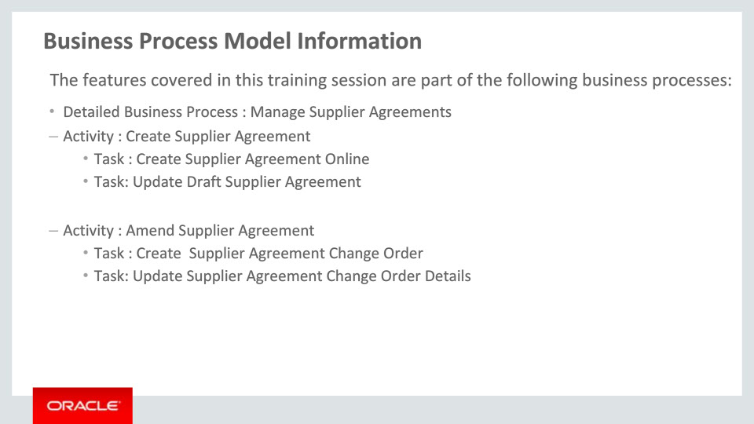
Slide notes
The high level business process here is Manage Supplier Agreements with activities Create Supplier Agreement and Amend Supplier Agreement.

Notes

Slide 95 - Business Process Model Information 11
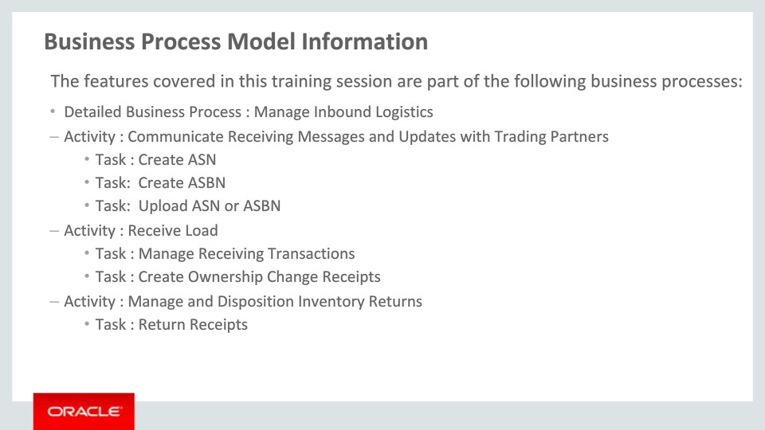
Slide notes
This high-level business process is Manage Inbound Logistics with activities Communicate Receiving Messages and Updates with Trading Partners, Receive Load and Manage and Disposition Inventory Returns.

Notes

Slide 96 - Related Reports & BI Analytic Information 1
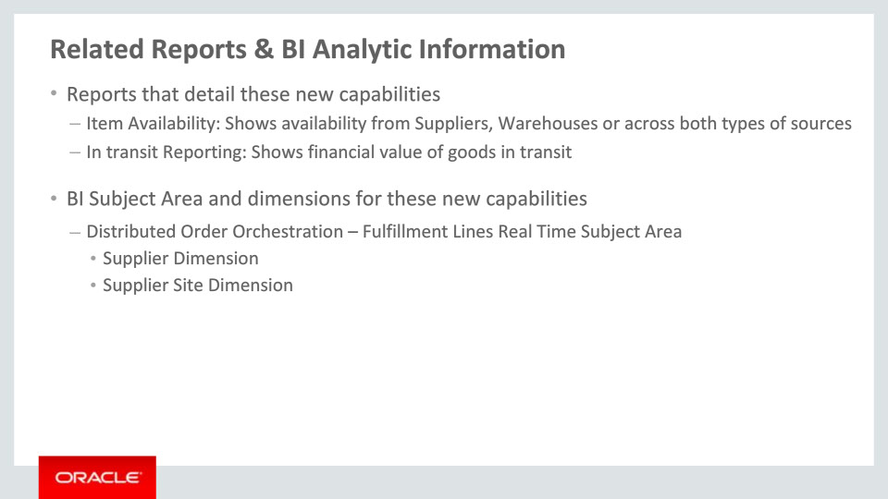
Slide notes
Next, let us talk about the enhancements in the reporting and analytics area.
In Order Management, the existing Item Availability report allows you to determine the availability of the item on the selected fulfillment line from multiple source types. You can choose the source value to be either Supplier or Warehouse or Both and the graph is refreshed to display the availability of the item from the chosen source type.
In Cost Management, the In-transit Reporting analytic shows the financial value of goods in transit.
You will find the Supplier and Supplier Site dimensions newly added to the Fulfillment Lines Real Time Subject Area.

Notes

Slide 97 - Related Reports & BI Analytic Information 2
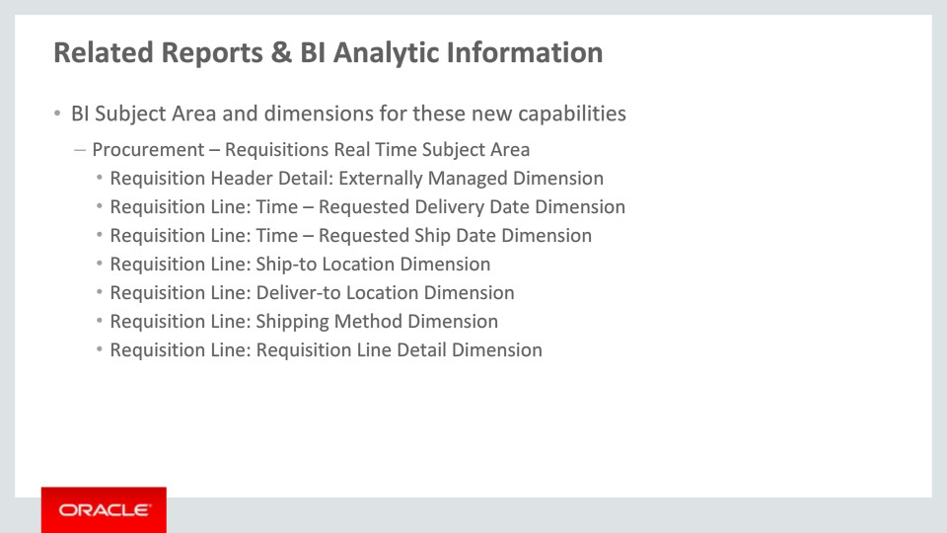
Slide notes
The subject area and associated dimensions that are added or enhanced in Self Service Procurement are mentioned in the following slides.
You will find new dimensions added under the Requisitions Real Time Subject Area under Procurement. These are:
• Externally Managed at the Requisition Header Detail level and
• Requested Delivery Date, Requested Ship Date, Ship-to Location, Deliver-to Location, and Shipping Method at the Requisition Line level and
• Customer Sales Order, Early Receipt Tolerance in Days, Late Receipt Tolerance in Days, and Over- receipt Tolerance Percent at the Requisition Line Detail level

Notes

Slide 98 - Related Reports & BI Analytic Information 3
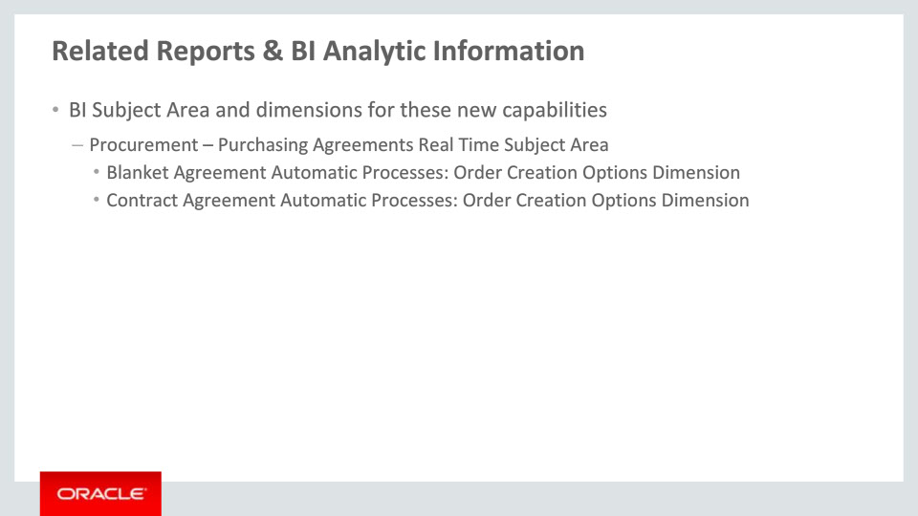
Slide notes
The subject area and associated dimensions that are added or enhanced in Purchasing are mentioned here. You will find new dimensions added under the Purchasing Agreements Real Time Subject Area under Procurement. These are:
Order Creation Options at the Blanket Agreement Automatic Processes level and
Order Creation Options at the Contract Agreement Automatic Processes level

Notes

Slide 99 - Related Reports & BI Analytic Information 4
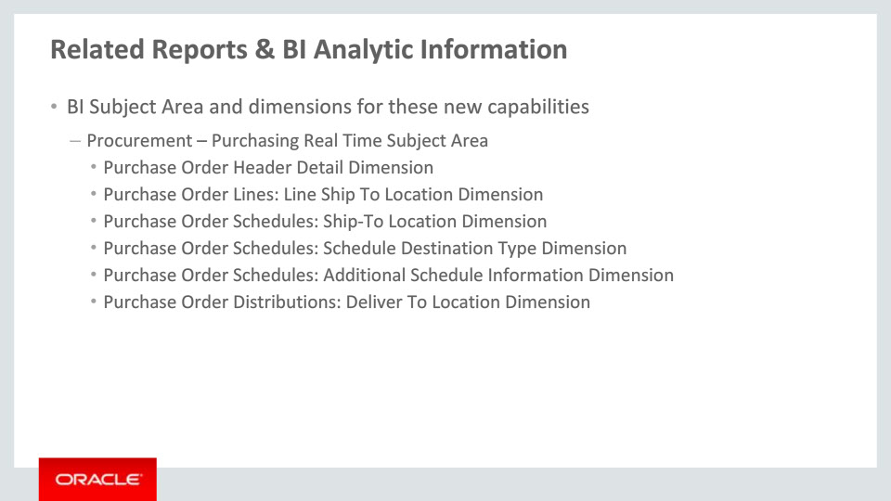
Slide notes
Additionally, some enhancements have been made under the Purchasing Real Time Subject Area. These are:
• The attribute ‘Interface Source Code’ has been renamed to ‘Import Source’ under Purchase Order Header Detail Dimension
• The dimension Line Ship To Location under Purchase Order Lines has been hidden
• Customer i.e., external location is displayed instead of internal i.e., HR location for the Ship-To Location Dimension under Purchase Order Schedules and Deliver-to Location Dimension under Purchase Order Distributions
• Location Type should be ‘External’ for Schedule Destination Type Dimension under Purchase Order Schedules
• Finally, a new attribute ‘Customer Sales Order’ has been added to the Additional Schedule Information Dimension under Purchase Order Schedules

Notes

Slide 100 - Related Reports & BI Analytic Information 5
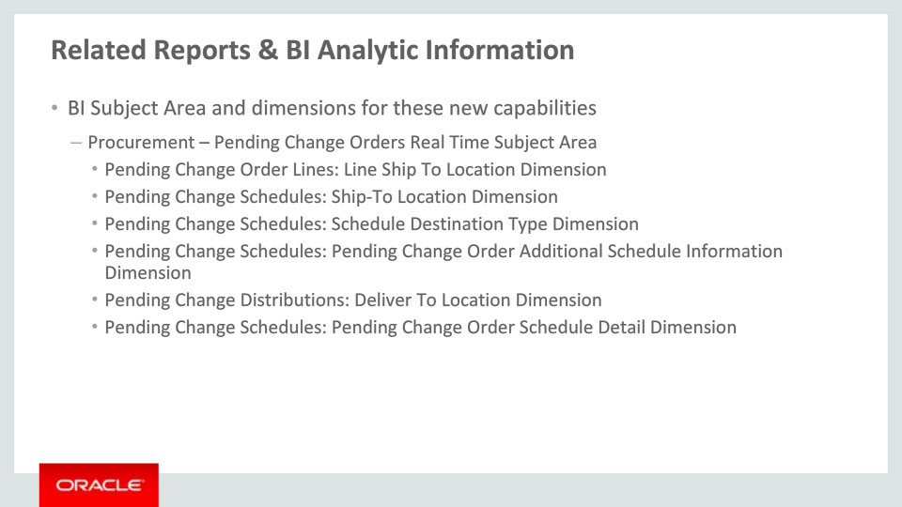
Slide notes
Next, let us talk about the enhancements to Pending Change Orders Real Time Subject Area under Procurement:
• Line Ship-To Location Dimension under Pending Change Order Lines has been hidden
• Customer i.e., external location is displayed instead of internal i.e., HR location for the Ship-To Location Dimension under Pending Change Schedules as well as for Deliver-to Location Dimension under Pending Change Distributions
• Location Type should be ‘External’ for Schedule Destination Type Dimension under Pending Change Schedules
• Finally, a new attribute ‘Customer Sales Order’ has been added to the Pending Change Order Additional Schedule Information Dimension under Pending Change Schedules
Notes

Slide 101 - Associated Release Training
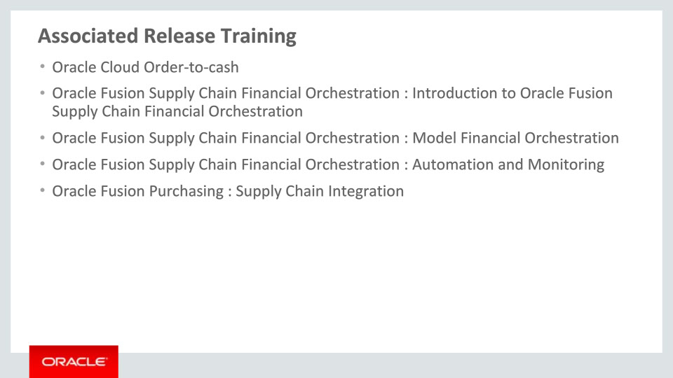
Slide notes
Finally let us review the list of associated release trainings that go with this training on Drop Shipment in the SCM Cloud. The training courses are:
• Oracle Cloud Order-to-cash
• Oracle Fusion Supply Chain Financial Orchestration : Introduction to Oracle Fusion Supply Chain Financial Orchestration
• Oracle Fusion Supply Chain Financial Orchestration : Model Financial Orchestration
• Oracle Fusion Supply Chain Financial Orchestration : Automation and Monitoring, and
• Oracle Fusion Purchasing : Supply Chain Integration

This concludes this presentation. Thank you for listening. You can pause and rewind any of these slides if you require additional time to take in the detail.
Notes

