Slide 3 - Oracle Project Portfolio Management Cloud Release 11
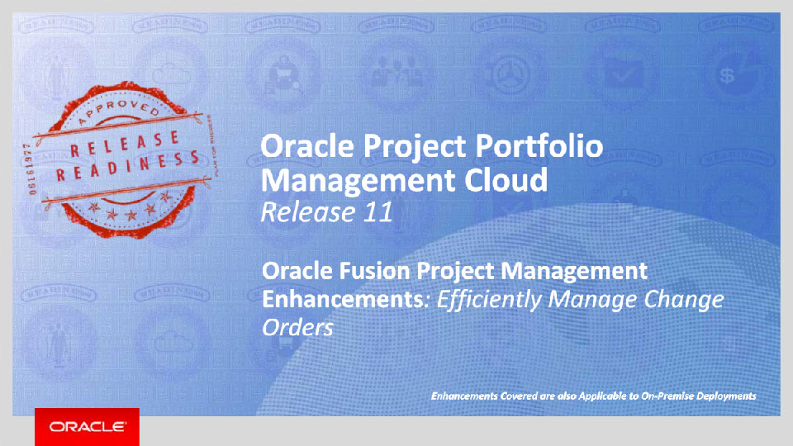
Slide notes
Hello, my name is Vineela. Welcome to training for Release 11. In this session we will talk what’s coming in Oracle Fusion Project Portfolio Management Cloud to efficiently manage your change orders.

Notes

Slide 4 - Agenda
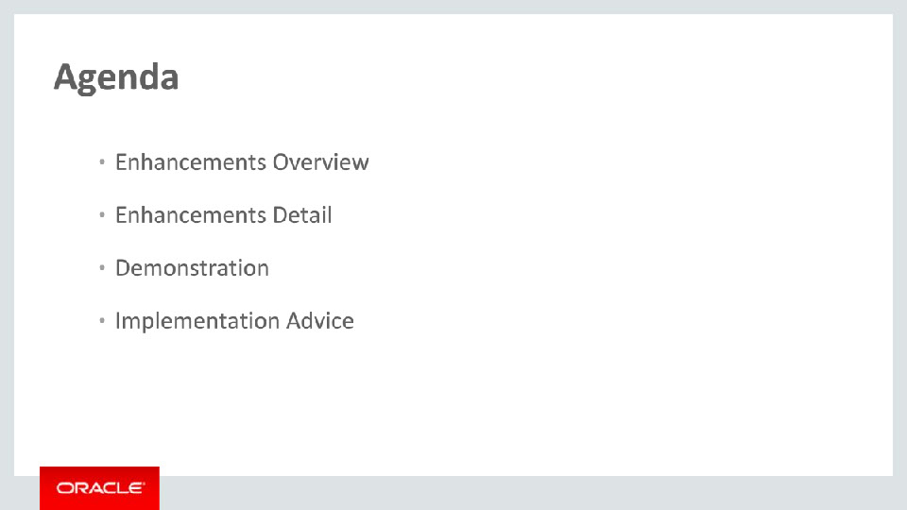
Slide notes
For the enhancements covered in this training, we’ll give an overview, followed by details to explain how you can use them, and what business value they add.

Then we’ll walk you through a demonstration.

Next we’ll explain what you need to consider before enabling these features for your business, and how you can set them up.

Notes

Slide 5 - Enhancements Overview
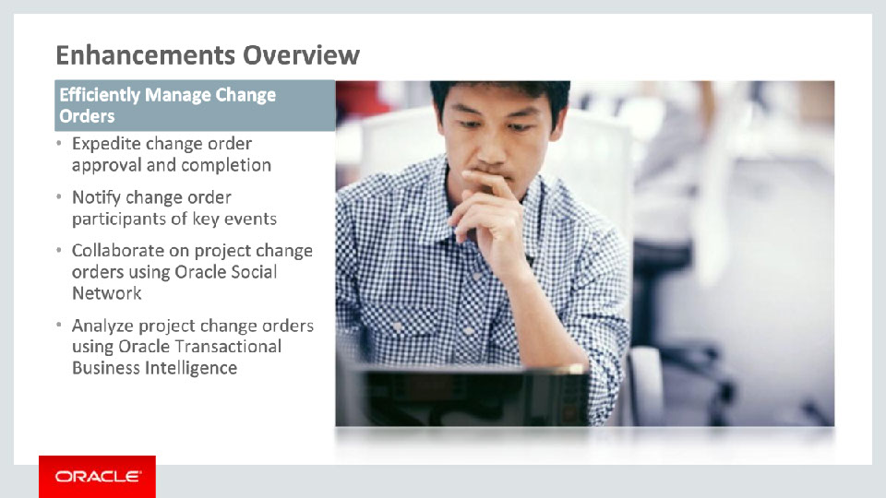
Slide notes
We have enhanced the Manage Change Order page to provide you with an even more powerful and modern user experience as you manage your changes. We have added intuitive filters and key information in the page to provide you with the latest on each change order at a glance and search for pending change orders easily.
We’ve also added new notifications to inform participants and owners of pending work so that necessary action can be taken by the stakeholder in a timely manner to expedite the approval and completion of the change requested.
These new enhancements also allow you to collaborate socially on change orders using Oracle Social Network.
We’ve also added a new subject area to analyze change orders in Oracle Transaction Business Intelligence (or for short, OTBI). We provide you with sample reports that you can readily use, or you can customize them, or refer to them when you create your own sample reports.
Notes

Slide 6 - Expedite Change Order Approval and Completion
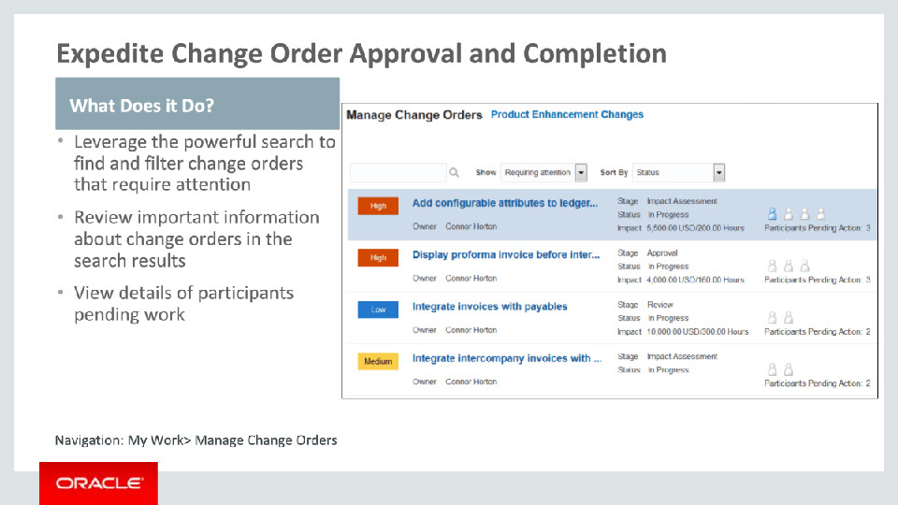
Slide notes
You can easily search for change orders requiring attention and view the latest information at a glance. You can sort the change orders based on your search criteria and view all the pertinent details of the change order in a user friendly layout.

The search results display change orders that meet the search criteria and facilitate quick action by focusing attention on critical information such as priority, total impact to cost and effort, and number of participants with pending work in each stage. You can also view details of the participants who have completed their work.

Notes

Slide 7 - Notify Change Order Participants of Key Events
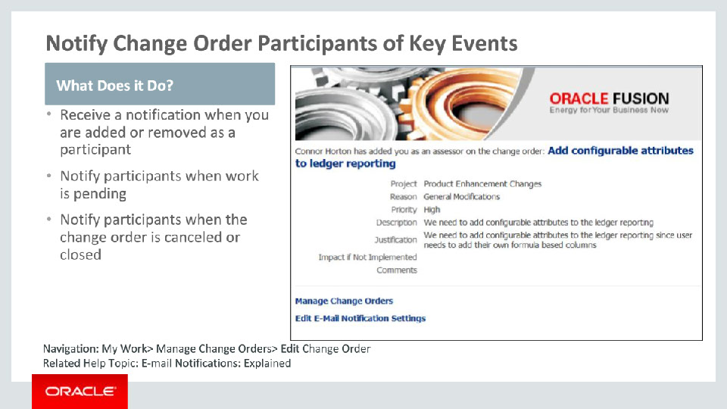
Slide notes
As a participant, you can choose to receive e-mail notifications for change orders when a change order moves to a stage where you have a role and are required to complete work. For example, if you are added as an impact assessor you receive an e-mail notification informing you about this. The notification helps you plan your work and expedite the completion of this task in time.

Participants also get notifications when the owner cancels the change order or closes the change order upon completion. Any time the owner removes you as a participant from a certain role, you will be notified of the change.

Notes

Slide 8 - Notify Change Order Participants of Key Events (Continued)
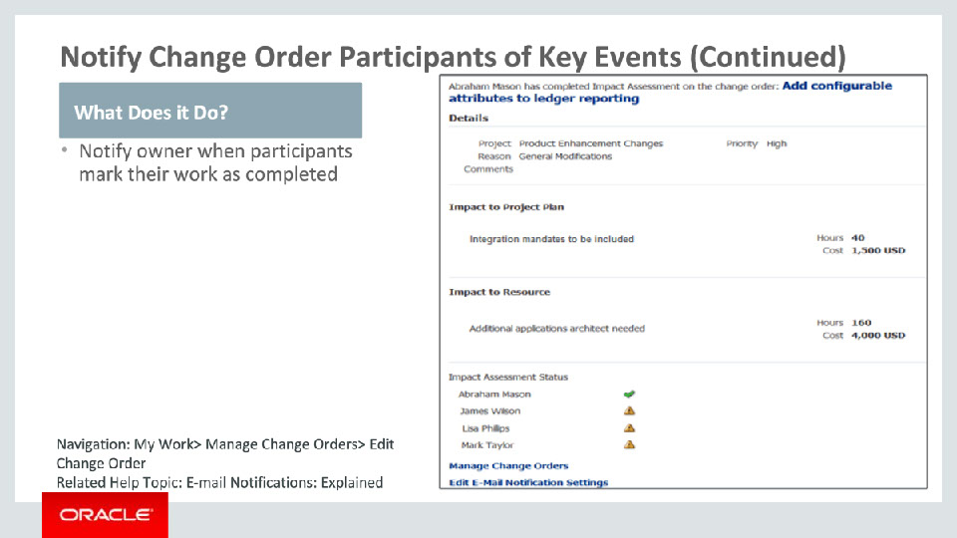
Slide notes
As an owner, you can choose to receive e-mail notifications for change orders when various participants complete their work on a change order. For example, after an approver approves or rejects a change order, the owner receives an e-mail notification with this information. Similarly, when an impact assessor enters the impact of a change order, the owner receives an e-mail notification containing the impact details entered by the assessor. The notification also includes the impact of all other assessors on the change order to help the owner decide the required action to move the change order to the next stage and towards completion.

Notes

Slide 9 - Collaborate on Project Change Orders Using Oracle Social Network
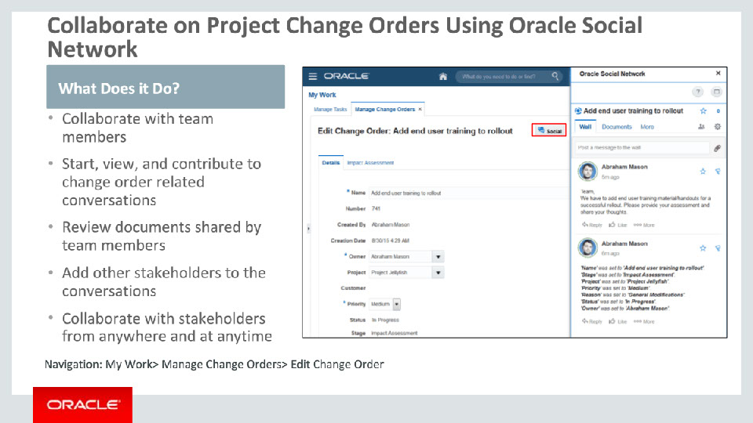
Slide notes
Project managers and team members can effectively collaborate with each other on change orders using Oracle Social Network. You can start, view, and contribute to change order conversations directly from the Edit Change Order page. You can easily review documents that team members make available and provide your feedback. For example, you can communicate concerns or issues with all team members using a conversation and review the artifacts shared by team members for those concerns.

Those who are not added to the project, such as project managers, executives and other stakeholders, can also be added to the conversations. You can collaborate with others on the change order at any time, from your desktop or mobile device using the Oracle Social Network.

Notes

Slide 10 - Analyze Project Change Orders Using Oracle Transactional Business Intelligence
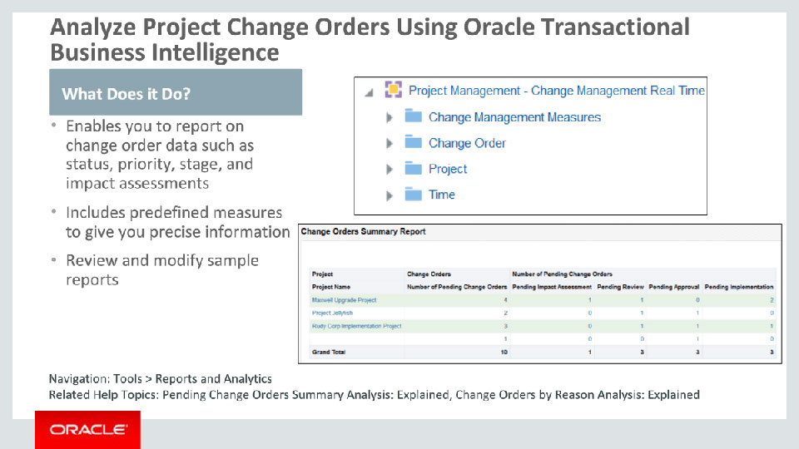
Slide notes
The Change Management Real Time subject area allows project managers, change order owners, creators, and assigned participants to evaluate, follow up, and keep track of change orders. For example, you can track the change orders that are pending for impact assessments, reviews, approvals, and implementations, grouped by project. We’ve included some predefined measures to give you precise information on change orders. For example, you can see the number of change orders that are closed, completed, or canceled in the last 30 days.
As seen in the first screen capture, you can open each folder to view the fields available to add to a report. For example, from the Change Order folder, you can add change order details such as owner, priority, stage, status, and impact to your report.
We’ve provided sample reports to highlight the various ways in which you might want to analyze your change order data. You can use the predefined reports or customize them to suit your specific needs.
Notes

Slide 11 - Efficiently Manage Change Orders
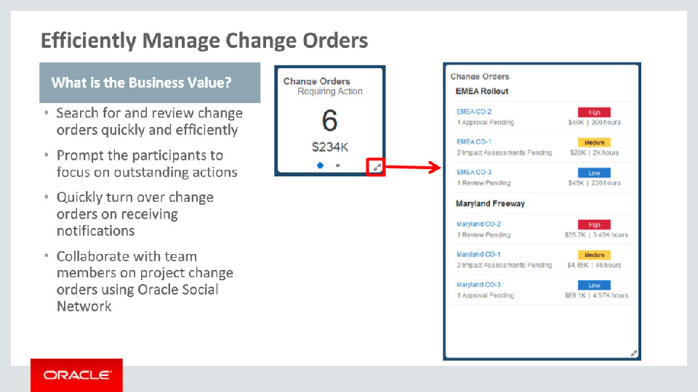
Slide notes
In summary, enhanced Manage Change Orders delivers business value to project managers and team members by providing efficient ways to manage change orders, their approvals, and implementation.
Participants get notified immediately when roles are assigned to them so that they can start working on them right away.
You will be able to track the progress on change orders as participants work on them. If anyone completes their work on a change order that you own, the owner is notified and help turn over the change orders quickly.
And, with Oracle Social Network you can:
• Collaborate with team members in real-time
• Share conversations with other people who are not part of the project team
• Share and review documents with different stakeholders by simply uploading the documents to the relevant conversation
• Start conversations for issues and gather consensus on resolutions with team members and interested parties
Notes

Slide 12 - Efficiently Manage Change Orders (Continued)
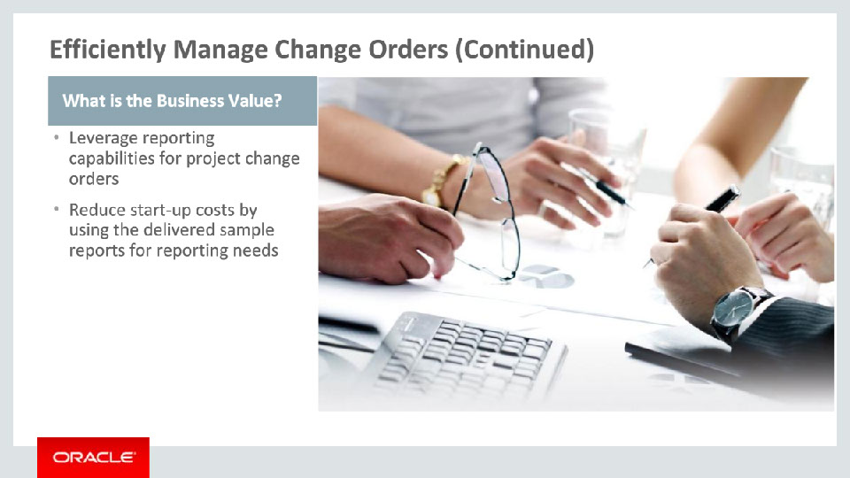
Slide notes
The business value is tremendous if you prefer to query data directly using a transaction reporting tool instead of the application regions. You can create and view your own analysis for project change orders. You can use the sample reports as delivered or speed up the implementation process by customizing the sample reports to suit specific needs.

Notes

Slide 15 - Summary of Enhancement Capabilities
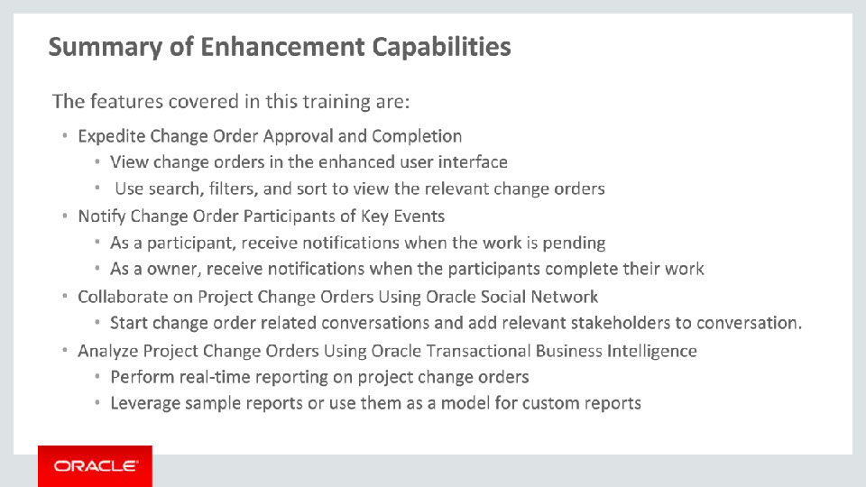
Slide notes
Here is a summary of the Release 11 enhancements that I talked about today:
First, manage your change orders in a modern and streamlined user interface. Use the intuitive filters and key information on the page to see the latest on each change order and search for specific change orders easily.
Second, use the new notifications to keep participants and owners informed of pending work so that necessary action can be taken by the stakeholder in a timely manner to expedite the approval and completion of the change requested.
Third, leverage Oracle Social Network to start conversations related to change orders and collaborate with the stakeholders accordingly. Once you start a conversation, you can add members, upload documents, and review them with other stake holders.
And finally, perform real time reporting on the project change orders using Oracle Transactional Business Intelligence. Leverage the sample reports as is or customize them specific to your needs.

Notes

Slide 16 - Implementation Advice
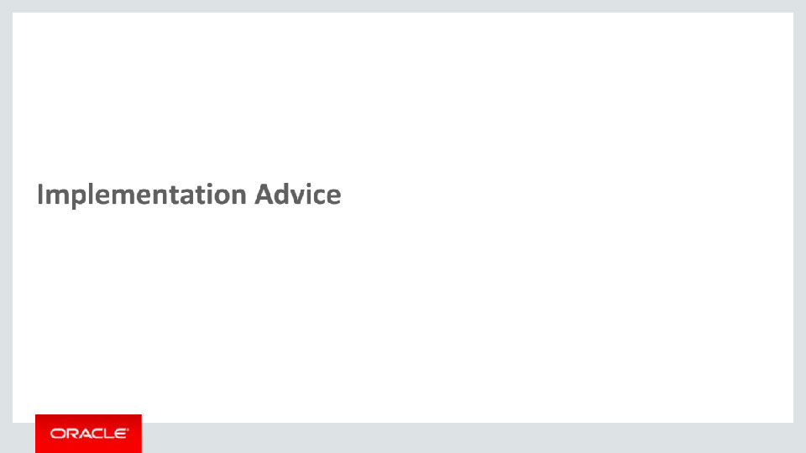
Slide notes
In the implementation advice section we will go through what you need to consider before enabling these features in your business, and what you need to know to set them up.

Notes

Slide 17 - Feature Impact Guidelines
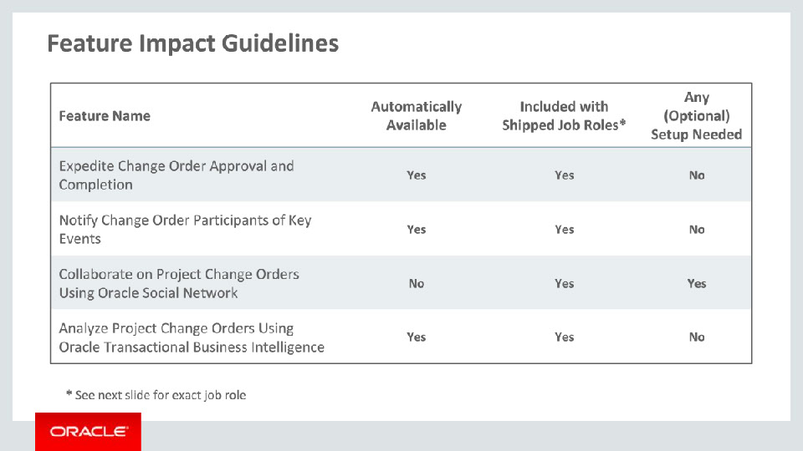
Slide notes
Three of the features covered in this training are automatically available after upgrade.
The social networking feature is not and has setup associated with it – setup specifies are covered later in this section.
All features can be accessed through existing shipped job roles.

Notes

Slide 18 - Setup Summary
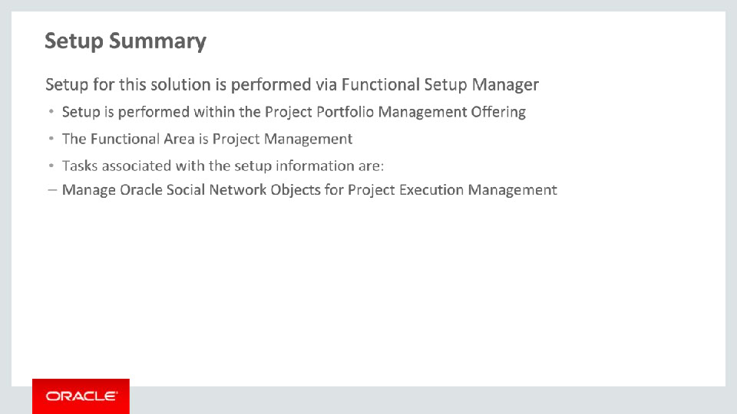
Slide notes
Before users can use Oracle Social Network for change orders, you as the administrator must perform some setup tasks.

As the administrator, you must enable the Project Change Order object for Oracle Social Network.

Notes

Slide 19 - Collaborate Using Oracle Social Network Setup Detail
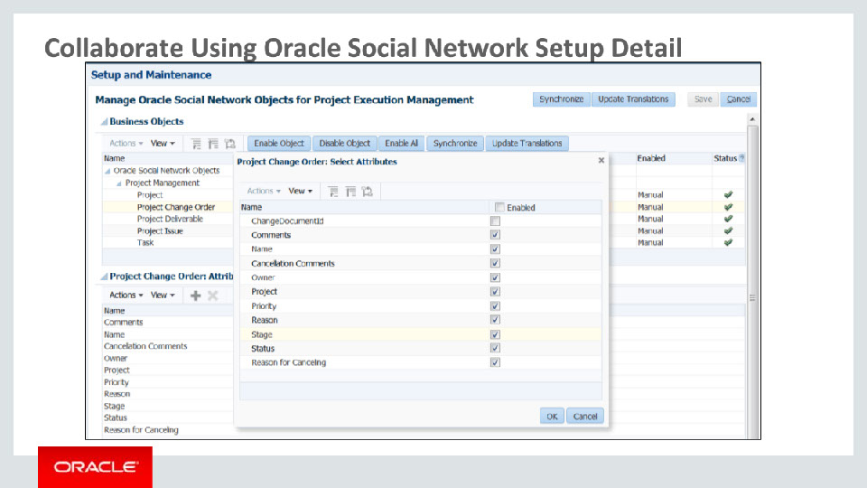
Slide notes
Before users can make individual change order records available to include in Oracle Social Network Conversations, you must enable the Project Change Order object. You can enable entire all or only specific attributes of the object. You can also decide whether new objects can be automatically shared in Oracle Social Network or whether they need to be manually shared.
To enable the attributes you want to make available to share, under Attributes, click the New button. A list of attributes for the Project Change Order, is displayed. Use the check box to enable or disable the attributes to suit your needs.
After you have enabled an object, users must share the object records they wish to collaborate on within Oracle Social Network.

Notes

Slide 20 - Job Roles
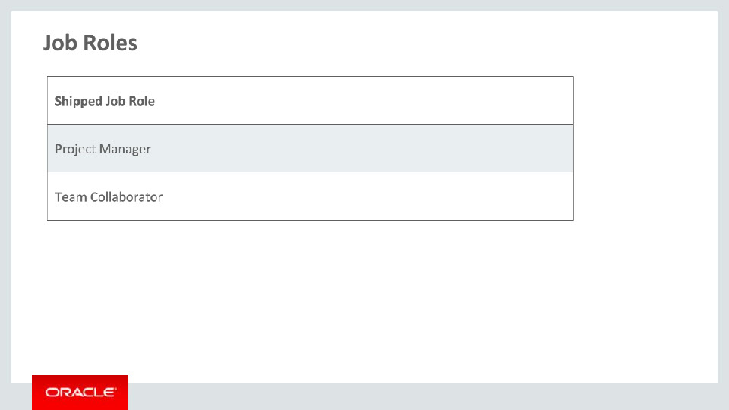
Slide notes
This table details the shipped job roles that will access the new capabilities covered in this training.

Notes

Slide 21 - Business Process Model Information
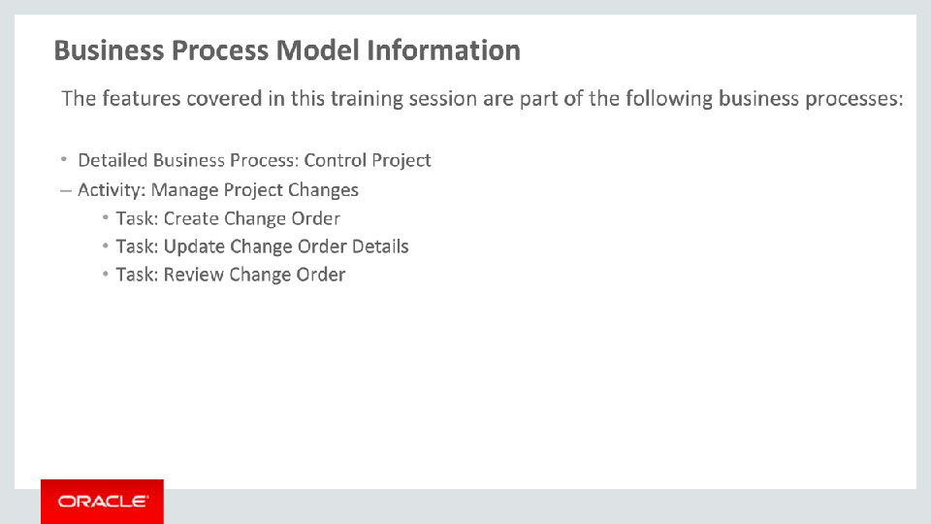
Slide notes
The business processes associated with the new capabilities covered in this training are detailed here.
The high level business process is Control Project with activity Manage Project Changes. There are three tasks involved: Create Change Order, Review Change Order, and Update Change Order Details.

Notes

Slide 22 - Related Reports & BI Analytic Information
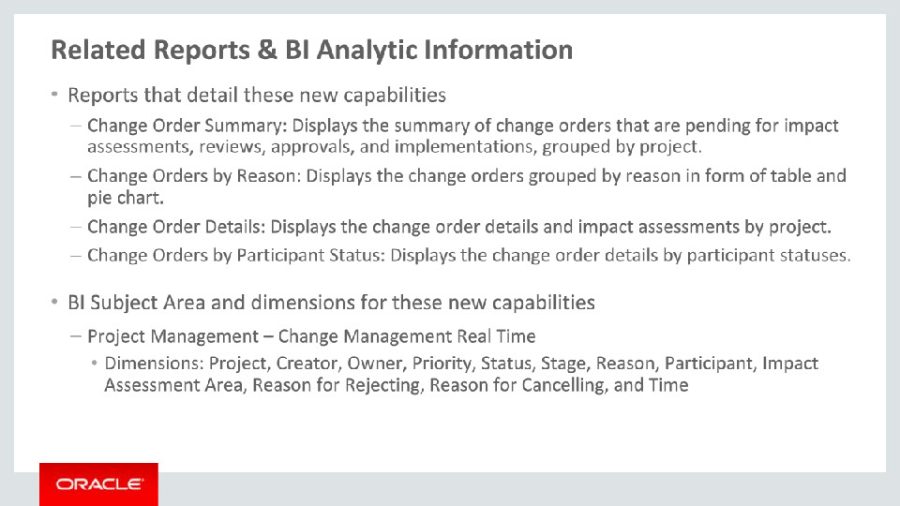
Slide notes
Listed on this page are the 4 sample reports for the Change Management Real Time Subject Area and the details of each sample report. You can also see the dimensions in the Change Management Real Time Subject Area. Take a few minutes to read through this slide.

This concludes this presentation, thank you for listening. You can easily pause and rewind any of these slides if you require additional time to take in the detail.

Notes

