Slide 3 - Oracle Project Portfolio Management Cloud Release 11
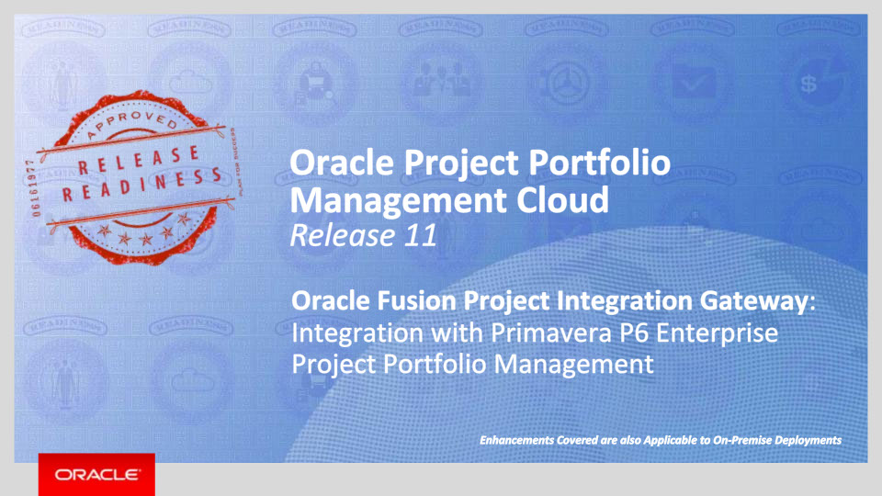
Slide notes
Hello, my name is Rupal. Welcome to training for Release 11. In this session we will talk about integration of Oracle Project Portfolio Management Cloud with P6 Enterprise Project Portfolio Management.

Notes

Slide 4 - Agenda
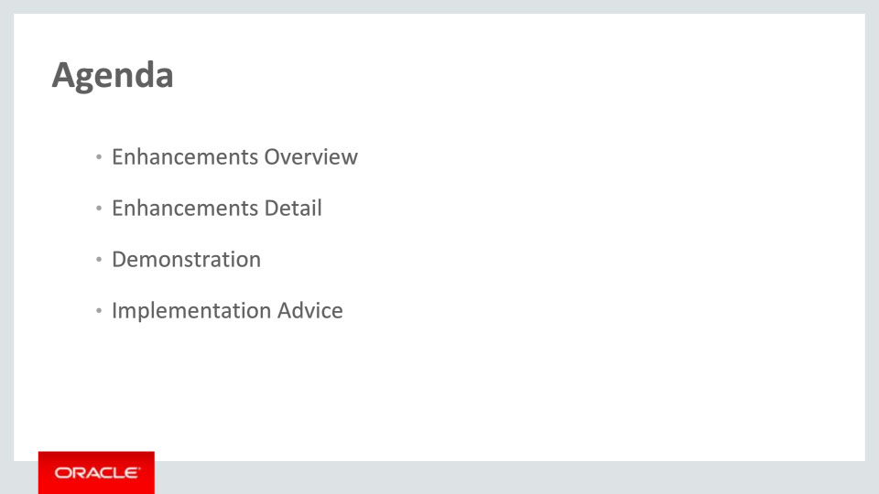
Slide notes
For the enhancements covered in this training, we’ll give an overview, followed by more detail to explain how you can use them, and what business value they bring.

Then we’ll walk you through a demonstration.

Next we’ll explain what you need to consider before enabling these features in your business, and what you need to know to set them up.

Notes

Slide 5 - Enhancements Overview
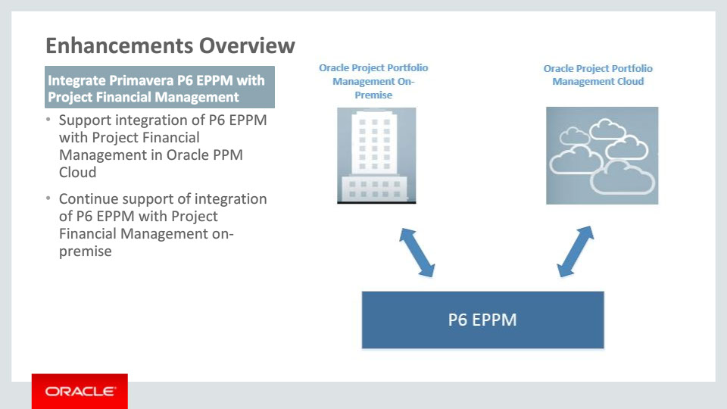
Slide notes
In this presentation, we will show you how to integrate Project Financial Management with Primavera P6 Enterprise Project Portfolio Management (P6 EPPM). The integration allows you to use Project Financial Management for financial purposes, such as accounting, billing, and executive reporting, and P6 EPPM for planning and managing projects on daily basis.
From this release, we are extending support to integrate P6 EPPM with Oracle Project Portfolio Management Cloud. Integrating P6 EPPM with Oracle Project Portfolio Management Cloud gives the same functional solution that is provided with the integration with on-premise Project Financial Management.
This presentation describes the functionality that is offered with the integration which is applicable to both on cloud and on premise implementations of Project Financial Management.

Notes

Slide 6 - Enhancements Overview
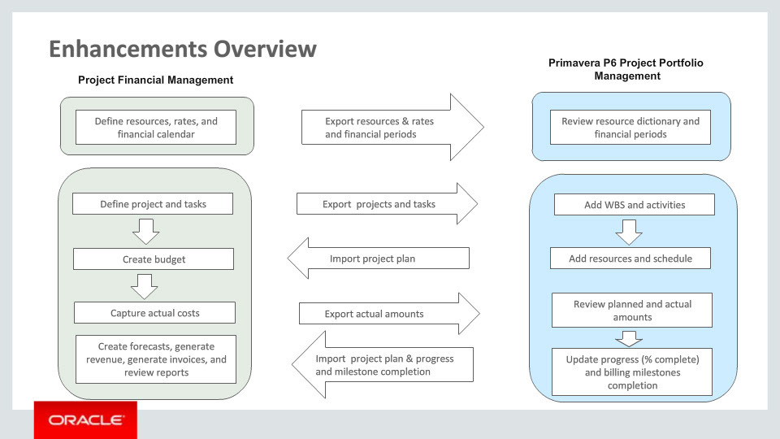
Slide notes
The integration begins by setting up the integration options between Project Financial Management and P6 EPPM. The project application administrator configures the integration and exports resources, resource rates, and financial periods to P6 EPPM as setup data. After the setup data is exported, you can create a project with a high level task structure and export the project and its tasks to P6 EPPM. In P6 EPPM, the project manager can break down the project further, assign resources and create the detailed project schedule. The project plan and the progress captured in P6 EPPM can be imported back to Project Financial Management. You can generate a budget based on the imported project plan and the project executive can review the budget for approval. You can capture cost and summarize actual amounts against the project plan, and the actual quantities and costs can be exported to P6 EPPM for comparing to planned amounts.
For contract billing projects, billing events can be exported to P6 EPPM and completed events can be imported back to Project Financial Management for billing purposes.

Notes

Slide 7 - Export Resources, Rates, and Financial Periods
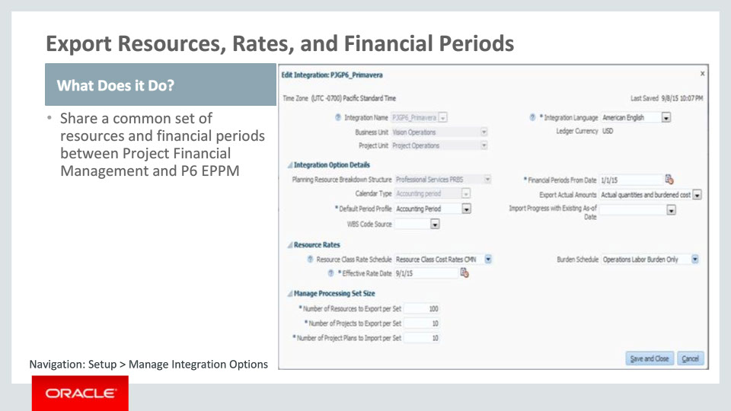
Slide notes
You begin the integration by setting up the integration option between Project Financial Management and P6 EPPM. From the Manage Integrations Options setup page, the project application administrator can do the setup for the integration.
Integration setup begins with selecting a business unit and a project unit for the integration. The business unit determines the ledger currency for the projects. The ledger currency is used to export actual costs and resource rates. P6 EPPM stores amounts in a single base currency across all projects.
The project unit plays a key role because it determines the planning resource breakdown structure that you can select to export resources to P6 EPPM. The planning resource breakdown structures are assigned to a project unit and cannot cross project units.
Selecting the planning resource breakdown structure is the most important part of setting up the integration setup data. It is the source of planning resources that will be exported to P6 EPPM. The resources exported to P6 EPPM will be part of the global resource dictionary and available for creating resource assignments on all integrated projects. In Project Financial Management, you must use this planning resource breakdown structure as the primary planning resource breakdown structure on all integrated projects.
In addition to exporting resources, you can select options for exporting cost rates associated with the resources. P6 EPPM maintains rates as part of the global dictionary for resources and roles.
The integration also provides the ability to export financial periods to P6 EPPM. This enables the integration to import the periodic planned quantity from P6 EPPM to Project Financial Management.
Notes

Slide 8 - Export Projects and Tasks
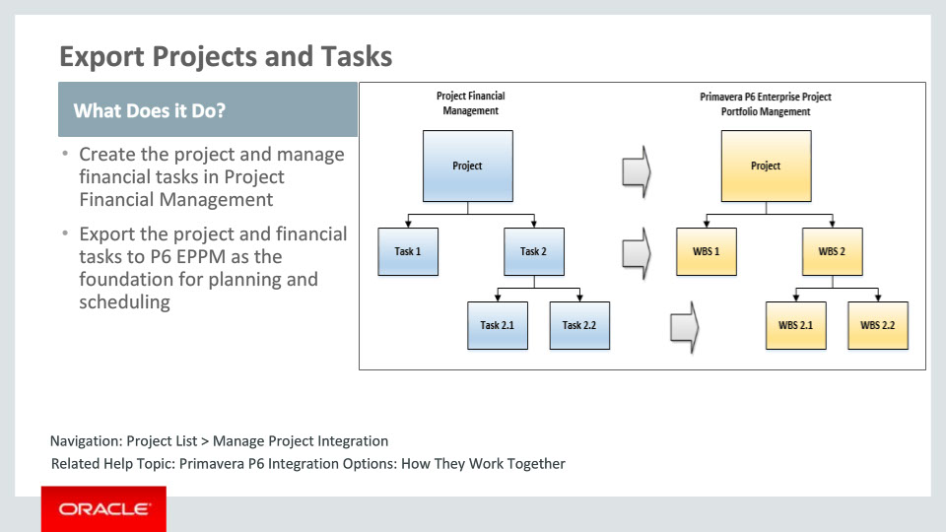
Slide notes
With Oracle Fusion Project Integration Gateway, you can share project financial and execution information throughout the life cycle and improve project transparency and maintain a single sourcesof truth for your project-planning needs.
The first step is to create the project and build out the financial tasks in Project Financial Management. Once the setup data is integrated, you can create one or more projects and create financial tasks under the projects. When you are ready, you can export the project and financial tasks to P6 EPPM to kick off detailed planning and scheduling.
In P6 EPPM, exported projects are added to an enterprise project structure node called Imported Projects. Each task becomes a WBS under the project.

Notes

Slide 9 - Plan Project in P6 EPPM
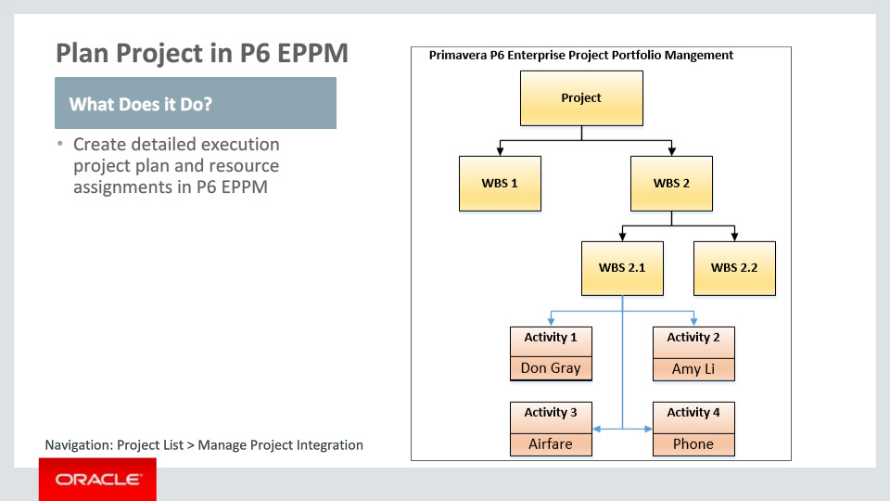
Slide notes
In P6 EPPM, the project manager can optionally break down the high level WBS nodes into more detailed execution oriented nodes, and plan out the project by adding activities and resource assignments. This enables the project manager to build out the project plan to the level of detail required, even if the detailed breakdown of the plan is not needed for financial purposes. The project manager uses the resources that were imported from Project Financial Management during the integration setup. You can also create new resources in P6 EPPM and assign them to tasks. However, these resources will be exclusive to P6 EPPM. All resource assignments created for these new resources , will be created against the generic resource classes when the assignments are imported back to Project Financial Management. These generic resource classes are Labor, Equipment, Material, and Financial Resources.

Notes

Slide 10 - Import Project Plan and Progress
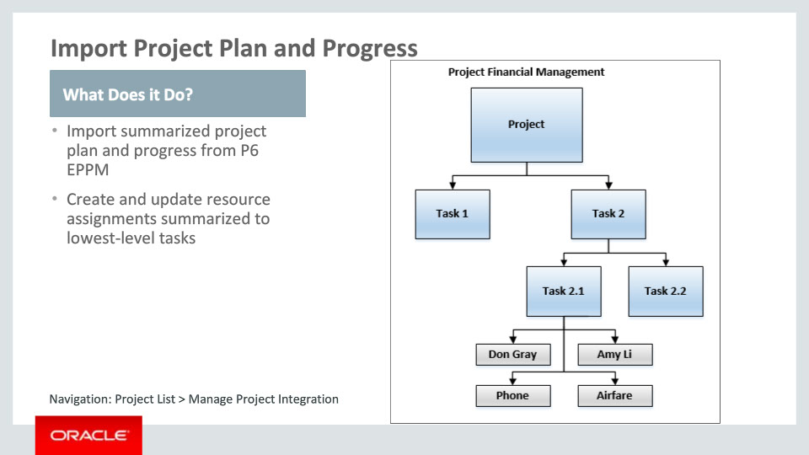
Slide notes
Once the project manager is satisfied with the plan, it is simply shared with the project accountant in Project Financial Management.
The project plan and progress information is imported into Project Financial Management and summarized at lowest-level financial task. You can baseline the project plan and generate the budget from the imported project plan.
The project plan import process captures and publishes progress in Project Financial Management. The published progress is then available throughout Project Financial Management for use in reporting, billing, revenue generation, and forecasting.

Notes

Slide 11 - Export Actual Amounts
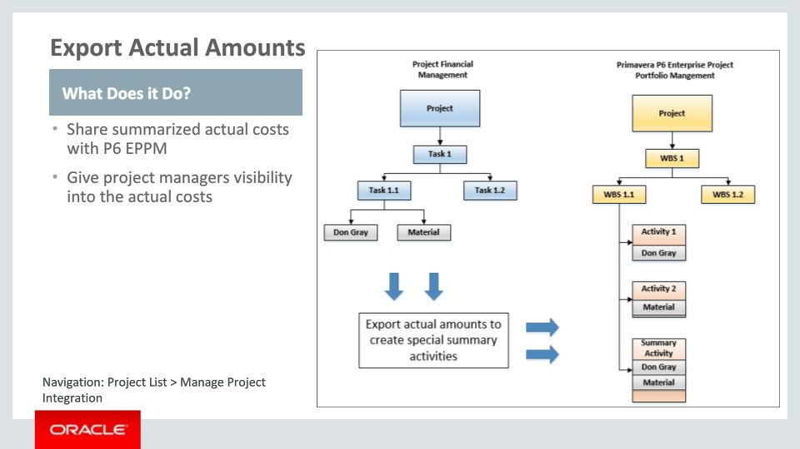
Slide notes
When costs are captured in Project Financial Management, they can be sent to P6 EPPM by initiating the Export Actual Hours process from the Manage Project Integrations page. The actual amounts are exported so that the project managers can compare them with the planned amounts in P6 EPPM. Exporting actual amounts sends the summarized costs to P6 EPPM by resource assignment at the lowest-level task. In P6 EPPM, the export process automatically creates a summary activity for each WBS that is integrated with a lowest-level task. Actual amounts are recorded against resources, roles, and expense categories for this summary activity. As planning in P6 EPPM can be much more detailed than in Project Financial Management, the export process cannot allocate actual amounts to the existing activities that hold the planned amounts.

Notes

Slide 12 - Export Billing Events
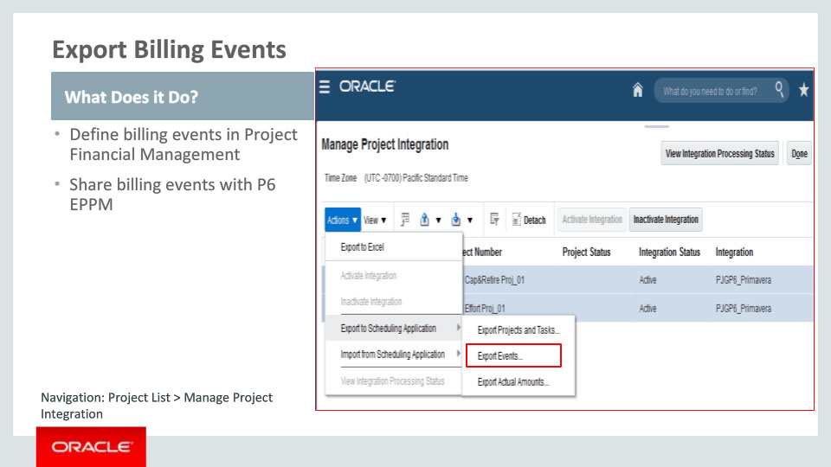
Slide notes
For contract-based projects, it is important to track billing events and mark them as complete to enable contract administrators to bill customers. The integration solution enables you to create billing events in Project Financial Management, track their progress and completion in P6 EPPM, and bring the completed events back for billing in Project Financial Management.

You can create billing events for contracts and associate them to project milestone tasks. To provide visibility of these billing events to the project manager, you export the billing events to P6 EPPM. These events become milestone activities in P6 EPPM.

Notes

Slide 13 - Import Event Completion
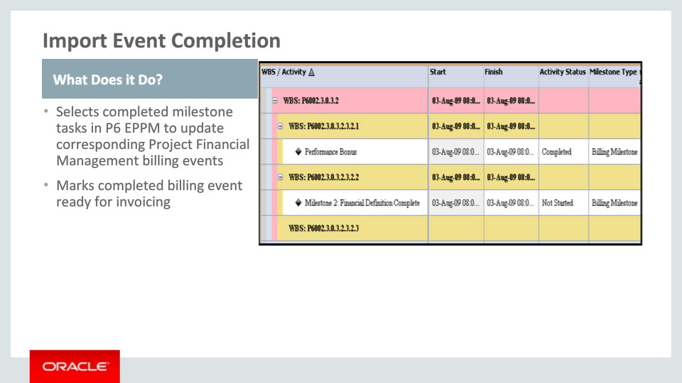
Slide notes
In P6 EPPM, the billing events are created as milestone activities. It provides visibility to the project manager that milestones will trigger billing, and need special focus. As the project is executed, the latest progress is collected and the project manager can record the actual finish date on the milestone task to mark it as complete. Once the milestone is marked as complete, you can send the billing event status to Project Financial Management. In Project Financial Management, the process picks up the completed milestone and populates the completion date on the linked billing event. The next time you run the process to generate invoices, the application includes the new billing event in the draft invoice.

Notes

Slide 14 - Integrate Primavera P6 EPPM with Project Financial Management
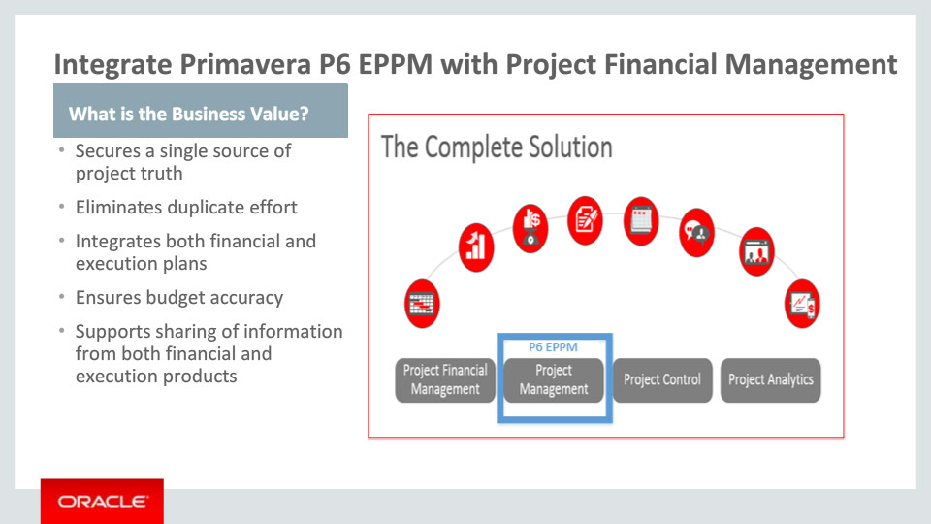
Slide notes
Oracle Fusion Project Integration Gateway brings you a fully integrated and automated solution between the world class financial project management from Oracle Fusion Project Portfolio Management and best in-class project execution from Primavera P6. With this integration, project financial and execution information is shared throughout the lifecycle, leading to project transparency and a single source of project truth.

Managing project plans in different applications without an integration requires you to manually keep both plans updated. This may result in delayed projects due to not having the most up-to-date information in both applications. With Oracle Fusion Project Integration Gateway, financial project management and project execution are seamlessly integrated and optimized into a single business process.

Project accountants and project managers often prefer to work at differing levels of detail, resulting in one of the parties having to manage their work outside the enterprise application. With this integrated solution, both the financial and the execution plans are supported and integrated, to satisfy the needs of both accountants and project managers.

Global resources and rates, defined in Project Financial Management, can be passed to P6 EPPM’s resource dictionary to support planning and estimating in P6 EPPM. Since the project accountants and project managers share a common set of rates, the chance of inaccuracies between the estimating and budgeting processes is eliminated. When the updated plan is sent to Project Financial Management, a budget is automatically generated at the level project accountants need to successfully manage costs while avoiding unnecessary detail.

As the project is executed, the latest progress and contract milestone status entered by the project team in P6 EPPM is used in Project Financial Management by the project financial team as input to the contract billing. Conversely, project accountants can send project updates and costs to P6 EPPM , so project managers get automatic visibility into the actual costs incurred for resources against the project plan.

To summarize, Oracle Fusion Project Integration Gateway supports a complete, streamlined and fully automated project lifecycle solution between Fusion Project Financial Management and Primavera P6 Enterprise Project Portfolio Management which supports functionality in both the products whilst reducing duplication of work.

Notes

Slide 21 - Summary of Enhancement Capabilities
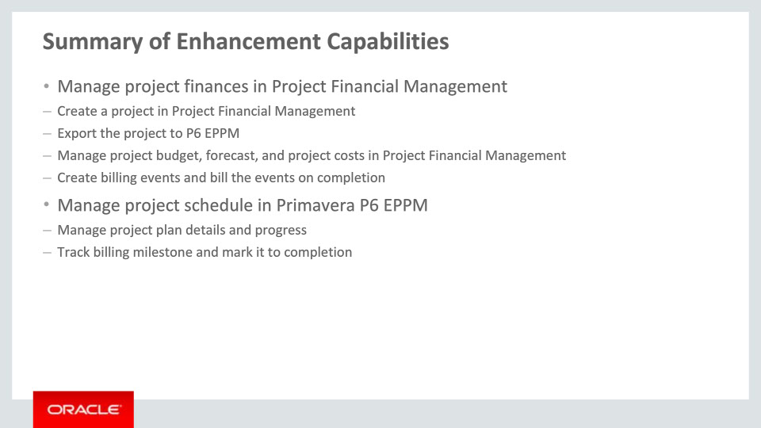
Slide notes
To summarize, the integration provides a robust solution where you can use Project Financial Management for financial purposes and P6 EPPM for scheduling purposes for the project.
You create a project in Project Financial Management. After adding financial tasks, you export the project and tasks to P6 EPPM. In P6 EPPM, the project manager can plan, capture progress, and manage the project on daily basis.
After planning is complete in P6 EPPM, the project manager can import the project plan back to Project Financial Management. The imported project plan can be used to generate the budget. The captured progress can be published and the published progress is available in Project Financial Management for reporting, billing, revenue generation, and forecasting.
For contract-based projects, you can use Project Financial Management to create the events and P6 EPPM to track the event completion. Once the event is marked complete and event completion is imported back to Project Financial Management, you can bill the event to customers.

Notes

Slide 22 - Implementation Advice
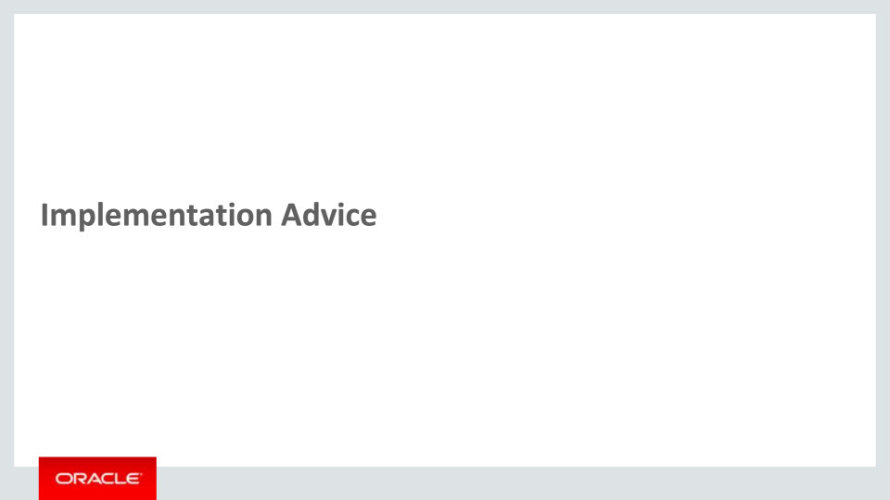
Slide notes
In this implementation advice section we will go through what you need to consider before enabling these features in your business, and what you need to know to set them up.

Notes

Slide 23 - Feature Impact Guidelines
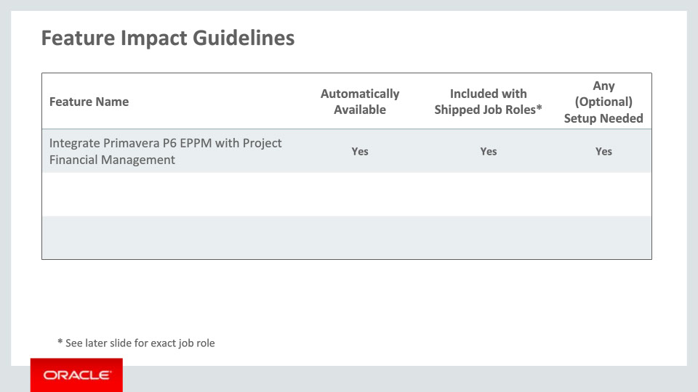
Slide notes
As you can see in the table, the feature shown here is available automatically, and included with the shipped job roles. The feature, Integrate Primavera P6 EPPM with Project Financial Management, needs some setup. We’ll get into the details later in this section.

Notes

Slide 24 - Setup Summary
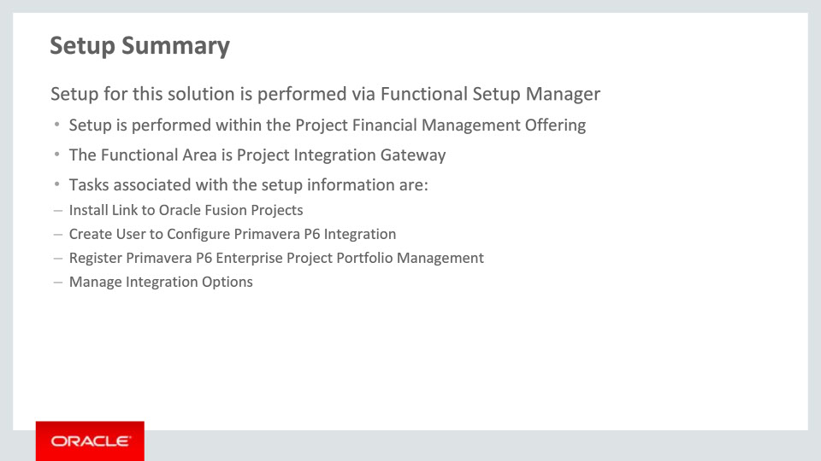
Slide notes
The setup for managing Project Financial Management and Primavera P6 integration is achieved by completing setup tasks within the Project Financial Management offering and under the Project Integration Gateway functional area.
The Install Link to Oracle Fusion Projects is a setup step that is for information purposes to indicate to the user that the link to Project Financial Management needs to be setup in Primavera P6 Enterprise Project Portfolio Management.
Setup link Create User to Configure Primavera P6 Integration takes you to Oracle Identity Management where you can create a new user for Oracle Fusion applications. This user should be shared with the Primavera P6 administrator for him to register the user in the Primavera P6 application. This user will be used by Primavera P6 EPPM when the Project Financial Management web services are called to send data back.

Notes

Slide 25 - Register Primavera P6 Enterprise Project Portfolio Management Setup Detail
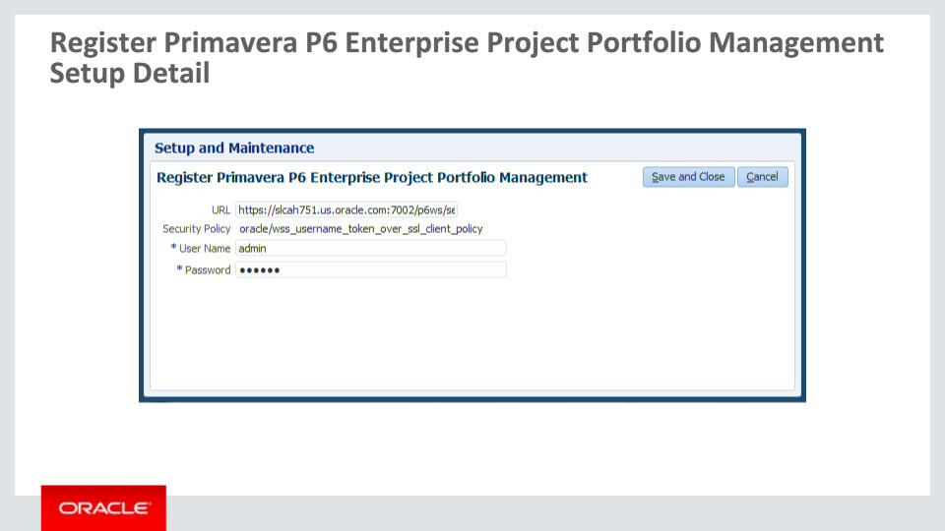
Slide notes
Register the Primavera P6 URL using the setup page Register Primavera P6 Enterprise Project Portfolio Management. Also specify the Primavera P6 Enterprise Project Portfolio Management user name and password which will be sent when exporting data from Project Financial Management to Primavera P6. This user name and password provides access to the Primavera P6 web services.

Notes

Slide 26 - Manage Integration Options Setup Detail
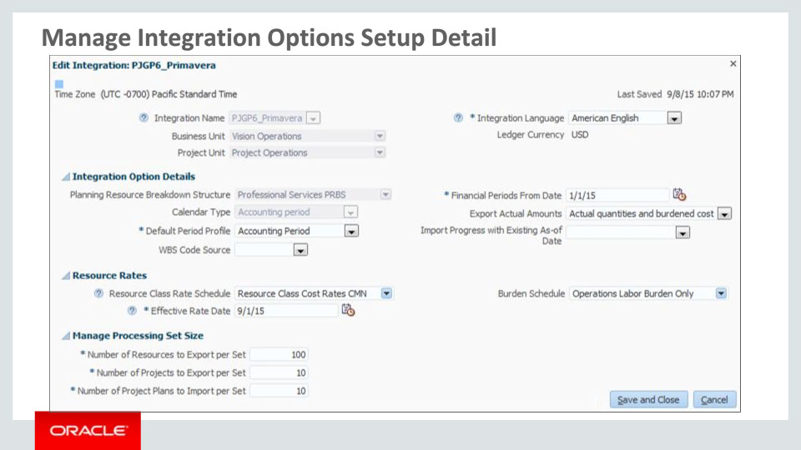
Slide notes
Project integration options defined in the Manage Integration Options user interface determine how Project Financial Management interacts with P6 EPPM.
On the Manage Integration Options page, you begin with defining the integration definition information. This includes the integration name, business unit, project unit, and the integration language. Select the business unit that owns the projects to be integrated with P6 EPPM. The ledger currency for the business unit is displayed on the page and becomes the currency in which currency amounts are exported to and imported from P6 EPPM. Select the project unit that owns the projects to be integrated with P6 EPPM.
Select the language for the integration. Any translated text is exported to and imported from P6 EPPM in this language.
Next, you select the planning resource breakdown structure which is the source for the resources that will be exported. Select a planning resource breakdown structure that is owned by the selected project unit and is centrally controlled. All integrated projects must use this planning resource breakdown structure as the primary planning resource breakdown structure.
In the Calendar Type field, select either the accounting calendar or the project accounting calendar. Periods from the selected calendar are exported to P6 EPPM and are used for all planning purpose. All integrated projects import planned amounts and export actual amounts for periods in this calendar.
In the Resource Rates details region, optionally specify a resource class rate schedule to be used to calculate rates when actual rates are not found otherwise. Specify a burden schedule to send burdened rates instead of raw cost rates to P6 EPPM.
Note: After you run integration processing for a business unit and project unit combination, you cannot change the project resource breakdown structure for the integration.
Notes

Slide 27 - Job Roles
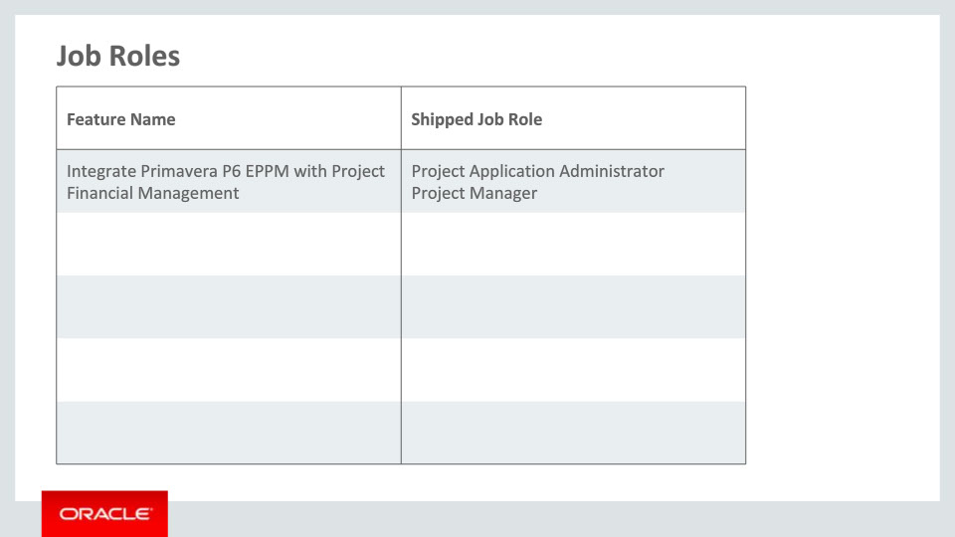
Slide notes
This table details the shipped job roles that will access the new capabilities covered in this training.

Notes

Slide 28 - Business Process Model Information
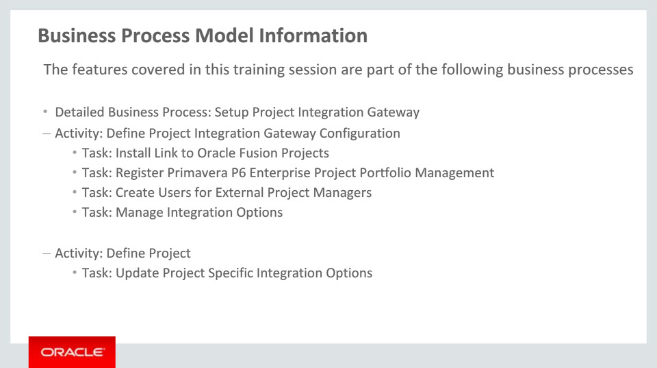
Slide notes
The business processes associated with the capabilities covered in this training are detailed here. The first detailed business process is Setup Project Integration Gateway.

Notes

Slide 29 - Business Process Model Information (Continued)
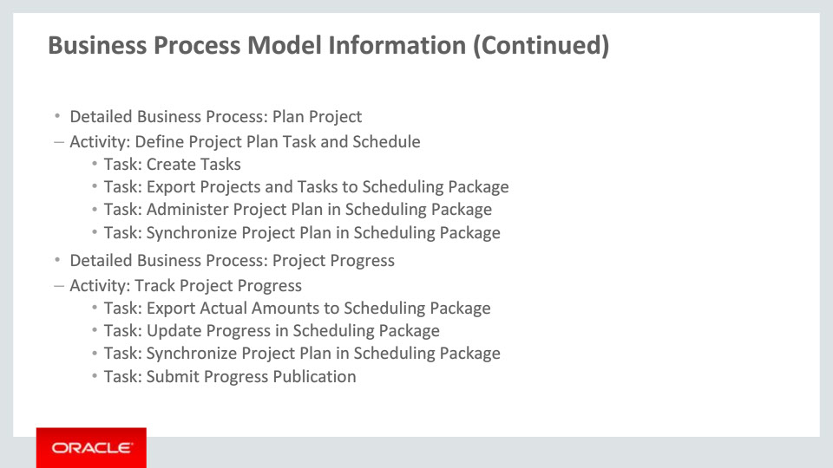
Slide notes
The next two detailed business processes are Plan Project and Project Progress.

Notes

Slide 30 - Business Process Model Information (Continued)
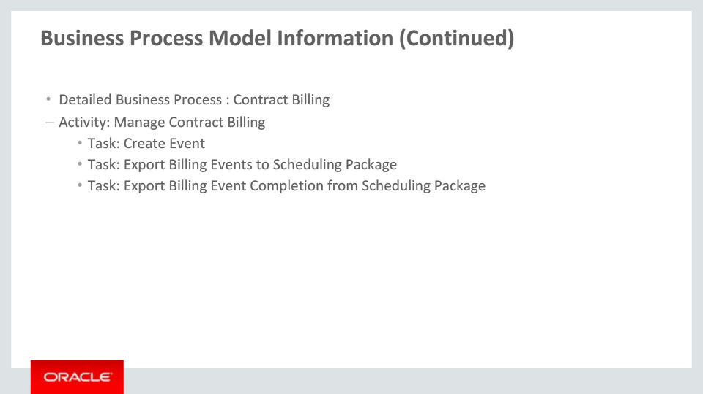
Slide notes
The last detailed business process is Contract Billing.

This concludes this presentation, thank you for listening. You can easily pause and rewind any of these slides if you require additional time to take in the detail.

Notes

