Slide 3 - Oracle Project Portfolio Management Cloud Release 11
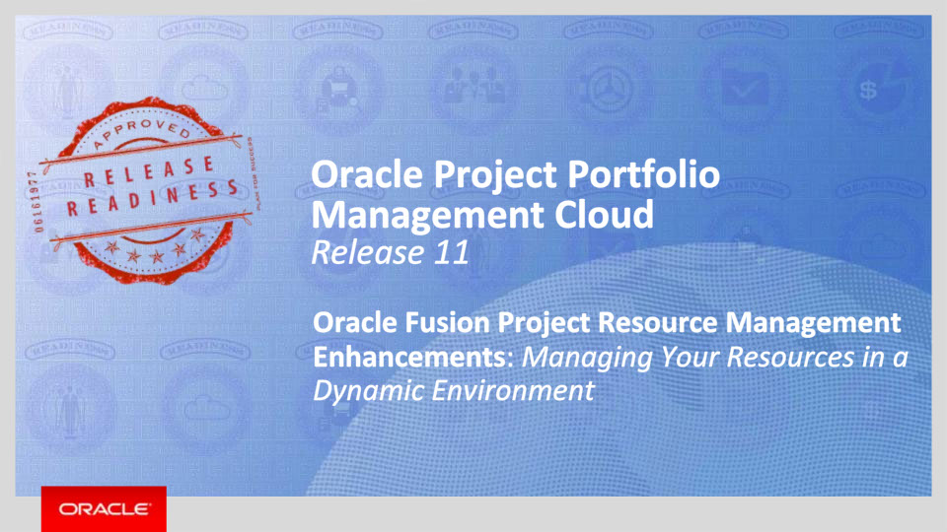
Slide notes
Hello, my name is Vicki. Welcome to the Release 11 Training for Oracle Applications Cloud Project Resource Management Enhancements. In this session we’ll cover the enhancements we have made in this release to help you manage your resources in a dynamic environment.

Notes

Slide 4 - Agenda

Slide notes
For the enhancements covered in this training, we’ll give an overview, followed by more detail to explain how you can use them, and what business value they bring.

Then we’ll walk you through a demonstration of a few key features.

Next we’ll explain what you need to consider before enabling these features in your business, and what you need to know to set them up.

Notes

Slide 5 - Enhancements Overview

Slide notes
In this presentation we will show you how the new features in Release 11 help your resource and project managers manage resources in a dynamic project environment.
Let’s start with a brief overview of the features that are part of this release.
Resource and project managers can plan for and reserve labor resources early in the project planning lifecycle. When the time is right, the resource can be confirmed to the project and begin work.
Project managers who manage both projects and resources can confirm and maintain resource assignments on projects without requiring approval from a resource manager.
When searching for and evaluating candidates to fulfill a project resource request, resource managers can review and filter on resource travel preferences to ensure the desires of the resources are considered.
Once assignments are underway, resource managers can monitor and maintain resource assignments that are ending soon on behalf of any resource pool owner.
Project managers can designate a default staffing owner on their project. This staffing owner is responsible for searching for and evaluating labor resources to fulfill open resource requests for the project and is automatically added to all resource requests for the project. Project managers can also plan for named resources in the project plan and generate project resource requests for these specific resources.
There are also many enhanced usability features. This includes the ability to adjust a resource’s hours per day on an existing confirmed assignment. Resource managers are also informed when a resource's assigned hours exceed the resource's capacity hours during assignment reservation, confirmation, or assignment schedule adjustment. When evaluating suitable candidates for a request, resource managers can immediately focus in on the top 5 scoring candidates and compare key attributes.

Release 11 has enhanced workflow that allows the ability to configure resource proposal workflow rules that meet an organization’s business process. In addition, resources now receive workflow notifications when they have been assigned to a project.

Notes

Slide 6 - Enhancements Overview

Slide notes
Resource managers can track resource and resource pool utilization through the entry of date ranges for resource pool memberships.
The maintenance of project enterprise resources have been enhanced. It is now possible to track the dates for which each project enterprise labor resource is active and available for project assignments. Other enhancements include a new a web service to read project enterprise resource information, the ability to update project enterprise resource information using file-based data import, and an option to update cost rates of resources who are employees or contingent workers based on financial rates logic.
When resources enter, review, and cancel absences in Oracle Fusion Absence Management the same information is reflected in their schedules and available capacity in Oracle Fusion Project Portfolio Management.
Finally, project resource assignments can be created, viewed, and updated in other applications using web services or a file-based data loader.
Notes

Slide 7 - Reserve Resources for Project Assignments
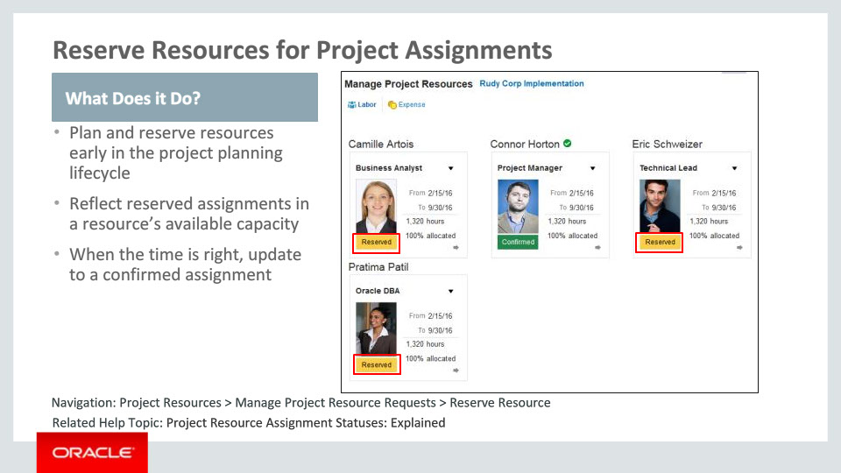
Slide notes
Resource managers and project managers can plan for and reserve project resources early in the project planning process. The reserved status on an assignment indicates an agreement between a resource manager and project manager that specific resources are soft-booked on the project. Resources’ available capacity will take into account the reserved assignments. These reserved assignments will show in the resource’s schedule. Resource managers or project managers can confirm the resource to the project when project planning is finalized and work is ready to start.

Notes

Slide 8 - Enable Project Managers to Confirm Resource Assignments
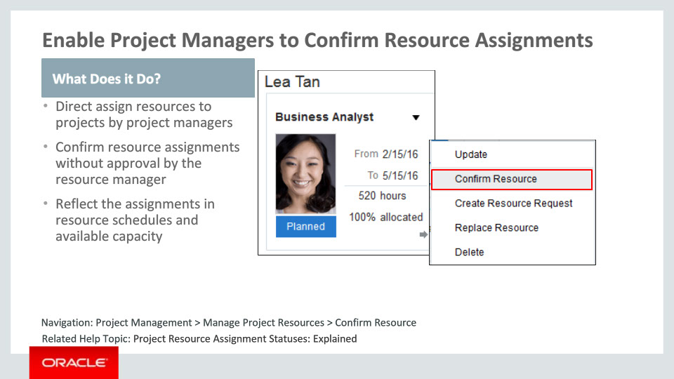
Slide notes
Project managers who manage both projects and resources can select and assign resources to projects without requiring resource manager approval. This allows project managers to quickly staff a project with resources that are directly managed by the project manager. Resource utilization is accurately reflected in reports and on the Resource Manager Dashboard. Resource assignments that a project manager creates are included in resource available capacity calculations. As project needs change, project managers can quickly change these assignments. The latest project assignment schedule is reflected on the resource’s schedule.

Notes

Slide 9 - Consider Resource Travel Preferences
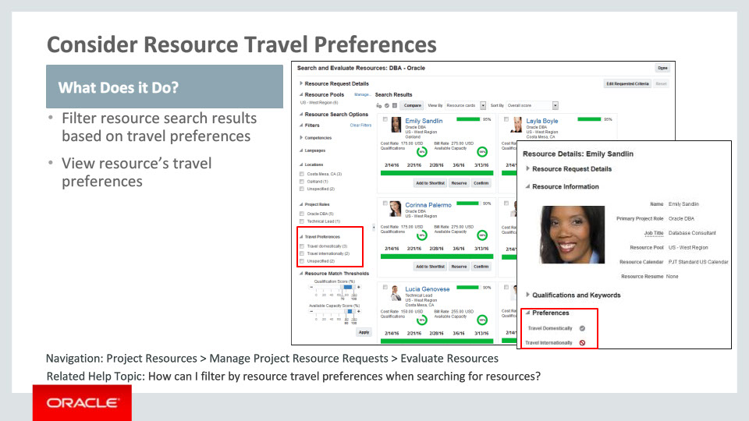
Slide notes
When searching for and evaluating candidates to fulfill a project resource request, resource managers can view the results based on the travel preferences of the resources. Resource travel preferences are in the worker portrait in Oracle Fusion Human Capital Management, or HCM, and are used to filter resources based on whether or not they want to travel for project assignments. If the resource has not declared any travel preferences, they will be grouped in a filter category called unspecified.

Notes

Slide 10 - Monitor Resource Assignments Ending Soon by Pool Owner
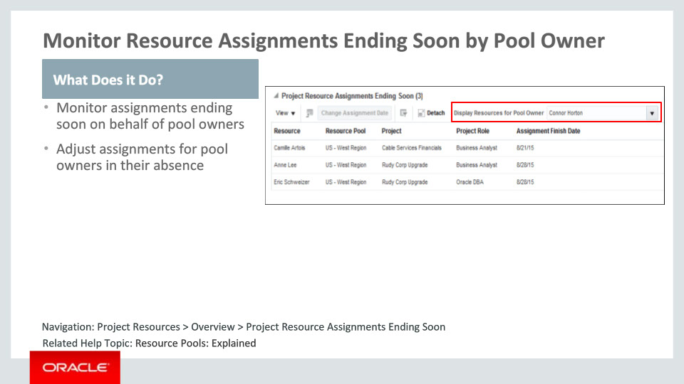
Slide notes
Resource managers can monitor resource assignments ending in the next 14 days on behalf of other resource pool owners. This enables resource managers to assist the pool owner in assignment maintenance when they are not available.

Notes

Slide 11 - Assign a Default Staffing Owner to a Project
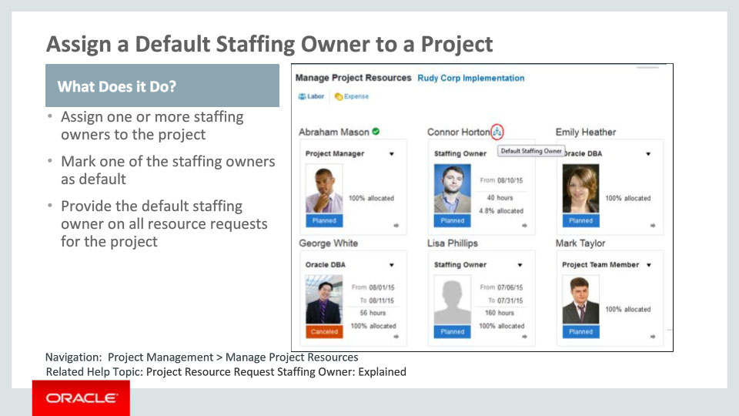
Slide notes
Project managers can specify one or more staffing owners on a project. The first staffing owner added on the project is marked as the default staffing owner. This can be changed at any point. All the resource requests submitted from this project will be assigned to the resource manager designated as the project's default staffing owner. The project manager can change the staffing owner on a request before it is submitted.

Notes

Slide 12 - Generate Requests for Specific Resources
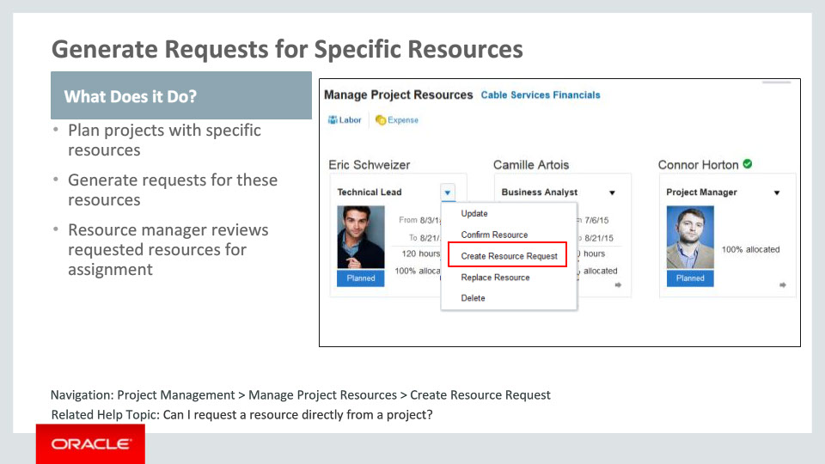
Slide notes
Project managers can plan project resources by specifying the desired resource names and allocation details, and generate requests for those specific resources using the planning data without leaving the Manage Project Resources page. A resource manager who receives a request for a specific resource can quickly evaluate the resource’s suitability and approve the resource for assignment to the project without further action from the project manager.

Notes

Slide 13 - Usability Enhancements for Project Resource Management
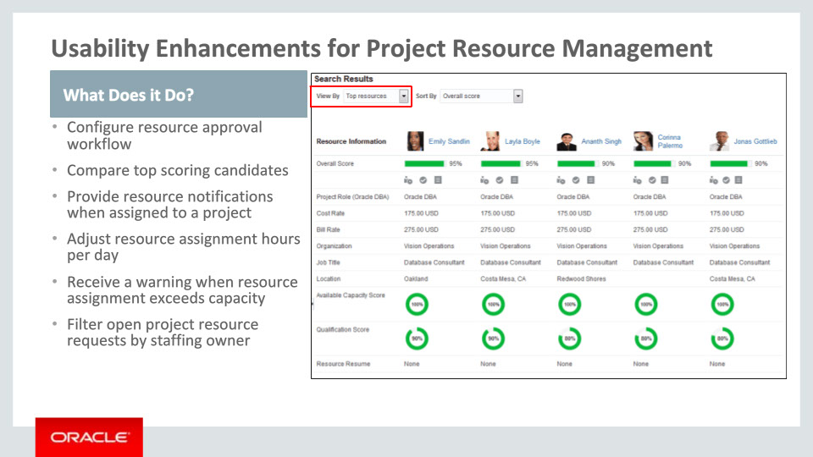
Slide notes
There are several new features in Oracle Fusion Project Resource Management that enhance usability for project and resource managers.
Workflow has been enhanced to allow project application administrators the ability to configure the workflow participants that approve a resource for an assignment and receive FYI notifications about the resource proposal and approval. In addition, resources are notified when they are reserved or confirmed for a project assignment.
When evaluating resources for a request, resource managers can immediately focus in on the top five scoring candidates based on the requested criteria. They can compare various attributes about these resources and assign the best fit. This can be their default view when they search for resources.
Project managers can adjust the hours per day a resource is assigned on a project and submit the changes for approval by the resource manager.
Resource managers can adjust the hours per day for single or multiple resource assignments and have the option to submit for approval by the project manager or make the updates without any further action required by the project manager.
Resource managers are notified if a resource’s assigned hours exceed the resource’s capacity hours when the resource is reserved or confirmed on a project or the resource assignment schedule is updated.
On the resource manager’s dashboard, resource managers have the option to filter open project resource requests by staffing owner. This provides a more focused view of requests that are owned by the resource manager.
Notes

Slide 14 - Activate Resource Pool Memberships on Specific Dates
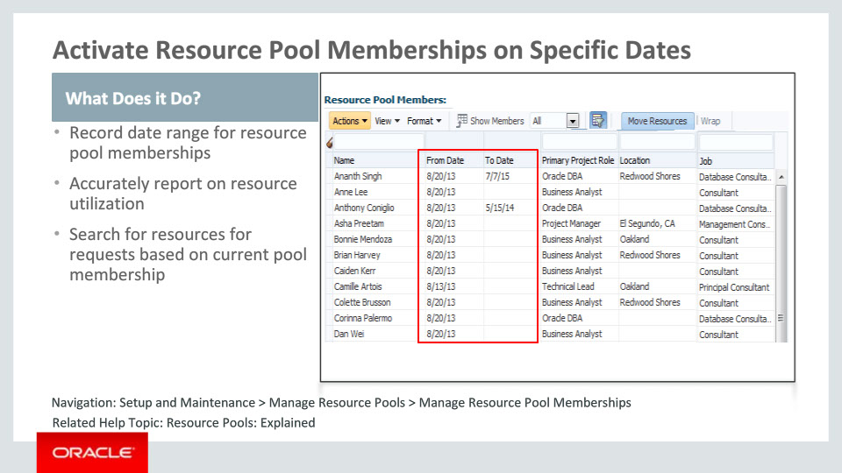
Slide notes
Application administrators can add resources to a resource pool and specify the date range the resource will be part of the pool. Resource pool memberships will always have a start date assigned to the membership, and can also have an end date. A resource can belong to multiple resource pools for non-overlapping date ranges. The membership dates must always be within the resource’s active dates as a project enterprise resource.
Utilization for a resource pool will take into consideration the dates the resource is part of the pool to report that pool's utilization.
When searching for and evaluating resources from specific pools for a request, only those resources that are members of those pools as of the requested start date will be considered.

Notes

Slide 15 - Track Active Dates for Project Enterprise Resources
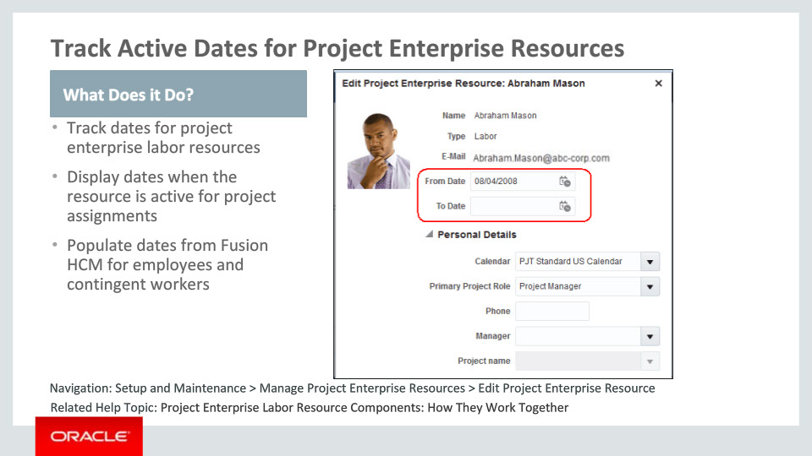
Slide notes
Project application administrators can now track the active dates for a project enterprise labor resource. A resource can only be assigned on a project between these dates. Resources that are enabled for staffing and utilization tracking should have their resource pool membership set within these dates. Whenever a resource is created based on an HCM person, the project enterprise resource from date is set to the resource’s hire date if the resource is an employee. If the resource is a contingent worker, the from date is set to the resource’s placement date.
When a resource is terminated, the project enterprise resource to date is updated based on the termination date in Fusion HCM. The to date is updated by the Maintain Project Enterprise Labor Resources process. These dates can be overwritten based on the resource’s project assignment eligibility.

Notes

Slide 16 - Maintain Project Enterprise Resources
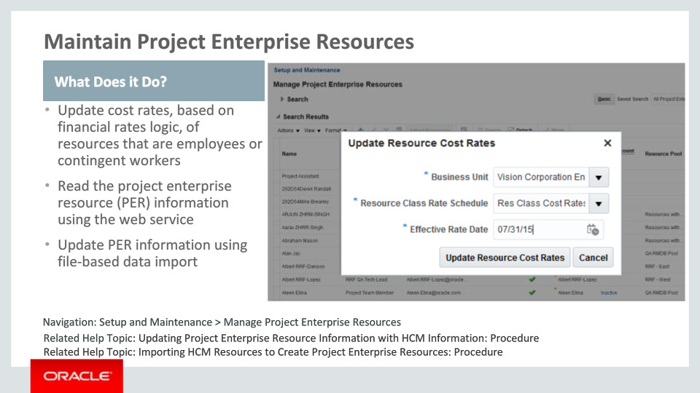
Slide notes
Project application administrators can update the cost rates of all the resources belonging to a business unit using a rate schedule defined in project financial management as of a specified effective date. A new service capability allows integrators to retrieve information about all the project enterprise resources to easily integrate with other applications. Integrators and project application administrators can also update the information about a large number of existing project enterprise resources using file-based data import capabilities. The enhancement allows the uploading of a single file containing new resources as well as updates to the existing resources without having to specify which ones are updates and which ones are new.

Notes

Slide 17 - Provide Single Entry Source for Absence Management Events
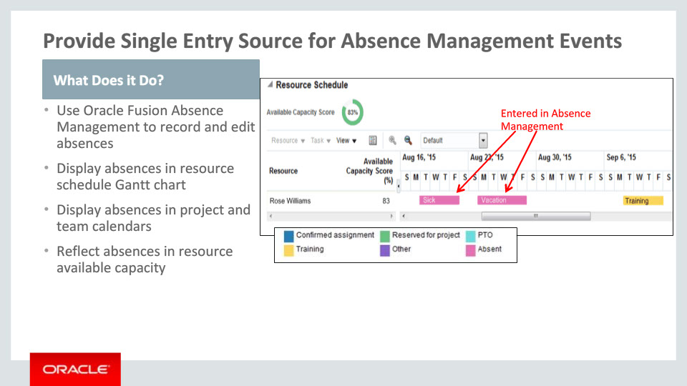
Slide notes
In Release 11, we have the ability to use the information that is reported in Oracle Fusion Absence Management and share it with Oracle Fusion Project Resource Management and Project Management. This means that there can be a single entry source for absences in Oracle Fusion. Absences that are created and modified in Oracle Fusion Absence Management can be shown in the resource schedule, as well as the project and team member calendars. The absences are considered when calculating a resource’s availability. For example, if a resource has entered their upcoming summer vacation, those hours will not be considered in their available capacity for scheduling.

Notes

Slide 18 - Create and Update Assignments with a File-Based Data Loader
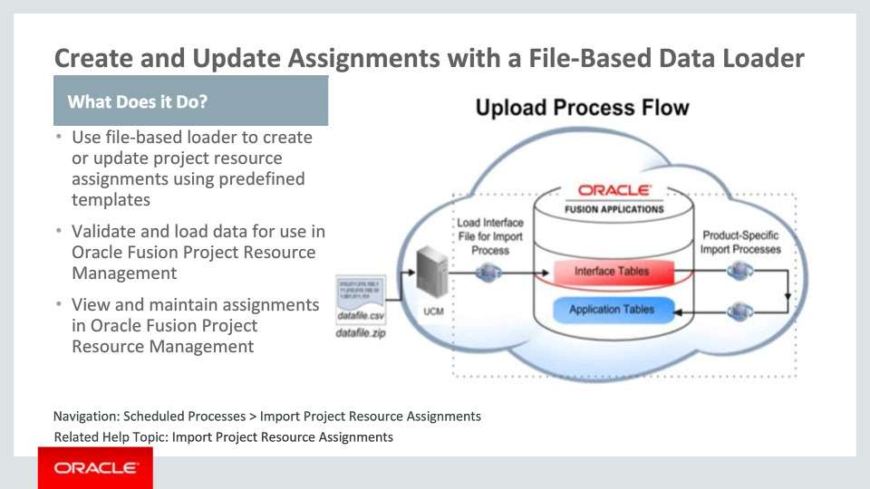
Slide notes
The file-based loader brings data from external applications to Oracle Fusion Project Resource Management. Initial data creation and ongoing updates are supported.
The import process creates assignments that can be viewed and reported on by the resource manager. Project resource assignments can be created in another system while the resource utilization can be tracked in Oracle Fusion Project Resource Management. This allows the customer to maintain their current infrastructure and still get the feature benefits in Oracle Fusion Project Resource Management.
The Project Application Administrator job role has the duty roles required to perform the Project Resource Management Resource Assignment Load and Import process.

Notes

Slide 19 - Create, Update, and View Assignments with Web Services
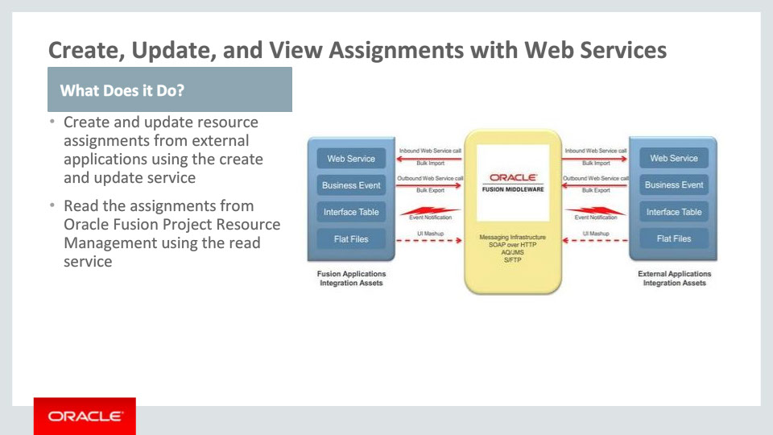
Slide notes
Oracle Fusion Applications provide web services as one of many mechanisms to integrate with and extend Oracle Fusion Applications. We are introducing Resource Assignment web services in this release. The Resource Assignment web service allows you to perform create and update operations on the resource assignment. This will allow assignments to be created and updated in Oracle Fusion Project Resource Management. It also allows the read operation that will read the resource assignment record from Project Resource Management.
Project resource assignments that originate in external applications can be created and maintained in Oracle Fusion Project Resource Management through services. This includes the ability to update reserved assignments to confirmed status. The service can also be used to bring in legacy data from other applications into Project Resource Management.

Notes

Slide 20 - Managing Your Resources in a Dynamic Environment

Slide notes
In summary, Oracle Fusion Project Resource Management delivers business value to resource managers and project managers by providing flexible, efficient features to manage their resources during project planning and project execution.
Resource managers and project managers can plan and reserve project resources early in the planning process and easily manage assignment confirmations when project details are firm.
Project managers with appropriate authority can efficiently staff their projects without needing to go through additional approvals. When project managers require resource manager approval, they can clearly communicate their desire for specific resources.
Project managers can operate more efficiently by including the project’s designated staffing owner as the default staffing owner on the project. This ensures all the resource requests are automatically assigned to the right staffing owner without requiring a project manager to manually assign a staffing owner each time a resource request is submitted for the project.
Resource desires for travel are shared with resource managers to ensure resource wishes are considered. Immediately honing in on top resources ensures the resource manager can efficiently focus on the best resources for a particular request.
Workflow routing that fits the unique needs of the organization ensures that those that need to participate in the staffing process are included at the right time.
Notes

Slide 21 - Managing Your Resources in a Dynamic Environment

Slide notes
Resource managers can create resource pool memberships for specific date ranges. The date ranges will be taken into consideration during resource search and also when reporting resource pool utilization.
Project application administrators can maintain project enterprise resources more effectively by using additional capabilities provided in this release such as update project enterprise resource information using file-based data import and export project enterprise resource information using web services.
Project application administrators can import bulk resource assignments using the file-based resource assignment loaders. Assignments can also be brought into Fusion using the Resource Assignment web service. This allows bringing in legacy data, as well as supporting the use of existing applications while providing new capabilities within Oracle Fusion Project Resource Management.
And finally, leveraging absence data that is already tracked in Oracle Fusion Absence Management will streamline the entire absence management entry and control process.

Notes

Slide 27 - Summary of Enhancement Capabilities
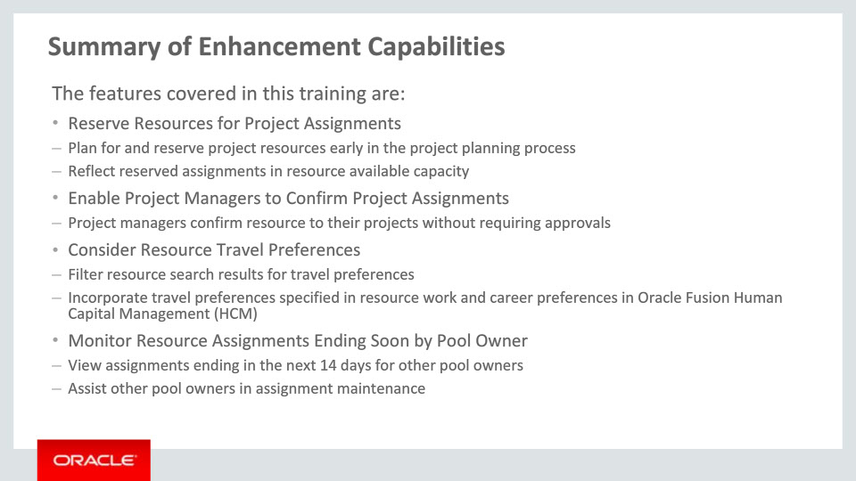
Slide notes
This release of Oracle Fusion Project Resource Management helps you do many things to manage your resources in a dynamic project environment.
Project managers and resource managers can soft book resources to reserve their capacity early on projects that are still in the planning stages. Project managers that manage both projects and resources can confirm resources directly to their projects so that the resources’ schedules and utilization reporting can accurately reflect what the resource is working on. This can be done in cases where formal resource managers may not be involved in all the detailed project staffing process.
Resource managers and their resources can be assured that their travel preferences are taken into account when evaluating resources for assignments.
When a resource manager is not available perhaps due to vacation, training, or other events, others can provide assistance by monitoring assignments ending soon for their resources and act on any assignments that need extensions.

Notes

Slide 28 - Summary of Enhancement Capabilities
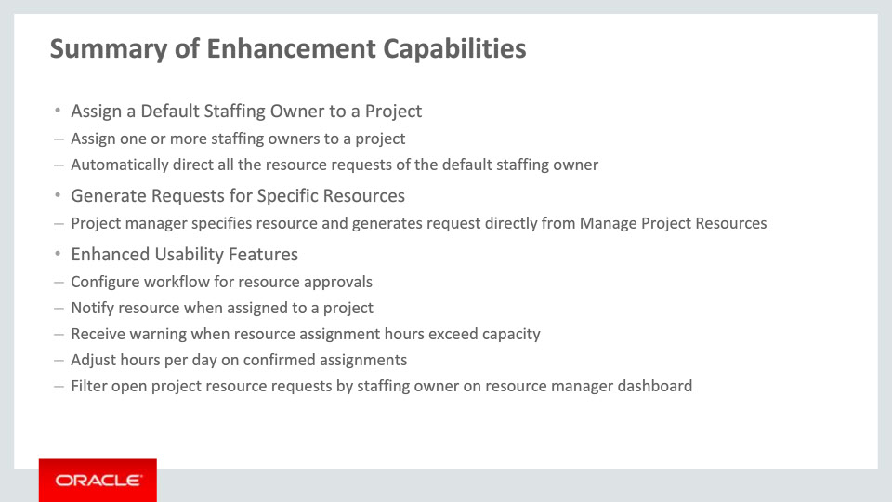
Slide notes
Project managers can specify one or more staffing owners for their projects and designate one of them as a default staffing owner for all the resource requests created from the project.
They can also easily submit project resource requests for specific resources to the staffing owner. This ensures that the staffing owner is made aware of the project manager’s desire for a particular resource.
New features in this release enhance the usability of day to day operations. Workflow rules for resource approvals can be configured to meet your specific business needs. Resources will be notified when they are assigned to projects.
The resource manager will be informed if the assignment they are making for a resource will exceed the resource’s capacity hours. This allows the resource manager to make an informed decision to continue with the assignment or make necessary adjustments.
The scheduled hours per day on an assignment can be adjusted to reflect the most accurate project demands.
On the Resource Manager dashboard, resource managers can filter open project resource requests by staffing owner to gain a more focused view of requests they own.
Notes

Slide 29 - Summary of Enhancement Capabilities
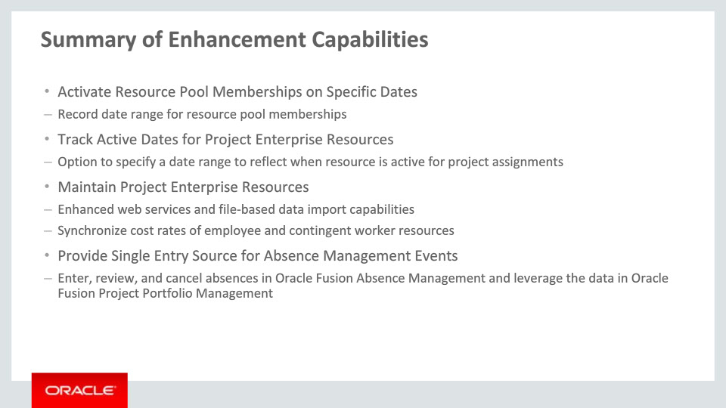
Slide notes
Resource managers can create resource pool memberships for specific date ranges. This information is taken into consideration during the resource search and when reporting resource pool utilization.
Administrators can also track the date range for when resources are available for project assignments. For HCM-linked resources, these dates are defaulted from HCM but can be further updated here if the resources are available for project assignments for only a subset of their employment.
Project application administrators can maintain project enterprise resources using enhanced web services and file-based data import capabilities. If Oracle Fusion Project Financial Management is also implemented, administrators can update the cost rates of HCM-linked resources based on their cost rate schedules defined there.
Absences can be entered, reviewed, and canceled in Oracle Fusion Absence Management and this same information appears in Oracle Fusion Project Portfolio Management. For example, when employees or contingent workers enter their upcoming absence in Oracle Fusion Absence Management, the absence is also considered when calculating the available capacity for people in Oracle Fusion Project Resource Management. Resource managers and project managers can view the absence in the resource's schedule and on the project calendar. Team members can see the absences on their calendar on the Team Member Dashboard.
Notes

Slide 30 - Summary of Enhancement Capabilities
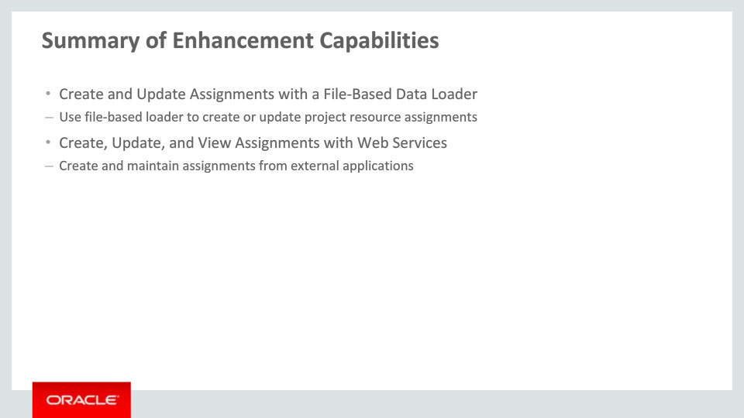
Slide notes
Finally, project application administrators can import bulk resource assignments using the file-based resource assignment loaders. Assignments can also be brought into Fusion using the Resource Assignment web service.

Notes

Slide 31 - Additional Information
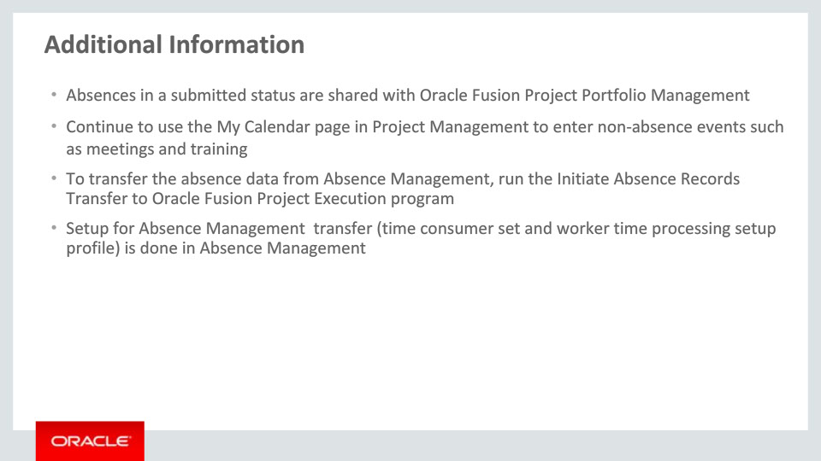
Slide notes
There is some additional information to note about integration with Oracle Fusion Absence Management. Absences that are in submitted status are immediately shared with Oracle Fusion Project Portfolio Management. This means that the absence data does not need to be approved before it is in Project Portfolio Management. The benefit is that resource managers can see such things as vacation requests sooner than if they had to wait for vacation approval. If the vacation request is denied, the absence will be deleted from Project Portfolio Management.
There are other events, such as meetings, on-site conferences, and training, that impact a resource’s availability that are not necessarily tracked in Absence Management. Resources should continue to use My Calendar page to enter those types of events.
The Initiate Absence Records Transfer to Oracle Fusion Project Execution program moves the data into Project Execution by either resource pool, resource, or project manager. This program should be scheduled on a daily basis to ensure that the latest data is in Project Management.
A predefined time consumer set for absence records transfer is provided. This time consumer set is referenced on the worker time processing setup profile. For more information, please see the Oracle Project Portfolio Management Cloud What’s New in Release 11 document.
Notes

Slide 32 - Implementation Advice

Slide notes
In this implementation advice section we will go through what you need to consider before enabling these features in your business, and what you need to know to set them up.

Notes

Slide 33 - Feature Impact Guidelines
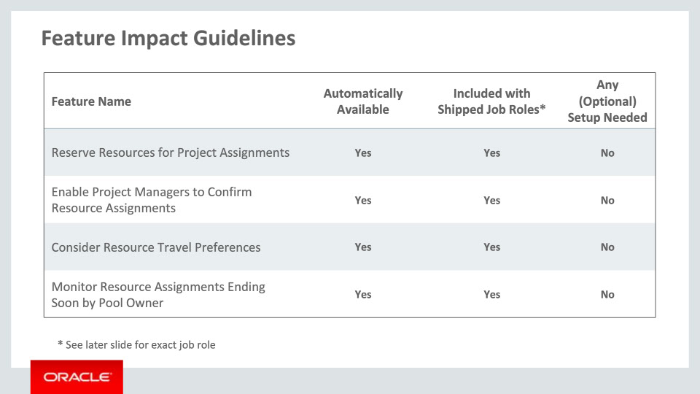
Slide notes
This table depicts key upgrade information for the new features covered in this training.
It details:
• If a feature is automatically available after the upgrade
• If a feature can be accessed using the shipped job roles – the exact job roles are detailed later in this section
• If a feature has any setup associated with it – setup specifics are covered later in this section.
The features Reserve Resources for Project Assignments, Enable Project Managers to Confirm Resource Assignments, Consider Resource Travel Preferences, and Monitor Resource Assignments Ending Soon by Pool Owner are all automatically available after upgrade, they can be accessed using shipped job roles, and there is no setup needed.
Notes

Slide 34 - Feature Impact Guidelines
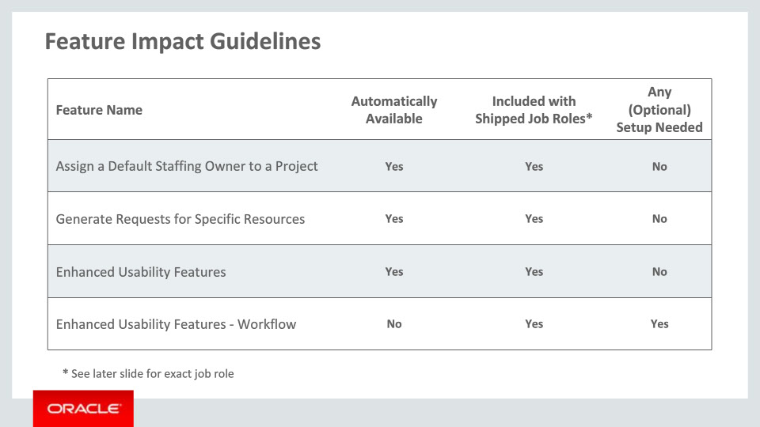
Slide notes
The features Assign a Default Staffing Owner to a Project, Generate Requests for Specific Resources, and most of the enhanced usability features are automatically available after upgrade, accessible using shipped job roles, and there is no setup needed.

The enhanced usability feature for workflow is not automatically available. The option to use workflow must be selected in setup to use the workflow feature. The feature can be accessed using the shipped job roles.

Notes

Slide 35 - Feature Impact Guidelines
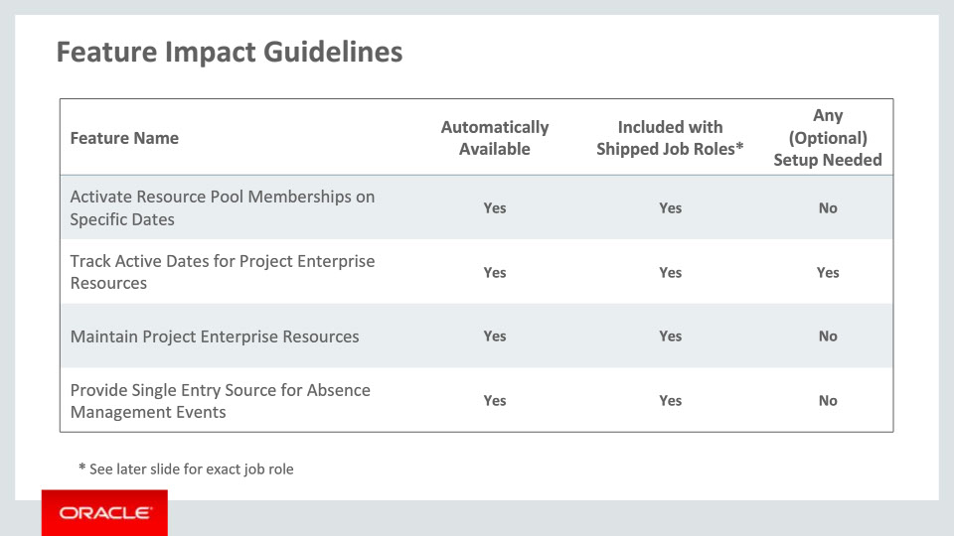
Slide notes
The feature Track Active Dates for Project Enterprise Resources is automatically available after upgrade and accessible using shipped job roles. There is optional setup that is available to gain full benefits of these features.

Activate Resource Pool Memberships on Specific Dates, Maintain Project Enterprise Resources, and Provide Single Entry Source for Absence Management Events are automatically available after upgrade, accessible using shipped job roles, and there is no setup needed.

Notes

Slide 36 - Feature Impact Guidelines
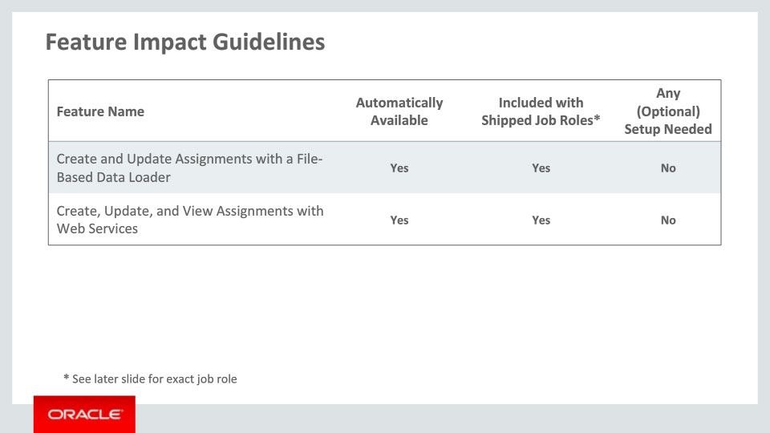
Slide notes
Finally, the features Create and Update Assignments with a File-Based Data Loader and Create, Update, and View Assignments with Web Services are automatically available, accessible using shipped job roles, and there is no setup needed.

Notes

Slide 37 - Setup Summary
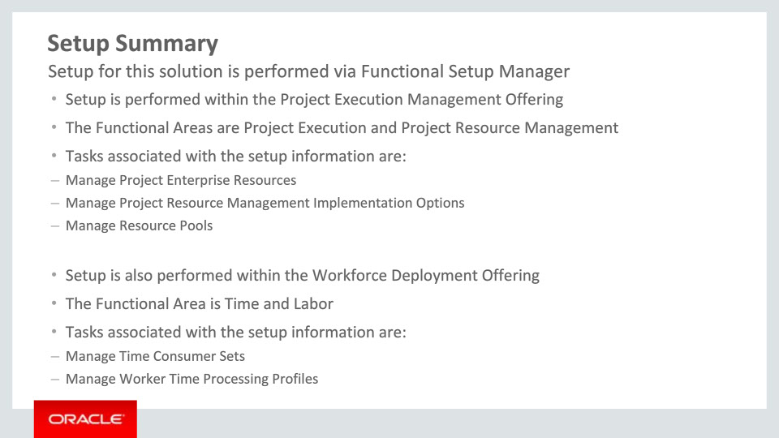
Slide notes
Most of the setup for managing resources in a dynamic environment is achieved by completing setup tasks within the Project Execution Management offering. Application implementation administrators enter and edit project enterprise resources through the Manage Project Enterprise Resources task found in the Project Execution functional area. Resource pool memberships for a particular resource can also be maintained through the Manage Project Enterprise Resources task.
Enable workflow options through the Manage Project Resource Management Implementation Options task. Setup and maintain resource pool memberships through the Manage Resource Pools task. Both of these tasks are located in the Project Resource Management functional area.
Setup tasks for the feature Provide Single Entry Source for Absence Management Events are available for review within the Workforce Deployment offering. There is a time consumer set called Project Execution Management Set Only that is already defined for your use. There is a worker time processing profile called Project Execution Management Time Processing Profile that is also provided. It is not necessary to create additional set up data to use this feature.
Notes

Slide 38 - Enhanced Usability Features: Workflow Setup Detail
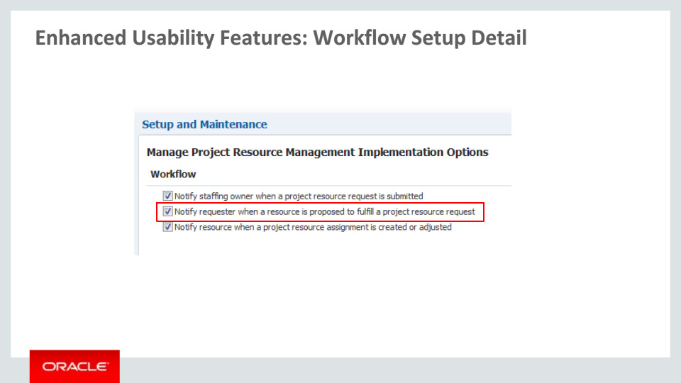
Slide notes
To enable workflow, set your preferences in Manage Project Resource Management Implementation Options. To specifically enable resource assignment approval workflow, enable the option Notify requester when a resource is proposed to fulfill a project resource request.

Notes

Slide 39 - Provide Single Entry Source for Absence Management Events Setup Detail
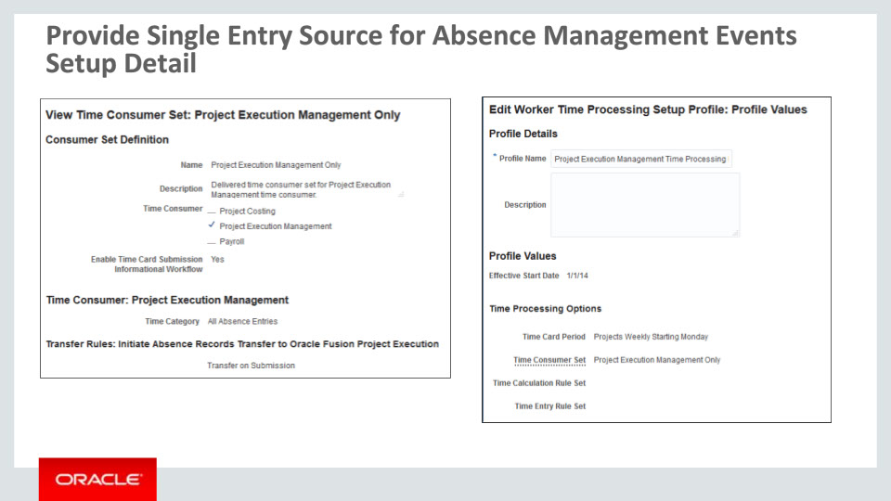
Slide notes
There is a seeded time consumer set as well as a seeded worker time processing setup profile for Project Execution Management. There is no need for further setup in order to take advantage of the single entry source for absence management events.

Notes

Slide 40 - Implementation Decision Points
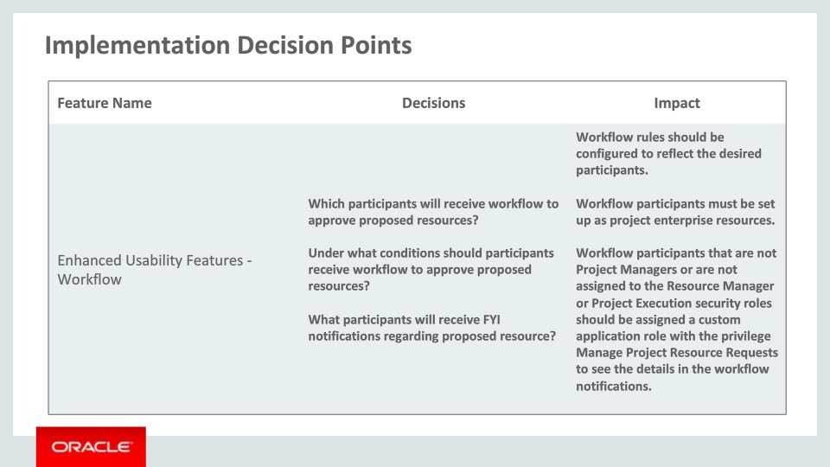
Slide notes
When implementing project resource management, you can determine if you want to use workflow to route resource approvals for project resource requests. If you use workflow, you should consider the following:
• Which participants will receive the workflow to approve proposed resources?
• Are there any specific business rules or conditions needed to determine which participants should receive approval workflow? For example, if the duration of the assignment is longer than 10 days, the resource’s line manager must approve.
There are a few other items to note when implementing this workflow:
• Workflow participants must be set up as project enterprise resources.
• If workflow participants are not project managers or are not provisioned with the Resource Manager or Project Execution security roles, you can create a custom application role with the Manage Project Resource Requests privilege to assign to the participants.
Notes

Slide 41 - Implementation Decision Points
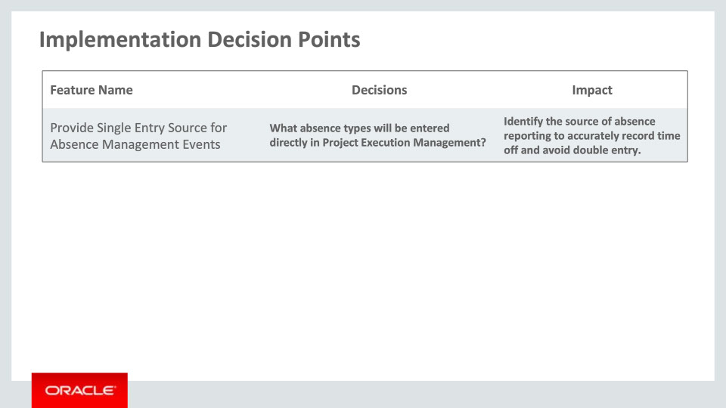
Slide notes
While we continue to allow users to enter absences in the team member and project calendars, those absences should be for events that do not impact payroll or other Human Resource requirements. Types of absences that should still be entered in Project Execution Management include training and other work-related events when the resource would not be considered for resource assignments, but is still considered on-the-clock. The option to enter paid time off is still available in the Team Member and Project calendars, but this should be used by companies that are not using Oracle Fusion Absence Management.

Notes

Slide 42 - Job Roles
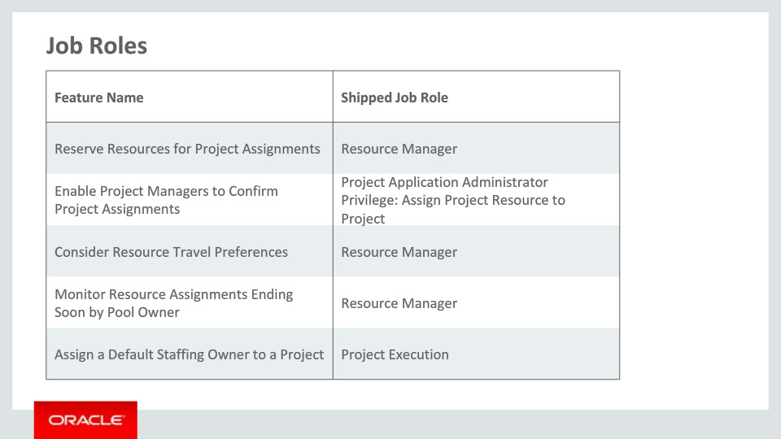
Slide notes
This table in the next three slides details the shipped job roles that will access the new capabilities covered in this training.
Please note the privilege that allows project managers to confirm resources without resource manager approval is Assign Project Resource to Project. This privilege can be associated to a custom role. This custom role can then be associated to project managers that should have this privilege.

Notes

Slide 43 - Job Roles
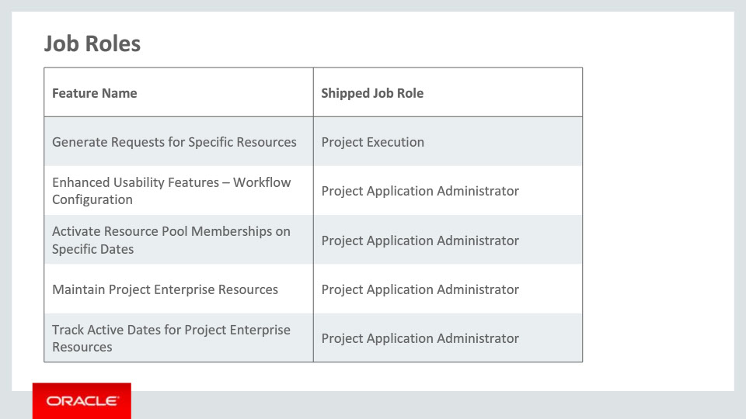
Slide notes

Notes

Slide 44 - Job Roles
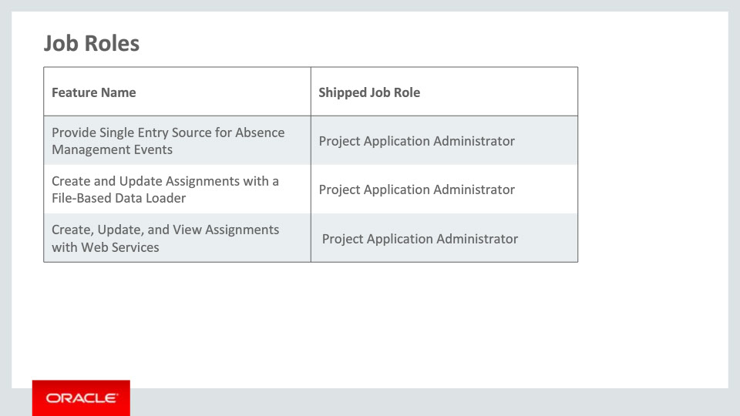
Slide notes

Notes

Slide 45 - Business Process Model Information
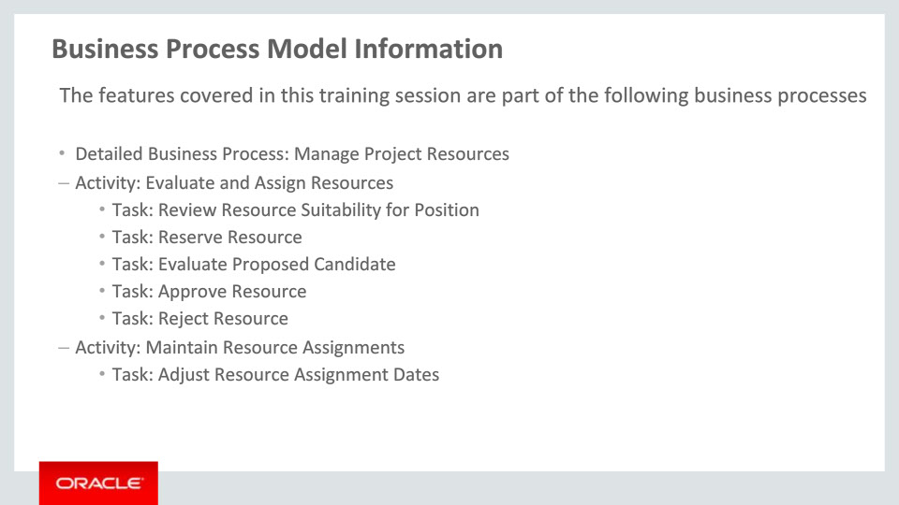
Slide notes
The business processes associated with the new capabilities covered in this training are detailed here.

One business process is Manage Project Resources with activities Evaluate and Assign Resources and Maintain Resource Assignments.

Notes

Slide 46 - Business Process Model Information
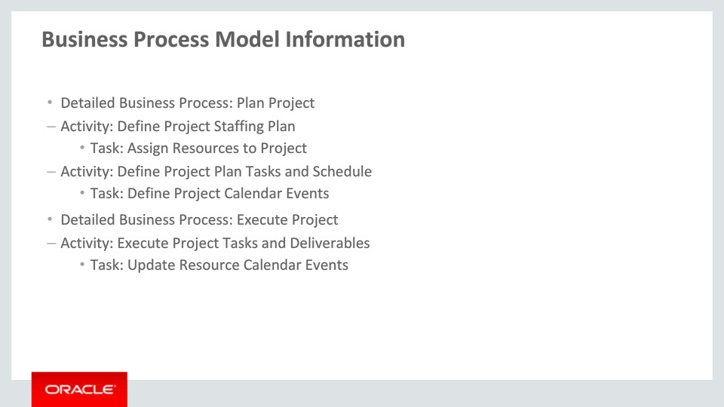
Slide notes
Another business process is Plan Project with the activities Define Project Staffing Plan and Define Project Plan Tasks and Schedule.

Lastly, the business process Execute Project has the activity Execute Project Tasks and Deliverables.

Notes

Slide 47 - Related Reports & BI Analytic Information
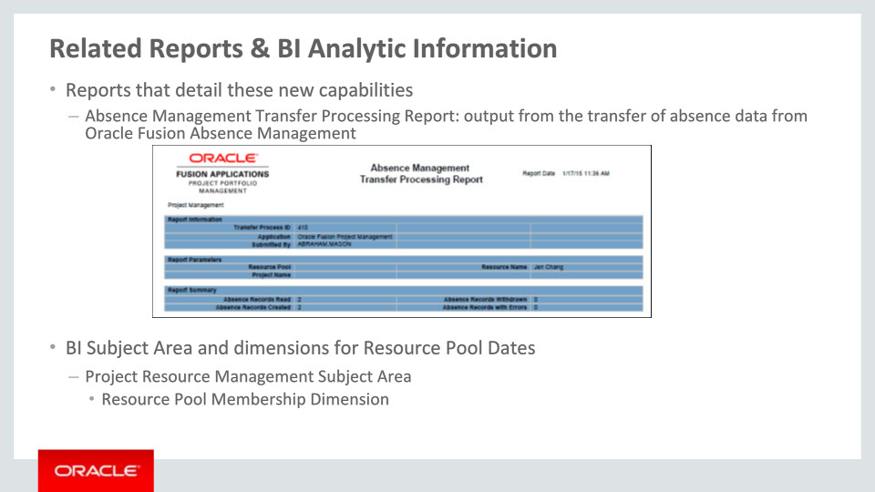
Slide notes
When the absences are transferred to Project Management, a processing report is generated that shows the parameters used, and number of records read, created, withdrawn, or with errors. This report should be reviewed to ensure that the process has run successfully.

In Oracle Transactional Business Intelligence, the Resource Pool Membership dimension has been enhanced to include the resource’s membership dates.

This concludes this presentation, thank you for listening. You can easily pause and rewind any of these slides if you require additional time to take in the detail.
Notes

