Slide 3 - Oracle Applications Cloud Release 10
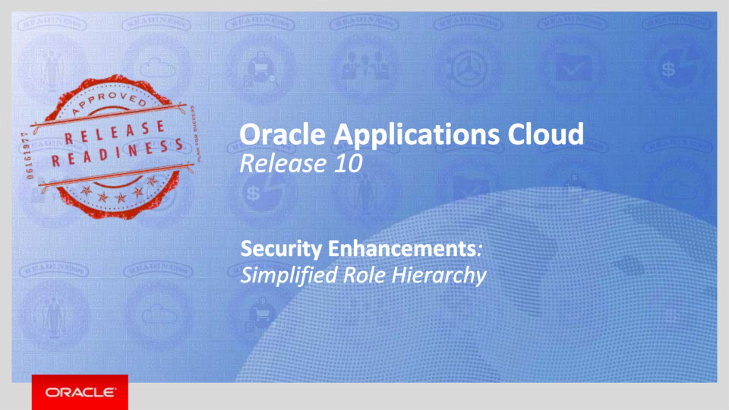
Slide notes
I am so excited to tell you more about Release 10! In the latest release from Oracle Applications Cloud we have added a new feature to simplify your security setups. Hello, my name is Nick and on behalf of the Enterprise Architecture team I welcome you to training for Release 10 Simplified Role Hierarchy.

Notes

Slide 4 - Agenda
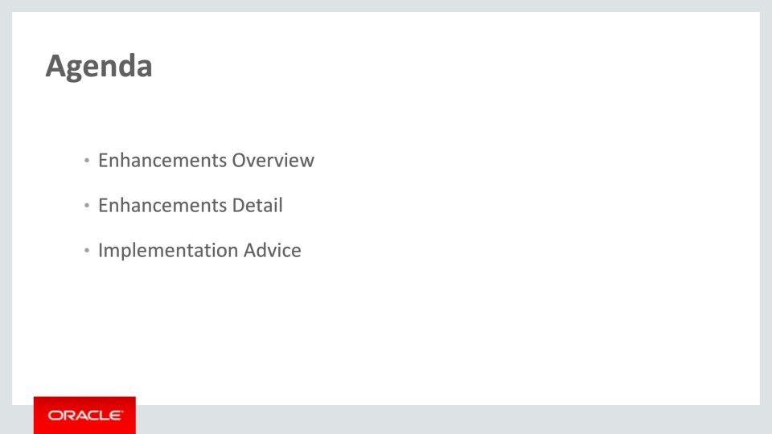
Slide notes
In this training, we will be giving an overview of this single topic, primarily focusing on upgrade customers. Following the overview will be more detailed descriptions, including a customer’s choices after the upgrade.

We will then walk you through a visual representation of the enhancement in each implementation choice. Finally, we’ll explain what you need to consider before enabling these features in your business, and where you can go to follow white papers detailing step-by-step instructions on how to set them up.

Notes

Slide 5 - Enhancements Overview
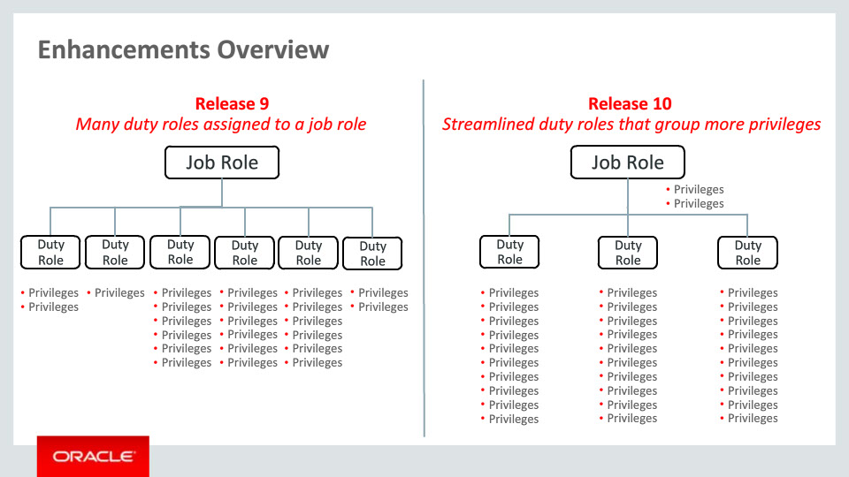
Slide notes
We are introducing a new security feature in R10 in order to increase the ease and flexibility of securing Oracle Applications Cloud.
Why change the Security Model in Release 10? Allow me to share this illustration with you as I answer that question:
• As you can see, the previous security model hierarchy was deeper than is now required. We have flattened the structure to make it less complicated.
• It was also noted a larger association of duty roles to a Job Role could be simplified.
• Lastly, customer feedback allowed for us to simplify the subscriber’s ability to customize their Job Roles.

Notes

Slide 6 - Enhancements Overview
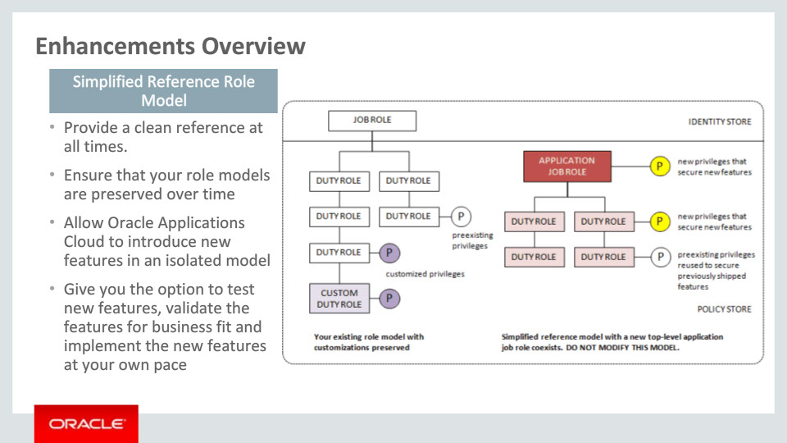
Slide notes
To help you understand what the simplified reference role model is we have a depiction of what a specific security model would look like after an upgrade process is complete.
Above the line is the identity store or the roles that are actually assigned to people e.g. Accounts Payables Manager. Below the line are roles in the Policy Store which are collections of authorizations that are assigned and even grouped together with other policy store roles e.g. Invoice Management.
The Simplified Reference Role Model is essentially a flattening of the security hierarchy found in previous versions of the Applications Cloud.
Several benefits this enhancement will provide are listed here:
1. Oracle will provide you with a clean security reference hierarchy in every release.
2. This hierarchy ensures that your role models are preserved over time.
3. Oracle will introduce new features from product families in an isolated model without impacting a customer’s structure.
4. Finally, this will allow you to decide when to implement new features in your own structures at your own pace.
The most visible aspect of the Release 10 simplification is the reduced number of duty roles when compared to the role model in the previous release.

Notes

Slide 7 - Enhancements Detail
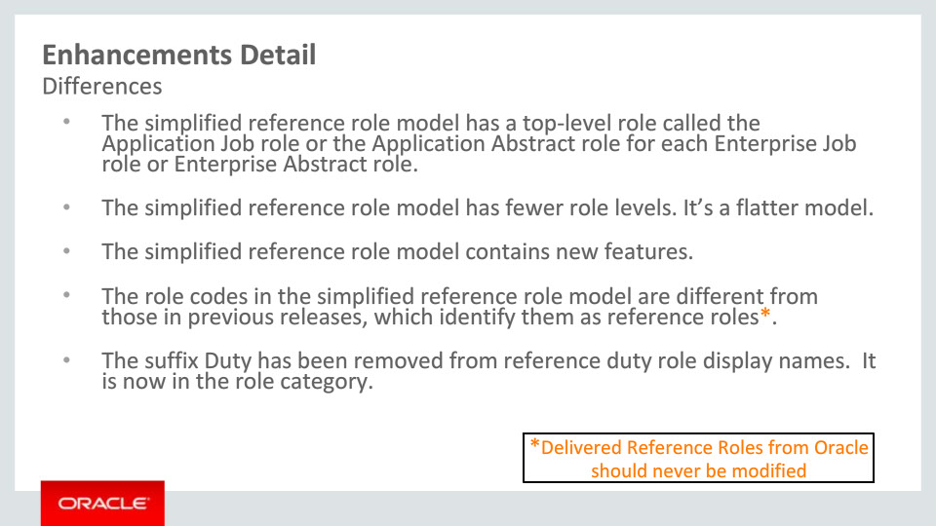
Slide notes
So an obvious question you may have on your mind is ‘What are the main differences between a preexisting role model and a corresponding simplified reference role model?
• If you recall from the previous slide, the Application Job role replaces the Enterprise roles from earlier releases.
• Again, we have made the new reference role model simpler by making it flatter with fewer levels.
• We also use and will continue to use the provided simplified reference role model as the mechanism to deliver new authorizations for new features created by the product teams.
• We have also made it easier for you to identify and find the delivered reference role codes by adding an ORA_ prefix.
• A further cleanup that we have performed is to removed the ‘Duty’ suffix from reference duty role names and moved the ‘Duty’ designation to the role category.
As always, Oracle recommends that you do not modify the delivered reference roles.

Notes

Slide 8 - Enhancements Detail
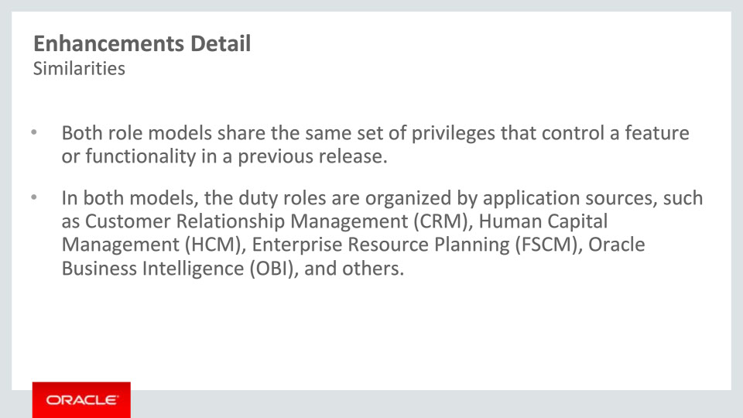
Slide notes
This then leads to the question ‘What are the similarities between the preexisting role model and a simplified reference role model?’
Both of the role models, up to Release 9, contain all of the previous privileges or functionality. They are both included.
We also continue to organize privileges using the Policy Store using a ‘Policy Stripe’ by application sources such as Customer Relationship Management (CRM), Human Capital Management (HCM), Oracle Business Intelligence (OBI) and so on…

Notes

Slide 9 - Enhancements Detail
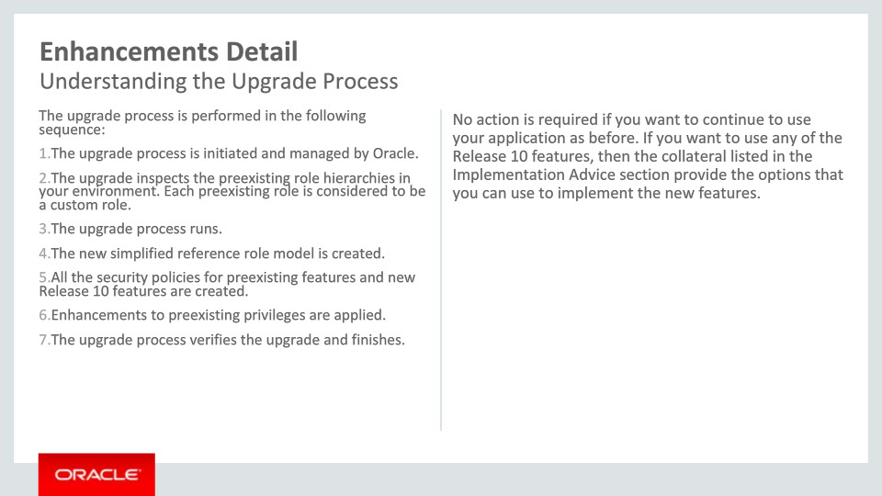
Slide notes
1. The first thing to understand about the upgrade process is that it is initiated and managed by Oracle.
2. The next thing that occurs is the upgrade inspects the preexisting role hierarchies and treats each one as a custom role. In this way we are not modifying in any way the existing role hierarchies.
3. The upgrade process is then executed and
4. The new simplified reference role model is created.
5. Now the authorizations for the preexisting features and the new Release 10 privileges are created and authorized to the new role model.
6. Finally, the enhancements to the preexisting privileges are applied and
7. The process then verifies the upgrade has completed its tasks and finishes.
It is important to note that there is no action required on your part. This especially applies if you want to continue to use the application as it was working before as it will work exactly the same.
If you want to use any of the Release 10 features, then the collateral listed in the Implementation Advice section of this presentation will provide you with a deeper description and step by step instructions to do this and more.

Notes

Slide 10 - Enhancements Detail
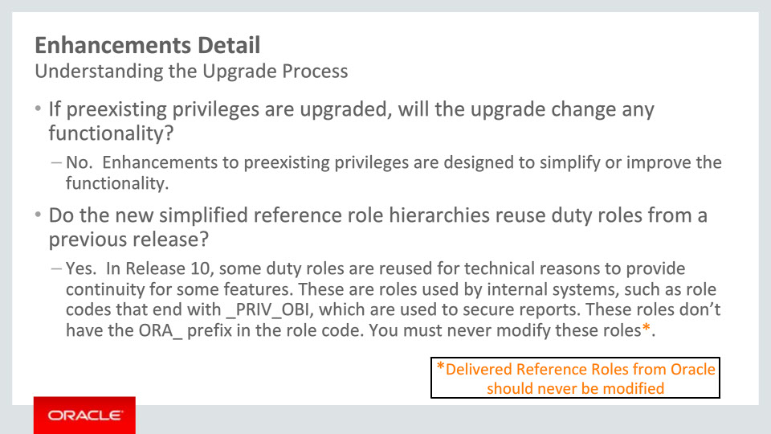
Slide notes
Let us also address a few possible frequently asked questions about this feature. We touched on these earlier, but they bear repeating:
‘If preexisting privileges are upgraded, will the upgrade change any functionality?’ No. Enhancements to preexisting privileges are designed to simplify and improve the functionality.
‘Do the new reference role hierarchies reuse duty roles from a previous release?’ Yes. In Release 10, some duty roles are reused for technical reasons to provide continuity for some features. These are roles used by internal systems, such as Oracle Business Intelligence role codes that end with _PRIV_OBI which are used to secure reporting. These roles don’t have the ORA_ prefix in the role code. Again, delivered reference roles should never by modified.

Notes

Slide 11 - Enhancements Detail
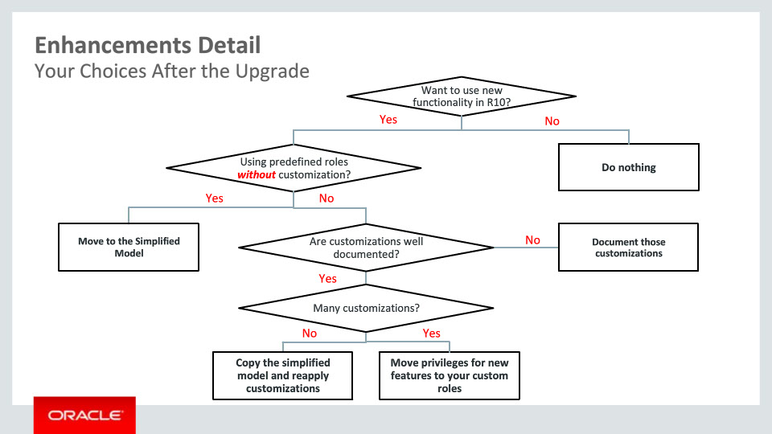
Slide notes
Decision #1: The first question you would need to ask yourself is whether you would need to use the new functionality in Release 10.
If the answer is ‘No’ – if you are implementing and you have just completed getting signoff from the design process and everyone is happy with the roles that they have – then there is NOTHING to do.
If the answer is ‘Yes’, then
Decision #2: you would ask ‘Does my implementation use the predefined roles without customization?
If the answer is ‘Yes’, then you should simply move to the simplified model.
If the answer is ‘No’, we have customized either the predefined roles or created custom roles from the ground up you have another question to ask.
Decision #3: you would ask yourself ‘Are the customizations well documented?’
If the answer is ‘No’, the customizations are not well documented, then you would need to document those setups before you could plan to move forward with the simplified role hierarchy.
If ‘Yes’, you know exactly what you have modified or customized, the you would move to the next
Decision #4, ‘Do we have many customizations?’.
If you are heavily customized or ‘Yes’, then you really should be following the steps to move new feature privileges into your custom role hierarchies.
If you have light customization or ‘No’, then you would make a copy of the simplified reference role model and apply your customizations to this new model you would have created.
Notes
Slide 12 - Implementation Advice
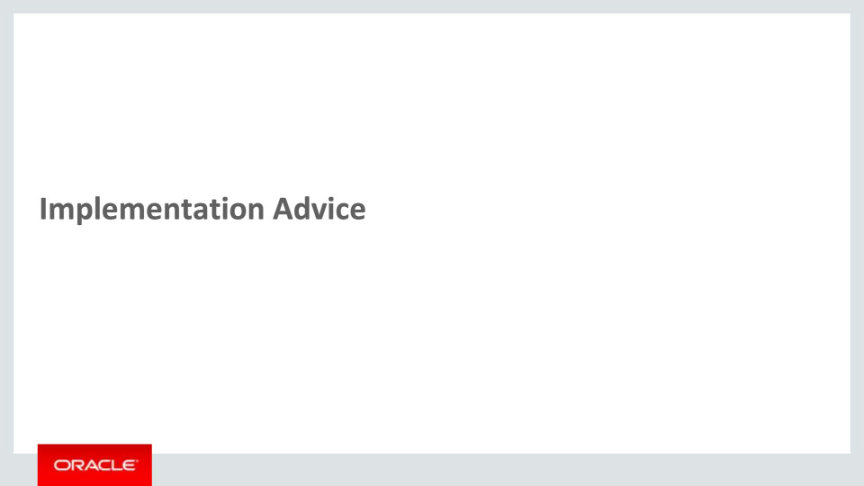
Slide notes
In this implementation advice section we will go through what you need to consider before enabling these features in your business, and what you need to know to set them up.

Notes

Slide 13 - Slide 11
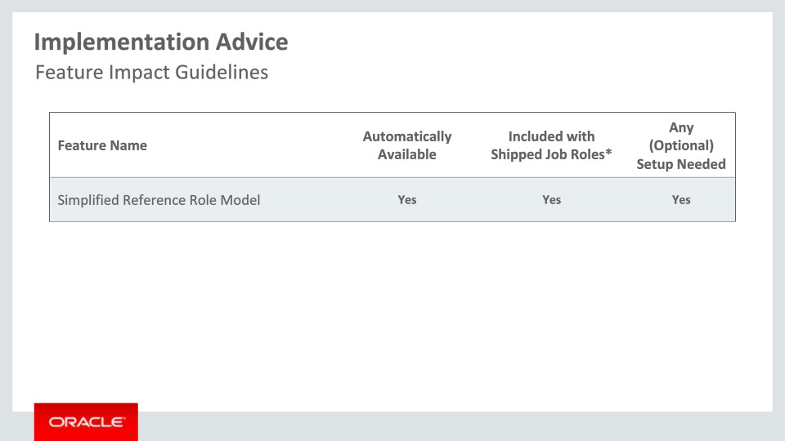
Slide notes
This table depicts key upgrade information for the new features covered in this training.
The features covered in this presentation are:
• Automatically available after upgrade
• Can be accessed using the shipped job roles, AND
• Require some Setup (if you want to use new Release 10 Product features)
Notes

Slide 14 - Slide 12
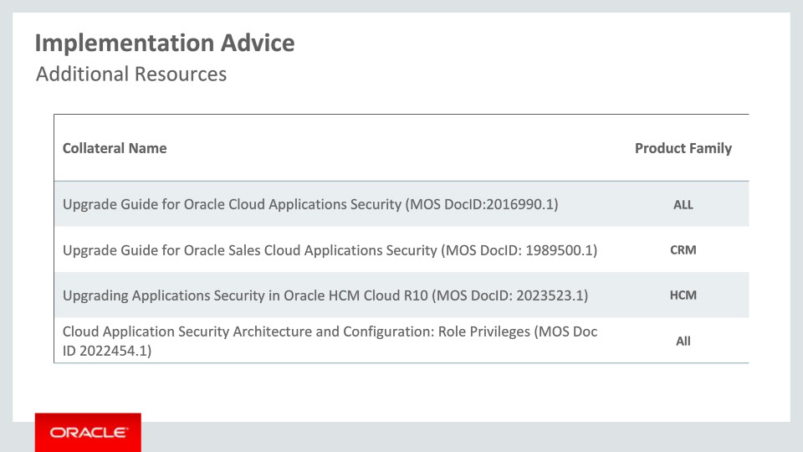
Slide notes
There are many resources to educate yourself on the new simplified reference role model enhancements. I wanted to list a few here as a guide.
The first is an Application Security Common Upgrade Guide or white paper detailing the steps and procedures to implement your choices made with regards to:
1. Migrating to the new simplified role model or
2. Adding the new features into your existing model.
Second is the same document, yet targeting our customers who are sales cloud focused.
As you will see the next is a document for our HCM customers using examples specific to HCM.
Lastly, I would like to point out maybe the most important document that contains references to the majority of content on this subject is Document ID 2022454.1 found in MyOracleSupport. All of the Release Readiness materials @ cloud.oracle.com/readiness, as well as standard content like security guides, the security reference role manuals for each family, user guides, etc… linked in this last document.

Notes

Slide 15 - Business Process Model Information
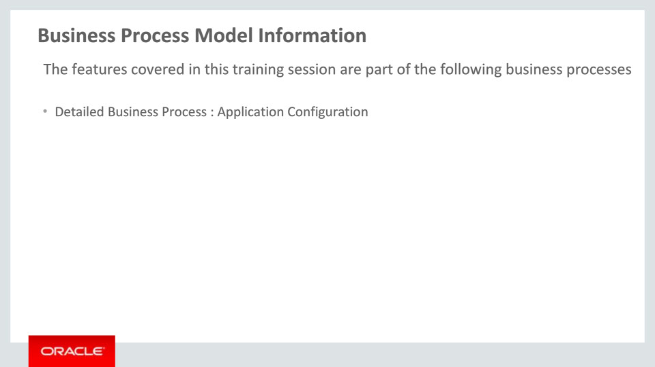
Slide notes
The business processes associated with the new capabilities covered in this training are detailed here.
The high level business process is Application Configuration – post upgrade.

This concludes this presentation, thank you for listening. You can easily pause and rewind any of these slides if you require additional time to take in the detail.

Notes

